Add a custom field Total Contacts of type Number on Account object with default value 0.

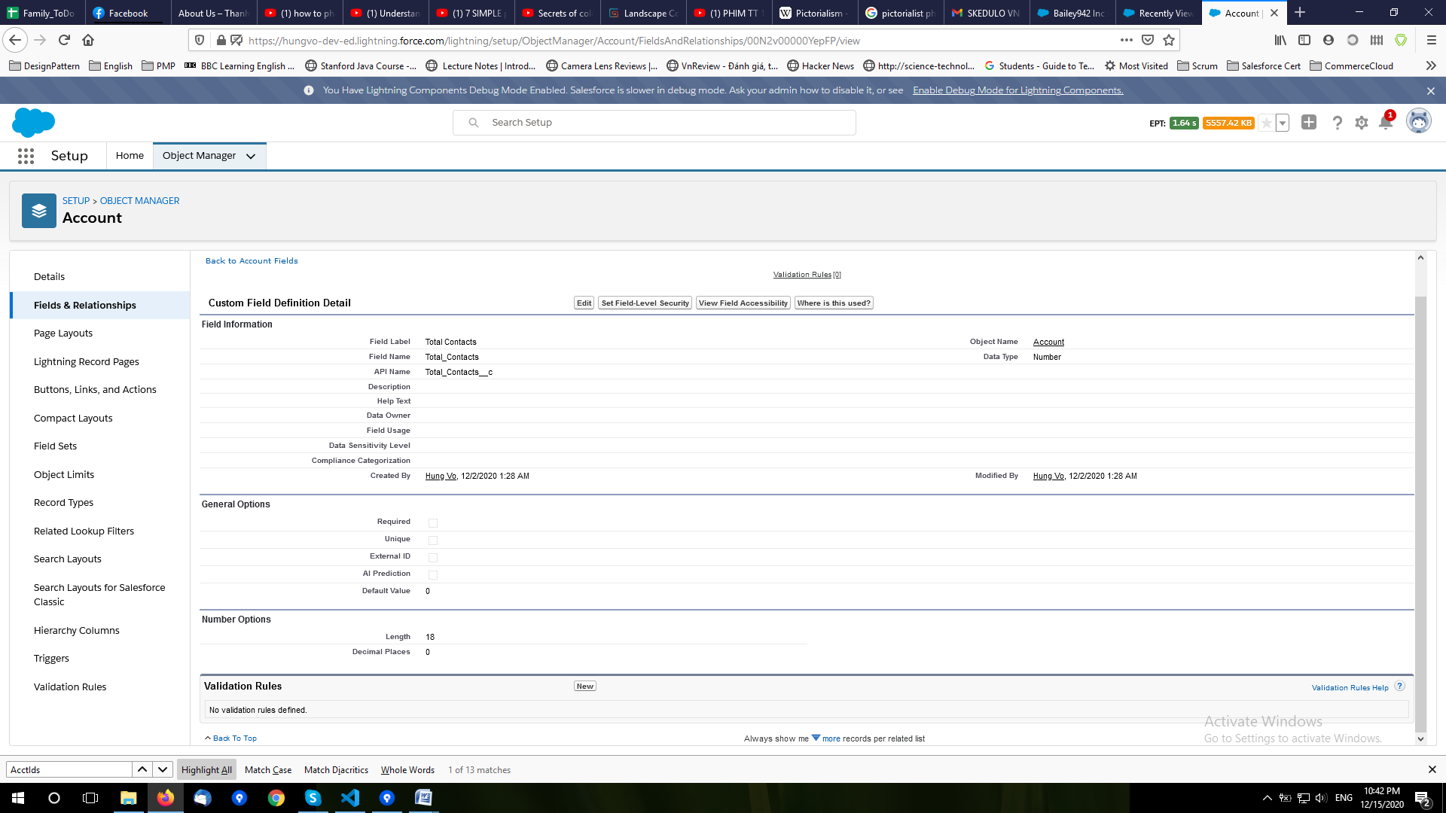

Add a custom field Active of type Boolean on Contact object with default value false

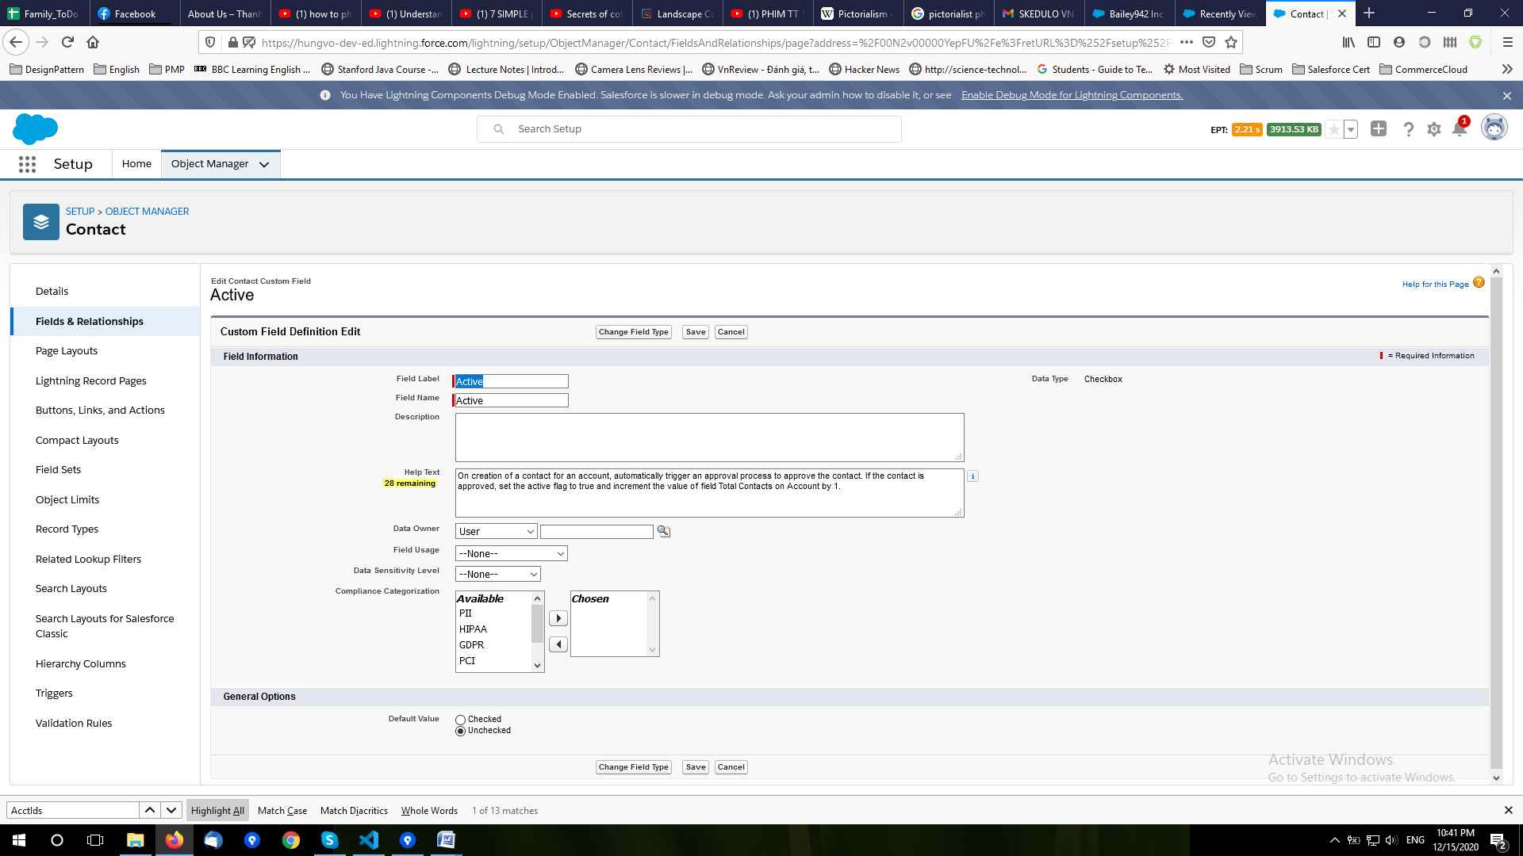

**Code:**

trigger creatingNewContact_trg on Contact (after insert, after delete, after update) {

MapId, ListContact AcctContactList = new MapId, ListContact();

SetId AcctIds = new SetId();

Listschema.Account AcctList = new Listschema.Account();

Listschema.Contact ConList = new Listschema.Contact();

if (Trigger.isInsert) {

for (Contact newContact Trigger.new) {

Create an approval request for the Opportunity

Approval.ProcessSubmitRequest req1 = new Approval.ProcessSubmitRequest();

req1.setComments('New contact waiting to approve.');

req1.setObjectId(newContact.id);

req1.setNextApproverIds(new Id[] {UserInfo.getUserId()});

Submit the approval request for the Opportunity

Approval.ProcessResult result = Approval.process(req1);

}

}

if(trigger.isInsert trigger.isUpdate) {

for(Contact Con trigger.New) {

if(String.isNotBlank(Con.AccountId)){

AcctIds.add(Con.AccountId);

}

}

}

if(trigger.isDelete) {

for(Contact oldContact Trigger.Old) {

if(String.isNotBlank(oldContact.AccountId)){

AcctIds.add(oldContact.AccountId);

}

}

}

if(AcctIds.size() 0){

ConList = [SELECT Id, AccountId FROM Contact WHERE AccountId IN AcctIds AND Active__c = True];

for(Contact Con ConList) {

if(!AcctContactList.containsKey(Con.AccountId)){

AcctContactList.put(Con.AccountId, new ListContact());

}

AcctContactList.get(Con.AccountId).add(Con);

}

AcctList = [SELECT Total_Contacts__c FROM Account WHERE Id IN AcctIds];

if (AcctList.size() 0){

for(Account Acc AcctList) {

Listschema.Contact ContList = new Listschema.Contact();

ContList = AcctContactList.get(Acc.Id);

if (AcctContactList.size() 0)

Acc.Total_Contacts__c = ContList.size();

else

Acc.Total_Contacts__c = 0;

}

}

update AcctList;

}

}