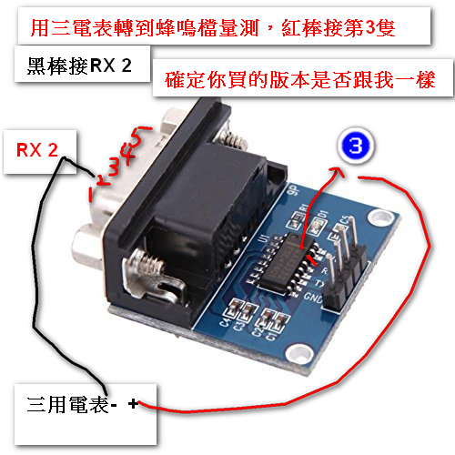

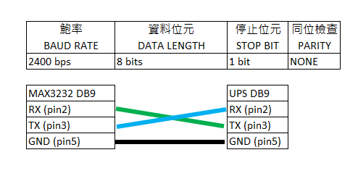 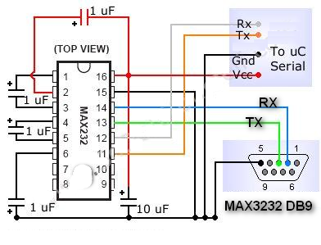

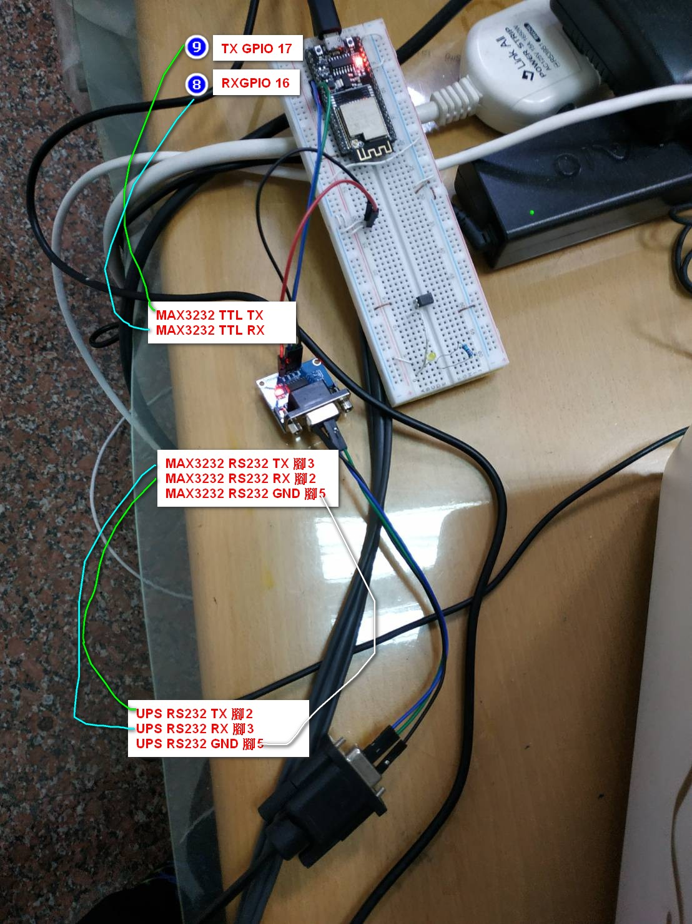

#define TXD2 17

#define RXD2 16

void setup() {

Serial.begin(2400);

Serial2.begin(2400, SERIAL_8N1, RXD2, TXD2);

}

void loop() {

String comdata ;

while (Serial.available() > 0) {

comdata = Serial.readString(); //Serial.readString 讀取文字 //Serial.read 讀字元

if (comdata == "1") {

Serial2.write("Q1\r");

Serial.println("開啟");

}

else if (comdata == "2") {

Serial2.write("T\r");

Serial.println("自我測試10秒");

}

else if (comdata == "3") {

Serial2.write("CT\r");

Serial.println("結束自我測試");

}

else {

Serial2.write((comdata + "\r").c_str());

Serial.println(comdata);

}

}

if (Serial2.available() > 0) {

Serial.print("傳回內容：");

Serial.println(Serial2.readString());

}

}

