BỘ GIÁO DỤC VÀ ĐÀO TẠO
TRƯỜNG ĐẠI HỌC CẦN THƠ
TRƯỜNG CÔNG NGHỆ THÔNG TIN VÀ TRUYỀN THÔNG



BÁO CÁO
CT239H NIÊN LUẬN CƠ SỞ NGÀNH

TÊN ĐỀ TÀI
CHAT BOT HỖ TRỢ CHÍNH SÁCH XÃ HỘI

LỚP (CHUYÊN NGÀNH, KHÓA, LỚP HỌC PHẦN): ______________________________
HỌC KỲ / NĂM HỌC: _________________________________________________

CÁN BỘ HƯỚNG DẪN SINH VIÊN THỰC HIỆN

TS. Phan Phương Lan Cao Tường Hưng B2303873

Cần Thơ, tháng ____ / năm ______

ABSTRACT
This project develops an authenticated web-based chatbot that assists Can Tho University students in finding information about tuition fees, scholarships, tuition exemption and reduction, social support, and student loans. The system combines a Retrieval-Augmented Generation architecture with structured tuition lookup and controlled financial tools. Policy documents are converted to Markdown, classified with business metadata, divided into parent and child chunks, embedded locally, and indexed in Qdrant. At query time, a constrained rewriter clarifies only genuinely vague follow-up questions; deterministic intent routing then selects structured data or an appropriate metadata-filtered retrieval lane. Candidate passages are restored from PostgreSQL, reranked by a multilingual cross-encoder, and supplied to Gemini with explicit grounding instructions. Redis provides short-term conversational context, while PostgreSQL stores accounts and persistent history. The implemented application also supports administrator-controlled PDF ingestion with validation and rollback. The resulting design prioritizes Vietnamese semantic retrieval, source separation, auditable calculations, and explicit abstention when supporting evidence is unavailable. Quantitative chatbot accuracy is intentionally reserved for completion after the final evaluation run.

TABLE OF CONTENTS
ABSTRACT i
TABLE OF CONTENTS ii
LIST OF TABLES vi
LIST OF FIGURES vii
LIST OF ABBREVIATIONS viii
CHAPTER 1: INTRODUCTION 1
1.1 PROBLEM STATEMENT 1
1.2 OBJECTIVES 2
1.2.1 General objective 2
1.2.2 Specific objectives 2
1.3 SCOPE AND LIMITATIONS 3
1.3.1 Project scope 3
1.3.2 Limitations 3
1.4 DEVELOPMENT METHOD 4
CHAPTER 2: THEORETICAL FOUNDATION 5
2.1 RETRIEVAL-AUGMENTED GENERATION 5
2.1.1 Retrieval, augmentation, and generation 5
2.1.2 Document preparation and metadata 5
2.1.3 Parent-child chunking 6
2.1.4 Vector search and HNSW 7
2.1.5 Cross-encoder reranking 7
2.1.6 Grounded prompt construction 7
2.2 EMBEDDING MODEL SELECTION 7
2.2.1 Selected model 7
2.2.1.1 Vietnamese-language specialization 8
2.2.1.2 Policy-domain compatibility 8
2.2.1.3 Semantic retrieval capability 8
2.2.1.4 Published model-card evidence 8
2.2.1.5 Efficient bi-encoder operation 8
2.2.1.6 Capacity and storage balance 8
2.2.1.7 Local data control 9
2.2.1.8 Technology integration 9
2.2.1.9 Licence and reproducibility 9
2.2.1.10 Fit with chunking 9
2.3 EMBEDDING MODEL TRADE-OFFS 9
2.3.1 Future embedding benchmark 10
2.4 RERANKER MODEL SELECTION 10
2.5 OTHER TECHNOLOGY CHOICES 11
2.5.1 Technology-selection criteria and operational trade-offs 12
CHAPTER 3: APPLICATION RESULTS 14
3.1 SOFTWARE REQUIREMENT SPECIFICATION 14
3.1.1 Overall description 14
3.1.1.1 Product perspective 14
3.1.1.2 Actors 14
3.1.1.3 Operating environment 15
3.1.1.4 Constraints and assumptions 15
3.1.2 Specific requirements 16
3.1.3 Functional requirements 16
3.1.3.1 FR-01 - Account authentication 17
3.1.3.2 FR-02 - Question submission 17
3.1.3.3 FR-03 - Conversational context 17
3.1.3.4 FR-04 - Safe query rewriting 17
3.1.3.5 FR-05 - Intent-aware retrieval 17
3.1.3.6 FR-06 - Structured tuition lookup 18
3.1.3.7 FR-07 - Controlled calculations 18
3.1.3.8 FR-08 - History management 18
3.1.3.9 FR-09 - Administrator upload 18
3.1.3.10 FR-10 - Atomic ingestion 18
3.1.4 Nonfunctional requirements 18
3.1.5 Requirements traceability 19
3.2 SOFTWARE DESIGN 20
3.2.1 Application architecture 20
3.2.2 Data design 22
3.2.2.1 Document metadata 23
3.2.3 Detailed design 23
3.2.3.1 Document ingestion pipeline 23
3.2.3.2 Chat query pipeline 24
3.2.3.3 Safe follow-up rewriting 25
3.2.3.4 Intent routing and retrieval lanes 25
3.2.3.5 Structured tuition lookup 25
3.2.3.6 Vector retrieval and reranking 25
3.2.3.7 Tool calling and response construction 26
3.2.3.8 History persistence 26
3.2.4 Failure handling and data consistency 27
3.2.5 User interface design 28
3.3 TESTING 31
3.3.1 Test plan 31
3.3.1.1 Representative test cases 32
3.3.1.2 Coverage and acceptance procedure 33
3.3.2 Results and analysis 34
3.3.2.1 Evaluation method 34
3.3.2.2 Reserved interpretation area 35
CHAPTER 4: CONCLUSION 36
4.1 PROJECT SUMMARY 36
4.2 ACHIEVEMENT OF OBJECTIVES 36
4.3 LIMITATIONS 37
4.4 FUTURE WORK 37
REFERENCES 39
APPENDICES 40
API ENDPOINT SUMMARY 40
TEXTUAL USER GUIDE 40
DEPLOYMENT OVERVIEW 41
PROPOSED EMBEDDING BENCHMARK PROTOCOL 41

LIST OF TABLES
Table 1. Project objectives and observable outcomes 2
Table 2. Project scope boundaries 3
Table 3. Embedding-model selection criteria 9
Table 4. Qualitative comparison of retrieval alternatives 10
Table 5. Separation of retrieval and reranking responsibilities 11
Table 6. Technology stack and rationale 11
Table 7. Technology decision risks and controls 13
Table 8. System actors and access boundaries 14
Table 9. Functional requirements 16
Table 10. Nonfunctional requirements 18
Table 11. Functional-requirement traceability matrix 19
Table 12. Architecture-layer responsibilities 21
Table 13. Data-store mapping 22
Table 14. Business and technical metadata 23
Table 15. Important implementation parameters 26
Table 16. Failure boundaries and consistency controls 28
Table 17. Testing strategy 32
Table 18. Automated test inventory 32
Table 19. Representative automated test cases 32
Table 20. Manual acceptance evidence 34
Table 21. Chatbot accuracy evaluation results - intentionally blank 35
Table 22. Achievement of project objectives 36
Table 23. Recommended future work 37
Table 24. Public API endpoint summary 40
Table 25. Deployment dependencies without secret values 41

LIST OF FIGURES
Figure 1. Primary system use cases 15
Figure 2. Current application architecture 20
Figure 3. Relational and vector data design 22
Figure 4. Document ingestion and rollback pipeline 23
Figure 5. Query routing, retrieval, and answer generation 24
Figure 6. Login and registration interface 29
Figure 7. Main chatbot interface 29
Figure 8. Conversation history and session controls 30
Figure 9. Chat answer presentation 30
Figure 10. Administrator PDF upload interface 31
Figure 11. Support and policy-topic page 31

LIST OF ABBREVIATIONS
Abbreviation | Meaning
AI | Artificial Intelligence
API | Application Programming Interface
CLO | Course Learning Outcome
CTU | Can Tho University
DBMS | Database Management System
ERD | Entity-Relationship Diagram
FR | Functional Requirement
HNSW | Hierarchical Navigable Small World
HTTP | Hypertext Transfer Protocol
JWT | JSON Web Token
LLM | Large Language Model
NFR | Nonfunctional Requirement
OCR | Optical Character Recognition
RAG | Retrieval-Augmented Generation
SRS | Software Requirement Specification
UAT | User Acceptance Testing

INTRODUCTION

PROBLEM STATEMENT
Student financial policy information at a large university is distributed across regulations, annual tuition schedules, scholarship announcements, administrative forms, and external government decisions. A student who asks a practical question rarely knows which document contains the answer or whether a figure represents the actual tuition rate, a statutory ceiling, or the amount used as the basis for exemption and reduction. Documents also differ in publication date, structure, terminology, and target audience. The resulting search task is not merely a keyword lookup: it requires identifying the correct policy domain, academic year, programme, cohort, subject, and eligibility context before extracting an answer.
Conventional website search and manual browsing impose a high cognitive cost. Students must formulate official terminology, open several PDF files, compare tables, and interpret cross-references. Short natural-language questions such as “How much do I pay after a seventy-percent reduction?” combine several facts that may be stored separately. A generic language model can produce fluent explanations but may mix actual tuition with exemption-basis rates, inherit an entity from an unrelated previous answer, or invent a value when the corpus is incomplete. In a student-finance setting, a confident but unsupported number can directly affect planning and trust.
The project therefore treats retrieval correctness, source separation, and controlled calculation as first-class requirements. The chatbot must accept conversational Vietnamese, preserve relevant context without allowing previous generated content to contaminate retrieval, and route questions to the correct information lane. Exact tuition-rate questions should use structured records when possible, while broader policy questions should use semantic retrieval over verified documents. When the evidence is absent, the system must state that it cannot find the information rather than fabricate an answer.
The implementation problem also includes operational concerns. Accounts and full conversation histories require durable storage; recent context requires low-latency access; document ingestion must validate uploads and avoid partial indexes; and administrative functions must be restricted by role. The solution must remain understandable enough for a student project while demonstrating a complete software-engineering process from requirements and architecture to implementation, testing, and evaluation.

OBJECTIVES

General objective
The general objective is to design and implement a web-based assistant that provides concise, source-grounded support for Can Tho University student financial policies by combining Vietnamese semantic retrieval, deterministic business rules, controlled calculations, and persistent conversational services.

Specific objectives
- Accept natural Vietnamese questions about tuition, scholarships, tuition exemption and reduction, social support, and student loans.
- Separate policy domains and fee concepts before retrieval so that semantically similar but legally different sources are not mixed.
- Use exact structured lookup for tuition rates that depend on programme, cohort, major, subject, or special rule.
- Retrieve relevant policy passages through a parent-child vector architecture and refine the candidates with cross-encoder reranking.
- Invoke deterministic scholarship and tuition-reduction tools only when the question explicitly requires calculation.
- Maintain short-term conversational context in Redis and durable accounts, sessions, messages, and parent documents in PostgreSQL.
- Permit administrators to upload validated PDF documents and roll back every artifact if ingestion fails.
- Provide a reproducible test and evaluation process while leaving final quantitative chatbot accuracy for the final assessment run.
Table 1. Project objectives and observable outcomes
Objective | Observable outcome | Evidence
O-01 | A user can authenticate and submit a policy question. | Auth and /chat APIs
O-02 | A question is routed to a domain-appropriate source path. | Intent and retrieval-lane tests
O-03 | Exact tuition facts are returned from structured records. | Tuition catalog tests
O-04 | Eligible calculation requests invoke deterministic tools. | Finance-tool tests
O-05 | Sessions and messages persist across visits. | PostgreSQL and history APIs
O-06 | A failed upload leaves no partial indexed document. | Upload rollback tests

SCOPE AND LIMITATIONS

Project scope
The information scope is limited to documents collected for CTU student financial support. The active metadata catalog currently classifies sources into tuition, scholarship, social-support, student-loan, and other domains. The application provides registration, cookie-based authentication, conversational question answering, session management, finance tools, and administrator document upload. The retrieval pipeline processes Vietnamese Markdown derived from PDF documents and uses metadata such as domain, content kind, fee kind, academic year, source, status, source hash, index version, and ingestion run.

Limitations
The chatbot cannot guarantee an answer beyond the coverage and currency of its active documents. External model and parsing services introduce network, quota, and provider dependencies. The local reranker requires substantial memory and is configured for a constrained GPU. The selected Vietnamese embedding model has a shorter input limit than newer multilingual alternatives, which motivates small child chunks but can reduce representation of very long passages. The current web interface is intentionally lightweight, and quantitative response accuracy remains to be completed after the final corpus and runtime have been frozen.
Table 2. Project scope boundaries
In scope | Out of scope
CTU student-finance and support policies | General entertainment, politics, or unrelated advice
Vietnamese natural-language questions | Full multilingual policy coverage
Policy retrieval and controlled calculations | Legal or financial guarantees
Authenticated web use and persistent history | Native mobile applications
Administrator PDF ingestion | Automatic trust of arbitrary internet content

DEVELOPMENT METHOD
The project follows an iterative evidence-first process. Requirements are derived from student question patterns and administrative document types. Architecture is divided into web, orchestration, retrieval, and storage responsibilities. Implementation is validated through focused unit and integration tests, followed by authenticated API evaluation using the same cookie-based flow as the user interface. Retrieval changes are separated from data-index changes so that code-only routing adjustments do not trigger unnecessary reindexing, whereas changes to content, metadata, chunking, or embeddings require a new immutable vector-index version.
- Identify the student problem, project scope, actors, and acceptance criteria.
- Collect and normalize policy documents and define business metadata.
- Design the parent-child RAG pipeline, exact tuition catalog, tools, and persistence services.
- Implement the APIs and browser client using modular project components.
- Verify deterministic behavior through automated tests and evaluate complete answers through authenticated /chat calls.
- Document limitations, reserve final accuracy fields, and prepare the system for demonstration.

THEORETICAL FOUNDATION

RETRIEVAL-AUGMENTED GENERATION

Retrieval, augmentation, and generation
Retrieval-Augmented Generation combines an information-retrieval system with a generative model. Instead of asking the language model to answer only from parameters learned during pre-training, the system first retrieves passages from a controlled corpus. Those passages are inserted into a prompt together with instructions and the user question. The language model then generates an answer conditioned on explicit evidence. This separation is useful for institutional policy because documents change more frequently than model weights and must remain auditable.
In this project, retrieval is not a single vector query. The system first decides whether a question can be answered by the structured tuition catalog or whether one or more document lanes are required. A lane represents a business distinction such as scholarship, student loan, social support, actual tuition, exemption basis, or exemption policy. Each Qdrant request includes an active-status condition and, when enabled, business metadata filters. The retrieved child vectors lead to larger parent documents in PostgreSQL, and a reranker selects the most relevant parents before context construction.
Augmentation labels every context block with source and business metadata. The labels explicitly distinguish actual tuition from the basis used to calculate exemption or reduction. Headers extracted from Markdown are also added so that a passage retains its position in the original policy. The prompt supplies a routing-specific answer instruction and requires the model to report missing evidence instead of substituting a semantically similar document. Generation is therefore constrained by both retrieved text and deterministic routing decisions.

Document preparation and metadata
Uploaded PDF documents are validated before processing. The current API accepts safe PDF filenames, checks the media type and PDF signature, enforces a five-mebibyte limit, validates the document class, and requires a consecutive academic-year value where relevant. LlamaParse converts the validated PDF to Markdown. The conversion preserves headings and tables better than plain text extraction, providing structure for downstream splitting.
The metadata catalog assigns each source a domain, content kind, fee kind, academic year, and active status. Technical metadata includes the source filename, effective date, timestamp, SHA-256 checksum, index version, and ingestion-run identifier. Business metadata controls retrieval; technical metadata supports drift detection, reproducibility, and rollback. This distinction prevents operational fields from being confused with the semantics of a student question.
During ingestion, heading-level metadata and business labels are attached before the second parent split, so every derived parent and child retains the same filterable classification. A table-aware splitter keeps Markdown tables intact whenever possible and repeats header rows when a large table must be divided. This behavior is important because tuition schedules often store meaning in column headings that would otherwise be separated from numeric rows.

Parent-child chunking
A single chunk size cannot simultaneously maximize retrieval resolution and generation context. Small chunks are easier to match semantically, but they may omit the surrounding rule or table heading. Large chunks preserve meaning but may contain several unrelated topics. The project applies a small-to-big strategy: child chunks are embedded for high-resolution vector search, while the associated parent passages are returned to the reranker and language model.
The parent splitter uses a 2,800-character target with 100-character overlap and prefers paragraph, line, sentence, and word boundaries. Child chunks use 400 characters with 50-character overlap. Smart table handling preserves headers in every table fragment. The overlap reduces boundary loss, while metadata labels make the business category visible to both the embedding model and the generated prompt. This configuration is an engineering choice that should be benchmarked against alternatives rather than treated as universally optimal.

Vector search and HNSW
Dense retrieval maps a question and document chunks into the same vector space. Cosine similarity compares their orientation, which approximates semantic relatedness while reducing the influence of vector magnitude. Qdrant stores 768-dimensional child vectors and uses a Hierarchical Navigable Small World index. HNSW builds a multi-layer proximity graph that offers approximate nearest-neighbour search with high recall and low query latency. The configured construction parameters balance graph connectivity and indexing cost for the project corpus.

Cross-encoder reranking
A bi-encoder independently represents questions and documents, enabling fast search but losing some token-level interaction. A cross-encoder receives the query and passage together and can evaluate detailed relationships. Running a cross-encoder over the entire corpus would be expensive, so the system uses vector search for a broad candidate set and reranks only the retrieved parents. The current pipeline searches for fifteen candidates and retains six after reranking. A soft temporal tie-break applies only when relevance scores fall within 0.05, ensuring that a clearly more relevant older policy is not displaced solely by date.

Grounded prompt construction
The final prompt contains the user’s original question, recent human and assistant messages, a retrieval-specific instruction, and labeled evidence. The original wording is preserved for natural response generation even when a clarified search query is used for retrieval. Tool results are appended as structured messages and a final model call verbalizes them. If no authoritative data or correctly filtered passages are available, the API returns an explicit no-result response without invoking speculative generation.

EMBEDDING MODEL SELECTION

Selected model
The implementation uses bkai-foundation-models/vietnamese-bi-encoder through LangChain’s HuggingFaceEmbeddings adapter. The model maps sentences and paragraphs into a 768-dimensional dense vector space and uses a PhoBERT-base-v2 backbone [2], [3]. It is selected for first-stage retrieval because the application corpus and user questions are predominantly Vietnamese and contain formal administrative language.

Vietnamese-language specialization
The model is trained for Vietnamese sentence similarity and semantic retrieval. A language-specific encoder is a more direct fit than an English-oriented encoder for questions containing Vietnamese grammar, diacritics, abbreviations, and institutional vocabulary.

Policy-domain compatibility
Its training mixture includes Vietnamese-translated MS MARCO and SQuAD together with data from the Legal Text Retrieval Zalo challenge. The latter is relevant to decisions, regulations, eligibility conditions, and administrative passages that resemble the project corpus.

Semantic retrieval capability
Dense 768-dimensional representations allow passages to match paraphrased questions even when they do not share exact surface terms. This supports natural student wording that differs from official policy titles.

Published model-card evidence
The authors report stronger legal-retrieval results for the fully trained model than for the listed Vietnamese-SBERT and partial-training baselines [2]. These external benchmark figures are evidence about the model, not measurements of this chatbot.

Efficient bi-encoder operation
Document chunks are embedded once during ingestion. At runtime only the query is embedded, after which Qdrant performs nearest-neighbour search. This is materially cheaper than joint query-passage scoring over the full corpus.

Capacity and storage balance
A 768-dimensional vector offers more representational capacity than common 384-dimensional compact models while remaining practical for the current document collection and local vector store.

Local data control
Embedding runs locally. Policy content does not need to be sent to an external embedding API, reducing network dependency, recurring cost, and unnecessary transfer of institutional documents.

Technology integration
The model is directly supported by Sentence Transformers and HuggingFaceEmbeddings. Its output dimension matches the configured Qdrant collection and cosine-distance function, so no projection or adapter service is required.

Licence and reproducibility
The published Apache-2.0 model, configuration, and weights support reproducible academic implementation and avoid dependence on a closed embedding endpoint.

Fit with chunking
The model card lists a maximum sequence length of 256 tokens. The 400-character child chunks reduce truncation risk, and the 50-character overlap protects meaning around boundaries.
Table 3. Embedding-model selection criteria
Criterion | Project requirement | Selected-model fit | Trade-off
Language | Vietnamese questions and documents | Vietnamese-specific PhoBERT backbone | Less multilingual flexibility
Domain | Administrative and policy retrieval | Includes Vietnamese legal-retrieval training data | Not trained exclusively on CTU policy
Vector size | Useful semantic capacity with local storage | 768 dimensions | More storage than 384-D models
Deployment | Repeatable local ingestion and query embedding | Open weights and Sentence Transformers support | Local CPU/GPU resources required
Context | Short retrieval chunks | Matches 400-character child strategy | 256-token maximum limits long passages

EMBEDDING MODEL TRADE-OFFS
The selected model is not presented as universally superior. It is an engineering choice based on language alignment, policy-domain evidence, local hardware, integration cost, and the current corpus. A replacement should be decided through a controlled benchmark using the same queries, relevance judgments, chunking, vector database, and latency conditions.
Table 4. Qualitative comparison of retrieval alternatives
Candidate | Advantage | Limitation | Decision
Vietnamese Bi-Encoder | Vietnamese-specific; legal-retrieval data; practical 768-D vectors | Shorter context and older than newer multilingual models | Selected for first-stage retrieval
Multilingual BGE-M3 | Long context and multilingual support | Higher resource needs; Vietnamese policy benefit requires local evidence | Future comparison
Multilingual MiniLM | Small and fast | Lower vector capacity and weaker Vietnamese policy alignment | Not selected
External embedding API | Managed infrastructure and simple scaling | Cost, network, privacy, and vendor dependence | Not selected
Keyword/BM25 | Fast and interpretable for exact terms | Weak for paraphrases and semantic equivalence | Potential hybrid extension

Future embedding benchmark
A future experiment should freeze the corpus and construct query-passage relevance judgments for each policy domain. Every candidate model should receive identical chunks and metadata filters. Recall at k, mean reciprocal rank, normalized discounted cumulative gain, index size, embedding throughput, and end-to-end latency should be measured. The experiment should also include exact-term and paraphrase subsets so that dense retrieval is not rewarded for behavior that a simpler keyword index could provide.

RERANKER MODEL SELECTION
The second-stage model is BAAI/bge-reranker-v2-m3, a multilingual cross-encoder derived from BGE-M3 [4], [5]. Unlike the embedding model, the reranker does not create reusable document vectors. It accepts each query-passage pair and returns a relevance score. This joint encoding captures detailed relationships that independent query and document vectors can miss.
- The bi-encoder maximizes candidate-retrieval speed and recall; the reranker improves precision within the small candidate set.
- Multilingual pre-training is useful because Vietnamese policies contain English technology terms, programme names, abbreviations, and policy codes.
- Only the top 15 retrieved candidates are reranked, avoiding the cost of cross-encoding the entire corpus.
- The top 6 parent passages control prompt size and reduce contamination by marginally relevant documents.
- The implementation sets max_length to 512 to reduce CUDA memory pressure on the available GPU.
- A temporal tie-break is permitted only within a score tolerance of 0.05, keeping semantic relevance primary.
Table 5. Separation of retrieval and reranking responsibilities
Stage | Model or method | Input | Output | Primary goal
1 | Vietnamese Bi-Encoder + Qdrant | Query and precomputed child vectors | Top 15 candidate parents | Fast recall
2 | BGE Reranker v2-m3 | Query-parent pairs | Top 6 ordered parents | Fine-grained precision
3 | Soft temporal tie-break | Near-equal reranker scores | Stable recency-aware order | Current-policy preference without relevance override

OTHER TECHNOLOGY CHOICES
Table 6. Technology stack and rationale
Technology | Project role | Selection rationale
FastAPI | Asynchronous web API | Typed request models, dependency injection, and efficient async integration
PostgreSQL | Persistent relational and parent-document storage | Transactions, relationships, indexing, and JSONB metadata
Redis | Recent conversation context | Low-latency list operations and simple session-scoped keys
Qdrant | Vector and payload store | HNSW search, cosine distance, metadata filters, and collection aliases
Gemini | Answer generation and tool calling | Structured tool-call support and Vietnamese response generation
Groq Llama 3.3 | Constrained follow-up rewriting | Low-temperature, low-latency clarification of vague queries
LlamaParse | PDF-to-Markdown conversion | Layout-aware extraction for headings and tables
HTML/CSS/JavaScript | Browser interface | Low deployment complexity and direct integration with FastAPI static hosting

The architecture deliberately assigns one primary responsibility to each storage system. PostgreSQL is authoritative for users, sessions, full message history, and parent-document content. Redis caches only the recent conversational window. Qdrant stores child vectors and filterable metadata. The structured tuition catalog represents exact monetary facts that should not be diluted by approximate vector similarity. This separation makes failure modes easier to reason about and prevents a single database from being forced into unsuitable workloads.

Technology-selection criteria and operational trade-offs
Technology selection was evaluated against five project constraints: Vietnamese policy content, correctness of monetary answers, modest local deployment resources, the need for reproducible student work, and the requirement to evolve the corpus without retraining a language model. No component is selected in isolation. For example, local embedding reduces recurring API dependency, but the larger reranker still benefits from a GPU; PostgreSQL provides transactional durability, while Redis is used only where temporary low-latency state is acceptable. The chosen stack therefore distributes responsibilities according to the consequence of data loss or approximation.
The generative and rewriting services are intentionally separated. Query rewriting is a narrow transformation task with a low-temperature prompt, strict output validation, and a safe fallback to the original question. Answer generation has a broader linguistic role but receives server-selected evidence and deterministic tool results. This design limits the authority granted to either model. A provider failure may reduce availability, yet it cannot silently change the structured tuition catalog, document metadata, account records, or calculation formulas.
The three data stores also have different recovery expectations. PostgreSQL backups protect durable identity, conversation, and parent-document state. Qdrant collections can be rebuilt from the retained source files and metadata manifest, although re-embedding has a computational cost. Redis history can be reconstructed from recent PostgreSQL messages after a session is reopened. Treating Redis and Qdrant as rebuildable projections reduces the risk that a cache or index becomes the only copy of important information.
These choices create explicit future comparison points. A hybrid BM25 and dense retriever may improve exact policy-code matching; a newer multilingual embedding model may improve long-context retrieval; and a self-hosted generator may reduce external dependency. Each alternative also adds indexing, hardware, or operational cost. The project therefore records model names, vector dimension, chunk parameters, filters, and index versions so that a future experiment can change one variable at a time and attribute any improvement correctly.
Table 7. Technology decision risks and controls
Decision concern | Current response | Residual risk | Planned control
Vietnamese semantics | Vietnamese-specific first-stage encoder | CTU terminology may differ from training data | Corpus-specific relevance benchmark
Exact monetary facts | Structured tuition catalog and deterministic tools | Catalog coverage may be incomplete | Coverage audit and clarification prompts
Source traceability | Metadata-labelled parents and immutable index versions | Answer UI does not yet expose full citations | Add source and effective-date display
External availability | Validated fallbacks and explicit errors | Generation, rewriting, and parsing still depend on providers | Monitoring and optional local alternatives
Operational recovery | Transactional parent storage and ingestion-run rollback | Reindexing may be time-consuming | Documented backup and rebuild procedure

APPLICATION RESULTS

SOFTWARE REQUIREMENT SPECIFICATION

Overall description

Product perspective
The product is a browser-based client served by a FastAPI application. It is not an unrestricted general-purpose chatbot. Its purpose is to answer CTU student-finance questions from an administered corpus and deterministic business data. The backend coordinates authentication, conversation state, intent routing, structured lookup, vector retrieval, reranking, tool calling, persistent history, and document ingestion.

Actors
Table 8. System actors and access boundaries
Actor | Responsibilities | Access boundary
Student user | Register, authenticate, ask questions, continue conversations, and manage owned sessions | Only own sessions and messages
Administrator | Perform all authenticated user actions and upload classified policy PDFs | Upload endpoint additionally requires persisted admin role
External model service | Rewrite constrained follow-ups, parse PDF content, and generate grounded answers | Receives only task-specific data through configured clients
Storage services | Persist accounts, history, parents, vectors, and recent context | Accessed through backend application

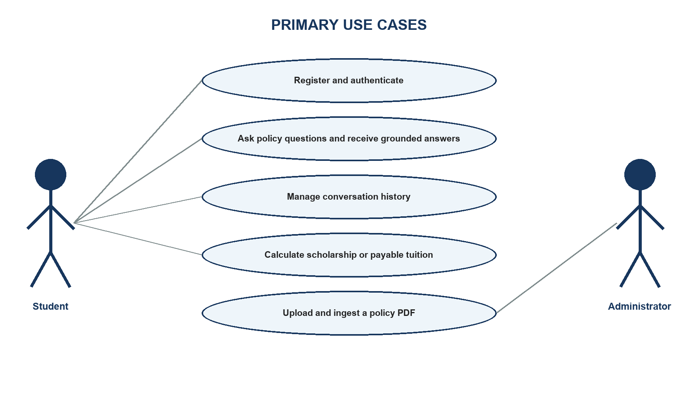
Figure 1. Primary system use cases

Operating environment
The application runs as a Python FastAPI service on port 8000 and serves a vanilla JavaScript frontend. PostgreSQL 15, Redis 7, and Qdrant 1.18 are declared as container services. Model execution uses configured Google and Groq APIs together with local Hugging Face embedding and reranking models. Environment variables hold service URLs and credentials; secrets must not be embedded in source files or documentation.

Constraints and assumptions
- A valid Gemini API key is required during application startup.
- Redis, PostgreSQL, and Qdrant must be reachable before chat operations can succeed.
- The active Qdrant collection or alias must match the embedding dimension and metadata schema.
- Uploaded documents must be valid PDF files no larger than five mebibytes.
- A tuition-rate document class requires a consecutive academic-year value.
- The final answer quality depends on document coverage and retrieval configuration.

Specific requirements
The primary user journey begins with registration or login. The server returns an HTTP-only access-token cookie rather than exposing a token to browser JavaScript. After authentication, the user can create or resume a session and submit a question. The server obtains recent context, optionally clarifies a vague follow-up, classifies the question, selects structured or document retrieval, obtains a grounded answer, returns the session identifier, and schedules durable message storage.
The administrator journey extends the authenticated user role. The upload form supplies a PDF, document class, and academic year when required. The server validates the filename, media type, file signature, size, class, and year before writing. It parses and ingests the document using a unique ingestion-run identifier. Any failure after partial ingestion triggers removal of same-run vectors, parents, generated Markdown, copied PDF, and metadata entries.

Functional requirements
Table 9. Functional requirements
ID | Name | Requirement
FR-01 | Account authentication | The system shall register users, verify credentials, issue an HTTP-only JWT cookie, report the current user, and delete the cookie on logout.
FR-02 | Question submission | The system shall accept an authenticated query and optional session identifier and return an answer with the active session identifier.
FR-03 | Conversational context | The system shall load up to five recent Redis messages scoped by user and session.
FR-04 | Safe query rewriting | The system shall rewrite only vague follow-ups and reject rewrites that introduce unsupported entities, numbers, years, or intentions.
FR-05 | Intent-aware retrieval | The system shall classify the question and apply domain, content-kind, fee-kind, academic-year, and active-status filters as appropriate.
FR-06 | Structured tuition lookup | The system shall answer exact course, programme, cohort, and special-rule tuition questions from authoritative structured records.
FR-07 | Controlled calculations | The system shall invoke scholarship or payable-tuition tools only when the required inputs and user intention justify calculation.
FR-08 | History management | The system shall list, load, rename, and delete only the current user’s sessions.
FR-09 | Administrator upload | The system shall restrict PDF ingestion to authenticated users whose persisted role is admin.
FR-10 | Atomic ingestion | The system shall register document metadata, index content, preserve source provenance, and roll back same-run artifacts on failure.

FR-01 - Account authentication
The system shall register users, verify credentials, issue an HTTP-only JWT cookie, report the current user, and delete the cookie on logout.

FR-02 - Question submission
The system shall accept an authenticated query and optional session identifier and return an answer with the active session identifier.

FR-03 - Conversational context
The system shall load up to five recent Redis messages scoped by user and session.

FR-04 - Safe query rewriting
The system shall rewrite only vague follow-ups and reject rewrites that introduce unsupported entities, numbers, years, or intentions.
The original question remains the source of user intent. The rewritten query is accepted only after validation and is used for retrieval, not as a generated answer. This protects clear questions from inheriting unrelated context and prevents the rewriter from injecting a policy domain or academic year.

FR-05 - Intent-aware retrieval
The system shall classify the question and apply domain, content-kind, fee-kind, academic-year, and active-status filters as appropriate.
The route decision may produce more than one lane when the question explicitly combines concepts. Results are deduplicated by document identity. Missing lanes are reported in the answer instruction so that the generator cannot silently substitute another fee type or policy domain.

FR-06 - Structured tuition lookup
The system shall answer exact course, programme, cohort, and special-rule tuition questions from authoritative structured records.

FR-07 - Controlled calculations
The system shall invoke scholarship or payable-tuition tools only when the required inputs and user intention justify calculation.

FR-08 - History management
The system shall list, load, rename, and delete only the current user’s sessions.

FR-09 - Administrator upload
The system shall restrict PDF ingestion to authenticated users whose persisted role is admin.

FR-10 - Atomic ingestion
The system shall register document metadata, index content, preserve source provenance, and roll back same-run artifacts on failure.
An ingestion-run identifier scopes rollback. This is safer than deleting every indexed version of a source because a failed replacement cannot remove a previously active document. Index versions and aliases support blue-green activation rather than destructive rebuilds.

Nonfunctional requirements
Table 10. Nonfunctional requirements
ID | Category | Requirement and verification
NFR-01 | Security | Passwords shall be bcrypt-hashed; JWTs shall be stored in HTTP-only cookies; admin operations shall verify the persisted role.
NFR-02 | Input safety | The upload boundary shall reject traversal names, reserved filenames, invalid media types, forged signatures, and oversized files.
NFR-03 | Data integrity | Document metadata mutation and upload rollback shall be atomic and shall not overwrite concurrent additions.
NFR-04 | Reliability | The chatbot shall abstain when evidence is unavailable and shall not replace actual tuition with an exemption-basis value.
NFR-05 | Performance | Recent history shall use Redis; vector retrieval shall limit candidates; reranking shall process only the candidate set.
NFR-06 | Maintainability | Authentication, chat, history, document, routing, catalog, RAG, and metadata responsibilities shall remain modular.
NFR-07 | Auditability | Retrieved contexts shall retain source, domain, fee kind, year, index version, and ingestion identifiers.
NFR-08 | Usability | The browser client shall expose clear authentication, chat, history, and upload states with actionable error messages.

Requirements traceability
Traceability connects each user-visible requirement to an implementation boundary and a verification method. This is especially important in a RAG application because a fluent response alone does not demonstrate that authentication, metadata filtering, structured lookup, rollback, or abstention has worked. The following matrix identifies the principal evidence expected for every functional requirement; detailed test names may change as the code evolves, but the contract and observable result remain stable.
Table 11. Functional-requirement traceability matrix
Requirement | Primary component | Verification focus | Acceptance evidence
FR-01 | Authentication API and User model | Registration, cookie login, logout, current user | HTTP status, cookie flags, persisted user
FR-02 | Chat API | Authenticated question and session creation | Response schema and owned session ID
FR-03 | Redis history service | Recent role-content context and isolation | Scoped key and bounded message list
FR-04 | Query rewriter and intent router | No unsupported entity or intent injection | Validated rewrite or original-query fallback
FR-05 | RAG engine and metadata lanes | Active, domain, content, fee-kind, and year filters | Retrieved payload and parent metadata
FR-06 | Tuition catalog | Exact rate, rule, course, cohort, and clarification behavior | Authoritative structured result
FR-07 | Finance tools | Input validation and deterministic arithmetic | Expected numeric output or safe error
FR-08 | History API | Ownership, load, rename, and deletion | HTTP result plus PostgreSQL and Redis state
FR-09 | Document API | Role, filename, signature, size, class, and year validation | Rejected unsafe upload or accepted work item
FR-10 | Ingestion pipeline | Manifest mutation, indexing, file movement, and rollback | Complete success state or same-run cleanup

Nonfunctional requirements are verified across several functional tests rather than by a single test case. For example, hallucination control is supported by intent routing, metadata filters, catalog authority, no-result behavior, and prompt constraints. Security is supported by authentication dependencies, persisted role checks, ownership filters, cookie settings, and upload validation. This cross-cutting view prevents a single passing endpoint test from being interpreted as proof of the broader quality attribute.

SOFTWARE DESIGN

Application architecture
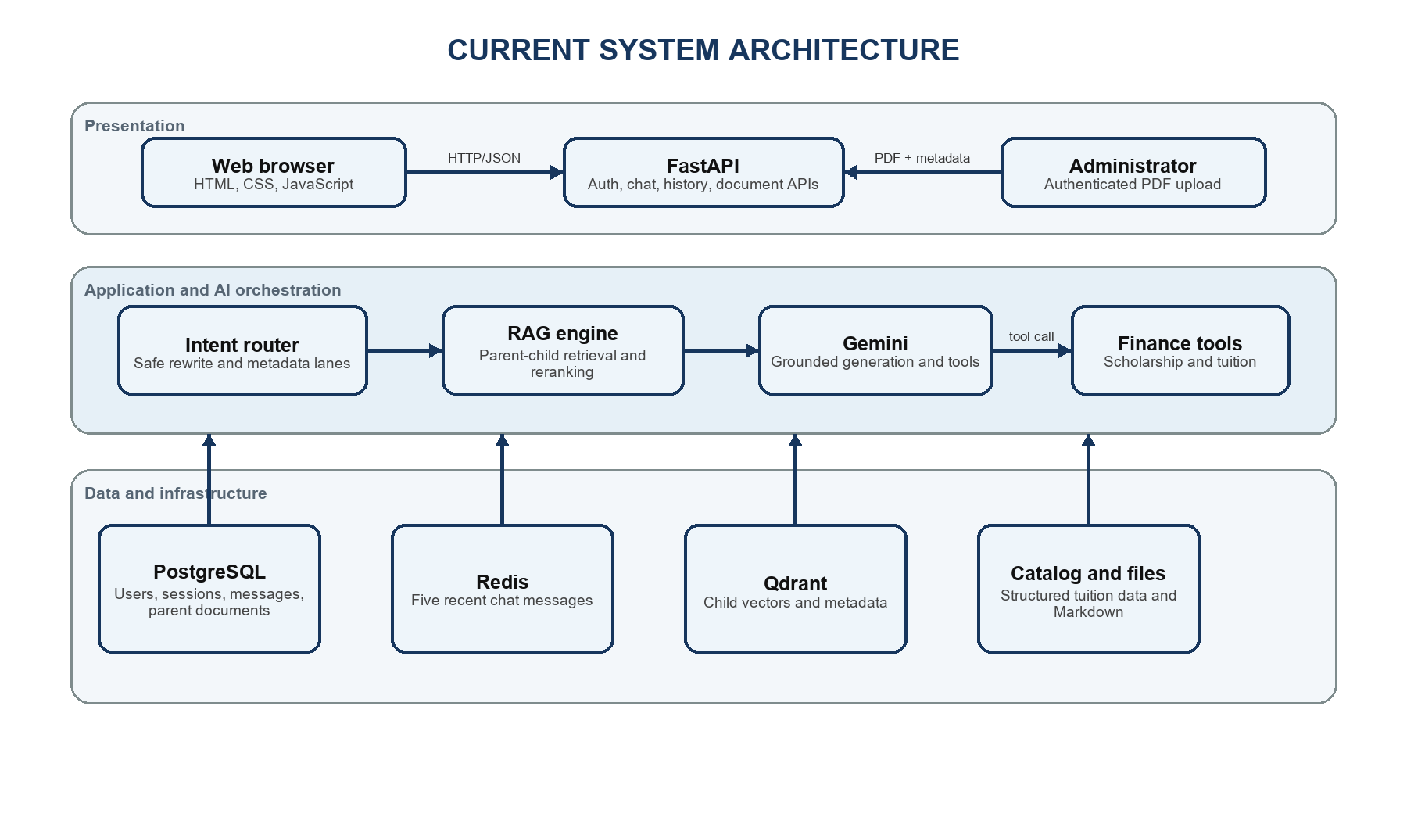
Figure 2. Current application architecture
The presentation layer consists of static HTML, CSS, and JavaScript served from the same FastAPI origin. The browser calls authentication, session, chat, and document endpoints with cookies. The application layer coordinates typed request models and authorization dependencies. It separates deterministic intent and catalog logic from RAG retrieval and from the generative model.
The AI orchestration layer uses a low-temperature Groq model only for constrained follow-up rewriting and Gemini for grounded answer generation and tool calling. The RAG engine is responsible for ingestion, vector retrieval, parent restoration, reranking, and metadata filtering. Scholarship and payable-tuition calculations are deterministic functions, ensuring that arithmetic is not delegated to unconstrained text generation.
The data layer separates workloads. Redis stores recent role-content pairs for low-latency context. PostgreSQL stores users, sessions, messages, and parent documents. Qdrant stores child embeddings and metadata used for filtering. The tuition catalog stores exact rate records and rules. The document metadata manifest ensures that every active Markdown source has a validated business classification.
Table 12. Architecture-layer responsibilities
Layer | Principal components | Responsibility
Presentation | index.html, support.html, script.js, style.css | User interaction, validation feedback, and API calls
API | auth.py, chat.py, history.py, document.py | Request boundaries, authorization, orchestration, and responses
Domain services | query_intent.py, tuition_catalog.py, document_metadata.py | Deterministic classification and business data
AI services | rag_engine.py, ocr_service.py, Gemini and Groq clients | Ingestion, retrieval, reranking, parsing, and generation
Persistence | PostgreSQL, Redis, Qdrant, JSON/Markdown files | Durable data, recent context, vectors, and source artifacts

Data design
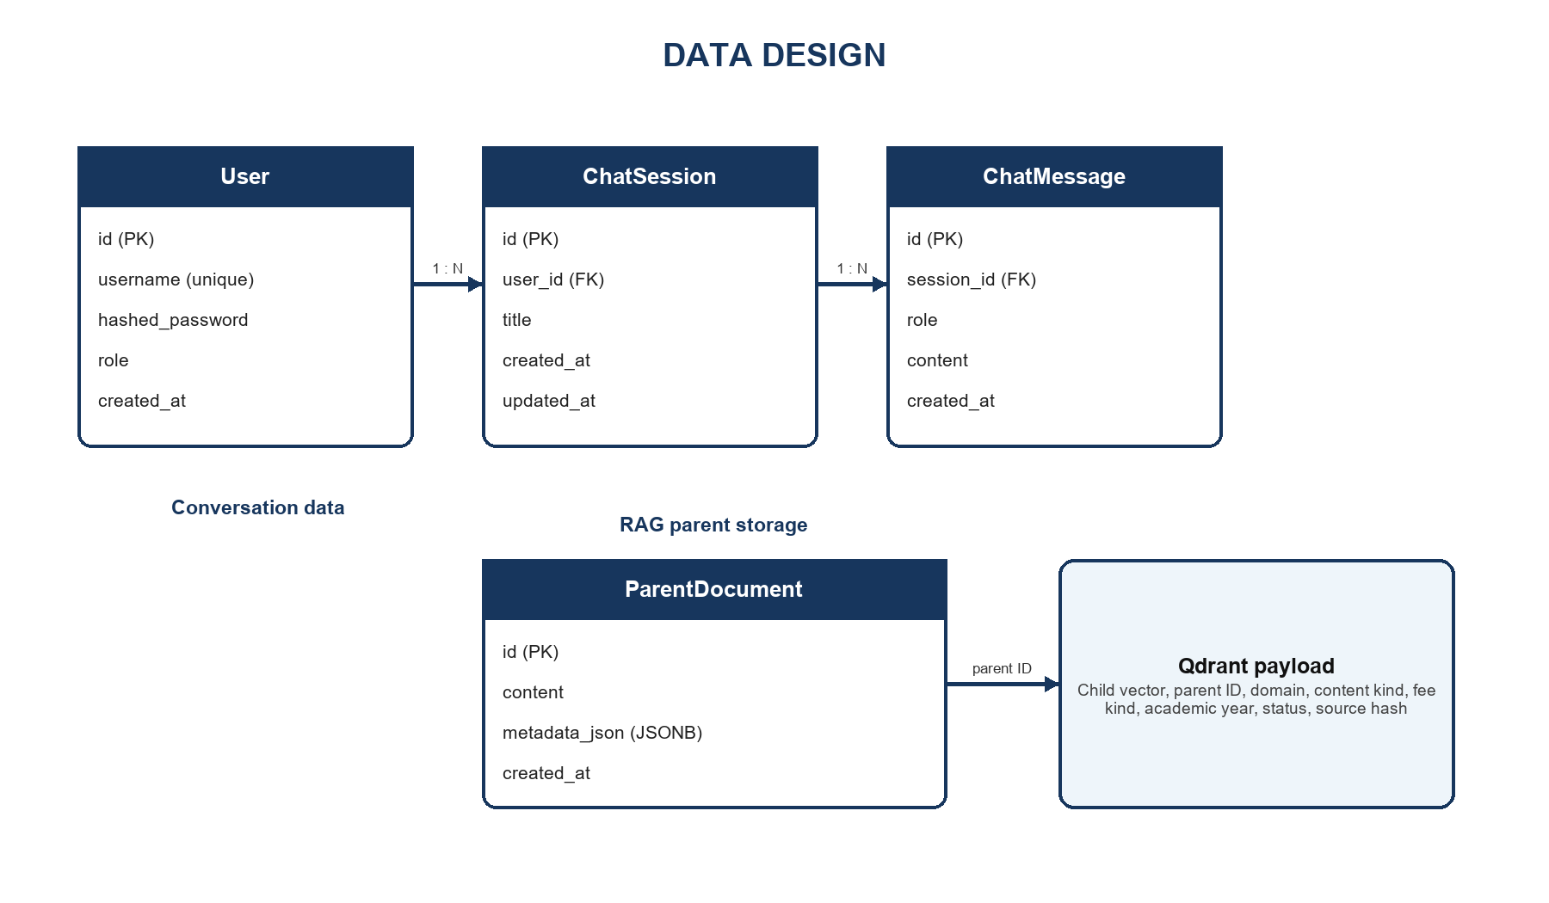
Figure 3. Relational and vector data design
The User-to-ChatSession and ChatSession-to-ChatMessage relationships are one-to-many with delete-orphan cascades. UUID version 7 string identifiers provide time-ordered identifiers without a central integer sequence. Message roles distinguish human and AI entries. Session titles are initially derived from the first query and can be renamed. ParentDocument stores the original parent text and JSONB metadata under the identifier referenced by Qdrant child payloads.
Table 13. Data-store mapping
Store | Key or identity | Stored information | Retention role
PostgreSQL users | user.id | Username, password hash, role, creation time | Durable
PostgreSQL sessions | session.id + user_id | Title and timestamps | Durable
PostgreSQL messages | message.id + session_id | Role, content, timestamp | Durable
Redis history | user:{user}:session:{session}:history | Recent JSON role-content pairs | Short-term context
PostgreSQL parents | parent document ID | Parent text and JSONB metadata | Durable RAG context
Qdrant children | vector point and parent ID | Embedding and filterable payload | Search index

Document metadata
Table 14. Business and technical metadata
Field | Purpose | Used at runtime
domain | Separates tuition, scholarship, loan, support, and other sources | Yes - retrieval filter
content_kind | Distinguishes policies, rate tables, announcements, forms, and procedures | Yes - lane refinement
fee_kind | Separates actual tuition, exemption basis, and not-applicable records | Yes - tuition routing
academic_year | Scopes year-specific material | Yes - retrieval filter
status | Excludes inactive content | Yes - mandatory filter
source_sha256 | Detects content drift | Validation and rollout
index_version | Identifies immutable vector build | Operations and audit
ingest_run_id | Scopes rollback | Failure recovery

Detailed design

Document ingestion pipeline
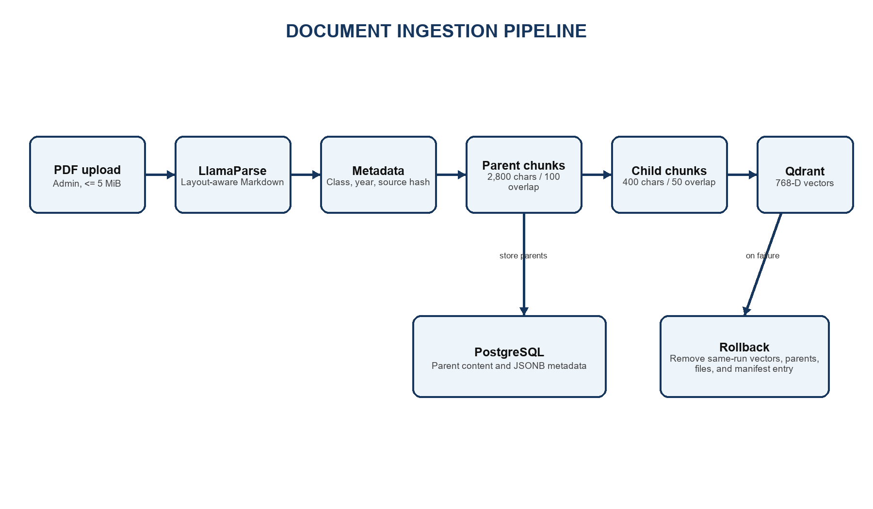
Figure 4. Document ingestion and rollback pipeline
- Validate the upload boundary before accepting a file path or writing untrusted content.
- Generate a unique ingestion-run identifier and a collision-safe working filename.
- Convert the PDF to Markdown through LlamaParse and classify the new source through server-owned mappings.
- Extract effective date and attach business and technical metadata to heading-derived parent blocks.
- Preserve tables while splitting large prose parents and generate 400-character child chunks.
- Embed children with the Vietnamese Bi-Encoder, store vectors in Qdrant, and store parents in PostgreSQL.
- Move final artifacts and atomically update the metadata manifest only after successful indexing.
- On any partial failure, purge the same ingestion run and remove generated files and catalog entries.

Chat query pipeline
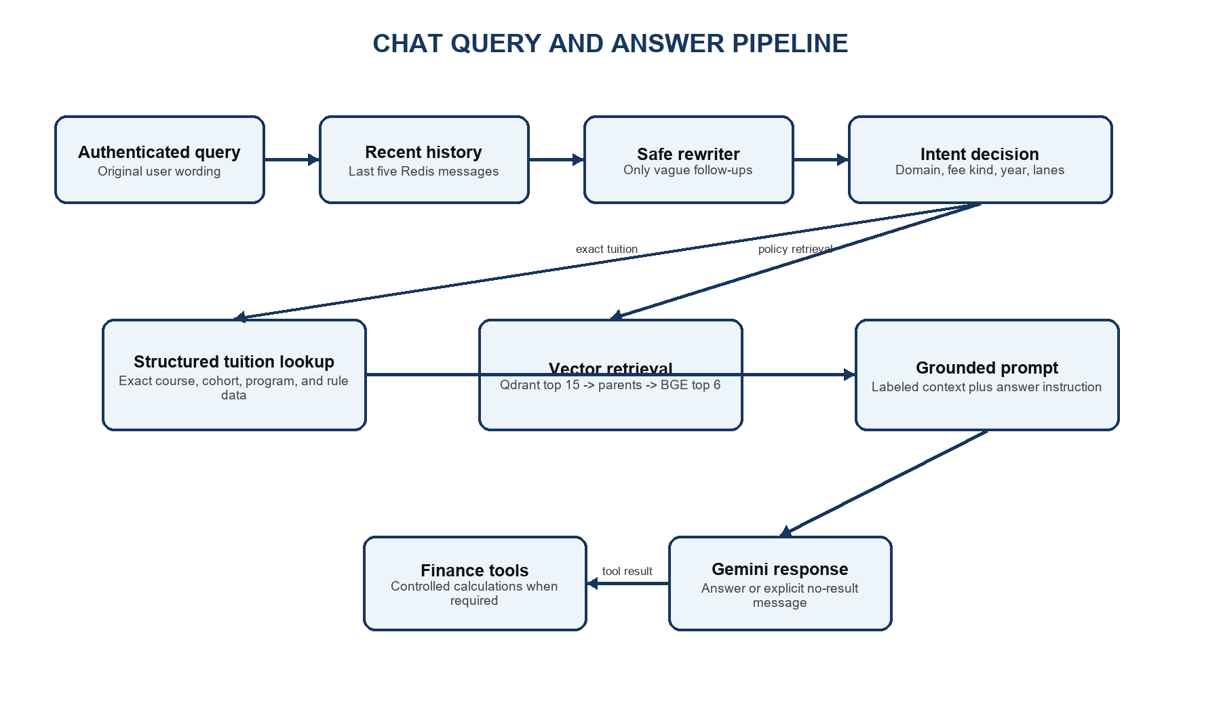
Figure 5. Query routing, retrieval, and answer generation
The API creates a new UUID session when the request does not provide one. Redis history is scoped by both user and session, preventing one account or conversation from inheriting another user’s context. Only the last five entries are supplied to the answer prompt. When a persisted session is loaded, the history endpoint repopulates Redis with the latest stored messages.

Safe follow-up rewriting
A heuristic first determines whether the current question is genuinely referential or elliptical. Clear questions bypass the rewriter. For a vague follow-up, the Groq model receives only the previous human question and the current question, not the previous AI answer. A validator rejects multiline output, answer-like text, unrelated numbers, new years, new entities, or an intent not supported by the two user questions. Rejection and provider failure both fall back to the original query.

Intent routing and retrieval lanes
The classifier recognizes actual tuition, exemption basis, exemption policy, calculation, combined tuition concepts, scholarship, student loan, social support, ambiguous tuition, and other topics. It can extract an academic year and identify whether the route came from the original or clarified query. Each decision maps to immutable retrieval-lane objects containing domain and content constraints. Hard domain separation reduces cross-topic contamination, such as matching SCC scholarship content to SCIC or retrieving loan documents for a tuition question.

Structured tuition lookup
Exact tuition questions first enter the structured catalog. The catalog normalizes Vietnamese text and extracts programme, cohort, major, subject, education level, study mode, and special-rule phrases. It can request clarification when an essential dimension is absent. A successful exact lookup is authoritative: the API does not add approximate vector passages that could dilute or contradict the monetary result. A rewritten query is used only when the catalog confirms that the rewrite did not inject an exemption intent or other unsafe entity.

Vector retrieval and reranking
For policy questions, the RAG engine creates request-scoped Qdrant filters and retrievers. An active-status condition is always applied. Business metadata filtering can be controlled during rollout so a new collection may be activated safely. The vector store returns child matches, the ParentDocumentRetriever restores larger PostgreSQL parents, and the BGE cross-encoder scores query-parent pairs. Duplicate parents are removed before prompt construction.

Tool calling and response construction
Gemini receives two deterministic tools. The scholarship tool uses GPA, conduct score, and discipline group to apply a defined award schedule. The tuition tool accepts actual tuition, the applicable exemption-basis ceiling, and the reduction percentage; it validates the percentage and calculates the payable amount using the correct cap. If the model requests an unknown tool, the server returns an explicit tool error rather than executing arbitrary code.

History persistence
After a response is produced, the API appends human and AI messages to Redis and trims the list to the configured window. A background task creates or updates the PostgreSQL session and writes both messages. History endpoints enforce ownership before listing messages, renaming a session, or deleting it. Deleting a session cascades relational messages and also removes the corresponding Redis key.
Table 15. Important implementation parameters
Parameter | Current value | Design purpose
Parent chunk size / overlap | 2,800 / 100 characters | Preserve policy context while controlling length
Child chunk size / overlap | 400 / 50 characters | High-resolution semantic matching
Vector dimension | 768 | Match Vietnamese Bi-Encoder output
Vector distance | Cosine | Compare semantic direction
Qdrant candidate count | 15 | Broad first-stage recall
Reranker result count | 6 | Control prompt size and contamination
Reranker max length | 512 tokens | Limit GPU memory consumption
Temporal tolerance | 0.05 | Prefer recent content only among near-equal scores
Redis history window | 5 messages | Provide context without excessive prompt growth

Failure handling and data consistency
The chat path distinguishes recoverable absence from infrastructure failure. A correctly processed query with no authoritative catalog result or relevant passage returns an explicit no-result answer. Invalid user input returns a controlled client error. Provider timeouts, database failures, and unexpected exceptions are logged and returned through a generic server boundary without exposing credentials or internal stack traces. This distinction is necessary for evaluation: abstention is a valid safety behavior, whereas an infrastructure error is not a policy answer.
Conversation persistence uses a fast path and a durable path. Redis is updated immediately so the next turn can use recent context. PostgreSQL writes run in a background task to reduce response latency, but ownership and session identity are established before scheduling the write. When a session is reloaded, durable messages repopulate Redis, making the cache disposable. A production deployment should additionally monitor background-task failures because a successful HTTP response does not by itself prove that later persistence completed.
Document ingestion requires stronger atomicity because partial state can contaminate future retrieval. Every upload receives an ingestion-run identifier shared by generated Markdown, parent rows, vector payloads, and metadata entries. The active manifest is changed only after conversion and indexing succeed. If a later step fails, rollback removes records carrying that run identifier rather than deleting by filename alone. This preserves an earlier active version of the same source and avoids erasing concurrent additions.
Index activation is separated from index construction. An immutable Qdrant collection can be populated and checked before an alias points traffic to it. Metadata-filter rollout can likewise be enabled only after payload coverage is validated. These blue-green practices allow a failed migration to leave the previous searchable collection intact. The source checksum and index version then provide enough evidence to determine which document content produced a retrieved passage.
Controlled tools form another consistency boundary. Monetary calculations receive explicit numeric arguments derived from authoritative records or verified user input, validate their allowed ranges, and return structured results. The language model explains the result but does not choose an undocumented formula. This design makes arithmetic independently testable and prevents a persuasive natural-language answer from hiding a calculation performed on the wrong fee type.
Table 16. Failure boundaries and consistency controls
Failure point | Protected state | Current response | Verification
Query rewrite provider | Original user intent | Reject unsafe output and reuse original query | Injection and provider-error tests
Generation provider | Stored data and tool rules | Return controlled error; do not mutate catalog or index | API failure-path test
Redis unavailable | Durable history | Use PostgreSQL as durable source after recovery | Cache-repopulation integration test
Qdrant retrieval failure | Source and parent records | Surface retrieval failure without fabricated evidence | Retriever error-path test
PDF parse or indexing failure | Previous active document version | Rollback only the same ingestion run | Partial-ingestion test
Background persistence failure | Delivered response and audit trail | Log failure for monitoring and retry design | Injected database-failure test

User interface design
The interface is implemented as a responsive single-page chat experience with modal authentication and administrator upload controls. The following reserved areas are intentionally empty so that final screenshots can be inserted after the deployment appearance has been approved.

Figure 6. Login and registration interface

Figure 7. Main chatbot interface

Figure 8. Conversation history and session controls

Figure 9. Chat answer presentation

Figure 10. Administrator PDF upload interface

Figure 11. Support and policy-topic page

TESTING

Test plan
Testing separates deterministic components from external model behavior. Unit tests verify validation, routing, catalog lookup, calculations, and scoring. Integration-style tests exercise the document upload transaction and authorization boundaries using controlled doubles for external systems. System evaluation uses the authenticated HTTP path so that cookies, request schemas, session behavior, and the real /chat orchestration are included.
Table 17. Testing strategy
Test level | Scope | Representative evidence | Pass criterion
Unit | Pure routing, lookup, calculation, and parser behavior | Intent, tuition catalog, finance tools, evaluator tests | Expected value or exception
Integration | API boundary plus coordinated components | Upload, metadata, authorization, rollback | HTTP status and complete state
System | Running browser-equivalent chat flow | Login cookie followed by POST /chat | Valid response and session
Security | Ownership, role, path, file, and token boundaries | Admin and upload validation cases | Unauthorized or unsafe input rejected
UAT | Student-facing usefulness and clarity | Natural policy questions and manual review | Correct, grounded, understandable answer

Table 18. Automated test inventory
Test file | Cases | Purpose
test_admin_authorization.py | 2 | Automated source test inventory
test_chat_dataset_eval.py | 9 | Automated source test inventory
test_document_metadata.py | 15 | Automated source test inventory
test_document_upload.py | 13 | Automated source test inventory
test_finance_tools.py | 9 | Automated source test inventory
test_query_intent.py | 41 | Automated source test inventory
test_tuition_catalog.py | 15 | Automated source test inventory
TOTAL | 104 | Recalculated during report generation

Representative test cases
Table 19. Representative automated test cases
ID | Scenario | Expected result | Actual result | Status
TC-01 | Student logs in with valid credentials | HTTP-only access cookie is issued | Cookie issued | Pass
TC-02 | Non-admin attempts PDF upload | Request rejected with HTTP 403 | HTTP 403 | Pass
TC-03 | Filename contains path traversal | Request rejected before writing | Rejected | Pass
TC-04 | Question asks actual tuition while negating exemption | Route to actual tuition | Actual-tuition intent | Pass
TC-05 | Course-name tuition lookup omits major | Find course record without false clarification | Record found | Pass
TC-06 | Reduction percentage is outside 0-100 | Calculation tool rejects input | Validation error | Pass
TC-07 | Partial ingestion fails after indexing | Same-run vectors, parents, files, and metadata removed | Rollback completed | Pass
TC-08 | Clear new question follows unrelated history | Original intent retained; no inherited entity | Rewrite skipped | Pass

Coverage and acceptance procedure
Automated execution should begin with deterministic unit tests because they isolate routing, normalization, calculation, and scoring defects without consuming external quotas. Integration tests then exercise authorization and transaction boundaries with controlled service doubles. A final live run is performed only after the application, corpus, model configuration, and database services are frozen. This sequence makes failures easier to localize and prevents a changing retrieval index from invalidating earlier results.
Authentication acceptance requires more than a successful login response. The test must retain the HTTP-only cookie, confirm that the current-user endpoint resolves the account, verify that protected endpoints reject an unauthenticated client, and demonstrate that one user cannot read or mutate another user's session. Administrator acceptance additionally verifies the persisted role at the upload endpoint; hiding the upload control in the browser is not considered authorization.
Retrieval acceptance uses representative questions from every policy lane. For each question, the reviewer records the classified intent, structured or vector path, applied metadata filters, retrieved sources, and final answer. Exact tuition cases must not fall back to a semantically related exemption-basis document. Scholarship, loan, and social-support cases must remain within their domains. Questions outside the indexed evidence must produce an abstention that does not invent a source or numeric value.
Ingestion acceptance verifies both the successful and interrupted paths. A successful upload must create classified Markdown, parent records, child vectors, metadata entries, and an active searchable version. Injected failure after each major step must leave no artifacts associated with the failed run and must preserve the previous active version. File validation is tested before external parsing so malformed, oversized, forged, or traversal filenames never become parser input.
The 100-question evaluation is the final system measurement, not a substitute for the preceding tests. It uses the same authenticated API flow as the browser and stores expected and actual answers for review. Before reporting accuracy, the evaluator configuration, timestamp, corpus checksum or index version, generator and rewriter model names, scoring version, and any failed infrastructure calls should be recorded. Blank report cells must remain blank until that evidence is available.
Table 20. Manual acceptance evidence
Acceptance area | Required evidence | Failure interpretation
Authentication and ownership | Cookie flow, current user, cross-user denial | Security failure regardless of chat quality
Routing and catalog | Intent, lane, clarification, authoritative record | Wrong source class or monetary basis
Vector retrieval | Filters, child match, restored parent, reranker order | Recall, filtering, or ranking defect
Finance tools | Validated arguments, formula result, final explanation | Input, arithmetic, or verbalization defect
Ingestion | Complete success artifacts and clean rollback artifacts | Data-integrity or corpus-contamination risk
End-to-end evaluation | Authenticated request log and per-case evidence | Answer defect, abstention, or infrastructure failure

Results and analysis

Evaluation method
The chatbot evaluation dataset contains 100 natural student questions distributed equally across four domains: tuition exemption and learning-cost support, tuition, student loans, and scholarships. Each case includes an expected answer and source. The evaluator authenticates through POST /auth/login, retains the HTTP-only cookie, and sends the question to POST /chat. This reproduces the application boundary used by the browser instead of calling internal retrieval functions directly.
The deterministic scorer combines typed numeric recall for money, percentage, dates, durations, and other numbers with Vietnamese content-token recall. Refusal-like answers are penalized when the expected answer contains requested facts. The metric is a repeatable heuristic, not a semantic judge; therefore per-case evidence and manual review remain necessary. The following cells are intentionally blank and will be completed only after the final runtime, corpus, and evaluator configuration have been frozen.
Table 21. Chatbot accuracy evaluation results - intentionally blank
Domain | Passed | Total | Accuracy | Average score
Tuition exemption and learning-cost support
Tuition
Student loans
Scholarships
Overall

Reserved interpretation area


CONCLUSION

PROJECT SUMMARY
The project delivers a complete web application for CTU student-finance policy support. It integrates secure account access, persistent conversations, structured tuition lookup, policy-domain routing, Vietnamese semantic retrieval, parent-child context recovery, multilingual reranking, grounded answer generation, controlled finance tools, and administrator document ingestion. The design distinguishes information retrieval from generation and distinguishes approximate semantic retrieval from exact monetary data.
The implementation addresses the central risk identified in Chapter 1: a fluent answer is not sufficient when several similar policy concepts contain different monetary values. Deterministic intent routing and business metadata separate actual tuition, exemption basis, exemption policy, scholarships, loans, and social support. Source labels, no-result behavior, and tool validation make the response process more auditable than unconstrained prompting.
The software-engineering objectives are also represented in the architecture. PostgreSQL, Redis, and Qdrant have separate storage roles; APIs enforce authentication, ownership, and administration boundaries; upload validation protects the file boundary; and ingestion-run identifiers support rollback. The automated tests cover routing, structured lookup, metadata integrity, finance tools, authorization, file validation, and evaluator behavior.

ACHIEVEMENT OF OBJECTIVES
Table 22. Achievement of project objectives
Objective | Implemented outcome | Status
Grounded policy answers | Labeled RAG context and explicit abstention instruction | Implemented
Vietnamese semantic retrieval | Vietnamese Bi-Encoder, parent-child retrieval, and BGE reranking | Implemented
Accurate tuition separation | Intent lanes, metadata filters, and structured tuition catalog | Implemented
Controlled calculations | Scholarship and payable-tuition tools with validation | Implemented
Conversation support | Redis recent context and PostgreSQL durable history | Implemented
Safe document growth | Administrator upload, validation, metadata, and rollback | Implemented
Quantitative accuracy | Method and blank result template prepared | To be completed

LIMITATIONS
The chatbot remains bounded by the active corpus. Missing, outdated, misclassified, or poorly parsed documents can cause abstention or retrieval errors. External Gemini, Groq, and LlamaParse services introduce availability, quota, and version dependencies. Local embeddings avoid an external embedding API but still require model download and compute resources. The reranker is substantially larger than the embedding model and is constrained by the available GPU and its configured 512-token input.
The current embedding selection is supported by Vietnamese and legal-retrieval evidence, but it has not yet been compared with newer multilingual alternatives on the exact CTU corpus. The evaluator provides deterministic repeatability but cannot fully judge semantic correctness, source faithfulness, or student usefulness. Final quantitative results are intentionally absent from this report version and must be completed after a fresh authenticated evaluation run.

FUTURE WORK
Table 23. Recommended future work
Priority | Improvement | Expected benefit
High | Run a controlled embedding benchmark and hybrid BM25-dense retrieval experiment | Evidence-based model and retrieval selection
High | Display source citations and policy-effective dates in answers | Improved auditability and user trust
High | Complete final 100-case evaluation and manual error analysis | Measured accuracy and targeted remediation
Medium | Add administration for document status, version, and rollback visibility | Safer corpus operations
Medium | Add latency, retrieval-lane, and no-result monitoring | Operational diagnosis
Medium | Expand UAT with students and staff | Usability evidence
Low | Evaluate multilingual and mobile-client support | Broader access

The highest-priority next step is not indiscriminate model replacement. The system should first freeze a representative corpus, construct relevance judgments, and measure candidate retrieval and end-to-end behavior under identical conditions. This approach preserves the evidence-first principle used throughout the project and ensures that added complexity is justified by measurable improvement.

REFERENCES
[1] P. Lewis et al., “Retrieval-Augmented Generation for Knowledge-Intensive NLP Tasks,” Advances in Neural Information Processing Systems, vol. 33, 2020.
[2] BKAI-HUST Foundation Models Lab, “bkai-foundation-models/vietnamese-bi-encoder,” Hugging Face model card. [Online]. Available: https://huggingface.co/bkai-foundation-models/vietnamese-bi-encoder. [Accessed: Jul. 23, 2026].
[3] N. Q. Duc, L. H. Son, N. D. Nhan, N. D. N. Minh, L. T. Huong, and D. V. Sang, “Towards Comprehensive Vietnamese Retrieval-Augmented Generation and Large Language Models,” arXiv:2403.01616, 2024.
[4] Beijing Academy of Artificial Intelligence, “BAAI/bge-reranker-v2-m3,” Hugging Face model card. [Online]. Available: https://huggingface.co/BAAI/bge-reranker-v2-m3. [Accessed: Jul. 23, 2026].
[5] J. Chen, S. Xiao, P. Zhang, K. Luo, D. Lian, and Z. Liu, “BGE M3-Embedding: Multi-Lingual, Multi-Functionality, Multi-Granularity Text Embeddings Through Self-Knowledge Distillation,” arXiv:2402.03216, 2024.
[6] C. Li, Z. Liu, S. Xiao, and Y. Shao, “Making Large Language Models a Better Foundation for Dense Retrieval,” arXiv:2312.15503, 2023.
[7] N. Reimers and I. Gurevych, “Sentence-BERT: Sentence Embeddings using Siamese BERT-Networks,” in Proc. EMNLP-IJCNLP, 2019, pp. 3982-3992.
[8] Y. A. Malkov and D. A. Yashunin, “Efficient and Robust Approximate Nearest Neighbor Search Using Hierarchical Navigable Small World Graphs,” IEEE TPAMI, vol. 42, no. 4, pp. 824-836, 2020.
[9] Qdrant, “Qdrant Documentation.” [Online]. Available: https://qdrant.tech/documentation/. [Accessed: Jul. 23, 2026].
[10] FastAPI, “FastAPI Documentation.” [Online]. Available: https://fastapi.tiangolo.com/. [Accessed: Jul. 23, 2026].
[11] PostgreSQL Global Development Group, “PostgreSQL 15 Documentation.” [Online]. Available: https://www.postgresql.org/docs/15/. [Accessed: Jul. 23, 2026].
[12] Redis, “Redis Documentation.” [Online]. Available: https://redis.io/docs/latest/. [Accessed: Jul. 23, 2026].
[13] LangChain, “LangChain Documentation.” [Online]. Available: https://python.langchain.com/docs/. [Accessed: Jul. 23, 2026].
[14] Google, “Gemini API Documentation.” [Online]. Available: https://ai.google.dev/gemini-api/docs. [Accessed: Jul. 23, 2026].
[15] Groq, “Groq API Documentation.” [Online]. Available: https://console.groq.com/docs. [Accessed: Jul. 23, 2026].
[16] LlamaIndex, “LlamaParse Documentation.” [Online]. Available: https://developers.llamaindex.ai/python/cloud/llamaparse/. [Accessed: Jul. 23, 2026].

APPENDICES

API ENDPOINT SUMMARY
Table 24. Public API endpoint summary
Method | Path | Authorization | Purpose
POST | /auth/register | Public | Create a student account
POST | /auth/login | Public | Issue HTTP-only access cookie
POST | /auth/logout | Public | Delete access cookie
GET | /auth/me | User | Return current identity and role
POST | /chat | User | Answer a question in a new or existing session
GET | /sessions | User | List owned sessions
GET | /sessions/{id}/messages | Owner | Load messages and repopulate recent history
PUT | /sessions/{id} | Owner | Rename a session
DELETE | /sessions/{id} | Owner | Delete a session and Redis history
POST | /document/upload | Admin | Validate, parse, classify, and ingest a PDF

TEXTUAL USER GUIDE
- Open the application at the configured FastAPI address.
- Choose Log in or Register and submit a username and password.
- After authentication, type a Vietnamese policy question in the message field.
- Review the answer and provide missing programme, cohort, course, year, or eligibility details when requested.
- Use the Recent list to reopen a conversation; use the session menu to rename or delete it.
- For administrator ingestion, open Upload PDF, choose a valid document class, provide a consecutive academic year when required, and submit a PDF no larger than five mebibytes.
The screenshot positions in the main report are intentionally blank. Insert the final deployment screenshots only after checking that no personal account data, access tokens, secret values, or private policy drafts are visible.

DEPLOYMENT OVERVIEW
Table 25. Deployment dependencies without secret values
Component | Default endpoint or mechanism | Required configuration
FastAPI | http://localhost:8000 | Python environment and application variables
Qdrant | http://localhost:6333 | Collection or active alias
Redis | Configured service endpoint | REDIS_URL
PostgreSQL | localhost:5432/ctu_chatbot | DATABASE_URL
Gemini | External API | GOOGLE_API_KEY
Groq | External API | GROQ_API_KEY
LlamaParse | External API | LLAMA_CLOUD_API_KEY
JWT | HTTP-only cookie | JWT_SECRET_KEY

PROPOSED EMBEDDING BENCHMARK PROTOCOL
- Freeze the Markdown corpus, metadata manifest, and Qdrant filtering rules.
- Create domain-balanced Vietnamese questions with passage-level relevance judgments.
- Use identical parent and child chunks for every embedding candidate.
- Build a separate immutable Qdrant collection for each model and record vector dimension, size, and build time.
- Measure Recall@5, Recall@15, MRR@10, nDCG@10, query-embedding time, retrieval latency, and storage cost.
- Repeat end-to-end evaluation with and without the BGE reranker to isolate first-stage quality.
- Inspect failures for exact terms, paraphrases, tables, negations, years, named scholarships, and fee-kind confusion.
- Select a replacement only if the measured gain justifies migration and reindexing cost.

