Dataset:

[EuroSAT：一种用于土地利用和土地覆盖分类的新型数据集和深度学习基准 --- EuroSAT: A Novel Dataset and Deep Learning Benchmark for Land Use and Land Cover Classification](https://zenodo.org/records/7711810#.ZAm3k-zMKEA)

EuroSAT_MS.zip contains the multi-spectral version of the EuroSAT dataset, which includes all 13 Sentinel-2 bands in the original value range.

Tif file (shown in RGB)

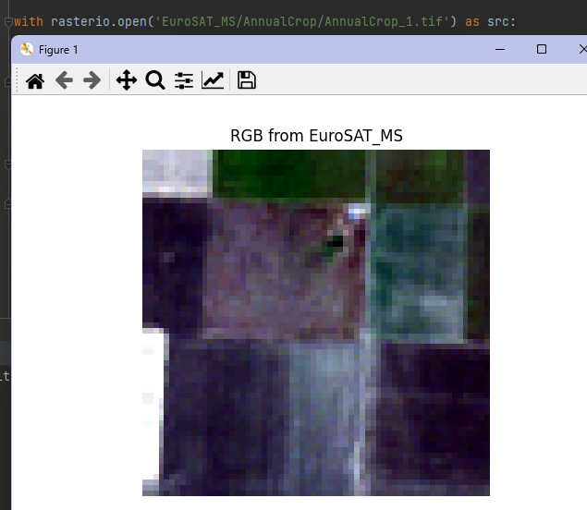

Train : Test=0.8 : 0.2

Network:

**resnet18**, modified to support input of 13*32*32

resnet50, for distillation

Output

net.py

resnet18_10classes_10epoch_standard.pth

Train with resnet18, with **no** data argumentation and distillation

Resnet18 epoch 10, test accuracy: **89.57%**

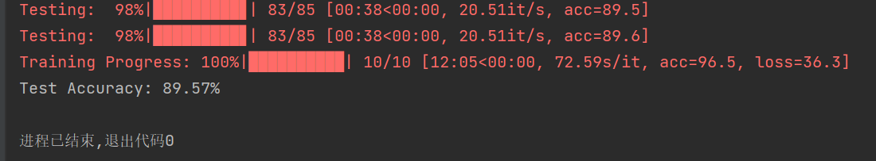

teacher.py, net_pro.py

resnet50_teacher_10classes_20epoch_epoch20.pth

resnet18_10classes_10epoch_student_epoch10.pth

Train with teacher resnet50(teacher Test Accuracy: 93.09%) and resnet18, with data **argumentation** and **distillation**

Resnet18 epoch 10, test accuracy: **96.65%**

