**SOFTWARE REQUIREMENT SPECIFICATION**

**DOCUMENT**

**CALCULATOR SYSTEM**

**Version:** Version 2.0

**ABSTRACT**

This document is intended to be the SRS for develop **CALCULATOR SYSTEM**

|  |  |  |  |
| --- | --- | --- | --- |
| **Project Title** | **CALCULATOR SYSTEM** | | |
| **Lead Institution** | **THE INTERNATIONAL SCHOOL - DUY TAN UNIVERSITY** | | |
| **Project Mentor** | **Mr. Nguyen Dang Quang Huy** | | |
| **Team Name** | **Group 1** | | |
| **Team Members** | **Tran Phuc Binh** | | |
| **Tran Van Phuc** | | |
| **Mai Vo Gia Huy** | | |
| **Vu Cong Duong** | | |
| **Le Duc Hung Son** | | |
| **Start Date** | Mar 2,2025 | **End Date** | Mar 8,2025 |

**ROPRIETARY INFORMATION**: The information contained in this document is the property of **Group 1**. Except as specifically authorized in writing by **Group 1**, the holder of this document shall keep all information contained herein confidential and shall protect same in whole or in part from disclosure and dissemination to all third parties

**Table of Contents**

[Revision History 4](#_Toc32347)

[1. Introduction 6](#_Toc32348)

[1.1. Purpose 6](#_Toc32349)

[1.2. Intended Audience and Reading Suggestions 6](#_Toc32350)

[1.3. References 6](#_Toc32351)

[2. Project Overview 6](#_Toc32352)

[2.1. Project Description 6](#_Toc32353)

[2.2. Business Need 7](#_Toc32354)

[2.3. Project Analyst 7](#_Toc32355)

[2.3.1. Business Function Diagram 7](#_Toc32356)

[2.3.2. System Context Diagram 8](#_Toc32357)

[2.3.3. Data Flow Diagram 9](#_Toc32358)

[2.4. Software Requirement Specification 11](#_Toc32359)

[2.4.1. High level Fucntional Requirement (FR) 11](#_Toc32360)

[2.4.2. Stakeholders 13](#_Toc32361)

[2.4.3. Usecase 14](#_Toc32362)

[2.4.3.1. <<Library Management>> Use Case Diagram Overview 15](#_Toc32363)

[2.4.4. List of use cases 15](#_Toc32364)

[2.4.5. Use Case Specification 15](#_Toc32366)

*[UC 01: Login](#_Toc32367)* [15](#_Toc32367)

*[UC 02: Search books](#_Toc32367)* [....17](#_Toc32367)

*[UC 03: Borrow books](#_Toc32368)* [18](#_Toc32368)

*[UC 04: Manage books](#_Toc32368)* [20](#_Toc32368)

*[UC 05: Receive return books](#_Toc32368)* [22](#_Toc32368)

*[UC 06: Manage readers](#_Toc32368)* [24](#_Toc32368)

*[UC 07: Search information about readers](#_Toc32368)* [25](#_Toc32368)

*[UC 08: Statistical report on borrowing books](#_Toc32368)* [26](#_Toc32368)

*[UC 09: Make a reader card](#_Toc32368)* [28](#_Toc32368)

*[UC 10: Card renewal for readers](#_Toc32368)* [29](#_Toc32368)

*[UC 011: Reader statistics report](#_Toc32368)* [31](#_Toc32368)

*[UC 012: Report ,statistics of books received](#_Toc32368)* [33](#_Toc32368)

[2.4.6. Software Quality Attributes 35](#_Toc32369)

[2.4.6.1. Usability 35](#_Toc32370)

[2.4.6.2. Reliability 35](#_Toc32371)

[2.4.6.3. Security 35](#_Toc32372)

[2.4.6.4. Maintainability 35](#_Toc32373)

[2.4.6.5. Portability 35](#_Toc32374)

[2.4.6.6. Performance 35](#_Toc32375)

[2.5. Software Design Description 36](#_Toc32376)

[2.5.1. Sequence Diagrams 36](#_Toc32377)

[2.5.1.1.](#_Toc32378)

[2.5.1.2.](#_Toc32379)

[2.5.2. Activity Diagrams 42](#_Toc32380)

[2.5.2.1.](#_Toc32381)

[2.5.3. Class Diagram 51](#_Toc32383)

[Appendix A: Glossary 51](#_Toc32385)

# Revision History

|  |  |  |  |  |
| --- | --- | --- | --- | --- |
| **Date** | **Change Iterm** | **Description** | **by** | **Version** |
| **31/3/2025** | Get requests from customers | After preparing the questions about the request and received the request from the customer | Mai Vo Gia Huy | Version 1.0 |
| **1/4/2025** | Start team meeting | Meet and refer to a number of training points, read through the training points and focus on project implementation, the team can fully understand the system requirements to create | Mai Vo Gia Huy, Tran Phuc Binh, Le Duc Hung Son, Nguyen Van Phuc, Vu Cong Duong | Verison 1.0 |
| **1/4/2025** | Job analysis | Through specific requirements, analysis, clearly speaking, the leader needs to prepare in advance for the members. | Mai Vo Gia Huy | Verison 1.0 |
| **2/4/2025** | Share the work | Get BFD, contextual diagram, DFD level 1, DFD level 2,  The mandatory rules of the project | Mai Vo Gia Huy, Tran Phuc Binh, Le Duc Hung Son, Nguyen Van Phuc, Vu Cong Duong | Verision 1.0 |
| **2/4/2025** | Mr. Huy corrected | Fix BFD, DFD, USE CASE, font size, font pattern, context diagram, more clearly about the missing and suggest some important things | Mai Vo Gia Huy | Verision 1.0 |
| **3/4/2025** | Editing group | BFD, DFD, USE CASE, Context Diagram, font size, font | Mai Vo Gia Huy, Tran Phuc Binh, Le Duc Hung Son, Nguyen Van Phuc, Vu Cong Duong | Verision 1.0 |
| **3/4/2025** | Complete DFD, System Context Diagram | DFD 1 and 2, System Context Diagram | Mai Vo Gia Huy | Verision 2.0 |

# Introduction

## Purpose

* This document intended to provide a detailed description of computer management software
* Is the primary reference for software design, testing, and implementation.
* Make sure that all team members, including developers, testers, and project managers, have a common understanding of how to use the software.

## Intended Audience and Reading Suggestions

|  |  |
| --- | --- |
| **Intended Audience** | **Reading Suggestions** |
| **Student Team Leader** | High-level functional requirements and business constraints for project planning and estimation. |
| **Student Team Members** | Overall description and use cases to architect and design the Calculator system. |
| **Student Testers** | Overall description and use cases to develop the test plan and write acceptance tests for the Calculator. |

## References

# Project Overview

## Project Description

Information Technology has revolutionized the way we perform everyday tasks, making our lives more efficient through a variety of digital applications. In light of the rapid advancements in technology, countless tools and systems have been developed to simplify even the most complex operations.  
This project is focused on developing a **Calculator System** designed to streamline mathematical computations. The Calculator System offers a fully automated, user-friendly platform capable of handling both basic arithmetic (addition, subtraction, multiplication, division) and advanced operations (exponentiation, square root, percentage). The main goals of this project are to provide an intuitive and reliable tool for quick calculations, ensure accurate processing, and support a wide range of mathematical functions to meet diverse user needs.

## Business Need

The Calculator System offers several significant advantages:

* **Enhanced Productivity:** Provides users with a fast and accurate method to perform both basic and advanced calculations, reducing the time spent on manual computations.
* **User-Friendly Interface:** Designed with simplicity in mind, the system features an easy-to-use interface that allows users of all levels to perform complex operations with minimal effort.
* **Comprehensive Functionality:** Supports a broad range of operations including error handling, calculation history, and real-time result display, ensuring a complete solution for everyday mathematical tasks.
* **Maintainability and Scalability:** Built with a modular approach, the system is easy to maintain and upgrade, allowing for the addition of new features as user requirements evolve.
* **Versatility:** Caters to both casual users and professionals by offering functionalities that extend beyond basic arithmetic, ensuring that advanced mathematical needs are met efficiently.

## Project Analyst

### Business Function Diagram

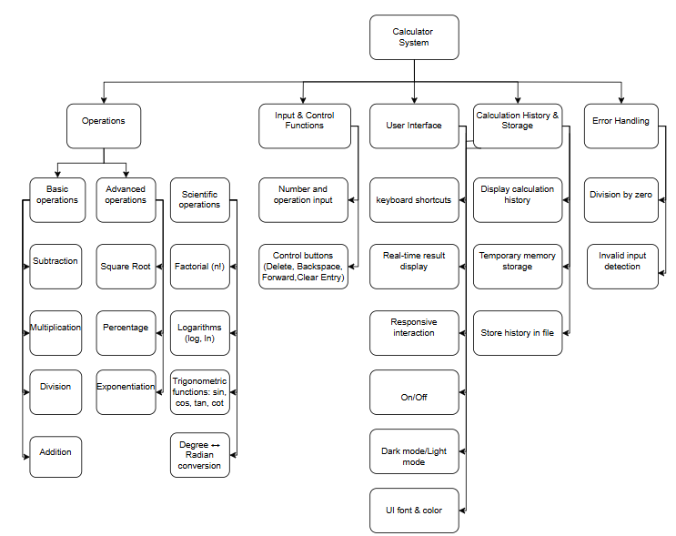

### System Context Diagram

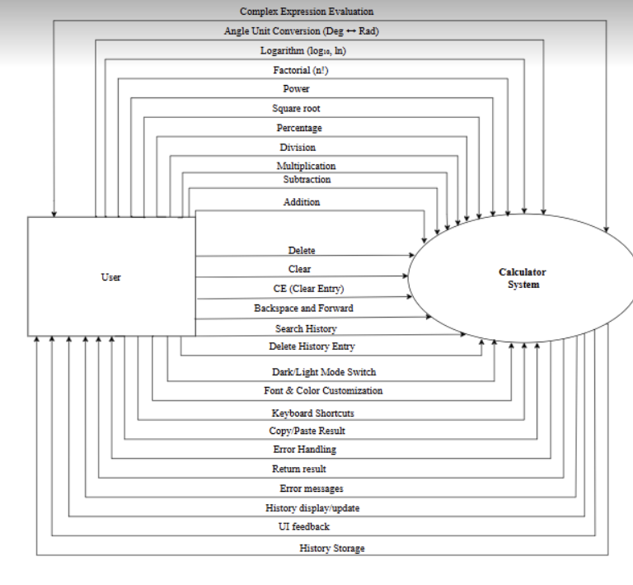

## Software Requirement Specification

### High level Functional Requirement (FR)

|  |  |  |
| --- | --- | --- |
| FR  1.1 | **Title** | **Calculate Addition** |
| User | The user enters two or more numbers and presses the “+” button to calculate the sum. |
| Description | The system receives the input values, performs the addition, and displays the result on the screen. |
| FR  1.2 | **Title** | **Calculate Subtraction** |
| **User** | The user enters the minuend and the subtrahend, then presses the “-” button to subtract. |
| Description | The system processes the subtraction and displays the result. |
| FR  1.3 | **Title** | Calculate Multiplication |
| User | The user enters two numbers to be multiplied and presses the “\*” button. |
| Description | The system performs the multiplication and displays the result. |
| FR  1.4 | **Title** | |  | | --- | | **Calculate Division** |  |  | | --- | |  | |
|  | User | The user enters the dividend and divisor, then presses the “/” button to divide. |
|  | Description | The system processes the division and displays the result. If the divisor is 0, the system shows an error message to prevent mathematical errors. |
| FR  1.5 | **Title** | **Advanced Calculations** |
|  | User | The user requests special calculations such as percentage (%), square root (√x), exponentiation (xʸ), etc. |
|  | Description | The system processes the advanced calculation and displays the accurate result. |
| FR  1.6 | **Title** | **Turn On/Off** |
|  | User | The user presses the power button to turn the calculator on or off. |
|  | Description | The system starts up and displays a ready-to-use interface or completely shuts down. |
| FR  1.7 | **Title** | **Delete/Clear** |
|  | User | The user can delete an incorrect entry or clear the entire calculation to start over. |
|  | Description | The system deletes the entered data or clears the entire screen, resetting to the initial state. |
| FR  1.8 | **Title** | **Error Handling** |
|  | User | If the user enters an invalid character or an incorrect operation (e.g., division by 0), the system should notify them. |
|  | Description | The system validates the input, detects errors, and displays appropriate messages like “Error: Cannot divide by 0” or “Invalid input format.” |
| FR  1.9 | **Title** | **History Storage** |
|  | User | The user can view previously performed calculations. |
|  | Description | The system stores the calculation history and displays it when requested. |

### Stakeholders

|  |  |
| --- | --- |
| **Stakeholder** | **Description** |
| Users | System users |

### Use case

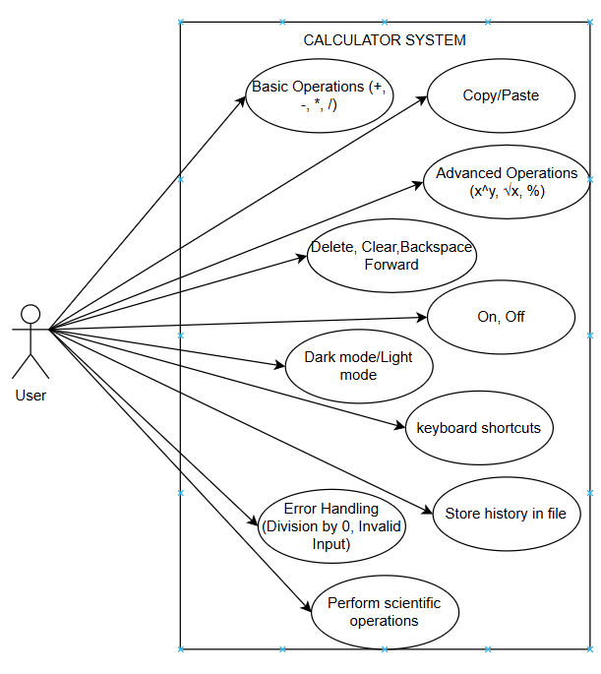

### List of use case

|  |  |  |
| --- | --- | --- |
| Use case ID | Use case name | Functional Req. |
| UC.01 | Addition | FR.1 |
| UC.02 | Subtraction | FR.2 |
| UC.03 | Multiplication | FR.3 |
| UC.04 | Division | FR.4 |
| UC.05 | Percentage | FR.5 |
| UC.06 | Square root | FR.6 |
| UC.07 | Power | FR.7 |
| UC.08 | Delete | FR.8 |
| UC.09 | Clear | FR.9 |
| UC.10 | History Storage | FR.10 |
| UC.11 | Error Handling | FR.11 |
| UC.12 | Factorial (n!) | FR.12 |
| UC.13 | Logarithm (log₁₀, ln) | FR.13 |
| UC.14 | Trigonometric Functions | FR.14 |
| UC.15 | Angle Unit Conversion (Deg ↔ Rad) | FR.15 |
| UC.16 | Search History | FR.16 |
| UC.17 | Delete History Entry | FR.17 |
| UC.18 | Dark/Light Mode Switch | FR.18 |
| UC.19 | Font & Color Customization | FR.19 |
| UC.20 | Keyboard Shortcuts | FR.20 |
| UC.21 | CE (Clear Entry) Button | FR.21 |
| UC.22 | Backspace and Forward (Cursor Control) | FR.22 |
| UC.23 | Copy/Paste Result | FR.23 |
| UC.24 | Complex Expression Evaluation | FR.24 |

**2.4.5.Use Case Specification**

##### UC 01: Addition

1. Use Case Diagram

Addition

User

1. Use Case Specification

|  |  |  |  |  |  |
| --- | --- | --- | --- | --- | --- |
| **Use case ID** | UC.01 | | | | |
| **Use case name** | **Calculate Addition** | | | | |
| **Create by** | Phuc Binh | | **Last updated by** | | Phuc Binh |
| **Date created** | April 3, 2025 | | **Date last updated** | | April 3,2025 |
| **Actor** | Users | | | | |
| **Description** | This use case allows users to perform addition calculations by entering numbers and receiving the result. | | | | |
| **Trigger** | |  |  |  | | --- | --- | --- | | |  | | --- | | The user initiates an addition calculation. |  |  | | --- | |  | |  |  | | --- | |  | | | | | |
| **Pre-condition** | None | | | | |
| **Post-condition** | The system displays the result of the addition calculation. | | | | |
| **Main Success Scenario:** | **Step** | **Actor Action** | | **System Response** | |
| 1 | The user opens the calculator application. | | |  | | --- | | The system loads and displays the calculator interface. |  |  | | --- | |  | | |
| 2 | |  | | --- | | The user enters two or more numbers and presses the **"+"** button. |  |  | | --- | |  | | | |  | | --- | | The system records the input numbers. |  |  | | --- | |  | | |
| 3 | |  |  |  | | --- | --- | --- | | |  | | --- | | The user presses the **"="** button. |  |  | | --- | |  | |  |  | | --- | |  | | | The system calculates the sum and displays the result. | |
| **Alternative Scenario** | **Step** | **Actor Action** | | **System Response** | |
| 1 | |  | | --- | | The user enters only one number and presses the **"="** button. |  |  | | --- | |  | | | |  | | --- | | The system displays the entered number as the result, assuming no second operand was provided. |  |  | | --- | |  | | |
| 2 | |  | | --- | | The user attempts to enter non-numeric characters. |  |  | | --- | |  | | | |  | | --- | | The system does not accept the input and shows an error message. |  |  | | --- | |  | | |
| 3 | |  | | --- | | The user presses the **"Clear"** button before completing the addition. |  |  | | --- | |  | | | The system resets the input fields, allowing the user to start over. | |
| **Exception** | **Step** | **Actor Action** | | **System Response** | |
| 1 | |  | | --- | | The user attempts to divide by zero during the addition process (e.g., mistakenly pressing another operator). |  |  | | --- | |  | | | |  | | --- | | The system detects the invalid operation and displays an error message. |  |  | | --- | |  | |  | | |
| 2 | |  | | --- | | The system encounters an internal error while processing the request. |  |  | | --- | |  | | | The system displays an error message and prompts the user to try again. | |
| **Priority** | High | | | | |
| **Business rule** | N/A | | | | |
| **Description:** |  | | | | |

##### 

##### UC.02: Subtraction

* 1. Use Case Diagram

Subtraction

User

b) Use Case Specification

|  |  |  |  |  |  |
| --- | --- | --- | --- | --- | --- |
| **Use case ID** | UC.02 | | | | |
| **Use case name** | **Calculate Subtraction** | | | | |
| **Create by** | Phuc Binh | | **Last updated by** | | Phuc Binh |
| **Date created** | April 3, 2025 | | **Date last updated** | | April 3,2025 |
| **Actor** | Users | | | | |
| **Description** | This use case allows users to perform subtraction calculations by entering numbers and receiving the result. | | | | |
| **Trigger** | |  |  |  | | --- | --- | --- | | |  | | --- | | The user initiates a subtraction calculation. |  |  | | --- | |  | |  |  | | --- | |  | | | | | |
| **Pre-condition** | None | | | | |
| **Post-condition** | The system displays the result of the addition calculation. | | | | |
| **Main Success Scenario:** | **Step** | **Actor Action** | | **System Response** | |
| 1 | The user opens the calculator application. | | |  | | --- | | The system loads and displays the calculator interface. |  |  | | --- | |  | | |
| 2 | |  | | --- | | The user enters two or more numbers and presses the **"-"** button. |  |  | | --- | |  | | | |  | | --- | | The system records the input numbers. |  |  | | --- | |  | | |
| 3 | |  |  |  | | --- | --- | --- | | |  | | --- | | The user presses the **"="** button. |  |  | | --- | |  | |  |  | | --- | |  | | | The system calculates the difference and displays the result. | |
| **Alternative Scenario** | **Step** | **Actor Action** | | **System Response** | |
| 1 | |  | | --- | | The user enters only one number and presses the **"="** button. |  |  | | --- | |  | | | |  | | --- | | The system displays the entered number as the result, assuming no second operand was provided. |  |  | | --- | |  | | |
| 2 | |  | | --- | | The user attempts to enter non-numeric characters. |  |  | | --- | |  | | | |  | | --- | | The system does not accept the input and shows an error message. |  |  | | --- | |  | | |
| 3 | |  | | --- | | The user presses the "**Clear**" button before completing the subtraction. |  |  | | --- | |  | | | The system resets the input fields, allowing the user to start over. | |
| **Exception** | **Step** | **Actor Action** | | **System Response** | |
| 1 | |  | | --- | | The user attempts to subtract from an empty input field. |  |  | | --- | |  | | | |  | | --- | | The system detects missing values and displays an error message. |  |  | | --- | |  | |  | | |
| 2 | |  | | --- | | The system encounters an internal error while processing the request. |  |  | | --- | |  | | | The system displays an error message and prompts the user to try again. | |
| **Priority** | High | | | | |
| **Business rule** | N/A | | | | |
| **Description:** |  | | | | |

##### UC.03: Multiplication

* 1. Use Case Diagram

Multiplication

User

b) Use Case Specification

|  |  |  |  |  |  |
| --- | --- | --- | --- | --- | --- |
| **Use case ID** | UC.03 | | | | |
| **Use case name** | **Calculate**  Multiplication | | | | |
| **Create by** | Phuc Binh | | **Last updated by** | | Phuc Binh |
| **Date created** | April 3, 2025 | | **Date last updated** | | April 3,2025 |
| **Actor** | Users | | | | |
| **Description** | This use case allows users to perform multiplication calculations by entering numbers and receiving the result. | | | | |
| **Trigger** | |  |  |  | | --- | --- | --- | | |  | | --- | | The user initiates a multiplication calculation. |  |  | | --- | |  | |  |  | | --- | |  | | | | | |
| **Pre-condition** | None | | | | |
| **Post-condition** | The system displays the result of the multiplication calculation. | | | | |
| **Main Success Scenario:** | **Step** | **Actor Action** | | **System Response** | |
| 1 | The user opens the calculator application. | | |  | | --- | | The system loads and displays the calculator interface. |  |  | | --- | |  | | |
| 2 | |  | | --- | | The user enters two or more numbers and presses the **"\*"** button. |  |  | | --- | |  | | | |  | | --- | | The system records the input numbers. |  |  | | --- | |  | | |
| 3 | |  |  |  | | --- | --- | --- | | |  | | --- | | The user presses the **"="** button. |  |  | | --- | |  | |  |  | | --- | |  | | | The system calculates the product and displays the result. | |
| **Alternative Scenario** | **Step** | **Actor Action** | | **System Response** | |
| 1 | |  | | --- | | The user enters only one number and presses the **"="** button. |  |  | | --- | |  | | | |  | | --- | | The system displays the entered number as the result, assuming no second operand was provided. |  |  | | --- | |  | | |
| 2 | |  | | --- | | The user attempts to enter non-numeric characters. |  |  | | --- | |  | | | |  | | --- | | The system does not accept the input and shows an error message. |  |  | | --- | |  | | |
| 3 | |  | | --- | | The user presses the "**Clear**" button before completing the multiplication. |  |  | | --- | |  | | | The system resets the input fields, allowing the user to start over. | |
| **Exception** | **Step** | **Actor Action** | | **System Response** | |
| 1 | |  | | --- | | The user attempts to multiply by zero. |  |  | | --- | |  | | | |  | | --- | | The system calculates the result as zero and informs the user. |  |  | | --- | |  | |  | | |
| 2 | |  | | --- | | The system encounters an internal error while processing the request. |  |  | | --- | |  | | | The system displays an error message and prompts the user to try again. | |
| **Priority** | High | | | | |
| **Business rule** | N/A | | | | |
| **Description:** |  | | | | |

##### UC.04: Division

* 1. Use Case Diagram

Division

User

b) Use Case Specification

|  |  |  |  |  |  |
| --- | --- | --- | --- | --- | --- |
| **Use case ID** | UC.04 | | | | |
| **Use case name** | **Calculate**  Division | | | | |
| **Create by** | Phuc Binh | | **Last updated by** | | Phuc Binh |
| **Date created** | April 3, 2025 | | **Date last updated** | | April 3,2025 |
| **Actor** | Users | | | | |
| **Description** | This use case allows users to perform division calculations by entering numbers and receiving the result. | | | | |
| **Trigger** | |  |  |  | | --- | --- | --- | | |  | | --- | | The user initiates a division calculation. |  |  | | --- | |  | |  |  | | --- | |  | | | | | |
| **Pre-condition** | None | | | | |
| **Post-condition** | The system displays the result of the multiplication calculation. | | | | |
| **Main Success Scenario:** | **Step** | **Actor Action** | | **System Response** | |
| 1 | The user opens the calculator application. | | |  | | --- | | The system loads and displays the calculator interface. |  |  | | --- | |  | | |
| 2 | |  | | --- | | The user enters two or more numbers and presses the **"/"** button. |  |  | | --- | |  | | | |  | | --- | | The system records the input numbers. |  |  | | --- | |  | | |
| 3 | |  |  |  | | --- | --- | --- | | |  | | --- | | The user presses the **"="** button. |  |  | | --- | |  | |  |  | | --- | |  | | | The system calculates the quotient and displays the result. | |
| **Alternative Scenario** | **Step** | **Actor Action** | | **System Response** | |
| 1 | |  | | --- | | The user enters only one number and presses the **"="** button. |  |  | | --- | |  | | | |  | | --- | | The system displays the entered number as the result, assuming no second operand was provided. |  |  | | --- | |  | | |
| 2 | |  | | --- | | The user attempts to enter non-numeric characters. |  |  | | --- | |  | | | |  | | --- | | The system does not accept the input and shows an error message. |  |  | | --- | |  | | |
| 3 | |  | | --- | | The user presses the "**Clear**" button before completing the division. |  |  | | --- | |  | | | The system resets the input fields, allowing the user to start over. | |
| **Exception** | **Step** | **Actor Action** | | **System Response** | |
| 1 | |  | | --- | | The user attempts to divide by zero. |  |  | | --- | |  | | | |  | | --- | | The system detects the invalid operation and displays an error message. |  |  | | --- | |  | |  | | |
| 2 | |  | | --- | | The system encounters an internal error while processing the request. |  |  | | --- | |  | | | The system displays an error message and prompts the user to try again. | |
| **Priority** | High | | | | |
| **Business rule** | N/A | | | | |
| **Description:** |  | | | | |

##### UC.04: Percentage

* 1. Use Case Diagram

Percentage

User

b) Use Case Specification

|  |  |  |  |  |  |
| --- | --- | --- | --- | --- | --- |
| **Use case ID** | UC.05 | | | | |
| **Use case name** | **Calculate**  Percentage | | | | |
| **Create by** | Phuc Binh | | **Last updated by** | | Phuc Binh |
| **Date created** | April 3, 2025 | | **Date last updated** | | April 3,2025 |
| **Actor** | Users | | | | |
| **Description** | This use case allows users to calculate the percentage of a given number by entering values and receiving the result. | | | | |
| **Trigger** | |  |  |  | | --- | --- | --- | | |  | | --- | | The user initiates a percentage calculation. |  |  | | --- | |  | |  |  | | --- | |  | | | | | |
| **Pre-condition** | None | | | | |
| **Post-condition** | The system displays the result of the percentage calculation. | | | | |
| **Main Success Scenario:** | **Step** | **Actor Action** | | **System Response** | |
| 1 | The user opens the calculator application. | | |  | | --- | | The system loads and displays the calculator interface. |  |  | | --- | |  | | |
| 2 | |  | | --- | | The user enters two or more numbers and presses the **"%"** button. |  |  | | --- | |  | | | |  | | --- | | The system records the input numbers. |  |  | | --- | |  | | |
| 3 | |  |  |  | | --- | --- | --- | | |  | | --- | | The user presses the **"="** button. |  |  | | --- | |  | |  |  | | --- | |  | | | The system calculates the percentage (divides the number by 100) and displays the result. | |
| **Alternative Scenario** | **Step** | **Actor Action** | | **System Response** | |
| 1 | |  | | --- | | The user enters two numbers and presses the "%" button. |  |  | | --- | |  | | | |  | | --- | | The system calculates the percentage of the first number based on the second (e.g., A % of B). |  |  | | --- | |  | | |
| 2 | |  | | --- | | The user attempts to enter non-numeric characters. |  |  | | --- | |  | | | |  | | --- | | The system does not accept the input and shows an error message. |  |  | | --- | |  | | |
| 3 | |  | | --- | | The user presses the "**Clear**" button before completing the percentage calculation. |  |  | | --- | |  | | | The system resets the input fields, allowing the user to start over. | |
| **Exception** | **Step** | **Actor Action** | | **System Response** | |
| 1 | |  | | --- | | The user attempts to calculate the percentage of zero. |  |  | | --- | |  | | | |  | | --- | | The system detects the operation and returns "0". |  |  | | --- | |  | |  | | |
| 2 | |  | | --- | | The system encounters an internal error while processing the request. |  |  | | --- | |  | | | The system displays an error message and prompts the user to try again. | |
| **Priority** | Medium | | | | |
| **Business rule** | N/A | | | | |
| **Description:** |  | | | | |

##### UC.06: Square Root

* 1. Use Case Diagram

Square Root

User

b) Use Case Specification

|  |  |  |  |  |  |
| --- | --- | --- | --- | --- | --- |
| **Use case ID** | UC.06 | | | | |
| **Use case name** | **Calculate** Square Root | | | | |
| **Create by** | Phuc Binh | | **Last updated by** | | Phuc Binh |
| **Date created** | April 3, 2025 | | **Date last updated** | | April 3,2025 |
| **Actor** | Users | | | | |
| **Description** | This use case allows users to calculate the square root of a given number by entering values and receiving the result. | | | | |
| **Trigger** | |  |  |  | | --- | --- | --- | | |  | | --- | | The user initiates a square root calculation. |  |  | | --- | |  | |  |  | | --- | |  | | | | | |
| **Pre-condition** | The user must enter a valid non-negative number. | | | | |
| **Post-condition** | The system displays the square root result of the input number. | | | | |
| **Main Success Scenario:** | **Step** | **Actor Action** | | **System Response** | |
| 1 | The user opens the calculator application. | | |  | | --- | | The system loads and displays the calculator interface. |  |  | | --- | |  | | |
| 2 | |  | | --- | | The user enters two or more numbers and presses the **"**√**"** button. |  |  | | --- | |  | | | |  | | --- | | The system records the input numbers. |  |  | | --- | |  | | |
| 3 | |  |  |  | | --- | --- | --- | | |  | | --- | | The user presses the **"="** button. |  |  | | --- | |  | |  |  | | --- | |  | | | The system calculates the square root and displays the result. | |
| **Alternative Scenario** | **Step** | **Actor Action** | | **System Response** | |
| 1 | |  | | --- | | The user enters two numbers and presses the "√" button. |  |  | | --- | |  | | | |  | | --- | | The system displays an error message indicating that square roots of negative numbers are not supported. |  |  | | --- | |  | | |
| 2 | |  | | --- | | The user attempts to enter non-numeric characters. |  |  | | --- | |  | | | |  | | --- | | The system does not accept the input and shows an error message. |  |  | | --- | |  | | |
| 3 | |  | | --- | | The user presses the "**Clear**" button before completing the percentage calculation. |  |  | | --- | |  | | | The system resets the input fields, allowing the user to start over. | |
| **Exception** | **Step** | **Actor Action** | | **System Response** | |
| 1 | |  | | --- | | The user enters zero and presses "√". |  |  | | --- | |  | | | |  | | --- | | The system calculates and displays "0" as the result. |  |  | | --- | |  | |  | | |
| 2 | |  | | --- | | The system encounters an internal error while processing the request. |  |  | | --- | |  | | | The system displays an error message and prompts the user to try again. | |
| **Priority** | Medium | | | | |
| **Business rule** | N/A | | | | |
| **Description:** |  | | | | |

##### UC.07: Power

* 1. Use Case Diagram

Power

User

b) Use Case Specification

|  |  |  |  |  |  |
| --- | --- | --- | --- | --- | --- |
| **Use case ID** | UC.07 | | | | |
| **Use case name** | **Calculate** power | | | | |
| **Create by** | Phuc Binh | | **Last updated by** | | Phuc Binh |
| **Date created** | April 3, 2025 | | **Date last updated** | | April 3,2025 |
| **Actor** | Users | | | | |
| **Description** | This use case allows users to calculate the power of a number by entering a base and an exponent, receiving the result. | | | | |
| **Trigger** | |  |  |  | | --- | --- | --- | | |  | | --- | | The user initiates a power calculation. |  |  | | --- | |  | |  |  | | --- | |  | | | | | |
| **Pre-condition** | The user must enter a valid base and exponent. | | | | |
| **Post-condition** | The system displays the result of the power calculation. | | | | |
| **Main Success Scenario:** | **Step** | **Actor Action** | | **System Response** | |
| 1 | The user opens the calculator application. | | |  | | --- | | The system loads and displays the calculator interface. |  |  | | --- | |  | | |
| 2 | |  | | --- | | The user enters two or more numbers and presses the **"** ^ **"** button. |  |  | | --- | |  | | | |  | | --- | | The system records the input numbers. |  |  | | --- | |  | | |
| 3 | |  |  |  | | --- | --- | --- | | |  | | --- | | The user presses the **"="** button. |  |  | | --- | |  | |  |  | | --- | |  | | | The system calculates the result and displays it. | |
| **Alternative Scenario** | **Step** | **Actor Action** | | **System Response** | |
| 1 | |  |  |  | | --- | --- | --- | | |  | | --- | | The user enters only a base number and presses "=". |  |  | | --- | |  | |  |  | | --- | |  | | | |  | | --- | | The system assumes an exponent of 1 and displays the same number. |  |  | | --- | |  | | |
| 2 | |  | | --- | | The user enters a base but no exponent, then presses "=". |  |  | | --- | |  | | | |  | | --- | | The system prompts the user to enter an exponent. |  |  | | --- | |  | | |
| 3 | |  |  |  | | --- | --- | --- | | |  | | --- | |  |  |  | | --- | | The user attempts to enter non-numeric characters. | |  |  |  |  |  | | --- | --- | --- | --- | |  |  |  |  | | | The system does not accept the input and shows an error message. | |
| 4 | The user presses the "**Clear**" button before completing the power calculation. | | The system resets the input fields, allowing the user to start over. | |
| **Exception** | **Step** | **Actor Action** | | **System Response** | |
| 1 | |  | | --- | | The user enters an exponent of zero. |  |  | | --- | |  | | | |  | | --- | | The system returns "1" as the result, since any number raised to the power of zero equals one. |  |  | | --- | |  | |  | | |
| 2 | |  | | --- | | The user enters a negative exponent. |  |  | | --- | |  | | | The system calculates the reciprocal of the power and displays the result. | |
| 3 | The user enters zero as both the base and exponent. | | The system displays an error message indicating an undefined result. | |
| 4 | The system encounters an internal error while processing the request. | | The system displays an error message and prompts the user to try again. | |
| **Priority** | Medium | | | | |
| **Business rule** | N/A | | | | |
| **Description:** |  | | | | |

##### UC.08: Delete

* 1. Use Case Diagram

Delete

User

b) Use Case Specification

|  |  |  |  |  |  |
| --- | --- | --- | --- | --- | --- |
| **Use case ID** | UC.08 | | | | |
| **Use case name** | **Calculate** Delete | | | | |
| **Create by** | Phuc Binh | | **Last updated by** | | Phuc Binh |
| **Date created** | April 3, 2025 | | **Date last updated** | | April 3,2025 |
| **Actor** | Users | | | | |
| **Description** | This use case allows users to delete entered values or clear calculations in the calculator. | | | | |
| **Trigger** | |  |  |  | | --- | --- | --- | | |  | | --- | | The user initiates a delete or clear action. |  |  | | --- | |  | |  |  | | --- | |  | | | | | |
| **Pre-condition** | The calculator must contain input values or a calculation result. | | | | |
| **Post-condition** | The system deletes the entered values or clears the calculation. | | | | |
| **Main Success Scenario:** | **Step** | **Actor Action** | | **System Response** | |
| 1 | The user opens the calculator application. | | |  | | --- | | The system loads and displays the calculator interface. |  |  | | --- | |  | | |
| 2 | |  | | --- | | The user enters numbers and/or performs a calculation. |  |  | | --- | |  | | | |  | | --- | | The system records the input and processes the calculation. |  |  | | --- | |  | | |
| 3 | |  |  |  | | --- | --- | --- | | |  | | --- | | The user presses the "Delete" or "Clear" button. |  |  | | --- | |  | |  |  | | --- | |  | | | The system deletes the last entered value (Delete) or clears all input (Clear). | |
| **Alternative Scenario** | **Step** | **Actor Action** | | **System Response** | |
| 1 | |  |  |  | | --- | --- | --- | | |  | | --- | | The user presses "Delete" when no input is available. |  |  | | --- | |  | |  |  | | --- | |  | | | |  | | --- | | The system does nothing or notifies the user that there is no input to delete. |  |  | | --- | |  | | |
| 2 | |  | | --- | | The user presses "Clear" after completing a calculation. |  |  | | --- | |  | | | |  | | --- | | The system resets all inputs and results, allowing the user to start over. |  |  | | --- | |  | | |
| **Exception** | **Step** | **Actor Action** | | **System Response** | |
| 1 | |  | | --- | | The user repeatedly presses "Delete" after all inputs are removed. |  |  | | --- | |  | | | |  |  |  | | --- | --- | --- | | |  | | --- | | The system does nothing. |  |  | | --- | |  | |  |  | | --- | |  | |  | | |
| 2 | |  | | --- | | The system encounters an internal error while processing the request. |  |  | | --- | |  | | | The system displays an error message and prompts the user to try again. | |
| **Priority** | Medium | | | | |
| **Business rule** | N/A | | | | |
| **Description:** |  | | | | |

##### UC.09: Clear

* 1. Use Case Diagram

Clear

User

b) Use Case Specification

|  |  |  |  |  |  |
| --- | --- | --- | --- | --- | --- |
| **Use case ID** | UC.09 | | | | |
| **Use case name** | **Calculate** Clear | | | | |
| **Create by** | Phuc Binh | | **Last updated by** | | Phuc Binh |
| **Date created** | April 3, 2025 | | **Date last updated** | | April 3,2025 |
| **Actor** | Users | | | | |
| **Description** | This use case allows users to clear all entered values and reset the calculator interface. | | | | |
| **Trigger** | |  |  |  | | --- | --- | --- | | |  | | --- | | The user presses the "Clear" button. |  |  | | --- | |  | |  |  | | --- | |  | | | | | |
| **Pre-condition** | The calculator must contain input values, an ongoing calculation, or a displayed result. | | | | |
| **Post-condition** | The system clears all input fields and resets the calculator state. | | | | |
| **Main Success Scenario:** | **Step** | **Actor Action** | | **System Response** | |
| 1 | The user opens the calculator application. | | |  | | --- | | The system loads and displays the calculator interface. |  |  | | --- | |  | | |
| 2 | |  | | --- | | The user enters numbers and/or performs a calculation. |  |  | | --- | |  | | | |  | | --- | | The system records the input and processes the calculation. |  |  | | --- | |  | | |
| 3 | |  |  |  | | --- | --- | --- | | |  | | --- | | The user presses the "Clear" button. |  |  | | --- | |  | |  |  | | --- | |  | | | The system resets all input fields and the displayed result. | |
| **Alternative Scenario** | **Step** | **Actor Action** | | **System Response** | |
| 1 | |  |  |  | | --- | --- | --- | | |  | | --- | | The user presses "Clear" when no input is available. |  |  | | --- | |  | |  |  | | --- | |  | | | |  | | --- | | The system remains in the default state without any change. |  |  | | --- | |  | | |
| 2 | |  | | --- | | The user presses "Clear" after completing a calculation. |  |  | | --- | |  | | | |  | | --- | | The system resets all inputs and allows a new calculation to begin. |  |  | | --- | |  | | |
| **Exception** | **Step** | **Actor Action** | | **System Response** | |
| 1 | |  | | --- | | The user repeatedly presses "Clear". |  |  | | --- | |  | | | |  |  |  | | --- | --- | --- | | |  | | --- | | The system remains in a cleared state with no changes. |  |  | | --- | |  | |  |  | | --- | |  | |  | | |
| 2 | |  | | --- | | The system encounters an internal error while processing the request. |  |  | | --- | |  | | | The system displays an error message and prompts the user to try again. | |
| **Priority** | Medium | | | | |
| **Business rule** | N/A | | | | |
| **Description:** |  | | | | |

##### UC.10: History Storage

* 1. Use Case Diagram

History Storage

User

b) Use Case Specification

|  |  |  |  |  |  |
| --- | --- | --- | --- | --- | --- |
| **Use case ID** | UC.10 | | | | |
| **Use case name** | **Calculate** History Storage | | | | |
| **Create by** | Phuc Binh | | **Last updated by** | | Phuc Binh |
| **Date created** | April 3, 2025 | | **Date last updated** | | April 3,2025 |
| **Actor** | Users | | | | |
| **Description** | This use case allows users to clear all entered values and reset the calculator interface. | | | | |
| **Trigger** | |  |  | | --- | --- | | The user completes a calculation and the system automatically saves the result or the user manually accesses the history feature   |  | | --- | |  | |  |  | | --- | |  | | | | | |
| **Pre-condition** | The calculator must have a history storage feature enabled. | | | | |
| **Post-condition** | The system saves the calculation history and allows users to view or delete past calculations. | | | | |
| **Main Success Scenario:** | **Step** | **Actor Action** | | **System Response** | |
| 1 | The user opens the calculator application. | | |  | | --- | | The system loads and displays the calculator interface. |  |  | | --- | |  | | |
| 2 | |  | | --- | | The user performs a calculation and gets a result. |  |  | | --- | |  | | | |  | | --- | | The system automatically saves the calculation to the history storage. |  |  | | --- | |  | | |
| 3 | |  |  |  | | --- | --- | --- | | |  | | --- | | The user accesses the history section. |  |  | | --- | |  | |  |  | | --- | |  | | | The system displays a list of past calculations. | |
| **Alternative Scenario** | **Step** | **Actor Action** | | **System Response** | |
| 1 | |  |  |  | | --- | --- | --- | | |  | | --- | | The user tries to access history when no calculations have been performed. |  |  | | --- | |  | |  |  | | --- | |  | | | |  | | --- | | The system displays an empty history or a message indicating no available records. |  |  | | --- | |  | | |
| 2 | |  | | --- | | The user selects a past calculation from the history. |  |  | | --- | |  | | | |  | | --- | | The system reuses the selected calculation for a new operation. |  |  | | --- | |  | | |
|  | 3 | The user presses “Clear history “ button | | The system deletes all saved history records. | |
| **Exception** | **Step** | **Actor Action** | | **System Response** | |
| 1 | |  | | --- | | The system runs out of storage space for history. |  |  | | --- | |  | | | |  |  |  | | --- | --- | --- | | |  | | --- | | The system notifies the user that new calculations cannot be saved until old ones are deleted. |  |  | | --- | |  | |  |  | | --- | |  | |  | | |
| 2 | |  | | --- | | The user attempts to retrieve a deleted history entry. |  |  | | --- | |  | | | The system notifies the user that the entry no longer exists. | |
| 3 | The system encounters an internal error while retrieving history. | | The system displays an error message and prompts the user to try again. | |
| **Priority** | High | | | | |
| **Business rule** | N/A | | | | |
| **Description:** |  | | | | |

##### UC.11: Error Handling

* 1. Use Case Diagram

Error Handling

User

b) Use Case Specification

|  |  |  |  |  |  |
| --- | --- | --- | --- | --- | --- |
| **Use case ID** | UC.11 | | | | |
| **Use case name** | **Calculate** Error Handling | | | | |
| **Create by** | Phuc Binh | | **Last updated by** | | Phuc Binh |
| **Date created** | April 3, 2025 | | **Date last updated** | | April 3,2025 |
| **Actor** | Users | | | | |
| **Description** | This use case ensures that the system properly detects, handles, and notifies users of errors encountered during calculations or operations. | | | | |
| **Trigger** | |  |  | | --- | --- | | An invailid operation or system error occurs   |  | | --- | |  | |  |  | | --- | |  | | | | | |
| **Pre-condition** | The user must interact with the calculator system. | | | | |
| **Post-condition** | The system detects the error, provides feedback, and prevents incorrect results. | | | | |
| **Main Success Scenario:** | **Step** | **Actor Action** | | **System Response** | |
| 1 | The user enters a valid mathematical operation. | | |  | | --- | | The system processes and displays the correct result. |  |  | | --- | |  | | |
| 2 | |  | | --- | | The user attempts an invalid operation (e.g., division by zero). |  |  | | --- | |  | | | |  | | --- | | The system detects the error and displays an appropriate error message. |  |  | | --- | |  | | |
| 3 | |  |  |  | | --- | --- | --- | | |  | | --- | | The user acknowledges the error message and corrects the input. |  |  | | --- | |  | |  |  | | --- | |  | | | The system allows the user to retry the operation. | |
| **Alternative Scenario** | **Step** | **Actor Action** | | **System Response** | |
| 1 | |  |  |  | | --- | --- | --- | | |  | | --- | | The user enters non-numeric characters in a calculation. |  |  | | --- | |  | |  |  | | --- | |  | | | |  | | --- | | The system rejects the input and displays an error message. |  |  | | --- | |  | | |
| 2 | |  | | --- | | The user attempts to use an operation incorrectly (e.g., pressing "=" without entering any values). |  |  | | --- | |  | | | |  | | --- | | The system notifies the user that the operation is incomplete. |  |  | | --- | |  | | |
|  | 3 | The user encounters a system crash or unexpected error. | | The system displays a general error message and suggests restarting the application. | |
| **Exception** | **Step** | **Actor Action** | | **System Response** | |
| 1 | |  | | --- | | The user attempts to divide by zero. |  |  | | --- | |  | | | |  |  |  | | --- | --- | --- | | |  | | --- | | The system displays "Error: Cannot divide by zero." |  |  | | --- | |  | |  |  | | --- | |  | |  | | |
| 2 | |  | | --- | | The user enters an operation that results in an undefined number (e.g., 0^0). |  |  | | --- | |  | | | The system notifies the user of an undefined result. | |
| 3 | The system fail to process a calculation due to an internal error | | The system displays an error message and suggests restarting or reporting the issue. | |
| **Priority** | High | | | | |
| **Business rule** | N/A | | | | |
| **Description:** |  | | | | |

##### UC.12: Factorial

* 1. Use Case Diagram

Factorial

User

b) Use Case Specification

|  |  |  |  |  |  |
| --- | --- | --- | --- | --- | --- |
| **Use case ID** | UC.12 | | | | |
| **Use case name** | Calculate Factorial (n!) | | | | |
| **Create by** | Phuc Binh | | **Last updated by** | | Phuc Binh |
| **Date created** | April 18, 2025 | | **Date last updated** | | April 18,2025 |
| **Actor** | Users | | | | |
| **Description** | This use case allows users to calculate the factorial of a number by entering a positive integer. | | | | |
| **Trigger** | |  |  | | --- | --- | | |  | | --- | | The user initiates a factorial calculation | |  |  | | --- | |  | | | | | |
| **Pre-condition** | The user has opened the calculator.. | | | | |
| **Post-condition** | The system displays the result of the factorial calculation. | | | | |
| **Main Success Scenario:** | **Step** | **Actor Action** | | **System Response** | |
| 1 | The user opens the calculator application. | | |  | | --- | | The system loads and displays the calculator interface. |  |  | | --- | |  | | |
| 2 | |  | | --- | | The user enters a positive integer and presses the "n!" button. |  |  | | --- | |  | | | |  | | --- | | The system calculates the factorial. |  |  | | --- | |  | | |
| 3 | |  |  |  | | --- | --- | --- | | |  | | --- | | The user views the result. |  |  | | --- | |  | |  |  | | --- | |  | | | The system displays the factorial result. | |
| **Alternative Scenario** | **Step** | **Actor Action** | | **System Response** | |
| 1 | |  |  |  | | --- | --- | --- | | |  | | --- | | The user enters a negative number and presses the "n!" button. |  |  | | --- | |  | |  |  | | --- | |  | | | |  | | --- | | The system shows an error indicating that factorial is undefined for negative numbers. |  |  | | --- | |  | | |
| 2 | |  | | --- | | The user re-enters a valid positive integer. |  |  | | --- | |  | | | |  | | --- | | The system accepts the input and waits for user confirmation. |  |  | | --- | |  | | |
|  | 3 | The user presses the "n!" button again. | | The system calculates the factorial and displays the result. | |
| **Exception** | **Step** | **Actor Action** | | **System Response** | |
| 1 | |  | | --- | | The user enters a very large number (e.g., > 170) |  |  | | --- | |  | | | |  |  |  | | --- | --- | --- | | |  | | --- | | The system shows a warning about  potential overflow or inaccuracy. |  |  | | --- | |  | |  |  | | --- | |  | |  | | |
| 2 | |  | | --- | | The user ignores the warning and presses the "n!" button. |  |  | | --- | |  | | | The system attempts calculation and displays an error or approximated result. | |
| 3 | The user presses “Clear” to reset. | | The system resets the input fields and returns to ready state.. | |
| **Priority** | High | | | | |
| **Business rule** | N/A | | | | |
| **Description:** |  | | | | |

##### UC.13: Logarithm

* 1. Use Case Diagram

Logarithm

User

b) Use Case Specification

|  |  |  |  |  |  |
| --- | --- | --- | --- | --- | --- |
| **Use case ID** | UC.13 | | | | |
| **Use case name** | Calculate Logarithm | | | | |
| **Create by** | Phuc Binh | | **Last updated by** | | Phuc Binh |
| **Date created** | April 18, 2025 | | **Date last updated** | | April 18,2025 |
| **Actor** | Users | | | | |
| **Description** | This use case allows users to calculate the base-10 (log₁₀) or natural (ln) logarithm of a positive number. | | | | |
| **Trigger** | |  |  | | --- | --- | | |  | | --- | | The user initiates a logarithmic calculation. | |  |  | | --- | |  | | | | | |
| **Pre-condition** | The user has opened the calculator.. | | | | |
| **Post-condition** | The system displays the result of the logarithmic calculation. | | | | |
| **Main Success Scenario:** | **Step** | **Actor Action** | | **System Response** | |
| 1 | |  | | --- | | The user opens the calculator application. |  |  | | --- | |  | | | |  |  |  | | --- | --- | --- | | |  | | --- | | The system loads and displays the  calculator interface. |  |  | | --- | |  | |  |  | | --- | |  | | |
| 2 | |  | | --- | | The user enters a positive number. |  |  | | --- | |  | | | |  | | --- | | The system accepts the input and waits  for an operation. |  |  | | --- | |  | | |
| 3 | |  |  |  |  |  | | --- | --- | --- | --- | --- | | |  |  |  | | --- | --- | --- | | |  | | --- | | The user presses the “log” or “ln”  button. |  |  | | --- | |  | |  |  | | --- | |  | |  |  | | --- | |  | | | The system calculates the logarithm and displays the result. | |
| **Alternative Scenario** | **Step** | **Actor Action** | | **System Response** | |
| 1 | |  |  |  |  | | --- | --- | --- | --- | | |  |  |  | | --- | --- | --- | | |  | | --- | | The user enters zero or a negative  number. |  |  | | --- | |  | | |  |  | | --- | |  | | | |  |  |  | | --- | --- | --- | | |  | | --- | | The system shows an error message:  “Input must be greater than 0.” |  |  | | --- | |  | |  |  | | --- | |  | | |
| 2 | |  | | --- | | The user clears the invalid input using the  "Clear" button. |  |  | | --- | |  | | | |  | | --- | | The system resets the input field. |  |  | | --- | |  | | |
|  | 3 | The user re-enters a valid number and presses “log” or “ln”. | | The system calculates the logarithm and displays the result. | |
| **Exception** | **Step** | **Actor Action** | | **System Response** | |
| 1 | |  | | --- | | The user enters a very large number that may cause overflow (e.g., 10¹⁰⁰⁰) |  |  | | --- | |  | | | |  |  |  |  |  | | --- | --- | --- | --- | --- | | |  |  |  | | --- | --- | --- | | |  | | --- | | The system shows a warning: “Input is too large, may result in overflow.” |  |  | | --- | |  | |  |  | | --- | |  | |  |  | | --- | |  | |  | | |
| 2 | |  | | --- | | The user proceeds and confirms to continue. |  |  | | --- | |  | | | The system attempts the calculation and shows either a result or overflow error. | |
| 3 | The user selects "Copy result" to save it. | | The system copies the result to the clipboard. | |
| **Priority** | High | | | | |
| **Business rule** | N/A | | | | |
| **Description:** |  | | | | |

##### UC.14: Trigonometric Functions

* 1. Use Case Diagram

Trigonometric Functions

User

b) Use Case Specification

|  |  |  |  |  |  |
| --- | --- | --- | --- | --- | --- |
| **Use case ID** | UC.14 | | | | |
| **Use case name** | Calculate Trigonometric Functions (Sine, Cosine, Tangent) | | | | |
| **Create by** | Phuc Binh | | **Last updated by** | | Phuc Binh |
| **Date created** | April 18, 2025 | | **Date last updated** | | April 18,2025 |
| **Actor** | Users | | | | |
| **Description** | |  | | --- | | This use case allows users to calculate trigonometric functions like sine (sin), cosine (cos), and tangent (tan) for a given angle in degrees or radians. | | | | | |
| **Trigger** | |  |  | | --- | --- | | |  | | --- | | The user initiates a trigonometric function calculation. | |  |  | | --- | |  | | | | | |
| **Pre-condition** | The user has opened the calculator.. | | | | |
| **Post-condition** | The system displays the result of the logarithmic calculation. | | | | |
| **Main Success Scenario:** | **Step** | **Actor Action** | | **System Response** | |
| 1 | |  | | --- | | The user opens the calculator application. |  |  | | --- | |  | | | |  |  |  | | --- | --- | --- | | |  | | --- | | The system loads and displays the  calculator interface. |  |  | | --- | |  | |  |  | | --- | |  | | |
| 2 | |  | | --- | | The user enters an angle (in degrees or  radians) . |  |  | | --- | |  | | | |  | | --- | | The system accepts the input and waits for  an operation . |  |  | | --- | |  | | |
| 3 | |  |  |  |  |  | | --- | --- | --- | --- | --- | | |  |  |  | | --- | --- | --- | | |  | | --- | | The user presses the "sin", "cos", or "tan" button . |  |  | | --- | |  | |  |  | | --- | |  | |  |  | | --- | |  | | | The system calculates the trigonometric function and displays the result. | |
| **Alternative Scenario** | **Step** | **Actor Action** | | **System Response** | |
| 1 | |  |  |  |  | | --- | --- | --- | --- | | |  |  |  | | --- | --- | --- | | |  | | --- | | The user enters an invalid value (e.g., a non-numeric value) . |  |  | | --- | |  | | |  |  | | --- | |  | | | |  |  |  | | --- | --- | --- | | |  | | --- | | The system shows an error message:  “Invalid input, please enter a valid number.” |  |  | | --- | |  | |  |  | | --- | |  | | |
| 2 | |  | | --- | | The user clears the invalid input using the  "Clear" button. |  |  | | --- | |  | | | |  | | --- | | The system resets the input field. |  |  | | --- | |  | | |
|  | 3 | The user re-enters a valid value and presses the "sin", "cos", or "tan" button. | | The system calculates the trigonometric function and displays the result. | |
| **Exception** | **Step** | **Actor Action** | | **System Response** | |
| 1 | |  | | --- | | The user enters a value that could lead to an undefined result (e.g., tangent of 90° or 270°). | | | |  |  |  |  |  | | --- | --- | --- | --- | --- | | |  |  |  | | --- | --- | --- | | |  | | --- | | The system shows a warning: “Undefined result, try a different value.” |  |  | | --- | |  | |  |  | | --- | |  | |  |  | | --- | |  | |  | | |
| 2 | |  | | --- | | The user proceeds or modifies the input. |  |  | | --- | |  | | | The system attempts the calculation and displays the result or error message. | |
| 3 | The user selects "Copy result" to save the result. | | The system copies the result to the clipboard. | |
| **Priority** | High | | | | |
| **Business rule** | N/A | | | | |
| **Description:** |  | | | | |

|  |
| --- |
|  |

##### UC.15: Angle Unit Conversion

* 1. Use Case Diagram

Angle Unit Conversion

User

b) Use Case Specification

|  |  |  |  |  |  |
| --- | --- | --- | --- | --- | --- |
| **Use case ID** | UC.15 | | | | |
| **Use case name** | Convert Angle Units (Degrees ↔ Radians) | | | | |
| **Create by** | Phuc Binh | | **Last updated by** | | Phuc Binh |
| **Date created** | April 18, 2025 | | **Date last updated** | | April 18,2025 |
| **Actor** | Users | | | | |
| **Description** | |  | | --- | | This use case allows users to convert angles between degrees and radians. | | | | | |
| **Trigger** | |  |  | | --- | --- | | |  | | --- | | The user initiates an angle unit conversion. | |  |  | | --- | |  | | | | | |
| **Pre-condition** | The user has opened the calculator.. | | | | |
| **Post-condition** | The system displays the result of the logarithmic calculation. | | | | |
| **Main Success Scenario:** | **Step** | **Actor Action** | | **System Response** | |
| 1 | |  | | --- | | The user opens the calculator application. |  |  | | --- | |  | | | |  |  |  | | --- | --- | --- | | |  | | --- | | The system loads and displays the  calculator interface. |  |  | | --- | |  | |  |  | | --- | |  | | |
| 2 | |  | | --- | | The user enters an angle value. |  |  | | --- | |  | | | |  | | --- | | The system accepts the input and waits for  the operation. |  |  | | --- | |  | | |
| 3 | |  |  |  |  |  | | --- | --- | --- | --- | --- | | |  |  |  | | --- | --- | --- | | |  | | --- | | The user selects the desired conversion  type (Degrees ↔ Radians). |  |  | | --- | |  | |  |  | | --- | |  | |  |  | | --- | |  | | | The system converts the angle and displays the result. | |
| **Alternative Scenario** | **Step** | **Actor Action** | | **System Response** | |
| 1 | |  |  |  |  | | --- | --- | --- | --- | | |  |  |  | | --- | --- | --- | | |  | | --- | | The user enters an invalid angle (e.g., a  non-numeric value). |  |  | | --- | |  | | |  |  | | --- | |  | | | |  |  |  | | --- | --- | --- | | |  | | --- | | The system shows an error message:  “Invalid input, please enter a valid number.” |  |  | | --- | |  | |  |  | | --- | |  | | |
| 2 | |  | | --- | | The user clears the invalid input using the  "Clear" button. |  |  | | --- | |  | | | |  | | --- | | The system resets the input field. |  |  | | --- | |  | | |
|  | 3 | The user re-enters a valid angle value and selects the conversion type. | | The system converts the angle and displays the result. | |
| **Exception** | **Step** | **Actor Action** | | **System Response** | |
| 1 | |  | | --- | | The user enters an extremely large angle value (e.g., greater than 10⁶). | | | |  |  |  |  |  | | --- | --- | --- | --- | --- | | |  |  |  | | --- | --- | --- | | |  | | --- | | The system shows a warning: “Input is too large for conversion.” |  |  | | --- | |  | |  |  | | --- | |  | |  |  | | --- | |  | |  | | |
| 2 | |  | | --- | | The user decides to proceed with the  conversion. |  |  | | --- | |  | | | The system performs the conversion and displays the result or a warning if necessary. | |
| 3 | The user selects "Copy result" to save the result. | | The system copies the result to the clipboard. | |
| **Priority** | High | | | | |
| **Business rule** | N/A | | | | |
| **Description:** |  | | | | |

##### UC.16: Search in History

* 1. Use Case Diagram

Search in History

User

b) Use Case Specification

|  |  |  |  |  |  |
| --- | --- | --- | --- | --- | --- |
| **Use case ID** | UC.16 | | | | |
| **Use case name** | Search in History | | | | |
| **Create by** | Phuc Binh | | **Last updated by** | | Phuc Binh |
| **Date created** | April 18, 2025 | | **Date last updated** | | April 18,2025 |
| **Actor** | Users | | | | |
| **Description** | |  | | --- | | This use case allows users to search for a specific calculation or result from their history. | | | | | |
| **Trigger** | |  |  | | --- | --- | | |  | | --- | | The user initiates a search action in the history section of the calculator. | |  |  | | --- | |  | | | | | |
| **Pre-condition** | The user has accessed the history feature of the calculator and the history contains past calculations. | | | | |
| **Post-condition** | The system displays the matching search results from the history. | | | | |
| **Main Success Scenario:** | **Step** | **Actor Action** | | **System Response** | |
| 1 | |  | | --- | | The user opens the calculator application. |  |  | | --- | |  | | | |  |  |  | | --- | --- | --- | | |  | | --- | | The system loads and displays the  calculator interface. |  |  | | --- | |  | |  |  | | --- | |  | | |
| 2 | |  | | --- | | The user navigates to the history section. |  |  | | --- | |  | | | |  | | --- | | The system displays the past calculations  stored in history. |  |  | | --- | |  | | |
| 3 | |  |  |  |  |  | | --- | --- | --- | --- | --- | | |  |  |  | | --- | --- | --- | | |  | | --- | | The user enters a search query (e.g., a  number, operation, or result). |  |  | | --- | |  | |  |  | | --- | |  | |  |  | | --- | |  | | | The system filters and displays matching results from the history. | |
| **Alternative Scenario** | **Step** | **Actor Action** | | **System Response** | |
| 1 | |  |  |  |  | | --- | --- | --- | --- | | |  |  |  | | --- | --- | --- | | |  | | --- | | The user enters a search query that does  not match any previous calculation. |  |  | | --- | |  | | |  |  | | --- | |  | | | |  |  |  | | --- | --- | --- | | |  | | --- | | The system shows a message: “No  matching results found.” |  |  | | --- | |  | |  |  | | --- | |  | | |
| 2 | |  | | --- | | The user clears the search query using the "Clear" button. |  |  | | --- | |  | | | |  | | --- | | The system resets the search field and  displays the full history again. |  |  | | --- | |  | | |
| **Exception** | **Step** | **Actor Action** | | **System Response** | |
| 1 | |  | | --- | | The user tries to search but the history is empty (no calculations performed). | | | |  |  |  |  |  | | --- | --- | --- | --- | --- | | |  |  |  | | --- | --- | --- | | |  | | --- | | The system shows a message: “No history available to search.” |  |  | | --- | |  | |  |  | | --- | |  | |  |  | | --- | |  | |  | | |
| 2 | |  | | --- | | The user proceeds or clears the search field. | | | The system displays an empty or full history accordingly. | |
| **Priority** | Low | | | | |
| **Business rule** | N/A | | | | |
| **Description:** |  | | | | |

##### UC.17: Delete Individual History Entry

* 1. Use Case Diagram

Delete Individual History Entry

User

b) Use Case Specification

|  |  |  |  |  |  |
| --- | --- | --- | --- | --- | --- |
| **Use case ID** | UC.17 | | | | |
| **Use case name** | Delete Individual History Entries | | | | |
| **Create by** | Phuc Binh | | **Last updated by** | | Phuc Binh |
| **Date created** | April 18, 2025 | | **Date last updated** | | April 18,2025 |
| **Actor** | Users | | | | |
| **Description** | |  | | --- | | This use case allows users to delete individual entries from the history of calculations. | | | | | |
| **Trigger** | |  |  | | --- | --- | | |  | | --- | | The user selects a specific calculation or result to delete from the history. | |  |  | | --- | |  | | | | | |
| **Pre-condition** | The user has accessed the history section, and the history contains past calculations. | | | | |
| **Post-condition** | The system removes the selected entry from the history and updates the list. | | | | |
| **Main Success Scenario:** | **Step** | **Actor Action** | | **System Response** | |
| 1 | |  | | --- | | The user opens the calculator application. |  |  | | --- | |  | | | |  |  |  |  |  | | --- | --- | --- | --- | --- | | |  |  |  | | --- | --- | --- | | |  | | --- | | The system loads and displays the  calculator interface. |  |  | | --- | |  | |  |  | | --- | |  | |  |  | | --- | |  | | |
| 2 | |  | | --- | | The user navigates to the history section. |  |  | | --- | |  | | | |  | | --- | | The system displays the past calculations stored in history. |  |  | | --- | |  | | |
| 3 | |  |  |  |  |  |  | | --- | --- | --- | --- | --- | --- | | |  |  |  | | --- | --- | --- | | |  | | --- | | The user selects an individual history entry they want to delete. |  |  | | --- | |  | |  |  |  | | --- | --- | |  |  | |  |  | | --- | |  | | | The system highlights the selected entry and asks for confirmation. | |
| 4 | The user confirms the deletion. | | The system removes the selected entry from the history and updates the display. | |
| **Alternative Scenario** | **Step** | **Actor Action** | | **System Response** | |
| 1 | |  |  |  |  | | --- | --- | --- | --- | | |  |  |  | | --- | --- | --- | | |  | | --- | | The user selects a history entry to delete but then decides to cancel. |  |  | | --- | |  | | | | | |  |  |  | | --- | --- | --- | | |  | | --- | | The system cancels the deletion process and retains the history unchanged. |  |  | | --- | |  | |  |  | | --- | |  | | |
| **Exception** | **Step** | **Actor Action** | | **System Response** | |
| 1 | |  |  |  | | --- | --- | --- | | |  | | --- | | The user attempts to delete an entry when the history is empty. |  |  | | --- | |  | | | | |  |  |  |  |  | | --- | --- | --- | --- | --- | | |  |  |  | | --- | --- | --- | | |  | | --- | | The system shows a message: “No entries available to delete.” |  |  | | --- | |  | |  |  | | --- | |  | |  |  | | --- | |  | |  | | |
| 2 | |  | | --- | | The user confirms deletion again. |  |  | | --- | |  | | | The system still doesn't delete anything and retains the empty history. | |
| **Priority** | Medium | | | | |
| **Business rule** | N/A | | | | |
| **Description:** |  | | | | |

##### UC.18: Toggle Dark/Light Mode

* 1. Use Case Diagram

Toggle Dark/Light Mode

User

b) Use Case Specification

|  |  |  |  |  |  |
| --- | --- | --- | --- | --- | --- |
| **Use case ID** | UC.18 | | | | |
| **Use case name** | Toggle Dark/Light Mode | | | | |
| **Create by** | Phuc Binh | | **Last updated by** | | Phuc Binh |
| **Date created** | April 18, 2025 | | **Date last updated** | | April 18,2025 |
| **Actor** | Users | | | | |
| **Description** | |  | | --- | | This use case allows users to switch the calculator's interface theme between dark and light mode for better visual comfort. | | | | | |
| **Trigger** | |  |  |  |  | | --- | --- | --- | --- | | |  |  |  | | --- | --- | --- | | |  | | --- | | The user toggles the theme switch in the settings or main interface. |  |  | | --- | |  | | |  |  | | --- | |  | | | | | |
| **Pre-condition** | The calculator application is running. | | | | |
| **Post-condition** | The interface updates to reflect the selected theme. | | | | |
| **Main Success Scenario:** | **Step** | **Actor Action** | | **System Response** | |
| 1 | |  | | --- | | The user opens the calculator application. |  |  | | --- | |  | | | |  |  |  | | --- | --- | --- | | |  | | --- | | The system loads and displays the default interface. |  |  | | --- | |  | |  |  | | --- | |  | | |
| 2 | |  | | --- | | The user accesses settings or clicks the  theme toggle button. |  |  | | --- | |  | | | |  | | --- | | The system switches to the opposite theme  (dark ↔ light) and updates the interface accordingly. |  |  | | --- | |  | | |
| **Alternative Scenario** | **Step** | **Actor Action** | | **System Response** | |
| 1 | |  |  |  |  | | --- | --- | --- | --- | | |  |  |  | | --- | --- | --- | | |  | | --- | | The user accidentally toggles the theme and wants to revert. |  |  | | --- | |  | | |  |  | | --- | |  | | | |  |  |  | | --- | --- | --- | | |  | | --- | | The user presses the toggle again, and the system switches back to the original theme. |  |  | | --- | |  | |  |  | | --- | |  | | |
| **Exception** | **Step** | **Actor Action** | | **System Response** | |
| 1 | |  | | --- | | The user toggles the theme but encounters a visual glitch or UI lag. | | | |  |  |  |  |  | | --- | --- | --- | --- | --- | | |  |  |  | | --- | --- | --- | | |  | | --- | | The system displays a message: “Theme change in progress…” and reloads the interface smoothly. |  |  | | --- | |  | |  |  | | --- | |  | | | |
| 2 | |  | | --- | | The theme fails to apply properly. |  |  | | --- | |  | | | The system shows a fallback message: “Failed to apply theme. Please try again.” and reverts to the previous theme. | |
| **Priority** | Low | | | | |
| **Business rule** | N/A | | | | |
| **Description:** |  | | | | |

|  |
| --- |
|  |
|  |

##### UC.19: Customize Font and Interface Colors

* 1. Use Case Diagram

Customize Font and Interface Colors

User

b) Use Case Specification

|  |  |  |  |  |  |
| --- | --- | --- | --- | --- | --- |
| **Use case ID** | UC.19 | | | | |
| **Use case name** | Customize Font and Interface Colors | | | | |
| **Create by** | Phuc Binh | | **Last updated by** | | Phuc Binh |
| **Date created** | April 18, 2025 | | **Date last updated** | | April 18,2025 |
| **Actor** | Users | | | | |
| **Description** | |  | | --- | | This use case allows users to personalize the calculator's appearance by changing font styles and interface colors. | | | | | |
| **Trigger** | |  |  | | --- | --- | | |  | | --- | | The user accesses appearance settings and selects customization options. | |  |  | | --- | |  | | | | | |
| **Pre-condition** | The calculator application is running. | | | | |
| **Post-condition** | The new font and color settings are applied and saved. | | | | |
| **Main Success Scenario:** | **Step** | **Actor Action** | | **System Response** | |
| 1 | |  | | --- | | The user opens the calculator application. |  |  | | --- | |  | | | |  |  |  | | --- | --- | --- | | |  | | --- | | The system displays the default interface . |  |  | | --- | |  | |  |  | | --- | |  | | |
| 2 | |  | | --- | | The user navigates to the appearance/customization settings . |  |  | | --- | |  | | | |  | | --- | | The system shows font and color options . |  |  | | --- | |  | | |
| 3 | |  |  |  |  |  | | --- | --- | --- | --- | --- | | |  |  |  | | --- | --- | --- | | |  | | --- | | The user selects a font and a color theme. |  |  | | --- | |  | |  |  | | --- | |  | |  |  | | --- | |  | | | The system applies the selected options and updates the interface. | |
| **Alternative Scenario** | **Step** | **Actor Action** | | **System Response** | |
| 1 | |  |  |  |  | | --- | --- | --- | --- | | |  |  |  | | --- | --- | --- | | |  | | --- | | The user previews a font or color but does not confirm the change. |  |  | | --- | |  | | |  |  | | --- | |  | | | |  |  |  | | --- | --- | --- | | |  | | --- | | The system shows a temporary preview  and reverts back if not confirmed. |  |  | | --- | |  | |  |  | | --- | |  | | |
| 2 | |  | | --- | | The user clicks "Reset to Default." |  |  | | --- | |  | | | |  | | --- | | The system restores the default font and  color settings. |  |  | | --- | |  | | |
| **Exception** | **Step** | **Actor Action** | | **System Response** | |
| 1 | |  | | --- | | The user selects a font or color that is not supported. | | | |  |  |  |  |  | | --- | --- | --- | --- | --- | | |  |  |  | | --- | --- | --- | | |  | | --- | | The system shows an error message:  “Selected option is not supported.” |  |  | | --- | |  | |  |  | | --- | |  | |  |  | | --- | |  | |  | | |
| 2 | |  | | --- | | The user selects "Apply" anyway. |  |  | | --- | |  | | | The system prevents the change and prompts the user to choose a valid option. | |
| **Priority** | Low | | | | |
| **Business rule** | N/A | | | | |
| **Description:** |  | | | | |

##### UC.20: Use Keyboard Shortcuts

* 1. Use Case Diagram

Use Keyboard Shortcuts

User

b) Use Case Specification

|  |  |  |  |  |  |
| --- | --- | --- | --- | --- | --- |
| **Use case ID** | UC.20 | | | | |
| **Use case name** | Use Keyboard Shortcuts | | | | |
| **Create by** | Phuc Binh | | **Last updated by** | | Phuc Binh |
| **Date created** | April 18, 2025 | | **Date last updated** | | April 18,2025 |
| **Actor** | Users | | | | |
| **Description** | |  | | --- | | This use case allows users to perform calculator operations quickly using keyboard shortcuts instead of clicking buttons. | | | | | |
| **Trigger** | |  |  | | --- | --- | | |  | | --- | | The user presses a designated keyboard shortcut key or combination. | |  |  | | --- | |  | | | | | |
| **Pre-condition** | The calculator application is active and focused. | | | | |
| **Post-condition** | The system executes the corresponding operation and displays the result. | | | | |
| **Main Success Scenario:** | **Step** | **Actor Action** | | **System Response** | |
| 1 | |  | | --- | | The user opens the calculator application. |  |  | | --- | |  | | | |  |  |  | | --- | --- | --- | | |  | | --- | | The system displays the calculator interface  and is ready for input. |  |  | | --- | |  | |  |  | | --- | |  | | |
| 2 | |  | | --- | | The user types a number and uses shortcut  keys (e.g., +, -, Ctrl+C, Enter). |  |  | | --- | |  | | | |  | | --- | | The system interprets the shortcuts and  performs the matching actions (e.g.,  calculate, copy, clear, etc.). |  |  | | --- | |  | | |
| 3 | |  |  |  |  |  | | --- | --- | --- | --- | --- | | |  |  |  | | --- | --- | --- | | |  | | --- | | The result is displayed or the appropriate action is executed. |  |  | | --- | |  | |  |  | | --- | |  | |  |  | | --- | |  | | | The system updates accordingly (e.g., shows result, copies to clipboard). | |
| **Alternative Scenario** | **Step** | **Actor Action** | | **System Response** | |
| 1 | |  |  |  |  | | --- | --- | --- | --- | | |  |  |  | | --- | --- | --- | | |  | | --- | | The user presses an undefined or incorrect  key. |  |  | | --- | |  | | |  |  | | --- | |  | | | |  |  |  | | --- | --- | --- | | |  | | --- | | The system ignores the input or shows a message: “Unknown shortcut.” |  |  | | --- | |  | |  |  | | --- | |  | | |
| **Exception** | **Step** | **Actor Action** | | **System Response** | |
| 1 | |  | | --- | | The user types too quickly or presses multiple conflicting keys. | | | |  |  |  |  |  | | --- | --- | --- | --- | --- | | |  |  |  | | --- | --- | --- | | |  | | --- | | The system may miss the input or show a message: “Shortcut conflict detected.”. |  |  | | --- | |  | |  |  | | --- | |  | |  |  | | --- | |  | |  | | |
| 2 | |  | | --- | | The user continues using shortcuts. |  |  | | --- | |  | | | The system resumes normal operation if valid keys are pressed. | |
| **Priority** | Medium | | | | |
| **Business rule** | N/A | | | | |
| **Description:** |  | | | | |

##### UC.21: Clear Entry (CE)

* 1. Use Case Diagram

Clear Entry (CE)

User

b) Use Case Specification

|  |  |  |  |  |  |
| --- | --- | --- | --- | --- | --- |
| **Use case ID** | UC.21 | | | | |
| **Use case name** | Clear Entry (CE) | | | | |
| **Create by** | Phuc Binh | | **Last updated by** | | Phuc Binh |
| **Date created** | April 18, 2025 | | **Date last updated** | | April 18,2025 |
| **Actor** | Users | | | | |
| **Description** | This use case allows users to clear only the most recent input without resetting the entire calculation. | | | | |
| **Trigger** | |  |  | | --- | --- | | |  | | --- | | The user presses the CE (Clear Entry) button. | |  |  | | --- | |  | | | | | |
| **Pre-condition** | A number or operand has been entered. | | | | |
| **Post-condition** | The most recent input is cleared; the rest of the expression remains intact. | | | | |
| **Main Success Scenario:** | **Step** | **Actor Action** | | **System Response** | |
| 1 | |  | | --- | | The user opens the calculator and begins entering a calculation. |  |  | | --- | |  | | | |  |  |  | | --- | --- | --- | | |  | | --- | | The system displays the input as the user  types. |  |  | | --- | |  | |  |  | | --- | |  | | |
| 2 | |  | | --- | | The user makes a mistake and presses the  CE button. |  |  | | --- | |  | | | |  | | --- | | The system clears only the last entered  number or operand. |  |  | | --- | |  | | |
| 3 | |  |  |  |  |  | | --- | --- | --- | --- | --- | | |  |  |  | | --- | --- | --- | | |  | | --- | | The user continues entering the rest of the expression. |  |  | | --- | |  | |  |  | | --- | |  | |  |  | | --- | |  | | | The system resumes normal input. | |
| **Alternative Scenario** | **Step** | **Actor Action** | | **System Response** | |
| 1 | |  |  |  |  | | --- | --- | --- | --- | | |  |  |  | | --- | --- | --- | | |  | | --- | | The user presses CE multiple times. |  |  | | --- | |  | | |  |  | | --- | |  | | | |  |  |  | | --- | --- | --- | | |  | | --- | | The system keeps clearing the most recent  input one by one. |  |  | | --- | |  | |  |  | | --- | |  | | |
| 2 | |  | | --- | | The user presses CE when no new entry has been made. |  |  | | --- | |  | | | |  | | --- | | The system does nothing or displays a  subtle animation indicating no action. |  |  | | --- | |  | | |
| **Exception** | **Step** | **Actor Action** | | **System Response** | |
| 1 | |  | | --- | | The user rapidly presses CE during a calculation. | | | |  |  |  |  |  | | --- | --- | --- | --- | --- | | |  |  |  | | --- | --- | --- | | |  | | --- | | The system prevents input lag and ensures only one action is executed per press. |  |  | | --- | |  | |  |  | | --- | |  | |  |  | | --- | |  | |  | | |
| 2 | |  | | --- | | The CE button fails to respond. |  |  | | --- | |  | | | The system shows a message: “Unable to clear entry. Please try again.” | |
| **Priority** | Medium | | | | |
| **Business rule** | N/A | | | | |
| **Description:** |  | | | | |

##### UC.22: Move Cursor (← and →)

* 1. Use Case Diagram

Move Cursor (← and →)

User

b) Use Case Specification

|  |  |  |  |  |  |
| --- | --- | --- | --- | --- | --- |
| **Use case ID** | UC.13 | | | | |
| **Use case name** | Move Cursor (← and →) | | | | |
| **Create by** | Phuc Binh | | **Last updated by** | | Phuc Binh |
| **Date created** | April 18, 2025 | | **Date last updated** | | April 18,2025 |
| **Actor** | Users | | | | |
| **Description** | |  | | --- | | This use case allows users to navigate through their input expression using left and right arrow keys or buttons, enabling them to edit specific parts without retyping everything. | | | | | |
| **Trigger** | |  |  | | --- | --- | | |  | | --- | | The user presses the left (←) or right (→) arrow key or taps the corresponding UI button. | |  |  | | --- | |  | | | | | |
| **Pre-condition** | An expression has been partially or fully entered. | | | | |
| **Post-condition** | The cursor moves to the intended position in the expression for editing. | | | | |
| **Main Success Scenario:** | **Step** | **Actor Action** | | **System Response** | |
| 1 | |  | | --- | | The user enters a mathematical expression. |  |  | | --- | |  | | | |  |  |  | | --- | --- | --- | | |  | | --- | | The system displays the expression and  tracks cursor position. |  |  | | --- | |  | |  |  | | --- | |  | | |
| 2 | |  | | --- | | The user presses the ← or → key to move  the cursor. |  |  | | --- | |  | | | |  | | --- | | The system moves the cursor accordingly  and highlights the new position. |  |  | | --- | |  | | |
| 3 | |  |  |  |  |  | | --- | --- | --- | --- | --- | | |  |  |  | | --- | --- | --- | | |  | | --- | | The user edits the expression at the new  cursor position. |  |  | | --- | |  | |  |  | | --- | |  | |  |  | | --- | |  | | | The system updates the input field based on changes. | |
| **Alternative Scenario** | **Step** | **Actor Action** | | **System Response** | |
| 1 | |  |  |  |  | | --- | --- | --- | --- | | |  |  |  | | --- | --- | --- | | |  | | --- | | The user presses ← at the beginning of the input. |  |  | | --- | |  | | |  |  | | --- | |  | | | |  |  |  | | --- | --- | --- | | |  | | --- | | The system does not move the cursor and  shows no change. |  |  | | --- | |  | |  |  | | --- | |  | | |
| 2 | |  | | --- | | The user presses → at the end of the input. |  |  | | --- | |  | | | |  | | --- | | The system keeps the cursor at the end with no change. |  |  | | --- | |  | | |
| **Exception** | **Step** | **Actor Action** | | **System Response** | |
| 1 | |  | | --- | | The user tries to move the cursor during calculation (while system is busy). | | | |  |  |  |  |  | | --- | --- | --- | --- | --- | | |  |  |  | | --- | --- | --- | | |  | | --- | | The system temporarily disables cursor movement and shows a brief message:  “Please wait…” |  |  | | --- | |  | |  |  | | --- | |  | |  |  | | --- | |  | |  | | |
| 2 | |  | | --- | | The user continues once the system is  ready. |  |  | | --- | |  | | | The cursor navigation resumes normally. | |
| **Priority** | Medium | | | | |
| **Business rule** | N/A | | | | |
| **Description:** |  | | | | |

##### UC.23: Copy/Paste Result

* 1. Use Case Diagram

Copy Result/ Paste Value

User

b) Use Case Specification

|  |  |  |  |  |  |
| --- | --- | --- | --- | --- | --- |
| **Use case ID** | UC.23 | | | | |
| **Use case name** | Copy/Paste Result | | | | |
| **Create by** | Phuc Binh | | **Last updated by** | | Phuc Binh |
| **Date created** | April 18, 2025 | | **Date last updated** | | April 18,2025 |
| **Actor** | Users | | | | |
| **Description** | |  | | --- | | This use case allows users to copy a calculated result to the clipboard or paste a value from the clipboard into the calculator. | | | | | |
| **Trigger** | |  |  | | --- | --- | | |  | | --- | | The user selects "Copy" or "Paste" from the interface or uses a keyboard shortcut. | |  |  | | --- | |  | | | | | |
| **Pre-condition** | A valid result must be present for copying. The clipboard must contain a valid number for pasting. | | | | |
| **Post-condition** | The copied value is stored in the clipboard or the pasted value appears in the input field. | | | | |
| **Main Success Scenario:** | **Step** | **Actor Action** | | **System Response** | |
| 1 | |  | | --- | | The user performs a calculation. |  |  | | --- | |  | | | |  |  |  | | --- | --- | --- | | |  | | --- | | The system displays the result. |  |  | | --- | |  | |  |  | | --- | |  | | |
| 2 | |  | | --- | | The user clicks "Copy" or presses Ctrl+C. |  |  | | --- | |  | | | |  | | --- | | The system copies the result to the  clipboard. |  |  | | --- | |  | | |
| 3 | |  |  |  |  |  | | --- | --- | --- | --- | --- | | |  |  |  | | --- | --- | --- | | |  | | --- | | The user switches context and presses  "Paste" or Ctrl+V. |  |  | | --- | |  | |  |  | | --- | |  | |  |  | | --- | |  | | | The system pastes the clipboard content into the input field. | |
| **Alternative Scenario** | **Step** | **Actor Action** | | **System Response** | |
| 1 | |  |  |  |  | | --- | --- | --- | --- | | |  |  |  | | --- | --- | --- | | |  | | --- | | The user presses "Paste" without any  number in the clipboard. |  |  | | --- | |  | | |  |  | | --- | |  | | | |  |  |  | | --- | --- | --- | | |  | | --- | | The system displays an error: “Clipboard  does not contain a valid number.” |  |  | | --- | |  | |  |  | | --- | |  | | |
| 2 | |  | | --- | | The user copies a value from an external source. |  |  | | --- | |  | | | |  | | --- | | The system allows pasting into the input  field if it’s valid. |  |  | | --- | |  | | |
| **Exception** | **Step** | **Actor Action** | | **System Response** | |
| 1 | |  | | --- | | The user pastes invalid or non-numeric content (e.g., letters, symbols). | | | |  |  |  |  |  | | --- | --- | --- | --- | --- | | |  |  |  | | --- | --- | --- | | |  | | --- | | The system rejects the input and shows a message: “Invalid input format.” |  |  | | --- | |  | |  |  | | --- | |  | |  |  | | --- | |  | |  | | |
| 2 | |  | | --- | | The user attempts to copy when no result is available. |  |  | | --- | |  | | | The system shows a message: “Nothing to copy.” | |
| **Priority** | Medium | | | | |
| **Business rule** | N/A | | | | |
| **Description:** |  | | | | |

##### UC.24: Evaluate Complex Expressions

* 1. Use Case Diagram

Evaluate Complex Expressions

User

b) Use Case Specification

|  |  |  |  |  |  |
| --- | --- | --- | --- | --- | --- |
| **Use case ID** | UC.24 | | | | |
| **Use case name** | Evaluate Complex Expressions | | | | |
| **Create by** | Phuc Binh | | **Last updated by** | | Phuc Binh |
| **Date created** | April 18, 2025 | | **Date last updated** | | April 18,2025 |
| **Actor** | Users | | | | |
| **Description** | This use case allows users to input and calculate multi-step expressions with multiple operators and parentheses. | | | | |
| **Trigger** | |  |  | | --- | --- | | |  | | --- | | The user enters a complex mathematical expression and presses “=” or Enter. | |  |  | | --- | |  | | | | | |
| **Pre-condition** | The expression is syntactically correct. | | | | |
| **Post-condition** | The correct result is computed and displayed. | | | | |
| **Main Success Scenario:** | **Step** | **Actor Action** | | **System Response** | |
| 1 | |  | | --- | | The user opens the calculator and inputs a complex expression |  |  | | --- | |  | | | |  |  |  | | --- | --- | --- | | |  | | --- | | The system displays the expression and  waits for user confirmation. |  |  | | --- | |  | |  |  | | --- | |  | | |
| 2 | |  | | --- | | The user presses “=” or Enter. |  |  | | --- | |  | | | |  | | --- | | The system evaluates the full expression  using the correct order of operations and  displays the result. |  |  | | --- | |  | | |
| **Alternative Scenario** | **Step** | **Actor Action** | | **System Response** | |
| 1 | |  |  |  |  | | --- | --- | --- | --- | | |  |  |  | | --- | --- | --- | | |  | | --- | | The user forgets to close a parenthesis. |  |  | | --- | |  | | |  |  | | --- | |  | | | |  |  |  | | --- | --- | --- | | |  | | --- | | The system highlights the error and  suggests a fix: “Missing closing parenthesis.” |  |  | | --- | |  | |  |  | | --- | |  | | |
| 2 | |  | | --- | | The user corrects the expression. |  |  | | --- | |  | | | |  | | --- | | The system allows evaluation. |  |  | | --- | |  | | |
| **Exception** | **Step** | **Actor Action** | | **System Response** | |
| 1 | |  | | --- | | The user inputs an invalid or unsupported expression. | | | |  |  |  |  |  | | --- | --- | --- | --- | --- | | |  |  |  | | --- | --- | --- | | |  | | --- | | The system shows an error: “Invalid  expression format.” |  |  | | --- | |  | |  |  | | --- | |  | |  |  | | --- | |  | |  | | |
| 2 | |  | | --- | | The user tries to include unsupported  functions (e.g., matrix ops). |  |  | | --- | |  | | | The system shows: “Feature not supported in this version.” | |
| **Priority** | High | | | | |
| **Business rule** | N/A | | | | |
| **Description:** |  | | | | |

## 2.4.6 . Activity Diagrams

## On/Off

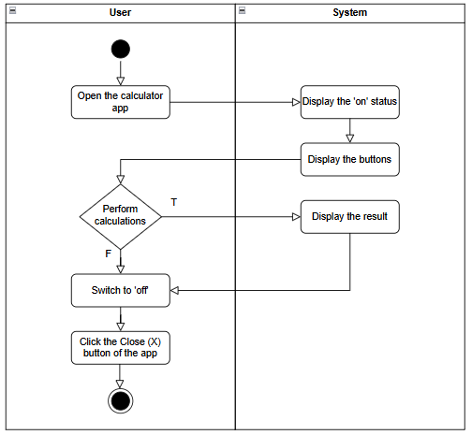

## Addition

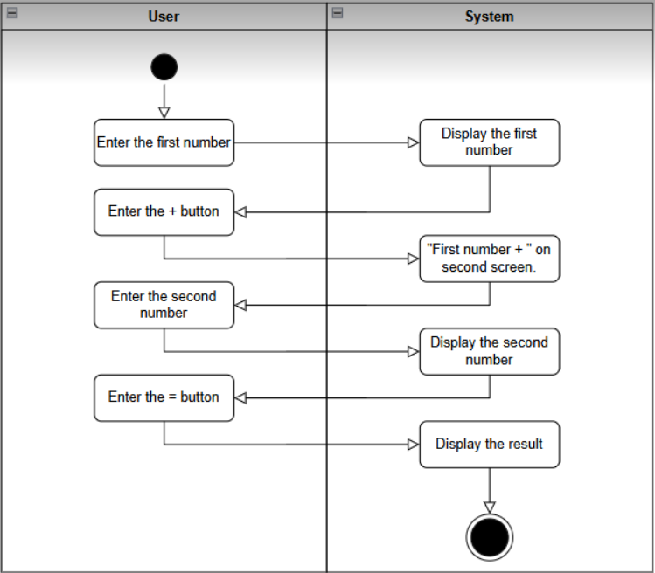

## Subtrction

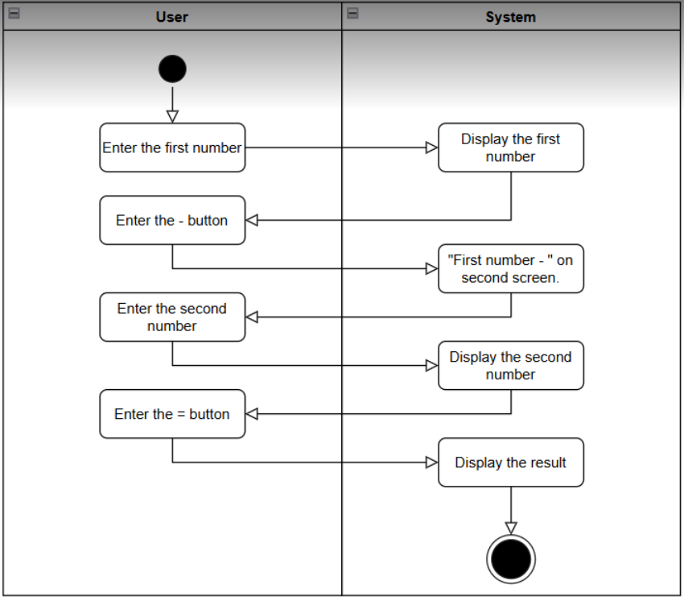

## Multiplication

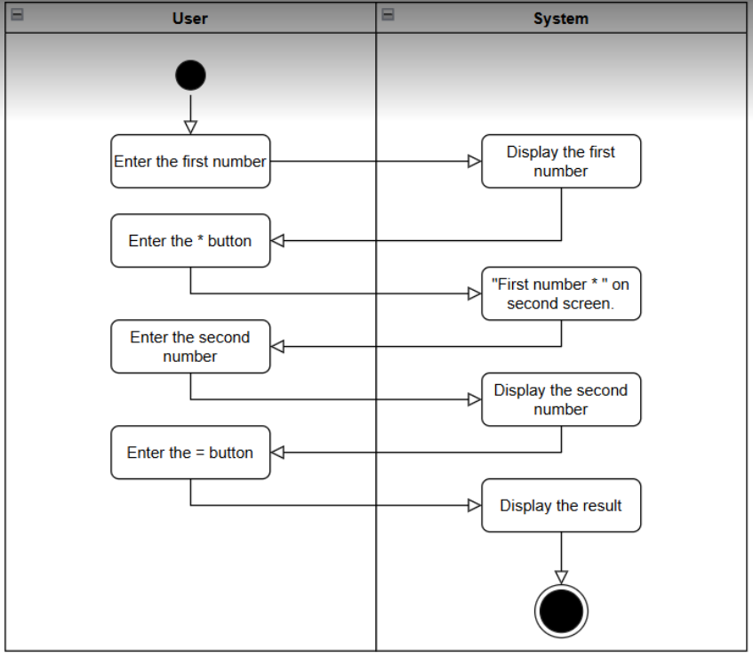

## Division

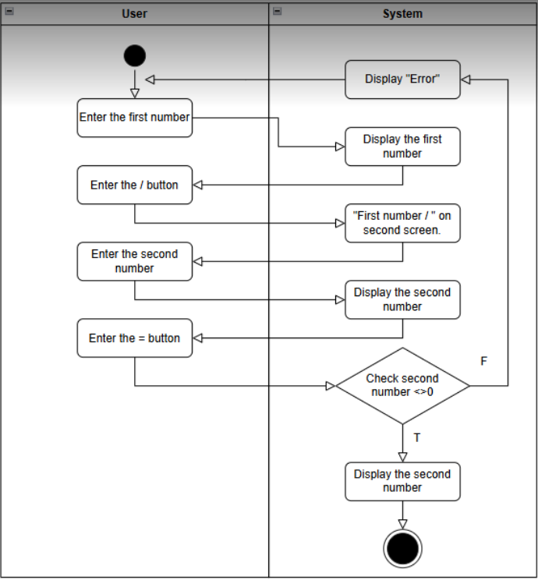

## Clear

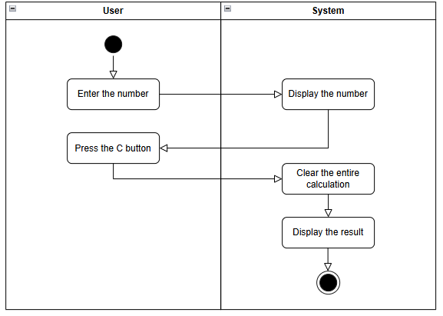

## Backspace

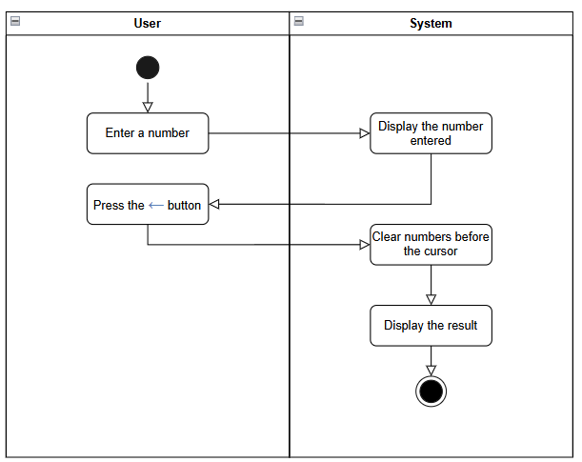

## History

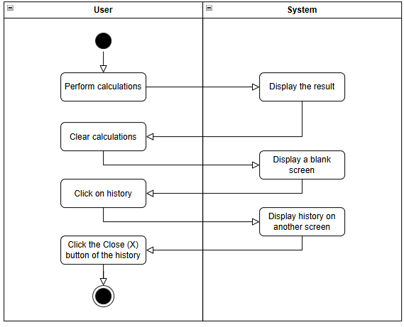

## Power

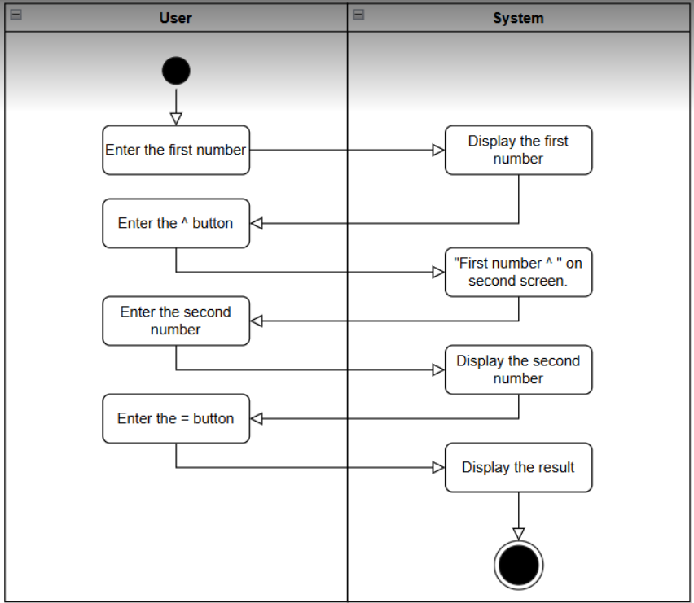

**Percentage**

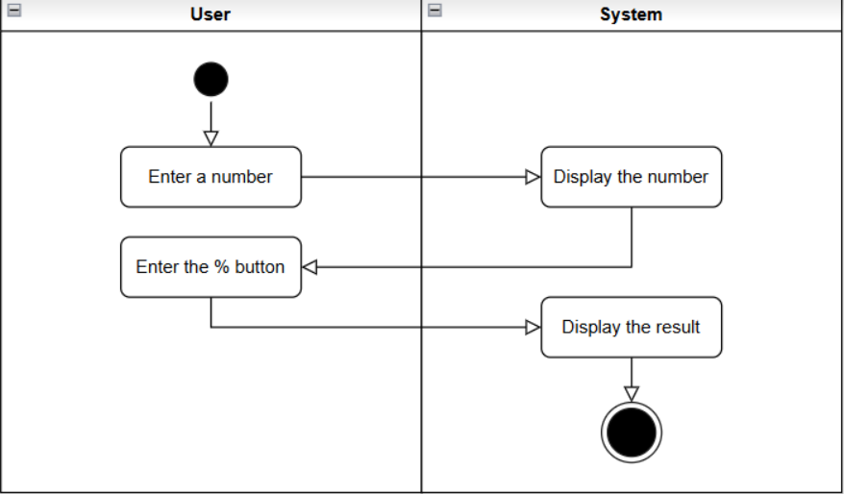

# **Square root**

# IMG_256

## Factorial

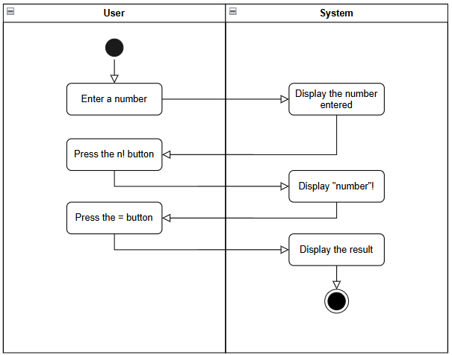

## Logarithmic

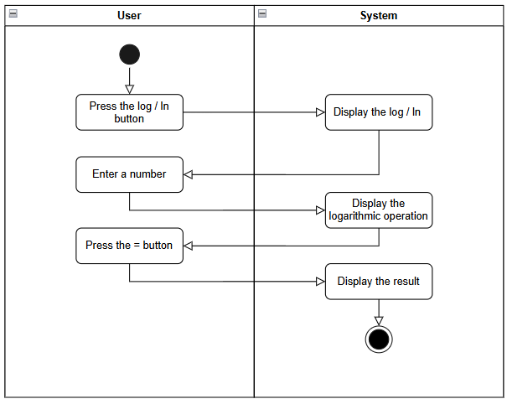

## Trigonometric

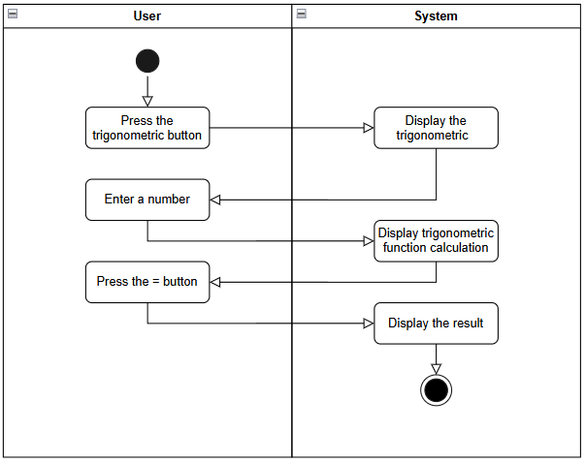

## DwpsR

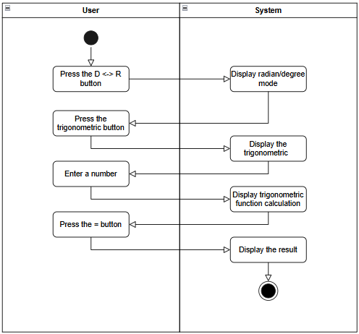

# **Dark/Light mode**

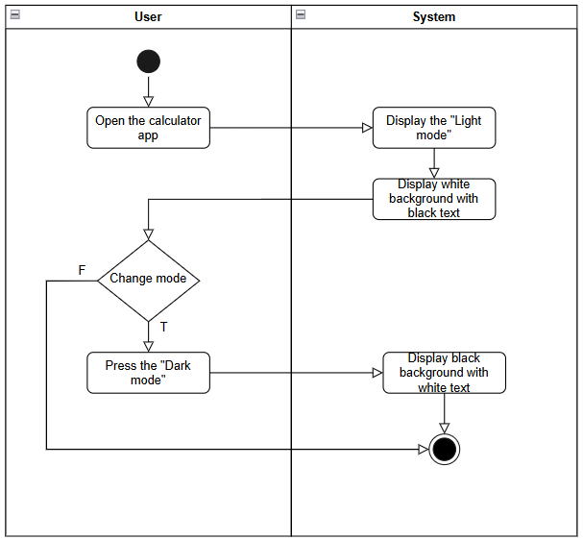

# **Clear entry**

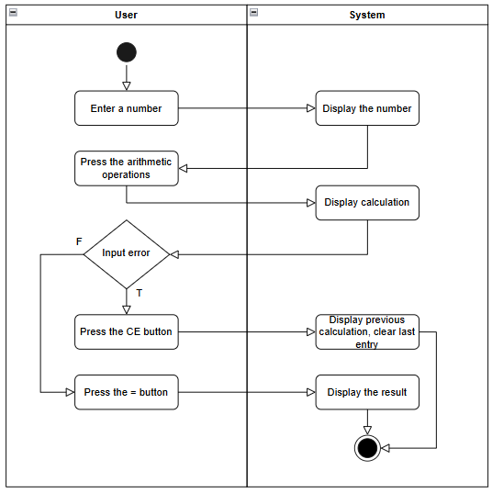

**Forward**

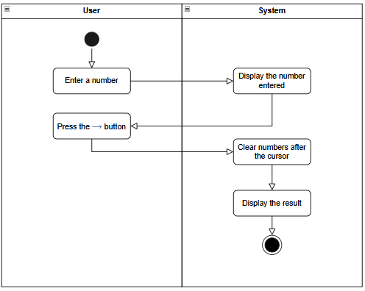

**Copy / Paste**

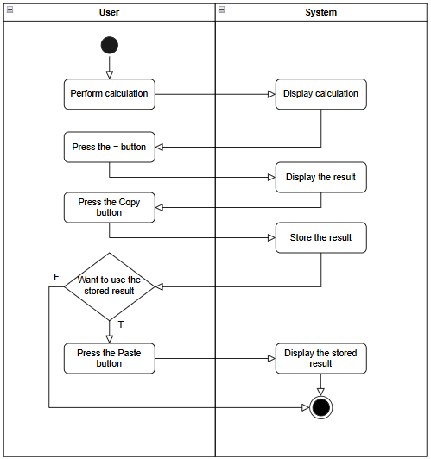

# Appendix A: Glossary

|  |  |
| --- | --- |
| FR | **Functional Requirement** |
| QA | Quality Attribute |
| UC | Use case |
| BR | Business rule |