Homework 3 Submission Evidence
Flash Sale E-Commerce Engine

Chat link
Open the AI conversation

Repository link
Open the Homework 3 repository folder

Evidence
The images below present the results of the latest local test and build runs.
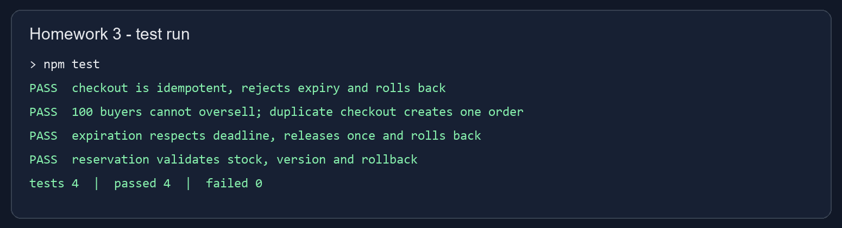
Figure 1. Test results: four tests passed and none failed.
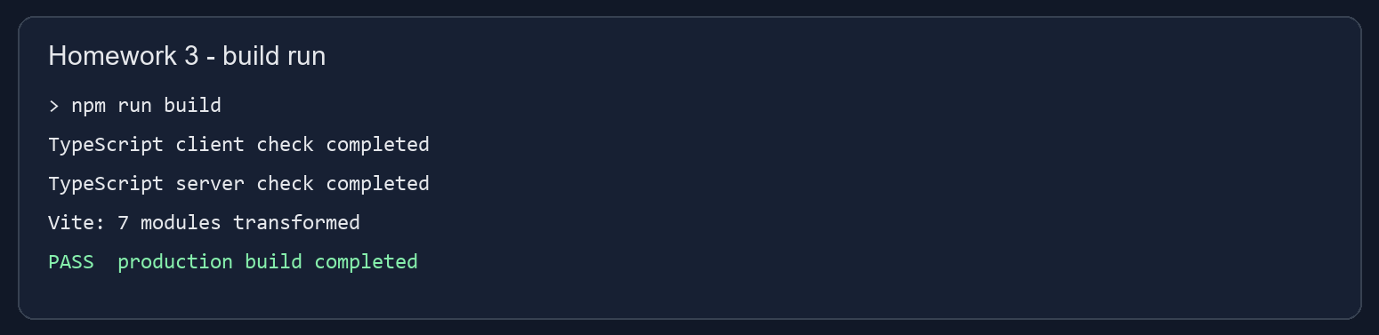
Figure 2. TypeScript checks and production build completed successfully.

WBS
The work breakdown structure summarizes the implemented project components and deliverables.
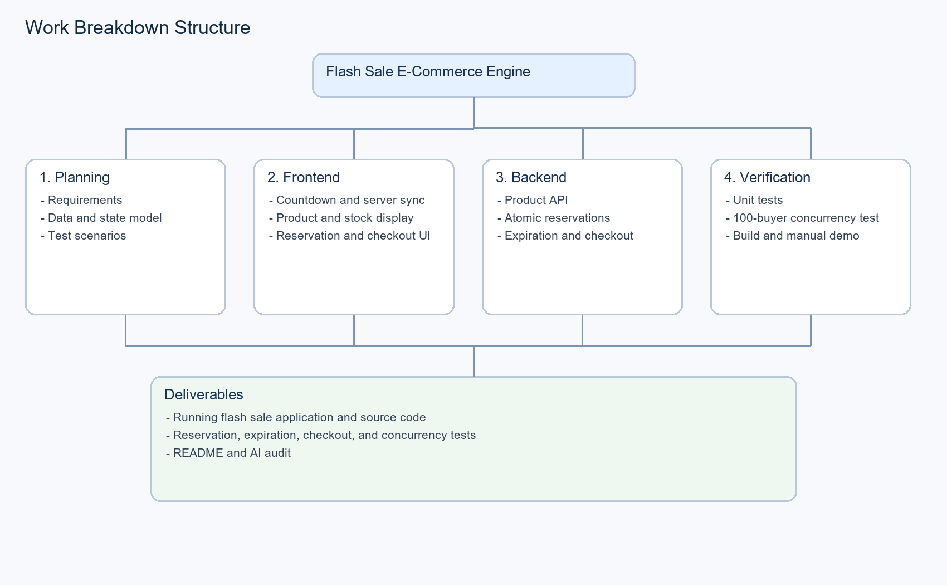
Figure 3. Homework 3 work breakdown structure.

