Homework 1 Accessibility Test Report
Data Grid component | 22 October 2026 | Chrome 155 on Windows
The current build passed 14 targeted checks and seven axe-core scans across dark, light, sorted, selected, filtered, empty, paginated and narrow states. Lighthouse scored Accessibility and Best Practices at 100/100 each. A criterion-by-criterion WCAG 2.2 A/AA review below identifies one failure: the browser tab title is only "homework1" and does not describe the employee grid. Therefore this build cannot be claimed to conform to WCAG 2.2 AA.

Project links
Chat link: https://chatgpt.com/s/cx_6ada10c574d481918e302678701be5dc
Repository link: Not available (no Git remote is configured).

Test results
Test area | Result | Observed evidence
Build and lint | PASS | TypeScript/Vite production build and Oxlint completed without errors.
Semantic structure | PASS | Native table with grid, row, columnheader and gridcell roles; four scoped headers and accessible grid name.
Keyboard navigation | PASS | One grid Tab stop; all four arrow keys moved focus; Tab exited the grid.
Row selection | PASS | Enter selected a row; Space removed selection.
Data functions | PASS | Numeric sort worked both ways; filtering, empty result status, and page 2 row index worked.
Text contrast samples | PASS | Ten computed text/background pairs across light and dark themes; lowest measured ratio was 5.73:1.
320 px heading | PASS | Heading line height was 43.2 px for 36 px text; no overlap in current screenshot.
Lighthouse scores | PASS | Chrome 155 Lighthouse reported Accessibility 100/100 and Best Practices 100/100 on the production preview.
Screen reader speech | PARTIAL | NVDA 2026.2 announced table name, cell coordinates, selection, sorting, empty results, and pages; deselection had no immediate spoken feedback.
Full WCAG 2.2 AA | FAIL | Manual review found an undescriptive page title (2.4.2). See the 55-criterion audit below.

Evidence
The screenshots below are from the current production preview. The machine readable check results are saved alongside this report as current-results.json.
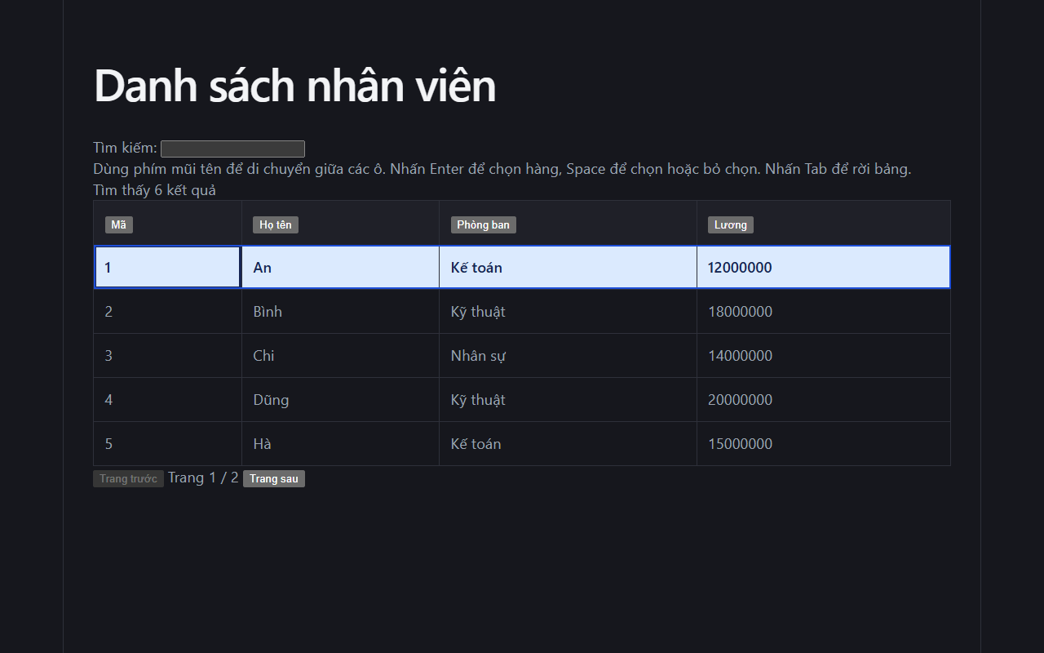
Figure 1. Keyboard focus and selected row in dark mode.
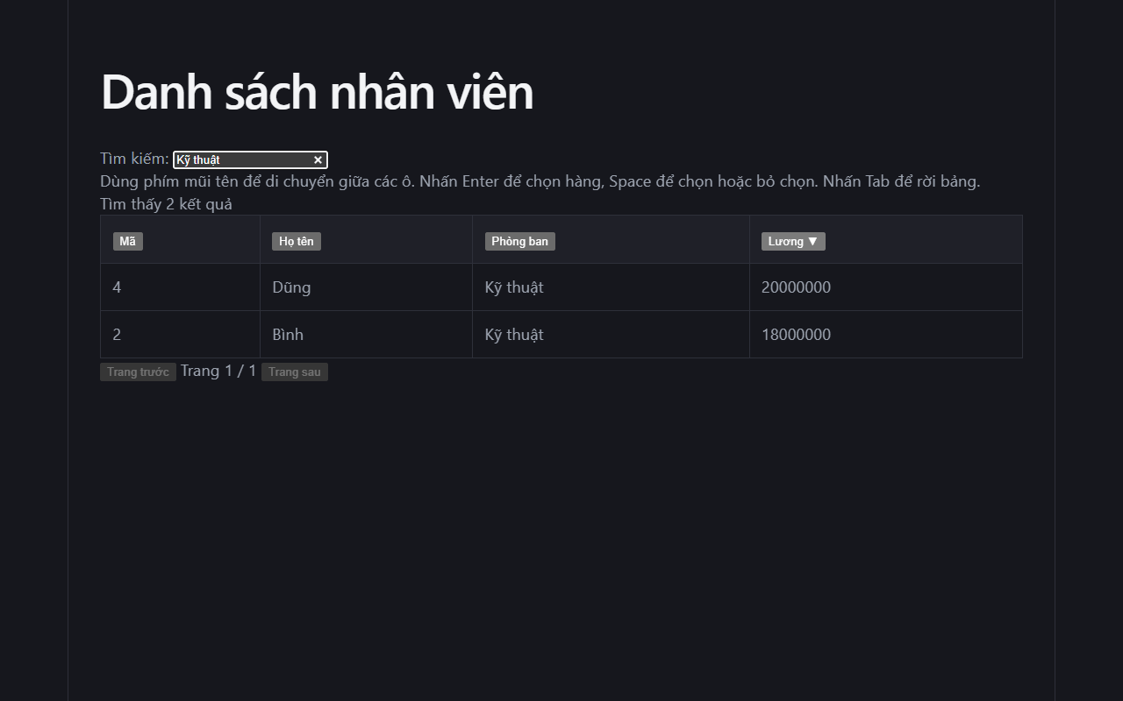
Figure 2. Filtered data grid.
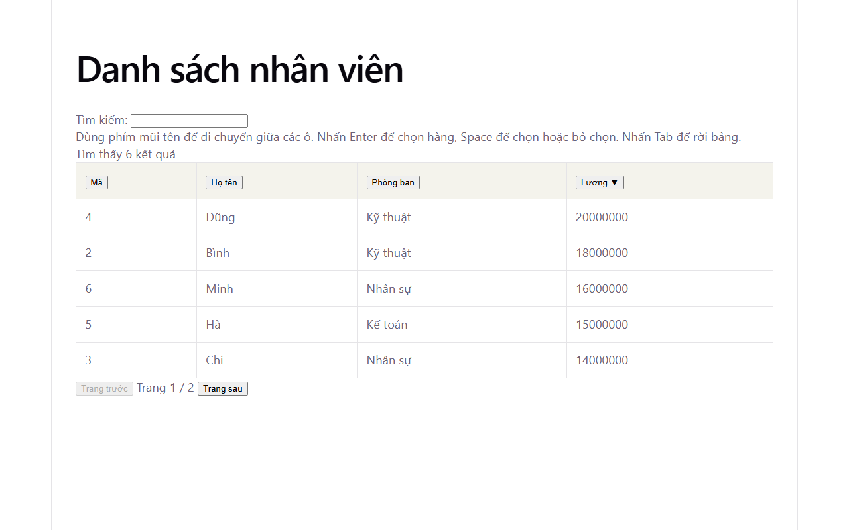
Figure 3. Light mode view used for sampled contrast measurements.
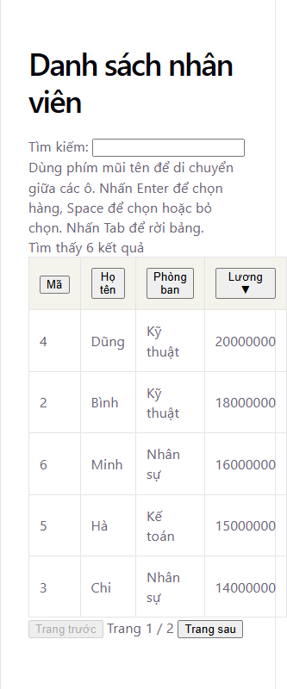
Figure 4. Current page at a 320 CSS px viewport.
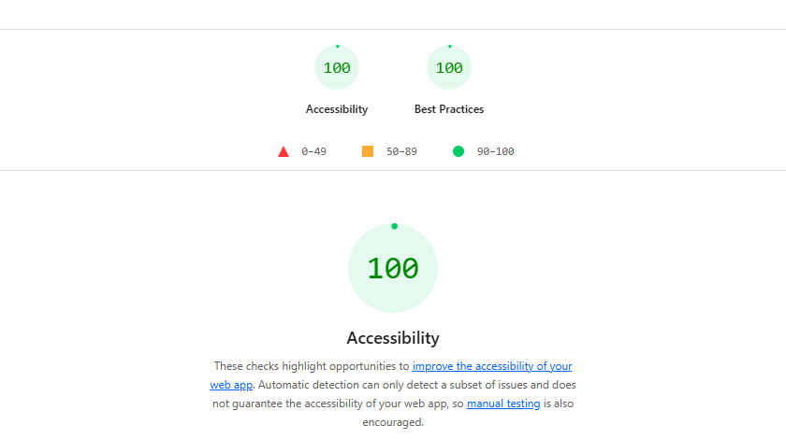
Figure 5. Lighthouse Accessibility and Best Practices scores of 100/100.

NVDA speech test
NVDA 2026.2 ran with Chrome 155. Its input/output speech log recorded the utterances below while keyboard actions were performed on the grid. In two runs, pressing Space to deselect a row did not produce an immediate deselection announcement. Speech pronunciation quality was not evaluated because the active NVDA voice did not support Vietnamese.
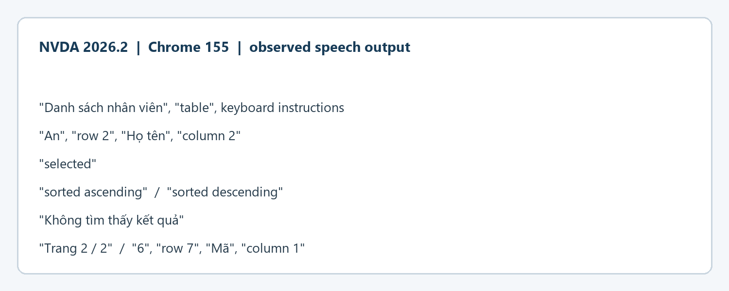
Figure 6. Selected utterances from the NVDA speech log, limited to this application.

Work breakdown structure
The WBS separates implementation, verification, and report evidence. The deselection announcement remains open under verification.
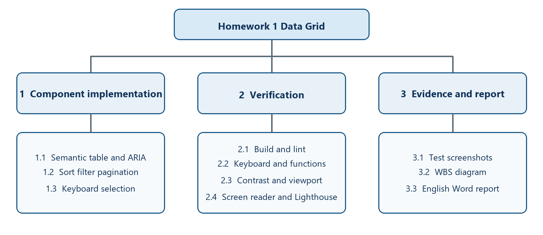
Figure 7. Homework 1 work breakdown structure.

WCAG 2.2 A and AA criterion audit
Scope: the single-page employee grid at http://127.0.0.1:4173/ on 22 October 2026. Methods: source and DOM inspection, 14 functional checks, axe-core in seven states (zero automated violations), measured dark/light text colors, 320 CSS px reflow and text spacing screenshots, a simulated 200% CSS zoom view, Lighthouse, and NVDA 2026.2 speech output in Chrome 155. “Pass” is limited to the observed page and states; “N/A” means the required content or feature is absent. Automated tools alone cannot establish conformance.
Audit summary: 24 pass, 1 fail, 27 n/a, 3 needs review. Because 2.4.2 fails and three criteria need more evidence, WCAG 2.2 AA conformance is not verified.
Criterion | Result | Evidence / rationale
1.1.1 Non-text Content (A) | N/A | No meaningful images or non-text content in the page.
1.2.1 Audio-only and Video-only (Prerecorded) (A) | N/A | No prerecorded audio-only or video-only media.
1.2.2 Captions (Prerecorded) (A) | N/A | No prerecorded synchronized media.
1.2.3 Audio Description or Media Alternative (Prerecorded) (A) | N/A | No prerecorded synchronized media.
1.2.4 Captions (Live) (AA) | N/A | No live synchronized media.
1.2.5 Audio Description (Prerecorded) (AA) | N/A | No prerecorded video.
1.3.1 Info and Relationships (A) | Pass | Native table, scoped column headers, visible search label; DOM and axe review.
1.3.2 Meaningful Sequence (A) | Pass | Heading, search, instructions, table and pager retain a meaningful DOM order.
1.3.3 Sensory Characteristics (A) | Pass | Instructions name keys and controls; no instruction depends only on shape or position.
1.3.4 Orientation (AA) | Pass | Page remains usable in narrow portrait and wide desktop layouts.
1.3.5 Identify Input Purpose (AA) | N/A | Search is not a personal-information input field.
1.4.1 Use of Color (A) | Pass | Selection and sort also have programmatic states/text, beyond color.
1.4.2 Audio Control (A) | N/A | No automatically playing audio.
1.4.3 Contrast (Minimum) (AA) | Pass | Measured text pairs in both schemes: lowest sample 5.73:1; selected-row sample 12.04:1.
1.4.4 Resize Text (AA) | Needs review | Simulated 200% CSS zoom view looked usable; native browser zoom still needs confirmation.
1.4.5 Images of Text (AA) | N/A | No images of text.
1.4.10 Reflow (AA) | Pass | At 320 CSS px, heading, search, guidance and pager reflow; table may scroll in two dimensions under the data-table exception.
1.4.11 Non-text Contrast (AA) | Needs review | Control borders and focus are visible; a complete 3:1 visual-state measurement was not recorded.
1.4.12 Text Spacing (AA) | Pass | WCAG text-spacing override at 320 CSS px did not clip non-table text or controls.
1.4.13 Content on Hover or Focus (AA) | N/A | No content appears only on hover or focus.
2.1.1 Keyboard (A) | Pass | Search, sort, cell navigation, selection and paging operated by keyboard.
2.1.2 No Keyboard Trap (A) | Pass | Tab exited the grid; no keyboard trap observed.
2.1.4 Character Key Shortcuts (A) | N/A | No single-character keyboard shortcuts.
2.2.1 Timing Adjustable (A) | N/A | No time limit.
2.2.2 Pause, Stop, Hide (A) | N/A | No moving, blinking or auto-updating content.
2.3.1 Three Flashes or Below Threshold (A) | Pass | No flashing content.
2.4.1 Bypass Blocks (A) | N/A | No repeated navigation block on this one-page application.
2.4.2 Page Titled (A) | Fail | Browser tab title is "homework1"; it does not describe the employee grid topic or purpose.
2.4.3 Focus Order (A) | Pass | Keyboard order follows search, grid and pager. Tab wrapping after the final disabled button is expected.
2.4.4 Link Purpose (In Context) (A) | N/A | No links on the page.
2.4.5 Multiple Ways (AA) | N/A | Single-page application; no set of multiple web pages.
2.4.6 Headings and Labels (AA) | Pass | Employee-list heading and search label describe their purpose.
2.4.7 Focus Visible (AA) | Pass | Focused buttons and grid cells show a visible outline in inspected states.
2.4.11 Focus Not Obscured (Minimum) (AA) | Pass | Focused controls remain visible in inspected desktop and narrow states.
2.5.1 Pointer Gestures (A) | N/A | No multipoint or path-based gestures.
2.5.2 Pointer Cancellation (A) | Pass | Native buttons and search field activate on release; no custom down-event action.
2.5.3 Label in Name (A) | Pass | Accessible names match visible labels for search, sorting and pager controls.
2.5.4 Motion Actuation (A) | N/A | No motion-actuated operation.
2.5.7 Dragging Movements (AA) | N/A | No dragging operation.
2.5.8 Target Size (Minimum) (AA) | Needs review | Targets were measured, but 24 CSS px size/spacing exceptions were not fully checked for every state.
3.1.1 Language of Page (A) | Pass | Document language is declared as Vietnamese (lang="vi").
3.1.2 Language of Parts (AA) | Pass | Visible application content is Vietnamese; no distinct-language passages found.
3.2.1 On Focus (A) | Pass | Focusing controls did not change context.
3.2.2 On Input (A) | Pass | Search and sort update the grid in place without unexpected navigation.
3.2.3 Consistent Navigation (AA) | N/A | Single-page application; no repeated navigation across pages.
3.2.4 Consistent Identification (AA) | N/A | No repeated components across multiple pages.
3.2.6 Consistent Help (A) | N/A | No help mechanism is provided across a page set.
3.3.1 Error Identification (A) | N/A | Search has no invalid-entry state.
3.3.2 Labels or Instructions (A) | Pass | Search input has a visible, programmatically associated label.
3.3.3 Error Suggestion (AA) | N/A | No input error state.
3.3.4 Error Prevention (Legal, Financial, Data) (AA) | N/A | No legal, financial or data-submission transaction.
3.3.7 Redundant Entry (A) | N/A | No multi-step entry process.
3.3.8 Accessible Authentication (Minimum) (AA) | N/A | No authentication.
4.1.2 Name, Role, Value (A) | Pass | Grid and controls expose names, roles and selection/sort state; NVDA announced sampled states.
4.1.3 Status Messages (AA) | Pass | Result count, no-results and page changes use live status; NVDA announced sampled updates.

Additional evidence
The seven-state axe-core results are saved in full-audit-results.json. The automated scan reported no violations; one contrast node was inconclusive in several states. Screenshots below show the narrow view, required text spacing override and 200% CSS zoom simulation. The zoom check is a proxy, not a full browser zoom and assistive-technology matrix.
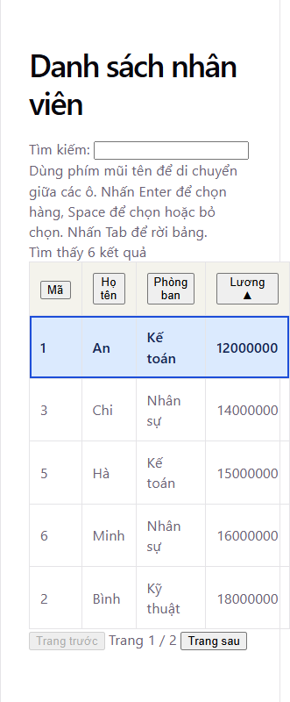
Figure 8. Light theme at 320 CSS px.
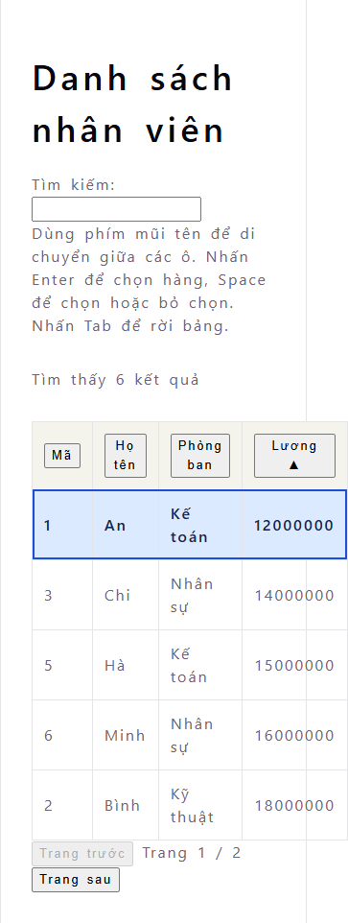
Figure 9. WCAG text spacing override at 320 CSS px.
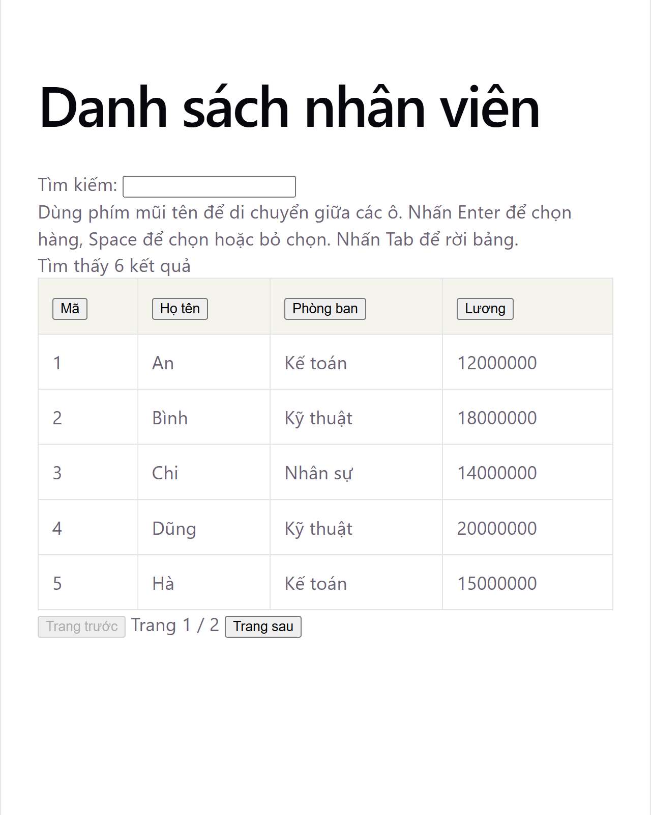
Figure 10. Simulated 200% CSS zoom on desktop.

Remediation and remaining verification
Replace the HTML title with a descriptive title such as “Employee Data Grid — Homework 1”, then rerun the page-title check. Confirm text resizing with native 200% browser zoom for 1.4.4. Measure non-text control and focus-state contrast against adjacent colors for 1.4.11 and verify all pointer targets or their spacing exceptions for 2.5.8. As a usability improvement, add immediate spoken feedback when Space deselects a row. Retest pronunciation with a Vietnamese NVDA voice and repeat with another screen reader/browser combination before making a broad compatibility claim.
Standards: WCAG 2.2 | W3C conformance guidance | W3C reflow guidance

HOMEWORK 2 TEST EVIDENCE REPORT
FIFO Audio Visualizer
This report collects the project links, browser test screenshots, and the work breakdown structure.

Chat link
https://chatgpt.com/s/cx_6ada0cc81f808191bcebab94e8ec8761

Repository link
https://github.com/Hunguwu1/homework-lab1
Project folder: lab2/homework2. Push this folder to GitHub before submission so the repository link contains the submitted source code.

Evidence
The screenshots were captured while testing http://localhost:5173/. For the concurrency test, a local test server delayed delivery of the sample audio by six seconds.
1 Concurrent loading
Tracks 1 and 2 are loading while track 3 waits. The third download starts when a slot becomes available.
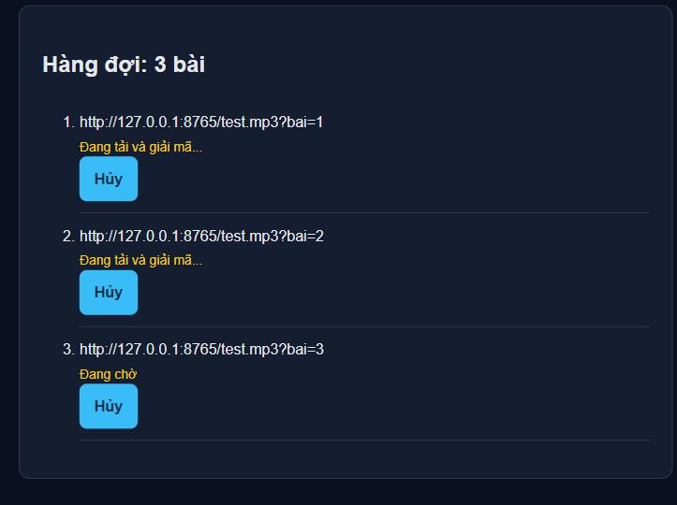
2 Cancellation
Track 3 was canceled while the first two tracks were loading. Its status changed to Canceled.
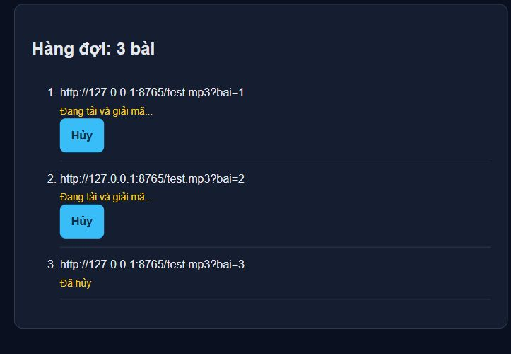
3 Playback and canceled-track handling
Track 1 is playing, track 2 is ready, and track 3 remains canceled. The valid tracks later completed in order.
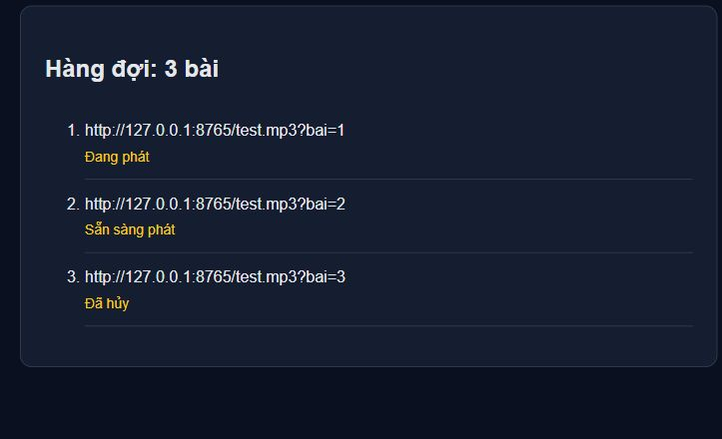
4 Invalid URL
The invalid URL produces a decoding error. The valid track behind it remains ready and can play.
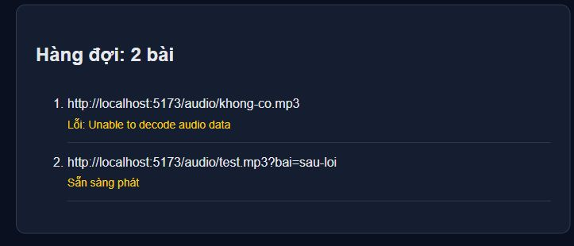
Stop and clear: clicking Stop re-enables Play and returns the current track to Ready. Clearing the queue reduces the count to zero; adding a new track afterward still works.
FPS and memory: the student reported successful checks. Screenshots of Chrome DevTools Frame rendering stats and Heap snapshot Comparison still need to be added. This report does not state an FPS or memory figure without a captured measurement.

WBS
Work breakdown structure for the FIFO Audio Visualizer.
