Exercise 2 Implementation Evidence
  - Interactive Scientist and Pioneer Directory
This report presents the React directory implementation, submission links, and evidence of filtering, sorting, deletion, stable element identity, and rendering performance.

Submission links
Chat link: Open the project conversation
GitHub link: __________________________________________

Implementation summary
- Case-insensitive name search and a numeric minimum IQ filter using valueAsNumber.
- IQ descending and age ascending sorting using toSorted().
- Immutable deletion using filter() and restoration of the initial data and controls.
- Only people, query, minIq, and sortBy are stored in state. The visible list is derived during rendering without useEffect.
- Inputs have labels linked through useId(). The result counter uses role="status" and aria-live="polite".
- Each list item uses the stable person.id as its React key.

Git history
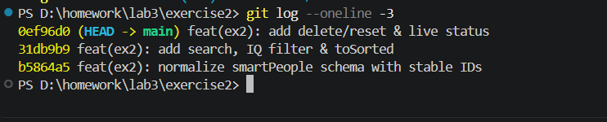
Figure 1. Three required atomic commits are recorded in Git history.

Search filtering and sorting evidence
Searching for einSTEIN returns Albert Einstein, demonstrating case-insensitive matching. With an empty name query and a minimum IQ of 200, the directory displays Goethe, Einstein, and Sidis, and reports three results.

Figure 2. Mixed-case name search returns Albert Einstein.
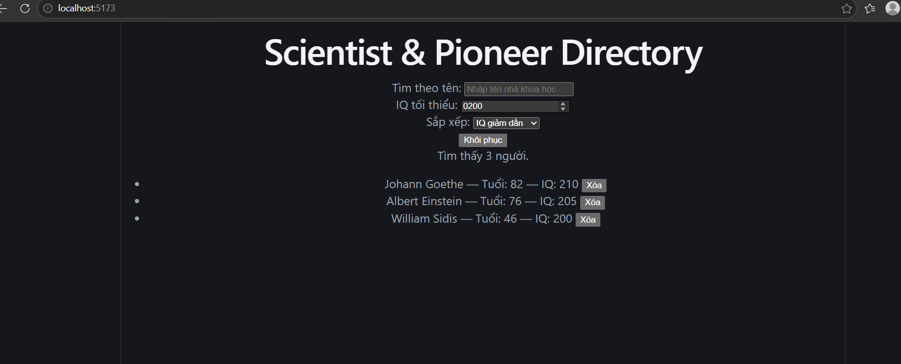
Figure 3. Combined controls, minimum IQ filtering, delete buttons, reset button, and live result count.
The IQ input in Figure 3 displays 0200; its numeric value is 200.

Figure 4. Age ascending produces Sidis, Einstein, and Goethe. This earlier development screenshot shows the sorting control in isolation; the combined controls appear in Figure 3.

React Profiler evidence
After resetting the directory, recording was started and exactly one character, a, was entered. The React DevTools Profiler shows 1 / 1, confirming one committed update for this interaction. All six names contain a, so six visible results are expected.
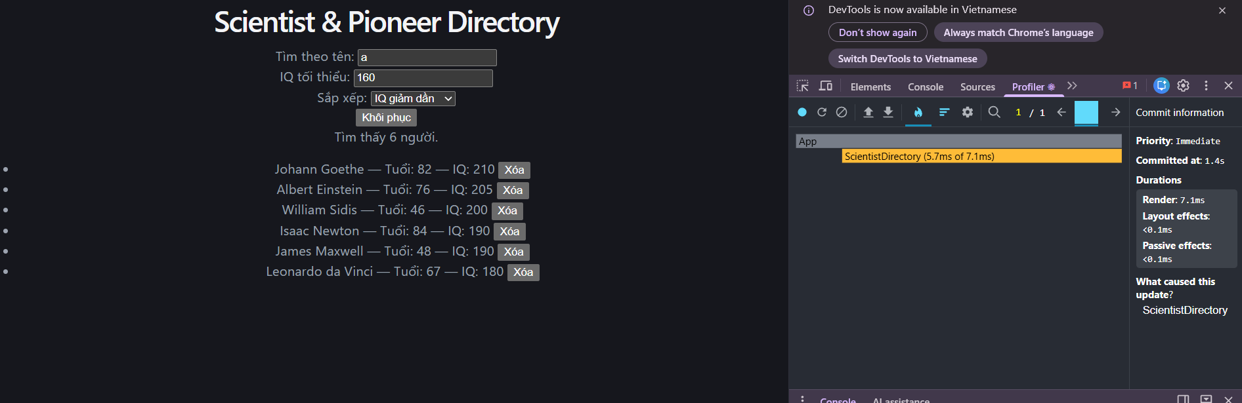
Figure 5. One character input produces one Profiler commit.

Deletion and stable element identity
The Einstein delete button was saved with document.querySelector before deleting Johann Goethe. Comparing the saved button with the current Einstein button returned true. The remaining count is five, and Einstein remains in the list.
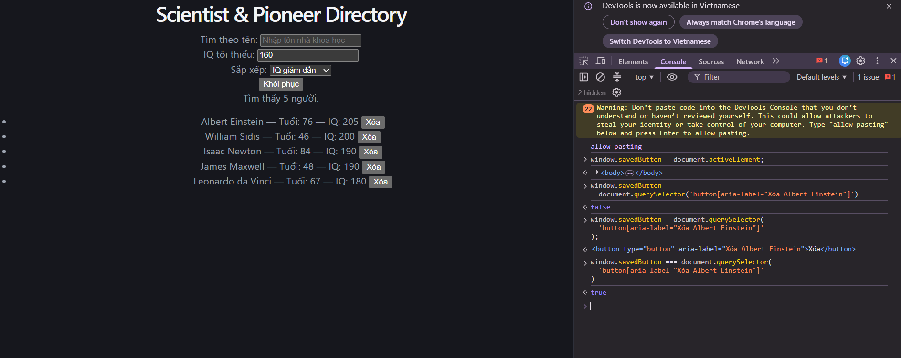
Figure 6. The final Console result is true, confirming that the remaining Einstein button retains its DOM identity after Goethe is deleted.
This identity check supports stable-key reconciliation. It does not independently demonstrate keyboard focus preservation. The implementation of reset and accessibility attributes was reviewed in the submitted component source; those behaviors are not independently demonstrated by these screenshots.

