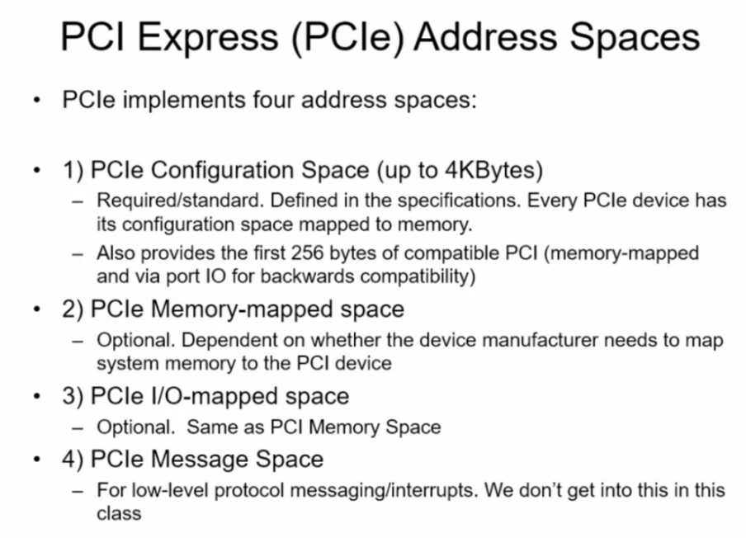

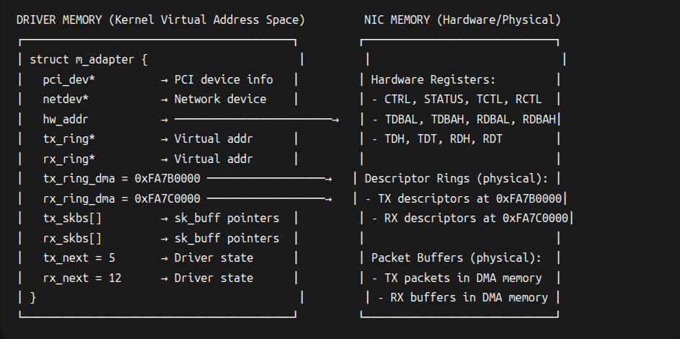

Guide to making an intel e1000 driver

Setup:

- Download virtualBox and setup Ubuntu
- Go to vm settings -> network
- Set e1000 intel card
- Select attached to “Bridged Adaptor”
- Promiscuous mode: Allow All
- Connect to your host NIC

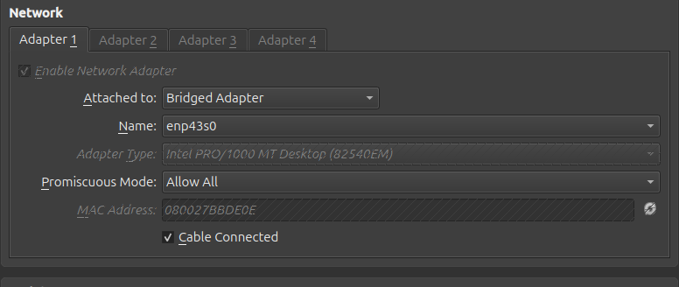

There are 3 major components for NIC that you have to take care of other than the standard linux driver initialization:
- PCIE

there are 3 ways to setup:
    - fully custom
- reading writing config header
    - unmanaged linux functions
- using pci_*
    - managed linux function (the one i used)
- using pcim_*
- this basically handles unloading/freeing automatically unlike others

status = pcim_enable_device(pci_dev);
pci_set_master(pci_dev);
status = pcim_iomap_regions(pci_dev, BIT(0), KBUILD_MODNAME);
ptr_bar0 = pcim_iomap_table(pci_dev)[0];

Together, these lines:
- Enable the PCI device.
- Allow it to do DMA.
- Reserve and map its BAR0 (register space).
- Get a kernel-accessible pointer to those registers.

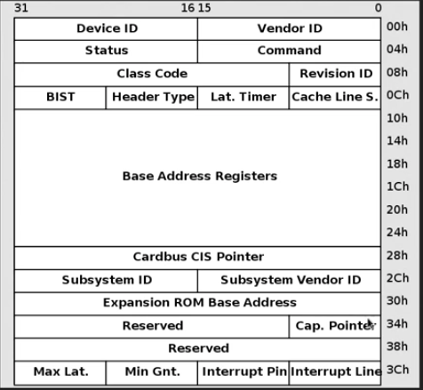
pci_read_config_
byte: 1 byte
word: 2byte
dword: 4bytes
qword: 8bytes
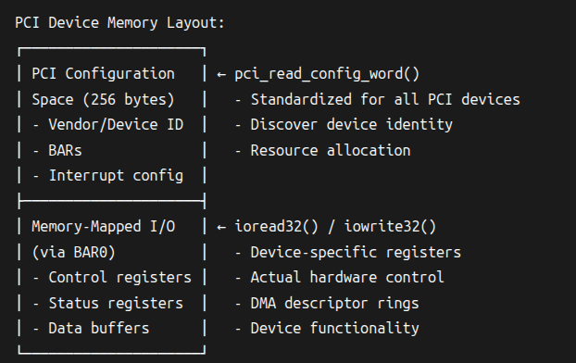
ioread32()_{//newer} = writel()_{//older}

- NET_DEV

- define
- allocate
- setup
- register
- link with pci obj

struct net_device *netdev;
netdev = alloc_netdev(sizeof(struct m_adapter), "mustafa%d", NET_NAME_UNKNOWN, m_setup);
// m_setup()-------------
ether_setup(dev); // sets up Ethernet-like device
dev->netdev_ops = &netdev_ops;
eth_hw_addr_random(dev); // assign random MAC
// ---------------------------
status = register_netdev(netdev);
pci_set_drvdata(pci_dev, netdev);

- Adapter

Adapter struct is mainly made after reading docs to encapsulate the hardware complexities of the device except for the 3 fixed components:
1. pci_dev 2. net_dev 3. ptr_bar0 (hw_addr)

struct m_adapter {
struct pci_dev *pci_dev;
struct net_device *netdev;
void __iomem *hw_addr;

struct tx_desc *tx_ring;
dma_addr_t tx_ring_dma;
struct sk_buff *tx_skbs[NUM_TX_DESC];
u16 tx_next;
u16 tx_dirty;

struct rx_desc *rx_ring;
dma_addr_t rx_ring_dma;
struct sk_buff *rx_skbs[NUM_RX_DESC];
u16 rx_next;

int irq;
};

Descriptors:

struct tx_desc {
u64 buffer_addr;
u16 length;
u8 cso; // Checksum offset
u8 cmd; // Command flags
u8 status; // Status field
u8 css; // Checksum start
u16 special;
};

struct rx_desc {
u64 buffer_addr;
u16 length;
u16 checksum;
u8 status;
u8 errors;
u16 special;
};

format of descriptor on page 50 of sw guide
rx/tx rings:
- "Ring" = array of descriptors.
- Each descriptor points to a packet buffer in memory.
- Hardware walks the ring and updates descriptor status.
- Software (driver) also walks the ring.
rx_ring_dma:

- The DMA (bus) address of the RX descriptor ring.
- This is the device-visible address.
- NIC uses this address to read/write descriptors.
- Allocated using dma_alloc_coherent() usually.
- Driver writes this address into a NIC register.

skb
- The Linux kernel’s main packet buffer structure.
- Abstracts packet + metadata.
- Contains pointers to actual data, protocol info, headroom, tailroom, etc.
- Used by networking stack, not hardware.

Full driver flow:
Init:

insmod driver.ko
↓
m_init() → pci_register_driver()
↓
PCI subsystem matches device
↓
m_probe() → register_netdev()
↓
(ip link set ethX up)
↓
m_open() → mac_setup() → tx_setup() → rx_setup() → enable interrupts

netif_carrier_on(dev); // ip link set up from drivers perspective

NIC will drop any unicast packets unless you program the MAC address into the NIC's RAL/RAH registers. (only broadcast would be seen)
static void m_setup_mac(struct m_adapter *adapter) {
void __iomem *hw = adapter->hw_addr;
u8 *mac_addr = adapter->netdev->dev_addr;
u32 ral, rah;

// Set Receive Address Low (RAL)
ral = (mac_addr[0] << 0) | (mac_addr[1] << 8) | (mac_addr[2] << 16) | (mac_addr[3] << 24);
writel(ral, hw + E1000_REG_RAL);

// Set Receive Address High (RAH) with Address Valid bit
rah = (mac_addr[4] << 0) | (mac_addr[5] << 8) | (1 << 31); // AV bit
writel(rah, hw + E1000_REG_RAH);
}

TX:

Linux → m_tx() → fill TX descriptor → write NIC doorbell
|
v
NIC DMA reads skb data

netif_start_queue(dev);
start taking packets from Linux network stack

TCTL => for transmittion enable and init tx config
TIPG => to control inter packet gap timer

RX:

NIC receives_packet
|
v
updates RX descriptor status
|
v
triggers interrupt → m_interrupt() → m_tx/rx_cleanup()
|
v
driver allocates skb + copies data
|
v
hands skb to network stack (netif_rx / NAPI)

netif_rx(skb);
driver hands of data to Linux network stack

my m_interrupt func calls m_rx_cleanup()

- Walk through RX descriptors in your ring.
- For each descriptor that hardware has filled (DD bit set):
- Unmap DMA.
- Build an skb.
- Pass packet to kernel networking stack.
- Refill that descriptor with a fresh buffer.
- Move the RX tail pointer (RDT) so NIC can use the new buffers.
- This is how packets move from NIC ➝ driver ➝ kernel.

while (processed < 16): limits work per interrupt (interrupt based polling not napi). added an if check in case packets end before 16

skb = netdev_alloc_skb(dev, 1536);
allocate skb

RCTL => for recieve enable and init rx config

1536 bytes:
Component | Size
Max Ethernet payload | 1500 bytes
Ethernet header (dest+src+type) | 14 bytes
VLAN tag (optional) | 4 bytes
CRC/FCS | 4 bytes
Driver alignment/padding | ~8–16 bytes

Stage | CPU view | NIC view
Before dma_map | virtual addr A | no access
After dma_map | virtual addr A | DMA addr dma
After dma_unmap | virtual addr A | access denied/invalid

Interrupts:

Register | Purpose
ICR | Shows WHICH interrupt happened (status). Read-only.
ICS | software-only register that lets the driver simulate interrupts for degbugging
IMS | Enables interrupts (mask set). Write-only.
IMC | Disables interrupts (mask clear).

For the minimal driver i enabled only 3 interrupts:

E1000_ICR_TXDW → Transmit Descriptor Written
E1000_ICR_RXT0 → Receive Timer (packet received)
E1000_ICR_LSC → Link Status Change

Interrupt flow:

- Driver writes IMS to enable interrupts. e.g., TXDW, RXT0, LSC
- Hardware receives an event → sets a bit in ICR
- Hardware interrupt line fires
- Driver interrupt handler reads ICR
- Driver clears ICR bits by reading the register

status = pci_alloc_irq_vectors(pci_dev, 1, 1, PCI_IRQ_LEGACY | PCI_IRQ_MSI); if (status < 0) {goto irq_fail_1;}
adapter->irq = pci_irq_vector(pci_dev, 0);
status = request_irq(adapter->irq, m_interrupt, IRQF_SHARED, netdev->name, netdev); if (status) {goto irq_fail_2;}

- kernal automatically chooses between legacy and msi
- why 0? we requested only one interrupt in prev line
- 3rd line registers interrupt handler function with the kernal

Type | Bus support | Max vectors | Trigger | Name
Legacy  (INTA-INTD) | PCI,PIC-X | 1-4  per device | Level | - Pysical pins  - Shared  - slower
MSI  (Message signaled interrup) | PCI-X, PCIe | 1-32  (power of 2) | Edge | - Memeory write to speicial address  - no sharing  - better performance
MSI-X | PCI-X, PCIe | till 2048 | Edge | - data per vector (independant address)  - ideal for multi queue driver  - most felxible
INTx  emulation | PCIe | 1 | Emulated | - uses special pcie messages (assert/dessert) for emulation

Summary:

Compulsory Responsibilities (Your Driver MUST Handle)

- Hardware Initialization/Shutdown:

- PCI resource mapping (pcim_enable_device, pcim_iomap_regions)
- Descriptor ring setup (TX/RX DMA memory allocation)
- Hardware register configuration (TCTL/RCTL, descriptor pointers)
- Interrupt setup/cleanup (request_irq, free_irq)

- Core Netdev Operations:

- .ndo_open: Enable hardware, start queues (netif_start_queue), enable interrupts
- .ndo_stop: Disable hardware, stop queues (netif_stop_queue), disable interrupts
- .ndo_start_xmit: Transmit packets (DMA mapping, descriptor management)
- Link state management: Report carrier status (netif_carrier_on/off)

- Resource Management:

- DMA mapping/unmapping for TX/RX buffers
- SKB lifecycle management (alloc/free in RX path, free after TX completion)
- Proper cleanup of all resources on removal (rings, IRQs, netdev)

- Interrupt Handling:

- Acknowledge hardware interrupts (read ICR register)
- Process TX completions (free SKBs, update ring pointers)
- Process RX packets (pass to stack via netif_rx)
- Handle critical errors (no buffers, DMA errors)

- Basic Statistics:

- Update dev->stats.tx_packets/bytes and rx_packets/bytes
- Track errors (drops, DMA failures)
Handled by Linux Network Stack (You DON'T Implement)

- Protocol processing: IP/TCP/UDP checksums (unless offloaded)
- Packet scheduling: QoS, traffic shaping
- Socket API handling: send()/recv() syscalls
- Routing decisions: Forwarding tables
- Buffer management: SKB allocation (though you do need to allocate RX buffers)
- Offload processing: TSO/GSO/GRO (unless explicitly supported)
Handled by NIC Hardware (You Configure but Don't Emulate)

- DMA engine: Moving packet data between host memory and NIC
- Packet framing: Adding/removing Ethernet FCS (if enabled)
- Interrupt generation: TX completion, packet arrival, link changes
- Hardware filtering: MAC address matching (if enabled)
- Flow control: Pause frames (if configured)

Optional but Recommended Features
NAPI | Critical for high-speed RX performance
ethtool support | Diagnostics (ethtool -S eth0)
Link state polling | Real-time carrier detection
Multicast support | Required for IPv6, mDNS, etc.
Watchdog timer | Recover from TX stalls
Hardware offloads | Checksum/TSO (for performance)
PCIe → main data interface between the NIC and the host (for sending/receiving packets).
SMBus → sideband management interface (for power management, wake-on-LAN, configuration, etc.), not for data transfer.

All inits for a network driver:
- Linux module init
- PCIe init
- Net_dev init
- RX init
- TX init
- irq init
- mac init

