TRUNCATE:-

What is Truncate?

TRUNCATE TABLE command in SQL is used to remove all the records from the table or specified partitions of a table. Once the TRUNCATE command is used, you can't recover the data even using ROLLBACK. It is similar to the DELETE command in SQL without a WHERE clause.

The TRUNC function can reduce the precision of its first numeric, DATE, or DATETIME argument by returning the truncated value. If the first argument is neither a number nor a point in time, it must be cast to a numeric, DATE, or DATETIME data type.

In Postgre[SQL](https://en.wikipedia.org/wiki/SQL), the TRUNCATE TABLE statement is a [Data Manipulation Language](https://en.wikipedia.org/wiki/Data_Manipulation_Language) (DML) operation that deletes all rows of a table without causing a triggered action. The result of this operation quickly removes all data from a [table](https://en.wikipedia.org/wiki/Table_(database)), typically bypassing a number of integrity enforcing mechanisms, "TRUNCATE TABLE statement".

Example: TRUNCATE TABLE (table name);

TRUNCATE TABLE removes all rows from a table, but the table structure and its columns, constraints, indexes, and so on remain. To remove the table definition in addition to its data, use the [DROP TABLE](https://en.wikipedia.org/wiki/Data_definition_language#DROP_statement) statement.

Example: DROP TABLE (table name);

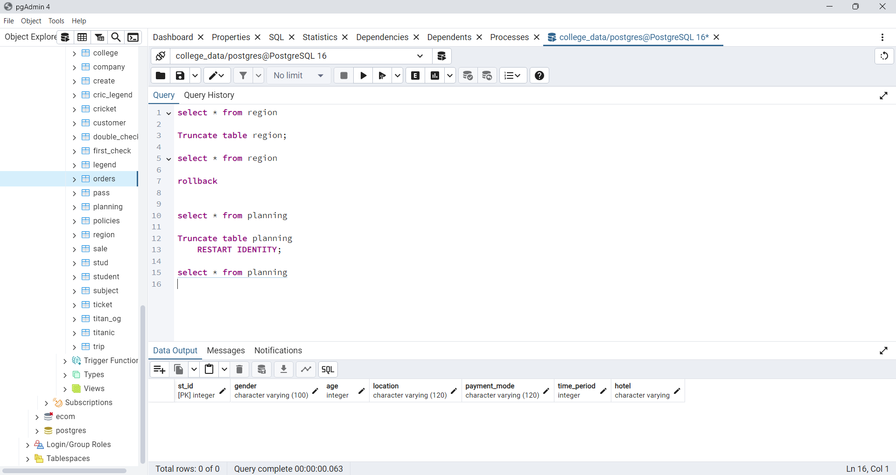

OLAP & OLTP

* OLTP (On-line Transaction Processing) is involved in the operation of a particular system. OLTP is characterized by a large number of short on-line transactions (INSERT, UPDATE, DELETE). The main emphasis for OLTP systems is put on very fast query processing, maintaining data integrity in multi-access environments and an effectiveness measured by number of transactions per second. In OLTP database there is detailed and current data, and schema used to store transactional databases is the entity model (usually 3NF). It involves Queries accessing individual record like Update your Email in Company database.
* OLAP (On-line Analytical Processing) deals with Historical Data or Archival Data. OLAP is characterized by relatively low volume of transactions. Queries are often very complex and involve aggregations. For OLAP systems a response time is an effectiveness measure. OLAP applications are widely used by Data Mining techniques. In OLAP database there is aggregated, historical data, stored in multi-dimensional schemas (usually star schema). Sometime query need to access large amount of data in Management records like what was the profit of your company in last year.
* OLTP databases are meant to be used to do many small transactions, and usually serve as a "single source of truth".
* OLAP databases on the other hand are more suited for analytics, data mining, fewer queries but they are usually bigger (they operate on more data).

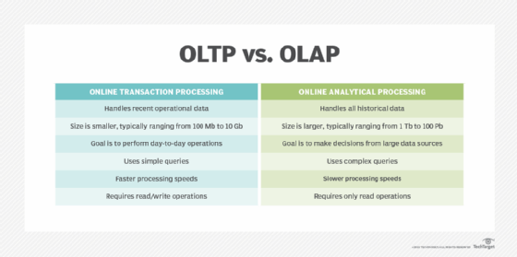

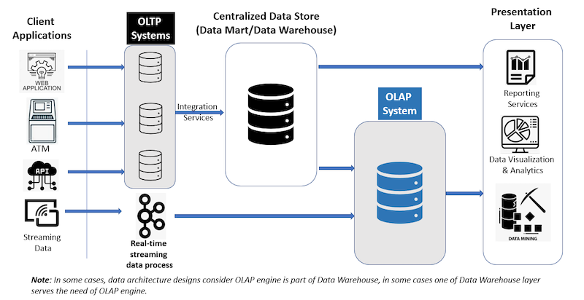

Examples of OLAP:

Sales analysis dashboards

Allow users to slice and dice sales data by dimensions like time, product category, and region. For example, a user might request a spreadsheet showing all of a company's products sold in Florida in July, and compare that to sales in September.

Apache Druid

A popular open-source distributed data store for OLAP queries that's used by many organizations in production.

Examples of OLAP:

Financial systems: ATMs, online banking, credit card processing, and password changes.

Booking systems: Online reservations for hotels and flights, and ticket bookings.

Recordkeeping: Inventory control, health records, and production scheduling.

E-commerce: Adding items to a cart, order entry, and in-store purchases.

SCHEMA

In a PostgreSQL, a schema is a list of logical structures of data. A database user owns the schema, which has the same name as the database manager. As of SQL Server 2005, a  schema is an individual entity (container of objects) distinct from the user who constructs the object. In other words, schemas are similar to separate namespaces or containers used to handle database files. Schemas may be assigned security permissions, making them an effective method for distinguishing and defending database objects based on user access privileges. It increases the database's stability for security-related management.

Key Concepts:

* Schema: A container that holds database objects.
* Default Schema: The default schema for a database is public, which is created automatically.
* Namespace: Schemas provide a namespace, meaning two objects can have the same name if they are in different schemas.

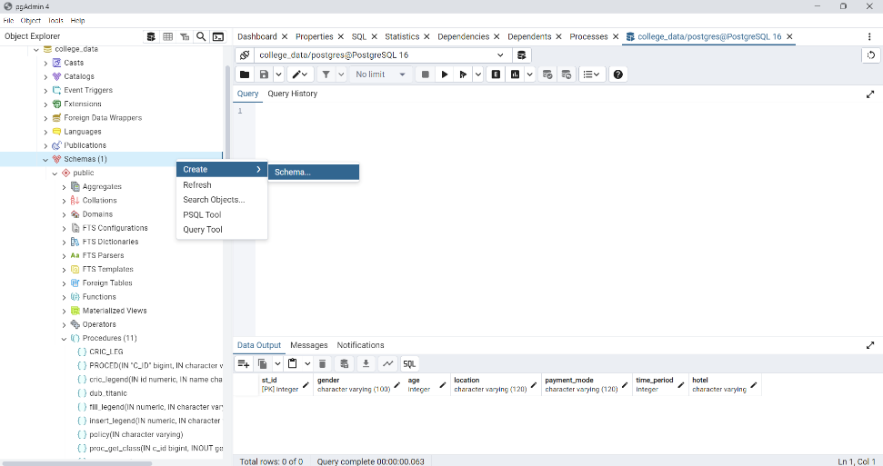 CREATE SCHEMA(schema name);

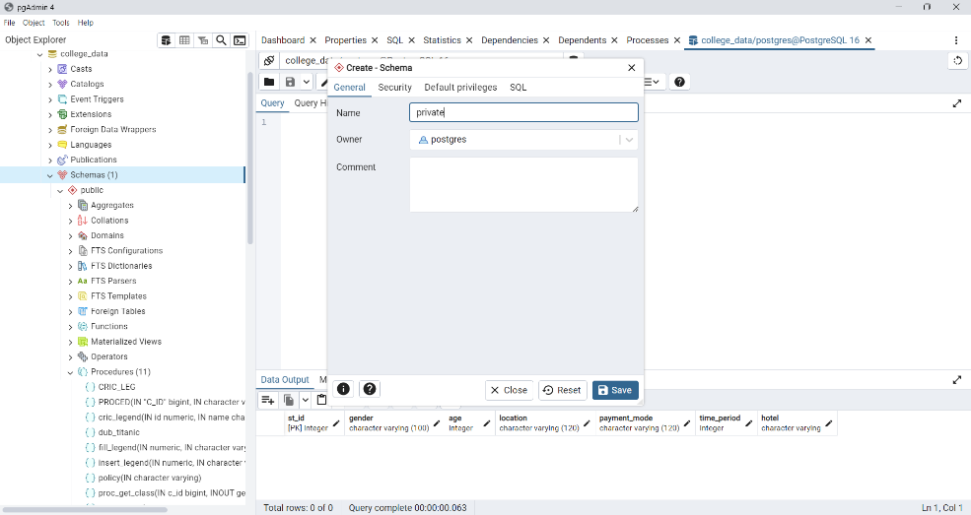

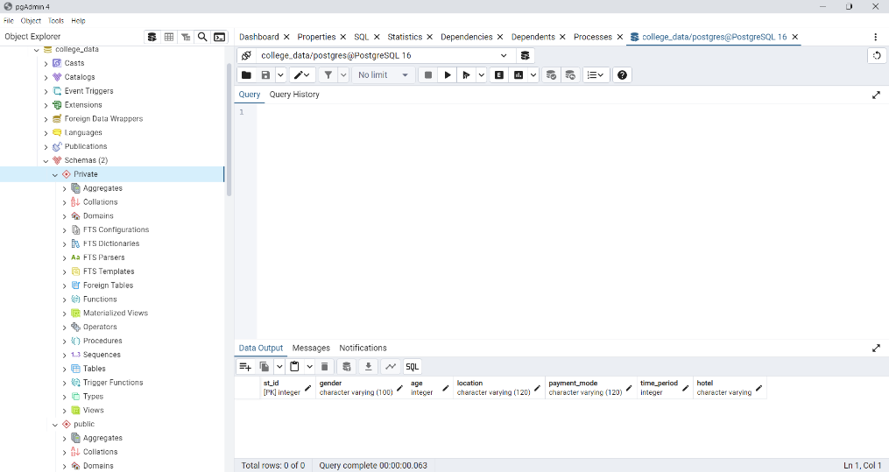

PROCEDURE

In PostgreSQL, a procedure is a stored program that can perform a series of SQL statements, including control-of-flow constructs such as loops and conditionals. Procedures are often used to encapsulate business logic or complex operations that need to be executed multiple times. It is created and stored in the database and can be called from an PostgreSQL statement or another procedure.

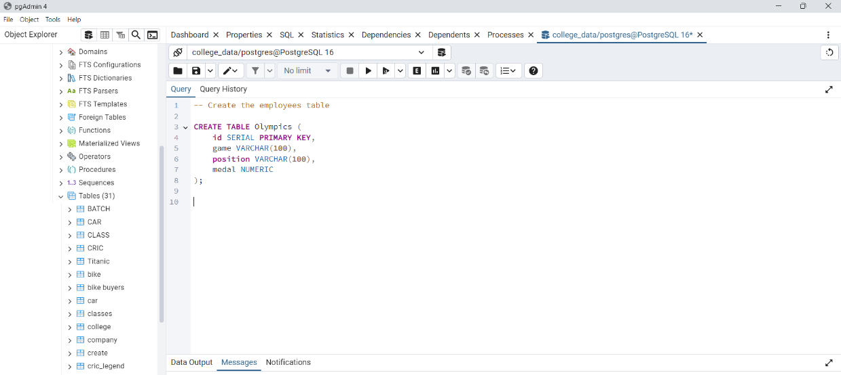 Create Table First

Create or Replace a Procedure Query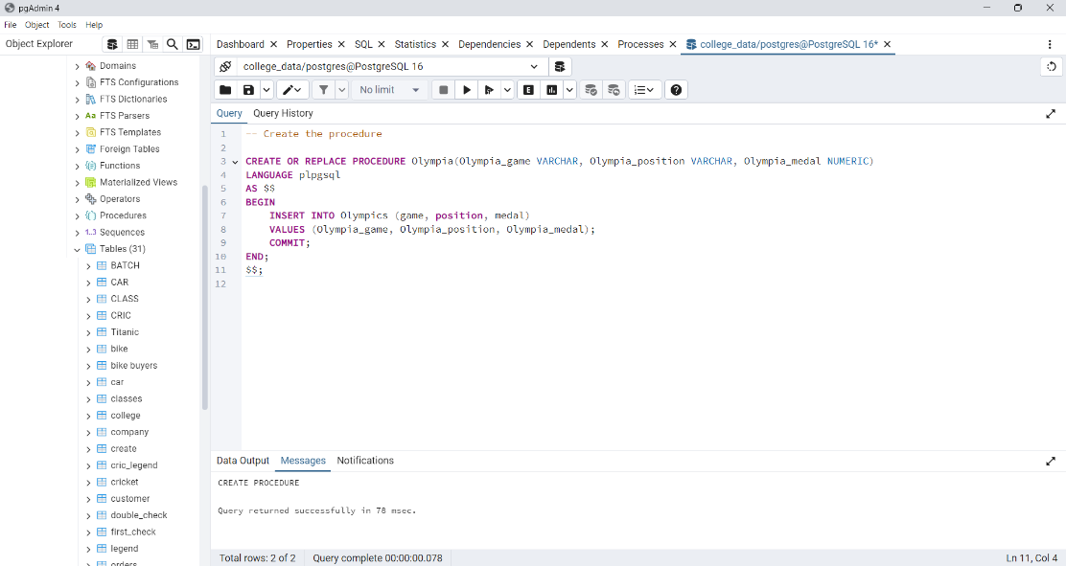

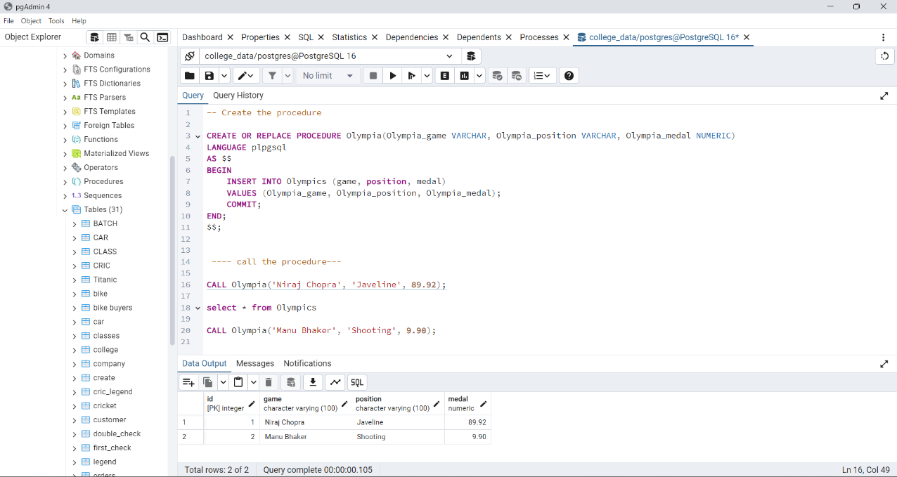

Call The Procedure after the procedure has been created.