Invisible Cloak
Personal Project

Real-Time Classical Computer Vision Project
Name : Champavat Jayvardhansinh B
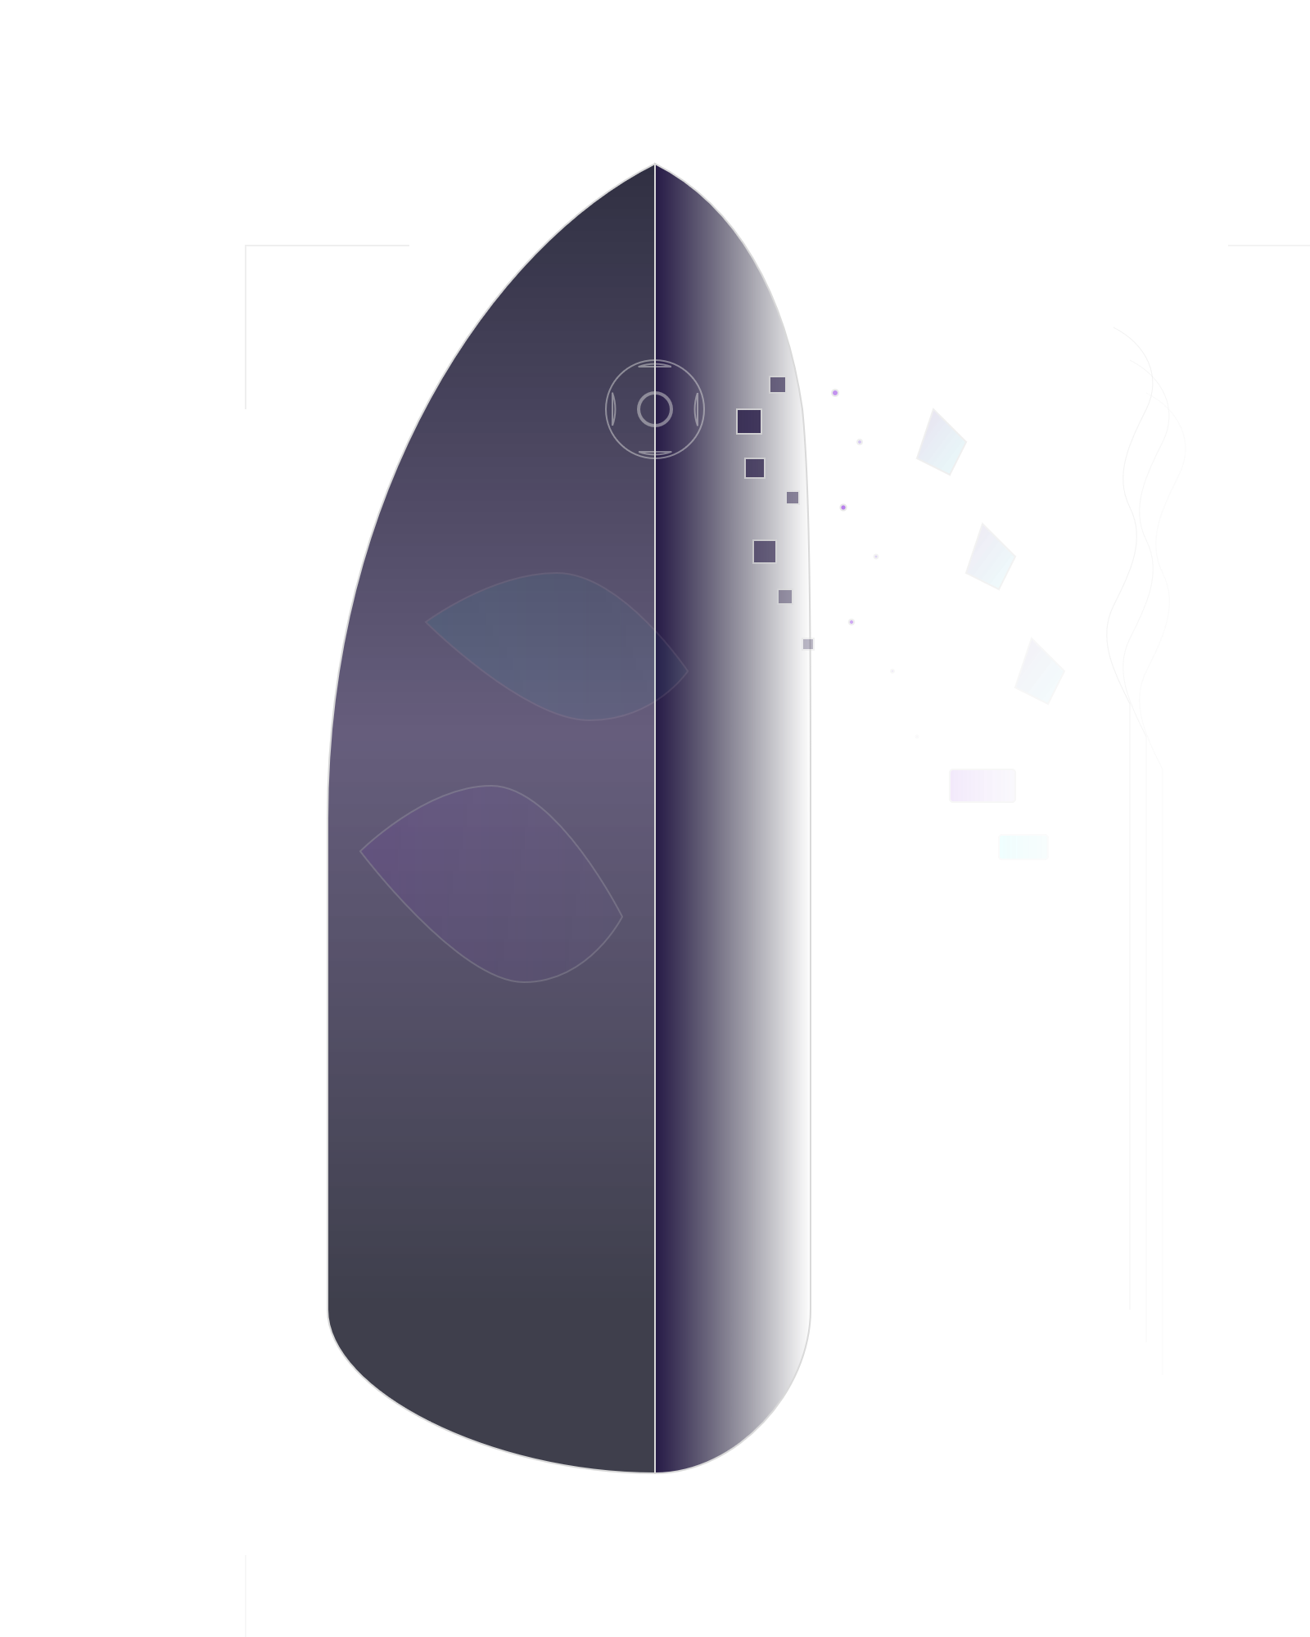

Contents
1 Project at a glance 1
2 Purpose, scope, and objectives 1
2.1 Purpose 1
2.2 Scope 1
2.3 Objectives 1
3 The Computer Vision pipeline 1
3.1 Why HSV is used 2
3.2 What the mask operations contribute 2
4 Background compositing 2
5 Software architecture 3
6 Implemented features and user interaction 3
6.1 User-facing behavior 3
6.2 Runtime trade-off 3
7 Requirements snapshot 4
7.1 Functional requirements 4
7.2 Non-functional requirements 4
8 Testing and development workflow 4
8.1 Git and GitHub workflow 4
9 Challenges, learning, and limitations 5
9.1 Challenges supported by the project brief 5
9.2 Practical learning outcomes 5
9.3 Honest limitations 5
10 Future improvements 5
11 Final result 5

How to read this document
This report explains what the application does, how the classical Computer Vision pipeline works, how the codebase is organized, how it is tested, and which improvements are deliberately left for future work. The technical claims are limited to the supplied project brief; no unsupported benchmarks or AI/ML capabilities are introduced.

Project at a glance
The Invisible Cloak is a real-time webcam application built with Python, OpenCV, and NumPy. It creates the familiar invisibility effect by detecting a selected cloak color and replacing that region of the current frame with a previously captured clean background.
The project is intentionally a classical Computer Vision system. It does not use Machine Learning, Deep Learning, TensorFlow, PyTorch, YOLO, convolutional neural networks, or other neural-network models. The processing is explicit: color conversion, thresholding, mask cleanup, contour handling, refinement, and compositing.
4
supported cloak colors : Blue, Red,
Green, Purple
9
automated pytest tests passing
2
processing/output resolutions:
640×360
/
1280×720

Purpose, scope, and objectives

Purpose
The purpose of the project is to turn a visually familiar effect into a transparent, testable software pipeline. A user captures a clean view of the scene, selects a cloak color, and then observes the cloak region being replaced in real time.

Scope
The system covers webcam capture, background capture and reset, multi-color selection, color segmentation, binary-mask processing, background compositing, runtime status information, debug views, keyboard controls, and automated testing. It is not a semantic person-segmentation system and does not attempt to understand objects beyond their color-based appearance.

Objectives
- Implement the effect with direct OpenCV and NumPy operations.
- Make the processing stages understandable enough to debug and explain.
- Support multiple cloak colors and a practical live interaction loop.
- Organize the project into modules, tests, documentation, and reproducible dependencies.

Design principle
The project is credible because its decisions are visible. The final illusion is the result of a chain of ordinary image-processing operations that can be inspected separately.

The Computer Vision pipeline
The application repeats the following sequence for each live webcam frame:
Webcam frame → BGR → HSV → Color thresholding
Read the current image |  | Separate hue, saturation, value |  | Select the configured cloak range
Binary mask | → | Mask cleanup | → | Contour filtering
Mark likely cloak pixels |  | Reduce noise and small gaps |  | Keep meaningful regions
Refinement | → | Compositing | → | Invisible output
Dilation and smoothing |  | Combine live frame and |  | Display the result in real time
background

Why HSV is used
OpenCV receives the webcam image in BGR format. The implementation converts that frame to HSV so that hue can be reasoned about as a color family, while saturation and value help distinguish vivid cloak pixels from weak or dark regions. HSV thresholding then produces a binary decision map.
Red is handled with two HSV ranges because red sits across the boundaries of OpenCV’s hue scale. Blue, green, and purple can each be represented by their configured ranges.

What the mask operations contribute
A binary mask is useful but rarely perfect on its first pass. Morphological processing reduces isolated noise and closes small gaps. Contours provide a way to filter irrelevant regions. Dilation expands the retained cloak region, and Gaussian smoothing helps avoid excessively harsh transitions at the edge.

Background compositing
The effect depends on a clean background captured before the person enters the scene. The program then uses the refined mask as a pixel-selection layer:
 | Current webcam frame |  |  | + |  |  | Clean captured background
Contains the live scene and the cloak. |  |  |  |  |  | Contains the scene before the cloak entered.
 | Mask decision | → |  |  |  |  | Final composite
Where the mask identifies cloak pixels, use the background; elsewhere, keep the live frame. |  |  |  |  |  | The cloak region visually reveals the earlier background.
What the system is not doing
It is not generating a plausible person or scene. It is copying pixels from a previously captured image according
to a refined color-based mask.

Software architecture
The high-level structure keeps responsibilities readable without inventing extra layers:
Module | Responsibility
src/camera.py | Webcam access, frame capture, and camera-related handling.
src/cloak.py | Color detection, mask processing, and background compositing logic.
src/config.py | Runtime settings, color ranges, and configuration/error handling.
src/main.py | Application flow, controls, display, runtime status, and timing.
tests/test_cloak.py | Automated tests for the core behavior described by the project.
The supporting repository structure includes assets/, docs/, .gitignore, LICENSE, README.md, and requirements.txt. The project also uses a Python virtual environment for reproducible setup.

Implemented features and user interaction

User-facing behavior
The completed application supports Blue, Red, Green, and Purple cloak colors; real-time webcam processing; a three-second background-capture countdown; background reset; pause/resume; current cloak-color and status information; FPS and processing-time information; debug visualization; and a 1280×720 output with 640×360 internal processing.
Key | Action | Key | Action
1 | Blue | 2 | Red
3 | Green | 4 | Purple
B | Capture background | R | Reset background
Space | Pause / resume | Q | Quit

Runtime trade-off
The project uses a 640×360 processing resolution to improve performance while producing a 1280×720 output. The brief does not provide a benchmark, so no numerical FPS or latency claim is made here. The important engineering decision is the explicit balance between live responsiveness and output size.

Requirements snapshot

Functional requirements
- Capture and display webcam frames in real time.
- Capture, store, reset, and reuse a clean background.
- Detect the selected cloak color and produce a refined mask.
- Composite the background into the detected cloak region.
- Support color selection, pause/resume, quit, status information, and debug views.

Non-functional requirements
- Remain responsive enough for live interaction.
- Keep camera, vision, configuration, application flow, and tests separated by responsibility.
- Handle configuration and image-dimension behavior predictably.
- Remain reproducible through a Python virtual environment and requirements file.
- Be explainable and maintainable rather than dependent on an opaque model.

Edge-case considerations
Lighting changes, shadows, reflections, similar-colored objects, background movement, camera instability, and imperfect mask boundaries can reduce the quality of a color-based effect. These are limitations of the chosen approach, not hidden capabilities.

Testing and development workflow
The final project includes 9 automated pytest tests, all passing.
The supplied brief identifies the tested areas as core color detection, mask processing, compositing, configuration and error handling, and image-dimension behavior. No coverage percentage or additional test result is claimed.
pytest → 9 tests → 9 passed → commit / push

Git and GitHub workflow
The project was developed with a development branch and a main branch. The final tested implementation was merged into main and pushed to GitHub. The repository includes the README, MIT License, requirements file, ignore rules, source modules, and tests.
- Develop and implement on the development branch.
- Run the automated tests and inspect the runtime behavior.
- Commit the tested implementation.
- Merge the final result into main and push it to GitHub.

Challenges, learning, and limitations

Challenges supported by the project brief
Reliable color detection requires meaningful HSV ranges. Red requires special treatment because its hue wraps across the OpenCV range boundary. Mask noise, mask boundaries, background consistency, camera handling, and real-time performance all affect whether the illusion looks convincing.

Practical learning outcomes
Building the project provided hands-on experience with Python project organization, OpenCV frame processing, NumPy image arrays, HSV segmentation, binary masking, morphological operations, contour processing, background compositing, real-time trade-offs, pytest, and Git/GitHub workflow.

Honest limitations
This is color-based segmentation rather than semantic understanding. Lighting sensitivity, similar colors in the environment, shadows, reflections, background movement, camera changes, and imperfect boundaries can cause false detections or visible edges. A stable camera and reasonably consistent background remain important.

Future improvements
The following ideas are intentionally separated from the implemented feature set:
Robustness Product direction
Automatic color calibration. 1. GUI improvements and recording support.
Better lighting compensation. 2. Person-aware segmentation.
More stable masks and improved edge 3. Additional profiling and test cases.
refinement. 4. A future ML/deep-learning approach, if
Advanced segmentation is required when
semantic and color alone fall short.
Final result
The Invisible Cloak project is a complete, explainable real-time Computer Vision application. Its value is not that it pretends to use advanced AI; its value is that the developer built the pipeline, exposed the important decisions, supported multiple colors, handled runtime interaction, tested core behavior, organized the repository, and documented the limitations.

One-sentence summary
OpenCV detects the selected cloak color in HSV space, refines a binary mask, and uses that mask to replace the cloak region with a previously captured background in real time.

