A Project on
LAP LEGENDS

As a partial fulfilment of B.C.A. SEM V
Batch Year (2025-26)

Under taken at

Matrushri L. J. Gandhi (Bakorvala) BCA College,
Modasa

Submitted By

NAME EXAM NO.
Patel Krish 113
Champavat Jayvardhansinh 20

Internal Guide External Guide Mrs.Hemali Patel Mr.Sanjay Patel


Submitted to
Matrushri L.J. Gandhi (Bakorvala) BCA College, Modasa
Affiliated by

Hemchandracharya North Gujarat University Patan-38426

INDEX

No. | Description | Page No.
1. | Introduction | 3
2. | Project Profile  2.1 Existing System  2.2 Need for New System | 4  5  6
3. | Requirement  Analysis  3.1 Hardware & Software Requirements | 7
4. | System Design  4.1 System flow chart  4.2 Data Flow Diagram  4.3 Entity Relation Diagram | 9  10  12  25
5. | Data Dictionary | 27
6. | Screen Shots  6.1 User Side Screenshots  6.2 Admin Side Screenshots  6.3 instructor Side Screenshots | 33  39  55  62
7. | Testing | 67
8. | Future Enhancement | 68
9. | Bibliography | 69

Introduction

The F1 Racing Website is a PHP-based web project developed to provide users with detailed information about Formula 1 racing. The website allows users to explore teams, drivers, race schedules, and results through an interactive and easy-to-use interface.

This project is built using HTML, CSS, PHP, and MySQL, showcasing how server-side scripting and database connectivity can be used to create dynamic and data-driven web applications.

The main objective of this project is to develop a professional, responsive, and informative platform for F1 racing enthusiasts, while demonstrating our understanding of web development and database management in PHP.

Project Profile

Project Title | LAP LEGENDS
Goal of the system | The main objective of this project is to develop a professional, responsive, and informative platform for F1 racing enthusiasts, while demonstrating our understanding of web development and database management in PHP
Type of application | WEB BASED -APPLICATION
Organization | Matrushri L.J Gandhi (Bakorvala) B.C.A College
Front end | HTML5 , CSS3
Back End | MYSQL, PHP
Tools Used | VISUAL STUDIO CODE, NOTEPAD++, XAMPP
Internal guide | Mrs. Hemali Patel
External guide | Mr. Sanjay Patel
Group number | 14
Submitted to | Matrushri L.J Gandhi (Bakorvala) B.C.A College, Modasa
Developed by | Champavat Jayvardhansinh B ( 20 ) Patel Krish H ( 113 )

Existing System

In the existing system, Formula 1 fans rely on multiple sources such as sports news websites, social media platforms, and official F1 apps to get information about races, drivers, and standings. These platforms are often scattered, not user-friendly for beginners, and do not allow customized browsing based on user preferences.

There is no single, simple website designed specifically for presenting F1 data in a clean and educational format suitable for learning or academic use. As a result, users face difficulties in finding all relevant race-related information in one place.

Need for New System

The proposed system — F1 Racing Website — aims to solve the limitations of the existing system by
providing a centralized platform for Formula 1 information.

This PHP-based website integrates a MySQL database to manage race schedules, teams, drivers, and results in one place. The user interface is designed using HTML and CSS for better navigation and responsiveness.

This PHP-based website integrates a MySQL database to manage race schedules, teams, drivers, and results in one place. The user interface is designed using HTML and CSS for better navigation and responsiveness.

Hardware & Software Requirements

Client-Side Configuration

Hardware configuration

Processor | IntelCorei5 processor
Hard Disk | 1GB
RAM | 4GB

Software configuration

Operating System | Windows10
Internet | Required

Browser | Chrome  (Recommended)you can use any latest Browser

Admin-Side Configuration

Hardware configuration

Processor | IntelCorei5 processor
Hard Disk | 1GB
RAM | 4GB

Software configuration

Operating System | Windows10
Front End | HTML , CSS
Back End | PHP, MYSQL
Software | Notepad++, Subline

System Design

- Flow Chart
- Data Flow Diagram



Symbols Used in System Flow Chart

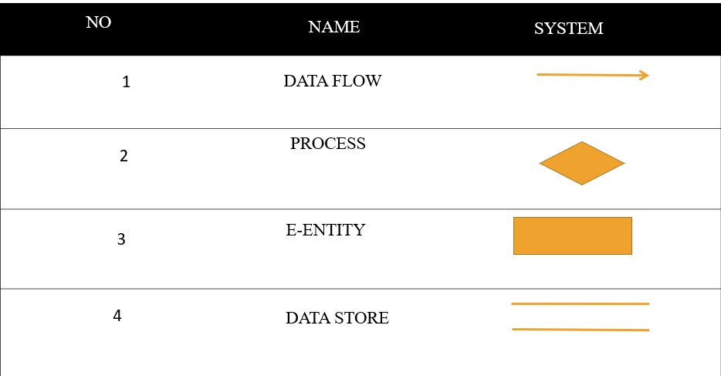

System Flow Chart

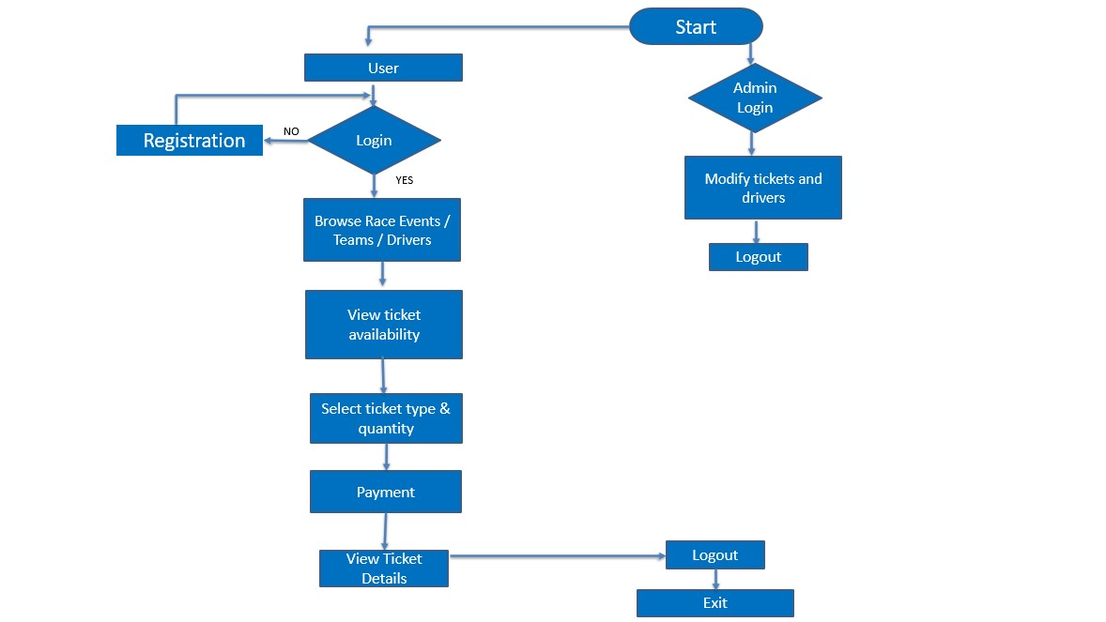

Data Flow Diagram
Context level (0 Level) DFD for E-LMS

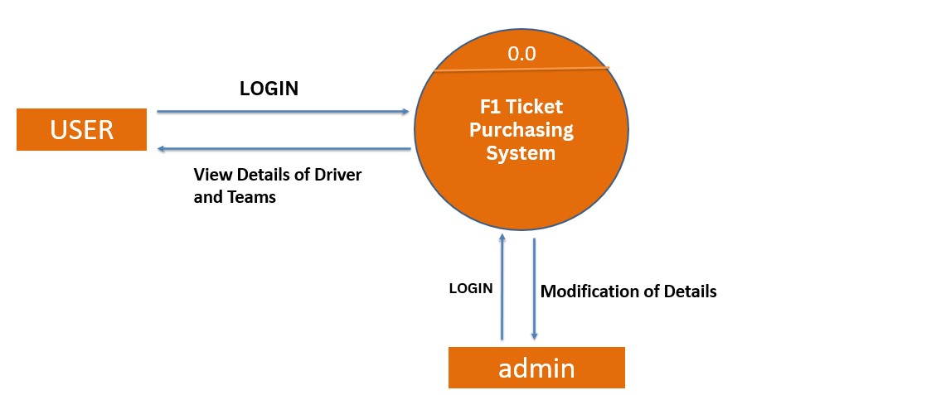

1st level DFD

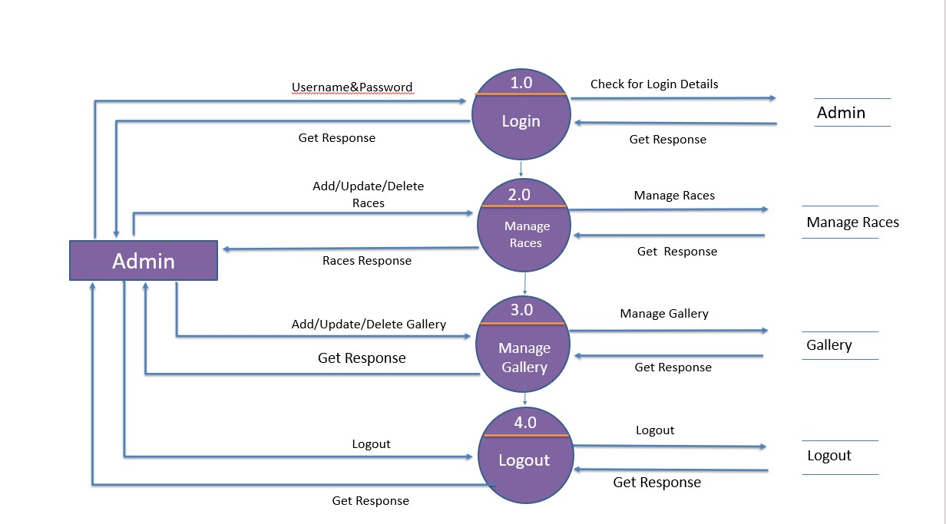

1st level DFD

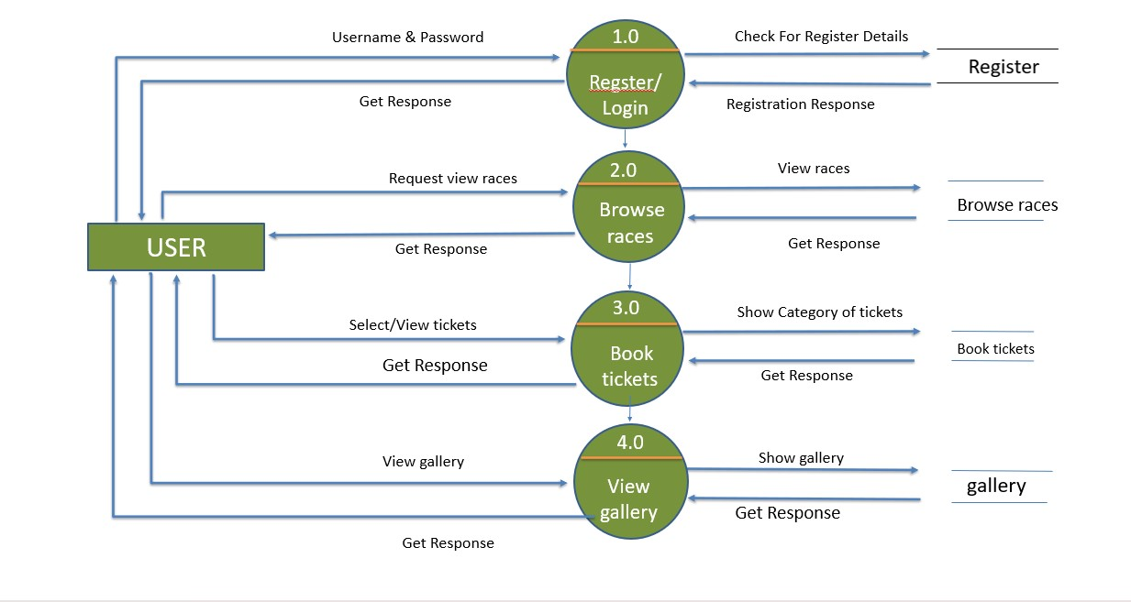

DATA Table DICTIONARY



Database Name : academy.Sql

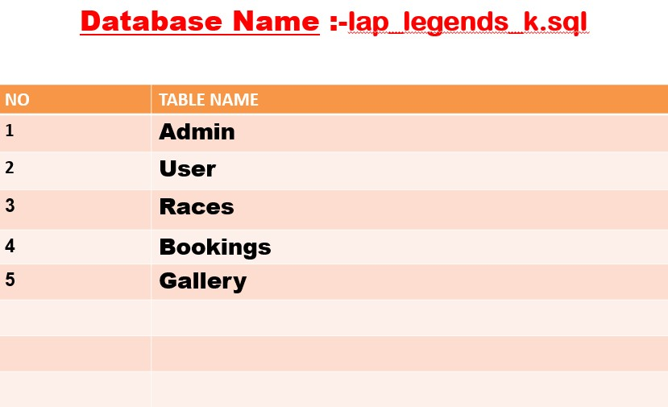

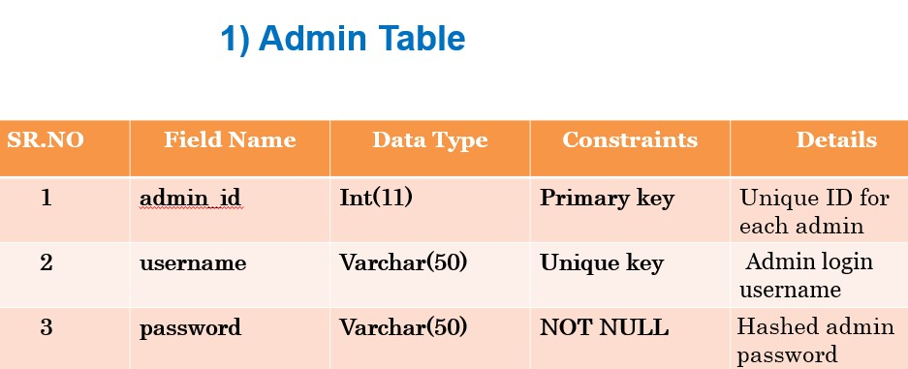

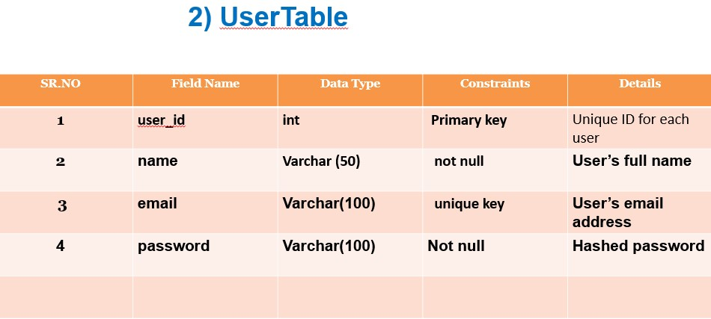

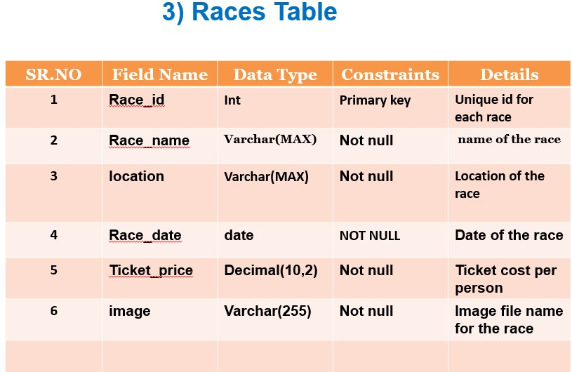

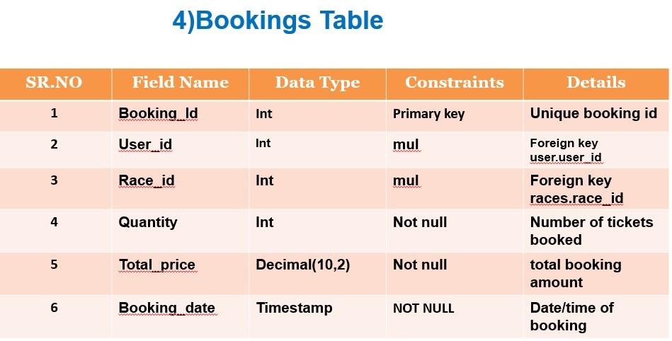

5) Test TABLE

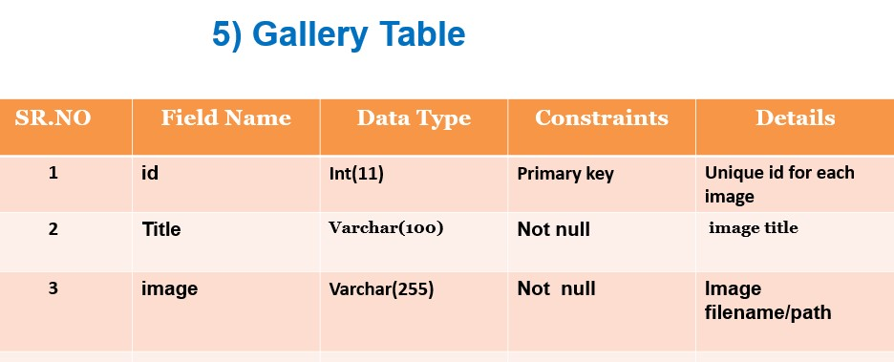

Screenshots

Home Page 1

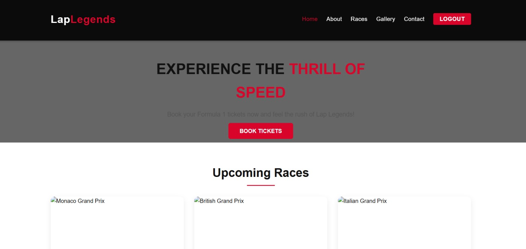

Home Page 2

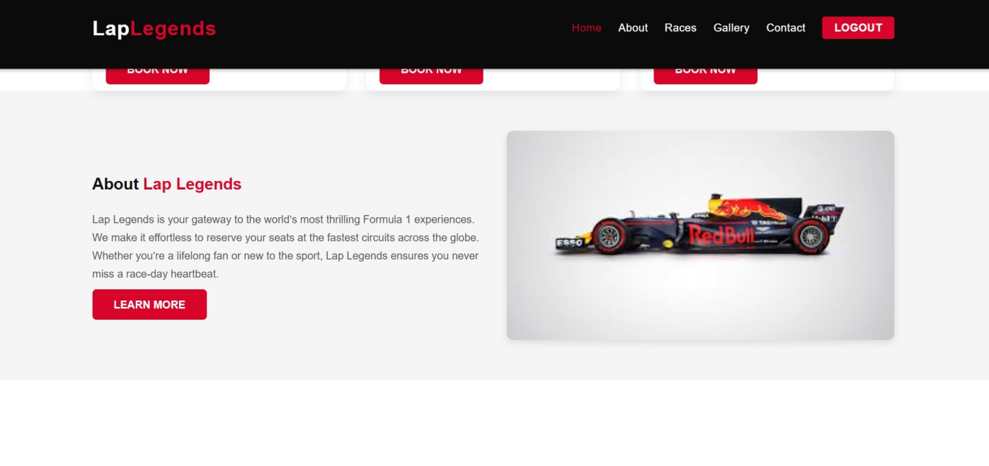

Home Page 3

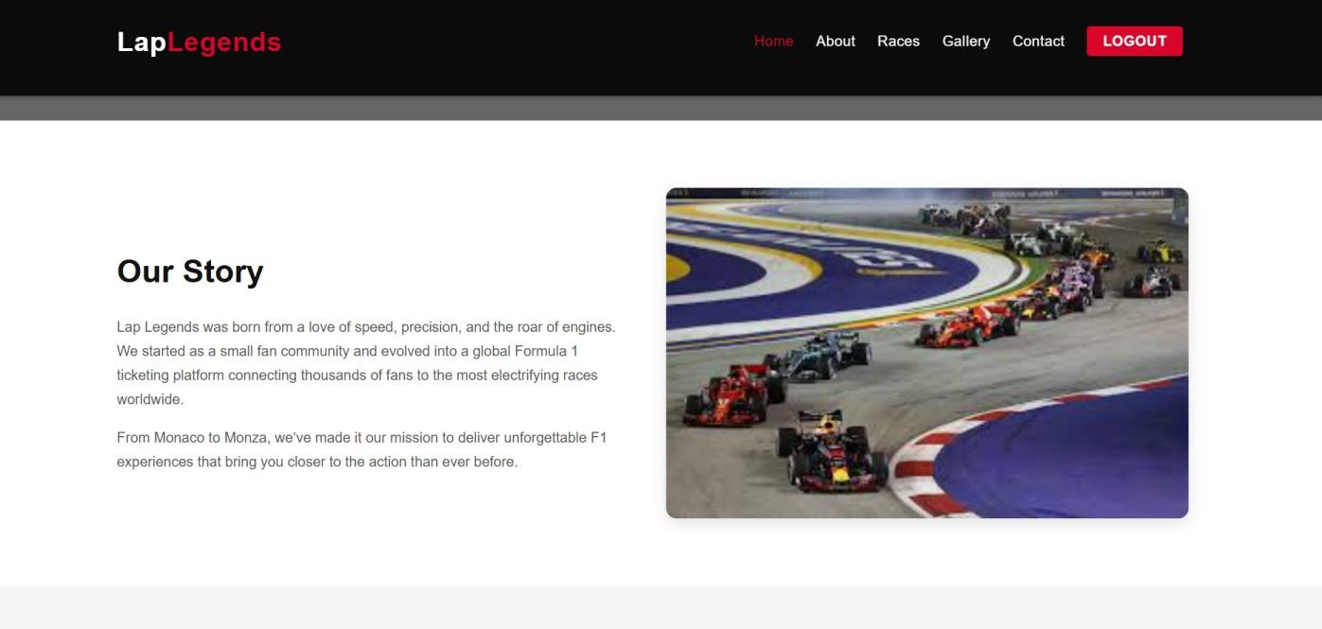

Home Page 4

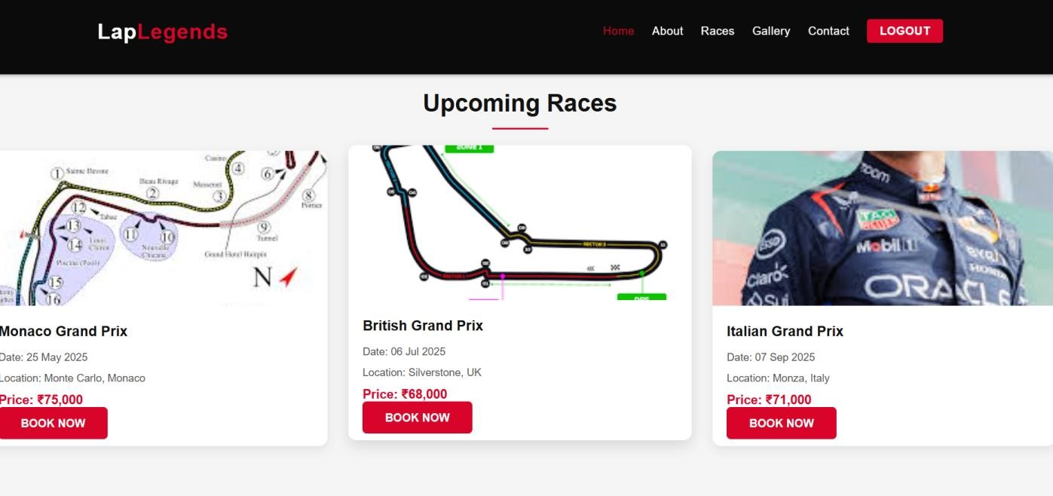

Home Page 5

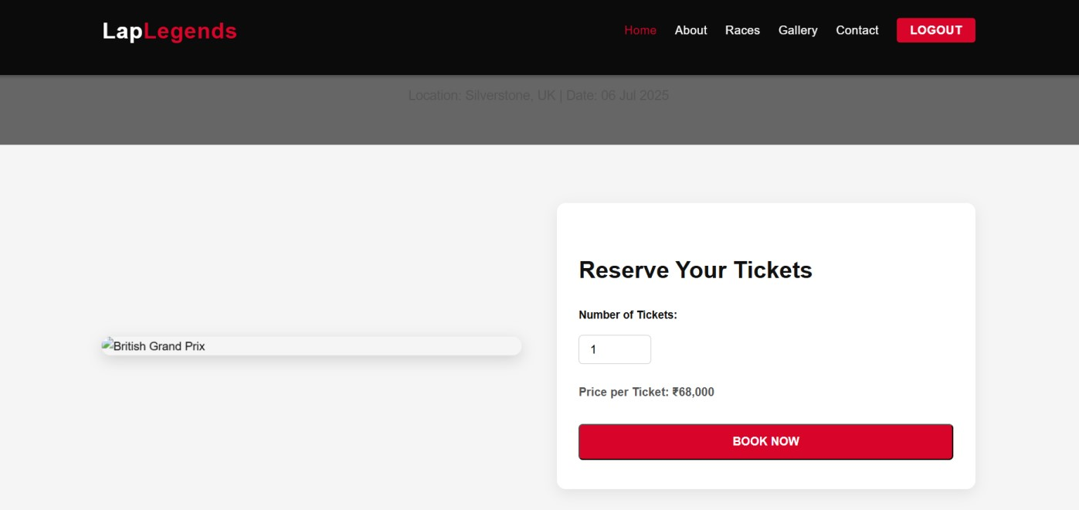

XAMPP DATABASE SCREENSHOT

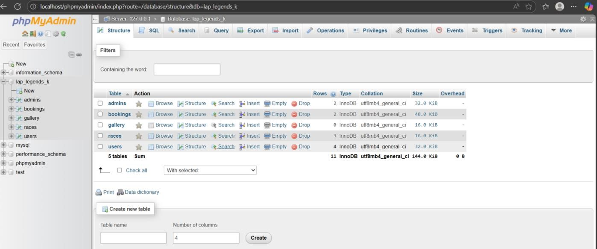

Admin Page

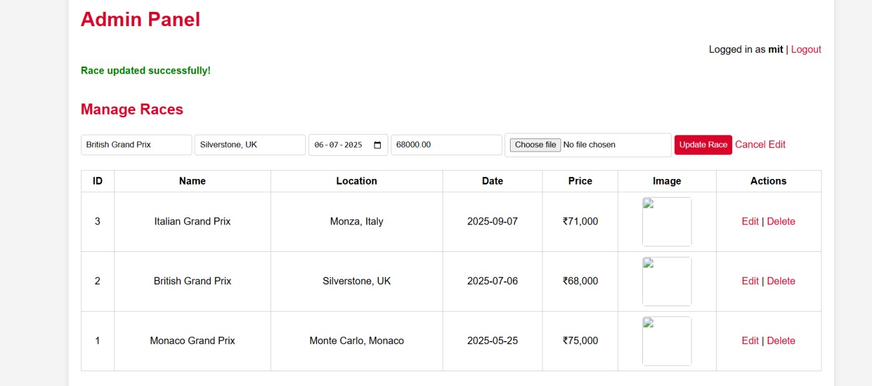

Testing

❖ Software testing

∙ Software testing is the process of evaluation a software item to detect differences between given input and expected output.
∙ Software testing is a process that should be done during the development process.

❖ Verification

∙ Verification is the process to make sure the product satisfies the conditions imposed at the start of the development phase. In other words, to make sure the product behaves the way we want it to.

❖ Validation

∙ Validation is the process to make sure the product satisfies the specified requirements at the end of the development phase. In other words, to make sure the product is built as per customer requirements.
∙
❖ Unit testing

Unit testing focuses verification effort on the smallest unit of software design the software component or module. Using the component-level design description as a guide, important control paths are tested to uncover errors within the boundary of the
module.

Future Enhancement

- AI-Powered Analytics

- Real-Time Collaboration Tools

- User-Friendly Interface and Navigation

Bibliography

❖ Book Reference

I. PHPBible2ndedition
  - Author: Tim Converse, Joyce Park
  - Publisher: John Wiley and Sons

❖ Web Reference

∙ https://www.w3schools.com/php/
∙ https://www.udemy.com/
∙ https://formula1.com/

THANKYOU

