Analyzing Stack Overflow for Online Education Expansion

# Part 1 - the Business Case

## Executive Summary

This project explores the feasibility and strategic potential of Stack Overflow expanding into the online education market. By leveraging insights from the 2024 Stack Overflow Developer Survey, we aim to analyze user engagement, demographic trends, and learning preferences. These insights will guide the development of structured online courses tailored to the needs of Stack Overflow's user base.

Our analysis addresses key stakeholder questions, such as the most in-demand programming languages, platforms, databases, user preferences for online learning methods, and pricing strategies for diverse user segments. By transforming and normalizing the survey data, we will provide actionable recommendations for course design, targeting strategies, and financial planning.

Utilizing Python and MySQL for data preparation and Tableau for visualization, the project will result in a comprehensive database design and interactive dashboards to support decision-making. This initiative aligns with Stack Overflow’s mission to become a holistic learning platform for developers while diversifying its revenue streams.

## Why is this analysis needed?

This analysis is essential because a significant portion of users already rely on Stack Overflow to learn coding skills, yet the platform does not provide structured courses. Expanding into online education will not only meet this demand but also diversify Stack Overflow’s revenue model, currently reliant on advertising. Additionally, offering educational services will strengthen Stack Overflow’s position as a comprehensive learning platform for developers, elevating its market presence.

## What stakeholders want to know?

Stakeholders seek to understand the feasibility and potential impact of expanding Stack Overflow’s services to include online courses. They want insights into user engagement, demographic trends, and the types of courses most likely to attract users, such as programming languages or platform-specific skills. Additionally, they are interested in pricing strategies for different user segments and the projected financial impact of this expansion to inform decisions about its viability and strategic value.

## Proposed Analyses

We will focus on analyzing user engagement, demographics, and learning preferences to assess the feasibility of offering online courses. This includes examining visit frequency, geographic distribution, employment status, and job satisfaction to understand the characteristics and motivations of Stack Overflow users. Additionally, we will explore the most desired programming languages, databases, and platforms to guide course content strategy. These analyses will provide actionable insights to support decisions about course design and potential business expansion.

## Data Sources

[Stack Overflow 2024 Survey Dataset](https://survey.stackoverflow.co/) gives access to a folder containing the survey pdf (2024 Developer Survey.pdf), the responses to the survey (survey_results_public.csv, which is the data we are analyzing), and a description of all the column names (survey_results_schema.csv).

## Database & Tools

*MySQL*: The majority of the ETL work was performed in MySQL. Key tasks included dropping irrelevant columns, replacing "NA" values with NULL for consistency, simplifying categorical values, filtering out rows with excessive missing values to retain 30,000 high-quality rows, and normalizing the data into nine tables to maintain relationships.

*Python*: Python was used to interact with MySQL through SQL-related libraries like Pandas and SQLAlchemy. Python facilitated integration with MySQL and automated repetitive SQL tasks, including one-hot encoding for multi-choice columns and sorting and dropping low-quality respondents’ answers.

*Tableau*: For data visualization, we connected the normalized MySQL database to Tableau for creating graphs. We designed visualizations showcasing user engagement, language preferences, and demographic trends, and delivered insights on the top 5 programming languages, databases, and platforms to guide decision-making for business expansion. Finally, we organized everything into a nice dashboard.

# Part 2 - Data Preparation/Cleaning Steps

**1. Removing Columns that Not Relevant to Analysis (See assumption for more details)**We began by removing 96 columns that were not relevant to our analysis or had similar meaning/purposes. Only 18 columns that are directly useful for providing business insights were retained. This helped streamline our data, allowing us to focus on the variables most pertinent to solving our business problem.

**2. Dropping Rows that Have Too Much Missing Data**The data source for this analysis is derived from survey responses. Given the nature of surveys, many respondents did not complete all questions, resulting in a high number of missing values. To ensure data quality, we removed rows that had excessive missing values, retaining only 30,000 rows that contained enough data for meaningful analysis. This process helps maintain a balance between data quality and data volume.

**3. Replacing All Remaining 'NA' Values**All occurrences of 'NA' were replaced with NULL values to prevent issues during the ETL (Extract, Transform, Load) process. The presence of 'NA' can often lead to errors or inconsistencies during transformations and aggregations. By replacing 'NA' with NULL, we ensured that the data is handled consistently throughout the ETL pipeline.

**4. Handling Multi-Choice Columns with One-Hot Encoding**Certain columns, such as "LanguageWantToWorkWith," "DatabaseWantToWorkWith," and "PlatformWantToWorkWith," allowed respondents to select multiple options. This resulted in messy, comma-separated values that were challenging to work with. To support our business analysis, we extracted the top 5 most frequently mentioned items from each of these columns and created new columns for each. This approach, known as one-hot encoding, allowed us to reorganize the data into a cleaner format, making it easier to analyze. Each newly created column, such as "language_skill_python," represents whether a respondent mentioned a particular item (1 for yes, 0 for no). The same method was applied to the "DatabaseWantToWorkWith" and "PlatformWantToWorkWith" columns.

**5. Cleaning Employment Data**The "employment" column was also a multi-choice question, making the responses complex and inconsistent. Since we were primarily interested in understanding employment status to assess purchasing power, we simplified the values as follows:

* If the response included "Student," it was changed to "Student" (indicating lower disposable income).
* If the response included "Retired," it was changed to "Retired" (indicating higher disposable income).
* If the response included "Not employed, but looking for work" and did not include "Student," it was changed to "Looking for work" (indicating lower disposable income).
* All other responses were categorized as "Employed" (indicating higher disposable income).

**6. Simplifying Learning Methods**The "LearnCode" column was also complex, containing multiple options. Since our goal was to determine how many people prefer online learning methods, we updated the values in this column as follows: If "Online" was mentioned anywhere in the response, the value was set to "Online." Otherwise, it was set to "Not online."

**7. Standardizing Column Names**To ensure consistency and readability, we renamed all column names using the following conventions:

* Removed spaces.
* Converted all names to lowercase.
* Replaced spaces with underscores where needed.

# Part 3 - Database Platform Considerations

We selected MySQL as the database platform for this project due to its robust support for structured and normalized relational databases, which aligns with our analytical needs. MySQL’s ease of integration with tools like Python (via SQLAlchemy) and Tableau allows for seamless ETL workflows and efficient visualization of insights. Its scalability makes it capable of handling the 30,000 cleaned rows while providing reliable performance for complex queries. Additionally, MySQL's indexing capabilities enhance query speed, ensuring timely access to data during analysis. This choice ensures that the database can accommodate future expansion and collaboration effectively, supporting both current project goals and potential future analytical needs.

**Why relational data model?**

We chose a relational data model for this project because the survey data is highly structured with well-defined entities and relationships, such as respondents, their coding experience, and desired skills. The relational model allows us to normalize the data to the 3rd Normal Form (3NF), which helps reduce redundancy and maintain data integrity. This approach ensures the data remains consistent and reliable for analysis.

Relational databases also excel at handling complex queries. They allow us to efficiently execute joins and analytical queries across multiple tables, such as identifying user preferences for programming languages, platforms, and databases. Given the dataset size of 30,000 cleaned rows, MySQL offers the scalability needed to maintain performance while managing this volume of data.

Additionally, MySQL integrates seamlessly with Python using libraries like SQLAlchemy for ETL processes and Tableau for creating dynamic visualizations. The use of Primary Keys (PKs) and Foreign Keys (FKs) enforces data integrity by maintaining consistency and accuracy between related tables. Finally, a relational model is easy to update, maintain, and expand as the dataset evolves, making it a practical and robust choice for this project.

**Why denormalization was not required**

No denormalization was required in the physical model because the dataset size of 30,000 rows did not create any performance issues. The primary focus of the project was on analysis and visualization, tasks that work efficiently with a normalized data structure. Normalization ensured data consistency and minimized redundancy, maintaining data integrity throughout the process. Additionally, the queries needed for analysis were straightforward and performed efficiently within the normalized structure, so there was no need for optimization through denormalization. The existing relational design was sufficient to meet performance and analytical requirements.

# Part 4 - Assumptions About Dataset

1. Assume people don't use Stack Overflow to learn AI (drop all AI relevant attributes).

2. Assume Stack Overflow focuses on language/database/platform that people want to work with (drop attributes of language/database/platform they have known or they admire).

3. Assume Stack Overflow opens classes for everyone on the internet, no membership required (drop SOCommunity attribute).

4. Assume Stack Overflow plans to only open classes for the top 5 most popular languages/databases/platforms among users (clean all other options).

5. Assume Stack Overflow wants to determine the number of users who have the strongest purchase power (set “employed,” “student,” “retired” in “employment”).

6. Assume Stack Overflow wants to determine the number of users who prefer online learning methods (set “online,” “not online” in “learn_code”).

7. Assume the analysis is not focused on any specific region, and all geographic data is treated equally unless otherwise filtered for specific insights.

8. Assume that focusing on the top 5 most popular languages, databases, and platforms captures the majority of user demand and sufficiently informs course content strategy.

9. Assume that the survey responses are representative of the broader Stack Overflow user base and reflect general trends accurately.

10. Assume employment status ("employed," "student," "retired") correlates directly with disposable income and ability to purchase courses.

11. Assume that users who did not participate in the survey have similar preferences and behaviors to those who did, justifying the use of survey data to guide decisions.

12. Assume that transforming multi-choice columns using one-hot encoding (e.g., only top 5 options) does not significantly alter the dataset’s representativeness or conclusions.

13. Assume that respondents who express a preference for "online" learning methods are likely to adopt Stack Overflow’s online courses similarly to how they engage with other platforms.

14. Assume that users identified as having the "strongest purchase power" are not significantly deterred by course pricing within reasonable limits.

15. Assume that removing irrelevant columns (e.g., AI attributes, admired languages) does not omit information critical to achieving project objectives.

# Part 5 - Final EER Diagram & Properly Normalized Data Model

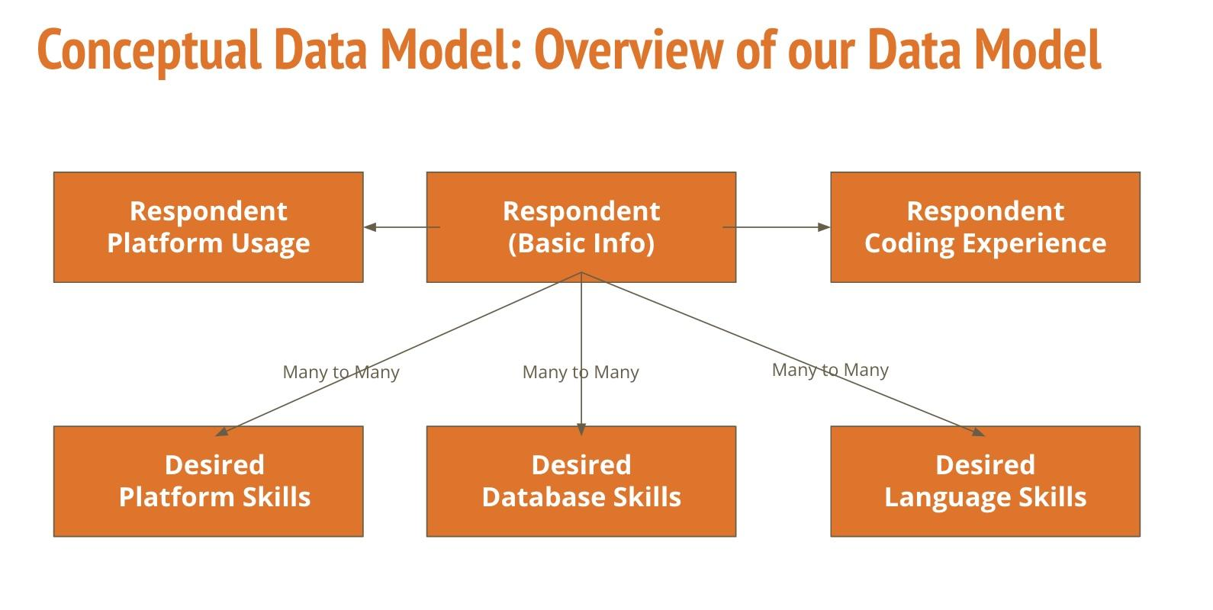

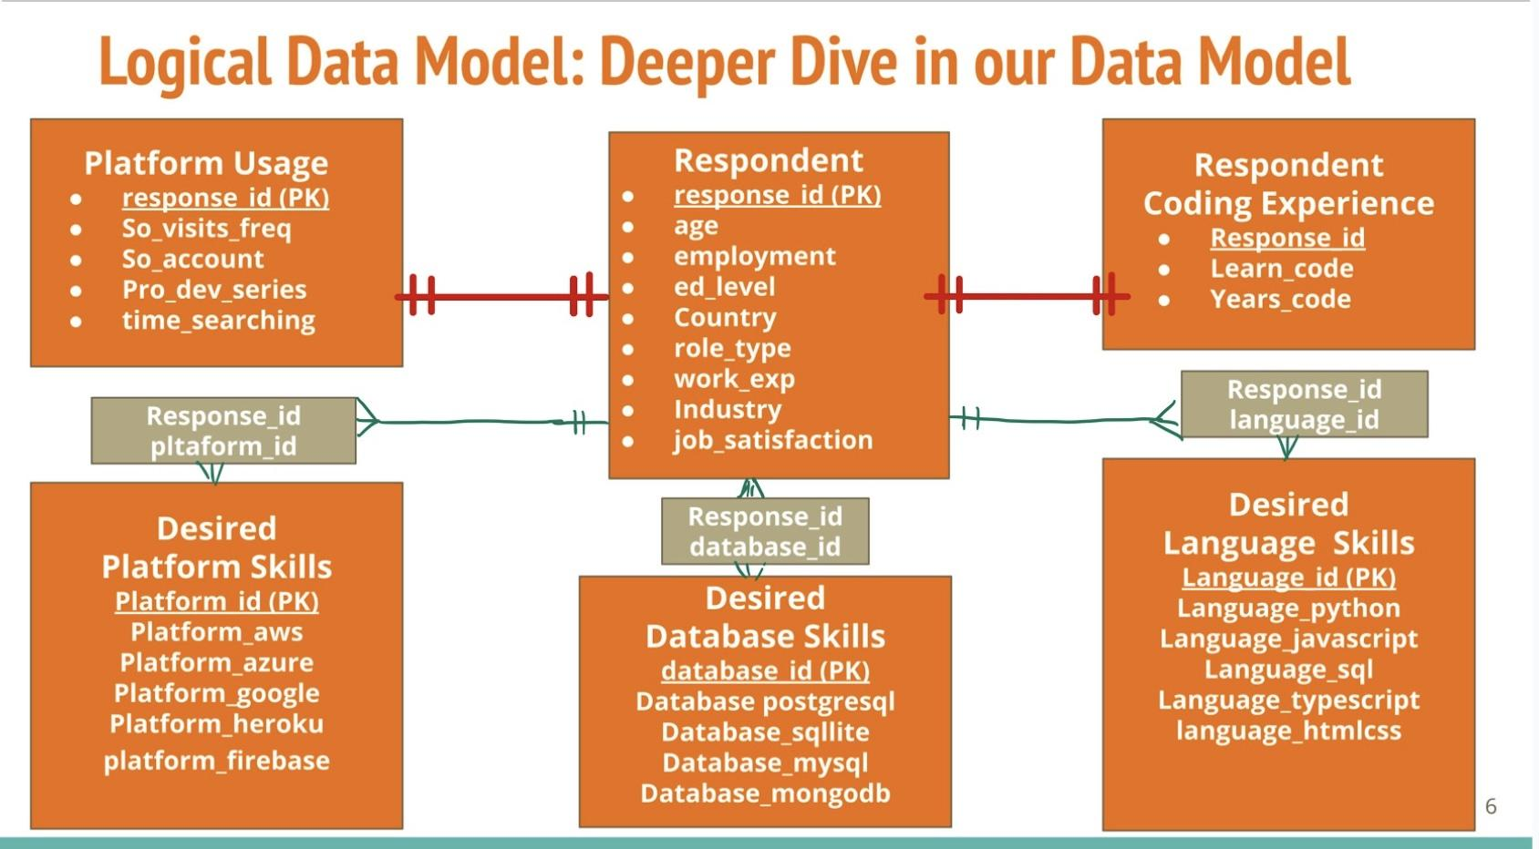

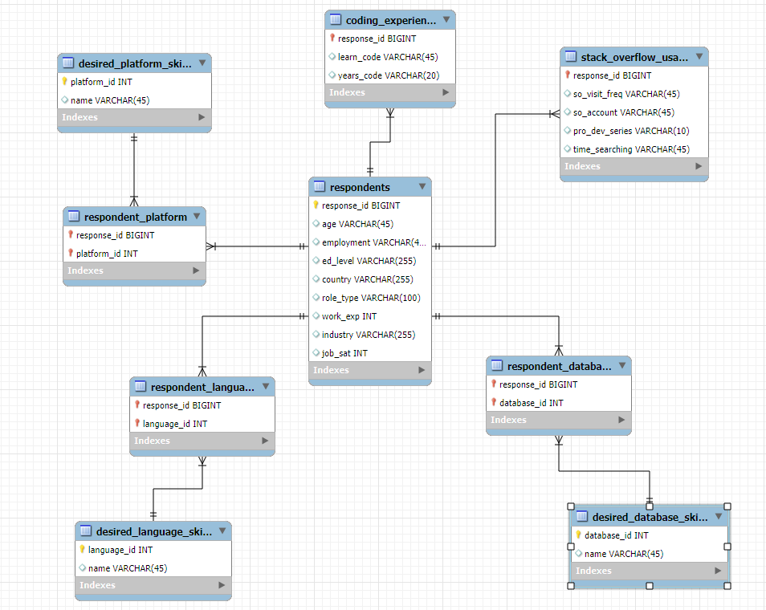

1. **respondents table**

Purpose: Stores primary respondent information, including demographic and employment-related details.

Variables:

response_id (BIGINT): Unique identifier for each respondent (Primary Key).

age (VARCHAR): Respondent's age.

employment (VARCHAR): Respondent's employment status (e.g., employed, student, retired).

ed_level (TEXT): Highest education level attained by the respondent.

country (TEXT): Country of residence.

role_type (VARCHAR): Job role type (e.g., individual contributor or project manager).

work_exp (DOUBLE): Years of work experience in a professional setting.

industry (VARCHAR): Industry in which the respondent works.

job_sat (INT): Level of job satisfaction on a scale or defined metric.

1. **coding_experience table**

Purpose: Captures information about respondents' coding backgrounds and learning experiences.

Variables:

response_id (BIGINT): Unique identifier for each respondent (Primary Key and Foreign Key linking to respondents).

learn_code (VARCHAR): Method used to learn coding (e.g., online or not online).

years_code (VARCHAR): Number of years the respondent has been coding.

1. **stack_overflow_usage table**

Purpose: Tracks respondent activity on Stack Overflow, including engagement levels and behavior.

Variables:

response_id (BIGINT): Unique identifier for each respondent (Primary Key and Foreign Key linking to respondents).

so_visit_freq (VARCHAR): Frequency of visits to Stack Overflow (e.g., daily, weekly).

so_account (VARCHAR): Indicates if the respondent has a Stack Overflow account (e.g., yes or no).

pro_dev_series (VARCHAR): Participation in professional development series or events on Stack Overflow.

time_searching (VARCHAR): Time spent searching for solutions on Stack Overflow.

1. **desired_language_skills table**

Purpose: Details the programming languages respondents are interested in or want to work with.

Variables:

response_id (BIGINT): Unique identifier for each respondent (Primary Key and Foreign Key linking to respondents).

language_python (TINYINT): Binary indicator (1 = yes, 0 = no) for interest in or usage of Python.

language_javascript (TINYINT): Binary indicator for JavaScript.

language_sql (TINYINT): Binary indicator for SQL.

language_typescript (TINYINT): Binary indicator for TypeScript.

language_htmlcss (TINYINT): Binary indicator for HTML/CSS.

1. **respondent_language table**

Purpose: This table links respondents to the programming languages they want to learn, representing a many-to-many relationship.

Variables:

response_id (BIGINT): Composite primary key in this table. Foreign key referencing the primary key of the respondents table.

language_id (INT): Composite primary key in this table. Foreign key referencing the primary key of the desired_language_skills table.

1. **desired_platform_skills table**

Purpose: Captures preferences of cloud platforms which respondents want to learn.

Variables:

response_id (BIGINT): Unique identifier for each respondent (Primary Key and Foreign Key linking to respondents).

platform_aws (TINYINT): Binary indicator (1 = yes, 0 = no) for Amazon Web Services.

platform_azure (TINYINT): Binary indicator for Microsoft Azure.

platform_googlecloud (TINYINT): Binary indicator for Google Cloud.

platform_heroku (TINYINT): Binary indicator for Heroku.

platform_firebase (TINYINT): Binary indicator for Firebase.

1. **respondent_platform skills table**

Purpose: This table connects respondents to the databases they are interested in learning, handling a many-to-many relationship.

Variables:

response_id (BIGINT): Composite primary key in this table.Foreign key referencing the primary key of the respondents table.

platform_id (TINYINT): Composite primary key in this table. Foreign key referencing the primary key of the desired_platform_skills table.

1. **desired_databse_skills table**

Purpose: This table stores information about the databases respondents are interested in learning.

Variables:

database_postgresql (TINYINT): Binary indicator (1 = yes, 0 = no). Indicates interest in PostgreSQL.

database_sqlite (TINYINT) : Binary indicator for SQLite.

database_redis (TINYINT): Binary indicator for Redis.

database_mysql (TINYINT): Binary indicator for MySQL.

database_mongodb (TINYINT): Binary indicator for MongoDB.

database_id (INT): Primary Key (PK) of this table; referenced as a Foreign Key (FK) in respondent_database to link respondents to their database interests.

1. **respondent_database table**

Purpose: This table connects respondents to the databases they are interested in learning, handling a many-to-many relationship.

Variables:

response_id (BIGINT): Composite primary key in this table. Foreign key referencing the primary key of the respondents table.

database_id (TINYINT): Composite primary key in this table.Foreign key referencing the primary key of the desired_database_skills table.

**Key Relationships:**

1. respondents and desired_language_skills:
   * Many-to-Many: A respondent can be interested in many programming languages, and a language can be chosen by many respondents.
   * Bridge Table: respondent_language.
2. respondents and desired_database_skills:
   * Many-to-Many: A respondent can be interested in many databases, and a database can be chosen by many respondents.
   * Bridge Table: respondent_database.
3. respondents and desired_platform_skills:
   * Many-to-Many: A respondent can be interested in many cloud platforms, and a platform can be chosen by many respondents.
   * Bridge Table: respondent_platform.
4. respondents and coding_experience:
   * One-to-One: Each respondent has one record in the coding_experience table, representing their learning methods and years of coding experience.
5. respondents and stack_overflow_usage:
   * One-to-One: Each respondent has one record in the stack_overflow_usage table, which tracks their usage habits on the platform.

# Part 6 - Automation Methodology

The ETL process was automated using Python scripts, which handled data extraction, cleaning, normalization, and loading into MySQL. The scripts also managed one-hot encoding for multi-choice fields, reducing the need for manual intervention. A live connection in Tableau was established to the MySQL database, allowing dashboards to display real-time data without the need for manual updates. For future improvements, using Apache Airflow or cron jobs is recommended to schedule the ETL pipeline, such as running it yearly for new survey data. This would ensure the database is automatically updated with new data. Automation reduces manual effort, minimizes errors, and ensures the pipeline is scalable, reproducible, and capable of providing real-time insights through Tableau’s live connection.

# Part 7 - Insights/Graphs

**High Engagement Highlights Opportunity for Learning Resources**

The data shows that most users visit Stack Overflow daily or weekly, reflecting a high level of consistent engagement with the platform. This frequent usage indicates that users rely on Stack Overflow as a regular resource for their development needs. By integrating educational content such as courses or tutorials directly into the platform, Stack Overflow can capitalize on this engagement. Providing seamless access to learning resources within a platform that users already visit frequently can enhance user satisfaction, encourage longer sessions, and improve overall retention rates.

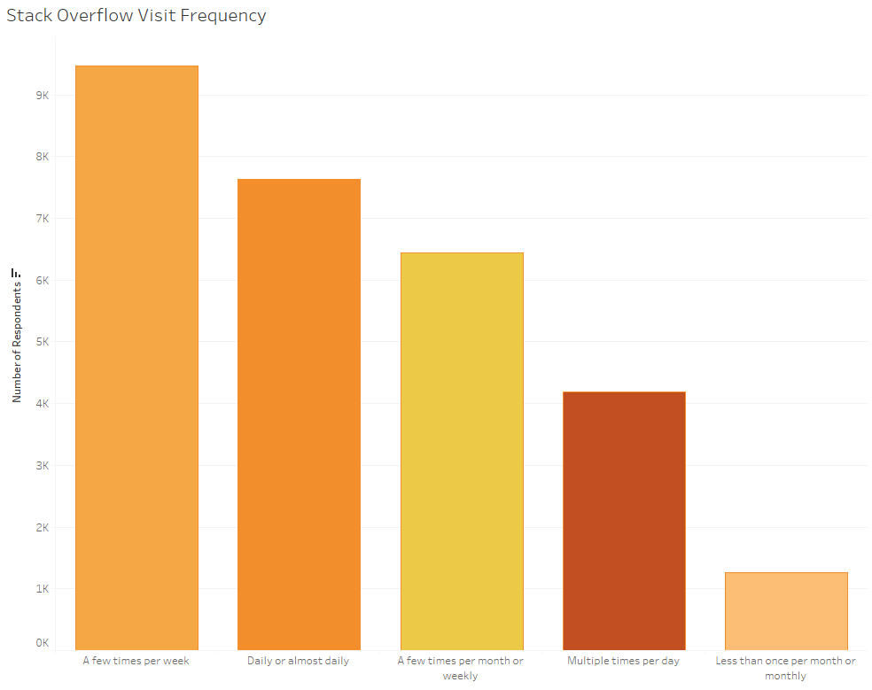

**Recommended Initial Focus for Educational Content**

The analysis suggests that the potential languages taught should start with Python, SQL, and JavaScript, as these are among the most in-demand skills. For databases, the primary focus should be on PostgreSQL, reflecting its popularity and relevance in the developer community. For platforms, courses should prioritize AWS (Amazon Web Services), which is widely used and highly sought after for cloud development. By offering courses in these key areas, Stack Overflow can effectively meet the needs of its user base and align with current industry trends.

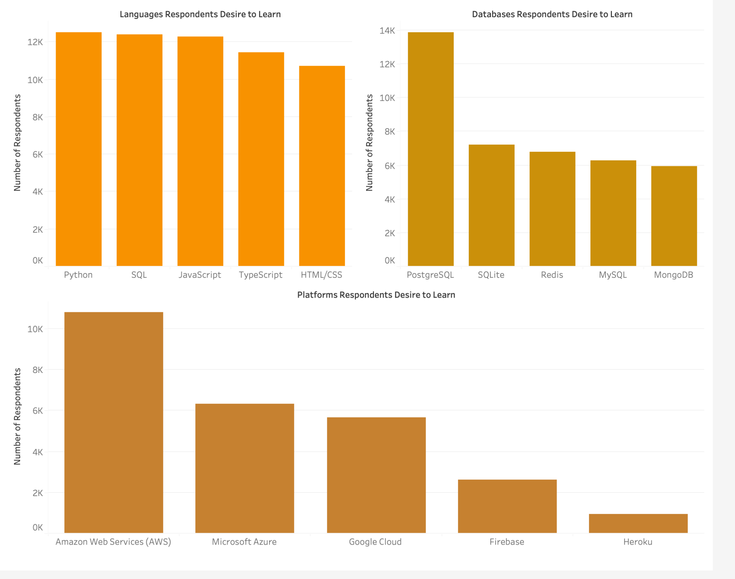

**Target Audience: Experienced Coders Seeking Career Development**

The majority of users have been coding for more than 2 years, and most hold a Bachelor’s degree. This demographic represents a key target audience of experienced coders who are likely seeking opportunities to advance their careers. To meet their needs, the focus should be on offering **intermediate-level courses** that provide skill advancement and support professional growth. These courses can cover in-depth technical topics and practical skills that help developers stay competitive and progress in their careers.

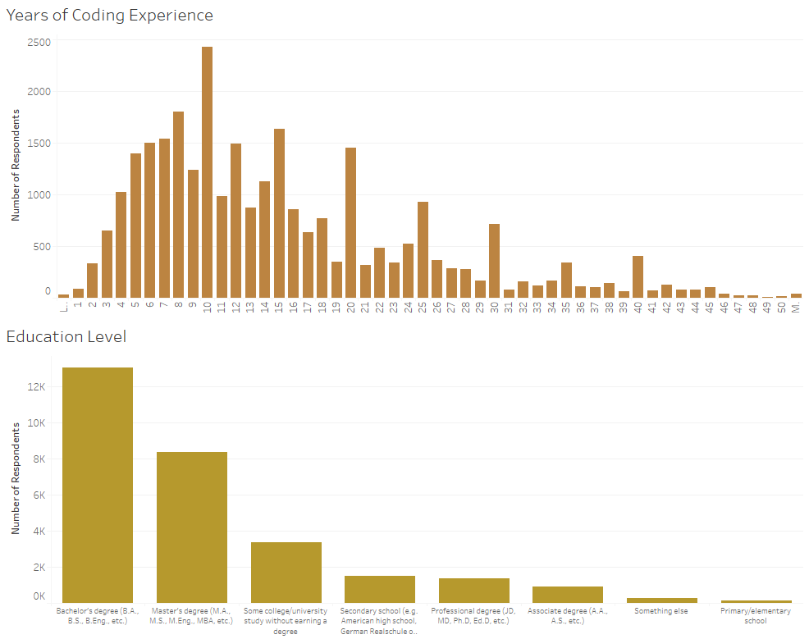

**Meeting the Needs of Tech Professionals Through Advanced Courses**

A large percentage of users work in software development, IT, and other tech-related industries. The data also shows that many users are satisfied with their jobs, suggesting they are invested in their professional growth. This indicates a strong demand for **continued learning** and **skill enhancement**. Offering advanced technical courses specifically tailored to the needs of these industries can fulfill this demand, helping users deepen their expertise. Providing such courses can drive engagement by supporting career progression and maintaining Stack Overflow’s relevance as a valuable resource for developers.

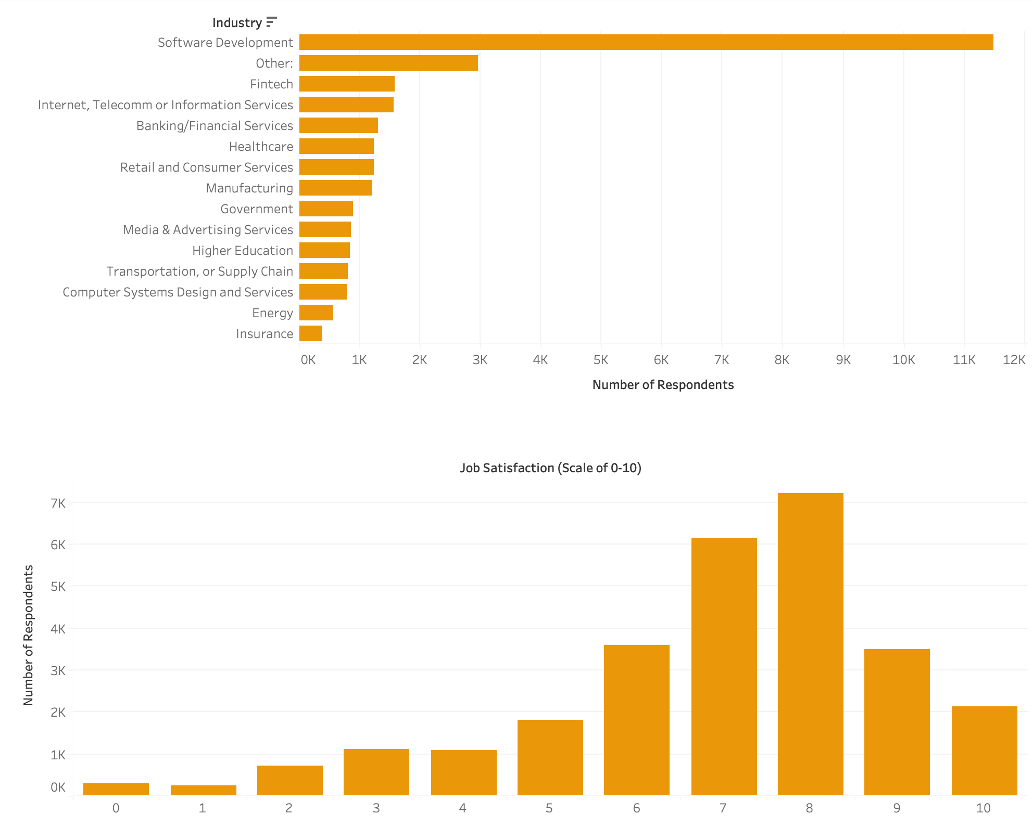

**Global Distribution: Focus on North American Audience**

The data shows that a significant portion of respondents are from **North America**, indicating that this region forms a major part of Stack Overflow's user base. To maximize impact, initial educational content offerings should cater to this audience by aligning with **North American time zones** and using **English** as the primary language. This approach ensures accessibility and relevance for the largest user segment, enhancing engagement and adoption of the educational resources.

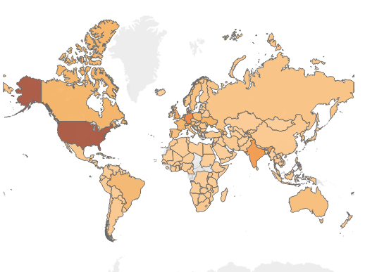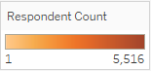

**Final Dashboard: Comprehensive Insights**

Our final dashboard combines all key graphs to deliver a holistic view of Stack Overflow's user base. It highlights user engagement frequency, preferred learning methods, demographics, global distribution, and educational background. These insights reveal a consistent need for online learning resources, a large segment of experienced developers, and a significant North American user base. This dashboard serves as a powerful tool for guiding decisions on course offerings, target audiences, and content strategies.

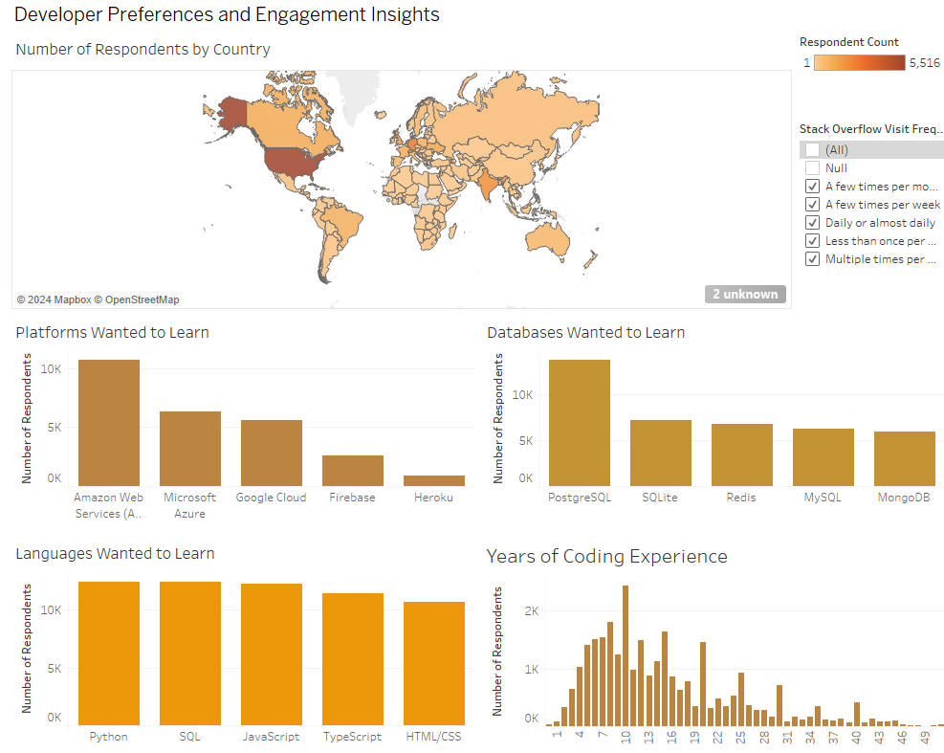

# 

# Part 8 - Final Notes: Lessons Learned and Future Suggestions

While we have developed a robust data pipeline for this analysis, there are always improvements that can be made. We have listed some of our suggestions for future iterations below:

1. Load the entire original dataset into MySQL to avoid issues and simplify the ETL process compared to loading separate normalized datasets.
2. Include separate SQL scripts within one master Python script to streamline automation and improve file management.
3. When handling a complex dataset, performing feature engineering tasks such as one-hot encoding and grouping categories will simplify dataset values and make analysis easier.
4. Host the database online to ensure consistency across all machines and enable real-time collaboration, eliminating local dependency issues.
5. Automate the data pipeline with Apache Airflow or cron jobs to schedule ETL tasks, ensuring the next year’s survey data is automatically processed and loaded into the database.
6. Maintain a history table or versioned database schema to store previous years' survey data for trend analysis. Incorporate monitoring tools to track pipeline performance, log errors, monitor CPU usage, and quickly identify bottlenecks to ensure smooth and efficient operations.

# Conclusion

This project explored Stack Overflow's potential to expand into the online education market by leveraging insights from its 2024 Developer Survey dataset. We implemented a robust data pipeline to extract, clean, and transform the survey data, ensuring consistency and integrity through normalization in MySQL. The database design consisted of six interrelated tables, optimized with bridge tables to manage many-to-many relationships effectively. Python scripts automated the ETL process, handling tasks such as data cleaning, normalization, and one-hot encoding for multi-choice responses. The use of a live connection in Tableau allowed for real-time visualization of key metrics, including user engagement frequency, learning preferences, demographics, and global distribution.

These visualizations revealed that most users engage with Stack Overflow daily or weekly, prefer online learning methods, and fall into the 25-34 age group with a background in software development and IT. The data highlighted high-demand skills like Python, SQL, JavaScript, PostgreSQL, and AWS, presenting clear opportunities for targeted course offerings. Automating the pipeline with tools like Apache Airflow or cron jobs ensures scalability and reproducibility, while hosting the database online enables real-time collaboration and consistency across systems.

By combining rigorous data engineering, automation, and visualization, this project delivers a scalable, data-driven approach that can guide Stack Overflow’s strategic expansion into online education, ultimately enhancing user engagement and diversifying revenue streams.