Dayton Home Repair Network

Home Repair, Weatherization, & ARPA Program Screening

ARPA information is highlighted in pink.

All program information is highlighted in green.

**Basic Resident Information:**

**Name:**

**Address:**

**Neighborhood:**

**Check on google maps:** [**google maps**](https://www.google.com/maps/@39.7644784,-84.1994791,14z?entry=ttu)

*\*residents are only eligible for ARPA funding if they live in one of the following neighborhoods*

*(see the ARPA street list and map to verify if their address is in one of these neighborhoods.)*

1. *Old North Dayton*
2. *5 Oaks*
3. *Wolf Creek*
4. *Carillon*
5. *Edgemont*
6. *Miami Chapel*

**County:**

***\*****Program County Requirements:*

*County Corp and Rebuilding Together Dayton–Montgomery ONLY*

*Habitat for Humanity–Clark, Greene, Montgomery*

*MVCAP–Montgomery, Mercer, Auglaize, Darke, Miami, Preble, Greene, Butler, Warren*

**Is the resident in either of the following special projects? (highlight or circle)**

Twin Towers / ARPA / Northwest Dayton Cooridor

**Preferred Method of Contact**

* Call

Phone number:

* Text
* Email

Email:

**How did they hear about us? (highlight or circle)**

Friend referral / Flyer / Neighborhood association / Website / Other: ___________________

**screening created by**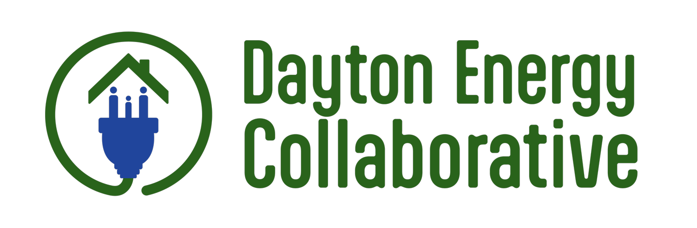

**Home Repair Program Screening:**

1. What are your top repair needs for your house? ____________________________________________________________________________________________________________________________________________________________
2. Do you own your home? *\*must be homeowner occupied*
   * Yes
   * No

*\*renters are only eligible to apply for MVCAP’s weatherization program*

1. Is your home a single family home?

*\*must be a single family home to be eligible for home repair programs. MVCAP weatherization is the only program that can work on multifamily structures.*

*\*\*If they are in an ARPA neighborhood, duplexes MIGHT BE ABLE to be worked on, but it will be case by case.*

* + Single family
  + Duplex
  + Other

1. Are you the homeowner listed on the deed? Is anyone else’s name listed on the deed? If so, who? If you are *not* the legal homeowner, what is the name of the homeowner on the deed? (verify deed: <https://www.mcrealestate.org/search/commonsearch.aspx?mode=address>)

*\*applicant must have name on the deed to be eligible*

* + Yes

Others Listed on the deed: __________________

*\*every other person on the deed must sign off on the applications*

* + No

Homeowner Name: __________________ Relationship to the resident: _____________

1. Are you up to date on your property taxes or on a payment plan?

*\*must be in good standing OR on a payment plan to be eligible*

* + Yes
  + No
  + Payment plan

*\*if on a payment plan, they need to show proof of the plan and receipts from their last 3 payments*

1. How many years have you lived there? *\*must have lived in home for >1 year to be eligible*

____ years

***VERIFY ARPA ELIGIBILITY: Resident is eligible if they…***

* ***live in one of the 6 neighborhoods listed on page 1***
* ***have answered “yes” to questions 2-5***
* ***have lived in their house for over 1 year***

***→ continue with the screening to determine if the resident is eligible for any additional programs.***

1. Do you have homeowners insurance? *\*County Corp and Habitat for Humanity require insurance*
   * Yes
   * No
2. Are you 60 years or older? *\*if so, eligible for Rebuilding Together’s regular program and may be prioritized for other programs*
   * Yes
   * No
3. Have you ever applied for and received help from any of these programs (County Corp, Habitat for Humanity, Miami Valley Community Action Partnership, Rebuilding Together Dayton)? If so, how long ago? *\*ineligible if received help within the last 2 years **ineligible for MVCAP weatherization if their house has EVER been weatherized by that program*
   * Yes

If yes, how many years ago? _____

* + No

1. Do you have CenterPoint as your natural gas supplier? *\*if so, eligible for MVCAP’s Centerpoint weatherization program*
   * Yes
   * No
2. What is the total number of people in your household?

_______ total

1. What is an estimate of your total household monthly income? (anyone over the age of 18 in the house who has income counts towards this total)

*\*resident is eligible for ALL programs if income is below 200% FPL*

*\*\*if resident is ABOVE 200%, look at the list of programs and their income requirements below and check the chart on pg. 4 to determine eligibility for the remaining programs.*

**Income: _____________**

| **Persons in Household** | **2023 200% FPL** |
| --- | --- |
| 1 | $29,160 |
| 2 | $39,440 |
| 3 | $49,720 |
| 4 | $60,000 |
| 5 | $70,280 |
| 6 | $80,560 |
| 7 | $90,840 |
| 8 | $101,120 |

**Full Income Limits Chart:**

| **Household Size** | **300% FPL** | **200% FPL** | **175% FPL** | **80% AMI 2023** | **60% AMI** | **50% AMI** |
| --- | --- | --- | --- | --- | --- | --- |
| 1 | $43,740 | **$29,160** | $25,515 | $49,850 | $38,850 | $31,150 |
| 2 | $59,160 | **$39,440** | $34,510 | $57,000 | $44,400 | $35,600 |
| 3 | $74,580 | **$49,720** | $43,505 | $64,100 | $49,950 | $40,050 |
| 4 | $90,000 | **$60,000** | $52,500 | $71,200 | $55,450 | $44,500 |
| 5 | $105,420 | **$70,280** | $61,495 | $76,900 | $59,900 | $48,100 |
| 6 | $120,840 | **$80,560** | $70,490 | $82,600 | $64,350 | $51,650 |
| 7 | $136,260 | **$90,840** | $79,485 | $88,300 | $68,800 | $55,200 |
| 8 | $151,680 | **$101,120** | $88,480 | $94,000 | $73,200 | $58,750 |

**Eligible Program(s):**

* Miami Valley Community Action Partnership Weatherization - **the CenterPoint program starts at 300% Federal Poverty Level (FPL). All other weatherization funding is for households at or below 200% FPL.**
* Habitat for Humanity Emergency Home Repair - **60% Area Median Income (AMI)**

\**must have homeowners insurance*

* County Corp Home Repair - **80% and 50% Area Median Income (2 programs)**

*\*must have homeowners insurance*

* Miami Valley Community Action Partnership Emergency Home Repair - **200% Federal Poverty Level**
* Rebuilding Together Dayton - **below 200% Federal Poverty Level**

*\*must be 60 years or older*

* Habitat for Humanity ARPA program (needs a new roof) - see ARPA requirements
* Rebuilding Together Dayton ARPA program

**What did you do? (mail, email, drop off, scheduled an appointment, will reach back out once they have more information, etc.)**