A MAJOR PROJECT REPORT ON

**DECENTRALIZED LAND OWNERSHIP SYSTEM USING BLOCKCHAIN**

SUBMITTED BY:

**Dipen Raut [21070510]**

**Isha Kandel [21070514]**

**Kshitiz Gupta [21070516]**

**Utsab Wagle [21070545]**

A MAJOR PROJECT REPORT FOR PARTIAL FULFILLMENT OF THE REQUIREMENT OF BACHELOR OF COMPUTER ENGINEERING

(8th SEMESTER)

**Course Code: [CMP-490]**

SUBMITTED TO:

**Department of Computer Engineering**

**United Technical College**

**(Affiliated to Pokhara University)**

Bharatpur – 11, Bhojad, Chitwan

July 2025

Final-Year Project Report for the Degree of

Bachelor of Computer Engineering

**Decentralized Land Ownership System Using Blockchain**

**Supervised by: Er. Mod Nath Acharya**

A final-year project report submitted in partial fulfilment of the

requirements for the

degree of Bachelor of Computer Engineering.

**Submitted by:**

**Dipen Raut [21070510]**

**Isha Kandel [21070514]**

**Kshitiz Gupta [21070516]**

**Utsab Wagle [21070545]**

**United Technical College**

**Faculty of Science and Technology**

**Affiliated to Pokhara University, Nepal**

**July 2025**

# Dedication

This project is dedicated to all those who journey along the roads daily, facing challenges and overcoming obstacles. We extend our deepest gratitude to the teacher whose invaluable guidance shaped this endeavour and to our department for assigning a supervisor who provided unwavering support and encouragement throughout the project. We also acknowledge the efforts of all individuals who have contributed tirelessly to support and guide us in bringing this project to fruition. This work stands as a testament to your collective dedication and a commitment to ensuring a safer and more efficient path forward.

# Declaration

We hereby affirm that this research study, titled **"Decentralized Land Ownership System Using Blockchain**" represents the culmination of our original work. Any relevant prior research conducted by other scholars has been duly acknowledged.

We assume full responsibility for the precision and authenticity of all data and information contained within this study.

Name of the Students:

Dipen Raut

Isha Kandel

Kshitiz Gupta

Utsab Wagle

Date: July 2025

# Recommendation

This is to certify that the project work titled “**Decentralized Land Ownership System Using Blockchain**” prepared and submitted by **Dipen Raut, Isha Kandel, Kshitiz Gupta, and Utsab Wagle** in partial fulfilment of the requirements for the degree of Bachelor of Engineering (BE) in Computer Science, awarded by Pokhara University, has been conducted under the supervision of Er. Mod Nath Acharya.

We recommend the acceptance of this project by Pokhara University based on its comprehensive research, innovative approach, and successful execution.

Signature: ____________________

Name of the Supervisor: Er. Mod Nath Acharya

Designation: Lecturer

Organization: United Technical College

Date: July 2025

# Departmental Acceptance

The project entitled “**Decentralized Land Ownership System Using Blockchain**” submitted by **Dipen Raut, Isha Kandel, Kshitiz Gupta, and Utsab Wagle** for the award of the degree in Bachelor of Computer Engineering has been accepted as benefice record of work independently carried out by them in department.

Signature: _____________________

Er. Sahit Baral

Head of Computer, IT, and Electrical & Electronics Engineering

# Certificate of Approval

This project entitled “**Decentralized Land Ownership System Using Blockchain**” was prepared and submitted by **Dipen Raut, Isha Kandel, Kshitiz Gupta, and Utsab Wagle** have been examined by us and are accepted for the award of the degree of Bachelor of Engineering in Computer by Pokhara University.

Name of the External: Navin Kumar Shrestha

Designation: Assistant Director

Organization: Boston International College

Signature: __________________

Name of the Supervisor: Er. Mod Nath Acharya

Organization: United Technical College

Signature: __________________

Name of Principal: Prof. Madhav Prasad Koirala (Ph.D.)

Organization: United Technical College

Signature: __________________

Date: July 2025

# Acknowledgement

We would like to express our heartfelt gratitude to all those who have contributed to the successful completion of this project.

First and foremost, we are deeply thankful to our project advisor, Er. Mod Nath Acharya for their unwavering guidance, invaluable insights, and constant encouragement throughout this journey. Their expertise and mentorship played a pivotal role in shaping the direction and quality of this project.

We extend our appreciation to the faculty members of the United Technical College Department of Computer Engineering for their dedication to imparting knowledge and for providing us with a conductive learning environment.

We are also indebted to our teammates who worked tirelessly, sharing their knowledge and experiences. Our collaborative efforts were instrumental in achieving the project’s goals.

We extend our gratitude to our family for their unwavering support and understanding during the demanding phases of this project.

Lastly, we would like to express our thanks to all the resources, books, and online materials that were instrumental in enhancing our understanding and knowledge in the field of computer engineering.

This project would not have been possible without the collective efforts and support of all these individuals and resources. We are truly grateful for their contributions.

DLOSUB

United Technical College

July 2025

# ABSTRACT

The Decentralized Land Ownership System Using Blockchain (DLOSUB) outlines the development of a decentralized land ownership management system utilizing blockchain technology to address the significant challenges faced by traditional land registration systems. Current systems are often plagued by issues such as fraud, inefficiencies, lack of transparency, and high transaction costs, which undermine trust and accessibility for individuals, particularly marginalized communities. By leveraging blockchain's inherent characteristics such as security, transparency, and immutability, this project aims to create a tamper-proof digital ledger for land ownership records, streamline transaction processes through smart contracts, and enhance user accessibility without the need for intermediaries. The proposed system will integrate existing land records, ensure secure ownership verification and reduce fraudulent claims. Through pilot testing and stakeholder engagement, the project seeks to evaluate its effectiveness in improving land management practices. Ultimately, this initiative aspires to empower individuals with secure proof of ownership, foster trust among stakeholders, and promote equitable access to land resources, contributing to social stability and economic growth. The successful implementation of this decentralized framework will serve as a model for future innovations in land management, addressing the growing global demand for secure land tenure.

**Keywords:***Decentralized Land Ownership System Using Blockchain, Land Registry, Smart Contracts, Tamper-proof Records, Transparency, Ownership Verification, Fraud Prevention, User Accessibility, Secure Transactions.*

**TABLE OF CONTENTS**

Dedication iii

Declaration iv

Recommendation v

Departmental Acceptance vi

Certificate of Approval vii

Acknowledgement viii

ABSTRACT ix

LIST OF FIGURES xii

LIST OF TABLES xiii

Acronyms and Abbreviation xiv

Chapter 1: Introduction 1

1.1 Background 1

1.2 Problem Statement 2

1.3 Objectives 3

1.4 Motivation and Significance 3

1.5 Scope and Limitations of the Work 3

1.6 Feasibility Analysis 4

1.6.1 Technical Feasibility 5

1.6.2 Economic Feasibility 5

1.6.3 Operational Feasibility 5

Chapter 2: Related Works 6

2.1 Overview of Existing System 6

2.2 Comparison of Features 7

2.3 Gaps in Existing System 7

2.4 Significance of Proposed Work 8

Chapter 3: Methodology 9

3.1 Development Process 9

3.2 Requirements Gathering 10

3.3 System Design 13

3.3.1 Use Case Diagram 14

3.4 Technology Stack 15

3.5 System Architecture 18

3.6 Testing and Maintenance 18

Chapter 4: Result and Discussions 21

4.1 Output 21

4.2 Web Development 21

4.2.1 Frontend 21

4.2.2 Backend 26

4.3 Future Enhancements 27

4.4 Issues Encountered 28

Chapter 5: Conclusion 29

REFERENCES 30

Appendices 32

Appendix A: Gantt Chart 32

Appendix B: Cost Estimation 32

# LIST OF FIGURES

Figure 3.1.1 Agile Development Approach (Group Study, 2025) 9

Figure 3.3.1 System Flow Diagram (Group Study, 2025) 13

Figure 3.3.2 Use Case Diagram (Group Study, 2025) 14

Figure 3.5.1 System Architecture (Group Study, 2025) 18

Figure 4.2.1 Landing Page (Group Study, 2025) 22

Figure 4.2.2 Contact Page (Group Study, 2025) 22

Figure 4.2.3 Lands For Sale Page (Group Study, 2025) 23

Figure 4.2.4 Ownership Page (Group Study, 2025) 23

Figure 4.2.5 Land Transfer Approval Page (Group Study, 2025) 24

Figure 4.2.6 Admin Dashboard Page (Group Study, 2025) 24

Figure 4.2.7 Registered Land Page (Group Study, 2025) 25

Figure 4.2.8 Land Record History (Group Study, 2025) 25

Figure 4.2.9 Local Transactions (Group Study, 2025) 26

Figure 4.2.10 Events In The System (Group Study, 2025) 27

Figure 4.2.11 Blocks Mined Into The Chain (Group Study, 2025) 27

# LIST OF TABLES

Table 1: Gantt Chart of Project.……………………………………………………………29

Table 2: Cost Estimation...………………………………………………………………....30

# Acronyms and Abbreviation

|  |  |
| --- | --- |
| ACL | Access Control List |
| CSS | Cascading Style Sheet |
| DApp | Decentralized Application |
| DLOSUB | Decentralized Land Ownership System Using Blockchain |
| EVM | Ethereum Virtual Machine |
| HTML | Hypertext Markup Language |
| HTTP | Hypertext Transfer Protocol |
| IPFS | InterPlanetary File System |
| JS | JavaScript |
| MySQL | My Structured Query Language |
| NPM | Node Package Manager |
| OECD | Organisation for Economic Co-operation and Development |
| QR Code | Quick Response Code |
| RDBMS | Relational Database Management System |
| RFID | Radio-Frequency Identification |
| SaaS | Software as a Service |
| VS Code | Visual Studio Code |

# Chapter 1: Introduction

## 1.1 Background

Land ownership is a critical asset for individuals and communities, serving as a foundation for economic stability and social development. However, traditional land registry systems, often paper-based or centralized, face numerous challenges, including fraud, incomplete records, and inefficiencies in ownership transfers. These shortcomings lead to disputes, lengthy litigation, and significant economic loss [1]​​.

The field of land ownership management is undergoing a significant transformation, driven by advancements in technology, particularly blockchain. Recent developments have highlighted the potential of decentralized systems to enhance the security, transparency, and efficiency of land registration processes. Countries such as Sweden, Georgia, and India have initiated pilot projects that leverage blockchain technology to create tamper-proof land registries. These projects aim to eliminate the inefficiencies associated with traditional paper-based systems, which are often plagued by issues such as fraud, bureaucratic delays, and lack of accessibility. By utilizing blockchain, these initiatives provide a secure digital ledger that records all transactions related to land ownership, ensuring that each transfer is verifiable and traceable [2].

Despite the promising advancements, existing land registration systems still face significant drawbacks. Many traditional systems are centralized, making them vulnerable to corruption and manipulation. The reliance on intermediaries, such as notaries and brokers, not only increases transaction costs but also introduces opportunities for fraud. Furthermore, the lack of interoperability between different land registries can lead to discrepancies and disputes over ownership, particularly in regions where land is frequently bought and sold. These challenges underscore the need for a more robust and integrated approach to land management that can address the limitations of existing systems [3].

The significance of developing a decentralized land ownership system using blockchain technology cannot be overstated. Such a system has the potential to empower individuals by providing them with secure and verifiable proof of ownership, thereby enhancing their access to credit and economic opportunities. Additionally, by reducing the need for intermediaries, the system can lower transaction costs and streamline the registration process, making it more efficient for all parties involved. As the global demand for secure land tenure continues to grow, the implementation of blockchain-based solutions represents a critical step towards creating a more equitable and transparent land management framework that can benefit communities and economies alike [4].

## 1.2 Problem Statement

The management of land ownership faces significant challenges that undermine the effectiveness of traditional land registration systems. These systems, primarily reliant on paper-based documentation, are time-consuming and highly susceptible to fraud and manipulation. The lack of transparency often leads to disputes over land titles, resulting in lengthy legal battles that consume valuable time and resources. Fraudulent activities, such as document forgery and unauthorized alterations of ownership records, create an environment of mistrust among stakeholders, complicating the verification of ownership and the transfer of land titles [5].

Moreover, the involvement of intermediaries, such as brokers and notaries, increases transaction costs and complicates the process, making it less accessible for individuals, particularly those from marginalized communities. These intermediaries often act as gatekeepers, deterring potential buyers and sellers due to high costs and bureaucratic hurdles. Additionally, existing land registries frequently lack transparency, making it difficult for individuals to verify ownership and access land records. This lack of accessibility can lead to disputes and further erode trust in the system, underscoring the need for a more efficient and reliable approach to land ownership management [6]. The major problems in land ownership today’s world are:

1. **Fraud and Manipulation:** Traditional land registration systems are vulnerable to fraudulent activities, including document forgery and unauthorized alterations of ownership records.
2. **Inefficiencies in Registration Processes:** The bureaucratic nature of current land registration systems often results in delays and inefficiencies, making the process cumbersome and time-consuming.
3. **Lack of Transparency and Accessibility:** Existing land registries frequently lack transparency, making it difficult for individuals to verify ownership and access land records, which can lead to disputes and mistrust among stakeholders.
4. **High Transaction Costs:** The involvement of intermediaries, such as brokers and notaries, increases transaction costs and complicates the land transfer process, making it less accessible for individuals, especially those from marginalized communities.

## 1.3 Objectives

This project aims to address the challenges of traditional land management systems by focusing on these key objectives, ultimately leading to a more efficient and reliable approach to land ownership. The following are the specific objectives of our project:

1. To provide tamper-proof and publicly verifiable land ownership records using blockchain.
2. To eliminate duplicate claims and ensure secure ownership with cryptographic authentication.
3. To streamline and automate land transactions with cost-effective smart contracts.

## Motivation and Significance

This project addresses inefficiencies and fraud in traditional land ownership by leveraging blockchain's decentralized, secure, and transparent framework. It aims to provide a user-friendly platform using technologies like smart contracts, and decentralized identity (DID) to resolve key challenges. The motivation for developing a decentralized land ownership system using blockchain technology stems from the need to address the inefficiencies and vulnerabilities of traditional land registration systems. As populations grow and urbanization increases, secure and transparent land management is essential. This project aims to empower individuals with secure proof of ownership, enhancing access to economic opportunities and promoting social equity.

The significance of this project lies in its potential to transform communities and economies. A reliable land ownership system can stimulate investment, encourage responsible land use, and attract both local and foreign investments, contributing to economic growth. By fostering trust among stakeholders, the project can also help mitigate conflicts over land ownership, ultimately advancing social stability and equity in land tenure.

## Scope and Limitations of the Work

The scope of this project encompasses the development and implementation of a decentralized land ownership management system utilizing blockchain technology. Key components include:

1. **System Design and Development**: Creating a user-friendly blockchain platform for secure land registration and transaction processing, including smart contracts.
2. **Data Integration**: Collaborating with existing land registries to integrate current land records into the blockchain system.
3. **User Accessibility**: Ensuring the platform is accessible to landowners, buyers, sellers, and government officials for easy verification of ownership.
4. **Security Measures**: Implementing robust security protocols to protect land records from unauthorized access and fraud.
5. **Stakeholder Engagement**: Involving local communities, government agencies, and legal experts to ensure the system meets user needs.
6. **Pilot Testing and Evaluation**: Conducting pilot tests in selected regions to evaluate functionality and gather feedback.
7. **Training and Support**: Providing training for users to facilitate adoption of the new system.

**Boundaries and Limitations**

1. **Geographic Scope**: Initial implementation will focus on specific regions, limiting applicability in areas with different legal frameworks.
2. **Regulatory Compliance**: The project must navigate varying legal requirements, which may impact design and functionality.
3. **Data Availability**: Success relies on the accuracy of existing land records; incomplete data may pose challenges.
4. **Technology Adoption**: Resistance to change or lack of digital literacy may limit user engagement.
5. **Funding and Resources**: Budget constraints may affect the scale and speed of implementation.

## Feasibility Analysis

Feasibility analysis is the process of evaluating whether a proposed project is practical, sustainable, and likely to succeed. It involves examining the technical, economic, and operational aspects of the project to determine if it can be implemented effectively.

### Technical Feasibility

The technical feasibility of the Decentralized Land Ownership System Using Blockchain is strong. The project is built on the Ethereum blockchain, utilizing smart contracts to ensure tamper-proof and transparent land ownership records. Development tools such as Ganache and MetaMask are used for local blockchain simulation and user interaction. The system requires developers with knowledge of Solidity, smart contract deployment, and secure front-end development. Given the maturity of the tools and frameworks being used, along with the modular structure of the platform, the technical requirements are achievable with available resources and skillsets.

### Economic Feasibility

The initial development and deployment of a blockchain-based land ownership system may incur costs related to development tools, infrastructure, and skilled personnel. However, in the long run, the system has the potential to significantly reduce costs associated with land fraud, manual record-keeping, and legal disputes. By automating land registration and transfer through smart contracts, administrative overhead is minimized. Moreover, the increase in transparency and trust among stakeholders can lead to broader adoption and potential integration with government systems, offering long-term value and return on investment.

### Operational Feasibility

From an operational standpoint, the system is designed to be user-friendly and accessible to various stakeholders, including landowners, buyers, and administrative authorities. While some users may initially require training to use digital wallets and understand blockchain transactions, the platform provides a simple interface to guide them through processes like land registration, verification, and ownership transfer. With proper onboarding and support, the system can be integrated into current land management practices with minimal disruption. Additionally, the decentralized nature of the system ensures high availability, security, and resistance to manipulation, which are essential for maintaining public trust and operational success.

# Chapter 2: Related Works

## 2.1 Overview of Existing System

The management of land ownership records has traditionally relied on centralized systems, which are often paper-based or utilize non-transparent digital databases. These conventional systems face challenges such as fraudulent ownership claims, inefficiencies in record verification, and disputes over land titles. Recent advancements have explored the use of blockchain technology to address these issues, offering a decentralized, secure, and transparent framework for land registry systems. Below are examples of existing systems that have been developed or proposed:

1. **Republic of Georgia Blockchain Land Registry**

The Republic of Georgia partnered with Bitfury to develop a blockchain-based land registry system. This system timestamps property transactions and stores them on a public blockchain, ensuring the authenticity and immutability of records. This system provides with transparent record-keeping, reduced transaction costs, and verifiable ownership records. However, it initially relies on existing centralized data for the genesis blocks and faced limited scalability during implementation [7].

1. **Sweden Land Registry (Lantmäteriet)**

Sweden’s Lantmäteriet collaborated with ChromaWay to test blockchain for land title transfers. The system integrates digital signatures and smart contracts to streamline transactions. Smart contracts for automated processes, reduced time for property transactions, and enhanced data integrity. However, the initiative faced challenges, including high implementation costs and reliance on stakeholder collaboration for successful data migration [8].

1. **India’s Telangana Blockchain Pilot**

The Indian state of Telangana initiated a blockchain pilot for land record management, leveraging Ethereum for decentralized record storage. The system features decentralized storage, tamper-proof records, and integration with government services, ensuring greater transparency and security. However, the pilot faces challenges in scaling due to the state's large population and existing bureaucratic hurdles, which complicate the widespread adoption and implementation of the system [9].

1. **Ghana’s Bitland Project**

Bitland uses blockchain to create a digital ledger for land transactions, targeting areas with weak property rights infrastructure. The system offers accessible records for underprivileged communities, helps reduce corruption, and simplifies dispute resolution. However, Bitland faces drawbacks such as limited funding and significant infrastructural challenges, which hinder its full implementation and expansion[10].

## 2.2 Comparison of Features

|  |  |  |
| --- | --- | --- |
| **System** | **Features** | **Drawbacks** |
| **Republic of Georgia** | -Public blockchain, timestamps, verifiable records   |  | | --- | | -Transparency, cost efficiency | | -Initial Reliance on centralized data |
| **Sweden’s Lantmäteriet** | -Utilization of smart contracts and digital signatures  -Reduction of transaction time  -Integrity of data | -High implementation cost  -Dependence on stakeholder for data migration |
| **India’s Telangana Pilot** | -Secured, tamper-resistant records | -Difficult to scale due to large population |
| **Ghana’s Bitland** | -Blockchain ledger for underprivileged communities  - Transparency resulting in reduction of corruption | - Infrastructural challenges and limited funding |

## 2.3 Gaps in Existing System

Despite the advancements in blockchain-based land registry systems, several gaps remain:

* **Integration Challenges**: Transitioning from legacy systems to blockchain requires significant effort, especially in digitizing and verifying historical records.
* **Scalability**: Many existing systems struggle to handle a large volume of transactions, particularly in populous regions.
* **Accessibility**: While blockchain increases transparency, its implementation often requires internet access and digital literacy, which may not be feasible in remote areas.
* **Fraud Prevention**: Although blockchain is tamper-proof, initial data entry errors or fraud during genesis block creation can propagate through the system.
* **Cost**: High setup costs and the need for specialized expertise deter widespread adoption.

## 2.4 Significance of Proposed Work

The proposed decentralized land ownership system aims to address the limitations identified in existing systems:

* **Improved Scalability**: Leveraging advanced consensus mechanisms to ensure efficient handling of high transaction volumes.
* **Enhanced Accessibility**: Integrating mobile and offline verification methods to include users in remote or underdeveloped areas.
* **Data Integrity**: Incorporating multi-layer verification for initial data entry to ensure the authenticity of records.
* **Cost Efficiency**: Utilizing open source blockchain platforms and optimized protocols to reduce implementation costs.
* **Interoperability**: Ensuring compatibility with existing government systems to streamline data migration and future updates.

By addressing these gaps, the proposed system aims to create a reliable, secure, and user-friendly framework for land ownership management, drawing inspiration from advancements in blockchain-based systems such as those implemented in Georgia and Sweden. These systems demonstrate the potential for increased transparency and efficiency but also reveal gaps in scalability and integration that this project seeks to improve upon., ensuring transparency and trust among all stakeholders.

# Chapter 3: Methodology

## 3.1 Development Process

**Approach**: To ensure a structured and flexible development process, we adopted the Agile methodology for building the Decentralized Land Ownership System (DLOSUB). The project was divided into multiple short iterations or sprints, each lasting approximately one to two weeks. This allowed us to plan, develop, test, and refine features in cycles, rather than waiting until the end for a complete release. One of the key aspects of our approach was the parallel development of the frontend and backend. The team was divided accordingly, while one group focused on smart contract logic and blockchain interactions, the other worked on designing and implementing the user interface.

Figure 3.1. Agile Development Approach (Group Study, 2025)

Each sprint began with a planning session, where we outlined the tasks for both frontend and backend. For example, in early sprints, the backend team focused on writing and deploying smart contracts for land registration and ownership transfer using Solidity and Ganache. Simultaneously, the frontend team set up the interface and implemented pages like "Register Land" and "My Lands", using placeholder data to test functionality until backend integration was complete.

At the end of each sprint, we conducted review and retrospective meetings where both teams came together to test end-to-end features, identify blockers, and discuss improvements. For instance, when the backend team implemented transaction logging with hashes, the frontend team adjusted the UI to display live transaction feedback. In another sprint, feedback regarding unclear navigation in the “Explore All Lands” section led to immediate UI changes in the next cycle. This continuous feedback loop helped both teams stay aligned and make improvements incrementally.

**Version Control**: Git was used for version control to manage code changes efficiently. GitHub served as the central repository, ensuring easy collaboration, version tracking, and branching for different features or bug fixes. This also provided a history of changes and allowed rollbacks when we felt the necessity.

**Collaboration and Task Management**: **GitHub Projects** was used to organize and monitor tasks. These tools help in visualizing the project timeline, assigning tasks, setting priorities, and tracking progress. They allowed the team to maintain focus on high-priority features, manage sprints, and ensure clear communication between developers, testers, and stakeholders.

## Requirements Gathering

The requirement collection phase involves identifying and analysing the needs of all stakeholders to ensure the system delivers the expected functionalities. For DLOSUB, requirements were gathered through team discussions, research into current land ownership challenges, and analysis of existing issues such as land fraud, lack of transparency, and inefficiencies in the traditional system.

**Stakeholder Analysis**

Key stakeholders for the system include:

* **Landowners**: Require a secure and easy way to register and manage ownership of their land.
* **Buyers**: Need a transparent and verifiable process to explore and purchase land.
* **General Public**: Should be able to explore public records and confirm land legitimacy.
* **System Admin**: Responsible for user verification, resolving conflicts, and overall platform supervision.

**Functional Requirements**

Key functional requirements for the DLOSUB system include:

1. **Land Registration**: Enables landowners to register land parcels on the blockchain with unique identifiers.
2. **Ownership Verification**: Allows any user to verify the authenticity and current owner of a land parcel.
3. **Ownership Transfer**: Facilitates transfer of land between users with full traceability.
4. **Smart Contracts**: Automate core processes such as registration, transfer, and verification securely.
5. **User Wallet Integration**: Enables users to connect their blockchain wallets for transactions.
6. **Role-Based Access**: Different access levels for users like landowners, and, buyers.

**Non-Functional Requirements**

Key non-functional requirements include:

1. **Scalability**: Should support a growing number of users and land records.
2. **Performance**: Ensures responsive transactions and quick blockchain updates.
3. **Security**: Implements measures to prevent tampering and unauthorized access.
4. **Reliability**: Maintains consistent performance with minimal downtime.
5. **Usability**: Provides a clean and intuitive interface for users with varying technical backgrounds.
6. **Transparency**: Displays transaction hashes and historical data for accountability.

**Technical Requirements**

The system depends on the following technical components:

1. **Blockchain Platform**: Ethereum used for storing and verifying land records.
2. **Smart Contracts**: Written in Solidity to handle land registration and transfers.
3. **Frontend Framework**: Developed using Vanilla.js for dynamic and responsive UI.
4. **Backend Framework**: Node.js and Express.js used to connect frontend and blockchain.
5. **Wallet Integration**: MetaMask used for blockchain interactions and user authentication.
6. **Off-chain Storage**: IPFS or a lightweight database (e.g., SQL or Firebase) used for storing land metadata.

**User Requirements**

Key user requirements identified are:

1. **Landowners**: Need a secure and simple way to register and manage their land.
2. **Buyers**: Need the ability to explore available lands and request ownership transfers.
3. **Government Authorities**: Require access to review, verify, and approve land ownership changes.
4. **General Users**: Want transparency and trust when browsing or verifying land records.

## 3.3 System Design

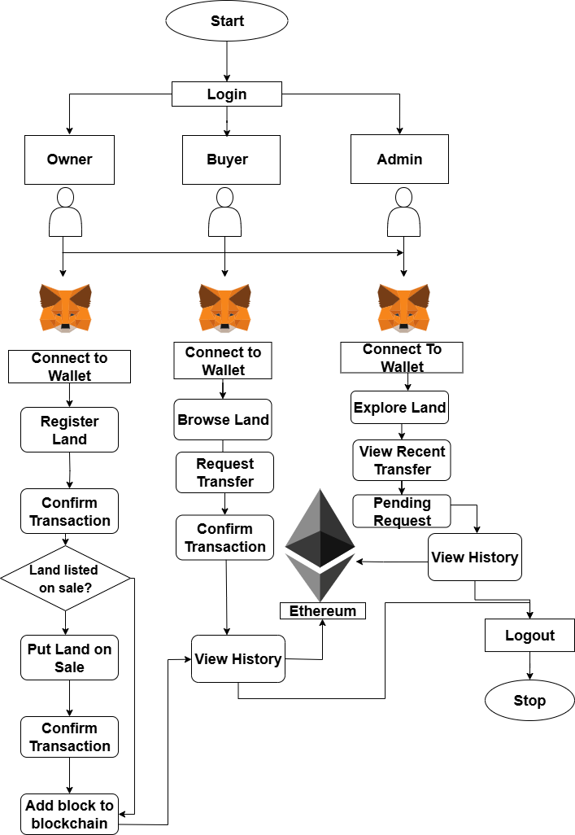The decentralized land ownership system is designed with a robust framework leveraging blockchain technology to ensure transparency, security, and immutability of land ownership records. Key components include a user authentication module for secure registration of landowners using multi-factor authentication, and a permissioned blockchain network to securely store and manage ownership data, allowing only authorized entities to access or modify records. Smart contracts automate processes such as transferring ownership, verifying titles, and executing transactions, ensuring tamper-proof operations. A user-friendly web application serves as the primary interface for landowners, authorities, and stakeholders to interact with the system, check ownership status, initiate transfers, and view transaction history. To support development, system architecture diagrams are created using draw.io, and user interface prototypes are designed using Figma to visualize and refine the platform's design. This comprehensive approach ensures a streamlined and secure land registration and ownership management process.

Figure 3.3.1 System Flow Diagram (Group Study, 2025)

### 3.3.1 Use Case Diagram

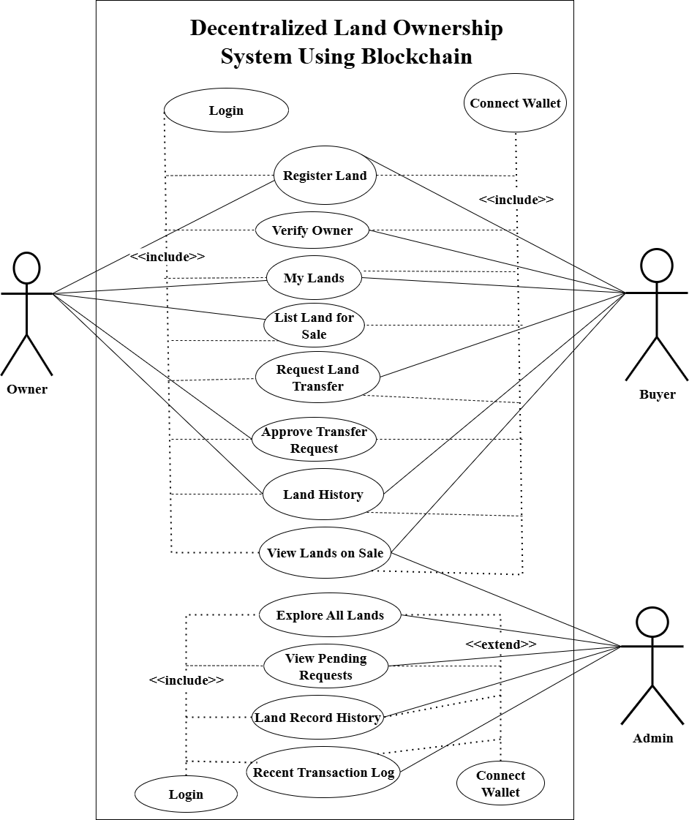 A use case diagram is a visual representation that illustrates the potential interactions between users and a system. It presents different scenarios in which users interact with the system and showcases the types of users involved. Use case diagrams are typically accompanied by other supporting diagrams to provide a comprehensive understanding of the system.

Figure 3.3.2 Use Case Diagram (Group Study, 2025)

## Technology Stack

* **HTML** - HTML is the fundamental language used to structure and define the content of web pages. It focuses on organizing and giving meaning to the information presented. Hypertext refers to the interconnectedness of web pages through links, allowing users to navigate between different pages and websites. By contributing and linking content online, individuals actively participate in the vast network of the World Wide Web [11].
* **CSS -** CSS is a language specifically designed to control the presentation and appearance of documents written in HTML or XML. It provides instructions on how elements should be displayed on various media, including screens, paper, and even speech. By using CSS, developers can define the visual styling of a web page or document, ensuring consistent and aesthetically pleasing rendering across different platforms [11].
* **JS -** JS is a dynamic programming language that enhances web pages by adding interactivity and functionality. It enables developers to manipulate HTML and CSS elements, handle user interactions, perform calculations, and communicate with servers for data updates. With JavaScript, web applications can respond in real-time, validate input, and create interactive features. JS plays a crucial role in enhancing user experience and creating engaging web experiences [11].
* **Tailwind CSS** - Tailwind CSS is a utility-first CSS framework that streamlines web development by providing ready-to-use classes for styling HTML elements. Developers can quickly design and customize web pages by composing utility classes, promoting consistency and efficiency in the styling process. With Tailwind CSS, creating visually appealing and responsive web applications becomes easier and more efficient [12].
* **MySQL** - MySQL is a widely used relational database management system (RDBMS) known for its scalability and efficiency. It provides robust data management capabilities. MySQL enables developers to perform data operations through SQL queries, ensuring reliable performance and data security for web applications [13].
* **VS Code** - VS Code is a popular and lightweight source code editor created by Microsoft. It offers a wide range of features and extensions to enhance the coding experience. With its intuitive interface, customizable settings, and support for multiple programming languages, developers can efficiently write, edit, and debug code. VS Code includes built-in Git integration, intelligent code completion, debugging tools, and a rich ecosystem of extensions. It is highly regarded for its user-friendly interface and powerful capabilities [14].
* **Solidity -** Solidity is a programming language specifically designed for developing smart contracts that run on blockchain platforms, with Ethereum being the most notable one. Smart contracts are self-executing contracts with the terms of the agreement between parties written into code. Solidity allows developers to write these contracts in a way that can be executed on the Ethereum Virtual Machine (EVM), making it a crucial language for decentralized application (DApp) development on the Ethereum blockchain [15].
* **NodeJS -** Node.js is a runtime environment that allows developers to execute JavaScript code server-side, outside of a web browser. It is built on the V8 JavaScript runtime and provides an event-driven, non-blocking I/O model that makes it well-suited for building scalable and high-performance applications. Node.js has gained widespread popularity for its ability to streamline the development of server-side applications, including web servers and APIs. It empowers developers to use JavaScript, traditionally a client-side language, for both frontend and backend development, fostering code reusability and consistency across the entire application stack. With a large and active community, extensive package ecosystem (via npm, the Node Package Manager), and asynchronous capabilities, Node.js has become a go-to platform for building efficient and scalable network application [16].
* **ExpressJS -** Express.js is a lightweight and flexible web application framework built on Node.js, designed to simplify the development of robust and scalable web applications and APIs. It provides a minimal yet powerful set of tools, including routing, middleware support, template engines, and a modular structure, allowing developers to structure their applications according to their preferences. With its unopinionated approach, Express.js accelerates the creation of web servers and APIs, offering versatility and extensibility. Its middleware architecture enables seamless integration of plugins, making it a popular choice in the Node.js ecosystem for building efficient, scalable, and easily maintainable server-side applications [17].
* **MythX -** The MythX platform is a commercial SaaS platform that offers security analysis tools for smart contracts. It utilizes symbolic execution and fuzzing techniques to detect vulnerabilities and bugs in contract code. Developers can submit their contracts to MythX for analysis, and the platform provides detailed reports on any identified issues. Although MythX has a free tier, it is limited in terms of usage. In comparison, Echidna is an open source fuzzer that has been shown to outperform MythX in terms of reachability targets detected and time required [18].
* **MetaMask -** MetaMask enhances counterfeit product detection by providing a secure interface to interact with blockchain-based applications on Ethereum. It enables users to verify product authenticity, trace origins, and ensure legitimacy through decentralized apps. By leveraging MetaMask, the Ethereum blockchain's immutability, and transparency features, it offers a seamless and secure gateway for users to engage in effective counterfeit detection efforts [19].
* **IPFS -** IPFS is a peer-to-peer hypermedia protocol designed to preserve and grow humanity's knowledge by making the web upgradeable, resilient, and more open. IPFS aims to surpass HTTP to build a better web for all of us. HTTP downloads files from one server at a time — but peer-to-peer IPFS retrieves pieces from multiple nodes at once, enabling substantial bandwidth savings. With up to 60% savings for video, IPFS makes it possible to efficiently distribute high volumes of data without duplication. In addressing the challenges of large file storage on traditional blockchains, integrating the InterPlanetary File System (IPFS), a decentralized file-sharing platform leveraging cryptographic hashes for secure and efficient file transfer. To enhance security and privacy, acl-IPFS, a modified system that interfaces with the Ethereum blockchain. Through an Ethereum smart contract, acl-IPFS establishes an access control list for dynamic file access management. This innovative approach provides a secure and permission-based file-sharing environment within blockchain applications, overcoming the inefficiencies associated with storing large files directly on traditional blockchains [20].

## System Architecture

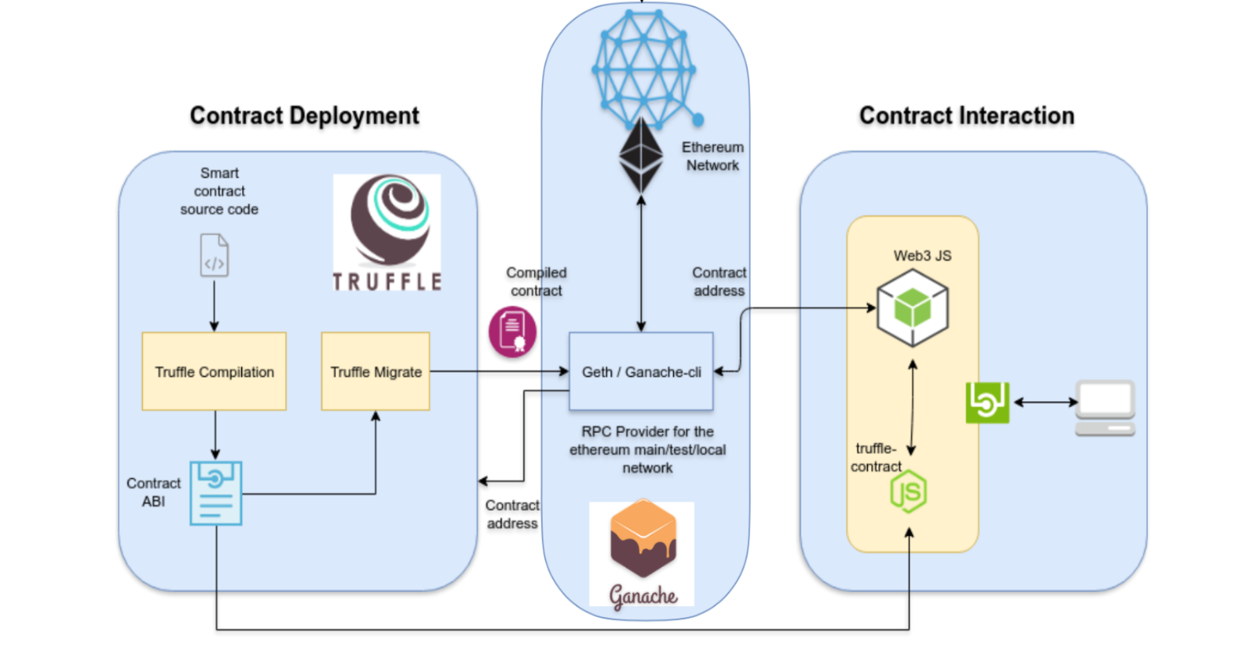The system architecture of DLOSUB is divided into two main components: Contract Deployment and Contract Interaction. In the Contract Deployment phase, smart contracts written in Solidity are compiled and deployed using the Truffle framework. The compiled contracts are deployed to a local Ethereum network using Ganache, which acts as the RPC provider. Truffle generates the contract ABI and contract address, which are essential for interacting with the smart contract later.

Figure 3.5.1 System Architecture (Group Study, 2025)

In the Contract Interaction phase, users interact with the blockchain through a web-based frontend using Web3.js and truffle-contract. The frontend, built with JavaScript and Node.js, communicates with the blockchain to perform operations like land registration, ownership verification, and transfer. This architecture ensures secure, transparent, and decentralized handling of land records.

## 3.6 Testing and Maintenance

Before making the DLOSUB system available for use, it underwent multiple rounds of testing to ensure that all components functioned correctly and met the intended requirements. Various input scenarios were tested across smart contracts, user interface, and blockchain interaction layers to validate the system’s performance, reliability, and correctness. The testing process helped identify and resolve bugs at early stages and ensured the system's readiness for real-world application.

**3.6.1 Unit Testing**

Unit testing involves testing individual components of the system in isolation to ensure they function as expected. Each module of the DLOSUB system was tested independently during development:

* **Smart Contract Functions**: We used the Truffle testing framework to perform unit tests on smart contract functions such as registerLand, requestTransfer, approveTransfer, and getLandDetails. These tests validated correct behavior under different input conditions and confirmed role-based restrictions and state transitions.
* **JavaScript Functions**: Frontend JavaScript code interacting with smart contracts was tested using browser development tools and console debugging. We ensured that wallet connections, form validations, and event handling were accurate and error-free during individual component execution.

**3.6.2 Integration Testing**

Integration testing was conducted to verify smooth interaction between various system components—frontend, backend, and blockchain.

* **Local Blockchain Testing**: Using Ganache, we simulated a local blockchain environment to test complete workflows, including wallet connection, land registration, transfer request, and approval. This verified that smart contract calls and blockchain updates occurred correctly across the application.
* **Error Handling and Validation**: We tested how the system responded to common issues such as invalid land IDs, unauthorized actions, or disconnected wallets. The platform displayed appropriate messages and prevented unauthorized access or invalid transactions, ensuring robustness.
* **Data Flow and Consistency**: Integration tests verified that data entered through the frontend (e.g., land location, value, and description) was accurately passed to the smart contract and retrieved without mismatch. This confirmed consistency between off-chain user inputs and on-chain data representation.

**3.6.3 System Testing**

System testing evaluated the overall behaviour of the entire DLOSUB system and confirmed that it aligned with functional and non-functional requirements.

* **Security Testing**: We conducted security checks to ensure that only verified users could perform sensitive operations like land registration and ownership approval. Smart contract permissions were enforced through role checks, and all user actions were traceable via transaction hashes.
* **Performance and Load Testing**: The system was tested with multiple user simulations and frequent blockchain interactions to observe its stability. The tests showed that the platform could handle concurrent transactions with minimal latency, confirming its readiness for broader deployment.

# Chapter 4: Result and Discussions

## 4.1 Output

The DLOSUB (Decentralized Land Ownership System Using Blockchain) project has resulted in the successful development of a fully functional prototype addressing the major issues in traditional land ownership systems, such as lack of transparency, fraud, and centralized data control. By utilizing Ethereum-based blockchain technology and smart contracts, the system provides a tamper-proof, traceable, and secure solution for land registration, verification, and ownership transfer.

The platform supports various real-time functionalities including Register Land, Verify Ownership, My Lands, Put Land for Sale, Explore All Lands, Request Transfer, and Approve Transfers. Users can connect their MetaMask wallets and interact with the system securely, with every action logged onto the blockchain through a unique transaction hash. This ensures transparency, non-repudiation, and auditability of all records.

The smart contract logic has been optimized to manage role-based access and ownership workflows securely. Landowners can register their land and manage listings, while authorized personnel can approve ownership transfers. The system also supports structured off-chain data storage for metadata such as descriptions, coordinates, or supporting documents, keeping the blockchain efficient while preserving necessary details.

A transaction status feedback system provides users with real-time updates on their activities, displaying whether transactions are pending, successful, or failed—thereby improving clarity and trust. Combined with a user-friendly interface and robust backend interaction, DLOSUB presents a complete, scalable, and practical model for decentralized land record management.

## 4.2 Web Development

### 4.2.1 Frontend

The front-end environment for this project comprised of interactive, desirable and understandable web pages: Landing Page, Login Page, Contact Page, Land Ownership Page, Available Lands Page, etc. are illustrated below:

* **Landing Page**

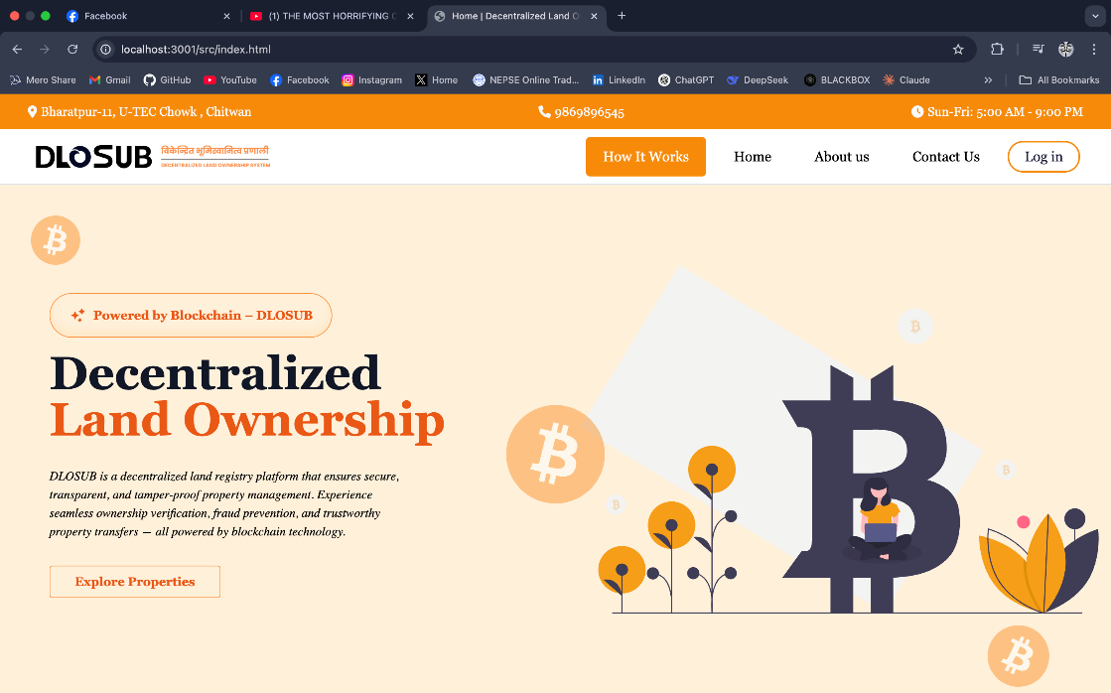This is the first page of the website; this is from where a user starts surfing the website

Figure 4.2. Landing Page (Group Study, 2025)

* **Contact Page**

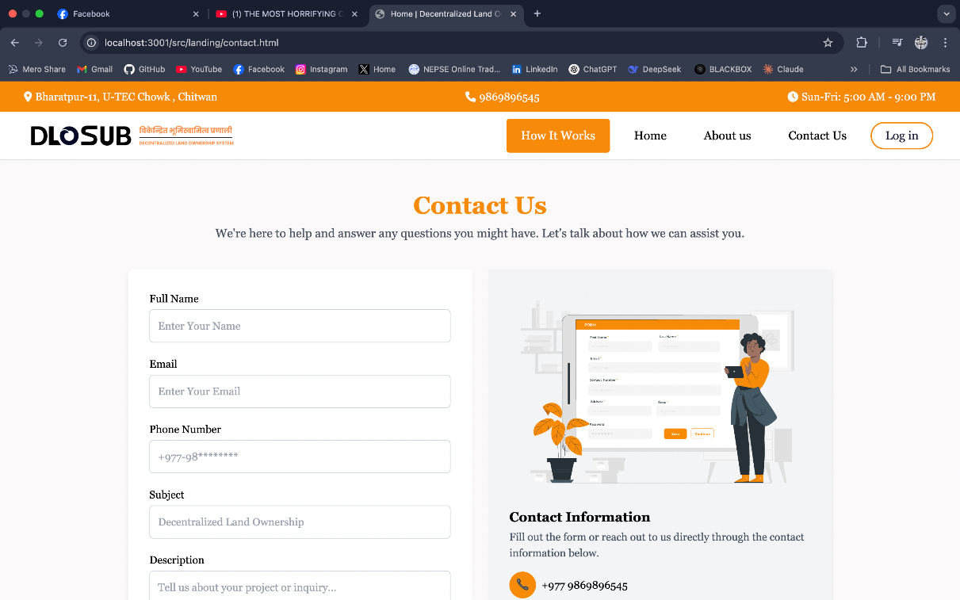This is the contact us page of the website; this is from where a user can contact the officials for getting more information and getting help if any issues faced.

Figure 4.2. Contact Page (Group Study, 2025)

* **Lands for Sale Page**

In this page, owner and buyer can view the lands that they have listed for sale.

Figure 4.2. Lands for Sale Page (Group Study, 2025)

* **Ownership Page**

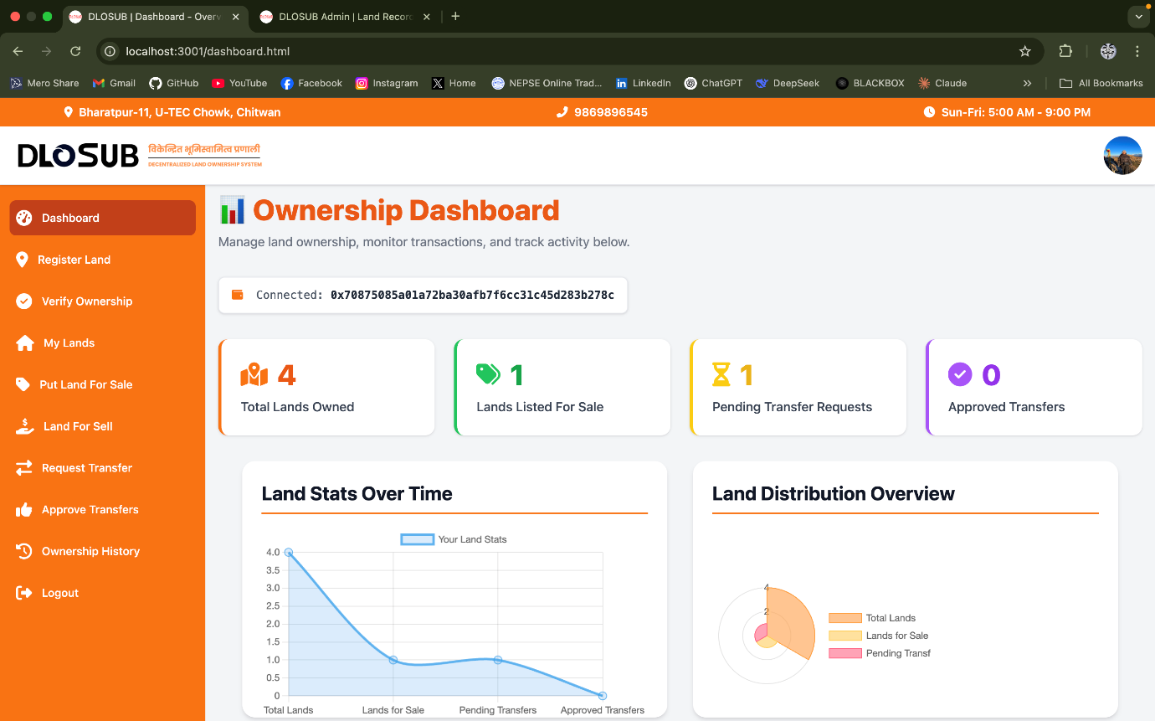In this page, the user can see the lands registered under their wallet address and see more details of their land.

Figure 4.2. Ownership Page (Group Study, 2025)

* **Land Transfer Approval Page**

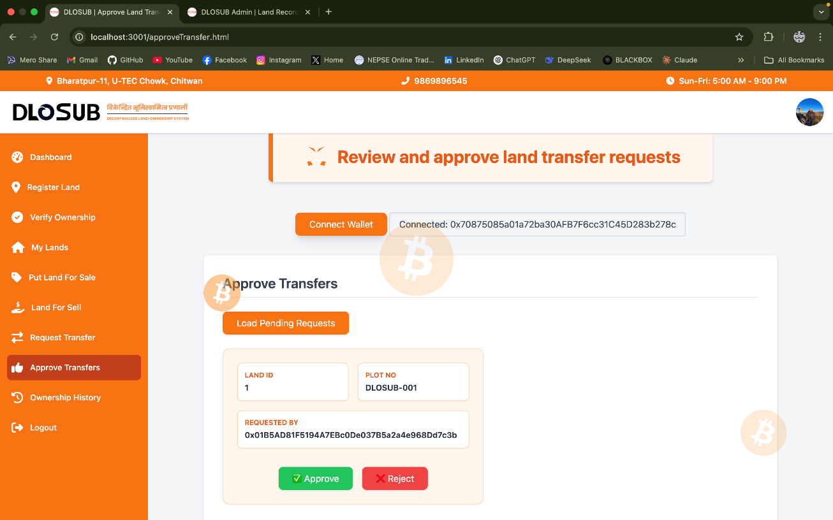In this page, the owner can approve or reject the transfer of the land they have listed on the chain for sale.

Figure 4.2. Land Transfer Approval Page (Group Study, 2025)

* **Admin Dashboard**

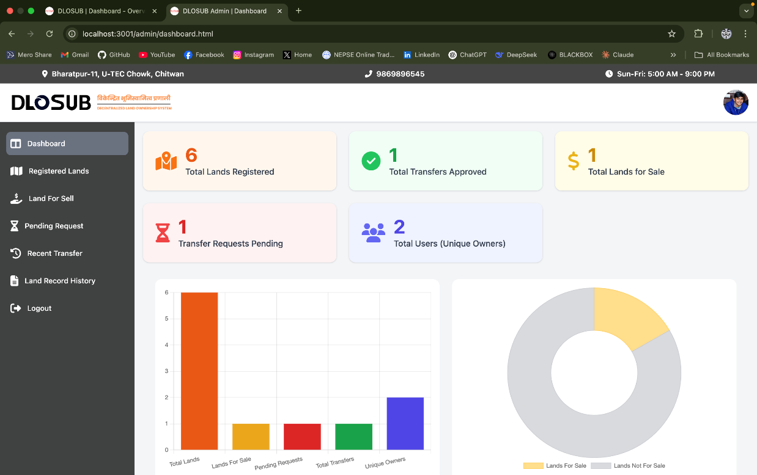In the admin Dashboard page, the admin can speculate on every land registered, the lands that have been transferred throughout the chain, total landowners, and other details.

Figure 4.2. Admin Dashboard Page (Group Study, 2025)

* **Registered Land Page**

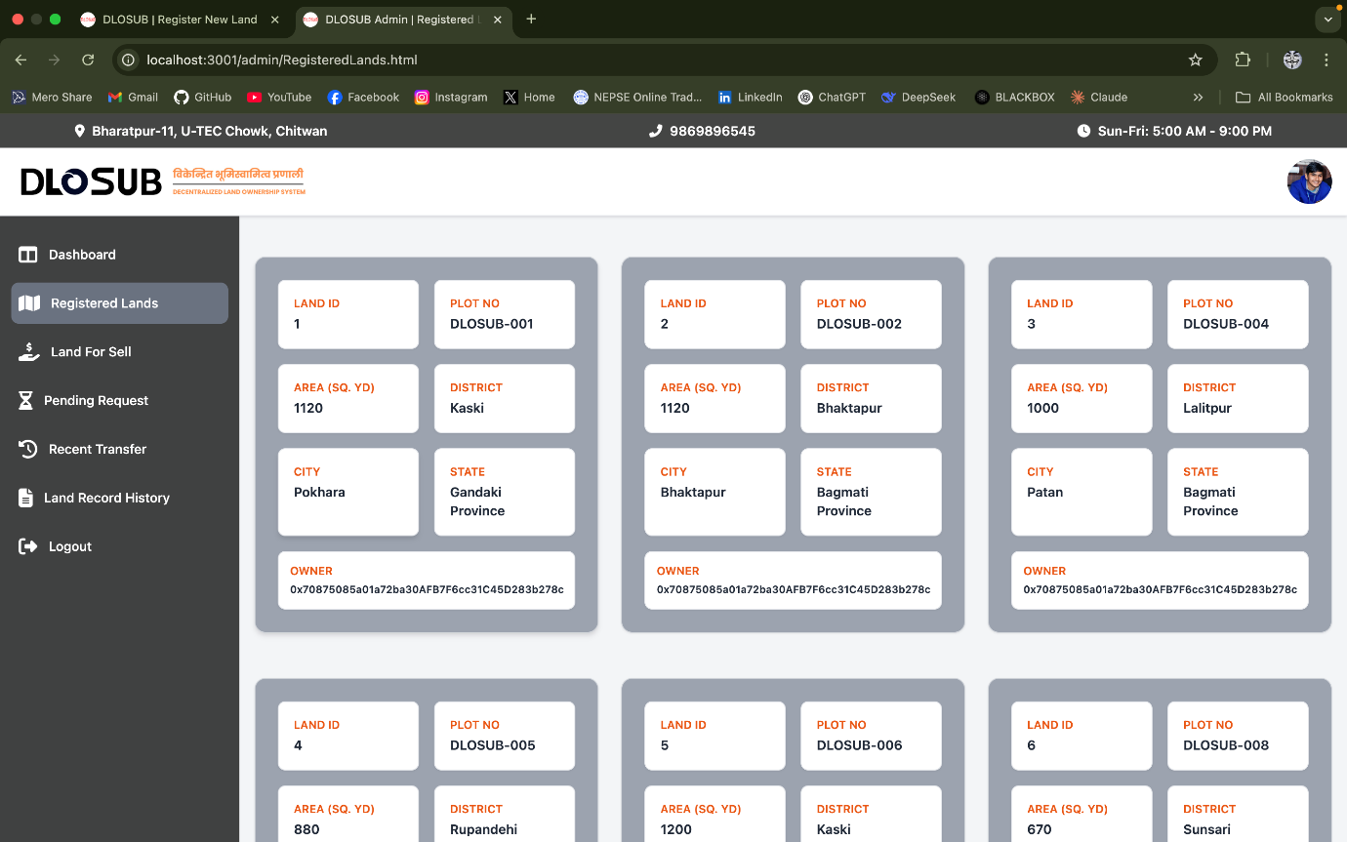In this page, admin can view and explore the lands registered into the blockchain.

Figure 4.2. Registered Land Page (Group Study, 2025)

* **Land Record History**

Admin can search and check for history of each land through land identification number and owner wallet address. They can download the pdf file for the land history.

Figure 4.2. Land Record History (Group Study, 2025)

### 4.2.2 Backend

To develop this project Truffle and Ganache were utilized as a backend local testing technology.

* **Deploying and Migrating Smart Contracts in DLOSUB Using Ganache and Truffle.** In DLOSUB utilizing Ganache, the process begins with compilation of the config file of truffle which deploys the smart contracts. After the compilation of the config js file, the file is now added into the Ganache GUI application, followed by the migration of the contracts written on Solidity into the blockchain. After this, the website is connected to the metamask wallet to perform operations by signing these contracts.

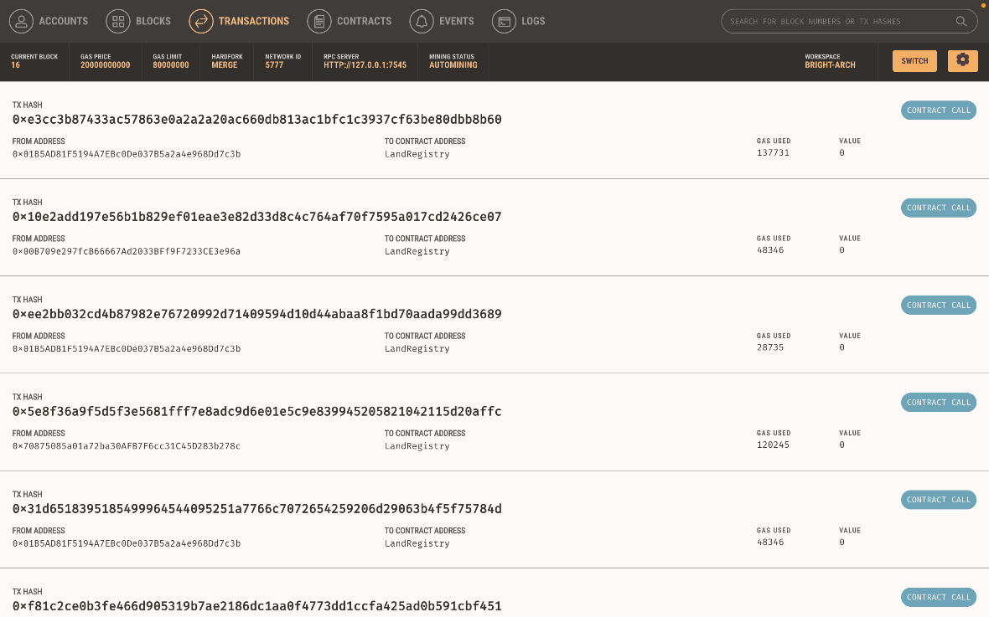

Figure 4.2. Local Transactions (Group Study, 2025)

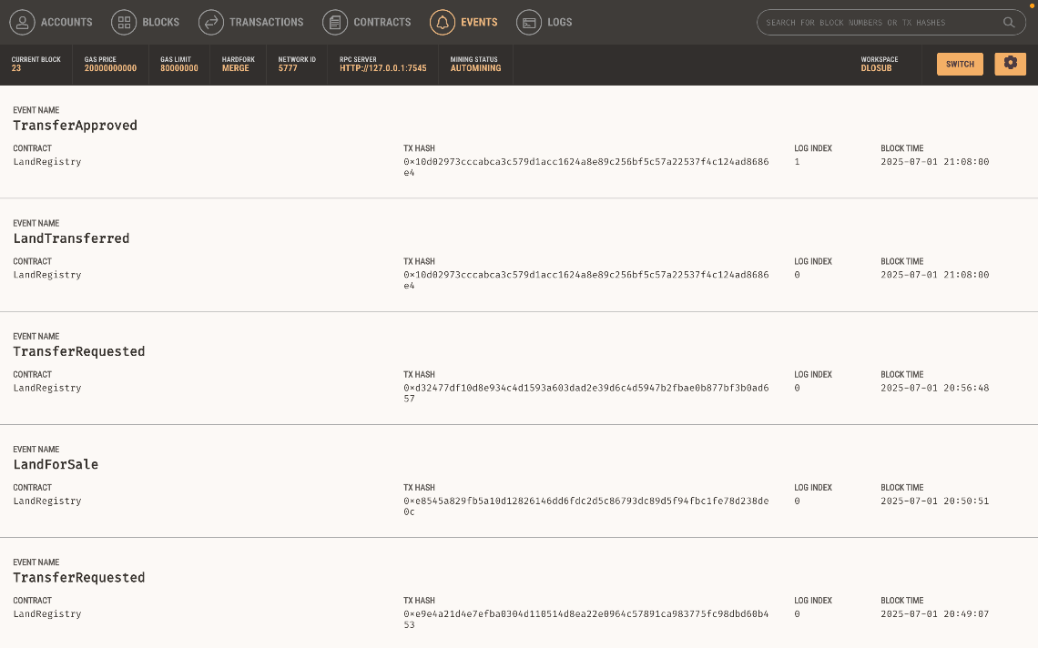

Figure 4.2.11 Blocks mined into the chain (Group Study, 2025)

Figure 4.2.10 Events in the system (Group Study, 2025)

## 4.3 Future Enhancements

While DLOSUB fulfils its core objectives as a blockchain-powered land management system, several enhancements can improve its scalability and readiness for real-world deployment:

1. **Integration with Government Registries**: Establishing a secure connection with government land databases or legal authorities would make the platform more practical for legal use.
2. **Geo-Mapping and Land Visualization**: Adding features such as geolocation tagging or GIS-based visualization could enhance the accuracy and usability of land records.
3. **IPFS Integration for Document Storage**: Although off-chain metadata is supported, integrating IPFS for decentralized storage of legal documents and proof files could further strengthen data resilience.
4. **Multi-Signature Verification**: Implementing a multi-signature approval system (e.g., owner + authority signatures) could increase the trust and security for sensitive operations like land transfer.
5. **Mobile App Version**: To increase accessibility, a mobile-friendly version or native app can be developed for wider adoption, especially in rural or offline-first areas.

implemented.

## 4.4 Issues Encountered

Issues Encountered during the development of the Decentralized Land Ownership System Using Blockchain, several challenges were encountered. Addressing these issues was crucial to ensuring the robustness and reliability of the final system. Here are the key issues:

* Gas Limit Issues: Insufficient gas limits caused deployment transactions to fail.
* Adaptation to new technology: Adapting to new programming languages and keeping up with rapid technological advancements presented a steep learning curve for the development team.
* Metamask Integration Issues: Problems connecting Metamask to the local blockchain occurred due to incorrect RPC settings and network IDs.

# Chapter 5: Conclusion

In conclusion, Decentralized Land Ownership System Utilizing Blockchain technology represents a transformative approach to addressing the longstanding challenges faced by traditional land registration systems. By leveraging the inherent advantages of blockchain such as security, transparency, and immutability, this project aims to create a more efficient and reliable framework for managing land ownership. The expected outcomes, including tamper-proof records, reduced fraudulent claims, streamlined transactions, and increased accessibility, highlight the potential for significant improvements in the land management landscape.

This initiative not only seeks to empower individuals with secure proof of ownership but also aims to foster trust among stakeholders, reduce transaction costs, and enhance overall economic opportunities. By addressing the critical issues of inefficiency, fraud, and lack of transparency, the project aligns with the growing global demand for secure land tenure and equitable access to land resources.

As we move forward with the implementation of this system, we anticipate that it will serve as a model for future innovations in land management, ultimately contributing to social stability, economic growth, and the promotion of equitable land rights for all. The successful execution of this project will pave the way for a more transparent and trustworthy land ownership framework, benefiting communities and economies alike.

# REFERENCES

[1] A. Shitole, R. Ghanpathi, A. Srivastava, R. Bhosikar, and A. Chattar, “Blockchain based Land Registry System.” [Online]. Available: https://www.researchgate.net/publication/359370049

[2] M. Shuaib, S. M. Daud, S. Alam, and W. Z. Khan, “Blockchain-based framework for secure and reliable land registry system,” *Telkomnika (Telecommunication Computing Electronics and Control)*, vol. 18, no. 5, pp. 2560–2571, Oct. 2020, doi: 10.12928/TELKOMNIKA.v18i5.15787.

[3] M. Nandi, R. K. Bhattacharjee, A. Jha, and F. A. Barbhuiya, “A secured land registration framework on Blockchain,” in *ISEA-ISAP 2020 - Proceedings of the 3rd ISEA International Conference on Security and Privacy 2020*, Institute of Electrical and Electronics Engineers Inc., Feb. 2020, pp. 130–138. doi: 10.1109/ISEA-ISAP49340.2020.235011.

[4] M. Moazzam, S. Gupta, and S. Waseem, “Issue 6 www.jetir.org (ISSN-2349-5162),” JETIR, 2021. [Online]. Available: www.jetir.org

[5] M. Faiz, S. K. Wagh, R. Shahapure, S. Deb, and P. Kamble, “Land Registration System Using Blockchain,” 2023. [Online]. Available: www.ijcrt.org

[6] V. Dr. Potdar, “Land-Registry-Blockchain,” pp. 1–12, Mar. 2021.

[7] S. Gurbanov and F. Suleymanli, “Analytical Assessment of Green Digital Finance Progress in the Republic of Georgia,” in *Economics, Law, and Institutions in Asia Pacific*, Springer, 2022, pp. 205–222. doi: 10.1007/978-981-19-2662-4_10.

[8] J. Mcmurren, A. Young, and S. Verhulst, “B LO C KC H A N G E Addressing Transaction Costs Through Blockchain and Identity in Swedish Land Transfers.”

[9] S. Pandey and C. Sen, “Blockchain Technology in Real-Time Governance: An Indian Scenario,” *Indian Journal of Public Administration*, vol. 68, no. 3, pp. 397–413, Sep. 2022, doi: 10.1177/00195561221105241.

[10] B. Lundstrøm Olsen -66937, “BEYOND THE HYPE: EXPLORING BLOCKCHAIN TECHNOLOGY IN LAND ADMINISTRATION A case study of Ghana and property rights,” 2018.

[11] Jennifer. Niederst Robbins, *Learning Web design : a beginner’s guide to HTML, CSS, JavaScript, and web graphics*.

[12] M. Christian Klimm and S. Bente, “Design Systems for Micro Frontends An Investigation into the Development of Framework-Agnostic Design Systems using Svelte and Tailwind CSS.”

[13] Steve. Suehring, *MySQL bible*. Wiley Pub, 2002.

[14] “VisualStudioCode-TipsAndTricks-Vol.1”.

[15] C. Dannen, “Solidity Programming,” in *Introducing Ethereum and Solidity: Foundations of Cryptocurrency and Blockchain Programming for Beginners*, C. Dannen, Ed., Berkeley, CA: Apress, 2017, pp. 69–88. doi: 10.1007/978-1-4842-2535-6_4.

[16] H. Sun, C. Humer, D. Bonetta, and W. Binder, “Efficient dynamic analysis for node.Js,” in *CC 2018 - Proceedings of the 27th International Conference on Compiler Construction, Co-located with CGO 2018*, Association for Computing Machinery, Inc, Feb. 2018, pp. 196–206. doi: 10.1145/3178372.3179527.

[17] S. L. Bangare, S. Gupta, M. Dalal, and A. Inamdar, “Using Node.Js to Build High Speed and Scalable Backend Database Server,” 2016. [Online]. Available: www.ijrat.org

[18] S. Sayeed, H. Marco-Gisbert, and T. Caira, “Smart Contract: Attacks and Protections,” *IEEE Access*, vol. 8, pp. 24416–24427, 2020, doi: 10.1109/ACCESS.2020.2970495.

[19] Y. S. Alslman and A. A. Taleb, “Exchanging Digital Documents Using Blockchain Technology,” in *3rd International Conference on Electrical, Communication and Computer Engineering, ICECCE 2021*, Institute of Electrical and Electronics Engineers Inc., Jun. 2021. doi: 10.1109/ICECCE52056.2021.9514253.

[20] M. Steichen, B. Fiz, R. Norvill, W. Shbair, and R. State, “Blockchain-Based, Decentralized Access Control for IPFS,” in *2018 IEEE International Conference on Internet of Things (iThings) and IEEE Green Computing and Communications (GreenCom) and IEEE Cyber, Physical and Social Computing (CPSCom) and IEEE Smart Data (SmartData)*, IEEE, Jul. 2018, pp. 1499–1506. doi: 10.1109/Cybermatics_2018.2018.00253.

# Appendices

## Appendix A: Gantt Chart

Before getting started with any project, we must prepare a working schedule consisting of several topics that we would be working on throughout the project development phase. For the same reason, the following is the Gantt chart representing our work schedule in a total span of 8 months, i.e., 32 weeks ranging from the phase after proposal defense to final report submission and defense:

Table 1: Gantt Chart of the project

## Appendix B: Cost Estimation

The budget estimation of our Decentralized Land Ownership System Using Blockchain (DLOSUB) is considered by various factors such as the scope of the project, the desired features and functionalities, the complexity of implementation, and any specific customization or integration requirements. Here’s the table with the estimated cost range for our Decentralized Land Ownership System Using Blockchain (DLOSUB) project:

Table 2: Cost Estimation

|  |  |
| --- | --- |
| **Cost Element** | Estimated Cost Range (NPR) |
| Infrastructure and Hosting | NPR 5,000 – NPR 10,000 |
| Testing and Quality Assurance | NPR 5,000 – NPR 10,000 |
| Training and Documentation | NPR 5,000 – NPR 10,000 |
| Maintenance and Support | NPR 10,000 – NPR 25,000 |