A MINOR PROJECT REPORT ON

**FAKE PRODUCT IDENTIFICATION SYSTEM USING BLOCKCHAIN**



SUBMITTED BY:

**Dipen Raut [21070510]**

**Isha Kandel [21070514]**

**Kshitiz Gupta [21070516]**

**Utsab Wagle [21070545]**

A MINOR PROJECT REPORT FOR FULFILLMENT OF THE REQUIREMENT OF BACHELOR OF COMPUTER ENGINEERING

(6th SEMESTER)

**Course Code: [CMP-390]**

SUBMITTED TO:

**Department of Computer Engineering**

**United Technical College**

**(Affiliated to Pokhara University)**

Bharatpur – 11, Bhojad, Chitwan

**June, 2024**

# Abstract

The Fake Product Identification System Using Blockchain (FPISUB) project is a ground-breaking initiative that aims to revolutionize the commercial industry by introducing a comprehensive blockchain based system. This document proposes the development of FPISUB to address the escalating challenges of counterfeit products in the global market. Leveraging blockchain technology in the supply chain, the system aims to enhance transparency and security, providing a full-proof method for distinguishing genuine from duplicate products. The project recognizes the inadequacies of current anti-counterfeiting measures and inefficient detection methods. Employing the Agile Software Development Life Cycle, the proposed system undergoes sequential phases from concept to launch, with detailed system designs, smart contract life cycle, and rigorous testing. The expected outcome envisions a revolutionary impact on product authentication, instilling consumer confidence and safeguarding manufacturers' interests through transparent and traceable information within a secure marketplace.

**Keywords:***Fake Product Identification System Using Blockchain, Counterfeit Products, Supply Chain, Transparency, Anti-Counterfeiting Measures, Product Authentication, Consumer Confidence, Manufacturers' Interests, Traceability.*

**TABLE OF CONTENTS**

Abstract ii

List of Figures v

List of Tables vi

Acronyms and Abbreviation vii

Chapter 1: Introduction 1

1.1 Background 1

1.2 Problem Statement 2

1.3 Objectives 3

1.4 Applications 3

1.5 Features 3

Chapter 2: Literature Review 5

2.1 Introduction 5

2.2 Case Study 6

2.2.1 VeChainThor 6

2.2.2 BlockVerify 6

2.2.3 Origin Trail 6

2.2.4 Ambrosus 7

2.2.5 IBM Food Trust 7

2.2.6 Conclusion on Case Study 8

Chapter 3: Methodology 9

3.1 Software Development Life Cycle (SDLC) 9

3.2 Flow of project 11

3.2.1 Concept 13

3.2.2 Initiation 13

3.2.3 Definition 13

3.2.4 Planning 13

3.2.5 Development 13

3.2.6 Launch and Execution 16

3.3 System Design 17

3.3.1 ER Diagram 17

3.3.2 Data Flow Diagram (DFD) 18

3.3.3 Use Case Diagram 21

3.3.4 System Flow Diagram 22

3.4 Smart Contracts Life Cycle 23

3.5 Testing and Maintenance 23

Chapter 4: Result and Discussion 24

4.1 Output 24

4.2 Web Development 24

4.2.1 Frontend 24

4.2.2 Backend 27

4.3 Pending Tasks 28

4.4 Limitations 29

4.5 Issues Encountered 29

4.6 Time Estimation 29

4.7 Cost Estimation 30

Chapter 5: Conclusion and Future Enhancement 31

5.1 Conclusion 31

5.2 Future Enhancements 31

REFERENCES 32

# List of Figures

Figure 3.1: Agile Project Management Approach 10

Figure 3.2: Flow of Project, FPISUB (Group Study, 2024) 12

Figure 3.3: Entity Relation Diagram (Group Study, 2024) 17

Figure 3.4: Level 0 Data Flow Diagram (Group Study, 2024) 18

Figure 3.5: Level 1 Data Flow Diagram (Group Study, 2024) 19

Figure 3.6: Level 2 Data Flow Diagram (Group Study, 2024) 20

Figure 3.7: Use Case Diagram (Group Study, 2024) 21

Figure 3.8: System Flow Diagram (Group Study, 2024) 22

Figure 4.1: Landing Page 25

Figure 4.2: Manufacturer Page 25

Figure 4.3: Seller Page 26

Figure 4.4: Consumer Page 26

Figure 4.5: Metamask Connection 27

Figure 4.6: Local Blockchain Transactions 28

# List of Tables

Table 1: Gantt Chart of Project ……………………………………………………………30

Table 2: Cost Estimation ..………………………………………………………………....30

# Acronyms and Abbreviation

|  |  |
| --- | --- |
| ACL | Access Control List |
| CSS | Cascading Style Sheet |
| DApp | Decentralized Application |
| DFD | Data Flow Diagram |
| ER | Entity Relation |
| EVM | Ethereum Virtual Machine |
| FPISUB | Fake Product Identification System Using Blockchain |
| HTML | Hypertext Markup Language |
| HTTP | Hypertext Transfer Protocol |
| IPFS | InterPlanetary File System |
| JS | JavaScript |
| MySQL | My Structured Query Language |
| NPM | Node Package Manager |
| OECD | Organisation for Economic Co-operation and Development |
| QR Code | Quick Response Code |
| RDBMS | Relational Database Management System |
| RFID | Radio-Frequency Identification |
| SDLC | Software Development Life Cycle |
| VS Code | Visual Studio Code |

# Chapter 1: Introduction

## 1.1 Background

In the rapidly evolving landscape of technology, the global development of products and technologies brings along inherent risks such as counterfeiting and duplication. These risks pose significant threats to company reputations, revenues, and, most importantly, consumer well-being. The focus of our project is to address the critical issue of verifying the authenticity of purchased products, ensuring that consumers receive genuine items. Traditional supply chain systems, characterized by centralized networks, have long been susceptible to manipulation and unauthorized alterations, compromising the integrity of product information[1].

In contrast, blockchain technology offers a decentralized database that operates on a peer-to-peer network, providing a transparent and secure framework for tracking and validating product transactions. Each block in the blockchain contains essential data, a unique hash code, and the hash of the previous block, ensuring data immutability. This intrinsic feature of blockchain makes it virtually impossible for any single entity to manipulate product information without majority control of the network. By leveraging blockchain, manufacturers can establish a full-proof system to deliver authentic products, fostering customer trust and elevating the brand value in the market [1].

The prevalence of counterfeit products on a global scale is a pressing concern, with reports estimating substantial financial losses and potential risks to consumer safety. Conventional intervention mechanisms by inspection bodies and authorities, such as the EU's Rapid Alert System, have limitations in engaging end-consumers in the detection process of counterfeiting. Recognizing this gap, our project proposes a Fake Product Identification System using Blockchain, aiming to revolutionize the way we ensure product authenticity in the market [2], [3].

By integrating blockchain technology into the supply chain, we seek to create a system that empowers consumers, merchants, retailers, and manufacturers with a robust mechanism for distinguishing between genuine and duplicate products. The proposed system utilizes the decentralized and tamper-resistant nature of blockchain to establish an efficient, transparent, and accessible means of detecting counterfeit products. This introduction sets the stage for our project, emphasizing the transformative potential of blockchain in addressing the pervasive issue of fake product identification [3], [4].

## 1.2 Problem Statement

The prevalence of counterfeit products in the market poses a significant challenge for both consumers and businesses. Counterfeit goods not only deceive customers but also harm the reputation and profitability of legitimate manufacturers. Current methods of product identification and anti-counterfeiting measures are often inadequate and can be easily circumvented by counterfeiters. The existing supply chain systems often lack the necessary mechanisms to effectively detect and prevent the circulation of counterfeit goods. Traditional methods of preventing counterfeiting have proven ineffective, and the introduction of technologies such as RFID has not been able to fully address the issue. As a result, there is a need for a more robust and secure system to combat counterfeit products and protect the interests of consumers and manufacturers. The major problems against fake products identification in today’s world are:

1. **Inadequate Anti-Counterfeiting Measures:** The current methods of product identification and anti-counterfeiting measures are often inadequate and can be easily circumvented by counterfeiters. This results in significant challenges for consumers and businesses, as counterfeit goods continue to deceive customers and harm the reputation and profitability of legitimate manufacturers.
2. **Lack of Efficient Authentication in Supply Chains:**

Existing supply chain systems lack efficient mechanisms to detect and prevent the circulation of counterfeit goods. The absence of reliable authentication methods hinders the ability to accurately verify product authenticity, contributing to risks in consumer safety, brand reputation, and economic stability.

1. **Inefficiency in Current Detection Methods:** The limitations of current inspection methods in detecting counterfeit products are a prominent problem. The existing approaches lack efficiency and accuracy, often requiring specialized devices and extensive manual efforts for verification. This inefficiency poses a significant challenge for consumers who seek convenient and reliable methods to ensure the authenticity of products in real-time.

## 1.3 Objectives

The primary objective of this Fake Product Identification System Using Blockchain project is to address the pervasive challenges posed by counterfeit products in the market and develop a robust and secure system for their identification and prevention. The following are the specific objectives of our project:

1. To ensure product authenticity with blockchain in the supply chain.
2. To establish a system to reduce fake products, boosting consumer confidence and protecting manufacturers’ interests.

## Applications

Our project can be implemented in several application areas for different purposes. Some of the major applications of using this project are listed below:

1. High-end brands can implement our system for verifying authenticity of products through the supply chain, ensuring traceability of the product.
2. Implementing this system introduces a consumer-centric and technologically advanced approach which provides consumers with transparent and trustworthy information.
3. Implementing our system, pharmaceutics can track the supply chain of pharmaceuticals, enabling integrity of medications and preventing counterfeit drug transactions which pose serious risks to public health.

## Features

FPISUB offers a suite of features designed to boost customer engagement. By deploying immutable and transparent smart contracts on the blockchain, the platform ensures trust and visibility. It facilitates seamless product transactions throughout the supply chain, enhancing consumer satisfaction and preventing counterfeiting. With user-friendly interfaces, robust integrations, and versatile functionalities, FPISUB is an indispensable tool for streamlining and optimizing the flow of products and services for brands. This results in a comprehensive and consumer-centric product authenticity experience.

# Chapter 2: Literature Review

## 2.1 Introduction

The Literature Review portion of the mid defense is based on the observations of research and systems made on similar title. A lot of effort has been put to study the number of research papers regarding data analysis and prediction to retrieve enough information that will help to achieve our goal.

Customers often seek out counterfeit goods for a variety of reasons, such as a lower price or as a substitute for the original, with the internet marketplace quickly becoming the major platform for purchasing counterfeit goods. The volume of counterfeit items on the internet and on the black market is expanding at an exponential rate. As a result, there is an urgent need to solve the issues of identifying counterfeit items and develop appropriate technologies to increase detection accuracy. This is one of the current research areas being investigated. This study addresses numerous strategies for detecting counterfeit items which includes QR code-based Product [4].

According to a report by the Organisation for Economic Co-operation and Development (OECD), counterfeit products account for up to 3.3% of global trade, with a value of up to 509 billion dollar per year. These products range from luxury goods to everyday items such as pharmaceuticals, electronics, and food. Current approaches for identifying counterfeit products rely on traditional methods such as security labels, holograms, or barcodes, which are often easy to counterfeit or replicate. This is where blockchain technology comes in as a game-changer. Blockchain is a distributed, decentralized, immutable, and secure ledger that enables transactions to be recorded in a transparent and tamper-proof manner. These features make blockchain a promising solution for ensuring the authenticity and traceability of products [5].

## 2.2 Case Study

### 2.2.1 VeChainThor

VeChainThor, a blockchain-based platform, has successfully tackled the challenge of counterfeit products by implementing a transparent and traceable supply chain system. Utilizing the VeChainThor blockchain, each product is assigned a unique identifier, allowing stakeholders to trace its origin, manufacturing details, and distribution history. To enhance authenticity detection, anti-counterfeiting measures like NFC/QR code labels and tamper-proof packaging have been integrated. Consumers can easily verify product authenticity by scanning these codes and accessing real-time information from the blockchain, fostering increased confidence in product legitimacy and brand reputation. VeChainThor's innovative approach exemplifies the transformative power of blockchain technology in ensuring the authenticity of products throughout the supply chain [6].

### 2.2.2 BlockVerify

The Blockchain based anti-counterfeit solution for the transparency of the supply chains. The Blockverify has the four main directions in the Blockchain use cases. The first one is the pharmacy – the pharmaceuticals are tracked throughout the supply chain to be sure that customer will receive authentic product. The second case is the diamonds – the diamonds certification is enhancing trust, and this leads to the fraud prevents. The third is the luxury items this solution is like as the previous (the diamonds), because it helps to provide the quality of the luxury items. The last one case is the electronics the aim of this solution is to be sure that the customer is getting the original equipment [7].

### 2.2.3 Origin Trail

Origin Trail is a blockchain-based protocol designed for supply chain transparency and data interoperability. It enables companies to share and verify supply chain data in a secure and decentralized manner, facilitating product authentication and ensuring compliance with regulations. Origin Trail has been utilized in various industries, including agriculture, logistics, and pharmaceuticals, to combat counterfeiting and ensure product integrity [8].

### 2.2.4 Ambrosus

The Ambrosus network uses tags, tracers and sensors to track pro ducts throughout their life cycles. Their goal is to associate the product with the packaging and the transportation car, in a way that, if compromised, a notification is sent to the blockchain. Tracking components are customized according to the product type and based on the clients’ needs. To track a fish from hook to fork, different tracking components are deployed. A smart gel tag is applied at the surface of the fish to assure product authenticity because the gel will react to fraudulent manipulation. A container sealed with a sensor contains all the collected fish. The sensor will assure the integrity of the product since it will detect any opened container. Another sensor is added to check the temperature and the GPS movement during the shipment. A Charge-coupled device (CCD) camera can be introduced to record all occurred activity until product shipment. All these sensors are bonded together and then bonded to the QR code. A QR code is a matrix barcode that contains information related to the product to which it is attached. All data obtained from the product, related to the QR code rectification, and collected by the sensors aggregate to the QR code [9].

### 2.2.5 IBM Food Trust

Founded in 1911, International Business Machines Corporation (abbreviated to IBM), is an American multinational technology company (IBM 2008). Having gone with the influx of Industry 4.0, specifically blockchain technology, this giant tech-emperor has developed IBM Food Trust Blockchain to ease the pains of food supply chain, especially food safety and traceability. IBM also claims itself to be one of the pioneering companies to provide the solution in-production using blockchain technology. IBM Food Trust is “a collaborative network of growers, processors, wholesalers, distributors, manufacturers, retailers, and others enhancing visibility and accountability in each step of the food supply”. The Trust in Food is built on four new modularized standards that IBM Blockchain promises to ease the existing pains of food supply chain:

• Food Safety: By securely tracing products in seconds can food supply chain actors, such as consumers and retailers, alleviate waste, cross-contamination and spread of food-borne illness.

• Food Waste: IBM Food Trust provides a panacea for product loss and ecosystem unsustainability by sharing and managing data across the food supply chain.

• Food Freshness: Customers of IBM Food Trust can identify inefficiencies and ensure quality of goods thanks to the unprecedented visibility into supply chain data for valuable insights and analysis.

• Food Confidence: “Confidence” is gained through important digitalized certificates and documents, which potentially optimize information management, certify provenance, and ensure authenticity [10].

### 2.2.6 Conclusion on Case Study

The case studies of blockchain-based anti-counterfeiting solutions illustrate the significant impact of blockchain technology on enhancing supply chain transparency and product authenticity. VeChainThor leverages unique identifiers, NFC/QR code labels, and tamper-proof packaging to ensure product legitimacy, increasing consumer confidence. BlockVerify targets pharmaceuticals, diamonds, luxury items, and electronics to prevent fraud and guarantee authenticity. Origin Trail focuses on supply chain data interoperability and compliance across various industries, while Ambrosus uses sophisticated sensors and QR codes for comprehensive product tracking. IBM Food Trust addresses food supply chain challenges, enhancing safety, reducing waste, and ensuring freshness and authenticity through a collaborative network. These innovative applications underscore blockchain's transformative potential in safeguarding product integrity across diverse sectors.

# Chapter 3: Methodology

Methodology refers to the comprehensive structure of principles, methodologies, and protocols employed in a specific field of study or research. It encompasses the organized approach used to gather, analyse, and interpret data, as well as the methods and instruments employed to address research inquiries or resolve issues within a particular discipline.

## Software Development Life Cycle (SDLC)

Agile methodology is employed in the development of FPISUB for several reasons such as its inherent flexibility, collaboration, and iterative nature. With the constantly evolving landscape of manufacturing and regulatory requirements, Agile allows FPISUB to adapt to changing needs effectively. By breaking the development process into short sprints, Agile enables the development team to address the highest-priority functionalities in each iteration, ensuring that the system aligns with the evolving requirements [11].

1. Requirements: For FPISUB, the Agile approach begins with gathering and prioritizing the desired functionalities and features of the system. These functionalities can include such as manufacturers can register their products on the blockchain, creating a unique digital identity for each item, implementation of smart contracts to automate verification processes, and audit trails for tracking record modifications. The development team needs to understand the needs and ensure that the highest-priority functionalities are addressed in each sprint [11].
2. Design: The Agile approach promotes iterative and incremental design for FPISUB. The initial design serves as a foundation for the system, incorporating blockchain technology and considering the architecture, data models, user interface and integration requirements. As development progresses, the design evolves and is refined based on user feedback and emerging requirements. Regular design discussions and collaborations within the team ensure that the evolving design aligns with the goals of FPISUB, meets regulatory requirements, and provides an intuitive and secure user experience [11].

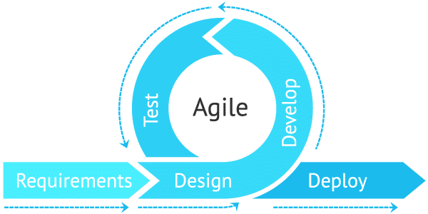

Figure 3.1: Agile Project Management Approach [11]

1. Development: Agile development of FPISUB is conducted in short sprints, typically lasting one to four weeks. At the beginning of each sprint, the development team selects a set of functionalities from the prioritized backlog to work on. The team then focuses on implementing and testing these functionalities, ensuring that the system functions as intended and adheres to the defined requirements. The development process is collaborative, with the team members, frequently communicating and coordinating their efforts. Continuous integration practices enable the team to integrate new code changes regularly, ensuring the team to integrate new code changes regularly, ensuring early detection of issues and maintaining a stable and reliable codebase [11].
2. Testing: Testing is an integral part of Agile development for success of FPISUB. The development team incorporates various testing techniques throughout the development process to ensure the quality and reliability of the system. This includes conducting unit tests to verify individual components, integration tests to validate the interaction between different modules, and system tests to evaluate the overall functionality. Security testing and vulnerability assessments are also performed to ensure the protection of sensitive information [11].
3. Deployment: Agile promotes frequent and regular deployments of working software. At the end of each sprint, a potentially usable increment of the system is formed. This increment may include new features, enhancements, and bug fixes. The deployment process for FPISUB is streamlined and automated to ensure quick and reliable releases. Continuous integration and delivery practices facilitate seamless integration of new changes into the production environment [11].

By adopting the Agile approach, FPISUB can benefit from flexibility, collaboration, and iterative development, enabling it to adapt to changing requirements, receive frequent feedback from supervisor, and deliver a powerful, secure, and efficient Fake Product Identification System.

## 3.2 Flow of project

A project flow diagram is a visual representation that presents the chronological order and interrelationships of tasks or activities within a project. It visually depicts the progression of work from its initiation to completion, highlighting the sequence and connections between different project components. This diagram serves as a useful tool for stakeholders to comprehend the project's timeline, significant milestones, and critical paths, facilitating effective project planning, coordination, and communication [12]. The project flow diagram is as shown in Figure 3.2.

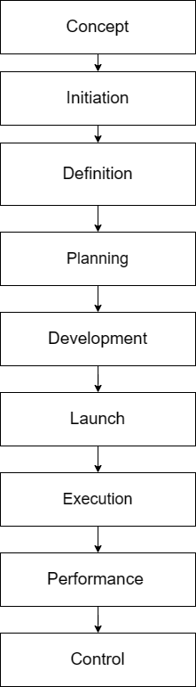s

Figure 3.2: Flow of project, FPISUB (Group Study, 2024)

### Concept

The concept phase of a project involves defining project objectives, scope, and stakeholders, establishing a clear understanding of the project's purpose and goals. It focuses on identifying the project's boundaries and desired outcomes, setting the foundation for effective planning and execution [12].

### Initiation

The initiation phase marks the beginning of the project and encompasses activities such as feasibility assessment and risk analysis. It evaluates the project's practicality, considering available resources, time constraints, and technical requirements. The initiation phase ensures that the project is viable and establishes strategies for mitigating potential risks, laying the groundwork for a successful project [12].

### Definition

The definition phase in research involves clearly outlining the approach, framework, and research questions. It establishes the scope and objectives of the study, providing a foundation for effective research [12].

### Planning

The planning phase includes developing a detailed plan for data collection, analysis, and interpretation. It ensures the research process is rigorous and valid by considering factors like sampling, data management, and ethical considerations [12].

### Development

The development phase involves implementing the planned approach, collecting data, conducting experiments, and creating prototypes or models. It requires attention to detail, adherence to procedures, and continuous monitoring for effective execution and reliable results [12].

* **HTML** - HTML is the fundamental language used to structure and define the content of web pages. It focuses on organizing and giving meaning to the information presented. Hypertext refers to the interconnectedness of web pages through links, allowing users to navigate between different pages and websites. By contributing and linking content online, individuals actively participate in the vast network of the World Wide Web [13].
* **CSS -** CSS is a language specifically designed to control the presentation and appearance of documents written in HTML or XML. It provides instructions on how elements should be displayed on various media, including screens, paper, and even speech. By using CSS, developers can define the visual styling of a web page or document, ensuring consistent and aesthetically pleasing rendering across different platforms [13].
* **JS -** JS is a dynamic programming language that enhances web pages by adding interactivity and functionality. It enables developers to manipulate HTML and CSS elements, handle user interactions, perform calculations, and communicate with servers for data updates. With JavaScript, web applications can respond in real-time, validate input, and create interactive features. JS plays a crucial role in enhancing user experience and creating engaging web experiences [13].
* **Tailwind CSS** - Tailwind CSS is a utility-first CSS framework that streamlines web development by providing ready-to-use classes for styling HTML elements. Developers can quickly design and customize web pages by composing utility classes, promoting consistency and efficiency in the styling process. With Tailwind CSS, creating visually appealing and responsive web applications becomes easier and more efficient [14].
* **MySQL** - MySQL is a widely used relational database management system (RDBMS) known for its scalability and efficiency. It provides robust data management capabilities. MySQL enables developers to perform data operations through SQL queries, ensuring reliable performance and data security for web applications [15].
* **VS Code** - VS Code is a popular and lightweight source code editor created by Microsoft. It offers a wide range of features and extensions to enhance the coding experience. With its intuitive interface, customizable settings, and support for multiple programming languages, developers can efficiently write, edit, and debug code. VS Code includes built-in Git integration, intelligent code completion, debugging tools, and a rich ecosystem of extensions. It is highly regarded for its user-friendly interface and powerful capabilities [16].
* **Solidity -** Solidity is a programming language specifically designed for developing smart contracts that run on blockchain platforms, with Ethereum being the most notable one. Smart contracts are self-executing contracts with the terms of the agreement between parties written into code. Solidity allows developers to write these contracts in a way that can be executed on the Ethereum Virtual Machine (EVM), making it a crucial language for decentralized application (DApp) development on the Ethereum blockchain [17].
* **NodeJS -** Node.js is a runtime environment that allows developers to execute JavaScript code server-side, outside of a web browser. It is built on the V8 JavaScript runtime and provides an event-driven, non-blocking I/O model that makes it well-suited for building scalable and high-performance applications. Node.js has gained widespread popularity for its ability to streamline the development of server-side applications, including web servers and APIs. It empowers developers to use JavaScript, traditionally a client-side language, for both frontend and backend development, fostering code reusability and consistency across the entire application stack. With a large and active community, extensive package ecosystem (via npm, the Node Package Manager), and asynchronous capabilities, Node.js has become a go-to platform for building efficient and scalable network application [18].
* **ExpressJS -** Express.js is a lightweight and flexible web application framework built on Node.js, designed to simplify the development of robust and scalable web applications and APIs. It provides a minimal yet powerful set of tools, including routing, middleware support, template engines, and a modular structure, allowing developers to structure their applications according to their preferences. With its unopinionated approach, Express.js accelerates the creation of web servers and APIs, offering versatility and extensibility. Its middleware architecture enables seamless integration of plugins, making it a popular choice in the Node.js ecosystem for building efficient, scalable, and easily maintainable server-side applications [19].
* **MythX -** The MythX platform is a commercial SaaS platform that offers security analysis tools for smart contracts. It utilizes symbolic execution and fuzzing techniques to detect vulnerabilities and bugs in contract code. Developers can submit their contracts to MythX for analysis, and the platform provides detailed reports on any identified issues. Although MythX has a free tier, it is limited in terms of usage. In comparison, Echidna is an open source fuzzer that has been shown to outperform MythX in terms of reachability targets detected and time required [20].
* **MetaMask -** MetaMask enhances counterfeit product detection by providing a secure interface to interact with blockchain-based applications on Ethereum. It enables users to verify product authenticity, trace origins, and ensure legitimacy through decentralized apps. By leveraging MetaMask, the Ethereum blockchain's immutability, and transparency features, it offers a seamless and secure gateway for users to engage in effective counterfeit detection efforts [21].
* **IPFS -** IPFS is a peer-to-peer hypermedia protocol designed to preserve and grow humanity's knowledge by making the web upgradeable, resilient, and more open. IPFS aims to surpass HTTP to build a better web for all of us. HTTP downloads files from one server at a time — but peer-to-peer IPFS retrieves pieces from multiple nodes at once, enabling substantial bandwidth savings. With up to 60% savings for video, IPFS makes it possible to efficiently distribute high volumes of data without duplication. In addressing the challenges of large file storage on traditional blockchains, integrating the InterPlanetary File System (IPFS), a decentralized file-sharing platform leveraging cryptographic hashes for secure and efficient file transfer. To enhance security and privacy, acl-IPFS, a modified system that interfaces with the Ethereum blockchain. Through an Ethereum smart contract, acl-IPFS establishes an access control list for dynamic file access management. This innovative approach provides a secure and permission-based file-sharing environment within blockchain applications, overcoming the inefficiencies associated with storing large files directly on traditional blockchains [22].

### Launch and Execution

Once the development of our Fake Product Identification System Using Blockchain is complete, we will launch it for real-world usage. Users will be able to access the system, submit complaints, and interact with its features. We will ensure compatibility, conduct testing, and gather valuable user feedback to make necessary improvements.

## 3.3 System Design

The architecture design for the Fake Product Identification System Using Blockchain incorporates various diagrams, including an Entity-Relationship (ER) diagram, a Data Flow Diagram (DFD), and a Use Case Diagram. These diagrams depict the entities, relationships, attributes, data flow, and system functionalities relevant to the FPISUB [23].

### 3.3.1 ER Diagram

An ER diagram is a graphical representation that illustrates the logical structure of a system or database. It uses entities, relationships, and attributes to depict real-world objects, their associations, and their properties. This diagram provides a visual overview of the data model, aiding in understanding data requirements and designing an efficient database schema [23].

Figure 3.3: Entity Relation Diagram (Group Study, 2024)

### 3.3.2 Data Flow Diagram (DFD)

Data Flow Diagram (DFD) is a visual tool that shows how information moves from one part of a system to another. It helps students understand the overall flow of data without getting too caught up in the technical details. DFDs can be used to zoom in on specific aspects of a system, providing more detailed information at different levels. These levels are often numbered, starting from 0 and going up to Level 2 or even higher. By using DFDs, students can grasp the flow of data within a system and analyse it at various levels of complexity [23].

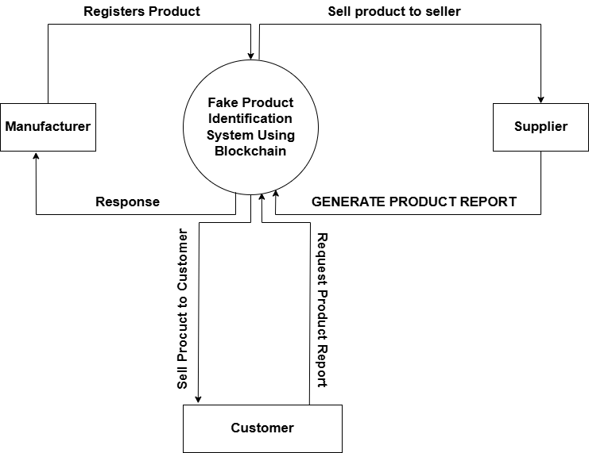

Figure 3.4: Level 0 Data Flow Diagram (Group Study, 2024)

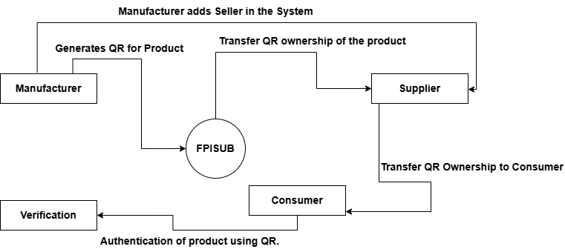

Figure 3.5: Level 1 Data Flow Diagram (Group Study, 2024)

Figure 3.6: Level 2 Data Flow Diagram (Group Study, 2024)

### 3.3.3 Use Case Diagram

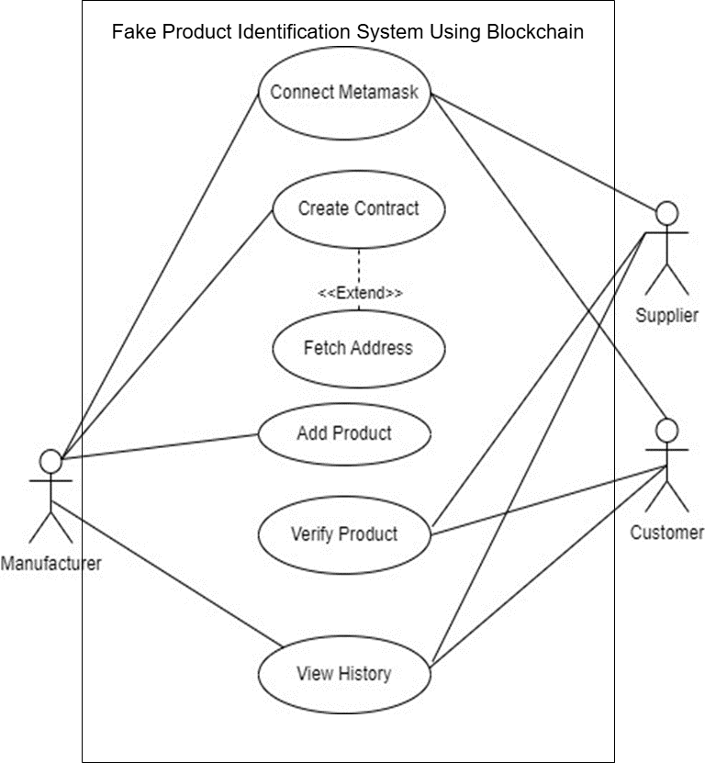A use case diagram is a visual representation that illustrates the potential interactions between users and a system. It presents different scenarios in which users interact with the system and showcases the types of users involved. Use case diagrams are typically accompanied by other supporting diagrams to provide a comprehensive understanding of the system [23].

Figure 3.7: Use Case Diagram (Group Study, 2024)

### 3.3.4 System Flow Diagram

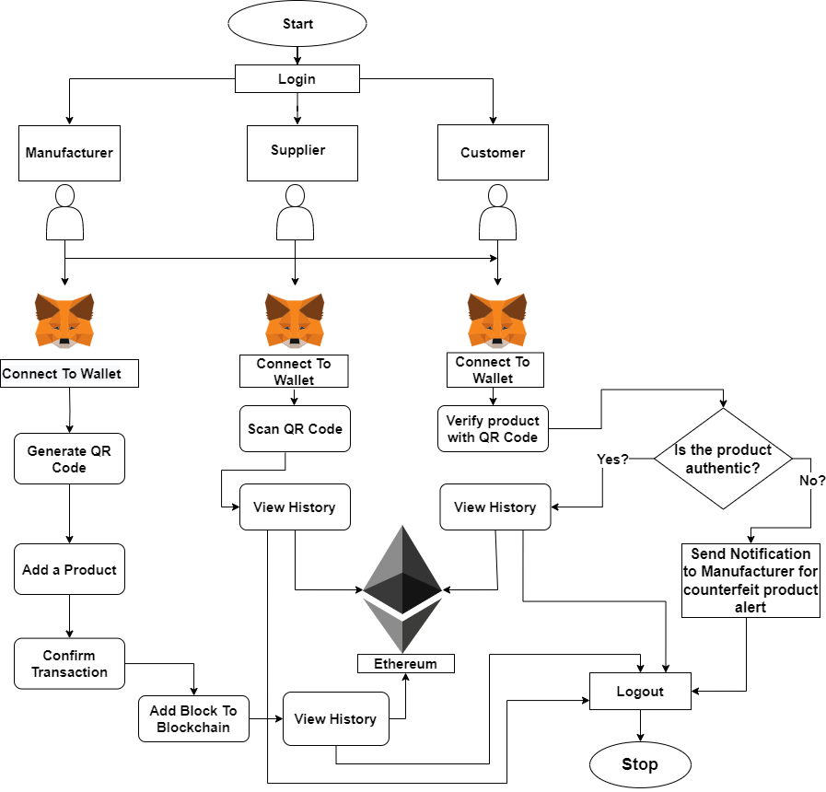A system flow diagram, also known as a system flowchart, is a visual representation of the flow of information or processes within a system. It typically uses symbols and arrows to illustrate the sequence of steps and decision points involved in a particular process or system [23].

Figure 3.8: System Flow Diagram (Group Study, 2024)

## 3.4 Smart Contracts Life Cycle

Smart contracts can be broken down into four major steps in the lifecycle. The lifecycle provided below is customized to be suitable in building our project [24].

1. Create: The smart contracts creation process involves the negotiation of contract in an iterative manner, followed by its implementation [24].
2. Freeze: After the creation of smart contracts, any transactions to the contract's wallet address is blocked, and the nodes start to operate based on the contract implementation [24].
3. Execute: After the contract's integrity is verified and the codes are executed in the inference engine of the smart contract, the contract is executed, which generates new transactions, and sets another state for the contract. This information is verified in the distributed ledger with the consensus mechanism [24].
4. Finalize: After the consensus process is completed to verify the new transactions, the contract's wallet is unfrozen, therefore completing the contract instructions to verify all transactions [24].

## 3.5 Testing and Maintenance

Before a project is made available to users, it must undergo testing to ensure its proper functionality. In this project, the application is subjected to various inputs to verify their validation and confirm that the application operates as intended. This testing process aims to determine whether the application behaves as expected and meets the desired requirements.

# Chapter 4: Result and Discussion

## 4.1 Output

Our project has made substantial progress in tackling the issue of counterfeiting faced by companies. This has been achieved through the integration of key technologies and the development of an intuitive user interface. Utilizing Ganache, a personal blockchain for Ethereum development, we have deployed contracts, developed applications, and conducted tests. Through FPISUB, we have successfully identified and monitored counterfeit products alongside genuine ones. This interface provides real-time updates on product additions and their movement across the entire blockchain using transaction hashes. These advancements mark a significant step forward in our project's aim to establish a seamless and efficient system for identifying fake products using blockchain technology.

## 4.2 Web Development

### 4.2.1 Frontend

The front-end environment for this project comprised of interactive, desirable and understandable web pages; Landing Page, Manufacturer Page, Seller Page, Consumer Page, Metamask Connection, are illustrated below:

**Landing Page**

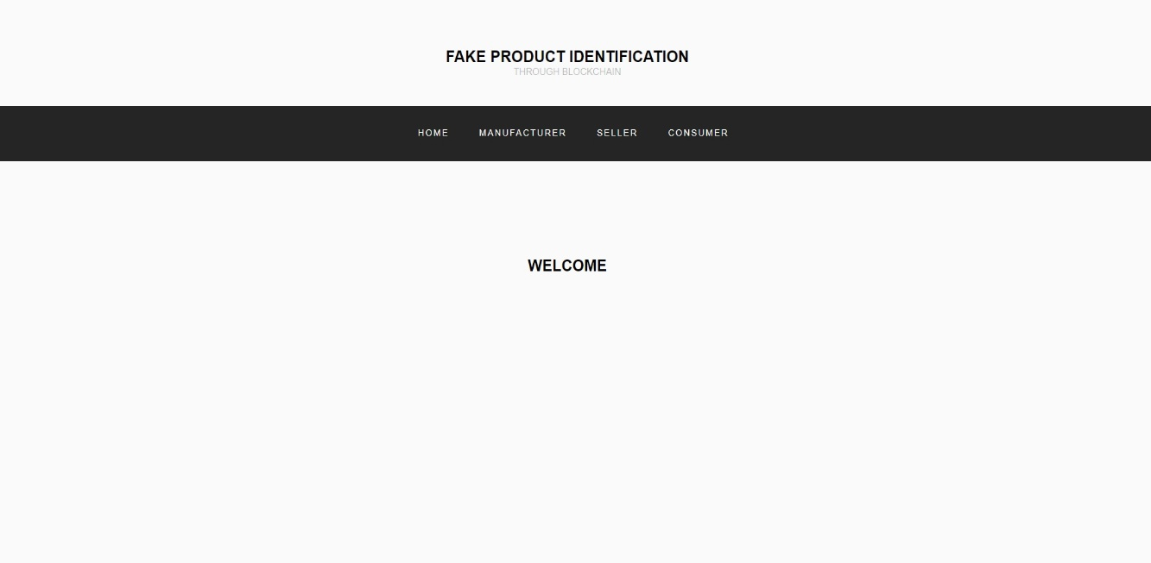This is the first page of the website; this is from where a user starts surfing the website.

Figure 4.1: Landing Page (Group Study, 2024)

**Manufacturer Page**

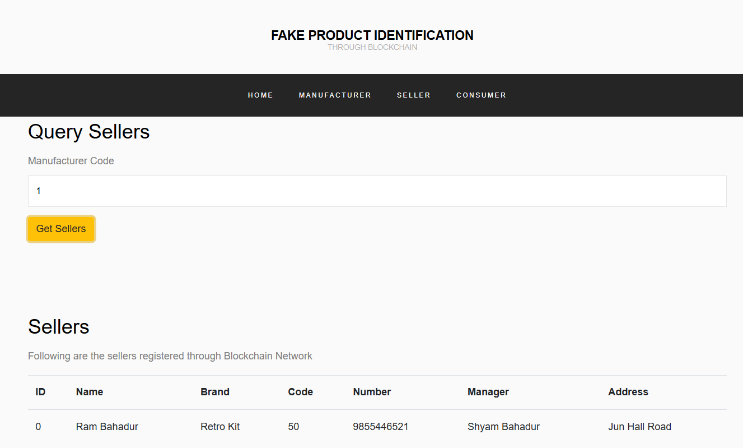This is the page of the website where manufacturer performs essential operations like adding sellers, products, selling products to seller and query the sellers linked to the manufacturer.

Figure 4.2 Manufacturer Page (Group Study, 202

Figure 4.2: Manufacturer Page (Group Study, 2024)

**Seller Page**

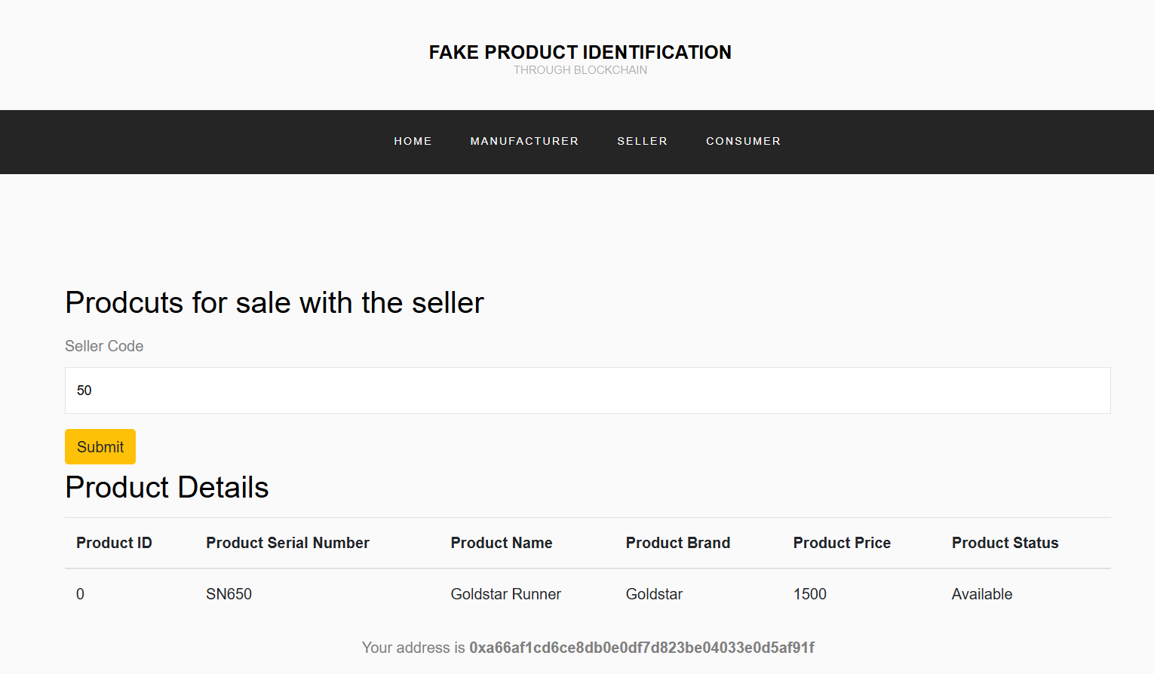This is the page of the website where seller performs essential operations like adding sellers, products, selling products to seller and query the products for sale linked to the seller.

Figure 4.3 Seller Page (Group Study, 2024)

Figure 4.3: Seller Page (Group Study, 2024)

**Consumer Page**

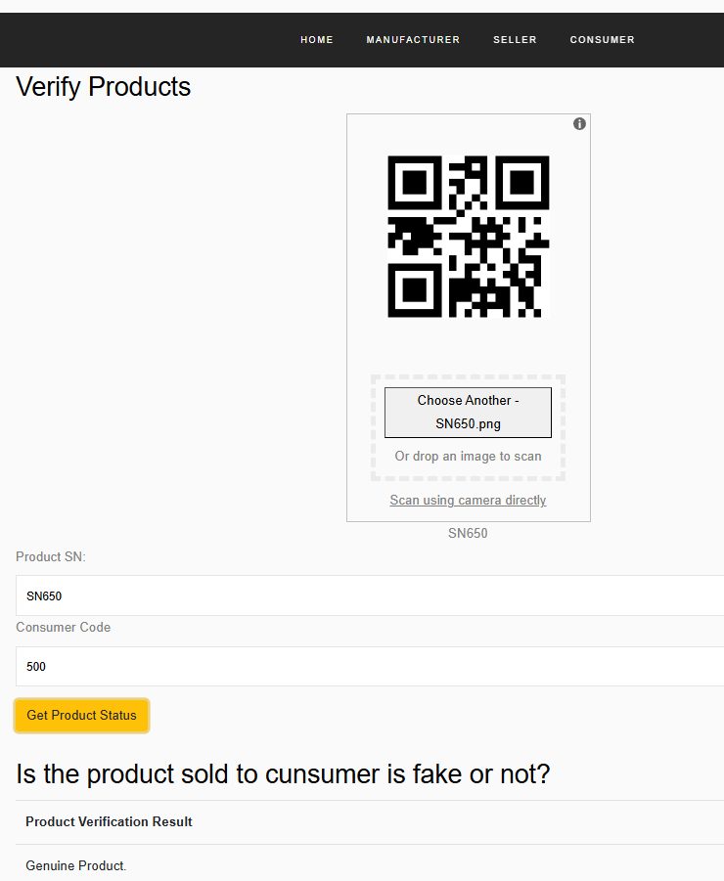This is the Consumer’s page where he/she can check for their purchase history and verify their product for authenticity using their Consumer code and QR.

Figure 4.4: Consumer Page (Group Study, 2024)

**Metamask Connection**

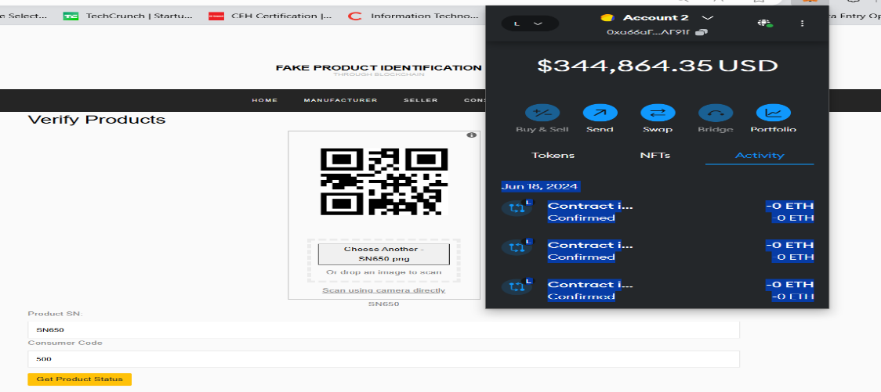We connect the metamask digital wallet to our website for confirming and signing contracts which can later be traced by their transaction hash.

Figure 4.5: Metamask Connection (Group Study, 2024)

### 4.2.2 Backend

To develop this project Truffle and Ganache were utilized as a backend local testing technology.

* **Deploying and Migrating Smart Contracts in FPISUB Using Ganache and Truffle**

In FPISUB utilizing Ganache, the process begins with compilation of the config file of truffle which deploys the smart contracts. After the compilation of the config js file, the file is now added into the Ganache GUI application, followed by the migration of the contracts written on Solidity into the blockchain. After this, the website is connected to the metamask wallet to perform operations by signing these contracts.

## 4.3 Pending Tasks

Figure 4.6 Local Blockchain Transactions (Group Study, 2024)

Figure 4.6: Local Blockchain Transactions (Group Study, 2024)

While FPISUB boasts significant progress, several crucial aspects require further development:

**1. Database Integration:** Integrating product’ and sellers’ data from our client company’s database to save time and ensure data redundancy as we have manually been entering the same data of the products and sellers that is with the company. We'll address this by designing a well-structured database schema and implementing robust data management practices to ensure seamless data integration and retrieval.

**2. User Interface (UI) Design and Usability:** Designing an intuitive and user-friendly interface is crucial for user adoption and efficient workflow integration. We'll conduct user testing throughout the development process to gather feedback and refine the UI, ensuring it's clear, easy to navigate, and caters to diverse user needs.

**3. Security:** As user bases and project data volume grow, security threats and scalability issues become more prominent. We'll prioritize implementing robust security measures (authentication, authorization, encryption) to protect user data. Additionally, we'll explore potential solutions like automation for alerting manufacturer when a fake product tries to be added into the blockchain to ensure FPISUB robustness.

## 4.4 Limitations

In offline transaction environments, our system’s impact is limited due to its reliance on digital records. Success hinges on broad acceptance across the supply chain, lack of adoption by manufacturers, retailers, and consumers reduces effectiveness. Resistance to industry-wide adoption, technological challenges, incomplete coverage of counterfeit risks, and the need for a broader marketplace shift present hurdles, potentially affecting the system’s effectiveness in countering product authentication and counterfeiting.

## 4.5 Issues Encountered

Issues Encountered during the development of the Fake Product Identification System Using Blockchain, several challenges were encountered. Addressing these issues was crucial to ensuring the robustness and reliability of the final system. Here are the key issues:

* **Gas Limit Issues:** Insufficient gas limits caused deployment transactions to fail.
* **Adaptation to new technology:** Adapting to new programming languages and keeping up with rapid technological advancements presented a steep learning curve for the development team.
* **Metamask Integration Issues:** Problems connecting Metamask to the local blockchain occurred due to incorrect RPC settings and network IDs.

## 4.6 Time Estimation

Before getting started with any project, we must prepare a working schedule consisting of several topics that we would be working on throughout the project development phase. For the same reason, the following is the Gantt chart representing our work schedule in a total span of 8 months, i.e., 32 weeks ranging from the phase after proposal defense to final report submission and defense:

Table 1: Gantt Chart of the project

## 4.7 Cost Estimation

The budget estimation of our Fake Product Identification System Using Blockchain (FPISUB) is considered by various factors such as the scope of the project, the desired features and functionalities, the complexity of implementation, and any specific customization or integration requirements. Here’s the table with the estimated cost range for our Fake Product Identification System Using Blockchain (FPISUB) project:

Table 2: Cost Estimation

|  |  |
| --- | --- |
| **Cost Element** | Estimated Cost Range (NPR) |
| Infrastructure and Hosting | NPR 5,000 – NPR 10,000 |
| Testing and Quality Assurance | NPR 5,000 – NPR 10,000 |
| Training and Documentation | NPR 5,000 – NPR 10,000 |
| Maintenance and Support | NPR 10,000 – NPR 25,000 |

# Chapter 5: Conclusion and Future Enhancement

## 5.1 Conclusion

In conclusion, the implementation of the Fake Product Identification System Using Blockchain is anticipated to revolutionize the landscape of product authentication and counterfeiting prevention. With the adoption of blockchain in the supply chain, a heightened level of product authenticity is expected, instilling confidence in consumers and stakeholders. The robust measures integrated into the system aim to effectively reduce the circulation of counterfeit goods, safeguarding manufacturers' interests and ensuring consumer safety. Empowerment of stakeholders, including high-end brands, consumers is foreseen through transparent and traceable information. The success of the system relies on widespread industry adoption, leading to a reduction in counterfeit risks, technological advancements in authentication, and an overall shift toward a more secure and trustworthy marketplace.

## 5.2 Future Enhancements

To further improve the functionality and impact of the Fake Product Identification System Using Blockchain project, several avenues can be explored:

* + **Interoperability with Other Blockchains:** Enable cross-chain compatibility for greater flexibility.
  + **Mobile Application Development:** Develop iOS and Android apps for better accessibility.
  + **Support for Additional Cryptocurrencies:** Extend support to include additional cryptocurrencies for transaction payments and rewards.

# REFERENCES

[1] S. Jambhulkar, H. Bhoyar, S. Dhore, A. Bidkar, and P. Desai, “BLOCKCHAIN BASED FAKE PRODUCT IDENTIFICATION SYSTEM.” [Online]. Available: www.irjmets.com

[2] E. Daoud, D. Vu, H. Nguyen, and M. Gaedke, “IMPROVING FAKE PRODUCT DETECTION USING AI-BASED TECHNOLOGY,” IADIS - International Association for the Development of the Information Society, Apr. 2020, pp. 119–125. doi: 10.33965/es2020_202005l015.

[3] A. Jain, A. Vats, K. Bhatnagar, M. Tyagi, and P. Tripathi, “Volume 6-Issue 2, August 2023 Paper : 08 Fake Product Identification Using Blockchain Fake Product Identification Using Blockchain.”

[4] A. Hongekar, A. Jaju, P. Bhargade, N. Acharya, and A. Pawar, “A Survey on Fake Product Identification System,” *Article in International Journal of Engineering Research*, 2023, doi: 10.17577/IJERTV12IS010063.

[5] *Global Trade in Fakes*. in Illicit Trade. OECD, 2021. doi: 10.1787/74c81154-en.

[6] “Web3 for Better Whitepaper 3.0,” 2023.

[7] J. Golosova, S. Remese, and A. Romanovs, “Development of the Business Processes Modelling Lab Tools,” in *2019 Open Conference of Electrical, Electronic and Information Sciences, eStream 2019 - Proceedings*, Institute of Electrical and Electronics Engineers Inc., Apr. 2019. doi: 10.1109/eStream.2019.8732148.

[8] “OriginTrail Ecosystem White Paper 2.0.”

[9] R. Azzi, R. K. Chamoun, and M. Sokhn, “The power of a blockchain-based supply chain,” *Comput Ind Eng*, vol. 135, pp. 582–592, Sep. 2019, doi: 10.1016/j.cie.2019.06.042.

[10] I. Malta, H. Nguyen, and L. Do, “THE ADOPTION OF BLOCKCHAIN IN FOOD RETAIL SUPPLY CHAIN Case: IBM Food Trust Blockchain and the Food Retail Supply Chain The adoption of blockchain in food retail supply chain Case: IBM Food Trust Blockchain and the food retail supply chain in Malta Bachelor of Business Administration,” 2018.

[11] F. Maurer, M. Cohn, M. Griffiths, J. Highsmith, K. Schwaber, and P. Kruchten, “Agile Project Management,” Jan. 2004, p. 201. doi: 10.1007/978-3-540-27777-4_29.

[12] A. Watt, “Project Management,” 2014. [Online]. Available: http://open.bccampus.ca

[13] Jennifer. Niederst Robbins, *Learning Web design : a beginner’s guide to HTML, CSS, JavaScript, and web graphics*.

[14] M. Christian Klimm and S. Bente, “Design Systems for Micro Frontends An Investigation into the Development of Framework-Agnostic Design Systems using Svelte and Tailwind CSS.”

[15] Steve. Suehring, *MySQL bible*. Wiley Pub, 2002.

[16] “VisualStudioCode-TipsAndTricks-Vol.1”.

[17] C. Dannen, “Solidity Programming,” in *Introducing Ethereum and Solidity: Foundations of Cryptocurrency and Blockchain Programming for Beginners*, C. Dannen, Ed., Berkeley, CA: Apress, 2017, pp. 69–88. doi: 10.1007/978-1-4842-2535-6_4.

[18] H. Sun, C. Humer, D. Bonetta, and W. Binder, “Efficient dynamic analysis for node.Js,” in *CC 2018 - Proceedings of the 27th International Conference on Compiler Construction, Co-located with CGO 2018*, Association for Computing Machinery, Inc, Feb. 2018, pp. 196–206. doi: 10.1145/3178372.3179527.

[19] S. L. Bangare, S. Gupta, M. Dalal, and A. Inamdar, “Using Node.Js to Build High Speed and Scalable Backend Database Server,” 2016. [Online]. Available: www.ijrat.org

[20] S. Sayeed, H. Marco-Gisbert, and T. Caira, “Smart Contract: Attacks and Protections,” *IEEE Access*, vol. 8, pp. 24416–24427, 2020, doi: 10.1109/ACCESS.2020.2970495.

[21] Y. S. Alslman and A. A. Taleb, “Exchanging Digital Documents Using Blockchain Technology,” in *3rd International Conference on Electrical, Communication and Computer Engineering, ICECCE 2021*, Institute of Electrical and Electronics Engineers Inc., Jun. 2021. doi: 10.1109/ICECCE52056.2021.9514253.

[22] M. Steichen, B. Fiz, R. Norvill, W. Shbair, and R. State, “Blockchain-Based, Decentralized Access Control for IPFS,” in *2018 IEEE International Conference on Internet of Things (iThings) and IEEE Green Computing and Communications (GreenCom) and IEEE Cyber, Physical and Social Computing (CPSCom) and IEEE Smart Data (SmartData)*, IEEE, Jul. 2018, pp. 1499–1506. doi: 10.1109/Cybermatics_2018.2018.00253.

[23] A. Saad, N. Hambira, H. M. Zin, R. Johan, and W. S. Li, “Object oriented VS structured analysis and design in system development courses,” *Int J Eng Adv Technol*, vol. 8, no. 6 Special Issue 3, pp. 82–88, Sep. 2019, doi: 10.35940/ijeat.F1014.0986S319.

[24] Z. Zheng *et al.*, “An Overview on Smart Contracts: Challenges, Advances and Platforms,” Dec. 2019, doi: 10.1016/j.future.2019.12.019.