LAB 10

Recovering a Database From a Critical Error With Journaling Commands

Lab activities:

1. Create a collection

2. View special objects used for commitment control

3. Copy a table into the collection using interactive SQL

4. View table contents and then make a small update that we want to keep.

5. Make a mistaken mass update that we will need to reverse.

6. Use the DSPJRN command to view table activities – adds and updates.

7. Determine what journal entries needs to be rolled back.

8. Use the RMVJRNCHG command to implement the rollback.

9. Prove that the table is now in the correct state using interactive SQL.

10. Investigate required commands to support journaling if a native CRTLIB command was used instead of an SQL CREATE COLLECTION command.

Creating a Collection

1. STRSQL

Create Collection JRN201??? (where ??? is the last three characters of your account

(what did you enter in interactive SQL?

CREATE COLLECTION JRN201A22

Exit from interactive SQL

Viewing Special Objects used for Commitment Control and Journaling

2. In all cases note the QSQJRN journal and QSQJRN0001 journal receiver

In Client Access WRKOBJPDM JRN201???

In iSeries Navigator

In RDi (not used in DBS201)

Client Access

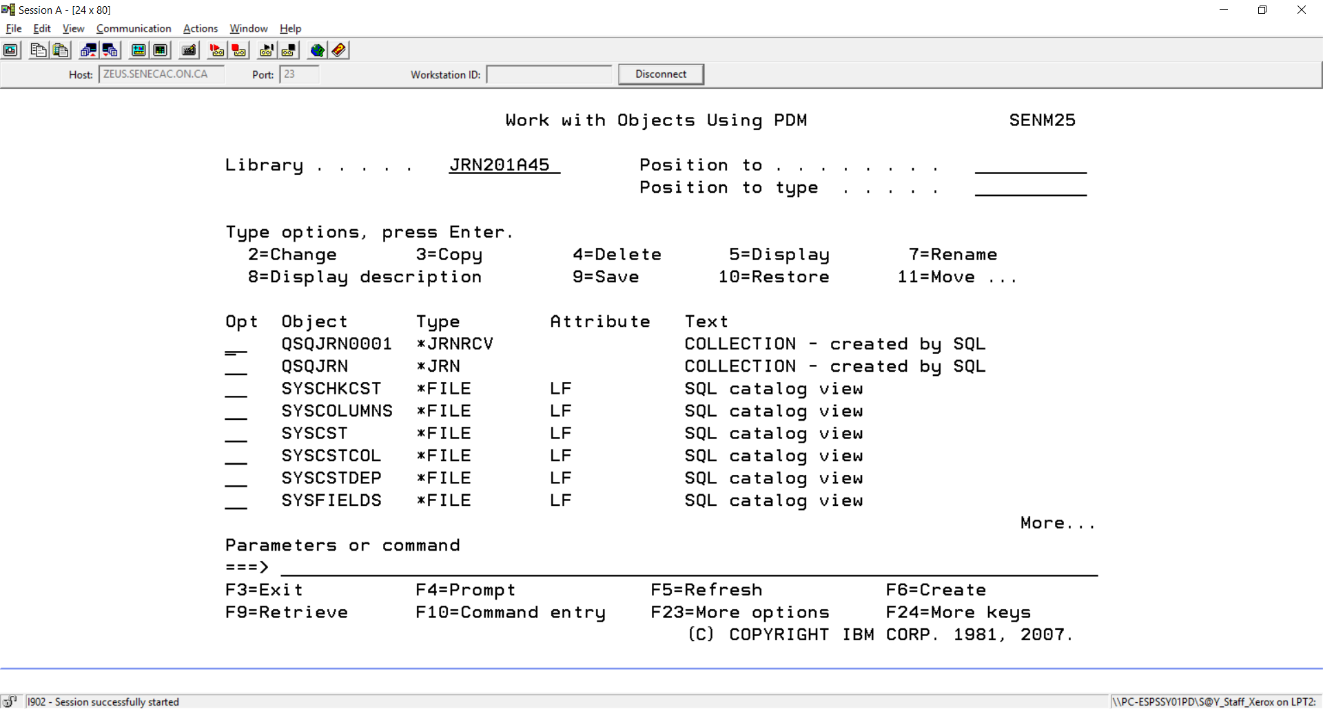

System i Navigator

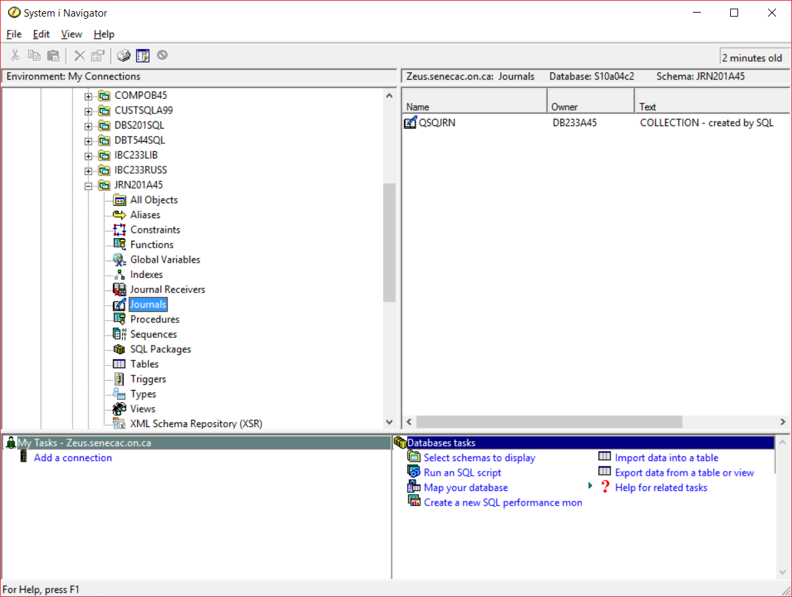

RDi

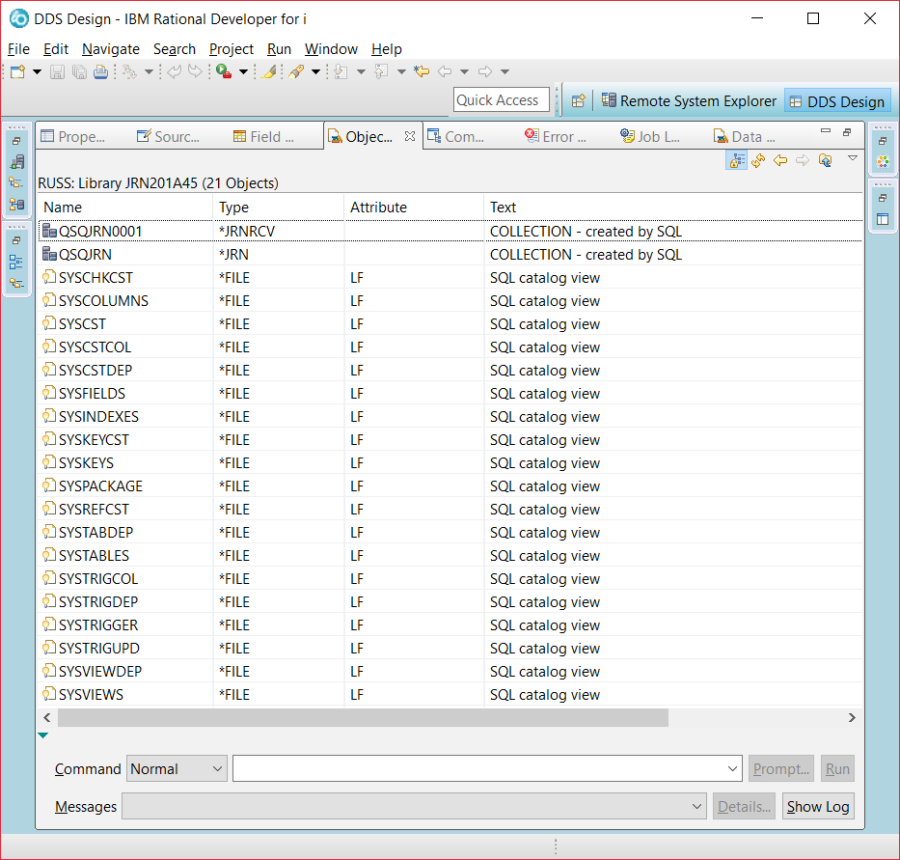

Copy a table into the collection using interactive SQL

3. In Client Access for remaining steps

STRSQL

SET SCHEMA JRN201???

COPY TABLE CUSTOMER19 FROM DBS201SQL

CREATE TABLE CUSTOMER19

AS (SELECT * FROM DBS201SQL.CUSTOMER19) WITH DATA

View table contents and then make a small update that we want to keep.

4. SELECT * FROM CUSTOMER19 (check data)

Then change the CUSTOMERNAME to your name for CUSTOMERNUMBER 579

UPDATE CUSTOMER19

SET CUSTOMERNAME = ‘HAASHER’

WHERE CUSTOMERNUMBER = 579

SELECT * FROM CUSTOMER19 (recheck data)

Make a mistaken mass update that we will need to reverse.

5. Change all addresses (CUSTOMERADDR) to SENECA COLLEGE.

UPDATE CUSTOMER19

SET CUSTOMERADDR = 'SENECA COLLEGE'

SELECT * FROM CUSTOMER19 (check data)

6. EXIT FROM INTERACTIVE SQL

Use the DSPJRN command to view table activities – adds and updates.

DSPJRN JRN(JRN201A22/QSQJRN) (F4)

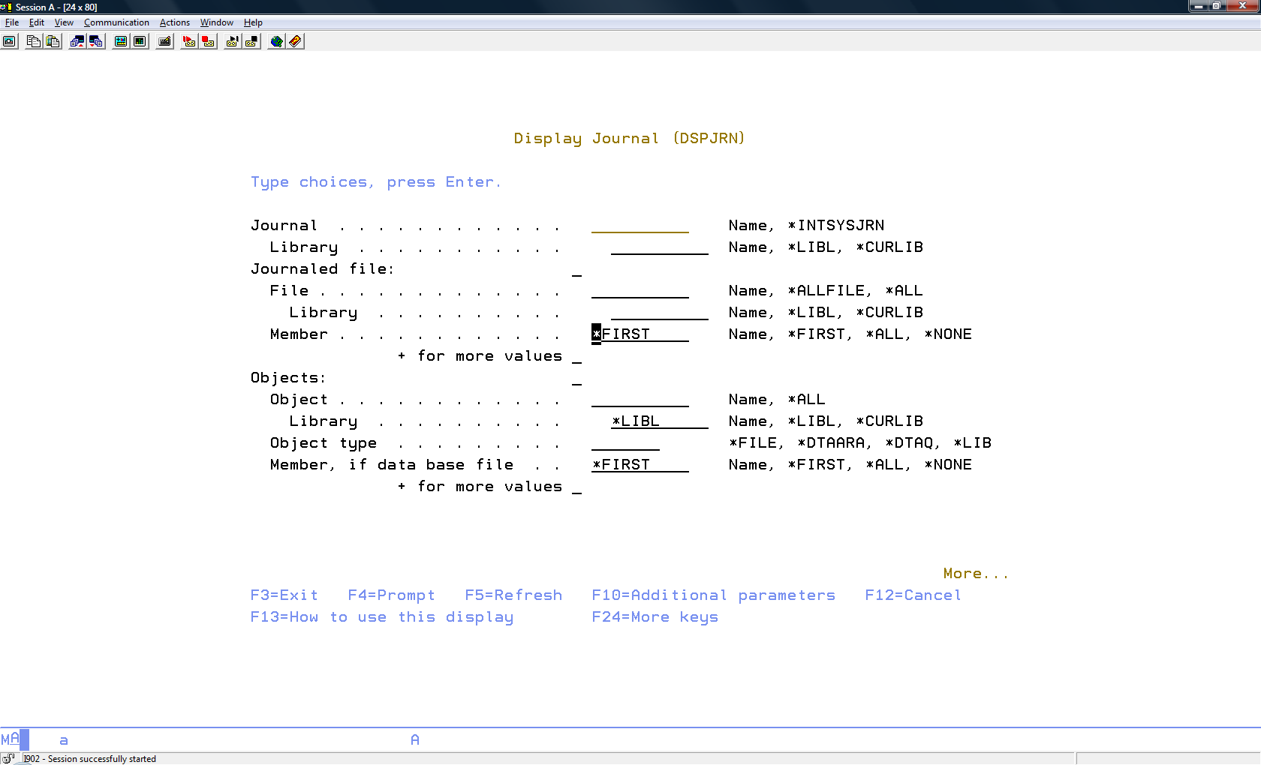

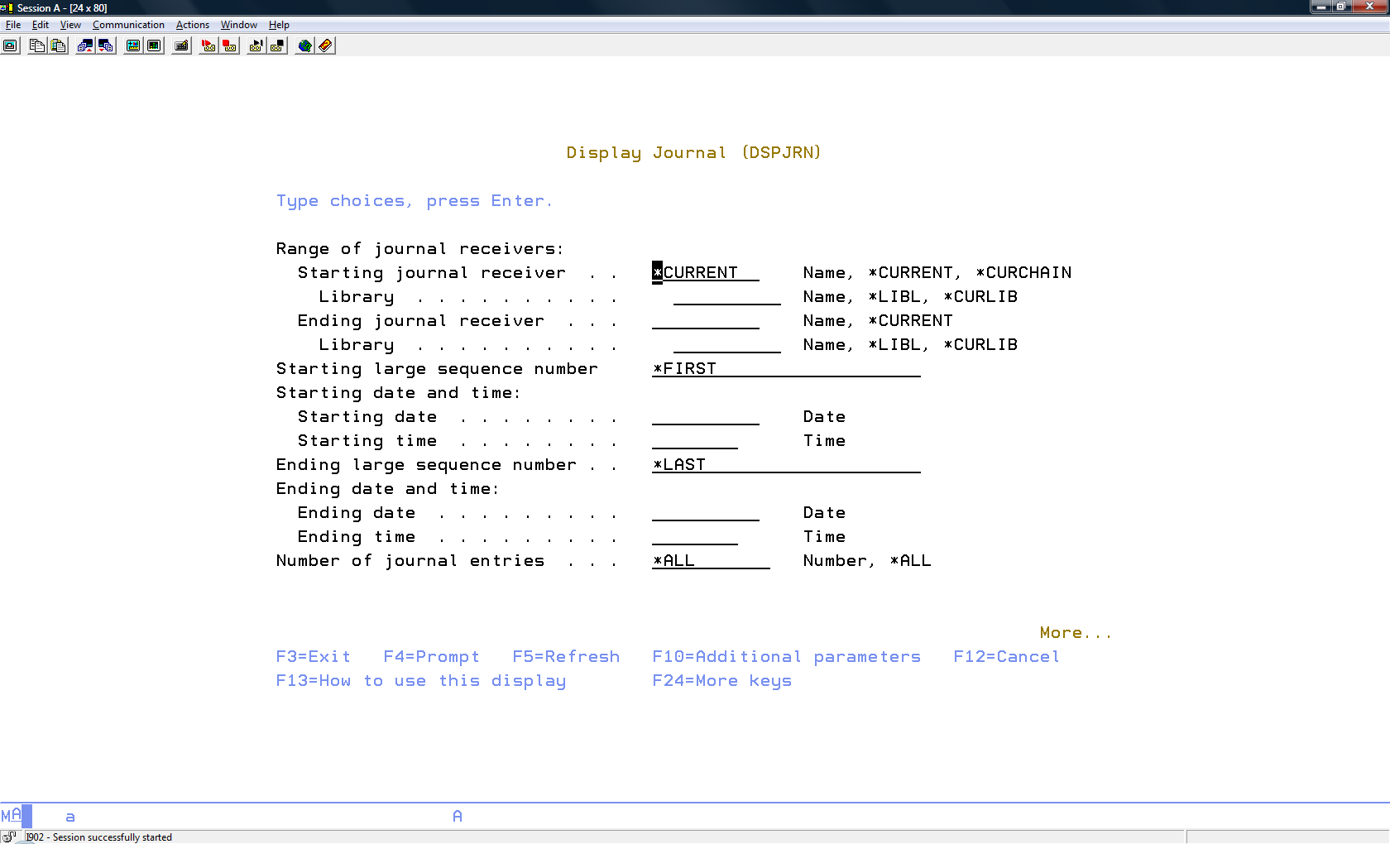

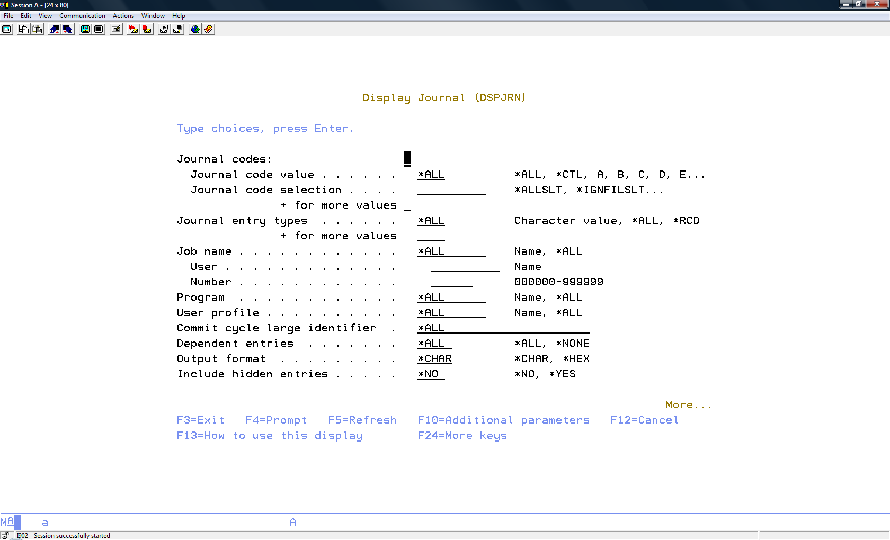

7. (screenshots show CUSTOMER17 – you are working with CUSTOMER19)

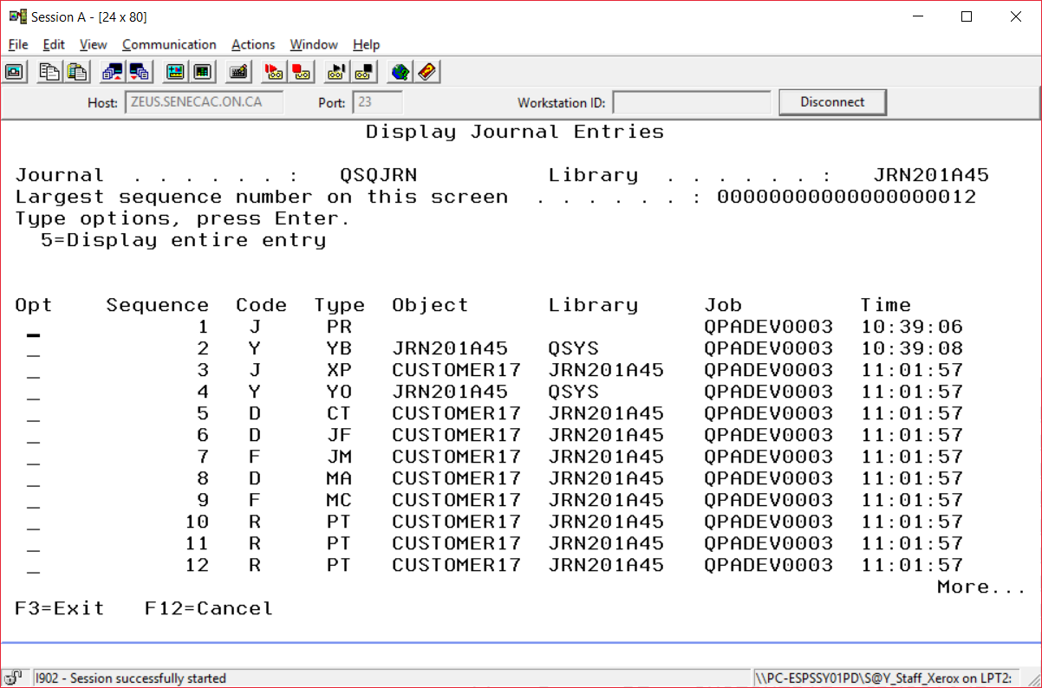

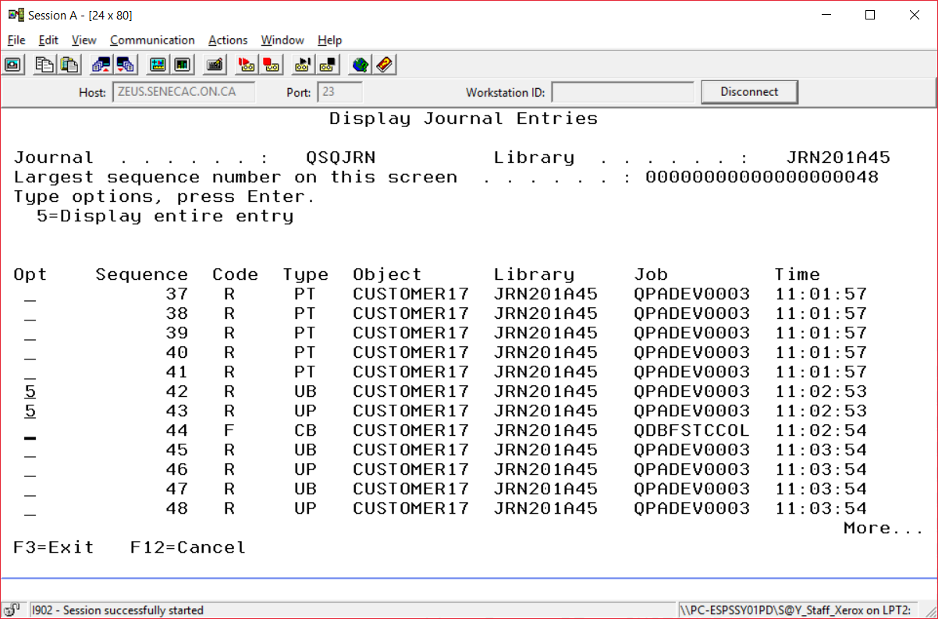

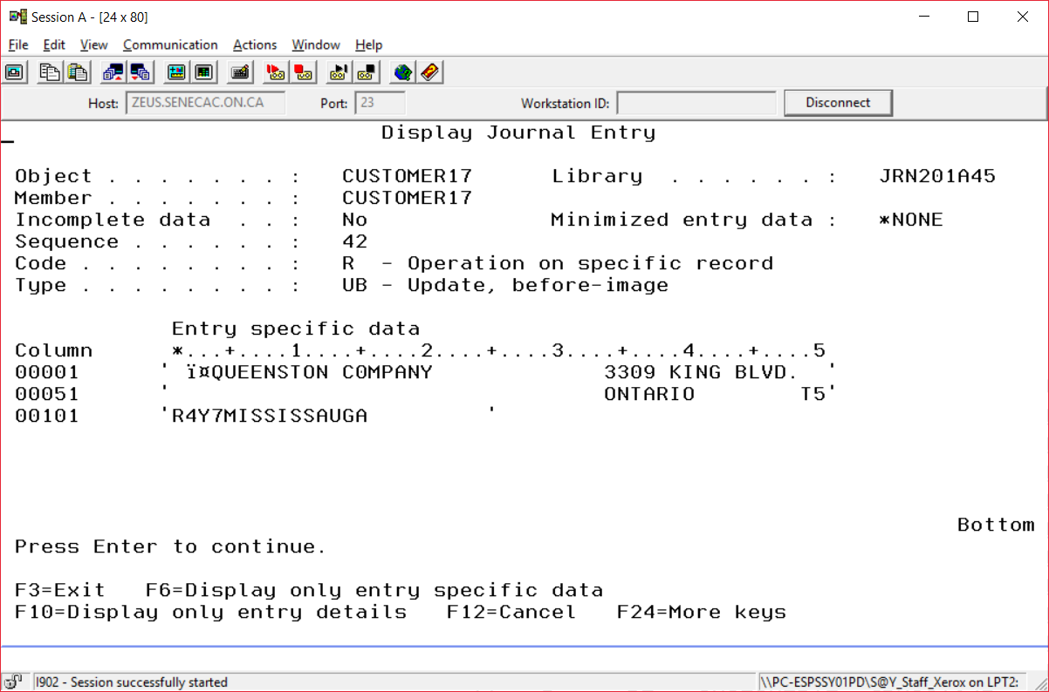

NOTE Your name would show instead of RUSSELL PANGBORN

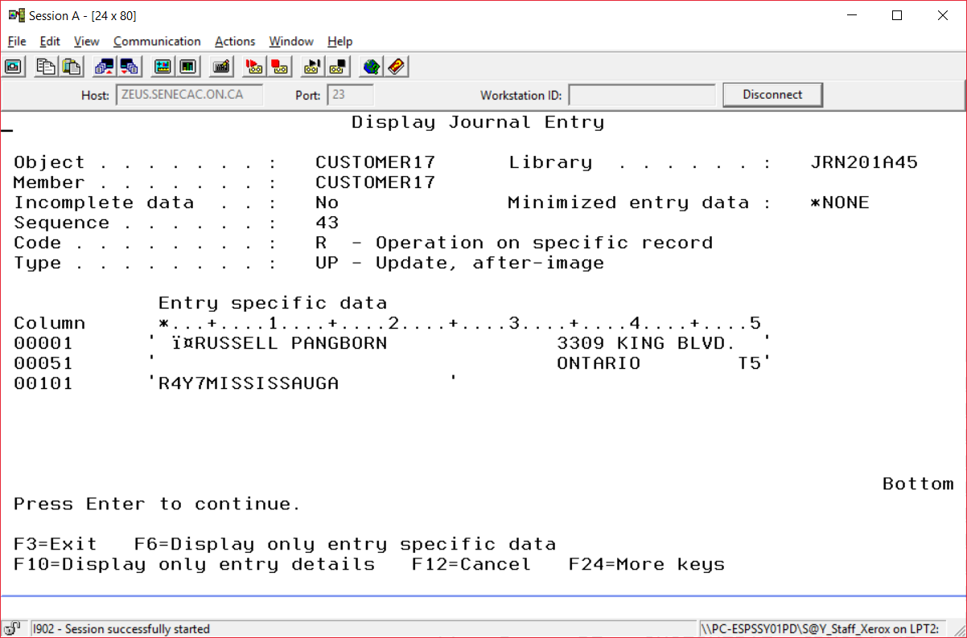

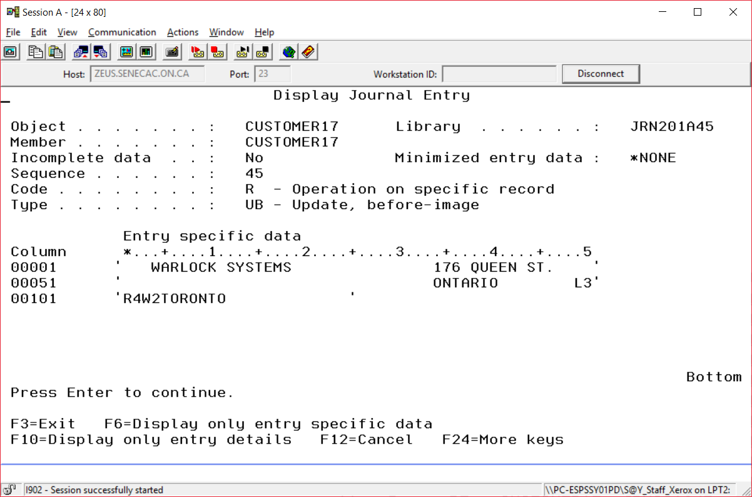

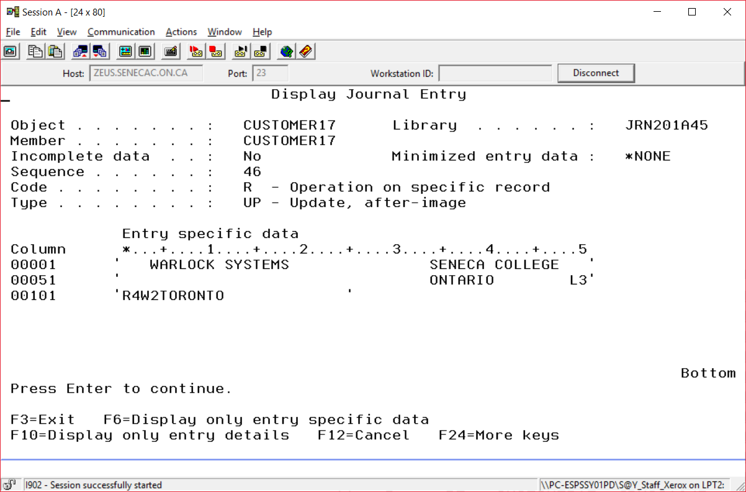

At Bottom (no more changed records)

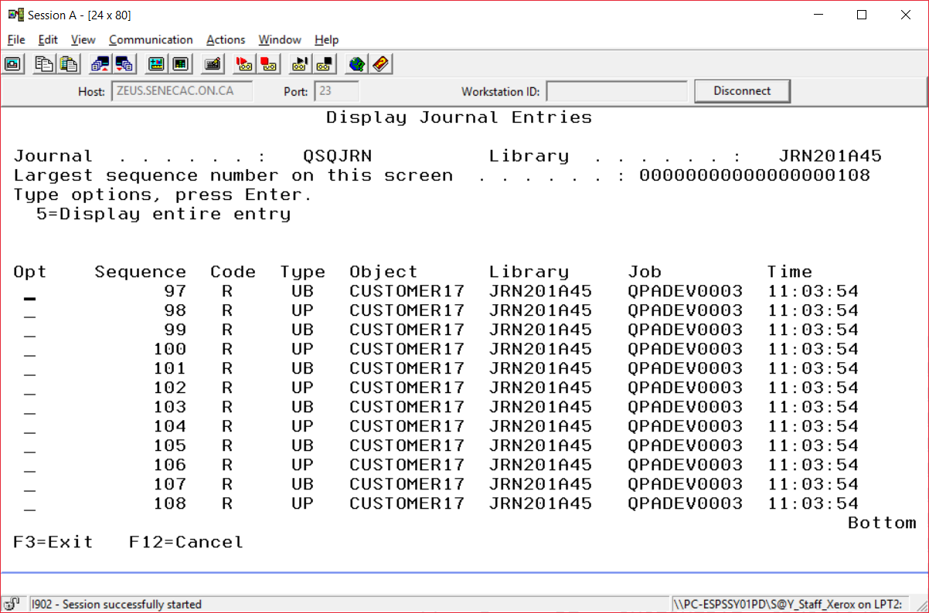

8. RMVJRNCHG JRN(JRN201A22/QSQJRN) (F4)

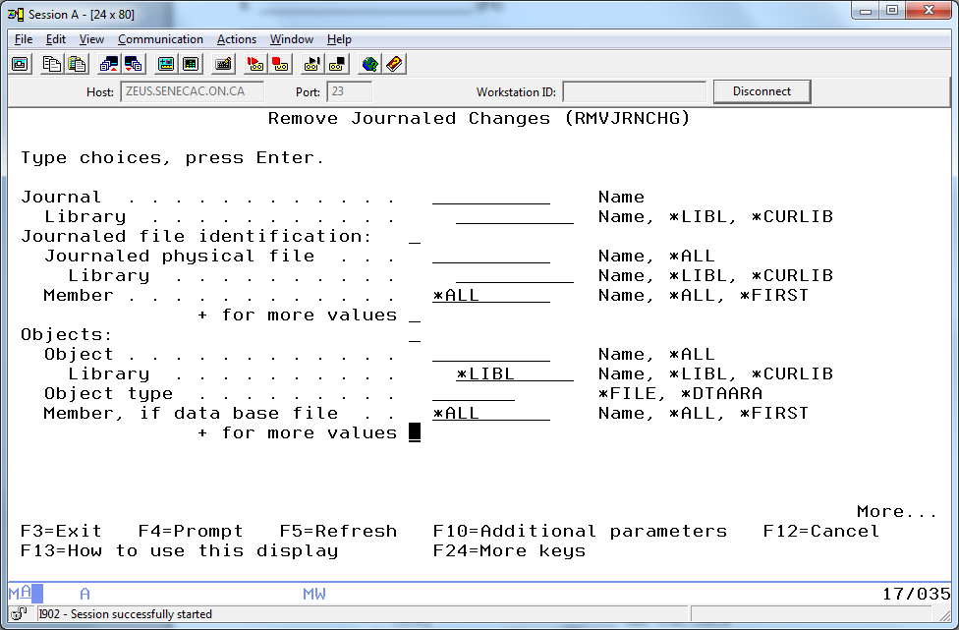

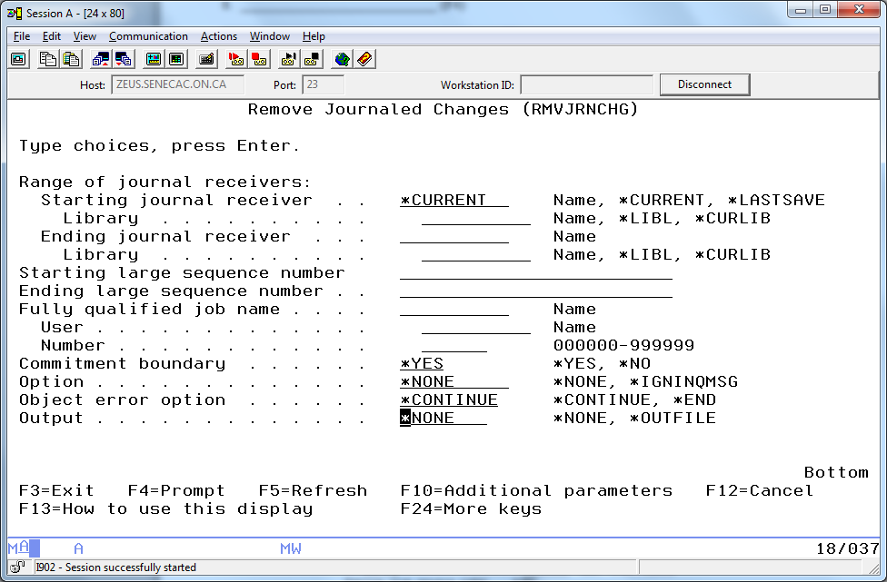

Should get the message: 32 entries removed for 1 objects

9. (To check) STRSQL

SELECT * FROM JRN201???/CUSTOMER19 The name update for customer 579 retained, the incorrect mass address update reversed

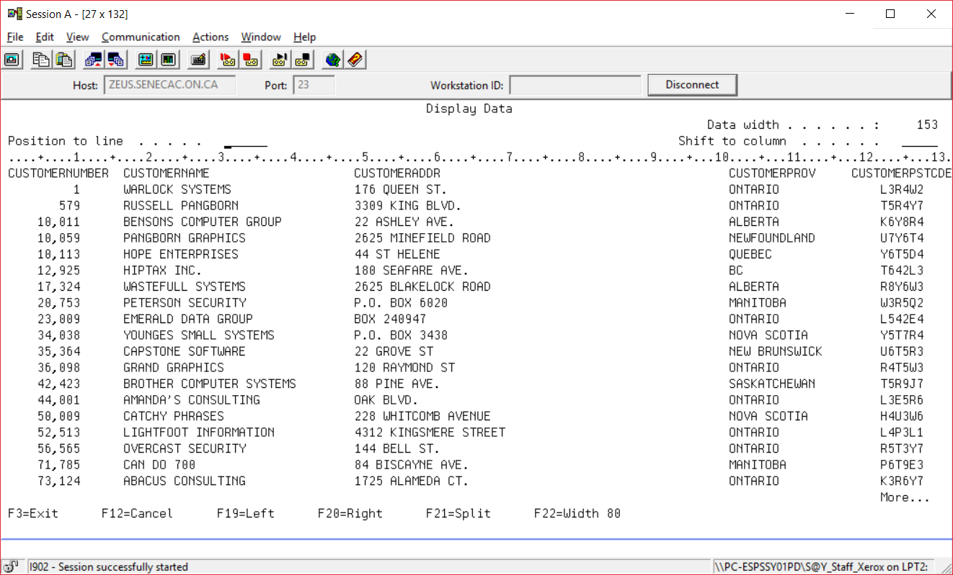

10. Exit SQL (F3)

CRTLIB NOJRN??? Where ??? is the last three characters of your id.

STRSQL

SET SCHEMA NOJRN???

USE F9 TO FIND YOUR CREATE TABLE COMMAND AND RERUN IT.

What is your warning about journaling? Table CUSTOMER19 in NOJRNA22 created but was not journaled.

We have some work to do.

1. Create the journal receiver CRTJRNRCV JRNRCV(NOJRNA22/QSQJRNRCV)

include the appropriate library references (NOJRN???)

2. Create the journal CRTJRN JRN(NOJRNA22/SQSJRNRCV) JRNRCV(NOJRNA22/QSQJRNRCV)

include the appropriate library references (NOJRN???)

3. Start journaling the physical file (table)

_____________________________________________________________________________________

Note to run the RMVJRNCHG command you need to record *BOTH record images.

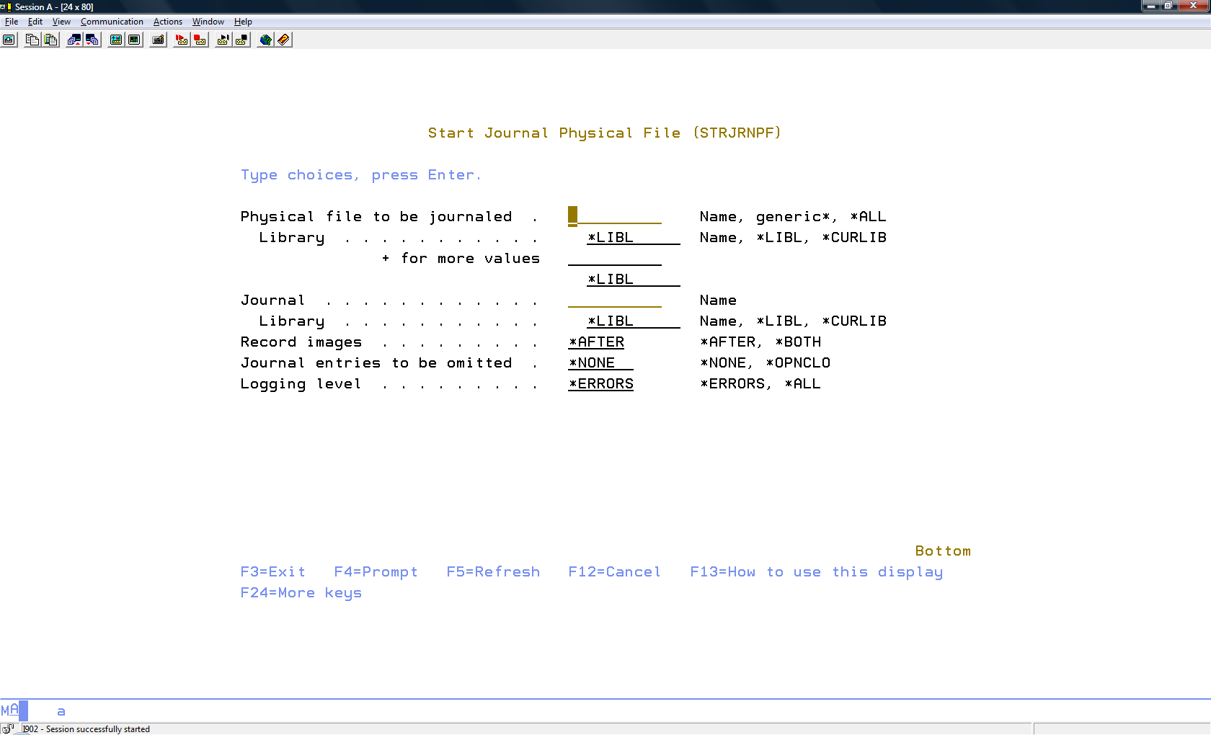

You can optionally omit *OPNCLO

4. Retry the first exercise.

First delete record number 1 (we want to keep that action)

Second do a mass update on all the records

Recover from that mistaken mass update.

LAB 10 SUBMISSION

Your instructor will ask you for one or more of: the answers filled in above, or selected printouts from this lab or a demonstration of a mistaken mass update and recovery.