SmartCare v0.5 - Architecture and Refactoring Workbook
Week 8 student resource

Current Architecture Problems
Problem | Evidence | Impact | Refactoring
Double-booking rules have no home. | Last week’s requirements were that duplicate bookings needed to be prevented. Appointment currently only knows itself, not other appointments. | Duplicate bookings might still happen. | Appointment service.book asks the repository before creating the appointment.
My demo/test code is all on one file, meaning their is a lack of user interface part. | completeClasses.py had everything on it. No separate python files | Very confusing, but also importing classes did not work correctly. | Split the classes into their own files.
Nowhere to store appointments | No way to list patient history or check a booking for a certain practitioner. | Nothing is kept between steps in the program. | Added appointment repository.

Layer Responsibilities
Layer | Responsibilities | Must not contain
Presentation | Creates the objects and service, calls that service and then shows the results to the user. | Any business rules
Service | Coordinates the workflow. Asks for data and calls for domain method. | Knowledge of how data is stored or rules that belong to just one domain object
Domain | Patient, practitioner, staff, appointment.  Validates data and enforces rules about an object | Workflows that span other appointments
Repository | The contract part describes how appointment storage should work. | Business rules
Persistence | Holds the list of appointments from the repository and fills in the contract’s method. | Business rules or any workflow logic

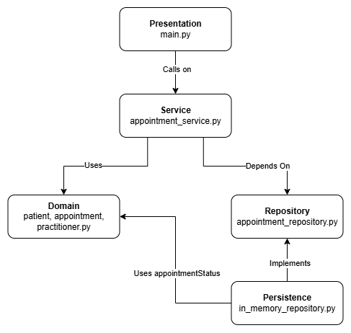
Architecture Diagram

SOLID Review
Principle | Relevant? | Evidence | Decision
SRP | Yes | Each class and layer only has 1 job. E.g. appointments own its own status rules. | Keep the layers separate.
OCP | Yes | A new type of storage could be added by just writing a new class. There would be no change to service. | Keep in mind if more features need to be added in the future.
LSP | Not really | There is inheritance when inmemoryappointmentrepository inherits from appointment repository. | It isn’t required so I think I’ll leave it as is.
ISP | Yes | Repository contact has only three methods that are used. | Only add methods when needed.
DIP | Yes | Appointmentservice imports the appointment repository abstraction, instead of the in-memory class. | Keep this.

AI Architecture Review
AI suggestion | Observed problem? | Decision | Reason | Verification
Move the check for double bookings into a service using a repository. | Yeah. Appointment is unable to know of other appointments | Accepted | Code that can see all appointments can enforce the rule. | In main.py, there is a check to see if a booking is in the same slot and it is rejected.
Create an interface for every class. | Not really, they aren’t required | Denied | Not a requirement of the system right now. | All of the tests in main.py pass without adding this.
Check that patient IDs and practitioner IDs are not the same. | Is a problem for sure but not required for this system right now. | Denied (for now) | Would need to make repositories. | Not implemented as of right now.
Replace time and day strings with a datetime variable instead. | Maybe. If an appointment is booked at a time that isn’t the exact time but still overlaps then yes, that would be a big problem. But it depends on how appointment time slots are setup. | Denied (for now) | Not in the UML | A clash is only on the same day and time exactly.

