EasyOpenVPN

Kenny Hunter

Beesham Sarendranauth

CENG609

2015/04/27

Contents

Introduction 1

Platform Specifications 2

Source Code 3

Implementation 8

OSI Model Interaction 9

Demonstration 10

Conclusion 11

Appendices

# Introduction

OpenVPN is an open-source software application that allows connection from point-to-point or site-to-site using a secure connection. It implements VPN techniques to create the secure connection needed. It uses a custom protocol that utilizes key exchange(SSL[Secure Sockets Layer]/TSL[Transport Layer Security]).

OpenVPN allows for peer authentication. That is, when connecting to another location, some sort of verification must happen. This is basically the pre-shared key that was generated when the OpenVPN server was setup.

A normal VPN client can be used to connect to the OpenVPN as long it has the client information needed by the server to authenticate.

# Platform Specifications

OpenVPN can be installed on a Windows distribution or a Linux distribution but for the purpose of this study we will be using a Linux distribution (CentOS7/Debian).

# Source Code

#!/bin/bash

clear

echo "******************************************"

echo "* Welcome to EasyOpenVPN Installer *"

echo "* by: Beesham and Kenneth *"

echo "******************************************"

echo " "

#checks if user is running file as root

if [ "$(id -u)" != "0" ]; then

echo "**This script must be run as root**" 1>&2

echo "**Please log in as root then re-run script**"

exit 1

fi

OS=centos

#RCLOCAL='/etc/rc.d/rc.local'

#chmod +x /etc/rc.d/rc.local

#Display Welcome Messages and Step by Step

echo "Hello, Welcome to EasyOpenVPN!, Sit back and relax during this setup!"

echo " "

echo "************ BASIC SETUP ****************"

echo "1) What is the IPv4 Address of the network interface you want to connect to?"

read -p "IPv4 Address: " IP

echo " "

echo "2) What port do you want OpenVPN on? (1194 is standard)"

read -p "Port: " PORT

echo " "

echo "3) Do you want to listen to port 53 as well?"

read -p "Port 53 (y/n): " OTHERPORT

echo ""

echo "4) Enable internal networking?"

read -p "Allow (y/n)? " INTERNAL

echo ""

echo "5) Enter Country Code (ex. CA, US)"

read -p "Code: " CONCODE

echo ""

echo "6) Enter Province/State (ex. Ontario)"

read -p "Prov/State: " PROVINCE

echo ""

echo "7) Enter City (ex. Toronto)"

read -p "City: " CITY

echo ""

echo "8) Enter Company Name (ex. Google)"

read -p "Name: " COMPANY

echo ""

echo "9) Enter EmailL"

read -p "Email: " EMAIL

echo ""

echo "10) What is your Client Name?"

read -p "Name: " NAME

echo ""

echo "GREAT!, we are done!, now we will install all the packages for you"

#Install all the Packages

yum install epel-release -y

yum install openvpn iptables openssl wget -y

wget --no-check-certificate -O ~/easy-rsa.tar.gz https://github.com/OpenVPN/easy-rsa/archive/2.2.2.tar.gz

tar xzf ~/easy-rsa.tar.gz -C ~/

mkdir -p /etc/openvpn/easy-rsa/2.0/

cp ~/easy-rsa-2.2.2/easy-rsa/2.0/* /etc/openvpn/easy-rsa/2.0/

rm -rf ~/easy-rsa-2.2.2

rm -rf ~/easy-rsa.tar.gz

#Make a New Client

newclient () {

# Generates the client.ovpn

cp /usr/share/doc/openvpn*/*ample*/sample-config-files/client.conf ~/$1.ovpn

sed -i "/ca ca.crt/d" ~/$1.ovpn

sed -i "/cert client.crt/d" ~/$1.ovpn

sed -i "/key client.key/d" ~/$1.ovpn

echo "<ca>" >> ~/$1.ovpn

cat /etc/openvpn/easy-rsa/2.0/keys/ca.crt >> ~/$1.ovpn

echo "</ca>" >> ~/$1.ovpn

echo "<cert>" >> ~/$1.ovpn

cat /etc/openvpn/easy-rsa/2.0/keys/$1.crt >> ~/$1.ovpn

echo "</cert>" >> ~/$1.ovpn

echo "<key>" >> ~/$1.ovpn

cat /etc/openvpn/easy-rsa/2.0/keys/$1.key >> ~/$1.ovpn

echo "</key>" >> ~/$1.ovpn

}

#Change Directory to Easy-RSA location

cd /etc/openvpn/easy-rsa/2.0/

#Remove Verison of OpenSSL to make it easier programming ;)

cp -u -p openssl-1.0.0.cnf openssl.cnf

#Change all the Vars Values

#Set to 2048 bit encyption

sed -i 's|export KEY_SIZE=1024|export KEY_SIZE=2048|' /etc/openvpn/easy-rsa/2.0/vars

#Set Country Code

sed -i 's|export KEY_COUNTRY="US"|export KEY_COUNTRY=$CONCODE|' /etc/openvpn/easy-rsa/2.0/vars

#Set Province / State

sed -i 's|export KEY_PROVINCE="CA"|export KEY_PROVINCE=$PROVINCE|' /etc/openvpn/easy-rsa/2.0/vars

#Set City

sed -i 's|export KEY_CITY="SanFrancisco"|export KEY_CITY=$CITY|' /etc/openvpn/easy-rsa/2.0/vars

#Set Org/Company

#sed -i 's|export KEY_ORG="Fort-Funston"|export KEY_ORG=$COMPANY|' /etc/openvpn/easy-rsa/2.0/vars

#Set Admin Email

sed -i 's|export KEY_EMAIL="me@myhost.mydomain"|export KEY_EMAIL=$EMAIL|' /etc/openvpn/easy-rsa/2.0/vars

# Create the PKI

. /etc/openvpn/easy-rsa/2.0/vars

. /etc/openvpn/easy-rsa/2.0/clean-all

#We are going to use the Easy-RSA Script from GitHub. The only problem

#is this script needs to be updated in Build-ca changes format

export EASY_RSA="${EASY_RSA:-.}"

"$EASY_RSA/pkitool" --initca $*

# We are going to run the Build Key Server!

export EASY_RSA="${EASY_RSA:-.}"

"$EASY_RSA/pkitool" --server server

#Now the client keys.

export KEY_CN="$NAME"

export EASY_RSA="${EASY_RSA:-.}"

"$EASY_RSA/pkitool" $NAME

# DH params

. /etc/openvpn/easy-rsa/2.0/build-dh

# Time to Confiugre the Server!

cd /usr/share/doc/openvpn*/*ample*/sample-config-files

#Copy the Server conf to openVPN folder

cp server.conf /etc/openvpn/

cd /etc/openvpn/easy-rsa/2.0/keys

cp ca.crt ca.key dh2048.pem server.crt server.key /etc/openvpn

cd /etc/openvpn/

# Set the server configuration, sets the port here

sed -i 's|dh dh1024.pem|dh dh2048.pem|' server.conf

sed -i 's|;push "redirect-gateway def1 bypass-dhcp"|push "redirect-gateway def1 bypass-dhcp"|' server.conf

sed -i "s|port 1194|port $PORT|" server.conf

# Find the Server DNS and Set it :)

sed -i 's|;push "dhcp-option DNS 208.67.222.222"|push "dhcp-option DNS 208.67.222.222"|' server.conf

sed -i 's|;push "dhcp-option DNS 208.67.220.220"|push "dhcp-option DNS 208.67.220.220"|' server.conf

# Listen to Port 53 if the user wants

if [[ "$OTHERPORT" = 'y' ]]; then

iptables -t nat -A PREROUTING -p udp -d $IP --dport 53 -j REDIRECT --to-port $PORT

sed -i "1 a\iptables -t nat -A PREROUTING -p udp -d $IP --dport 53 -j REDIRECT --to-port $PORT" $RCLOCAL

fi

# Enable net.ipv4.ip_forward for the system

if ! grep -q "net.ipv4.ip_forward=1" "/etc/sysctl.conf"; then

echo 'net.ipv4.ip_forward=1' >> /etc/sysctl.conf

fi

# Stop the Server from Rebooting

echo 1 > /proc/sys/net/ipv4/ip_forward

# Set the IP Tables

if [[ "$INTERNAL" = 'y' ]]; then

iptables -t nat -A POSTROUTING -s 10.8.0.0/24 ! -d 10.8.0.0/24 -j SNAT --to $IP

sed -i "1 a\iptables -t nat -A POSTROUTING -s 10.8.0.0/24 ! -d 10.8.0.0/24 -j SNAT --to $IP" $RCLOCAL

else

iptables -t nat -A POSTROUTING -s 10.8.0.0/24 -j SNAT --to $IP

sed -i "1 a\iptables -t nat -A POSTROUTING -s 10.8.0.0/24 -j SNAT --to $IP" $RCLOCAL

fi

#Restart OpenVPN

if pidof systemd; then

systemctl restart openvpn@server.service

systemctl enable openvpn@server.service

else

service openvpn restart

chkconfig openvpn on

fi

EXTERNALIP=$(wget -qO- ipv4.icanhazip.com)

if [[ "$IP" != "$EXTERNALIP" ]]; then

echo ""

echo "Looks like your server is behind a NAT!, What is your External IP?"

echo ""

read -p "External IP: " -e USEREXTERNALIP

if [[ "$USEREXTERNALIP" != "" ]]; then

IP=$USEREXTERNALIP

fi

fi

sed -i "s|remote my-server-1 1194|remote $IP $PORT|" /usr/share/doc/openvpn*/*ample*/sample-config-files/client.conf

newclient "$NAME"

echo ""

echo "Finished!"

echo ""

echo "Your client config is available at ~/$NAME.ovpn"

echo "If you want to add more clients, you simply need to run this script another time!"

# Implementation

OpenVPN can be installed to a linux distribution via a number of ways. One way was by following a specific number of commands that installs and setup the server. We took those commands and make a bash script so as to simplify the process. All that needs to be done is to run the script and enter the information needed/required/asked for.

The script will setup the server and generate the required files for the connection of a client.

The client will import the configuration file generated by the server in order to connect.

# OSI Model Interaction

|  |  |
| --- | --- |
| Layer | Interaction |
| Layer 1 (Physical) |  |
| Layer 2 (Data) | SSL/TLS protocol |
| Layer 3 (Network) | SSL/TLS protocol |
| Layer 4 (Transport) | TLS protocol |
| Layer 5 (Session) |  |
| Layer 6 (Presentation) |  |
| Layer 7 (Application) |  |

# Demonstration

# 

Note: IPv4 changed, client name changed

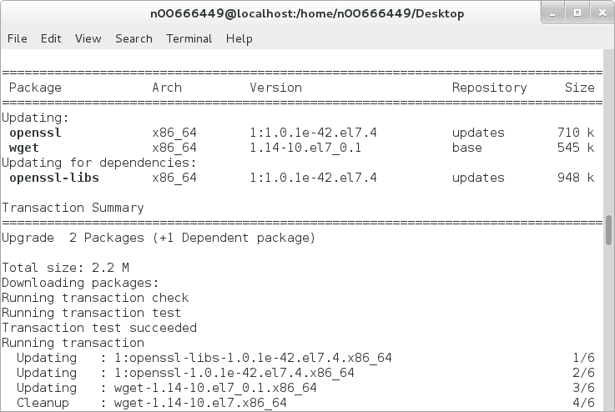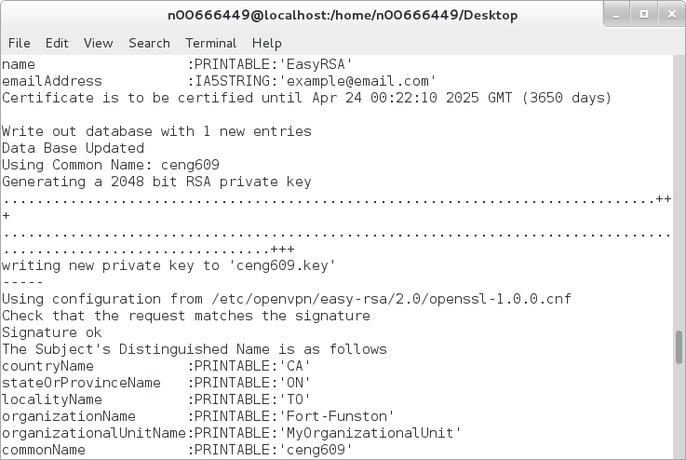

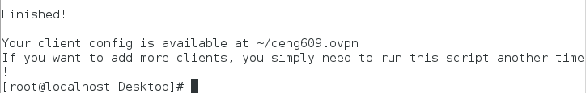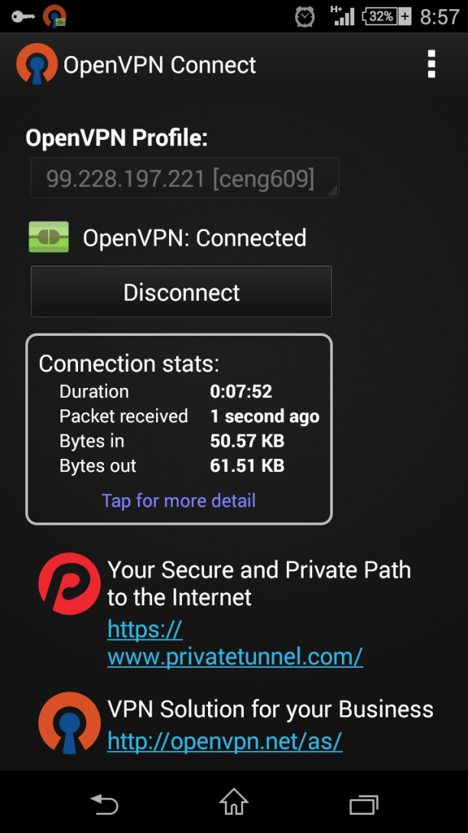

# Conclusion

EasyOpenVPN was created as a bash script to be executed on a linux based server. It sets up a VPN network that can be accessed from a remote location, point-to-point or site-to-site. It uses SSL protocols for security and works on the data link layer of the OSI model. In order for a client to connect the server, the client configuration generated by the OpenVPN when it was set up must be imported. This gives the access via a shared key.

# Appendix A

Project Proposal

Project Scope:

Project objectives: to create an easy, user friendly way to setup an OpenVPN server and/or client on a machine.

Goals: - create a bash script to aid in the setup of OpenVPN server

- create a bash script to aid int the setup of OpenVPN client

Tasks: - select specific OS to setup OpenVPN server on (client can be any OS)

- determine steps/commands to install and setup an OpenVPN server/client

- compile steps/commands into a server/client bash script

Resources: - CentOS7, Debian, OpenVPN software

Schedule: - Project time period: March 9 - April 26

- March 9: Project Overview

- March 16: Project Scope

- March 23: Project Research

- March 30: Project Development Begin

- April 06: Project Dev. Cont'd

- April 13: Project Dev. Debug

- April 20: Project Finalization

- April 26: Project Complete and Summission

Tools/Techniques/Technology used:

Technology used in the development of this project are:

* CentOS7
* Debian

Hardware/Software Specs:

* CentOS7 ver. 7.10
* Debian

Project Planning:

Schedule: - Project time period: March 9 - April 26

- March 9: Project Overview

This outline what the project is and should be about. To install/setup an OpenVPN server/client with a user friendly bash script is the main idea of the project.

- March 16: Project Scope

Determining the project scope is critical and helps to put the work entailed into perspective. This will help to distribute the work load per team member.

- March 23: Project Research

Project research is essential. Finding and determine the proper tools and technology to use to complete this project will aid in the efficiency of the end product.

- March 30: Project Development Begin

Project development begins.

- April 06: Project Dev. Cont'd

Continuation of project development.

- April 13: Project Dev. Debug

Finding any bugs in the code and creating patches to ensure smooth service delivery.

- April 20: Project Finalization

Finilization of the project. Proper documentation and user friendly introduction to how to use the service.

- April 26: Project Complete and Summission