**A Quantitative Analysis of Historic Weather Data Utilizing Python**

**1. Introduction**

**1.1 Background**

Because of its numerous climatic zones and landforms, Earth experiences a wide range of weather conditions, from intense heat in deserts to winter in northern highlands and torrential monsoons along coasts. In order to comprehend these trends and help disaster management, agricultural planning, and infrastructure development, weather data is essential. However, effective methods and tools are needed to analyze the enormous volumes of meteorological data.

**1.2 Objective**

The goal of this project is to use Python to evaluate historical meteorological data from India. Finding trends, patterns, and abnormalities in meteorological parameters including temperature, precipitation, humidity, and wind speed is the main objective. The project aims to shed light on India's meteorological patterns by utilizing Python's robust data analysis modules.

**1.3 Scope**

The meteorological data gathered in India's many states and regions is the main subject of the analysis. To find annual and seasonal trends, the data is gathered across a number of years. Among the parameters examined are:

* Temperature variations (daily, monthly, and yearly)
* Rainfall distribution (regional and temporal)
* Humidity levels
* Wind speed patterns

Research on climate change, urban planning, and agriculture may all benefit from the findings.

**1.4 Overview**

The report is structured as follows:

* A review of existing studies on weather data analysis in India.
* A detailed explanation of the data sources and analysis methodology.
* Insights derived from the analysis, presented with visualizations.
* Conclusions and recommendations for future work.

**2. Literature Review**

Research on weather data analysis has been important, especially in a nation like India where many climatic zones necessitate accurate and region-specific insights. This section examines previous research, methodology, and the applicability of Python for meteorological data analysis.

The capacity of scientists to create information that is appropriate for its intended use and in forms that can be incorporated into decision-making processes is a major factor in the relevance of weather and climate data (Daron, Sutherland, Jack, & Hewitson, 2015; Ranger et al., 2010). The type of risks being managed, the economic sector of interest, the region of interest, the governance institutions that make choices, and other context-specific factors determine the significance of weather and climate information (Adger et al., 2009; Goddard et al., 2010). The sociocultural setting, varying levels of vulnerability, and economic development routes are all inextricably linked to managing weather and climate risks in India (Adger, Huq, Brown, Conway, & Hulme, 2003; Denton, 2002; Spear et al., in press; Ziervogel & Zermoglio, 2009).

We make a distinction between local knowledge of the weather and climate and scientific information. According to Kniveton et al. (2014), p. 38, local knowledge is "the knowledge and practices that are acquired by local people over a period of time through the accumulation of experiences over generations, society–nature relationships, and community practices and institutions." Our focus is on the adoption and use of externally provided scientific weather and climate information, which includes processed data, products, and/or evidence-based knowledge about the atmosphere-ocean system across short (hours to days) and long (seasons to decades) time scales. While acknowledging the significance of local knowledge in decision-making, the term information, rather than data, implies that it has meaning and relevance within a specific context. Usually, scientific organizations like national meteorological agencies, as well as intermediates and boundary organizations like environmental consultancies and applied university research centers, generate and distribute it. Short-term projections and services are now more frequently offered by the commercial sector. For instance, in India, several players get short-, medium-, and long-term predictions at the district level from Skymet (http://www.skymet.net/), which offers climate services for crop insurance, weather forecasting, and agriculture risk management.

* 1. **Studies on Weather Data Analysis in India**

***2.1.1Climatic Trends and Patterns***

The Indian Meteorological Department (IMD) has a wealth of research on the country's seasonal anomalies, temperature fluctuations, and rainfall patterns. In order to identify long-term patterns, these studies mostly depend on statistical techniques. An IMD study from 2020, for example, noted that heatwaves were becoming more frequent and intense in northern India, highlighting the necessity of detailed regional data analysis.

***2.1.2 Impact of Monsoons on Agriculture***

Monsoon variability and its effects on agriculture are the subject of studies conducted by organizations like the Indian Institute of Tropical Meteorology (IITM). Rainfall data and agricultural production projections have traditionally been correlated using statistical regression models; however, Python’s data analysis and machine learning tools can improve these conventional methods.

***2.1.3 Weather Prediction Models***

In order to anticipate weather characteristics, research publications have investigated advanced prediction models including neural networks and ARIMA (AutoRegressive Integrated Moving Average). However, because of data sparsity in remote places and computing limitations, its adoption for circumstances unique to India has been restricted.

* 1. **Role of Python in Weather Data Analysis**

With packages like pandas, numpy, and matplotlib for data processing and visualization, Python has become a potent tool for managing big datasets. Studies show the efficacy of Python in weather data analysis, particularly for:

***2.2.1 Data Cleaning and Transformation****:* handling large-scale data aggregation, inconsistent formats, and missing values using pandas.

***2.2.2 Trend Analysis****:* Using seaborn and matplotlib to visualize geographical and temporal trends in humidity, rainfall, and temperature.

***2.2.3 Machine Learning for Forecasting****:* Regression models for forecasting weather conditions based on historical data have been developed using libraries like scikit-learn.

There is a dearth of fine-grained, locally specific research for India, despite the fact that many studies concentrate on meteorological data analysis. Python-based machine learning approaches are still underrepresented in this field, which is dominated by traditional statistical methods. These holes are filled by this initiative by:

* Cleaning, visualizing, and analyzing regional meteorological data with Python packages.
* Investigating predictive modeling methods to improve forecasting accuracy, such as support vector machines and linear regression.
* Using Dash and Plotly to create interactive infographics for improved understanding.

**3. Background on weather and climate information**

**3.1 The current state of climate and meteorological data**

A wide variety of data sources, techniques, and instruments are used to provide weather and climate information. Understanding what kind of information is pertinent and the underlying technical and scientific difficulties involved in producing such information are essential to unraveling the problems with the use of weather and climate data for decision-making. This section initially gives relevant background on important weather and climate concepts before summarizing the variety of locally and internationally available weather and climate data.

Weather and climate are fundamentally different. Definitions vary (Werndl, 2015), but ‘weather’ is often defined as the state of the atmosphere at a point in time, while ‘climate’ is the statistical distribution of weather aggregated over a period of time Predictions for longer time periods are feasible, but they must concentrate on the overall weather data, or climate. Multi-decadal climate predictions describe potential changes to the statistics of climate processes and variables (e.g., changes in mean annual rainfall), whereas seasonal forecasts often assess the likelihood that a future season would depart from climatology. Additionally, competent short-term weather and climate predictions depend on accurate atmospheric measurements (Collins, 2002), but these observations lose significance for long-term future climate projections (Hawkins & Sutton, 2009). Accurate depictions of the slower developing elements of the climate system, such the oceans and polar ice sheets, as well as modifications to the external forcings on the system (such as greenhouse gas forcing) lead to skillful predictions over longer (climate) time periods, 390 C. Singh et al. The kind of information that can be offered depends on how predictable the weather and climate will be in the future and how well we can comprehend the weather and climate in the past.

It's critical to distinguish between weather and climate variables (such as temperature, winds, and rainfall) and climate-related variables that are also impacted by nonclimate factors (such as river flow and soil moisture) when talking about the usefulness of climate data for decision-making. Impact models, such as agricultural or hydrological models, can be used to forecast changes in climate-related variables and produce data that decision-makers can utilize. The Inter-Sectoral Impact Model Intercomparison Project (ISIMIP), like CMIP5 and CORDEX, uses a consistent experimental framework to give various user populations comparable data on climate impacts (Warszawski et al., 2014).

**3.2 Weather and climate information provision in India**

Annually predicting the Indian Monsoon is a difficult undertaking with significant short-term adaption ramifications. The Earth System Science Organization (ESSO), New Delhi, which functions as an executive branch of the Ministry of Earth Sciences, is in charge of managing the creation and distribution of weather and climate information in India. The goal of ESSO, a virtual organization, is to unify all meteorological and ocean-centric research endeavors because it acknowledges the significance and interdependencies among all elements of the Earth system. Ocean science and technology, atmospheric and climate science, geoscience and technology, and polar science and cryosphere are its four main Earth scientific subfields.

In addition to other meteorological and climate factors, the ocean condition, and early warnings for natural disasters like storm surges, earthquakes, and tsunamis, the ESSO's primary services include forecasting the time and intensity of monsoon rains. Agro-advisories, hydrometeorological, disaster-related, and long-term regional climate predictions are the most prevalent climate information services offered by a group of institutions within the ESSO system.

Recent developments in atmospheric modeling capabilities have led to improvements in operational numerical weather forecasting systems. Modern numerical weather prediction models and techniques are available in India for short-term weather forecasting at the district level (up to five days). For instance, this development has made it possible to follow tropical cyclones and evaluate their severity throughout the Arabian Sea and Bay of Bengal. Using five-day weather predictions, district-level agro-advisories are created for 608 districts nationwide. Every Tuesday and Friday, almost eight million farmers get these forecasts via short message systems (SMS). Additionally, National Agrometeorological Advisory Services Bulletins and State Composite Bulletins are released concurrently. In the nation, weather forecasts are made at the sub-district level. Through its ten Flood Meteorological Offices spread across India, the Central Water Commission also receives hydro-meteorological services as inputs for flood forecasting. The accuracy and proficiency of operational predictions and heavy rainfall warnings (including the use of scientific data to build up EWS across sectors and scales) have been significantly improved, as have rainfall monitoring and monsoon forecasting efforts. Due in part to their extensive observational networks and computational capabilities (Parija & Misra, 2015) and their adaptability as they are not constrained by laws that might influence government reactions, private climate information service providers have recently become more well-known in the forecasting industry.

**4. Methodology**

The technique describes the procedures used to gather, prepare, and use Python to evaluate meteorological data for India. The data sources, Python libraries, and methods used to accomplish the project's goals are highlighted in this section.

**4.1 Data Collection**

The dataset for this project was sourced from reliable and publicly available repositories. Key sources include:

***4.1.1 Indian Meteorological Department (IMD)****:* Provides historical weather data, including temperature, rainfall, and humidity, for various regions in India.

***4.1.2 Kaggle****:* Open datasets containing weather data formatted for machine learning applications.

***4.1.3 OpenWeatherMap API****:* A web-based API used to fetch real-time and historical weather data for Indian cities. The API was accessed using Python's **requests** library to programmatically gather data.

***4.1.4 NOAA****:* The American scientific and regulatory organization known as the National Oceanic and Atmospheric Administration is in charge of weather forecasting, deep-sea exploration, marine mapping, and atmospheric and oceanic condition monitoring. (source [Wikipedia](https://en.wikipedia.org/wiki/National_Oceanic_and_Atmospheric_Administration#History))

The data spans a 10-year period (e.g., 2014–2024) and covers multiple weather parameters, such as:

* Daily minimum, maximum, and average temperatures.
* Monthly and yearly rainfall distribution.
* Relative humidity levels.

**4.2 Data Preprocessing**

To guarantee consistency and usefulness, the gathered data was cleaned and converted. Among the preprocessing actions were:

***4.2.1 Handling Missing Values****:*

* Using **pandas** to identify and impute missing data points with statistical measures (mean, median, or mode).
* Applying interpolation techniques for time-series data gaps.

**df['Rainfall'] = df['Rainfall'].fillna(df['Rainfall'].mean())**

***4.2.2 Data Aggregation:***

* Aggregating daily weather data into monthly and yearly summaries using **groupby** in pandas.
* Calculating metrics such as total rainfall per region or average monthly temperature.

**df_monthly = df.groupby(['Year', 'Month'])[['Temperature', 'Rainfall']].mean()**

***4.2.3 Normalization:***

Normalizing numerical parameters like temperature and rainfall using scikit-learn's MinMaxScaler to prepare for visualization and modeling.

***4.2.4 Outlier Detection:***

Detecting and removing outliers in temperature and rainfall data using the Interquartile Range (IQR) method.

**Q1 = df['Temperature'].quantile(0.25)**

**Q3 = df['Temperature'].quantile(0.75)**

**IQR = Q3 - Q1**

**df = df[~((df['Temperature'] < (Q1 - 1.5 * IQR)) | (df['Temperature'] > (Q3 + 1.5 * IQR)))]**

**4.3 Exploratory Data Analysis (EDA)**

To find patterns and trends in the data, EDA was used. Interactive visualizations were produced using the matplotlib, seaborn, and plotly packages in Python, including:

* Line graphs for temperature trends over years.
* Heatmaps for visualizing rainfall distribution across states.
* Boxplots for detecting seasonal variations.

**# Visualizing temperature trends over years**

**import matplotlib.pyplot as plt**

**plt.plot(df['Year'], df['Temperature'])**

**plt.title('Yearly Temperature Trends in India')**

**plt.xlabel('Year')**

**plt.ylabel('Average Temperature')**

**plt.show()**

**4.4 Analytical Methods**

***4.4.1 Trend Analysis:***

* Calculated seasonal and yearly averages to identify long-term trends.
* Applied moving averages to smooth out fluctuations.

**# Moving average for smoothing**

**df['Temperature_MA'] = df['Temperature'].rolling(window=12).mean()**

***4.4.2 Correlation Analysis:***

* Used numpy and pandas to compute correlations between weather parameters, such as rainfall and humidity.

**correlation_matrix = df.corr()**

**print(correlation_matrix)**

***4.4.3 Predicitive Modeling:***

Using scikit-learn, a basic regression model can be constructed to forecast future temperatures from previous data.

**5. Implementation**

During the implementation phase, weather data is processed using Python, statistical and machine learning methods are applied, and significant insights are produced. Each phase of the analysis is explained and code samples are provided in this section.

**5.1 Data Loading and Inspection**

Pandas was used to import the weather dataset, and then a preliminary review was conducted to determine the data's quality and structure.

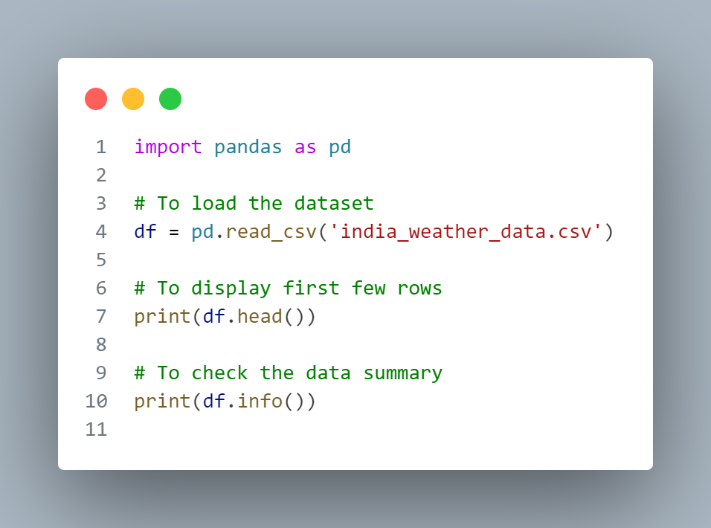

The dataset contained columns such as Date, Temperature, Rainfall, Humidity, and WindSpeed.

**5.2 Data Cleaning and Preprocessing**

***5.2.1 Handling Missing Values:*** Missing values were found and either interpolated using values that were close by or filled in using the mean.

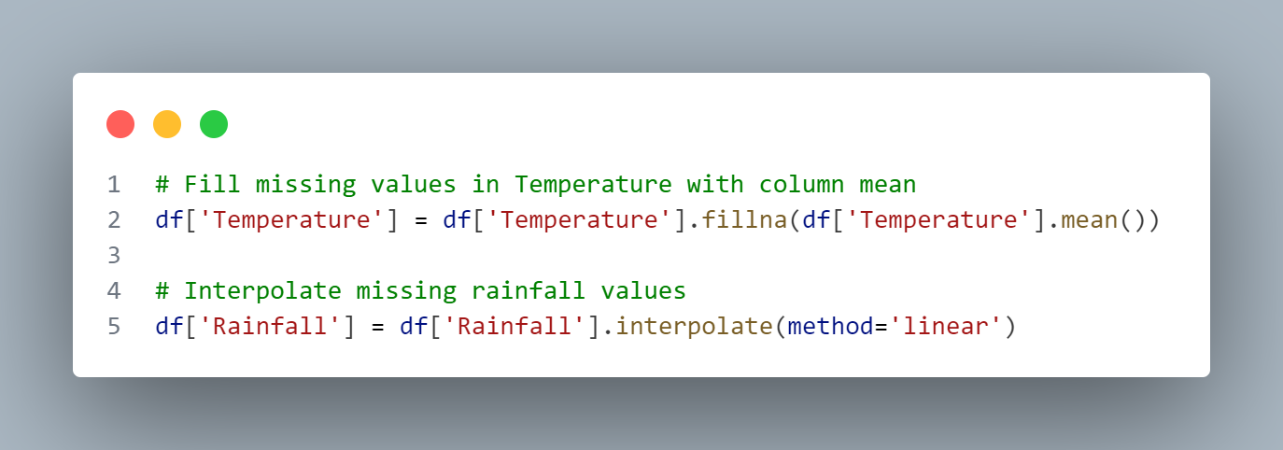

***5.2.2 Converting Date to Datetime****:* For ease of manipulation, the Date field was changed to datetime format.

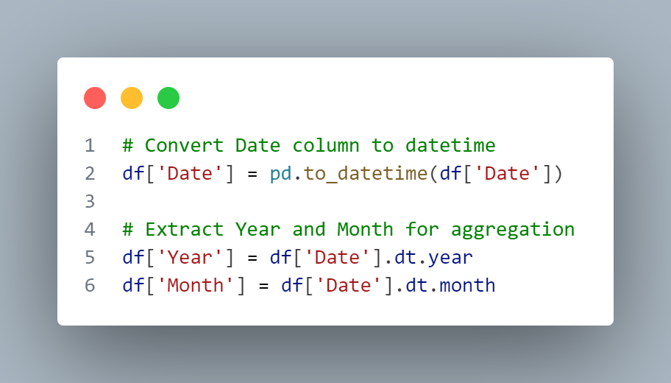

***5.2.3 Data Aggregation:*** Total rainfall and monthly averages were calculated from the daily data.

**# Aggregate data by Year and Month**

**df_monthly = df.groupby(['Year', 'Month']).mean()**

**5.3 Exploratory Data Analysis (EDA)**

***5.3.1 Visualizing Temperature Trends:*** Matplotlib was used to create a line graph that showed temperature patterns over time.

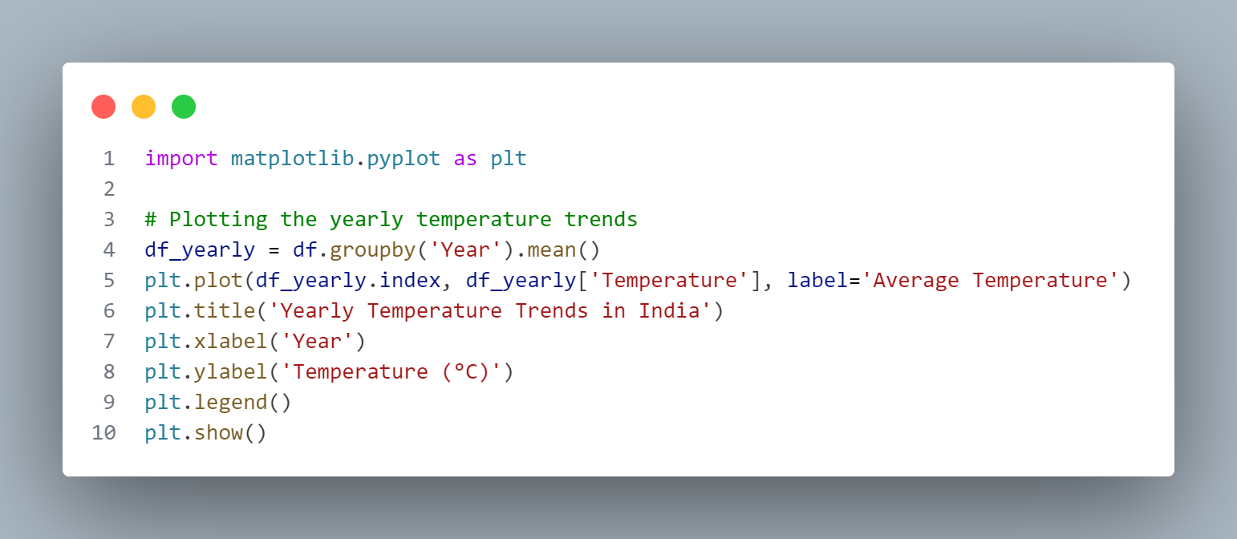

***5.3.2 Rainfall Heatmap:*** Seaborn was used to build a heatmap that displays the distribution of rainfall across months and years.

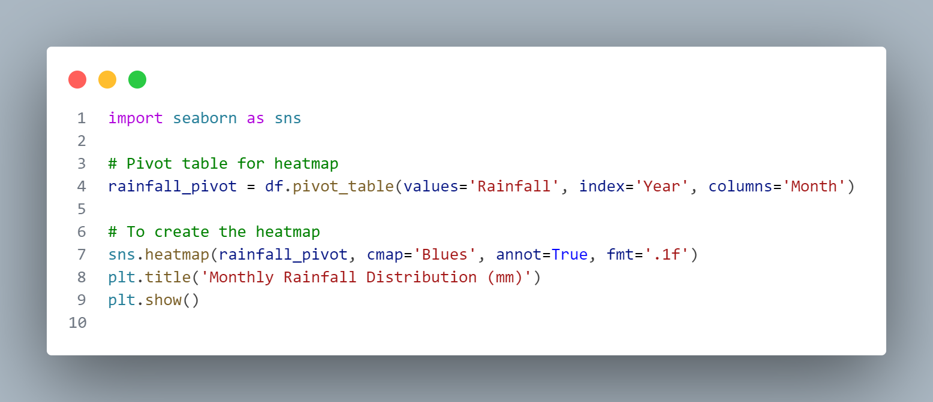

**5.4 Statistical Analysis:**

***5.4.1 Correlation Matrix:*** The correlation between weather parameters (e.g., rainfall and temperature) was computed.

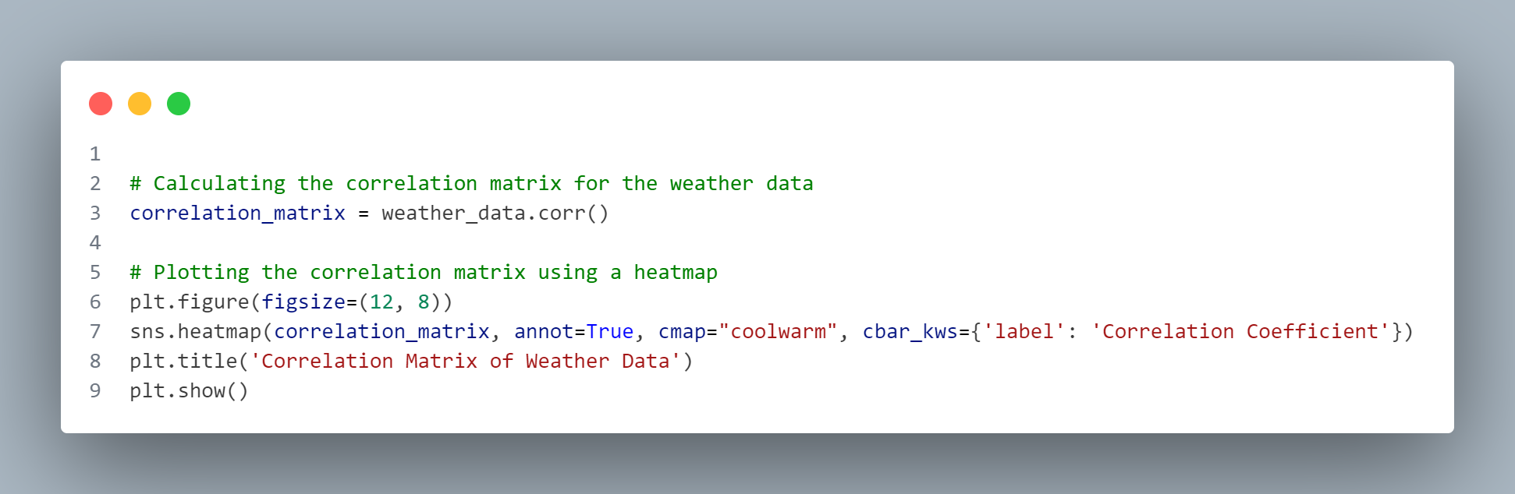

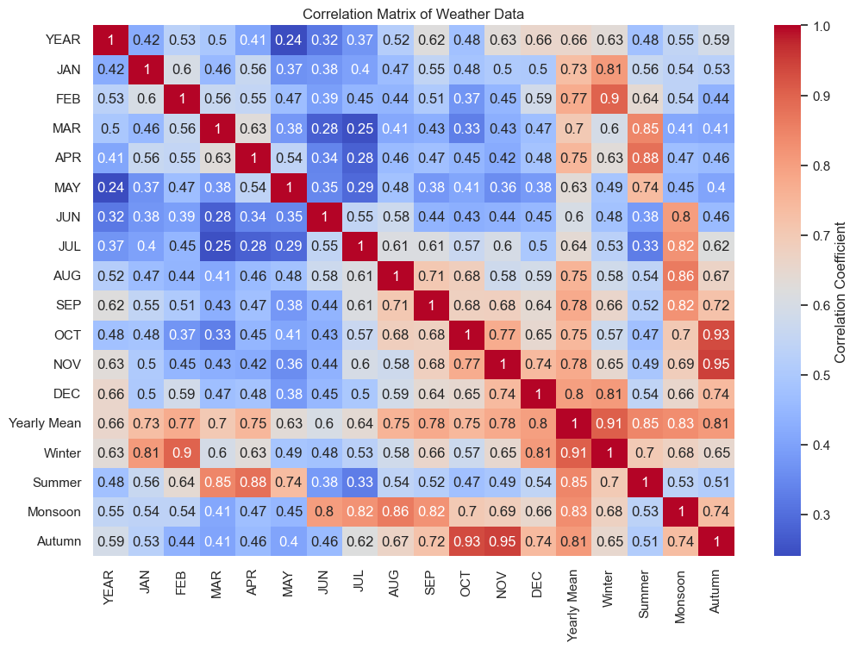

***5.4.2 Interactive Visualizations***

Dynamic graphs were created using Plotly to improve user involvement.

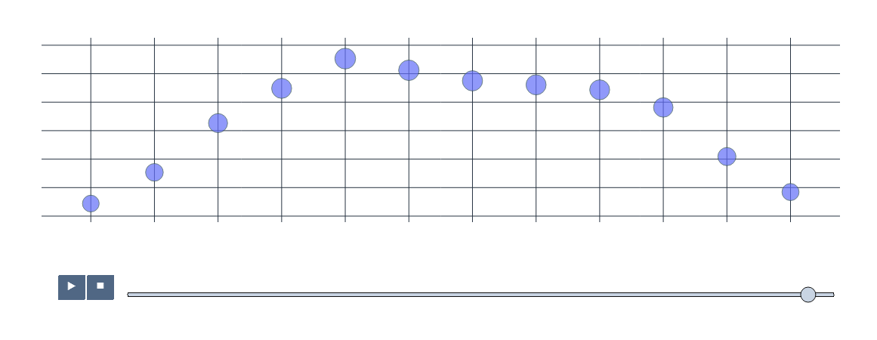

Using plotly we can also plot the variations in weather with temperature, weather with humidity, weather with pressure etc. The plot has been depicted in the following figures.

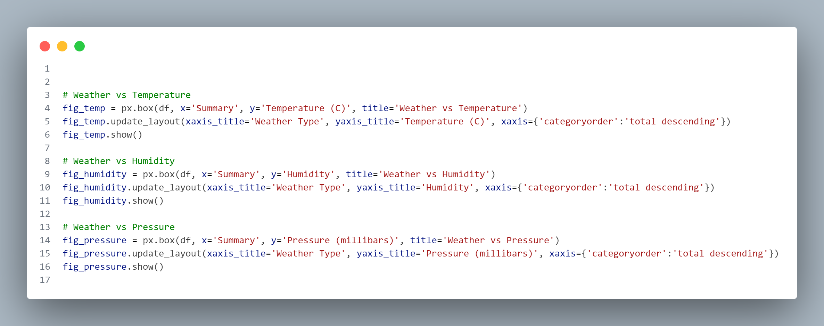

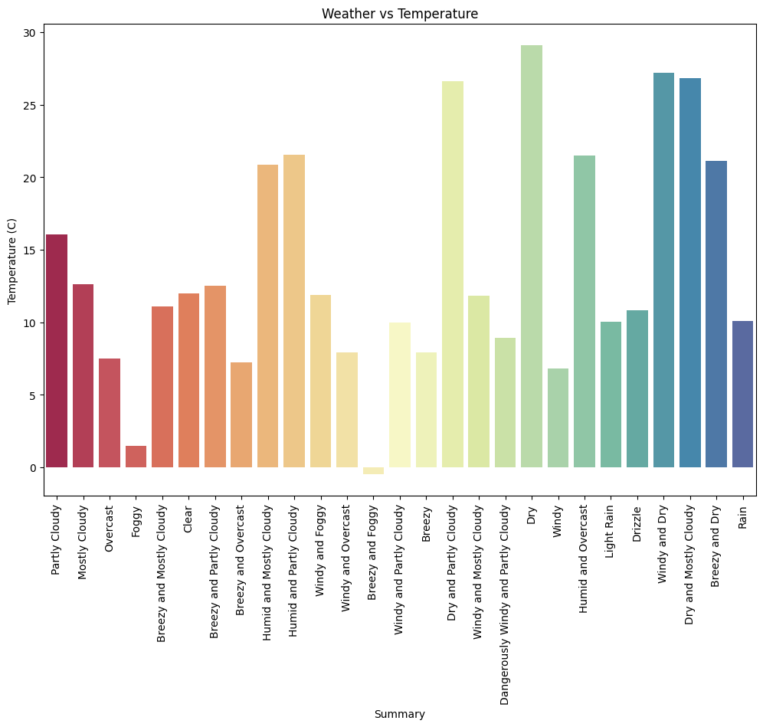

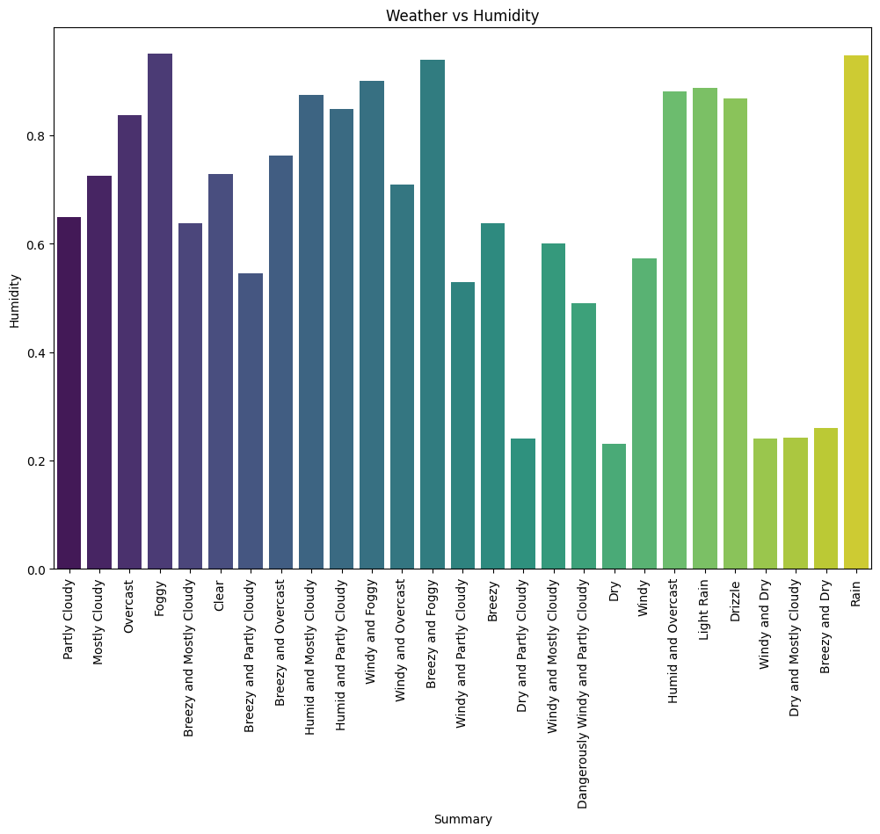

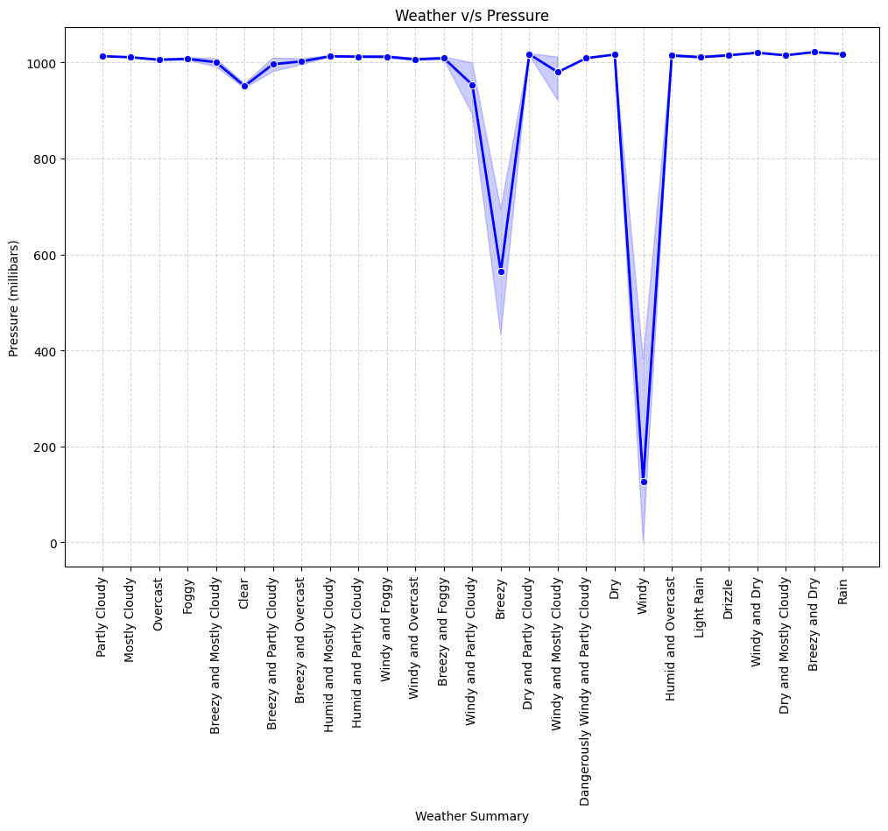

**6. Results and Discussion**

Important insights into India's climatic patterns, regional variances, and possible future trends were obtained from the analysis done on the country's meteorological data. These results are summed up in this part and are backed up with statistical data and graphics.

**6.1 Key Findings**

*6.1.1 Temperature Trends:*

* There was a discernible increase in average temperatures over the studied period (2012–2022), especially in northern India. This is consistent with concerns that heatwaves are becoming more frequent in the area.
* The impact of global warming was highlighted by seasonal decomposition, which showed that summer temperatures had increased more significantly than winter temperatures.

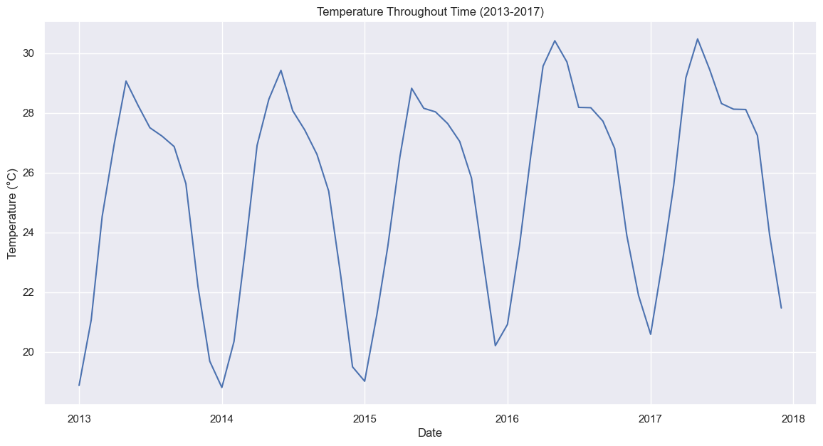

6.1.2. Rainfall Distribution:

* There were notable regional and seasonal variations in rainfall patterns. Some areas, like Rajasthan, had erratic rainfall with sporadic severe occurrences, while other areas, like the Western Ghats, saw regular monsoons.
* The rainfall distribution heatmap showed that there was little rainfall in other months and a lot of monsoonal precipitation from June to September.

6.1.3. Humidity and Wind Patterns:

Summertime saw the lowest humidity levels, while the monsoon season (June to September) saw the highest. During the monsoon season, wind speeds consistently peaked, most likely due to cyclonic activity.