The State of Ohio,

Plaintiff,

**FILED**

**DELAWARE**

**MUNICIPAL COURT**

**2022-Jul-03 6:25 AM**

**CINDY DINOVO**

**CLERK**

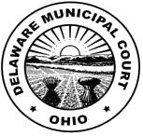

vs. Case No. {{ case_number }}

{{ defendant.first_name }} {{ defendant.last_name }},

Defendant.

**NOTICE OF HEARING**

This case is scheduled for a **{{ hearing_type }}** at **{{ hearing_time }} on {{ hearing_date }}**, in {{ hearing_location }}.

Assignment Commissioner

cc: Prosecutor

{{ defendant.first_name }} {{ defendant.last_name }}