SECURITY INCIDENT REPORT
Phase 09 | Brute-Force Authentication Investigation
Incident ID | SOC-HL-2026-0711 | Severity | HIGH
Date | 11 July 2026 | Status | Closed — Lab Exercise
Target | WIN11-01 / 192.168.10.20 | Attacker IP | 192.168.10.30
Account | localadmin | Category | Credential Attack / Brute Force
Executive Summary
During a controlled SOC lab exercise, 192.168.10.30 repeatedly attempted to authenticate to the localadmin account on WIN11-01. Splunk recorded 31 failed logons (Windows Event ID 4625), followed by four successful network logons (Event ID 4624, Logon Type 3) from the same address. Taken together, the events show that the tested credentials were successfully used. The supplied logs do not show destructive activity, persistence, or data exfiltration after authentication.
KEY FINDING | Thirty-one failed attempts were followed by four successful localadmin network logons from the same source address.
Lab Architecture and Data Flow
Role | System | Address | Function
Attacker | Kali Linux | 192.168.10.30 | Nmap / NetExec activity in the isolated lab
Target | WIN11-01 | 192.168.10.20 | Windows Security + Sysmon telemetry
SIEM | DC01 / Splunk | 192.168.10.10 | Receives logs on TCP 9997 and supports investigation
Scope and Method
- Reviewed Windows Security Event IDs 4625 and 4624 by source address, account, time, and logon type.
- Reviewed Sysmon Operational telemetry and validated Universal Forwarder collection into Splunk.
- Used filtered authentication results for the incident finding and retained broader searches as investigation context.

Detailed Timeline and Findings
Time | Event | Observation | Assessment
06:35–06:58 | 4625 | 31 failures from 192.168.10.30 against localadmin | Brute-force pattern
06:46:41 | 4624 | Successful localadmin logon from 192.168.10.30; Type 3 | Access confirmed
06:50:30 | 4624 | Second successful network logon from same IP/account | Repeated access
06:58:40 | 4624 | Third successful localadmin network logon | Credential reuse
10:34:55 | 4624 | Fourth successful localadmin network logon | Later access
08:10:00 | Sysmon 3 | Network connection existed locally in Sysmon | Local logging confirmed
12:17:21 | Sysmon 3 | PowerShell 192.168.10.20 → 192.168.10.10:9997 | Telemetry test
12:25:04 | Sysmon 3 | Second PowerShell connection to Splunk receiver | Forwarding validated
Confirmed Indicators
Indicator | Value | Interpretation
Attacker address | 192.168.10.30 | Source of 31 failed attempts and four successful logons
Target account | localadmin | Local administrative account exposed to network authentication
Target host | WIN11-01 / 192.168.10.20 | System receiving the authentication activity
Logon type | 3 | Network logon; consistent with remote SMB/RPC authentication
Splunk receiver | 192.168.10.10:9997 | Validated telemetry destination; not an attacker connection
Analyst Assessment
The correlation is high confidence because the same source IP and account appear in both the failed and successful authentication records, and the successful records use Logon Type 3. Events labelled ANONYMOUS LOGON were excluded from the success determination. The four localadmin successes—not the anonymous events—support the compromise conclusion.
LIMITATION | The supplied logs confirm authentication success but do not prove command execution, persistence, privilege escalation, or data theft after access.

Authentication Evidence
Figures 1–3 establish the volume, source, and targeted account for the failed authentication activity.
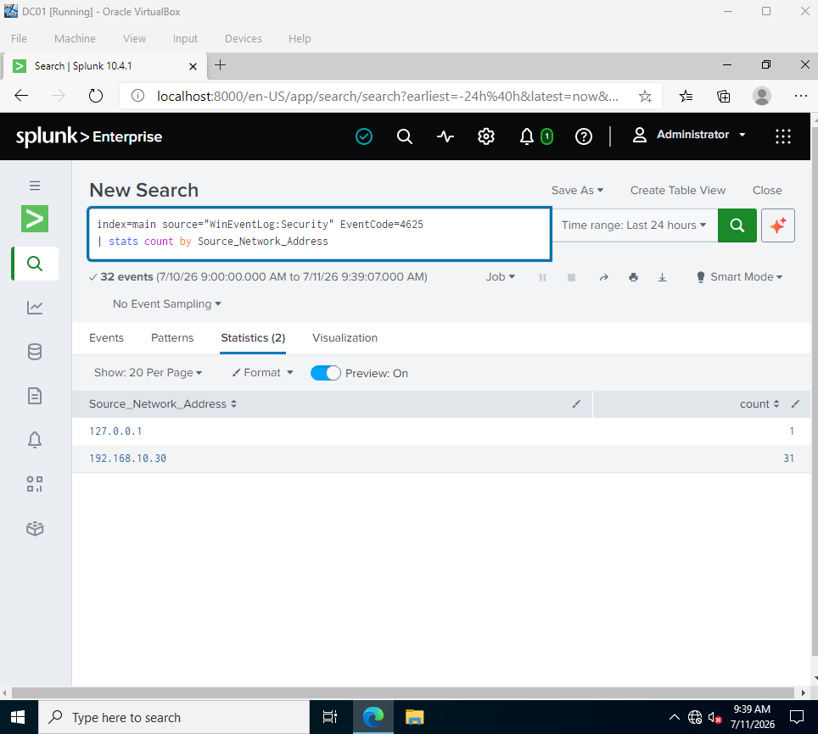 | 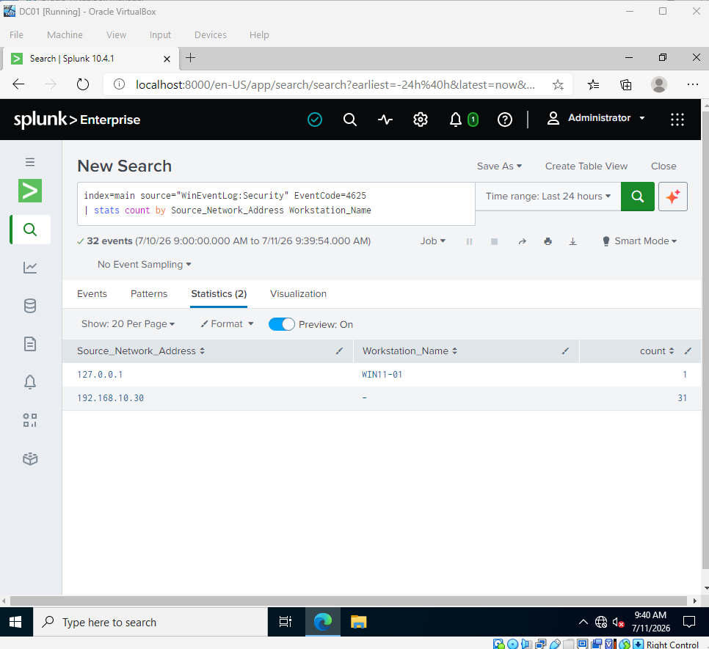
Figure 1. Failed logons grouped by source address. | Figure 2. Source address and workstation field for failed logons.
INTERPRETATION | 192.168.10.30 was responsible for 31 failed logons. The single 127.0.0.1 event is local loopback activity and is not attributed to the attacker.
Targeted Account
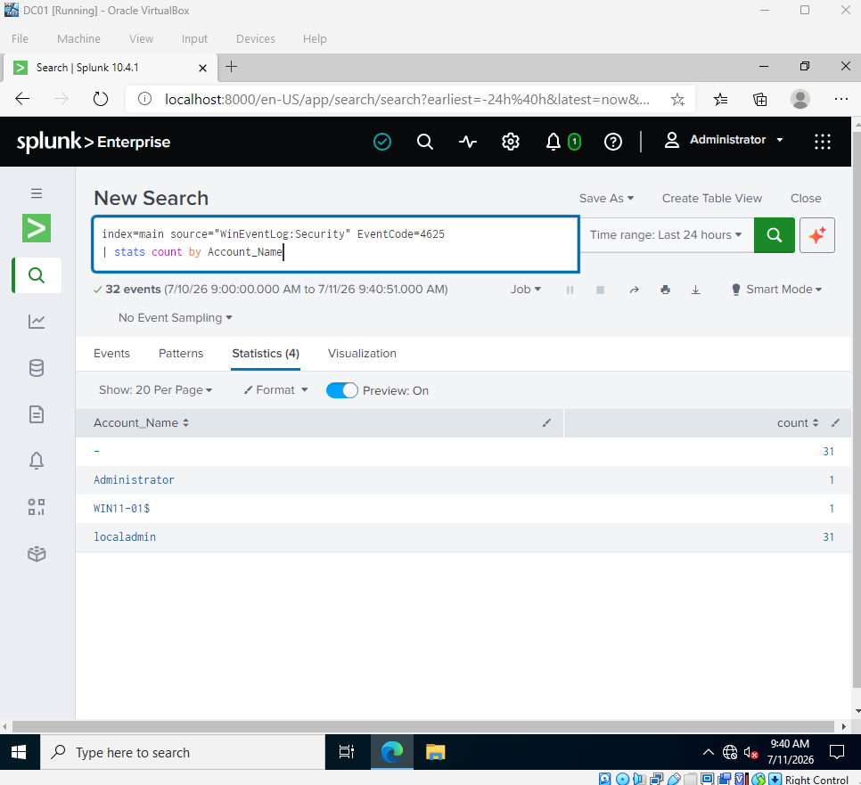
Figure 3. The localadmin account appears in 31 failed authentication events.

Timeline Construction — Initial Searches
These screenshots document the investigation process. They helped locate relevant time windows, but they are not used alone as proof because the searches were broad.
Broad 4624/4625 Timeline
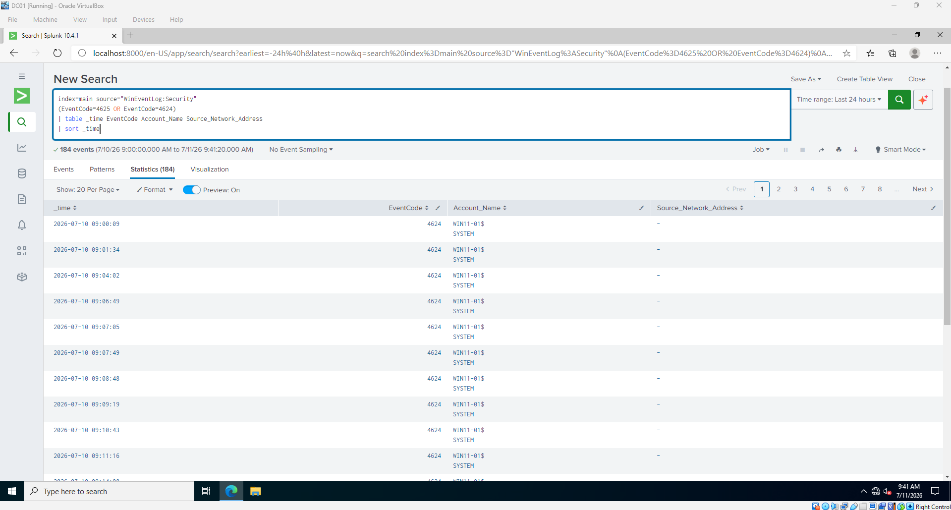
Figure 4. Broad authentication timeline used to establish the investigation window.
First Combined Attack Search
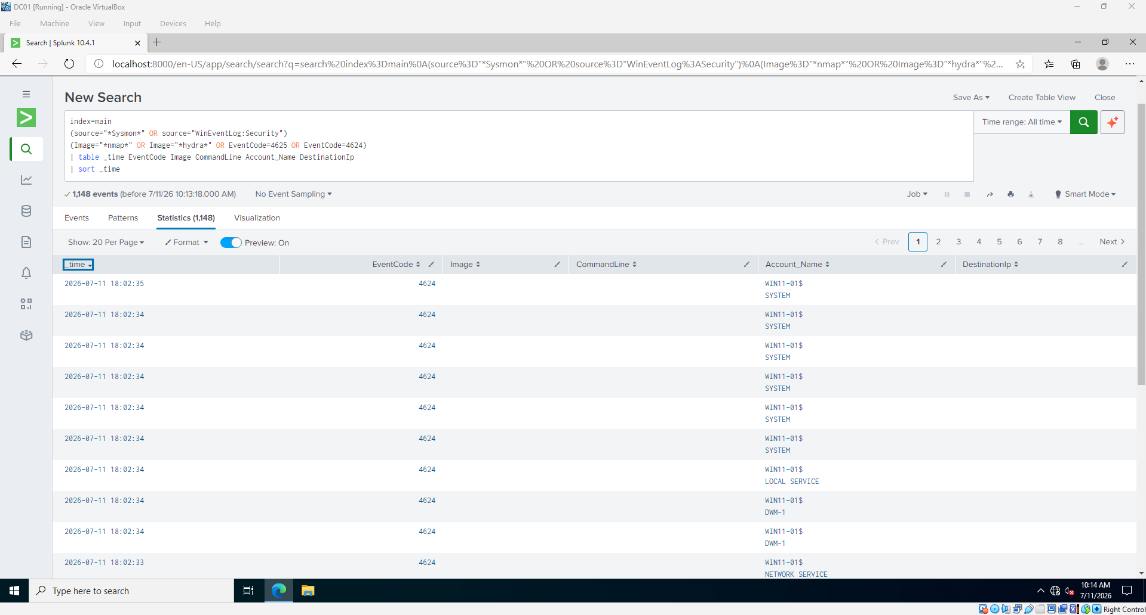
Figure 6. Exploratory combined search used while narrowing the event set.
ANALYST NOTE | This search was useful for exploration, but its OR logic also returned general 4624/4625 events. Hydra was not used in the exercise, and Nmap and NetExec ran on Kali, so their process images would not appear in Windows Sysmon.

Authentication Correlation and Final Proof
Correlation Review
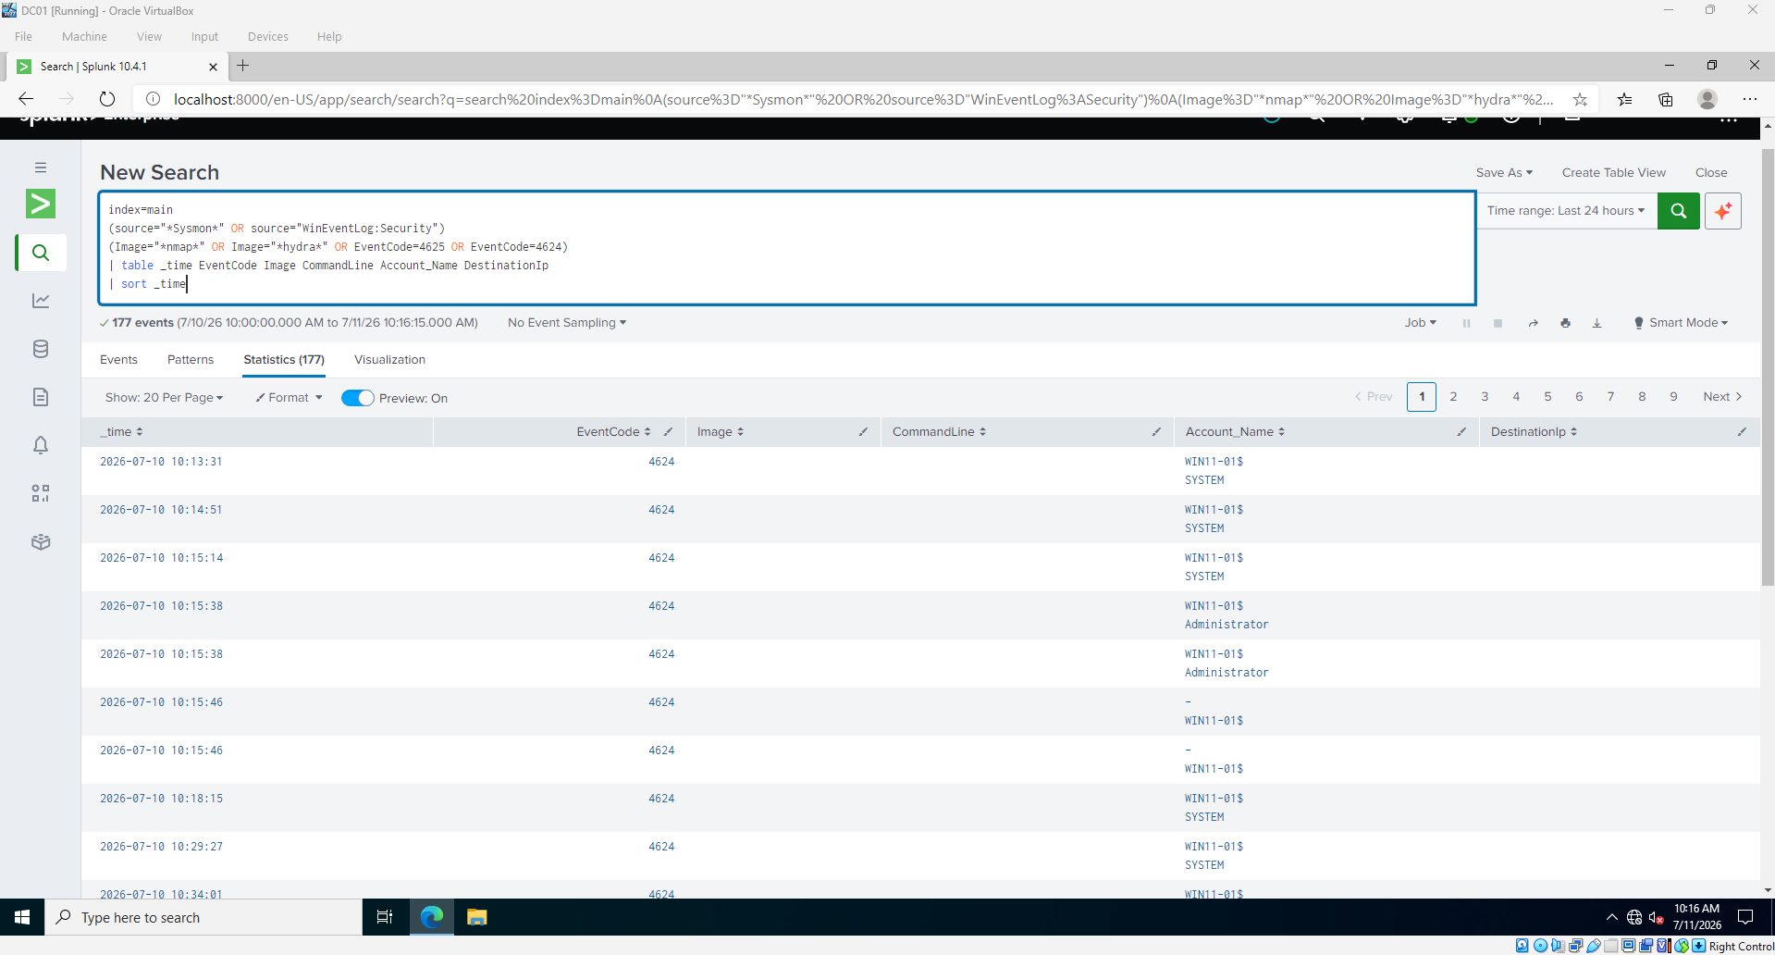
Figure 7. Exploratory Sysmon and authentication correlation view.
Successful Logons from the Attacker IP
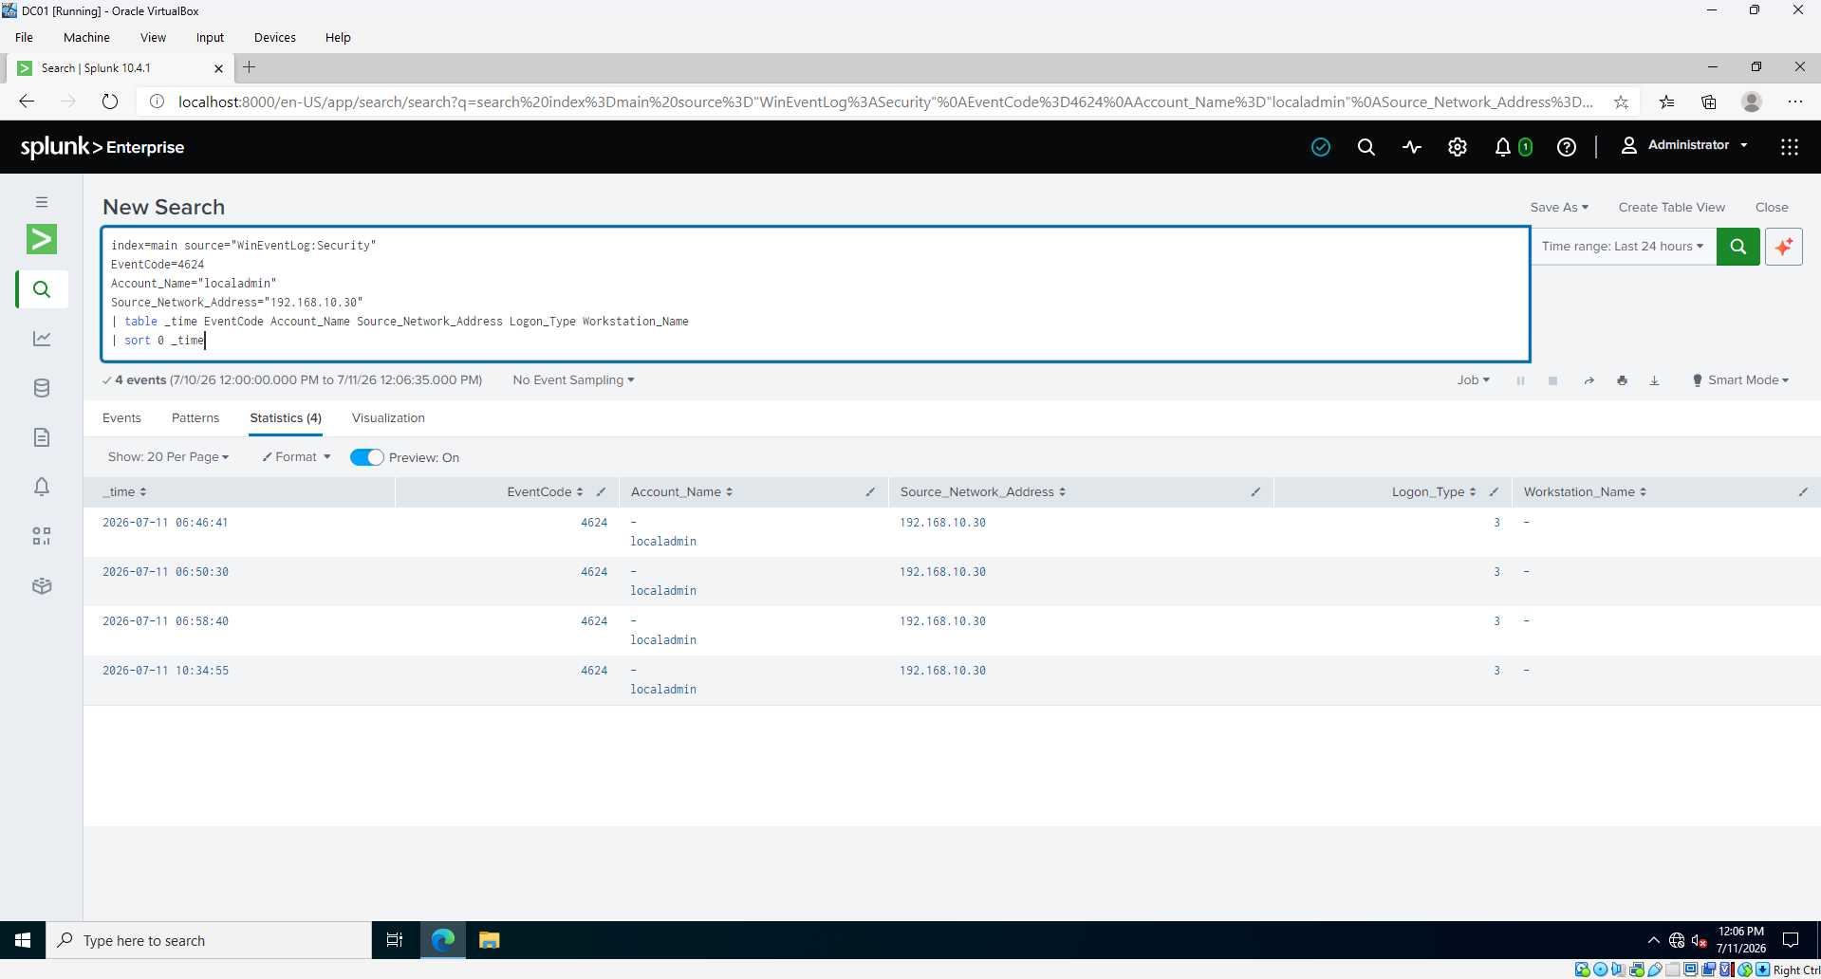
Figure 8. Four successful localadmin network logons from 192.168.10.30.
FINAL PROOF | Figure 8 uses explicit EventCode=4624, Account_Name=localadmin, and Source_Network_Address=192.168.10.30 filters. It replaces the broad searches above.

Sysmon Event ID 3 — Diagnostic Sequence
The investigation initially returned zero Sysmon network-connection records in Splunk. Local validation then proved that Event ID 3 was enabled and present on WIN11-01.
Initial Splunk Result
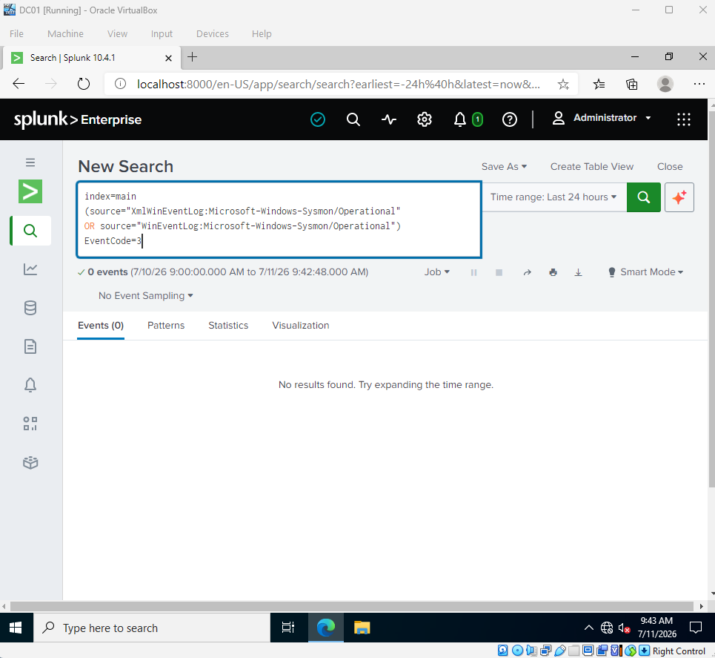
Figure 5. Event ID 3 initially returned no results in Splunk.
Local Windows Validation
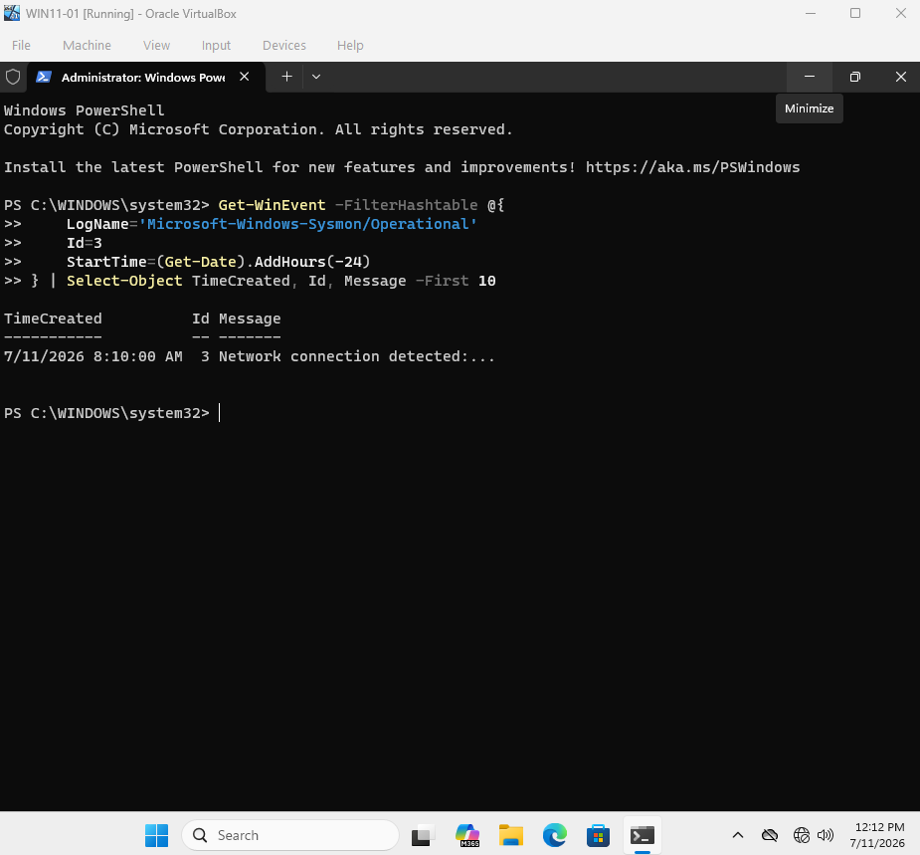
Figure 9. Local validation confirmed that Sysmon Event ID 3 was present on WIN11-01.
ROOT CAUSE BOUNDARY | Sysmon was functioning locally. The issue was therefore between collection/reload and Splunk ingestion, not the Sysmon NetworkConnect configuration itself.

Forwarding Recovery and Telemetry Validation
The Universal Forwarder inputs.conf already contained the correct Sysmon channel and the service was running. Restarting SplunkForwarder reloaded the input, after which fresh Sysmon events arrived in Splunk.
Collection Restored
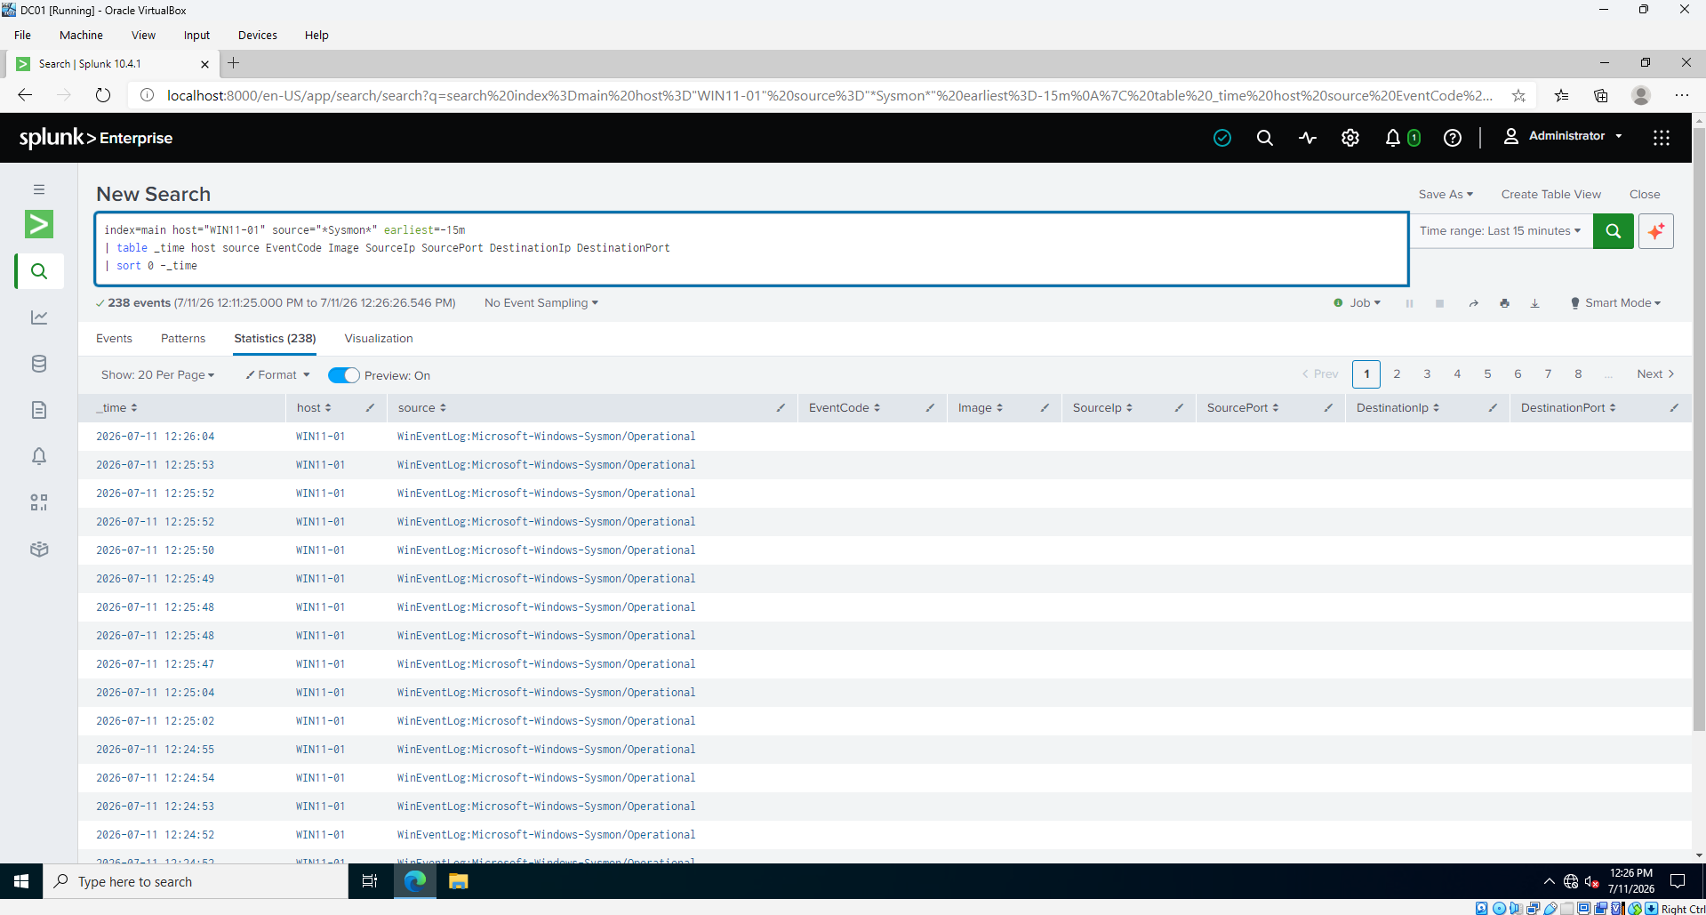
Figure 10 — 238 fresh events from the correct Sysmon source (RECOVERY VALIDATION).
Event ID 3 Extracted from XML
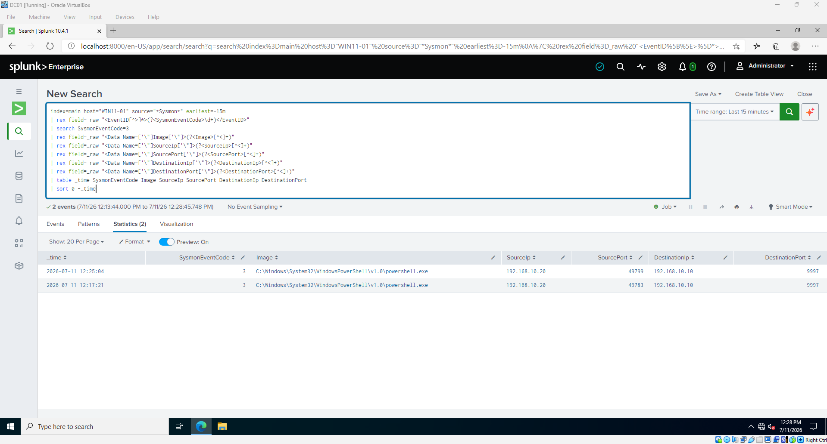
Figure 11 — Event ID 3 with process and network fields extracted (PRIMARY TELEMETRY EVIDENCE).
IMPORTANT | The Figure 11 connections are controlled PowerShell telemetry tests from 192.168.10.20 to Splunk port 9997. They verify visibility and are not attacker traffic.

Technical Analysis and Detection Logic
Root Cause
The Universal Forwarder inputs.conf already contained the correct Sysmon channel, and the SplunkForwarder service was running. Restarting the service reloaded the input and restored collection of fresh Sysmon events. Because renderXml=true was enabled, the events arrived in XML format and the investigation search extracted the required fields from _raw.
Authentication Search
Successful localadmin logons from the attacker IP
index=main source="WinEventLog:Security" EventCode=4624
Account_Name="localadmin" Source_Network_Address="192.168.10.30"
| table _time EventCode Account_Name Source_Network_Address Logon_Type
| sort 0 _time
Sysmon XML Extraction Search
Extract Event ID 3 network fields
index=main host="WIN11-01" source="*Sysmon*"
| rex field=_raw "<EventID[^>]*>(?<SysmonEventCode>\d+)</EventID>"
| search SysmonEventCode=3
| rex field=_raw "<Data Name=['\"]Image['\"]>(?<Image>[^<]+)"
| rex field=_raw "<Data Name=['\"]SourceIp['\"]>(?<SourceIp>[^<]+)"
| rex field=_raw "<Data Name=['\"]DestinationIp['\"]>(?<DestinationIp>[^<]+)"
| rex field=_raw "<Data Name=['\"]DestinationPort['\"]>(?<DestinationPort>[^<]+)"
| table _time SysmonEventCode Image SourceIp DestinationIp DestinationPort
Recommended Splunk Correlation
Alert on failures followed by success
index=main source="WinEventLog:Security" (EventCode=4625 OR EventCode=4624)
| stats count(eval(EventCode=4625)) AS failures
count(eval(EventCode=4624)) AS successes
earliest(_time) AS first_seen latest(_time) AS last_seen
BY Source_Network_Address Account_Name
| where failures>=5 AND successes>=1
| convert ctime(first_seen) ctime(last_seen)
Recommended alert policy: trigger when five or more failures for the same source IP and account are followed by at least one successful logon within ten minutes. Review the successful event’s Logon Type, target host, and account privileges before escalation.

Impact, Response, and Closure
Impact Assessment
- Observed impact: Successful network authentication to the localadmin account.
- Potential impact: Unauthorized system access, privilege abuse, credential reuse, and lateral movement.
- Not observed in supplied evidence: Persistence, destructive execution, privilege escalation, or data exfiltration.
Recommended Actions
- Reset or disable localadmin credentials and review membership in local privileged groups.
- Enable account lockout and enforce strong, unique passwords; use MFA where supported.
- Restrict SMB/RPC and remote administrative access to authorized management systems.
- Block or isolate suspicious source addresses during a real incident and preserve relevant logs.
- Deploy the Splunk correlation rule above and tune thresholds against normal administrative activity.
- Monitor Universal Forwarder health and validate XML field extraction for Sysmon data.
Evidence Register
Fig. | Evidence | Classification
1 | Failed logins by IP | Primary evidence
2 | Attacker IP / workstation field | Supporting evidence
3 | Targeted account | Primary evidence
4 | Broad 4624/4625 timeline | Timeline context
5 | Initial Event ID 3 zero result | Diagnostic record
6 | First combined attack timeline | Investigation context
7 | Sysmon and authentication correlation view | Investigation context
8 | Successful logons after failures | Primary evidence
9 | Local Sysmon Event ID 3 | Diagnostic record
10 | Sysmon forwarding restored | Recovery verification
11 | Event ID 3 network connection | Telemetry verification
Conclusion
Phase 09 is complete. The investigation reconstructed a successful credential attack against WIN11-01, documented the evidence and its limitations, restored Sysmon collection, and produced a repeatable Splunk detection approach. The SOC lab can now proceed to Phase 10.

