HARDENING VALIDATION REPORT
Phase 10 | Windows, SMB, Logging, and Attack Validation
Report ID | SOC-HL-P10-2026-0711 | Result | PASSED
Date | 11 July 2026 | Status | Closed — Lab Exercise
Target | WIN11-01 / 192.168.10.20 | Source | KALI-01 / 192.168.10.30
Scope | Hardening and validation | Primary control | Account lockout
Executive Summary
Phase 10 strengthened the SOC lab with account-lockout controls, service and protocol verification, host firewall enforcement, reduced remote-access exposure, and renewed logging checks. A final NetExec validation against the local Administrator account returned STATUS_ACCOUNT_LOCKED_OUT. Splunk also recorded post-hardening failed logons and an account-lockout event, while no new successful localadmin network logon appeared after the hardening window. The evidence confirms that the lockout and monitoring controls operated as intended.
OUTCOME | The final validation did not obtain authenticated access. Windows enforced account lockout, and Splunk preserved evidence of the defensive response.
Before and After Summary
Control | Before | After | Assessment
Domain lockout | Threshold 0 | 5 attempts / 15 min | Improved
Local lockout | Never locked | 5 attempts / 15 min | Improved
SMB1 | Disabled | Disabled | Already compliant
SMB signing | Required | Required | Verified
RDP | Not baselined | Disabled | Reduced exposure
Firewall | Not baselined | All profiles ON | Verified
Logging | Operational | Operational | Revalidated
Attack outcome | Phase 9 access succeeded | Account locked | Blocked

Recovery Point and Pre-Hardening Baseline
Before applying controls, the lab state was preserved for all three virtual machines. The baseline captures the domain policy, local account policy, and SMB configuration used for the final comparison.
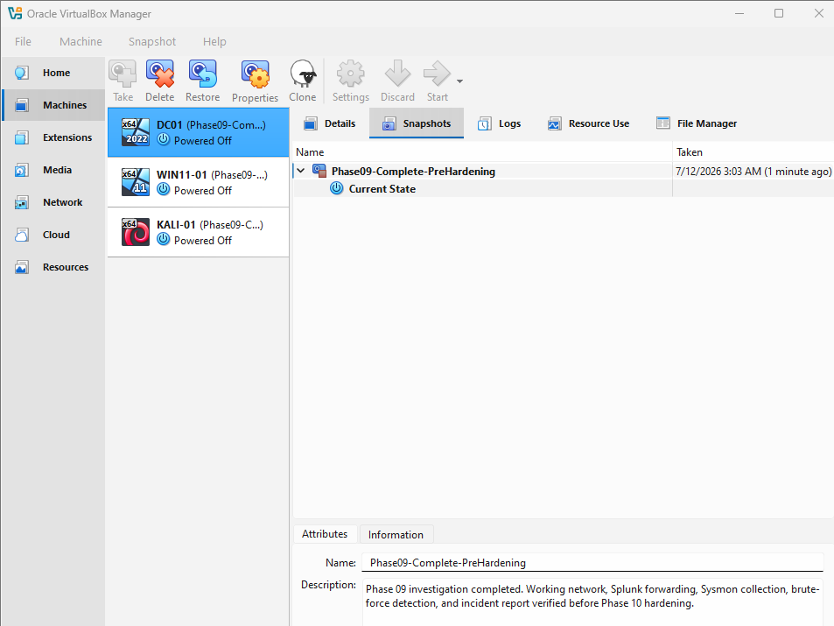 | 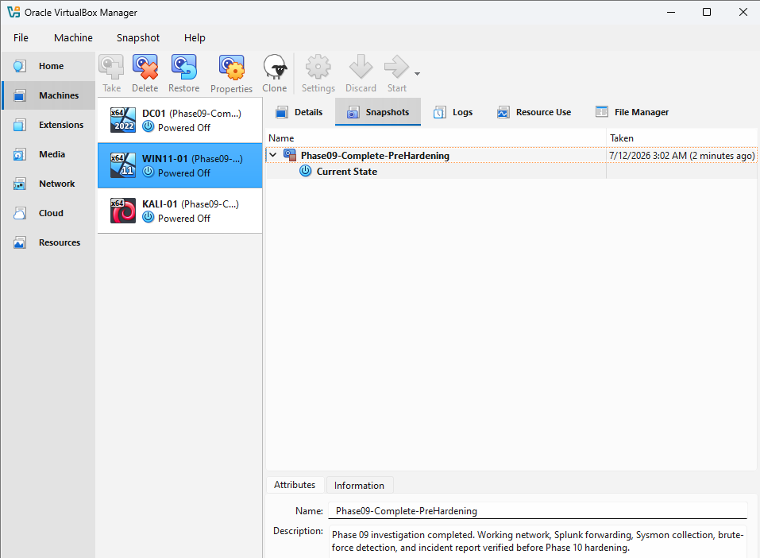 | 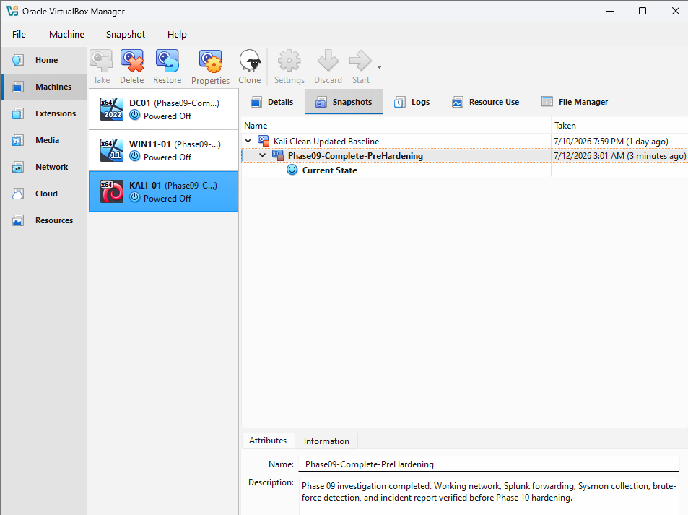
DC01 recovery snapshot | WIN11-01 recovery snapshot | KALI-01 recovery snapshot
Baseline Findings
Area | Setting | Before value | Interpretation
Domain | Complexity | True | Already enabled
Domain | Min length | 7 | Retained
Domain | Password history | 24 | Retained
Domain | Lockout threshold | 0 | No domain lockout
Local | Min length/history | 7 / 20 | Retained
Local | Lockout threshold | Never | No local lockout
SMB | SMB1 / SMB2 | False / True | SMB1 already disabled
SMB | Signing required | True | Already required
BASELINE NOTE | SMB1 and mandatory server signing were already configured securely before Phase 10; they were verified rather than newly enabled.

Baseline Evidence
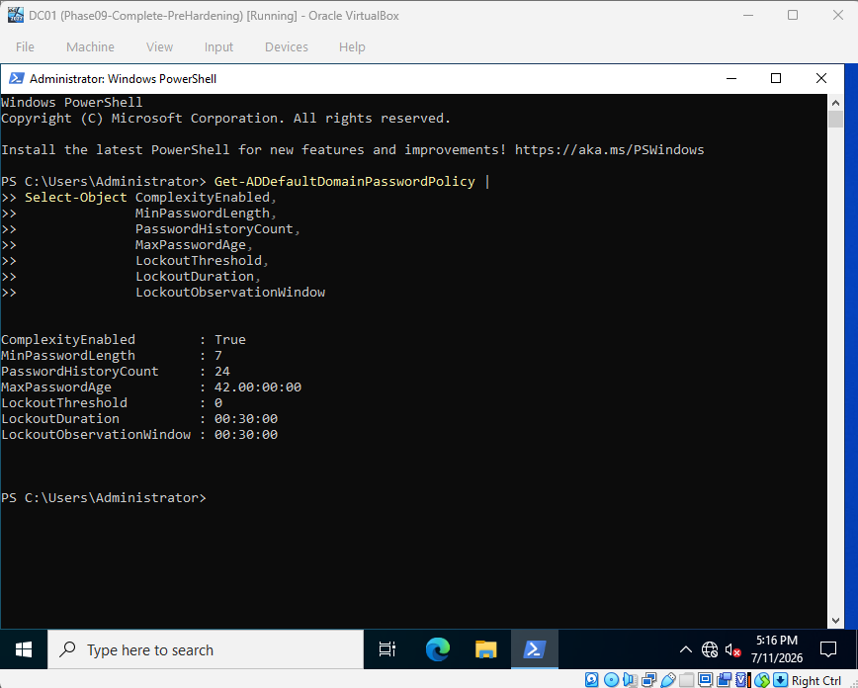 | 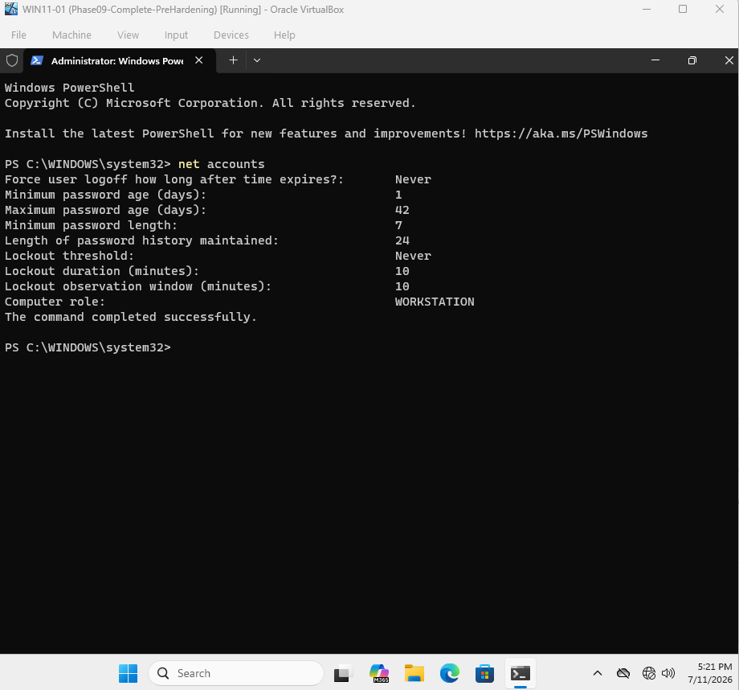
Figure 1. Domain policy before hardening. | Figure 2. Local account policy before hardening.
SMB Baseline
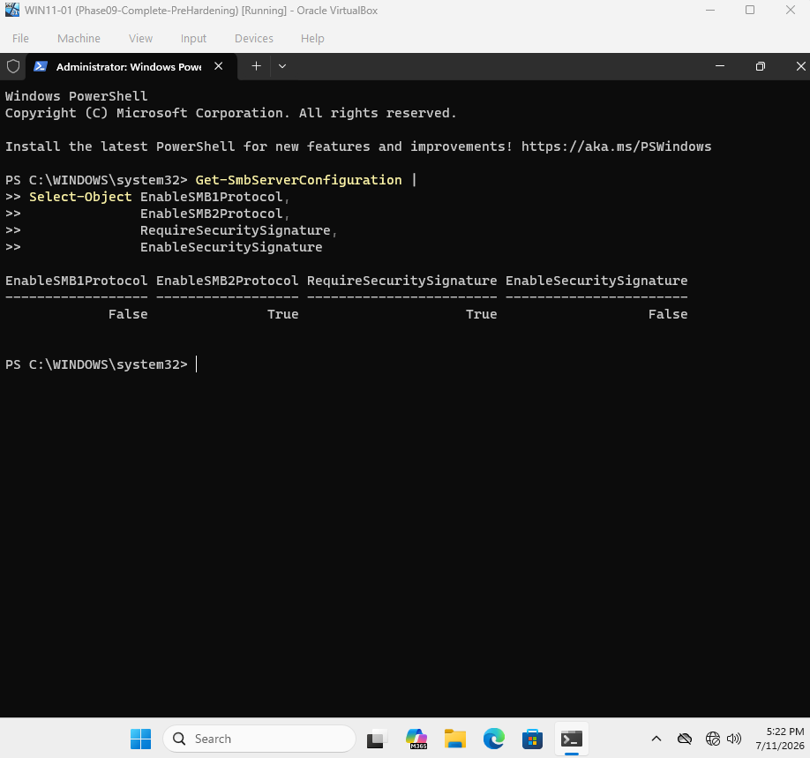
Figure 3. SMB1 was disabled and server signing was already required before Phase 10.

Password and Account-Lockout Controls
The principal security change was enabling account lockout for both the domain and the Windows 11 local account policy. Password complexity, minimum length, and history settings remained in place.
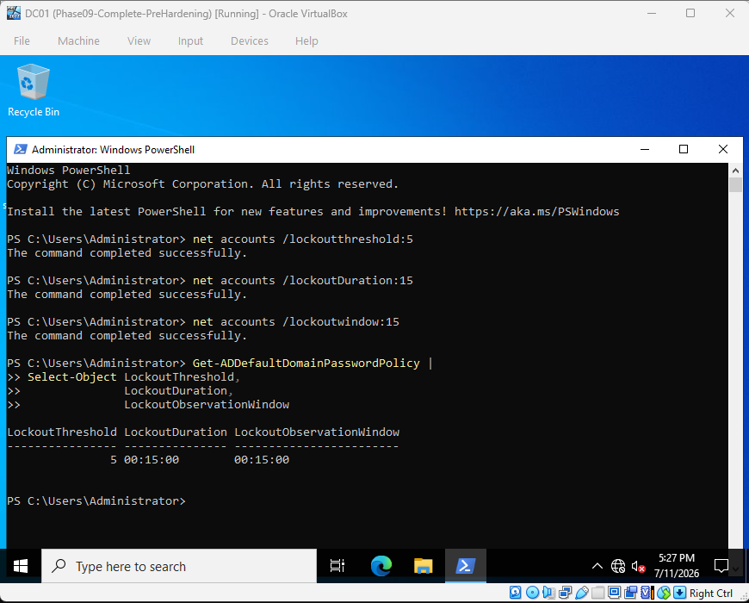 | 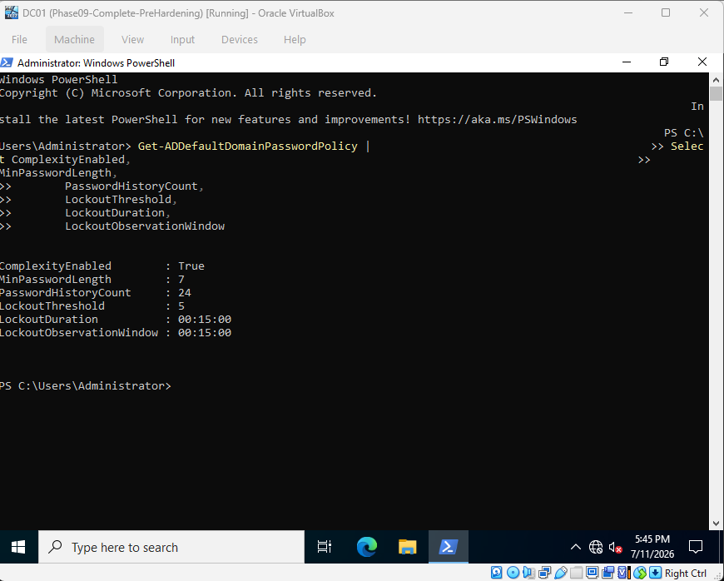
Figure 4. Domain lockout policy after hardening. | Figure 5. Domain password policy after hardening.
Local Lockout Policy
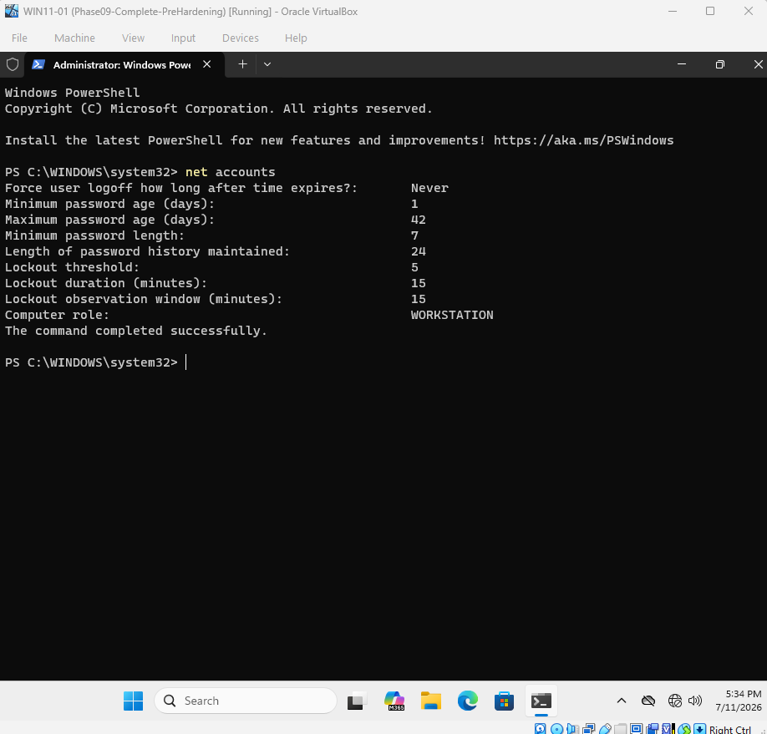
Figure 6. WIN11-01 local accounts lock after five failures for 15 minutes.

Account and SMB Hardening Verification
Local Account State
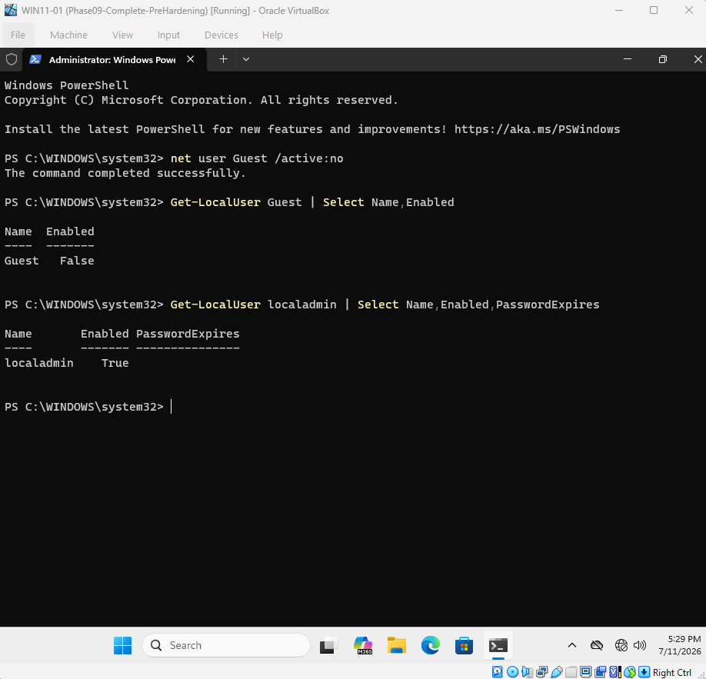
Figure 7. Guest is disabled; localadmin remained enabled for the controlled test.
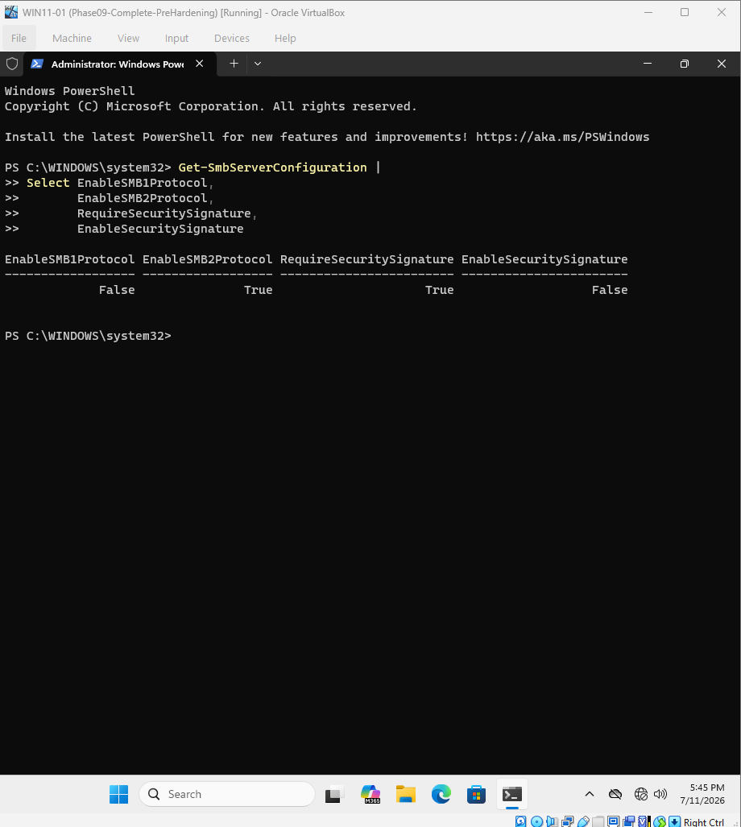 | 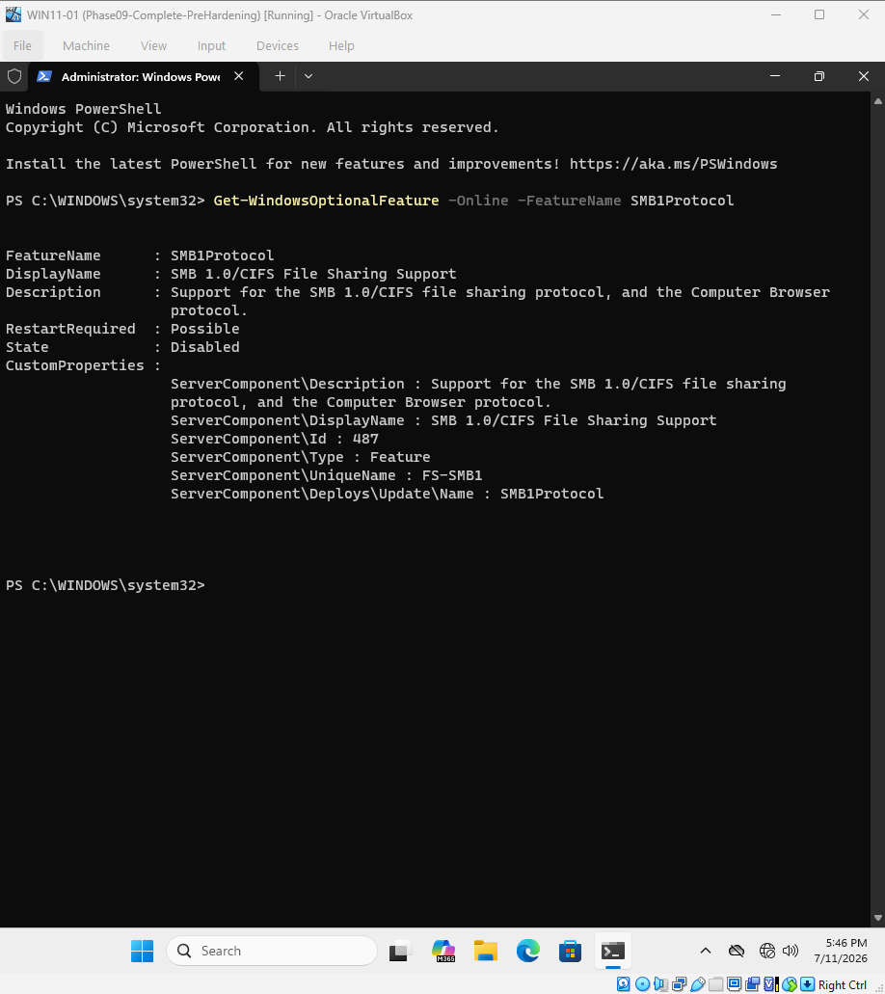
Figure 8. SMB configuration verified. | Figure 9. SMB1 optional feature disabled.
ASSESSMENT | The SMB evidence confirms secure settings but does not show a before/after change: SMB1 and required signing were already present in the baseline.

Remote Access and Host Firewall
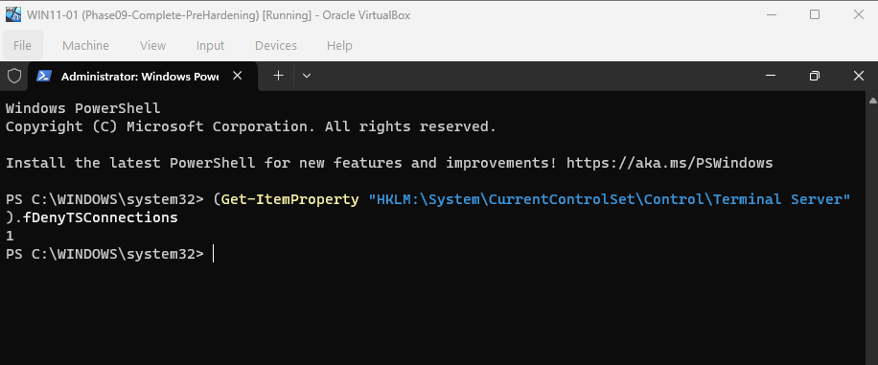 | 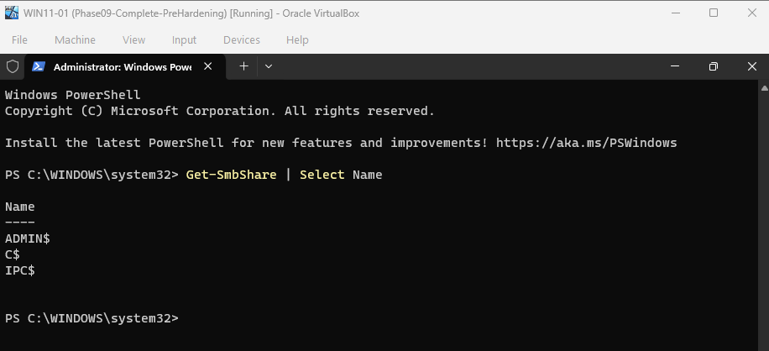
Figure 10. RDP disabled. | Figure 12. Default administrative shares remain.
Windows Firewall
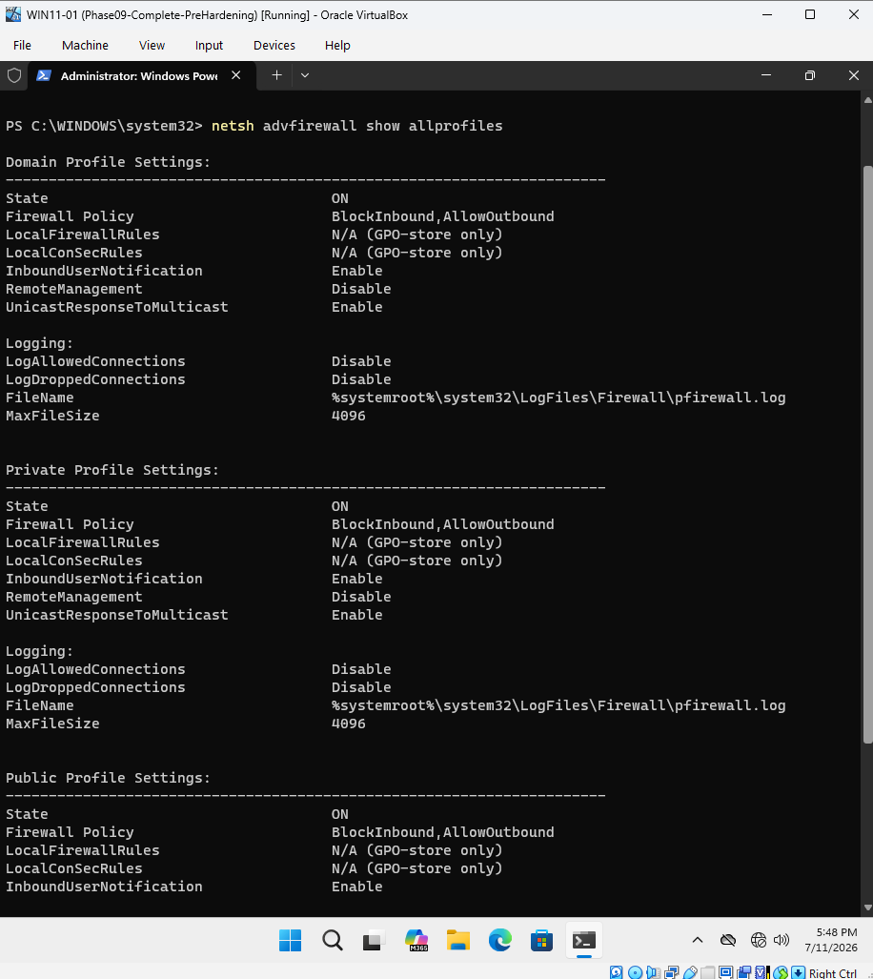
Figure 11. All Windows Firewall profiles are enabled with inbound traffic blocked by default.
RESIDUAL RISK | ADMIN$, C$, and IPC$ remain available. In a production environment, access should be limited to approved management hosts through firewall and administrative controls.

Logging and Telemetry Health
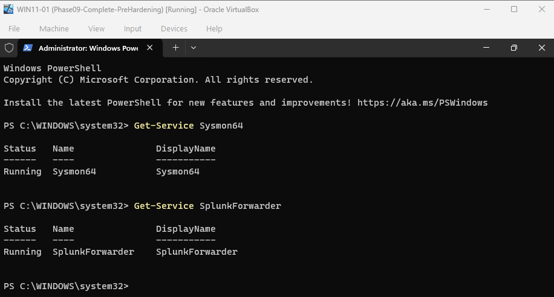 | 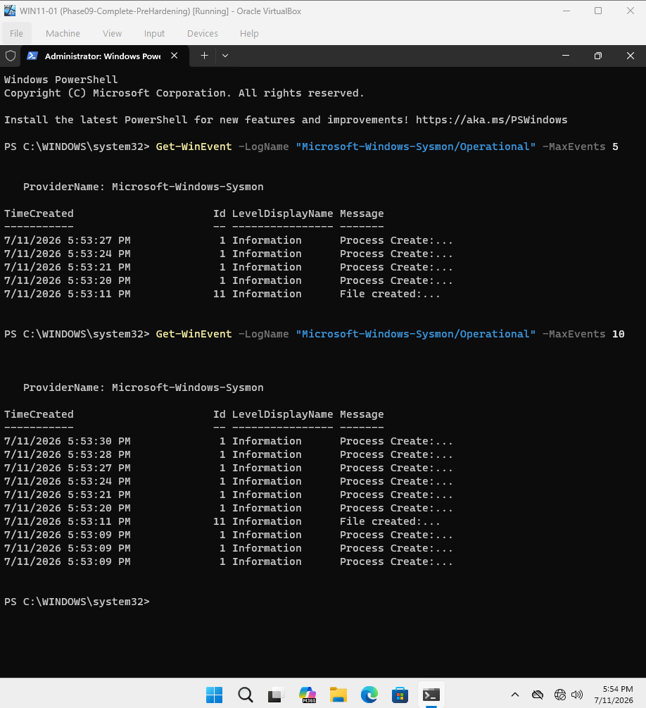
Figure 13. Sysmon and SplunkForwarder services running. | Figure 14. Live Sysmon events on WIN11-01.
Security Log Ingestion
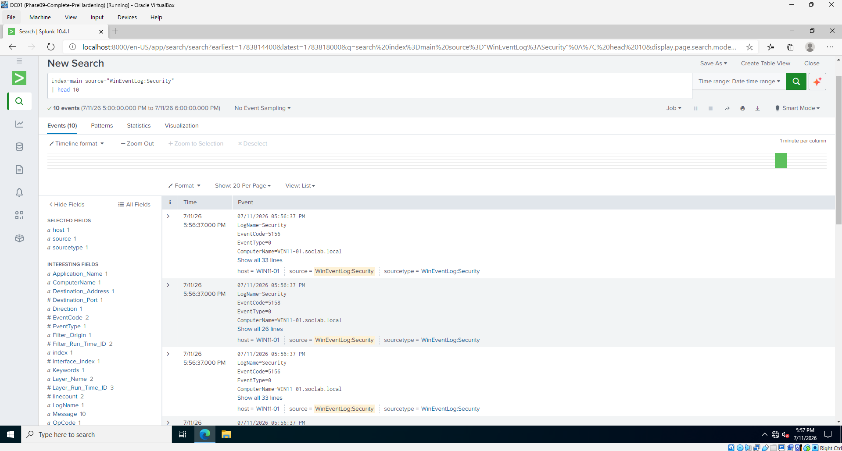
Figure 15. Windows Security logs continue to arrive in Splunk after hardening.

SIEM Detection Readiness
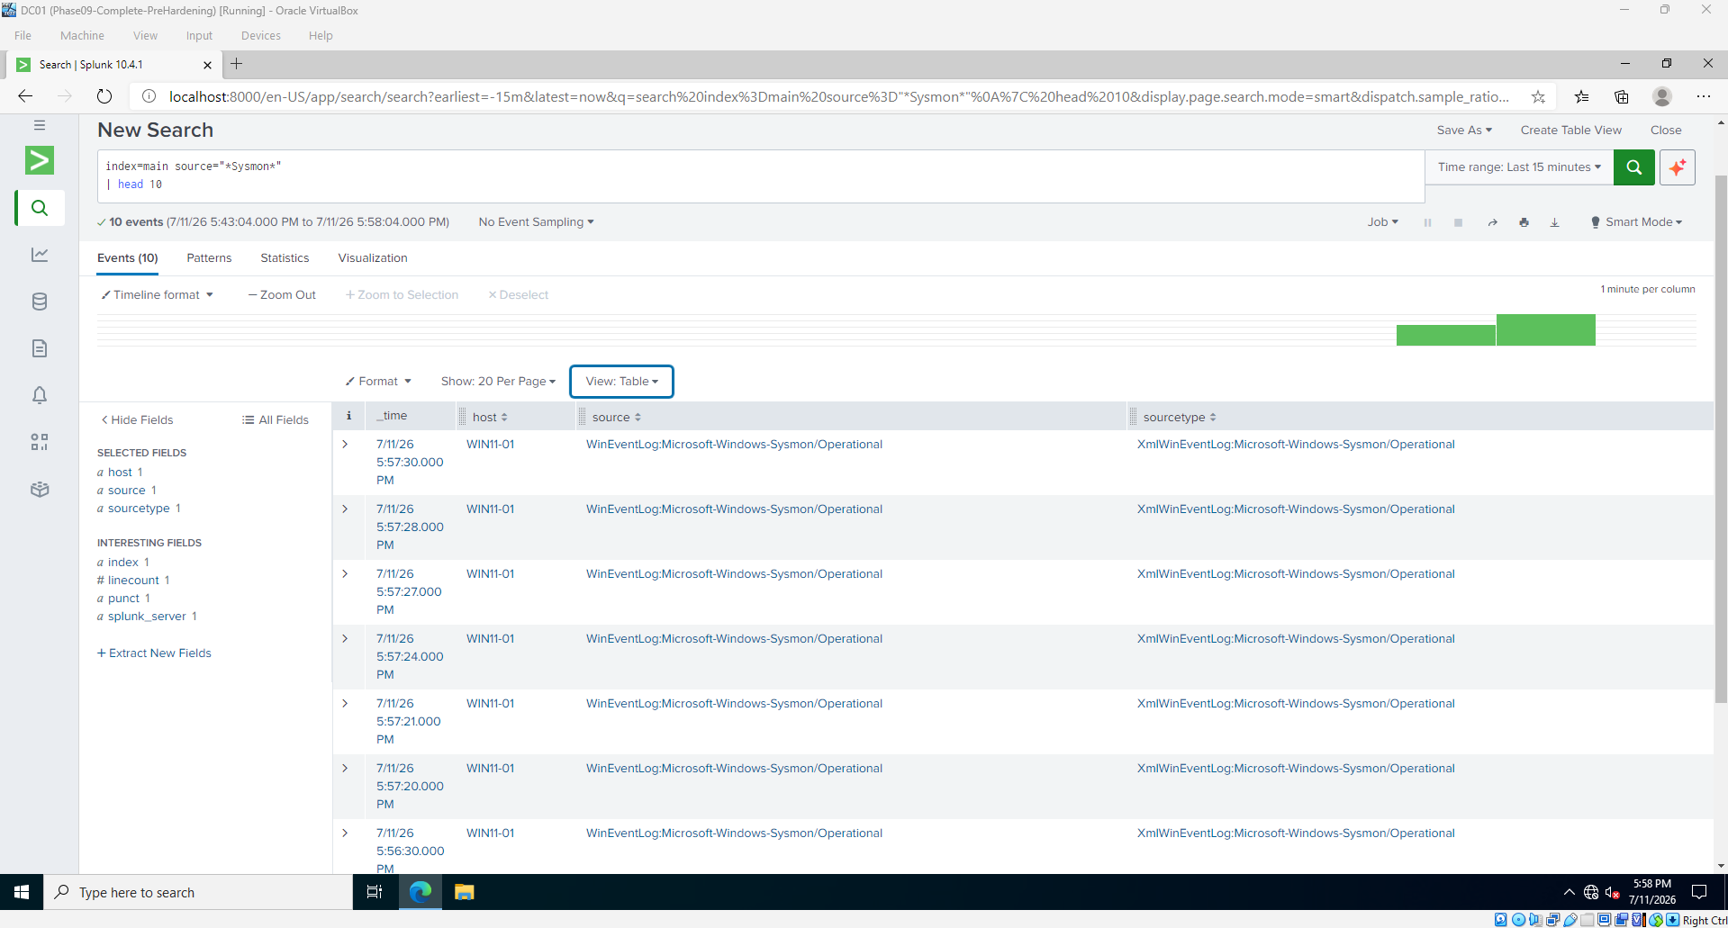
Figure 16. Sysmon logs are received and searchable in Splunk.
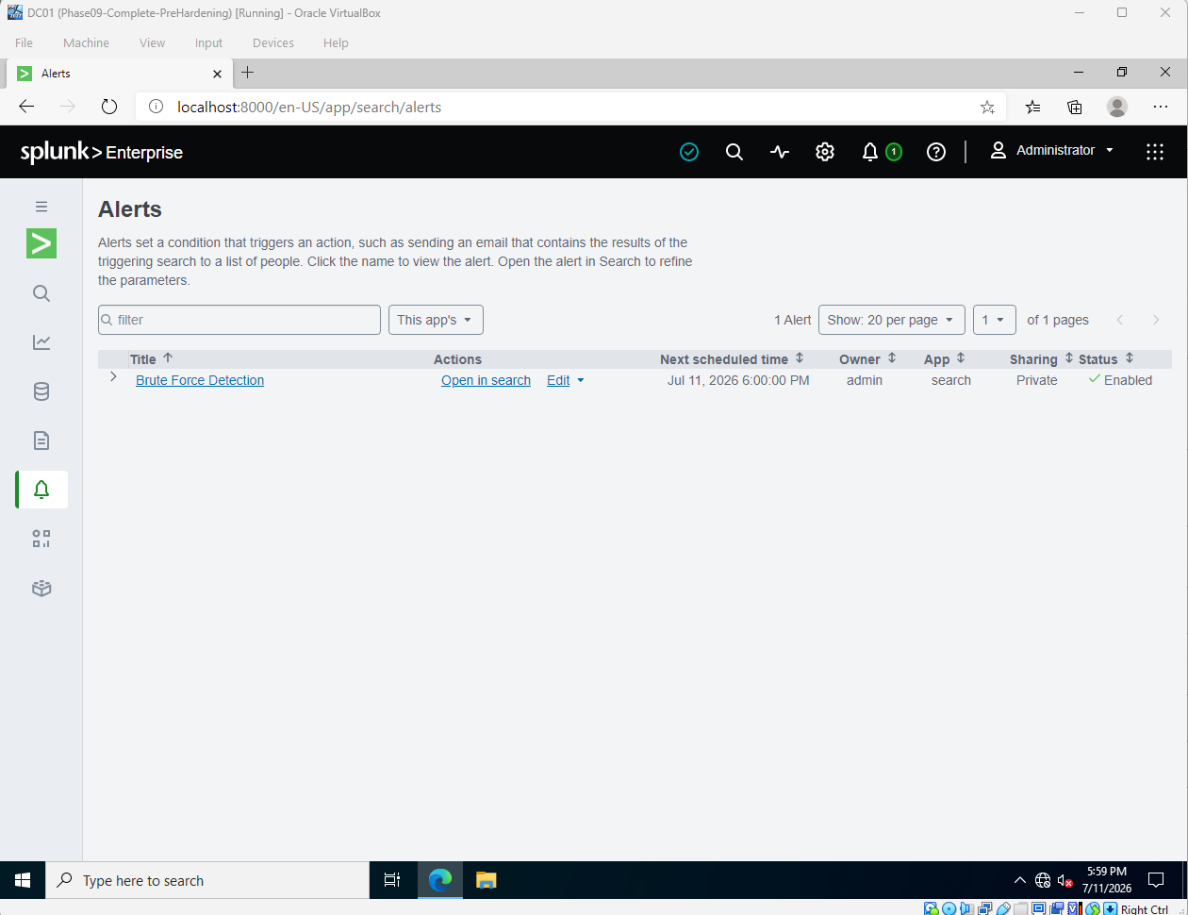 | 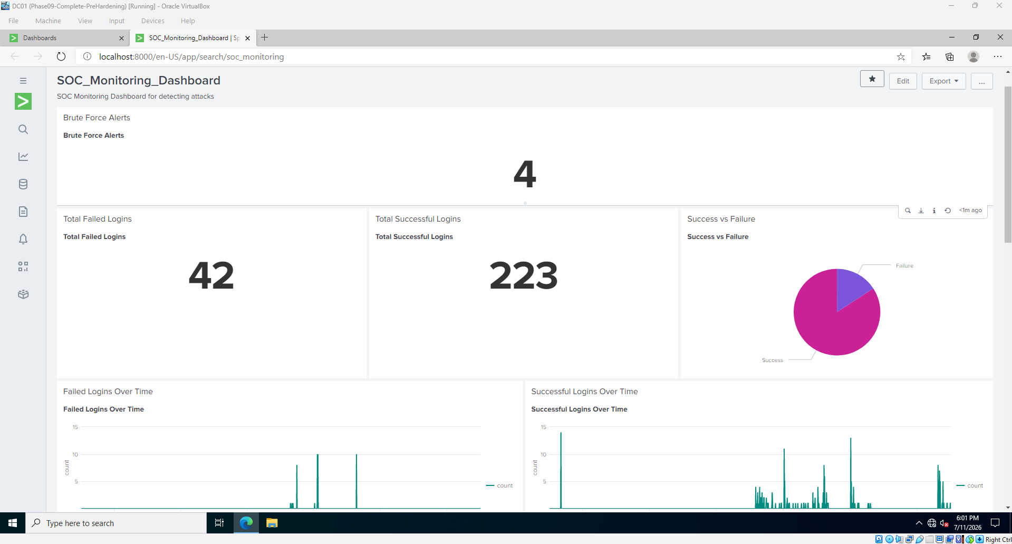
Figure 17. Brute Force Detection alert enabled. | Figure 18. SOC monitoring dashboard healthy.
VALIDATION | The log pipeline, scheduled alert, and dashboard remained operational after the host and account-policy changes.

Final NetExec Validation
KALI-01 repeated an authorized SMB authentication test against WIN11-01 using local authentication. NetExec identified Windows 11 with SMB signing enabled and returned STATUS_ACCOUNT_LOCKED_OUT for the local Administrator account. Several SMB/NetBIOS timeout messages were also present, but no successful authentication marker appeared.
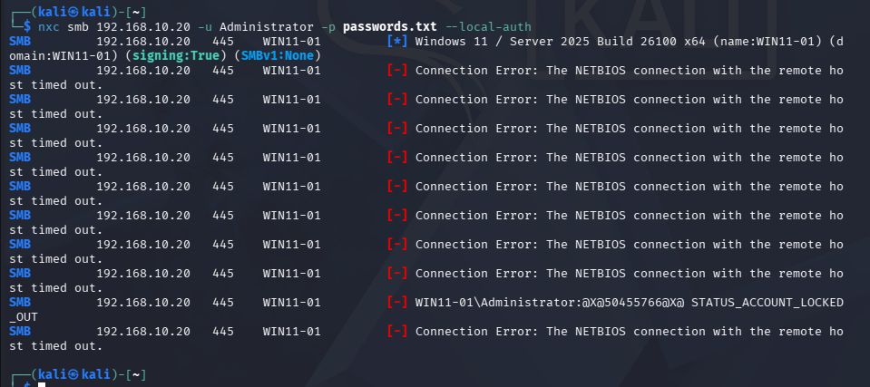
Figure 19. NetExec receives STATUS_ACCOUNT_LOCKED_OUT; no successful authentication is shown.
RESULT | PASSED — the lockout control prevented authenticated access during the final validation.
Validation Scope
In Phase 9, testing focused on localadmin. The final NetExec check used the local Administrator account with --local-auth. This confirms that the local account-lockout policy is enforced. The Splunk evidence below separately documents post-hardening failures for localadmin and confirms that no later successful localadmin network logon was recorded.
Validation point | Before hardening | After hardening
Authentication outcome | Four successful localadmin logons | Administrator locked; no NetExec success
Lockout event | Not enforced | Event ID 4740 recorded
Failed logons | Detected | Detected after hardening
Monitoring | Operational | Remained operational

Splunk Validation After Hardening
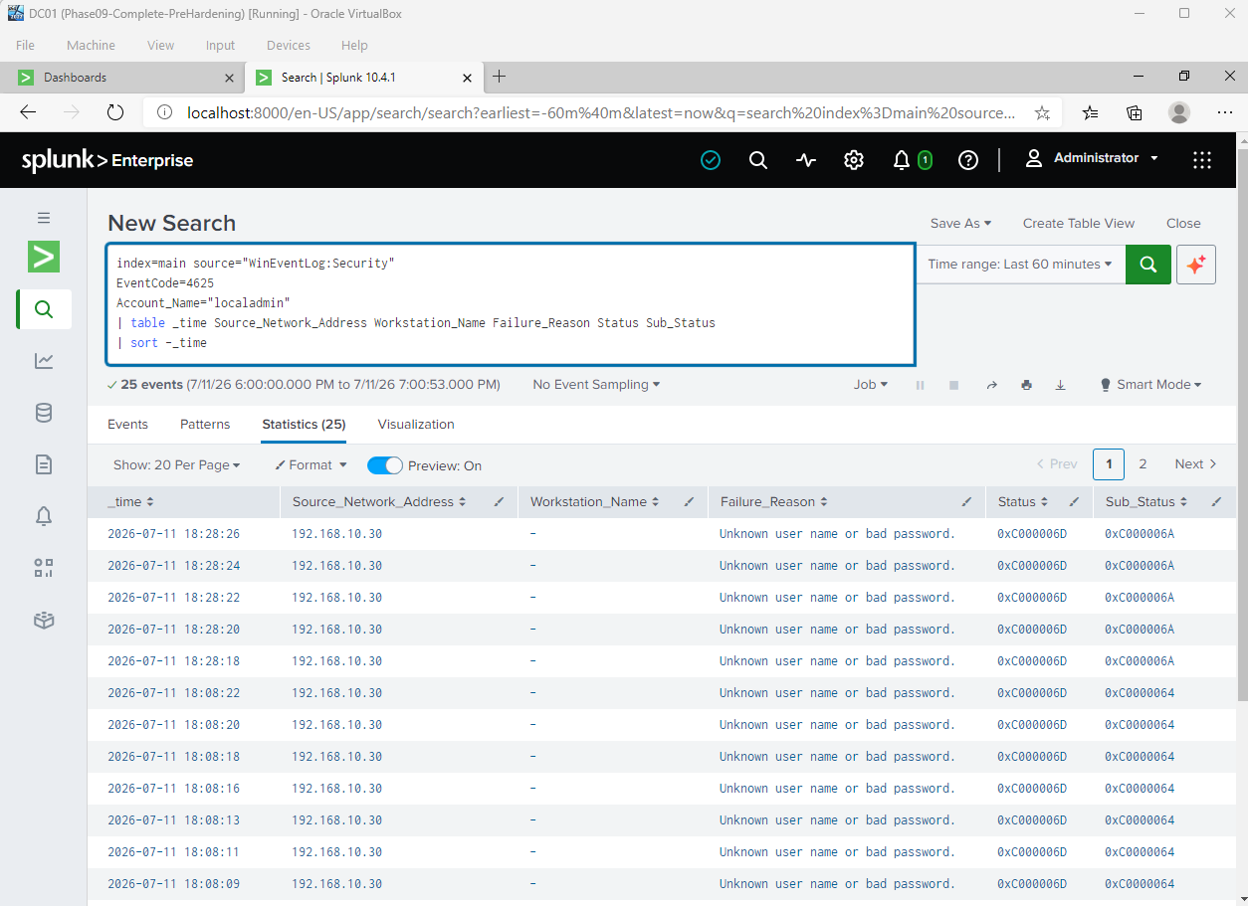 | 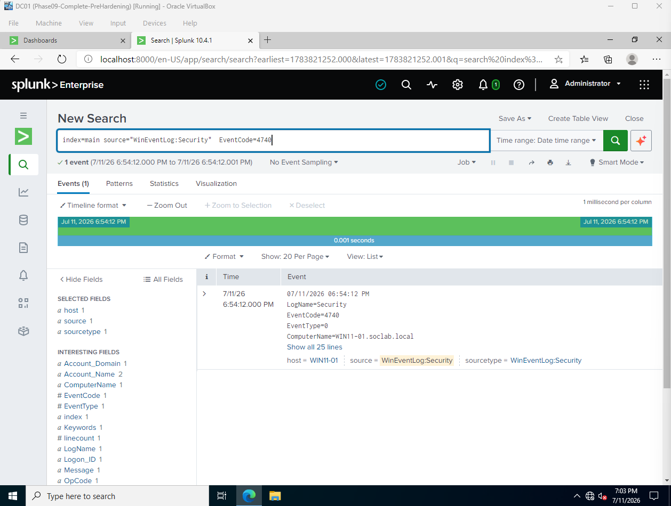
Figure 20. Failed localadmin logons after hardening. | Figure 21. Account-lockout event recorded.
Successful Logon Review
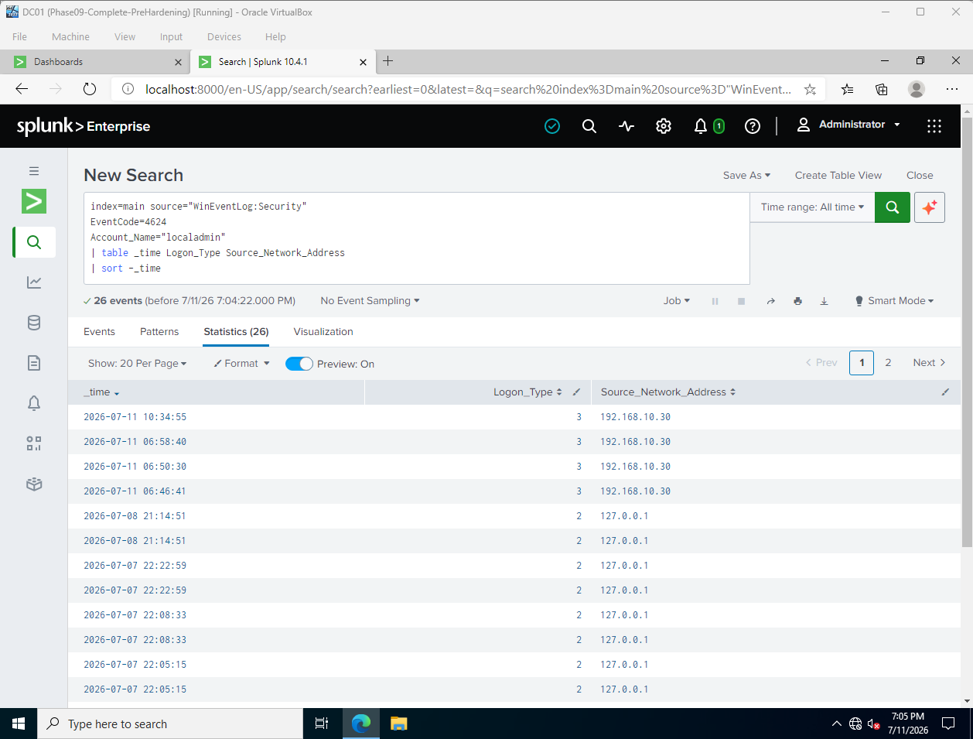
Figure 22. No new localadmin Event ID 4624 appears after hardening; the newest listed success remains 10:34:55.
EVIDENCE NOTE | The screenshots document separate validation steps. The 4625 search covers localadmin failures, the NetExec test covers Administrator, and Event ID 4740 confirms that WIN11-01 enforced account lockout. Together they show the control working across the host without presenting them as one continuous command sequence.

Security Assessment and Recommendations
Controls Demonstrated
- Domain and local account-lockout thresholds set to five attempts with 15-minute duration and observation windows.
- SMB1 disabled and SMB server signing required.
- RDP disabled and all Windows Firewall profiles enabled with inbound traffic blocked by default.
- Sysmon and Splunk Universal Forwarder services healthy, with Security and Sysmon data visible in Splunk.
- Brute-force alert enabled and SOC dashboard operational.
- NetExec received STATUS_ACCOUNT_LOCKED_OUT and no successful validation authentication was observed.
Residual Risks and Limitations
- Default administrative shares ADMIN$, C$, and IPC$ remain enabled.
- The final NetExec validation used Administrator, while the Phase 9 baseline used localadmin.
- The 4740 event predates the final NetExec screenshot and may reflect the earlier manual lockout validation.
- The no-success search uses an all-time window; the conclusion depends on the newest displayed 4624 timestamp being earlier than the hardening validation.
- Password minimum length remained seven characters and should be increased for a production environment.
Recommended Next Improvements
- Increase password minimum length to at least 14 characters and use unique service/admin credentials.
- Limit SMB and administrative-share access to approved management hosts or a dedicated administration subnet.
- Enable Windows Firewall dropped-packet logging and forward those logs to the SIEM.
- Repeat the final validation with localadmin for a strict same-account before/after comparison.
- Tune the Splunk alert to correlate failures, lockout, and any later success by host, source IP, and account.
Final Conclusion
Phase 10 is complete. The lab preserved a recoverable pre-hardening state, introduced effective lockout controls, verified protocol and host protections, confirmed telemetry health, and demonstrated that the final local-authentication test did not obtain access. The project now covers the complete defensive cycle: build, attack, detect, investigate, harden, and validate.
PROJECT STATUS | SOC Home Lab technical objectives completed. The final evidence set is suitable for academic or portfolio use, with the validation scope clearly documented.

Evidence Register
The filenames below map the submitted evidence to the control or validation point documented in this report. Numbering follows the original evidence package.
ID | Evidence file | Purpose
01 | DC01 / WIN11 / KALI snapshots | Recovery points
02 | Domain-Policy-Before-Hardening | Domain baseline
03 | Local-Account-Policy-Before | Local baseline
04 | SMB-Configuration-Before | SMB baseline
05 | Domain-Lockout-Policy-After | Domain lockout
06 | LocalAdmin-Status | Account state
07 | Local-Lockout-Policy-After | Local lockout
08 | Domain-Password-Policy-After | Domain verification
09 | SMB-Hardening | SMB verification
10 | SMB1-Disabled | Legacy protocol disabled
11 | RDP-Disabled | Remote-access reduction
12 | Firewall-Enabled | Host firewall
13 | Administrative-Shares | Residual exposure
14 | Sysmon & Forwarder Services | Service health
16 | Sysmon-Live-Events | Local telemetry
17 | Security-Logs-Received | Security ingestion
18 | Sysmon-Logs-Received | Sysmon ingestion
19 | BruteForce-Alert-Enabled | Detection readiness
20 | SOC-Dashboard-Healthy | Monitoring health
21 | NetExec-Blocked | Final attack validation
23 | 4625-After-Hardening | Failed logons
24 | Account-Lockout-Event | Event ID 4740
25 | No-Successful-Logon | No later localadmin 4624

