COMPLETE PROJECT RECORD
SOC HOME LAB
Complete Technical Documentation
Phases 0–10 | Build, Attack, Detect, Investigate, Harden, Validate
Environment: Isolated VirtualBox SOC Home Lab
Domain: soclab.local
Primary systems: DC01 / Splunk, WIN11-01, KALI-01
Network: 192.168.10.0/24 Host-Only
Documentation date: 12 July 2026
Project status: Core technical objectives completed

OUTCOME | The lab demonstrates an end-to-end defensive workflow: infrastructure deployment, endpoint telemetry, attack simulation, SIEM detection, incident investigation, security hardening, and post-hardening validation.

Document Purpose and Scope
This document consolidates the complete SOC Home Lab project from Phase 0 through Phase 10. It records the implemented architecture, work performed, validation methods, incident findings, hardening controls, troubleshooting decisions, evidence, and remaining improvement opportunities.
The report distinguishes implemented work from the original blueprint. Where the final configuration differed from the initial plan, the working configuration is documented as the authoritative state.
EVIDENCE BOUNDARY | Most Phase 0–8 screenshots are referenced by filename in the exported conversation. Phase 9 and Phase 10 were directly verified from their submitted evidence packages and final reports.

Executive Summary
The project created an isolated Windows-focused SOC environment using VirtualBox. DC01 provided Active Directory, DNS, and Splunk services; WIN11-01 acted as the monitored endpoint; and KALI-01 generated authorized test activity. Windows Security logs and Sysmon telemetry were forwarded into Splunk for search, dashboards, alerts, and investigation.
The principal incident scenario was an SMB credential attack against WIN11-01. Splunk recorded 31 failed logons followed by four successful localadmin network logons from 192.168.10.30. Phase 9 reconstructed and documented the event. Phase 10 then enabled account lockout, verified host and protocol protections, repeated the test, and demonstrated that Windows returned STATUS_ACCOUNT_LOCKED_OUT while monitoring remained operational.
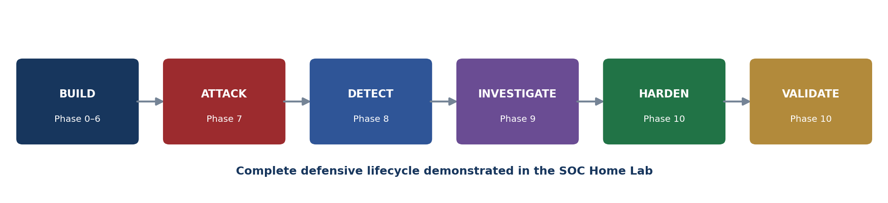
Figure 1. Defensive lifecycle demonstrated across Phases 0–10.

Project Status at a Glance
Phase | Focus | Status | Primary result
0 | Preparation and network | Complete | VirtualBox and isolated host-only network prepared
1 | Windows Server VM | Complete | DC01 deployed and stabilized
2 | AD DS and DNS | Complete | soclab.local operational
3 | Windows client | Complete | WIN11-01 joined and used in the domain
4 | Splunk platform | Complete | Splunk available on DC01 and receiving data
5 | Forwarder and Sysmon | Complete | Endpoint telemetry collected
6 | Kali attacker | Complete | KALI-01 configured at 192.168.10.30
7 | Safe simulations | Core complete | Nmap and NetExec scenarios executed
8 | Detections and dashboard | Complete | Queries, alert, and dashboard operational
9 | Investigation | Complete | High-severity credential incident documented
10 | Hardening and validation | Complete | Account lockout enforced; validation passed

Implemented Architecture
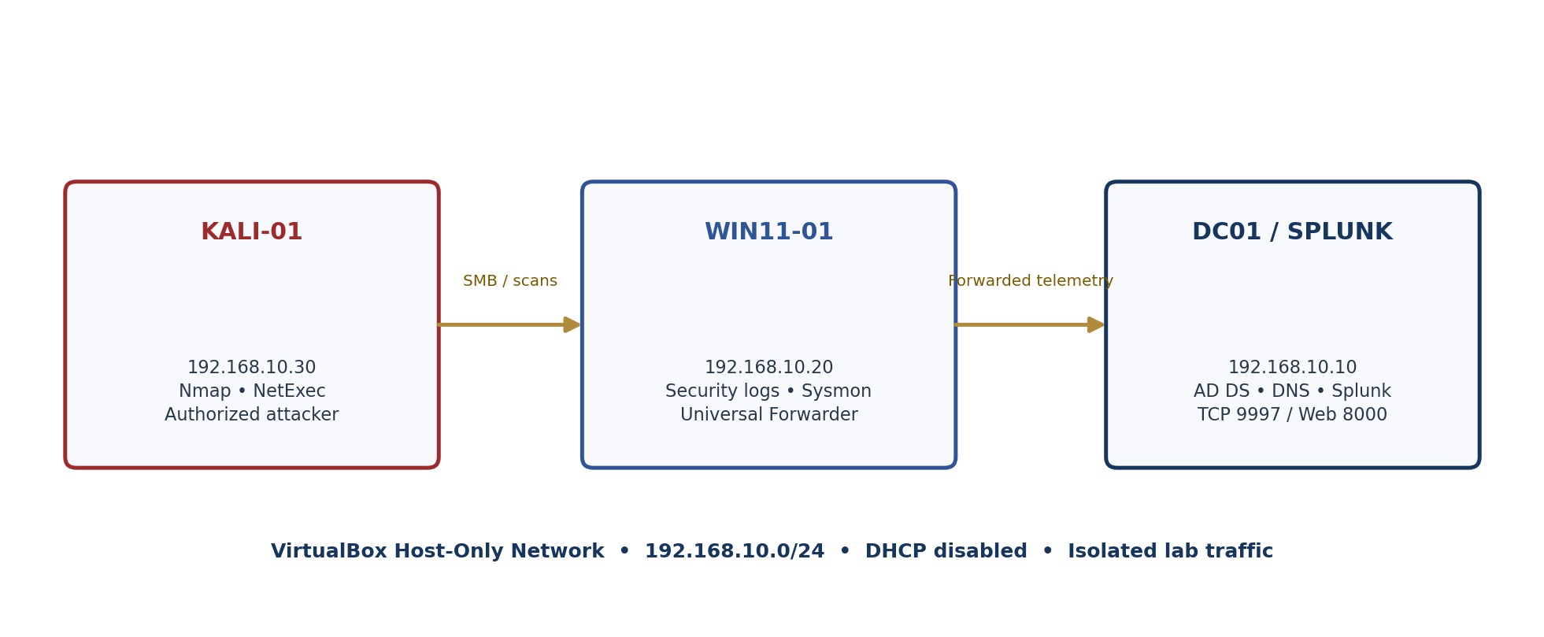
Figure 2. Implemented SOC Home Lab architecture and data flow.
Role | System | Address | Primary functions
Host / isolation | VirtualBox host adapter | 192.168.10.1 | Host-only network; DHCP disabled
Domain and SIEM | DC01 / Splunk | 192.168.10.10 | AD DS, DNS, Splunk Enterprise, TCP 9997 receiver
Monitored endpoint | WIN11-01 | 192.168.10.20 | Windows client, Security logs, Sysmon, Universal Forwarder
Authorized attacker | KALI-01 | 192.168.10.30 | Nmap reconnaissance and NetExec SMB testing

Telemetry Flow
- Windows generates Security, System, Application, and Sysmon Operational events.
- The Splunk Universal Forwarder on WIN11-01 collects enabled event channels.
- Telemetry is sent to the Splunk receiver at 192.168.10.10 on TCP port 9997.
- Splunk indexes, searches, visualizes, and alerts on the collected activity.
- Analyst searches correlate attacker IP, account, host, event ID, and time.
IMPLEMENTED CONFIGURATION | The original blueprint proposed separate wineventlog and sysmon indexes. The working deployment used index=main. Sysmon arrived as XML with renderXml=true, so required fields were extracted from _raw during investigation.

PHASE 0

Phase 0 — Lab Preparation

Objective
Prepare a safe, organized virtualization environment before deploying any systems.

Work Performed
- Installed Oracle VirtualBox and confirmed that virtualization could support the required virtual machines.
- Created VirtualBox Host-Only Ethernet Adapter #2 with address 192.168.10.1/24.
- Disabled DHCP so each lab system could use a predictable static address.
- Downloaded the Windows Server 2022, Windows 11, Ubuntu Server, and Kali Linux installation or VM media during initial planning.
- Created organized locations for ISOs, VM files, screenshots, reports, configurations, and Splunk searches.
- Adopted a checkpoint approach: verify networking, services, and logs before advancing to the next phase.

Validation and Result
- The isolated 192.168.10.0/24 network supported later communication among DC01, WIN11-01, and KALI-01.
- The attack simulations remained within the Host-Only network rather than using a bridged adapter.
- Project evidence was saved throughout later phases, confirming that the folder and screenshot workflow was used.

Recorded Evidence
- Host-Only adapter configuration screenshots referenced in the conversation.
- Organized screenshot and report folders used in Phases 6–10.
SAFETY DECISION | Host-Only networking was intentionally used to keep authorized attack traffic isolated from external networks.

PHASE 1

Phase 1 — Windows Server 2022 and DC01

Objective
Deploy the Windows Server virtual machine that would become the central domain and monitoring system.

Work Performed
- Created the DC01 VM in VirtualBox using Windows Server 2022 Evaluation media.
- Allocated a dynamically expanding VDI disk and appropriate processor and memory resources for the lab.
- Configured the VM storage, boot order, clipboard integration, and Host-Only network adapter.
- Installed Windows Server, completed administrator setup, and applied the DC01 hostname.
- Troubleshot Guest Additions, boot order, network-adapter selection, and VM performance while moving VM storage to SSD.

Validation and Result
- DC01 remained operational throughout the project and hosted the services required by later phases.
- WIN11-01 forwarded telemetry to 192.168.10.10:9997, confirming DC01 network reachability.
- Splunk searches were later performed locally on DC01 through port 8000.

Recorded Evidence
- DC01 installation, configuration, network, and VirtualBox screenshots referenced in the conversation.

PHASE 2

Phase 2 — Active Directory Domain Services and DNS

Objective
Create the soclab.local identity environment and provide centralized naming and authentication.

Work Performed
- Configured DC01 with the static address 192.168.10.10.
- Installed and promoted Active Directory Domain Services.
- Created the soclab.local domain and enabled DNS services on the domain controller.
- Created and used domain identity records required for Windows client testing.
- Verified domain operation indirectly through later client authentication, domain policy queries, and Phase 10 lockout-policy changes.

Validation and Result
- Get-ADDefaultDomainPasswordPolicy returned the active domain policy during Phase 10.
- The domain lockout threshold was successfully changed from 0 to five attempts.
- WIN11-01 operated within the domain environment and domain credentials were used during earlier checkpoints.

Recorded Evidence
- Active Directory, DNS, user, and domain-policy screenshots referenced across the conversation and Phase 10 evidence.
EVIDENCE IMPROVEMENT | For a public portfolio, add one clear screenshot of nslookup soclab.local and one view of the final OU/user structure.

PHASE 3

Phase 3 — Windows 11 Client Deployment

Objective
Deploy the monitored Windows endpoint and integrate it with the domain and lab network.

Work Performed
- Created and installed the WIN11-01 virtual machine.
- Assigned the static address 192.168.10.20 and used DC01 as the domain/DNS service.
- Connected the VM to the same Host-Only network used by DC01.
- Joined the Windows client to soclab.local and used a domain user account during validation.
- Moved VM storage to SSD to resolve performance problems while preserving the working VM configuration.

Validation and Result
- WIN11-01 communicated with DC01 and KALI-01 during later telemetry and attack tests.
- Windows Security events and Sysmon events from WIN11-01 appeared in Splunk.
- The client processed network logons and generated Events 4624, 4625, and 4740.

Recorded Evidence
- WIN11-01 network, domain, account, and VirtualBox screenshots referenced in the exported conversation.

PHASE 4

Phase 4 — Splunk Enterprise Deployment

Objective
Provide a central SIEM platform for receiving, searching, visualizing, and alerting on Windows telemetry.

Work Performed
- Deployed Splunk Enterprise on the implemented DC01/Splunk system at 192.168.10.10.
- Used the Splunk web interface on port 8000.
- Enabled the Splunk receiving service on TCP port 9997.
- Used index=main for the final working deployment.
- Created searches for Windows authentication, Sysmon telemetry, Nmap-related activity, and brute-force behavior.

Validation and Result
- WIN11-01 successfully forwarded Security and Sysmon data to the Splunk receiver.
- Splunk supported the Phase 9 incident investigation and the Phase 10 validation searches.
- The SOC dashboard and Brute Force Detection alert remained operational after hardening.

Recorded Evidence
- Splunk search, receiver, index, alert, and dashboard screenshots referenced in the conversation and evidence packages.
ARCHITECTURE DECISION | Although Ubuntu Server appeared in the initial download plan, the verified implemented topology used DC01 / Splunk at 192.168.10.10.

PHASE 5

Phase 5 — Universal Forwarder and Sysmon

Objective
Collect native Windows audit events and enhanced endpoint telemetry from WIN11-01.

Work Performed
- Installed the Splunk Universal Forwarder on the Windows endpoint.
- Configured Windows Security, System, Application, and Sysmon Operational event collection.
- Installed Sysmon and enabled endpoint telemetry including process creation, file creation, and network connection events.
- Configured the Sysmon channel with renderXml=true in the working inputs.conf.
- Validated that the SplunkForwarder and Sysmon64 services were running.

Validation and Result
- Local Get-WinEvent checks confirmed that Sysmon Event ID 3 existed on WIN11-01.
- Restarting SplunkForwarder reloaded the input and restored fresh Sysmon ingestion.
- Splunk received 238 fresh Sysmon events during recovery validation.
- XML extraction produced Image, SourceIp, SourcePort, DestinationIp, and DestinationPort fields.

Recorded Evidence
- Phase 9 Figures 9–11 and Phase 10 service and live-event screenshots.
TROUBLESHOOTING RESULT | Sysmon itself was functioning. The zero-result problem was in collection/reload and XML field extraction, not in the local Sysmon NetworkConnect configuration.

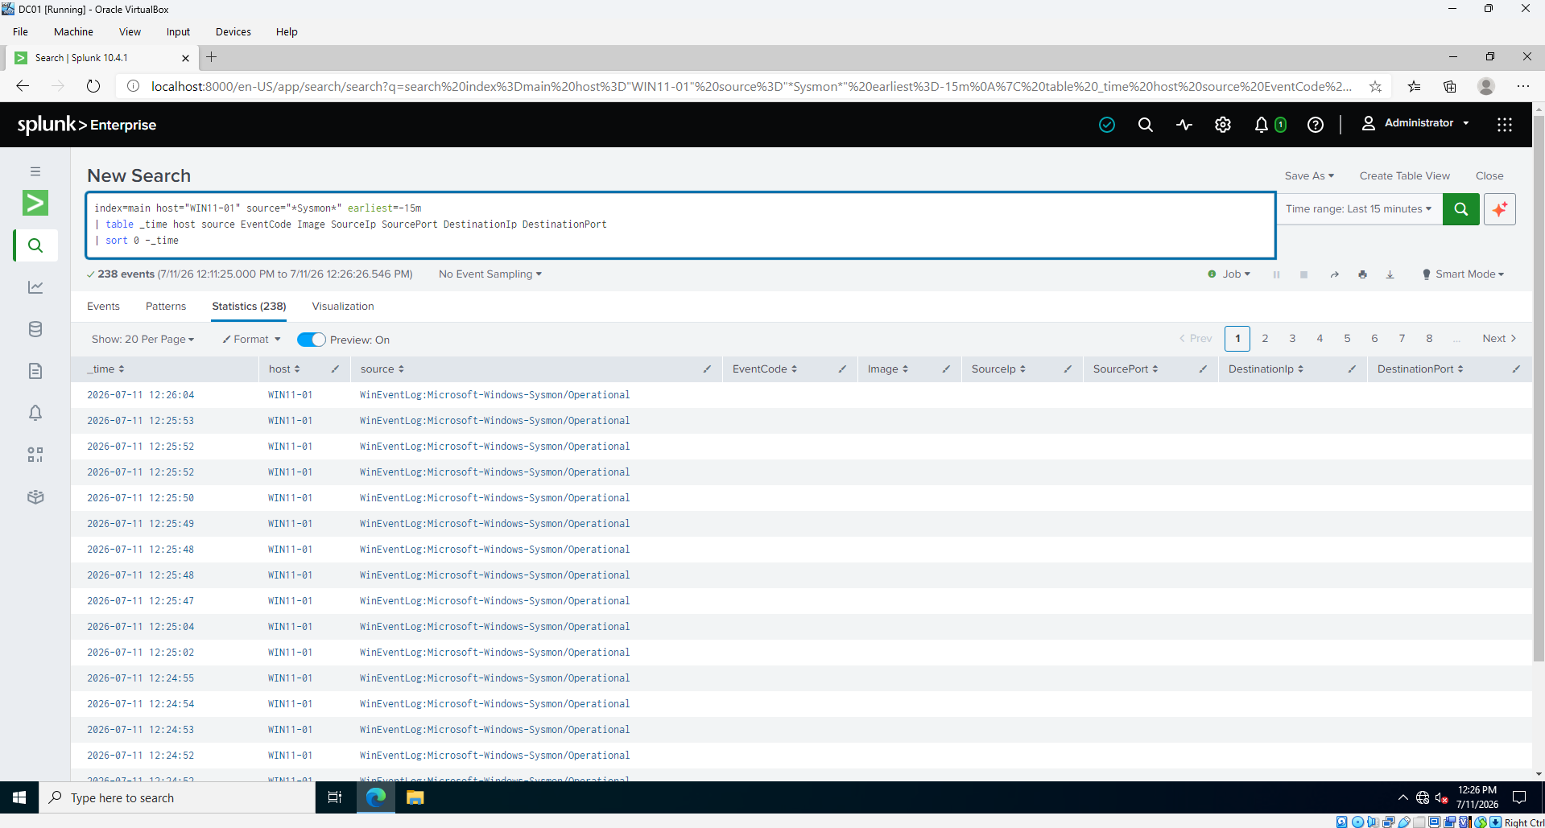
Figure 3. Fresh Sysmon events arrived after the Universal Forwarder input was reloaded.

PHASE 6

Phase 6 — Kali Linux Attacker Workstation

Objective
Prepare an isolated system for authorized reconnaissance and authentication testing.

Work Performed
- Imported the Kali Linux VirtualBox image and connected it to the Host-Only network.
- Assigned KALI-01 the static address 192.168.10.30.
- Verified communication with the Windows systems.
- Used Nmap for port scanning and NetExec for controlled SMB authentication testing.
- Stored attack and detection screenshots in organized phase folders.

Validation and Result
- Nmap activity generated searchable monitoring results and visualizations.
- NetExec generated the authentication sequence investigated in Phase 9.
- The same Kali system was used for the Phase 10 post-hardening validation.

Recorded Evidence
- Kali network screenshots, Nmap screenshots, and NetExec validation screenshots.
AUTHORIZATION BOUNDARY | KALI-01 was used only within the isolated lab and only against systems owned by the project.

PHASE 7

Phase 7 — Safe Attack Simulations

Objective
Generate controlled activity that can be detected and investigated through the SIEM.

Work Performed
- Performed Nmap scans against the lab endpoint and reviewed event-code statistics, time charts, and port-scan timelines in Splunk.
- Performed repeated SMB authentication attempts with NetExec against WIN11-01.
- Used the localadmin account in the Phase 9 scenario and generated both failed and successful logons.
- Repeated local-authentication testing after hardening in Phase 10.

Validation and Result
- Nmap detection screenshots and an SOC monitoring dashboard were created.
- NetExec activity generated 31 failed logons and four successful localadmin network logons in the Phase 9 evidence window.
- The final Phase 10 NetExec test returned STATUS_ACCOUNT_LOCKED_OUT.

Recorded Evidence
- 04-Nmap-Detection-Statistics-byEventcode.png
- 04-Nmap-Detection-Statistics-byTimechart.png
- 08-Splunk-Full-Scan-Detection.png
- 09-Port-Scan-Timeline.png
- 21-NetExec-Blocked.png
SCOPE NOTE | The original blueprint also proposed encoded PowerShell and new-local-user simulations. They were not present in the submitted evidence and are therefore recorded as future extensions, not completed work.

PHASE 8

Phase 8 — SPL Detections, Alerting, and Dashboard

Objective
Convert collected telemetry into repeatable SOC monitoring and detection content.

Work Performed
- Created basic Nmap/port-scan detection searches and visualizations.
- Created authentication searches for Event IDs 4625 and 4624 by source address, account, host, and time.
- Developed a correlation approach for repeated failures followed by successful authentication.
- Enabled the Brute Force Detection alert.
- Built and verified an SOC monitoring dashboard.

Validation and Result
- The alert was shown enabled during Phase 10.
- The dashboard remained healthy after Windows and account-policy changes.
- Searches supported both the Phase 9 incident reconstruction and Phase 10 after-hardening validation.

Recorded Evidence
- Nmap detection queries and statistics screenshots.
- Brute Force Detection alert enabled.
- SOC monitoring dashboard healthy.
EVIDENCE IMPROVEMENT | A future portfolio update should add one screenshot of the alert firing, including trigger time, source IP, account, and drill-down results.

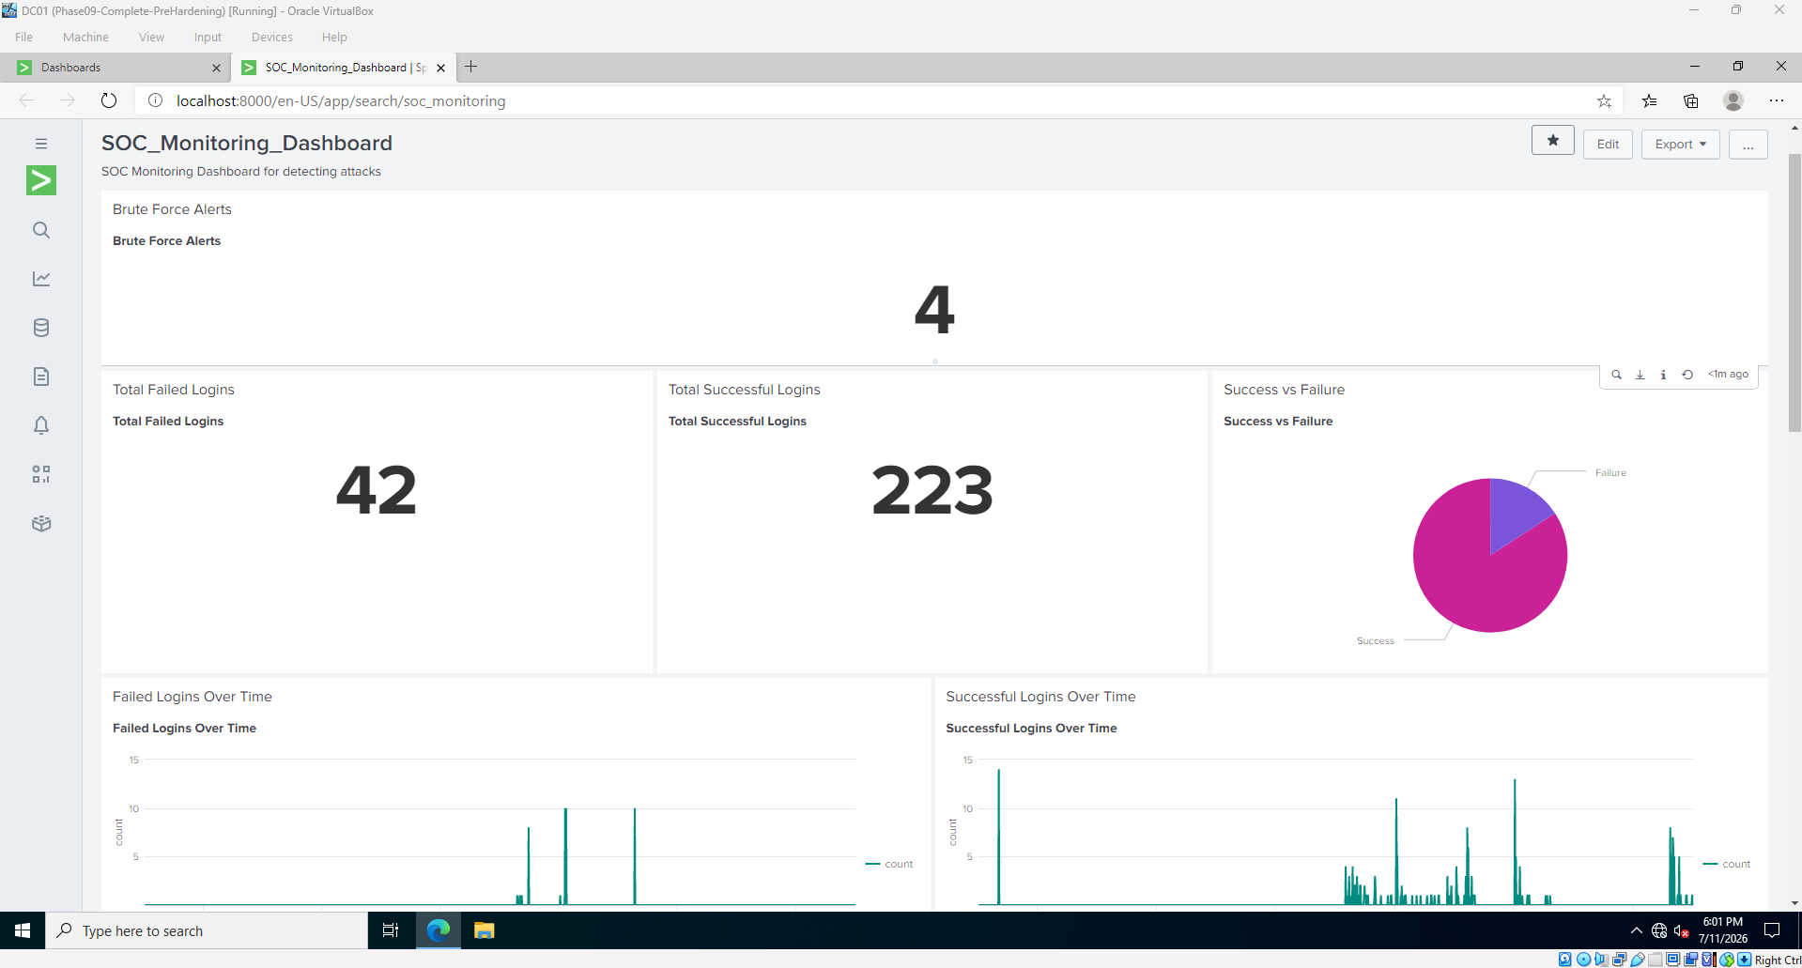
Figure 4. SOC monitoring dashboard remained operational after hardening.
PHASE 9

Phase 9 — Brute-Force Incident Investigation

Objective
Investigate the authentication attack, reconstruct the timeline, determine impact, restore missing telemetry, and document the incident.

Work Performed
- Identified 192.168.10.30 as the source of 31 failed logons against localadmin on WIN11-01.
- Confirmed four successful Event ID 4624 network logons from the same address and account.
- Validated Logon Type 3, consistent with remote network authentication.
- Excluded ANONYMOUS LOGON records from the success conclusion.
- Investigated the missing Sysmon Event ID 3 results, validated events locally, restarted the forwarder, and extracted XML fields.
- Produced and closed a professional high-severity incident report.

Validation and Result
- Incident finding: controlled credentials were successfully used against WIN11-01.
- Observed impact: successful network authentication to localadmin.
- Not demonstrated: persistence, privilege escalation, destructive activity, or data exfiltration.
- Phase 9 status: Closed — Lab Exercise.

Recorded Evidence
- 31 Event ID 4625 failures.
- Four Event ID 4624 successes.
- Sysmon Event ID 3 local and Splunk validation.
- Final Phase 9 incident report.
SEVERITY | HIGH — successful authentication followed repeated failed attempts from the same source address.

Time | Event | Finding
06:35–06:58 | 4625 | 31 failures from 192.168.10.30 against localadmin
06:46:41 | 4624 | First successful localadmin network logon; Type 3
06:50:30 | 4624 | Second successful network logon
06:58:40 | 4624 | Third successful network logon
10:34:55 | 4624 | Fourth successful network logon
12:17 / 12:25 | Sysmon 3 | Controlled telemetry connections to 192.168.10.10:9997

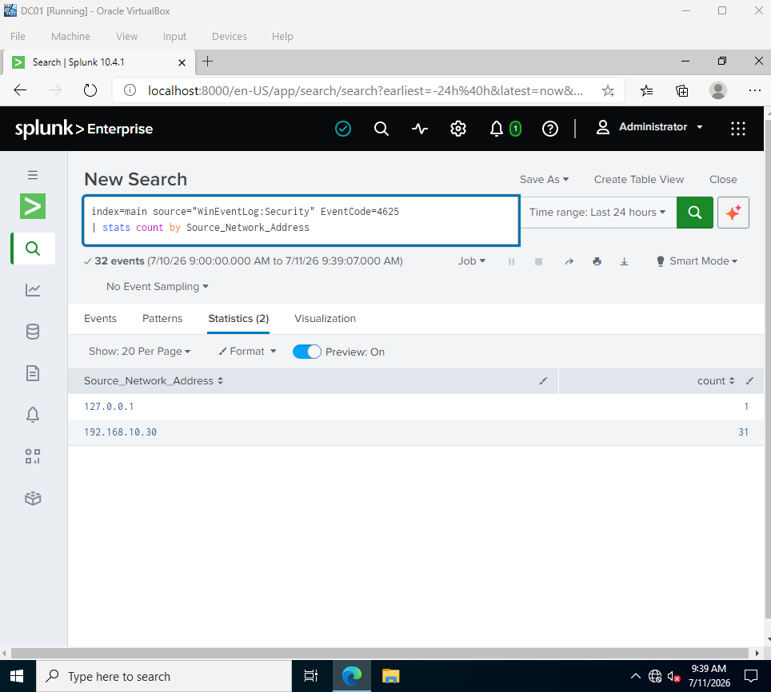
Figure 5. Failed logons grouped by source address; 192.168.10.30 generated 31 failures.
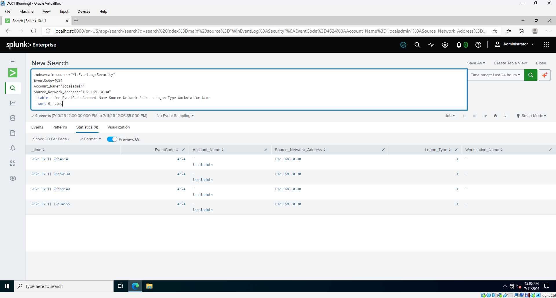
Figure 6. Four successful localadmin network logons from the attacker address.

PHASE 10

Phase 10 — Security Hardening and Validation

Objective
Reduce the likelihood of another successful credential attack and prove that preventive and detective controls remained effective.

Work Performed
- Created recovery snapshots for DC01, WIN11-01, and KALI-01 before changing security policy.
- Captured domain, local account, and SMB baseline configurations.
- Set domain and local lockout thresholds to five attempts with 15-minute duration and observation windows.
- Verified SMB1 disabled, SMB2 enabled, and SMB server signing required.
- Disabled RDP and verified all Windows Firewall profiles enabled with inbound traffic blocked by default.
- Verified Sysmon, SplunkForwarder, log ingestion, alert, and dashboard health.
- Repeated the NetExec authentication test and reviewed lockout and post-hardening evidence.

Validation and Result
- NetExec returned STATUS_ACCOUNT_LOCKED_OUT and did not display a successful-authentication marker.
- Splunk recorded post-hardening Event ID 4625 failures and an Event ID 4740 lockout event.
- No later successful localadmin Event ID 4624 appeared after the hardening window.
- Phase 10 status: PASSED and Closed — Lab Exercise.

Recorded Evidence
- Before/after policy screenshots.
- Host and protocol hardening evidence.
- Service and telemetry validation.
- Final blocked-attack and Splunk validation screenshots.
VALIDATION SCOPE | Phase 9 targeted localadmin. The final NetExec screenshot targeted the local Administrator account. This proves enforcement of local lockout, but a strict same-account replay remains a recommended improvement.

Control | Before | After | Assessment
Domain lockout | Threshold 0 | 5 attempts / 15 min | Improved
Local lockout | Never locked | 5 attempts / 15 min | Improved
SMB1 | Disabled | Disabled | Already compliant
SMB signing | Required | Required | Verified
RDP | Not baselined | Disabled | Exposure reduced
Firewall | Not baselined | All profiles ON | Verified
Logging | Operational | Operational | Revalidated
Attack outcome | Authentication succeeded | Account locked | Blocked

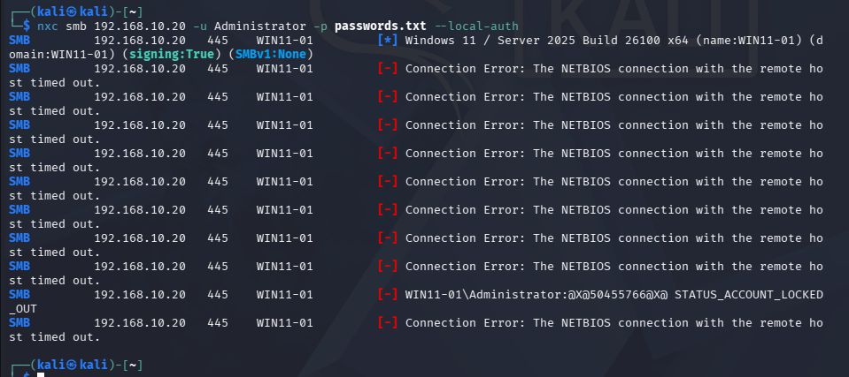
Figure 7. Post-hardening NetExec validation returned STATUS_ACCOUNT_LOCKED_OUT.
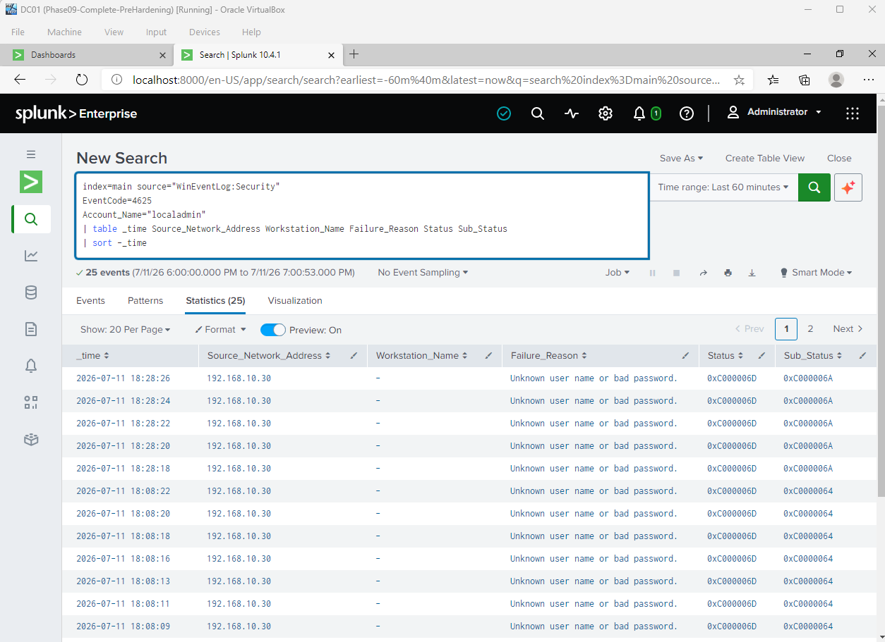
Figure 8. Failed authentication events remained visible in Splunk after hardening.

Key Splunk Searches
Successful localadmin network logons from the attacker address
index=main source="WinEventLog:Security" EventCode=4624
Account_Name="localadmin" Source_Network_Address="192.168.10.30"
| table _time EventCode Account_Name Source_Network_Address Logon_Type
| sort 0 _time

Failed authentication activity
index=main source="WinEventLog:Security" EventCode=4625
| stats count BY Source_Network_Address Account_Name host
| sort -count

Sysmon Event ID 3 extraction from XML
index=main host="WIN11-01" source="*Sysmon*"
| rex field=_raw "<EventID[^>]*>(?<SysmonEventCode>\d+)</EventID>"
| search SysmonEventCode=3
| rex field=_raw "<Data Name=['\"]Image['\"]>(?<Image>[^<]+)"
| rex field=_raw "<Data Name=['\"]SourceIp['\"]>(?<SourceIp>[^<]+)"
| rex field=_raw "<Data Name=['\"]DestinationIp['\"]>(?<DestinationIp>[^<]+)"
| rex field=_raw "<Data Name=['\"]DestinationPort['\"]>(?<DestinationPort>[^<]+)"
| table _time SysmonEventCode Image SourceIp DestinationIp DestinationPort

Recommended failures-followed-by-success correlation
index=main source="WinEventLog:Security" (EventCode=4625 OR EventCode=4624)
| stats count(eval(EventCode=4625)) AS failures
count(eval(EventCode=4624)) AS successes
earliest(_time) AS first_seen latest(_time) AS last_seen
BY Source_Network_Address Account_Name
| where failures>=5 AND successes>=1
| convert ctime(first_seen) ctime(last_seen)

Account-lockout validation
index=main source="WinEventLog:Security" EventCode=4740
| table _time host TargetUserName CallerComputerName
| sort -_time

Troubleshooting Record and Lessons Learned
Problem | Diagnosis | Resolution / lesson
VM performance and storage | VM files initially located on slower HDD | Moved working VM files to SSD while preserving configuration
Host-only communication | Wrong or inactive adapter caused connectivity problems | Returned systems to Host-Only Adapter #2 and verified pings
Sysmon Event 3 returned zero | Local Sysmon contained Event 3, so logging was not the root cause | Restarted SplunkForwarder, reloaded input, and extracted XML fields
Sysmon fields appeared empty | renderXml=true stored required values inside _raw XML | Used rex extraction for EventID and network fields
Initial Phase 10 NetExec timeouts | Some attempts did not complete SMB authentication | Continued controlled validation until Windows returned account locked out
Blueprint versus implementation | Separate indexes were planned but main was used | Document the working configuration as authoritative

Security Lessons
- Detection alone does not prevent access; preventive controls such as lockout and restricted remote administration are also required.
- A successful authentication event must be interpreted carefully and correlated by source, account, host, logon type, and time.
- Analysts should not overstate evidence. Authentication success did not prove execution, persistence, privilege escalation, or data theft.
- Telemetry health must be validated locally and centrally before concluding that an event did not occur.
- Post-hardening attack repetition provides stronger evidence than configuration screenshots alone.

Residual Risks and Recommended Improvements
Priority | Item | Recommended action
High | Minimum password length remains seven | Increase to at least 14 characters and use unique administrative credentials
High | Final NetExec account differs from Phase 9 account | Repeat the validation against localadmin for a strict before/after comparison
Medium | Default ADMIN$, C$, and IPC$ shares remain | Restrict access to approved management hosts or an administration subnet
Medium | Event 4740 timing is not tied to one final command sequence | Correlate attack, 4625, 4740, and absence of 4624 in one time window
Medium | Alert enabled but trigger evidence is limited | Capture the alert firing and preserve its result details
Low | Encoded PowerShell simulation not evidenced | Add a harmless encoded-command test with Sysmon Event 1 detection
Low | New-local-user simulation not evidenced | Add an authorized test and detect Windows Event ID 4720
Portfolio | Earlier-phase images are not consolidated | Create phase folders and a sanitized public README with selected evidence

MITRE ATT&CK Context
Technique | ID | Observed context
Brute Force | T1110 | Repeated credential attempts against a local Windows account
Valid Accounts | T1078 | Successful use of tested credentials during the Phase 9 lab scenario
Network Service Scanning | T1046 | Nmap reconnaissance against the isolated Windows endpoint

PUBLIC-RELEASE CHECK | Before publishing, sanitize passwords, attempted credential strings, personal account names, and any information that should not be publicly exposed.

Evidence Register
The following evidence groups support the project record. Phase 9 and Phase 10 filenames correspond to the submitted packages; Phase 0–8 items are referenced in the exported conversation.
Phase | Evidence group | Examples
0 | Preparation | VirtualBox, Host-Only adapter, DHCP disabled, project folders
1 | DC01 deployment | VM settings, Windows Server installation, boot/network screenshots
2 | AD and DNS | Domain services, user/account, domain-policy evidence
3 | WIN11-01 | VM, static IP, domain use, connectivity evidence
4 | Splunk | Web interface, receiver, searches and indexed events
5 | Sysmon / Forwarder | Local Event 3, inputs.conf, service state, recovered ingestion
6 | Kali | Static IP, communication, Nmap and NetExec evidence
7 | Simulations | Nmap statistics, scan timeline, brute-force results
8 | Detection content | Port-scan searches, brute-force alert, SOC dashboard
9 | Investigation package | Figures 1–11 and Phase 9 Incident Report
10 | Hardening package | Snapshots, baselines, policy changes, telemetry, blocked validation

Primary Phase 9 Evidence
ID | Evidence | Purpose
01–03 | Failed logons, attacker IP, targeted account | Authentication-source and target proof
04, 06, 07 | Timeline and exploratory correlation | Investigation context
08 | Successful login after brute force | Primary compromise evidence
09–11 | Local Sysmon, forwarding restored, Event 3 extraction | Telemetry validation

Primary Phase 10 Evidence
ID | Evidence | Purpose
01–04 | Snapshots and pre-hardening baselines | Recovery and comparison
05–13 | Policy, SMB, RDP, firewall, shares | Hardening and residual exposure
14, 16–20 | Services, logs, alert, dashboard | Monitoring health
21 | NetExec blocked | Final attack validation
23–25 | 4625, 4740, no later 4624 | Post-hardening SIEM proof

Final Conclusion
The SOC Home Lab achieved its core technical objective: a complete, evidence-based defensive workflow operating inside an isolated environment. The project progressed from virtualization and identity infrastructure through endpoint telemetry, attack simulation, SIEM detection, incident investigation, security hardening, and validation.
Phase 9 proved that repeated failed authentication attempts were followed by successful localadmin network logons. Phase 10 converted the investigation findings into preventive controls, preserved recovery points, revalidated monitoring, and demonstrated account-lockout enforcement during the final test.
The remaining items are improvements rather than blockers. The strongest next steps are an exact localadmin before/after replay, a captured alert trigger, additional safe simulations for encoded PowerShell and local-user creation, and a sanitized public README that consolidates the earlier phase evidence.
FINAL STATUS | CORE SOC HOME LAB COMPLETE — build, attack, detect, investigate, harden, and validate objectives demonstrated.

