Homework #1

Hunter Ratliff

10/30/2019

Table of Contents

# Part I

Please incicate (by entering x in the cell) the appropriate type for each variable in the following table

*Insert the table here*

# Part II

Compute the following descriptive statisitcs for variable Dur_Stay from HOSPITAL.DAT

1. Mean
2. Median
3. Mode
4. Geometric mean
5. Variane & Std Dev
6. Range (minimum and maximum)
7. 10th quartile
8. IQR ({Q}_{25})

Dur_stay <- hospital$Dur_stay # save as vector  
  
# Mean  
mean(Dur_stay)

## [1] 8.6

# Median  
median(Dur_stay)

## [1] 8

## # A tibble: 12 x 2  
## Dur_stay n  
## <dbl> <int>  
## 1 5 4  
## 2 11 4  
## 3 3 3  
## 4 9 3  
## 5 4 2  
## 6 7 2  
## 7 8 2  
## 8 6 1  
## 9 10 1  
## 10 14 1  
## 11 17 1  
## 12 30 1

asd

# Geometric mean isn't a base function, so calculate below  
exp(sum(log(Dur_stay)) / length(Dur_stay))

## [1] 7.303239

summary(Dur_stay)

## Min. 1st Qu. Median Mean 3rd Qu. Max.   
## 3.0 5.0 8.0 8.6 11.0 30.0

range(Dur_stay)

## [1] 3 30

quantile(Dur_stay)

## 0% 25% 50% 75% 100%   
## 3 5 8 11 30

# Part III

This is an R Markdown document. Markdown is a simple formatting syntax for authoring HTML, PDF, and MS Word documents. For more details on using R Markdown see <http://rmarkdown.rstudio.com>.

When you click the **Knit** button a document will be generated that includes both content as well as the output of any embedded R code chunks within the document. You can embed an R code chunk like this:

## speed dist   
## Min. : 4.0 Min. : 2.00   
## 1st Qu.:12.0 1st Qu.: 26.00   
## Median :15.0 Median : 36.00   
## Mean :15.4 Mean : 42.98   
## 3rd Qu.:19.0 3rd Qu.: 56.00   
## Max. :25.0 Max. :120.00

## Including Plots

You can also embed plots, for example:

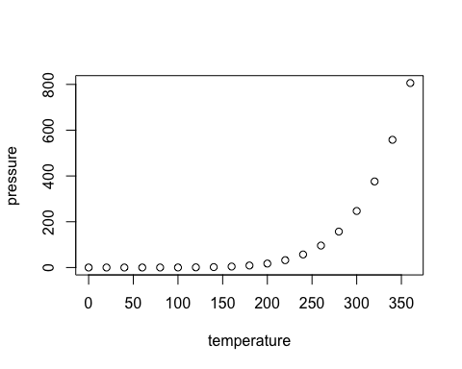

Note that the echo = FALSE parameter was added to the code chunk to prevent printing of the R code that generated the plot.