
■ H HEURISTICS
SAMPLE · ILLUSTRATIVE DATA
RESEARCH REPORT
Decision Quality in the Age of AI
How heuristics, forecasting discipline and machine assistance shape organizational judgment
▬▬
H Heuristics Research Team · Pipeline sample
November 2026 | HH-2026-001

ABOUT THIS REPORT
Organizations have never had more data, more analytical tooling or more access to machine intelligence, yet the quality of their most consequential decisions remains stubbornly uneven. This report reviews six decades of research on judgment and decision-making, from bounded rationality to modern forecasting tournaments, and asks what changes when AI systems join the decision process. We set out where heuristics help and where they fail, what disciplined forecasting teaches about calibration, how human–AI teams succeed or go wrong, and a practical operating model leaders can adopt.
This is a pipeline sample. Quantitative series in the charts and tables are illustrative and labelled as such; the research literature cited is real and linked in the text.
Keywords: decision quality · heuristics · forecasting · AI decision support · governance
CONTENTS
Executive Summary
Who this report is for
1 Why Decision Quality Matters Now
1.1 Decisions as the unit of performance
1.2 Three forces raising the stakes
1.3 What we mean by decision quality
1.4 Scope and approach
2 The Science of Heuristics
2.1 From perfect rationality to bounded rationality
2.2 Heuristics and biases
2.3 Ecological rationality: when simple rules win
2.4 Reconciling the two traditions
2.5 Implications for organizations
3 Where Organizational Decisions Fail
3.1 Individual biases, organizational consequences
3.2 The planning fallacy and the inside view
3.3 Overconfidence and the illusion of control
3.4 Groupthink, cascades and the loudest voice
3.5 Escalation of commitment
3.6 Noise: the overlooked error
3.7 How failures compound
3.8 Summary
4 Lessons from Forecasting Science
4.1 Why forecasting is the right test bed
4.2 The forecasting tournaments
4.3 Measuring accuracy: the Brier score and calibration
4.4 What makes good forecasters different
4.5 Prediction markets and crowd forecasting
4.6 Implications
5 AI as a Decision Partner
5.1 An old debate in a new form
5.2 Where machine assistance helps
5.3 Where it goes wrong
5.4 Evidence on human–AI teams
5.5 Governance frameworks
6 A Decision-Quality Operating Model
6.1 Design principles
6.2 Tiering decisions
6.3 The core protocol
6.4 Roles for AI within the protocol
6.5 Making it stick
7 Measuring Decision Quality
7.1 Why measurement is hard and why it matters
7.2 A balanced scorecard for decisions
7.3 Scoring forecasts in practice
7.4 Reviewing decisions
7.5 Benchmarks and maturity
8 Outlook and Recommendations
8.1 The next five years
8.2 Recommendations for leaders
8.3 Questions for boards
8.4 Limitations and open questions
8.5 Conclusion
References
DECISION QUALITY IN THE AGE OF AI

Executive Summary
Most organizations judge their decisions by outcomes. A product that sells well was a good bet; an acquisition that disappoints was a bad one. This instinct is understandable and deeply misleading. Outcomes mix the quality of a decision with luck, timing and the actions of others, and a single result says little about which of these dominated. The research literature on judgment under uncertainty offers a better standard: a good decision is one made through a sound process, with the information reasonably available, and with an honest view of the odds. That standard can be taught, measured and improved, and it is the subject of this report.
The case for attention is growing. Decision cycles are shortening, the volume of information that decision-makers must filter is rising, and AI systems now draft analyses, score options and generate forecasts inside everyday workflows. These tools can raise the floor of decision quality by reducing noise and surfacing evidence that people would otherwise miss. They can also lower the ceiling, by encouraging automation bias, hiding uncertainty behind fluent prose, and concentrating error when many teams rely on the same model. Which of these effects dominates depends far less on the technology than on the decision process that surrounds it.
Key findings
- Heuristics are not the enemy. Simple rules of thumb often match or beat complex models in unstable, data-poor environments. Failures arise when a heuristic is used outside the environment it fits, not because heuristics exist.
- Process predicts outcomes better than talent. Across the evidence we review, structured practices such as reference-class forecasting, pre-mortems and independent estimates improve accuracy more reliably than hiring for individual brilliance.
- Calibration is trainable. Forecasting tournaments show that short training, teaming and frequent feedback measurably improve probabilistic accuracy, and that the gains persist.
- AI shifts where errors occur. Machine assistance reduces random inconsistency but introduces correlated error and over-reliance. Teams that keep human judgment active get the benefit without the fragility.
- What gets measured gets better. Organizations that log decisions, state probabilities and score them later build a feedback loop that outcome-based reviews cannot provide.

Our review draws three practical conclusions. First, leaders should separate the evaluation of decisions from the evaluation of outcomes, and should review a sample of decisions on process grounds regardless of how they turned out. Second, the highest-return interventions are cheap: writing down a forecast with an explicit probability, asking “what would have to be true?” before a commitment, and gathering independent judgments before discussion. Third, AI adoption in decision-making should be governed as a change to the decision process, not as a software procurement, with clear rules on when the model advises, when it decides and when it must be overruled.
5  practices that account for most of the improvement we observe in decision audits | 3  failure modes that AI introduces: over-reliance, correlated error and false precision | 1  page: the length of an effective decision record, written before the outcome is known

Who this report is for
This report is written for executives, board members and the people who support them: strategy and planning teams, risk and finance functions, and the growing number of leaders responsible for deploying AI inside their organizations. It assumes no background in psychology or statistics. Where technical ideas such as calibration or proper scoring rules matter to the argument, they are explained in plain terms and linked to accessible sources for readers who want more depth.
The evidence base is broad but uneven. Some findings, such as the planning fallacy, the benefits of aggregating independent estimates and the trainability of probabilistic judgment, rest on decades of replicated research across many settings. Others, particularly those concerning human–AI collaboration with modern language models, come from a young literature in which results are still accumulating and sometimes conflict. We indicate the strength of evidence throughout, and we distinguish between what the research shows and what we infer from it.
Finally, a note on ambition. The practices recommended here will not eliminate bad outcomes; no process can. Their aim is to shift the odds, decision by decision, so that an organization’s portfolio of choices performs better over time. Small, consistent improvements in the quality of many decisions compound into a durable advantage, which is why we argue that decision quality deserves the same management attention as operational efficiency or financial discipline.
The remainder of the report is organized as follows. Section 2 reviews the science of heuristics and biases and the more recent ecological view of rationality. Section 3 maps where organizational decisions fail in practice. Section 4 turns to the evidence from forecasting research and what it implies for calibration. Section 5 examines AI as a decision partner, Section 6 sets out an operating model, Section 7 describes how to measure decision quality, and Section 8 closes with an outlook and a set of recommendations.
The recommendations are deliberately modest in cost. None requires a new platform or a large consulting engagement; most require a small number of people to change how they write down and review the choices they make. The organizations that do this consistently tend to discover that their decision quality was never limited by information or intelligence, but by the absence of a feedback loop. Building that loop is the central task of decision leadership in the coming decade, and AI makes it both more urgent and more achievable.
SECTION 01

Why Decision Quality Matters Now

1.1 Decisions as the unit of performance
Every strategy, budget and operating plan is the visible residue of a sequence of decisions. Some are large and deliberate: entering a market, acquiring a company, committing capital to a multi-year program. Most are small and frequent: approving a hire, setting a price, escalating an incident, choosing which customer complaint to act on first. The cumulative effect of these choices determines whether an organization compounds its advantages or slowly erodes them. Yet most management systems measure activity and outcomes, not the quality of the decisions that connect the two.
This gap matters because outcomes are a noisy signal. A forecast of 70 percent that a project will finish on time is not wrong when the project slips; it implies that roughly three in ten such projects should slip. Judging the forecaster by the single outcome punishes good calibration and rewards lucky overconfidence. The psychologist and poker champion Annie Duke calls this tendency “resulting”; the statistician would call it ignoring the base rate. Either way, organizations that learn only from outcomes learn slowly, and often learn the wrong lessons.
Decision quality, by contrast, can be assessed at the moment of choice. Did the team frame the problem correctly and consider genuine alternatives? Did it gather the information that was reasonably available, and weigh it without obvious bias? Did it state its uncertainty honestly, and did it commit to a course of action with a clear view of what would cause it to change course? These questions have defensible answers before the outcome is known, which is precisely what makes them useful.

1.2 Three forces raising the stakes
Three developments make the quality of organizational judgment more consequential today than a decade ago.
The first is speed. Product cycles, capital markets and competitive responses move faster, which compresses the time available for deliberation. Compressed time does not merely reduce the hours spent analysing a choice; it changes which cognitive processes dominate. Under time pressure, people rely more heavily on fast, intuitive judgment, the mode Daniel Kahneman labelled System 1, and less on slow, effortful reasoning. That is not inherently bad, but it raises the premium on having good intuitions and on knowing when they cannot be trusted.
The second is information abundance. Leaders now face more dashboards, reports and alerts than they can reasonably process. More information does not automatically improve decisions; beyond a point, it increases confidence faster than it increases accuracy. Classic experiments with horse-race handicappers and clinical psychologists found that adding information raised judges’ confidence while leaving their accuracy almost unchanged. The constraint on modern decision-making is rarely access to data. It is attention, and the discipline to separate signal from noise.
The third is machine assistance. Generative AI and predictive models are now embedded in the tools where analysis happens: spreadsheets, documents, customer systems and code. These systems produce fluent, confident output at almost no marginal cost. They can be excellent at summarizing evidence, generating options and estimating probabilities from historical data. They can also be wrong in ways that are hard to detect, and their fluency can make weak reasoning look rigorous. Whether AI improves decisions depends on how it is placed within the decision process, a theme we return to in Section 5.
FIGURE 1 Decision volume and available time are moving in opposite directions
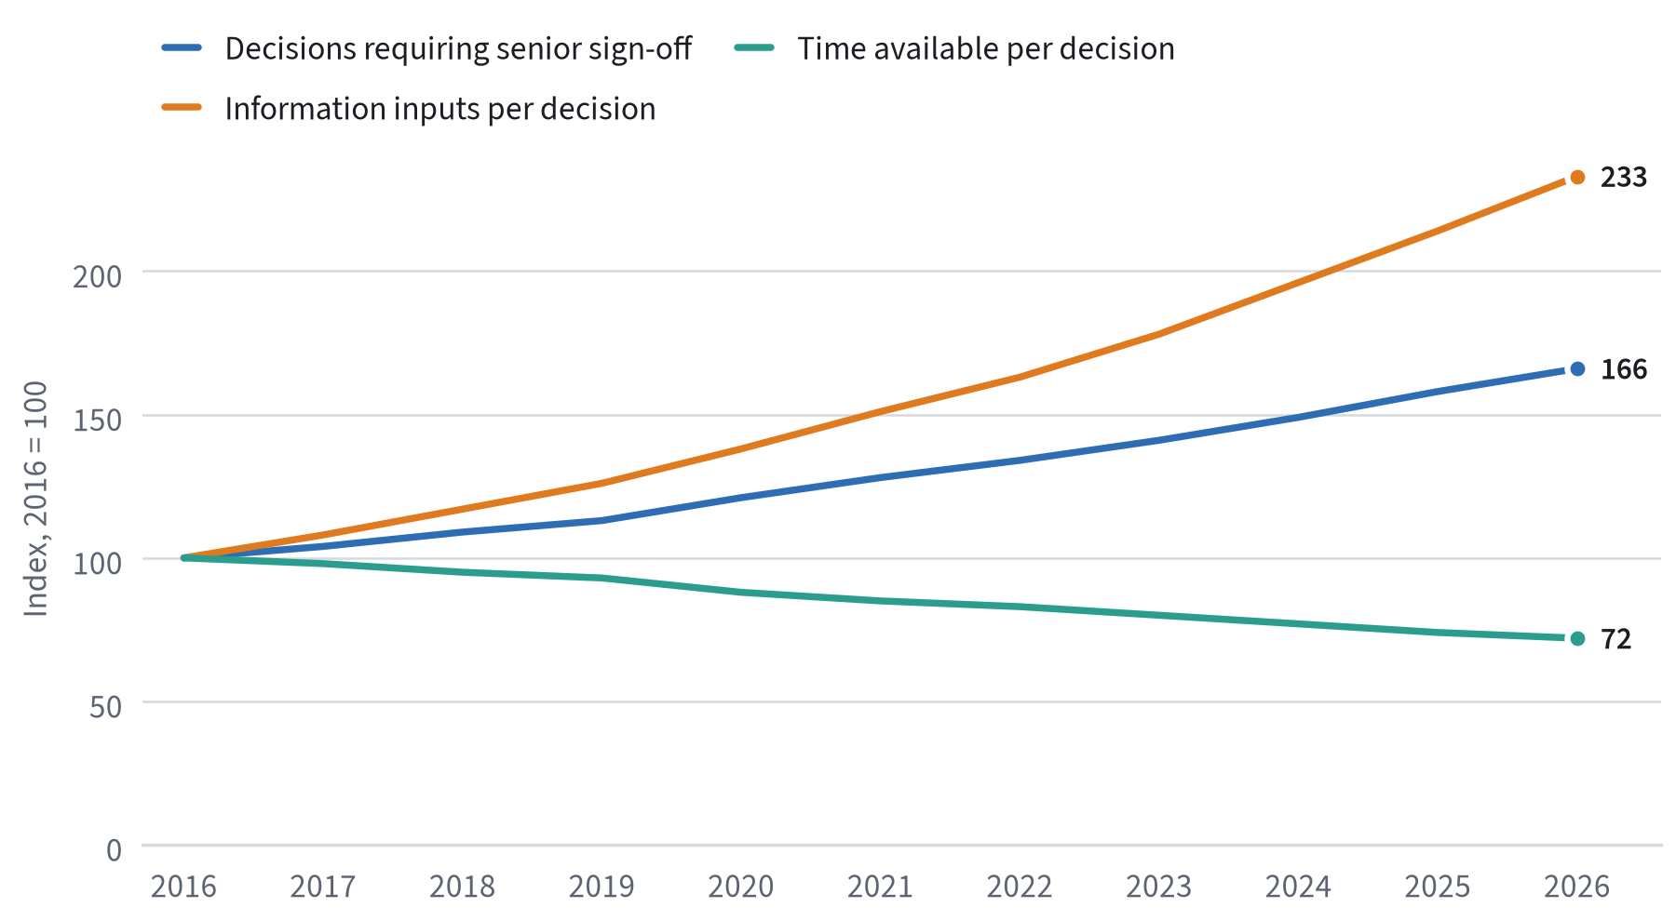
Illustrative index (2016 = 100) constructed for this pipeline sample; not survey data.

1.3 What we mean by decision quality
We use the term decision quality to mean the degree to which a decision process is likely to produce good outcomes across many similar decisions. This definition has three consequences. It is probabilistic, so a single bad outcome does not prove a poor decision. It is process-oriented, so it can be evaluated before results arrive. And it is comparative, so the relevant question is whether one process beats another over time, not whether any process guarantees success.
Practitioners in the decision analysis tradition often break decision quality into six elements, sometimes drawn as a chain whose overall strength is set by its weakest link. We adopt a slightly simplified version, summarized in Table 1, because it maps cleanly onto practices organizations can adopt.
TABLE 1 The six elements of decision quality
Element | Guiding question | Common failure
Frame | Are we solving the right problem, at the right scope? | Narrow framing; treating a symptom as the problem
Alternatives | Have we considered genuinely different options? | “Whether or not” choices with a single option
Information | Do we have the relevant facts and their uncertainty? | Confirmatory search; ignoring base rates
Values and trade-offs | Are we clear on what we want and what we will give up? | Unstated objectives; conflicting goals hidden
Reasoning | Is the logic connecting information to choice sound? | Overconfidence; anchoring on a first estimate
Commitment | Will we act, and do we know what would change our mind? | Analysis paralysis or escalation of commitment
Source: H Heuristics synthesis adapted from the decision analysis literature; see Decision quality for an overview.
A useful property of this framework is that each element can be strengthened by a specific, low-cost practice. Framing improves when teams write a one-paragraph problem statement and have it challenged. Alternatives improve when a rule requires at least three options, including the status quo. Information improves when estimates are anchored on base rates from comparable cases. The rest of this report examines the evidence behind these practices and how they interact with AI tools.

1.4 Scope and approach
This report synthesizes research from cognitive psychology, behavioral economics, forecasting science, human factors engineering and the emerging literature on human–AI collaboration. We focus on decisions made by professionals inside organizations, rather than consumer choices, and on decisions where uncertainty is material and outcomes are delayed. We draw on peer-reviewed studies, well-documented field experiments and authoritative frameworks such as the NIST AI Risk Management Framework.
Because this document is a sample produced to demonstrate H Heuristics’ publication pipeline, the quantitative series shown in charts and some tables are illustrative. They are designed to show the shape of the relationships discussed in the literature and are labelled as such in every source note. The qualitative findings and the studies cited are real, and each is linked so that readers can consult the original work.
Readers in a hurry may wish to begin with Section 6, which translates the evidence into an operating model, and Section 7, which sets out how to track progress. Readers interested in why the recommended practices work should read the sections in order, since each builds on the evidence presented before it.
SECTION 02

The Science of Heuristics

2.1 From perfect rationality to bounded rationality
For much of the twentieth century, economic models assumed that decision-makers were perfectly rational: they knew all relevant alternatives, could compute the consequences of each, and chose whichever maximized expected utility. Herbert Simon challenged this picture in a series of papers beginning with A Behavioral Model of Rational Choice in 1955. Real people, Simon argued, operate under limits of information, time and computational capacity. They do not optimize; they satisfice, searching until they find an option that is good enough and then stopping.
Simon’s concept of bounded rationality reframed the question. The interesting issue was no longer whether people are rational in some absolute sense, but which strategies allow a bounded mind to perform well in a given environment. Simon’s own metaphor was a pair of scissors: one blade is the mind’s cognitive limitations, the other is the structure of the environment, and behavior can only be understood by looking at how the two blades fit together.
This framing remains the most useful starting point for leaders. It implies that the right question about any decision rule, whether a rule of thumb, a scoring model or an AI system, is not “is it rational?” but “does it fit the environment in which we are using it?”

2.2 Heuristics and biases
In the 1970s, Amos Tversky and Daniel Kahneman launched a research program that documented systematic departures from the predictions of rational choice theory. Their 1974 paper in Science, Judgment under Uncertainty: Heuristics and Biases, described three general-purpose heuristics people use to estimate probabilities and quantities:
- Representativeness. Judging the probability that something belongs to a category by how much it resembles the category’s stereotype, often while neglecting base rates.
- Availability. Judging frequency or probability by how easily examples come to mind, which inflates vivid, recent or emotionally salient events.
- Anchoring and adjustment. Starting from an initial value and adjusting insufficiently, even when the anchor is arbitrary.
Their 1979 prospect theory added a descriptive model of choice under risk: people evaluate outcomes as gains and losses relative to a reference point, weigh losses more heavily than equivalent gains, and overweight small probabilities. Together, these findings gave rise to a catalogue of cognitive biases that now runs to well over a hundred entries.
The heuristics-and-biases program has been enormously influential, and its core findings are robust. But its emphasis on errors can leave a misleading impression: that heuristics are defects to be engineered away. The biases were identified precisely by designing situations in which a normally useful heuristic would produce a wrong answer. Outside those situations, the same heuristics often work well.

2.3 Ecological rationality: when simple rules win
A second research tradition, associated with Gerd Gigerenzer and colleagues, studies ecological rationality: the conditions under which simple heuristics perform well. Its central finding is counterintuitive. In environments with high uncertainty, limited data and many potential predictors, simple rules that ignore much of the available information frequently predict as well as, or better than, complex statistical models.
The reason is the bias–variance trade-off. A complex model fitted to limited data captures noise along with signal, so it performs well on past data and poorly on new cases. A simple rule has more bias but far less variance, and when data are scarce or the environment is shifting, lower variance wins. The “1/N” rule for allocating investments equally across options, for example, has been shown to be competitive with optimized portfolio models when estimation windows are short.
FIGURE 2 Simple rules hold up better out of sample when data are scarce
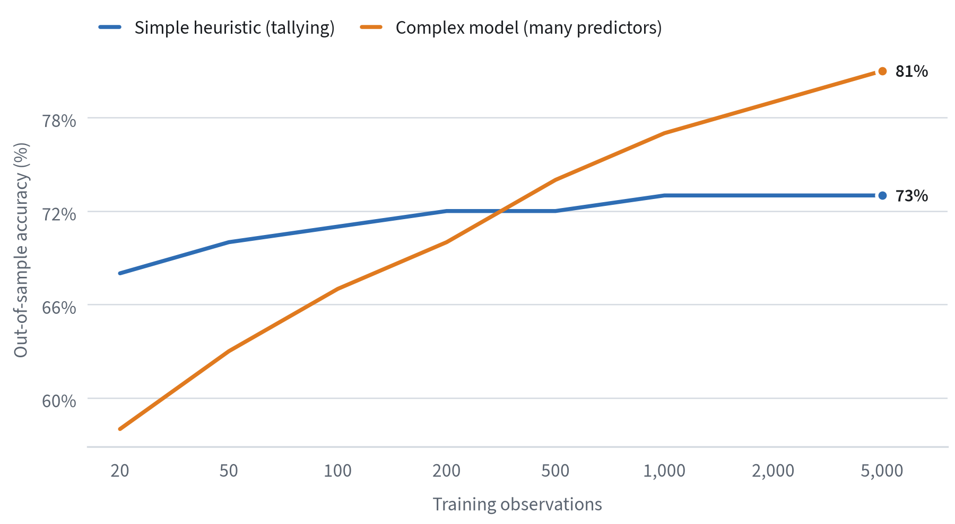
Illustrative simulation pattern for this pipeline sample, consistent with the bias–variance trade-off described in the forecasting literature.
Figure 2 illustrates the typical pattern. With few observations, a tallying heuristic that counts favorable cues outperforms a model that estimates a weight for each cue. As data accumulate and the environment remains stable, the complex model eventually overtakes the heuristic. The crossover point is not fixed; it depends on how noisy and how stable the environment is. Leaders rarely know where it lies, which is itself an argument for robust, simple decision rules in novel or volatile situations.

2.4 Reconciling the two traditions
The heuristics-and-biases and ecological-rationality schools are sometimes presented as rivals. For practical purposes they are better seen as complementary. The first tells us where intuitive judgment predictably fails; the second tells us where simple rules are a strength rather than a weakness. Taken together, they suggest a contingency view summarized in Figure 3.
FIGURE 3 Which decision approach fits which environment
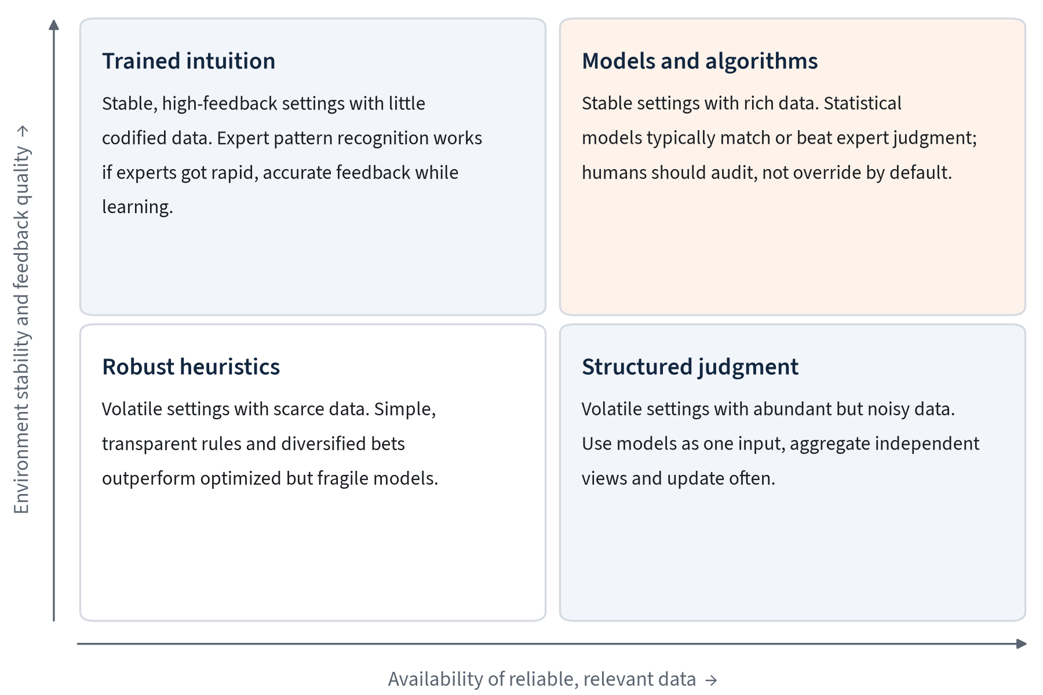
H Heuristics framework drawing on Kahneman and Klein (2009) and the ecological rationality literature.
The quadrant that deserves most attention is the upper-left. Kahneman and the naturalistic decision researcher Gary Klein, often seen as representing opposed camps, co-authored an influential paper, Conditions for Intuitive Expertise: A Failure to Disagree, concluding that intuition can be trusted when two conditions hold: the environment is regular enough to be predictable, and the expert has had extensive practice with rapid, unambiguous feedback. Firefighters, chess players and anaesthetists often meet these conditions. Stock pickers, political pundits and many corporate strategists do not.

2.5 Implications for organizations
Three implications follow from this body of research.
First, match the decision method to the environment. Organizations often apply the same decision process to everything, from routine pricing to once-a-decade strategic bets. The research suggests that routine, data-rich decisions are prime candidates for models and decision rules, while novel and volatile decisions benefit from structured human judgment supported by simple, robust heuristics.
Second, be sceptical of intuitive confidence. Subjective confidence is a poor guide to accuracy, especially in environments without fast feedback. A senior executive’s strong conviction about a market entry carries information, but much less than the conviction suggests. Asking “how would we know if we were wrong?” is a practical antidote.
Third, design for the bias, not against the person. Because biases arise from general-purpose cognitive mechanisms, they affect experts and novices alike, and they are largely invisible from the inside. Training people to “be less biased” has a weak track record. Changing the decision process, for instance by requiring independent estimates before discussion, has a much stronger one. The next section examines where these process failures most commonly appear.
SECTION 03

Where Organizational Decisions Fail

3.1 Individual biases, organizational consequences
The biases documented in laboratory studies do not disappear when people enter an office. They are amplified or dampened by the structures around them: hierarchy, incentives, meeting norms and the way information flows. Some organizational practices correct individual biases; others compound them. Understanding the difference is the starting point for improvement.
In our review of the literature and of published post-mortems, five failure patterns account for a large share of costly organizational decisions. They are summarized in Table 2 and discussed in turn below. None is exotic. Each is familiar to anyone who has sat through a budget review or a project steering committee, which is part of what makes them so persistent.
TABLE 2 Five recurrent failure patterns in organizational decisions
Pattern | Mechanism | Typical setting | Process remedy
Planning fallacy | Inside view; neglect of base rates | Capital projects, product launches | Reference-class forecasting
Overconfidence | Narrow intervals; illusion of control | Forecasts, M&A synergies | Calibrated ranges; tracking
Groupthink and cascades | Social conformity; early anchors | Executive meetings, committees | Independent estimates first
Escalation of commitment | Sunk costs; reputational stakes | Failing programs, R&D bets | Pre-set kill criteria
Noise | Unwanted variability between judges | Underwriting, hiring, appraisal | Structured scales; aggregation
Source: H Heuristics synthesis of the judgment and decision-making literature.

3.2 The planning fallacy and the inside view
The planning fallacy, first described by Kahneman and Tversky, is the tendency to underestimate the time, cost and risk of future actions while overestimating their benefits. It persists even when people know that similar past projects ran late. The cause is the inside view: planners focus on the specifics of their own project, construct a plausible scenario for how it will unfold, and fail to consider the distribution of outcomes for comparable projects.
The evidence from large projects is striking. Research by Bent Flyvbjerg and colleagues on infrastructure and IT megaprojects, summarized in What You Should Know About Megaprojects and Why, finds that cost overruns and benefit shortfalls are the norm rather than the exception, and that the pattern has been stable for decades. Flyvbjerg describes this as an “iron law”: over budget, over time, under benefits, over and over again.
FIGURE 4 Average cost overrun by project type
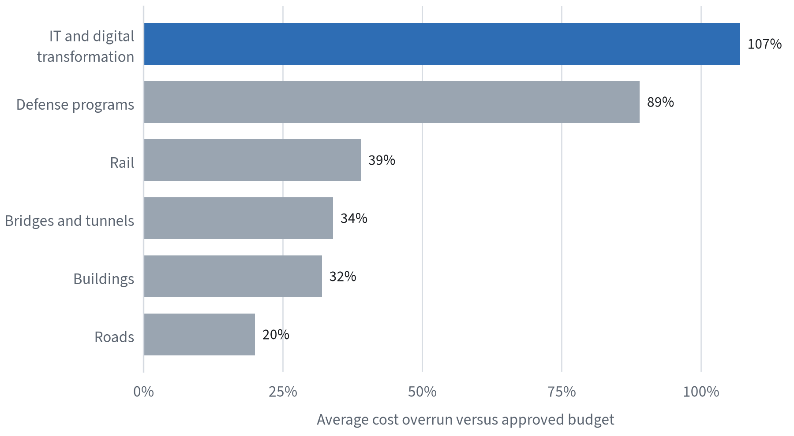
Illustrative values for this pipeline sample, reflecting the direction and rough ordering reported in the megaproject literature; consult Flyvbjerg (2014) for measured estimates.
The remedy with the strongest evidence base is reference-class forecasting: identify a class of comparable past projects, establish the distribution of their outcomes, and position the current project within that distribution, adjusting only for specific, demonstrable differences. The method forces the outside view onto the table before the inside view has hardened. Several governments now require it for large public investments.

3.3 Overconfidence and the illusion of control
Overconfidence takes several forms. Overestimation is believing one’s performance is better than it is. Overplacement is believing one is better than others. Overprecision, the most consequential for forecasting, is excessive certainty about the accuracy of one’s beliefs. When asked to give 90 percent confidence intervals for uncertain quantities, people typically produce ranges that contain the true value only about half the time.
In organizations, overprecision shows up as single-point forecasts presented without ranges, synergy estimates that are treated as facts once approved, and scenario plans that span a narrower band of futures than history would suggest. The overconfidence effect is reinforced by social norms that reward decisive, confident communication and penalize expressed doubt.
Practice: the calibrated range
Replace every single-number forecast in a decision paper with a range and a confidence level, for example “revenue of $40–55 million (80% confidence)”. Record the range. When the outcome is known, check whether it fell inside. After twenty or thirty such forecasts, each forecaster has a personal hit rate. People whose 80% ranges capture the truth only half the time learn quickly to widen them, and the organization learns whose forecasts deserve weight.

3.4 Groupthink, cascades and the loudest voice
Group discussion can aggregate dispersed knowledge, but it often does the opposite. Irving Janis coined the term groupthink to describe cohesive groups that suppress dissent in pursuit of consensus. A subtler mechanism is the information cascade: early speakers anchor the discussion, later speakers defer, and the group converges on a view that reflects the first opinions expressed rather than the information everyone holds.
The practical antidote is to collect independent judgments before discussion. When each participant writes down an estimate or a recommendation privately, and those views are revealed simultaneously, the group retains the diversity of its information. This is the mechanism behind the wisdom of crowds: averaging independent estimates cancels individual errors, but only if the errors are not correlated by prior discussion.

3.5 Escalation of commitment
Once a course of action is chosen, people and organizations tend to keep investing in it even as evidence mounts that it is failing. Escalation of commitment is driven by the sunk cost fallacy, by reputational stakes for the sponsors, and by the simple difficulty of admitting error in public. The cost is not only the additional money spent; it is the opportunity cost of resources and attention that could have gone elsewhere.
The most effective defence is to agree, at the moment of commitment, on the conditions that would trigger a review or termination. Pre-set kill criteria convert a future emotional decision into a present analytical one. They work best when combined with a separation of roles, so that the people who championed an initiative are not the only ones assessing whether it should continue.

3.6 Noise: the overlooked error
Bias is a systematic deviation in one direction. Noise, as Kahneman, Olivier Sibony and Cass Sunstein argue in their 2021 book, is unwanted variability: different judges reaching different conclusions on the same case, or the same judge reaching different conclusions on different days. Noise audits in insurance underwriting, criminal sentencing and medical diagnosis have found variability far larger than the organizations involved expected.
FIGURE 5 Expected versus observed variability in professional judgments
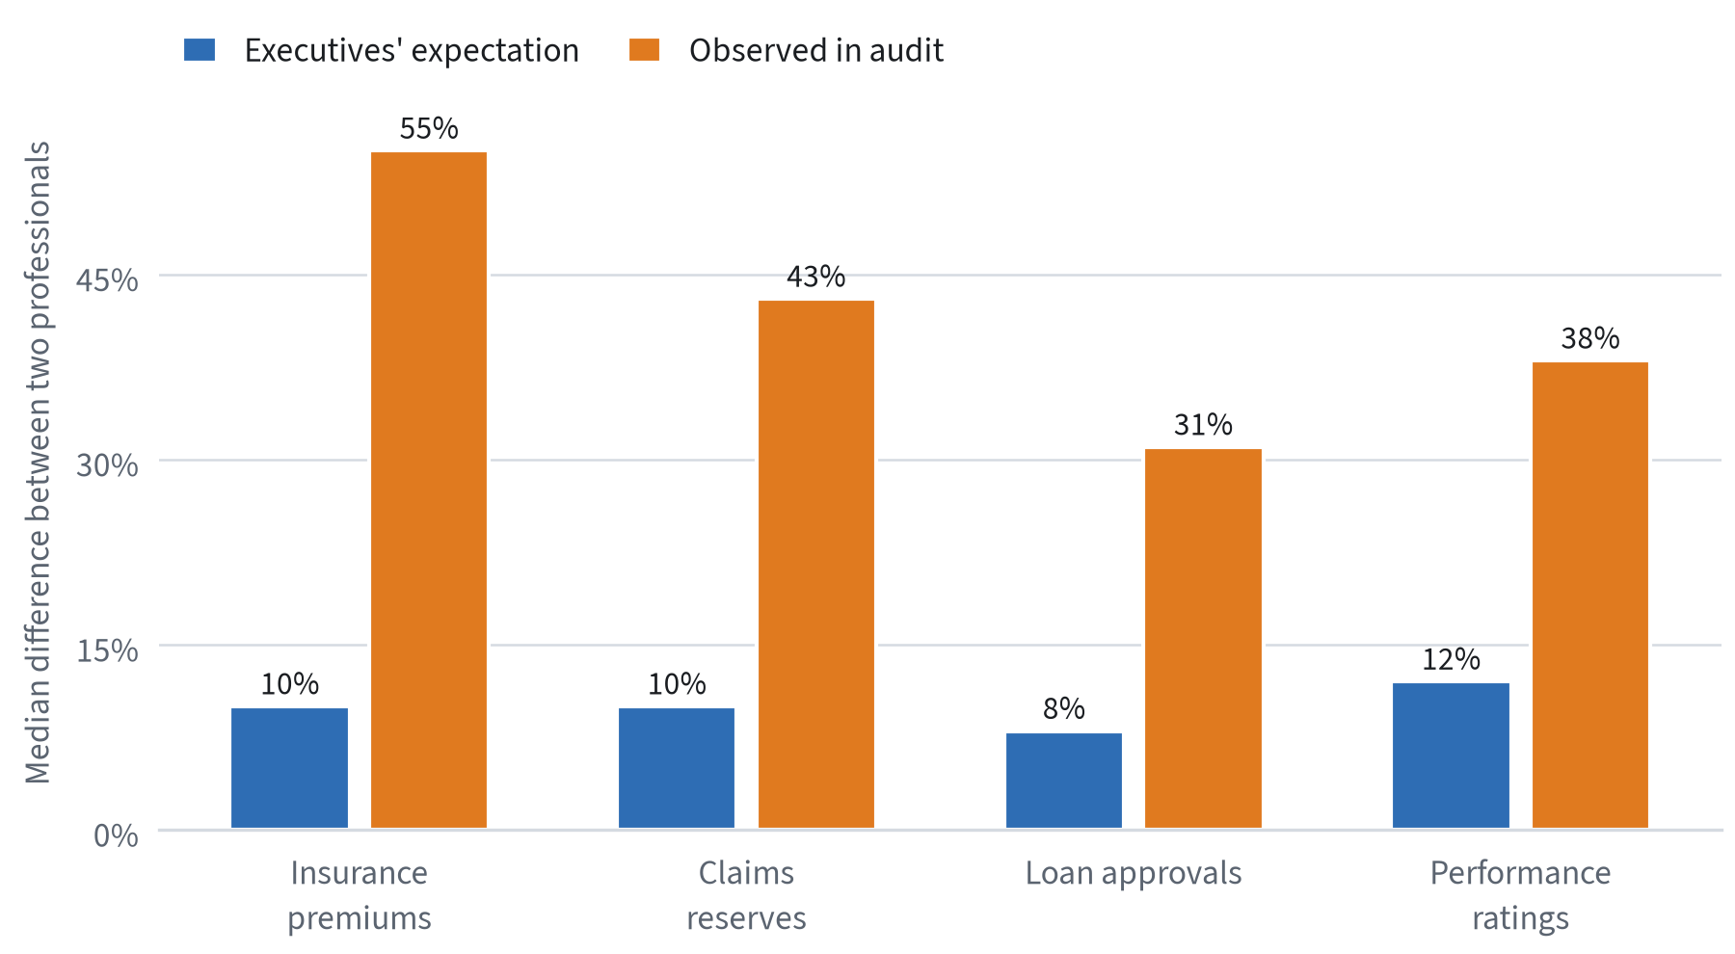
Illustrative pattern for this pipeline sample, modelled on the noise audits described by Kahneman, Sibony and Sunstein (2021).
Noise is easier to reduce than bias, because reducing it does not require knowing the right answer. Structured judgment scales, checklists, independent assessments and simple averaging all reduce noise. So, notably, do algorithms, which return the same output for the same input. This is one of the clearest benefits of machine assistance, and one reason the next sections focus on how human and machine judgment can be combined without introducing new failure modes.

3.7 How failures compound
The five patterns rarely occur alone. A typical sequence begins with an inside-view plan that understates cost and time. Overconfidence narrows the range of outcomes considered, so the plan contains no contingency for the most likely problems. In the approval meeting, the sponsor speaks first, and a cascade forms around the sponsor’s optimistic estimate. When early warning signs appear, the reputational cost of admitting error has grown, and escalation of commitment sets in. Meanwhile, noise in how different reviewers assess progress makes it hard to tell whether the project is genuinely off track or simply being judged by a harsher reviewer this quarter.
Each step in this sequence is individually understandable. Together they produce the familiar pattern of large initiatives that run late, over budget and short of their promised benefits, with warning signs visible in hindsight but discounted at the time. Because the failures reinforce one another, interventions that address only one of them tend to disappoint. Reference-class forecasting improves the initial estimate, but its benefit is lost if a cascade in the approval meeting overrides it. Kill criteria help, but only if the estimates they are compared against were honest in the first place.
This is why the most effective programs bundle several practices into a single, lightweight protocol rather than introducing them one at a time. A decision record that requires an outside-view estimate, independent forecasts, a pre-mortem and pre-set review triggers addresses all five patterns at once, at a cost of a few hours per major decision. We describe such a protocol in Section 6. Before doing so, we turn to the evidence from forecasting research, which shows most clearly that judgment can be trained and measured.

3.8 Summary
The failure patterns in this section share a common feature: they are predictable. Planning fallacies, overconfidence, cascades, escalation and noise are not random misfortunes; they arise from known mechanisms in known settings. That predictability is the basis for intervention. The practices that address them, from reference-class forecasting to independent estimates and pre-set kill criteria, are cheap relative to the cost of the errors they prevent. The question for leaders is less what to do than how to make these practices routine, a question we address in Section 6.
SECTION 04

Lessons from Forecasting Science

4.1 Why forecasting is the right test bed
Most decisions embed a forecast. Approving a product launch implies a forecast of demand; hiring a candidate implies a forecast of performance; delaying an investment implies a forecast that conditions will improve. Yet in most organizations these forecasts remain implicit, unquantified and unscored. Forecasting research is valuable precisely because it makes the implicit explicit: it asks people to state probabilities for well-defined events, waits for the events to resolve, and scores the results. This turns judgment into something that can be measured and improved.
The modern science of forecasting owes much to Philip Tetlock. His long-running study of expert political judgment, published in 2005, asked hundreds of experts to make thousands of predictions about political and economic events. The headline finding was sobering: on many long-range questions, experts performed only slightly better than simple extrapolation rules, and the most famous experts were often the least accurate. But the study also found meaningful differences between forecasters. Those who drew on many perspectives, held their views tentatively and updated readily, whom Tetlock called “foxes”, consistently outperformed confident “hedgehogs” who viewed the world through a single big idea.

4.2 The forecasting tournaments
Between 2011 and 2015, the U.S. Intelligence Advanced Research Projects Activity ran the Aggregative Contingent Estimation (ACE) program, a set of large forecasting tournaments on geopolitical questions. Several research teams competed to produce the most accurate probability forecasts. The Good Judgment Project, led by Tetlock and Barbara Mellers, won decisively, and its experiments produced some of the most useful evidence available on how to improve human judgment.
Three interventions stood out in the published results, notably Mellers et al. (2014):
- Training. A one-hour module on probabilistic reasoning, covering base rates, reference classes, averaging across sources and common biases, improved accuracy for the rest of the tournament.
- Teaming. Forecasters working in teams, sharing information and challenging each other’s reasoning, outperformed those working alone, provided the teams were structured to encourage constructive disagreement.
- Tracking. Identifying the most accurate forecasters each year and placing them in elite teams, the so-called superforecasters, produced further gains, and their accuracy did not regress to the mean as much as luck alone would predict.
FIGURE 6 Forecast error by intervention (lower is better)
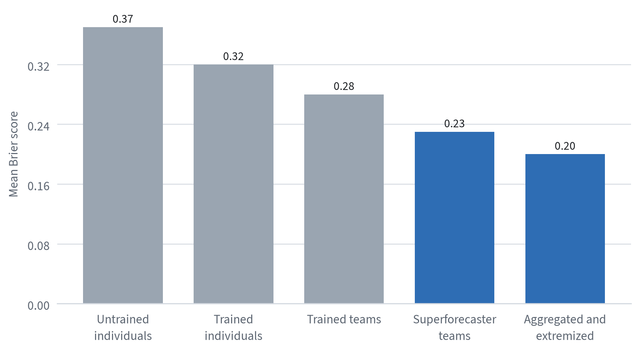
Illustrative Brier-score pattern for this pipeline sample, reflecting the ordering of effects reported in Mellers et al. (2014).
A fourth finding concerned aggregation. Combining many individual forecasts, weighting more accurate forecasters more heavily, and then extremizing the result, pushing the aggregate probability further from 50 percent, produced the most accurate forecasts of all. Extremizing works because each individual holds only part of the available information; when many independent forecasters lean the same way, the combined evidence is stronger than any single forecaster’s confidence reflects.

4.3 Measuring accuracy: the Brier score and calibration
Forecasting science depends on proper scoring rules, the most common of which is the Brier score: the mean squared difference between the forecast probability and the outcome, coded as 1 if the event occurred and 0 if it did not. A perfect forecaster scores 0; always guessing 50 percent on binary questions scores 0.25; confident wrong forecasts are punished heavily. Because the score is proper, the strategy that minimizes it is to report one’s true belief, which removes the incentive to hedge or exaggerate.
The Brier score can be decomposed into two components that matter for organizations. Calibration asks whether events forecast at 70 percent happen about 70 percent of the time. Resolution, sometimes called discrimination, asks whether the forecaster assigns meaningfully different probabilities to events that do and do not occur. A forecaster who always says 50 percent may be perfectly calibrated and entirely useless. The goal is high resolution with good calibration: confident when there are grounds for confidence, and right about as often as that confidence implies.
FIGURE 7 Calibration curves: stated confidence versus observed frequency
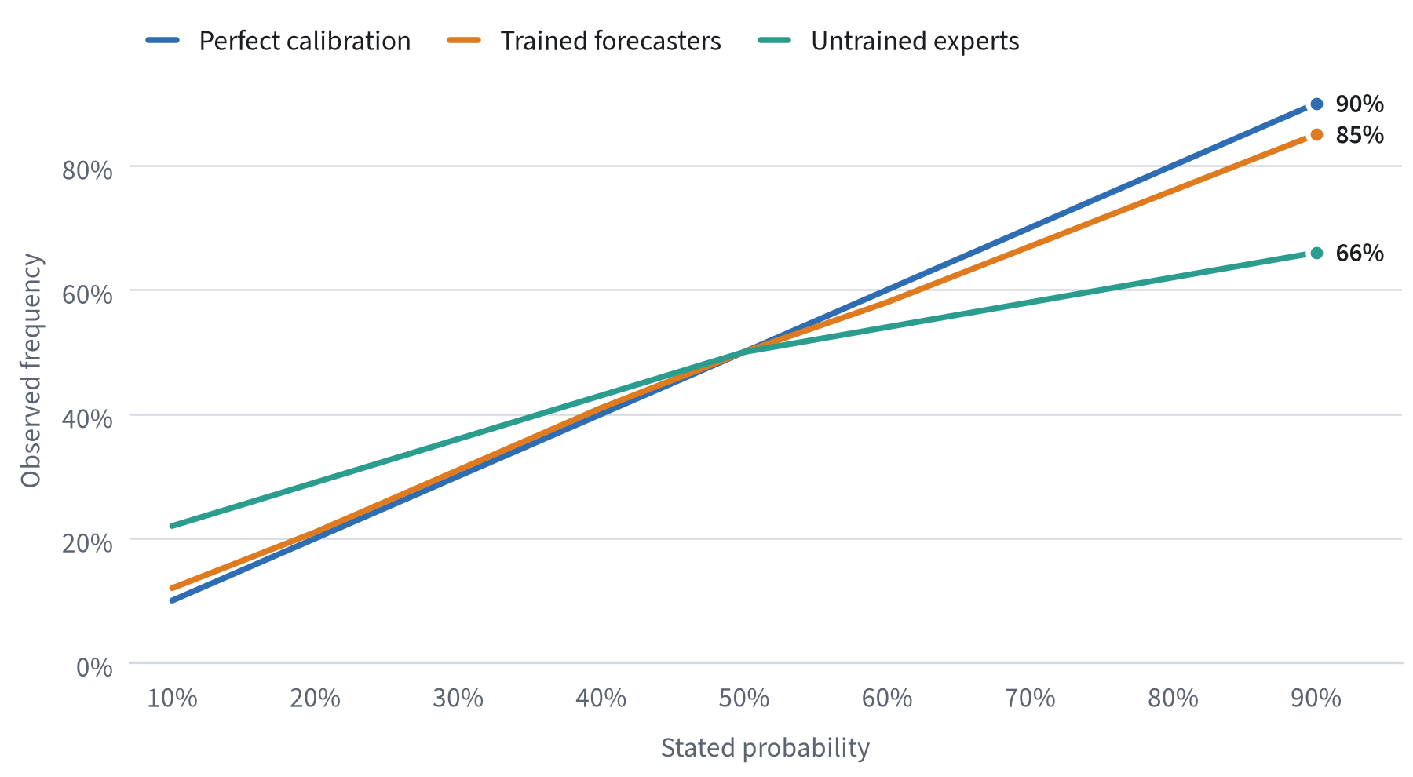
Illustrative calibration data for this pipeline sample. A perfectly calibrated forecaster lies on the diagonal.
Figure 7 shows the characteristic pattern of overconfidence. Untrained experts’ high-confidence forecasts come true far less often than claimed, and their low-confidence forecasts come true more often. Training flattens this distortion considerably. For organizations, the practical point is that calibration is visible only when probabilities are written down and scored over time. Without that record, overconfidence is invisible and therefore uncorrectable.

4.4 What makes good forecasters different
The superforecaster research identified a recognizable cluster of habits. None depends on unusual intelligence or specialist access to information. Most can be adopted by anyone willing to practise them.
Habits of accurate forecasters
- Start with the outside view. Begin with the base rate for the class of event, then adjust for specifics.
- Decompose the question. Break a hard question into smaller, more tractable parts, an approach often called Fermi estimation.
- Update frequently, in small steps. Revise forecasts as news arrives, avoiding both stubbornness and overreaction.
- Seek out disagreement. Actively look for the strongest version of the opposing view.
- Think in fine-grained probabilities. Distinguish 60 percent from 70 percent; the distinction carries real information.
- Keep score. Review past forecasts honestly, especially the ones that turned out well for the wrong reasons.

Two further findings are relevant to organizational design. First, superforecasters spend a large share of their effort on question clarification: understanding exactly what would count as the event occurring. Many organizational forecasts fail not because the probability was wrong but because the question was vague. Second, accuracy depends heavily on time horizon. Forecasts more than a year or two out degrade sharply towards chance for most geopolitical questions, which argues for planning processes that build in frequent re-forecasting rather than relying on a single long-range projection.

4.5 Prediction markets and crowd forecasting
Prediction markets and crowd-forecasting platforms such as Metaculus and Good Judgment Open offer another way to aggregate dispersed information. Internal corporate prediction markets, tried by a number of large technology and consumer companies, have sometimes produced forecasts of launch dates and sales volumes that were more accurate than official plans. Their record is mixed, however: thin participation, politically sensitive questions and the temptation to manipulate prices for signalling purposes have limited their adoption.
TABLE 3 Comparison of forecast aggregation methods
Method | Strengths | Limitations | Best suited to
Simple average of experts | Cheap; reduces noise; easy to explain | Ignores differences in skill | Frequent, routine estimates
Weighted, extremized aggregate | Highest accuracy in tournaments | Needs track records to weight | Recurring strategic questions
Internal prediction market | Continuous updating; incentives to share | Thin markets; cultural friction | Large firms with many informed staff
Delphi panel | Structured iteration; anonymity | Slow; can converge prematurely | Long-horizon, expert-heavy topics
Model-generated forecast | Consistent; scalable; fast | Correlated errors; opaque failure | Data-rich, stable domains
Source: H Heuristics synthesis; see also Delphi method.

4.6 Implications
Forecasting research offers the clearest evidence that judgment can be measurably improved through process. The interventions are modest: brief training, structured teamwork, aggregation and, above all, keeping score. Organizations that adopt even a few of these practices gain something most lack entirely, which is an objective record of whose judgment has been reliable and under what conditions. That record becomes even more valuable when AI systems begin to produce forecasts of their own, because it provides the benchmark against which machine judgment can be fairly compared.
SECTION 05

AI as a Decision Partner

5.1 An old debate in a new form
The question of whether machines should assist or replace human judgment is not new. In 1954 the psychologist Paul Meehl published Clinical versus Statistical Prediction, comparing the accuracy of clinicians’ judgments with simple statistical formulas across a range of prediction tasks. The formulas matched or beat the clinicians in nearly every comparison. A later meta-analysis by Grove and colleagues (2000), covering 136 studies, reached a similar conclusion: mechanical prediction was about as accurate or more accurate than clinical prediction in the large majority of cases.
Despite this evidence, adoption of statistical decision aids has been slow. One reason is algorithm aversion: research by Berkeley Dietvorst, Joseph Simmons and Cade Massey found that people lose confidence in an algorithm more quickly than in a human forecaster after seeing both make the same mistake. People hold algorithms to a standard of perfection they do not apply to themselves or to other people. Interestingly, the same researchers found that aversion falls sharply when people are allowed to adjust the algorithm’s output, even slightly.
Large language models and other modern AI systems change this debate in two ways. They extend machine assistance from narrow, structured prediction tasks to the open-ended, language-based work that makes up much of professional decision-making: framing problems, summarizing evidence, generating options and drafting recommendations. And they present their output in fluent natural language, which makes them feel more like colleagues than formulas. Both changes raise the potential value of machine assistance and the risk that it is used badly.

5.2 Where machine assistance helps
The evidence and early field experience point to four areas where AI tends to improve decision quality.
Reducing noise. Because a model returns consistent outputs for consistent inputs, it removes much of the unwanted variability that noise audits reveal in human judgment. Even when a model is no more accurate on average than a skilled professional, combining the two often reduces total error by damping the human’s inconsistency.
Widening the search. Models are good at generating alternatives, counter-arguments and considerations that a decision team has missed. Used as a structured devil’s advocate, they can counteract narrow framing and confirmatory search, two of the most common failures described in Section 3.
Imposing the outside view. Models trained on large datasets can supply base rates and reference-class information quickly, making it easier to start an estimate from the outside view.
Documenting reasoning. AI tools lower the cost of writing a decision record, summarizing the evidence considered and the reasoning applied. This makes later review, and learning, much more practical.

5.3 Where it goes wrong
The same properties that make AI useful create characteristic failure modes. Three deserve particular attention.
FIGURE 8 How over-reliance develops in human–AI decision teams
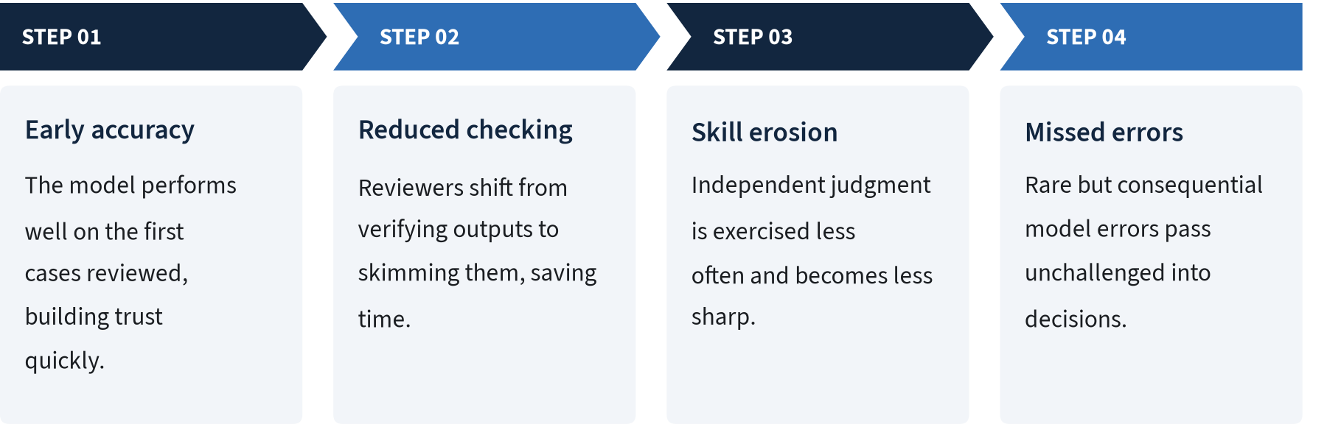
H Heuristics framework drawing on the automation bias literature, including Parasuraman and Manzey (2010).
Automation bias and complacency. Decades of research in aviation, medicine and process control, reviewed by Parasuraman and Manzey (2010), show that people working with automated aids tend to over-rely on them: they accept incorrect recommendations (errors of commission) and fail to notice problems the aid did not flag (errors of omission). This automation bias affects experts as well as novices and is not reliably cured by training alone. It grows with the aid’s general reliability, which creates a paradox: the better the system usually is, the less likely people are to catch its occasional failures.
Correlated error. When many analysts consult the same model, their judgments become correlated. The wisdom-of-crowds effect depends on errors being independent; a shared model removes that independence. An organization that once had twenty analysts making partly independent errors may now have twenty analysts making the same error. The risk extends across organizations when many firms rely on the same few foundation models.
False precision and fluent confabulation. Language models produce confident, well-structured prose regardless of the strength of the underlying evidence. They may cite sources that do not exist, present estimates without meaningful uncertainty, or reconcile conflicting evidence with a plausible but unfounded narrative. Fluency is a powerful cue to credibility in human cognition, so these errors are harder to detect than the obviously wrong outputs of earlier systems.

5.4 Evidence on human–AI teams
Research on human–AI collaboration is growing quickly, and its findings are more nuanced than either enthusiasts or sceptics suggest. A consistent pattern is that human–AI teams outperform humans alone on tasks within the model’s competence, but can underperform the model alone when humans override it in the wrong cases. On tasks at or beyond the edge of the model’s competence, teams frequently do worse than humans alone, because people accept confident but incorrect AI suggestions.
FIGURE 9 Accuracy with and without AI assistance, by task type
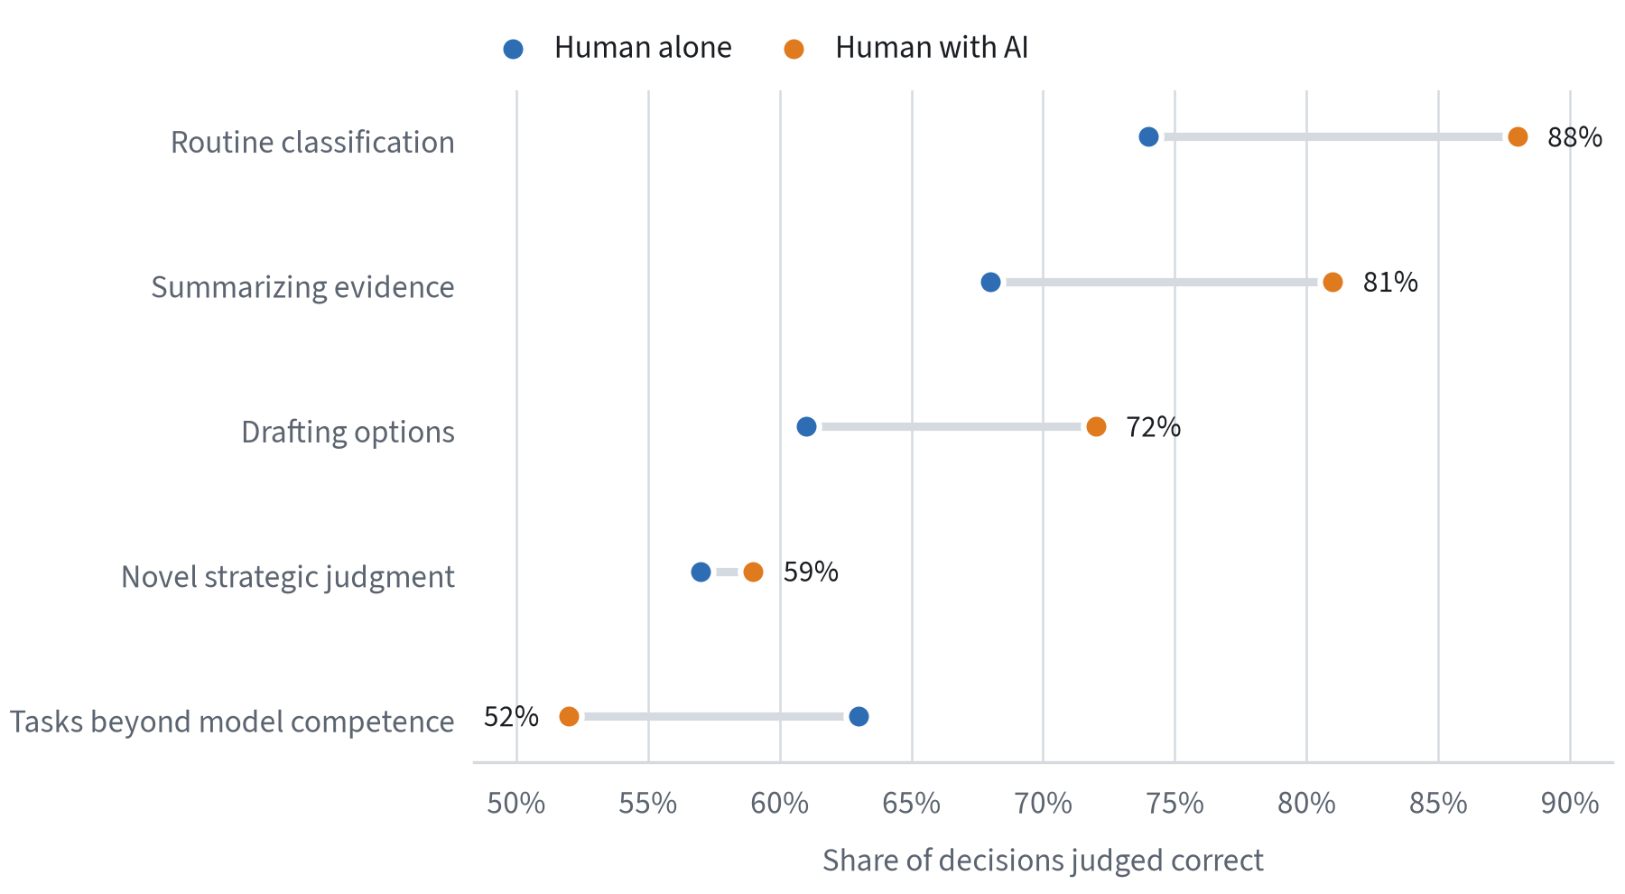
Illustrative values for this pipeline sample, reflecting the direction of effects reported in recent human–AI collaboration studies.
The practical lesson is that the value of AI assistance depends heavily on whether users know where the model’s competence ends. That boundary is often jagged and invisible: a model may excel at one task and fail at a superficially similar one. Organizations therefore need explicit guidance on which decisions AI may inform, which it may make, and which require independent human judgment, along with routine checks that the boundary is where they think it is.

5.5 Governance frameworks
Regulators and standards bodies have begun to codify expectations for AI in consequential decisions. The NIST AI Risk Management Framework, released in January 2023, organizes AI risk management into four functions, Govern, Map, Measure and Manage, and emphasizes that trustworthy AI depends on the context of use. The European Union’s AI Act takes a risk-based approach, imposing obligations on high-risk systems, including requirements for human oversight designed to prevent automation bias. The OECD AI Principles set out high-level commitments to transparency, robustness and accountability that many national frameworks reference.
TABLE 4 How major frameworks treat human oversight of AI-assisted decisions
Framework | Scope | Treatment of human oversight | Relevance to decision process
NIST AI RMF 1.0 | Voluntary, cross-sector | Oversight roles defined under Govern and Manage | Map decision context; measure reliance
EU AI Act | Binding for high-risk uses | Human oversight measures required by design | Users must be able to override and interpret
OECD AI Principles | Intergovernmental principles | Human agency and accountability | Sets expectations for accountability
ISO/IEC 42001 | Certifiable management system | Roles, competence and controls | Embeds AI governance in management processes
Source: H Heuristics summary of public framework documents; see ISO/IEC 42001.
These frameworks share an important premise with the decision-quality literature: the risks of AI arise not from the model alone but from the interaction between model, user and decision process. Governance that focuses only on model accuracy will miss the most common failure, which is a sound model used in an unsound process. The next section translates this premise into a concrete operating model.
SECTION 06

A Decision-Quality Operating Model

6.1 Design principles
The evidence reviewed so far points to a small number of design principles for organizations that want to improve decision quality in an era of machine assistance. The operating model in this section is built on five of them.
- Tier decisions by consequence and reversibility. Not every decision deserves the same process. Effort should concentrate on decisions that are both consequential and hard to reverse.
- Separate the process from the outcome. Evaluate decisions on the quality of the process at the time they were made, and review outcomes separately to learn about the environment.
- Independence before discussion. Collect individual judgments, human and machine, before any group deliberation, to preserve the diversity of information.
- Make uncertainty explicit. State key forecasts as probabilities or ranges, and write them down where they can be scored later.
- Close the loop. Build a routine in which past decisions are reviewed, forecasts are scored and lessons are fed back into the process.
None of these principles is novel on its own. What distinguishes high-performing organizations is that they apply them consistently, with lightweight tools, and without making the process so burdensome that people route around it.

6.2 Tiering decisions
The first step is to decide which decisions warrant a structured process at all. A useful heuristic, popularized by Amazon’s distinction between “one-way” and “two-way” doors, is to classify decisions by how consequential and how reversible they are. Figure 10 maps the four resulting categories to an appropriate level of process.
FIGURE 10 Decision tiers by consequence and reversibility
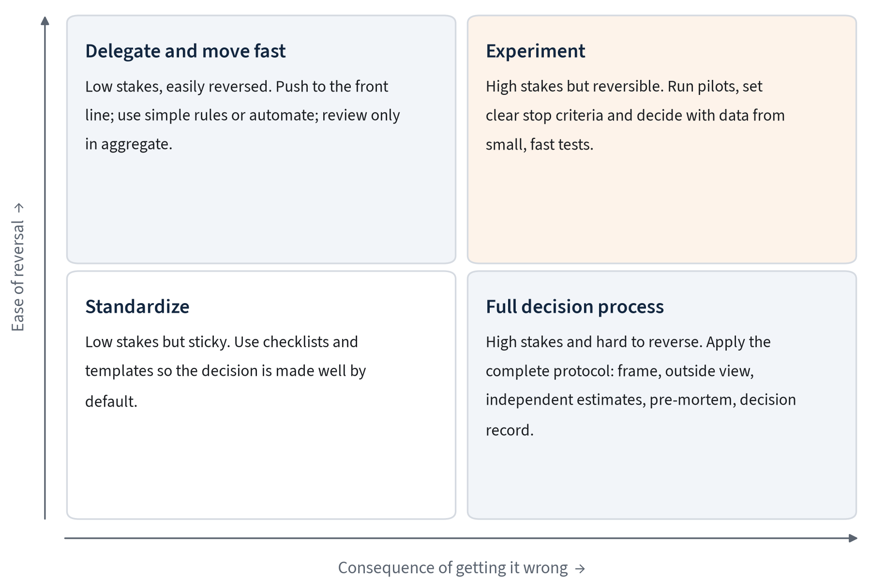
H Heuristics framework.
In practice, fewer than one in twenty decisions in a typical organization will fall into the full-process quadrant. Those decisions, however, account for a disproportionate share of value created or destroyed. The tiering exercise also clarifies where AI can be given more autonomy: low-stakes, reversible decisions in data-rich environments are natural candidates for automation, provided outcomes are monitored in aggregate.

6.3 The core protocol
For decisions in the full-process tier, we recommend a protocol of six steps. Each step is supported by a specific practice with a research basis, and each produces a short written artefact. The complete set fits comfortably into a decision record of one to three pages.
FIGURE 11 The H Heuristics decision protocol for high-stakes decisions
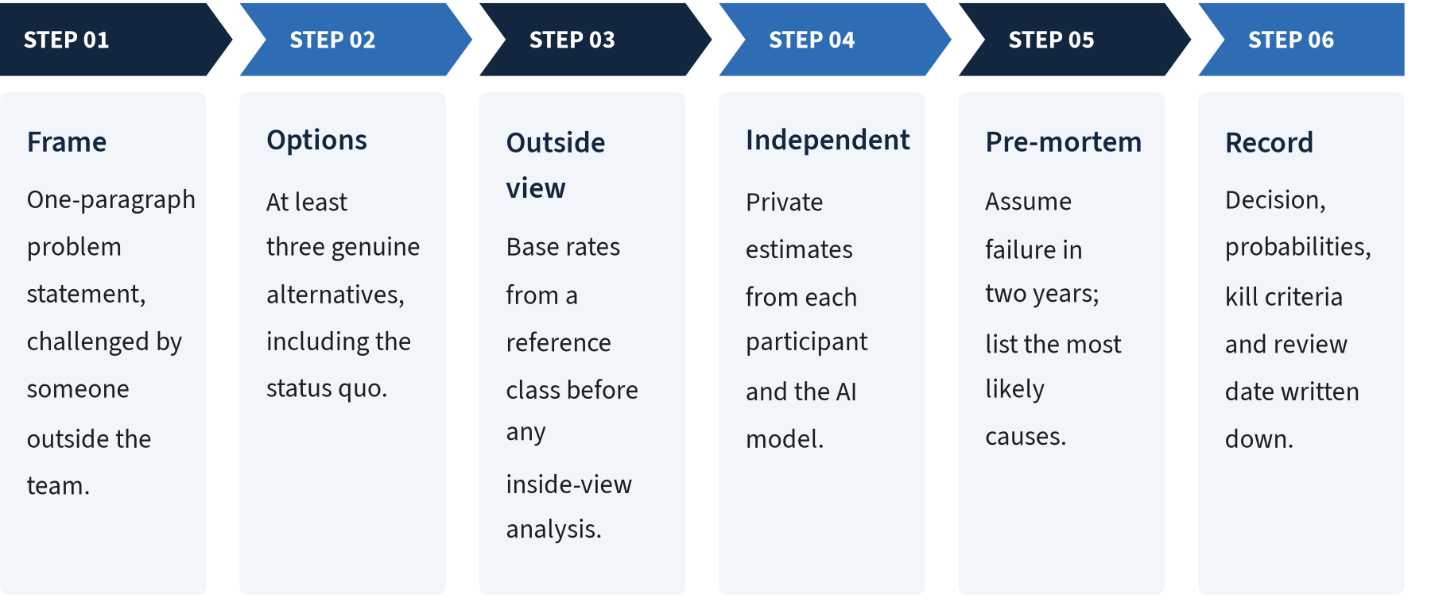
H Heuristics framework; practices drawn from the literature cited in Section 3 and Section 4.
Frame. The problem statement should name the decision, the objective, the time horizon and the constraints. Having it challenged by someone outside the team surfaces hidden assumptions early, when they are cheap to change.
Options. Requiring at least three options, one of which is the status quo, breaks the “whether or not” framing that research on organizational decisions has found to be common and costly.
Outside view. Before building a bespoke business case, the team identifies a reference class and its distribution of outcomes. This is where AI assistance is often most valuable, retrieving comparable cases quickly, provided the cases are verified.
Independent estimates. Each participant, and the AI model if one is used, submits key estimates privately. Divergence between estimates is treated as information to be explored rather than noise to be averaged away. Treating the model as one independent voice among several preserves its value while limiting automation bias.
Pre-mortem. The team imagines that the decision has failed and writes down the most plausible reasons. Gary Klein’s pre-mortem technique legitimizes dissent and has been found to increase the identification of risks compared with conventional risk reviews.
Record. The decision record captures the choice, the key forecasts with probabilities, the conditions that would trigger a review, and a scheduled date to revisit the decision. Without this artefact, later learning is impossible.

6.4 Roles for AI within the protocol
The protocol makes it possible to be precise about where AI fits. Table 5 sets out recommended roles for each step, together with the guardrails that limit the failure modes discussed in Section 5.
TABLE 5 Recommended roles and guardrails for AI in the decision protocol
Step | Recommended AI role | Guardrail
Frame | Critic: identify ambiguities and alternative framings | Human owns the final problem statement
Options | Generator: propose additional alternatives | Team must evaluate at least one AI-proposed option seriously
Outside view | Researcher: retrieve reference cases and base rates | Every cited source is verified and linked
Independent estimates | Independent forecaster | Model estimate revealed only after human estimates are locked
Pre-mortem | Red team: generate failure scenarios | Team ranks scenarios; model does not
Record | Scribe: draft the decision record | Decision owner edits and signs the record
Source: H Heuristics framework.
Two guardrails deserve emphasis. The first is sequencing: revealing the model’s estimate only after humans have committed to their own preserves independence and avoids anchoring. The second is verification: every factual claim and citation that enters a decision record from an AI tool should be checked against its source. This is tedious but essential; fabricated or misattributed sources are among the most common and damaging AI errors in professional settings.

6.5 Making it stick
Process improvements fail most often not because they are wrong but because they are abandoned. Three design choices increase the odds that a decision-quality program survives contact with day-to-day pressures.
Three conditions for adoption
Keep it light. A decision record that takes more than an hour to write will not be written. Templates, AI-assisted drafting and a strict page limit help.
Make leaders go first. When senior leaders publish their own decision records, including forecasts that turned out wrong, the practice becomes a norm rather than a compliance exercise.
Reward process, not luck. Performance conversations should include the quality of decisions, assessed on the record, alongside results. Otherwise people will rationally optimize for outcomes they can attribute to themselves.

SECTION 07

Measuring Decision Quality

7.1 Why measurement is hard and why it matters
Measuring decision quality is difficult for the same reason improving it is valuable: outcomes are noisy, delayed and confounded. A single decision cannot be graded by its result. But a portfolio of decisions can be assessed, and the process behind each decision can be evaluated at the time it is made. Organizations that build both kinds of measurement gain a feedback loop that most lack, and with it the ability to learn faster than competitors.
Measurement also changes behavior. When forecasts are written down and scored, people become more careful about the probabilities they state. When decision records are reviewed, teams take more care in writing them. The act of measuring is itself one of the most effective interventions available, a version of the Hawthorne effect that leaders should welcome rather than discount.

7.2 A balanced scorecard for decisions
We recommend tracking four families of indicators. Process indicators are leading, available immediately and under the organization’s control. Accuracy indicators accumulate over months as forecasts resolve. Outcome indicators lag further still. Learning indicators show whether the feedback loop is actually operating.
TABLE 6 Indicators for a decision-quality scorecard
Family | Indicator | How it is measured | Typical cadence
Process | Protocol adherence | Share of tier-one decisions with complete records | Monthly
Process | Alternatives considered | Average number of genuine options per decision | Monthly
Process | Independence | Share of decisions with private estimates before discussion | Monthly
Accuracy | Brier score | Mean squared error of resolved probability forecasts | Quarterly
Accuracy | Calibration gap | Difference between stated and observed frequencies | Quarterly
Accuracy | Range hit rate | Share of outcomes falling within stated 80% ranges | Quarterly
Outcome | Value versus plan | Realized versus forecast value for major decisions | Annually
Outcome | Reversal rate | Share of decisions reversed within 12 months | Annually
Learning | Review completion | Share of decisions reviewed on schedule | Quarterly
Learning | Lessons applied | Changes to templates or base rates from reviews | Semi-annually
Source: H Heuristics framework.
The scorecard should be used diagnostically, not punitively. A high reversal rate, for example, may indicate poor initial decisions, or it may indicate a healthy willingness to change course when evidence shifts. A rising Brier score may reflect worse judgment, or a deliberate move into harder questions. The indicators are prompts for conversation rather than targets to be hit, and they lose their value quickly if people are rewarded for gaming them, as Goodhart’s law warns.

7.3 Scoring forecasts in practice
The accuracy indicators depend on forecasts being stated in a scorable form. That requires three things: a clear question with an unambiguous resolution criterion, a probability or range, and a resolution date. “The launch will go well” cannot be scored. “There is a 65 percent chance that the product reaches 10,000 paying users by 30 June” can.
Once forecasts are recorded, scoring is straightforward. Each resolved forecast receives a Brier score; scores are averaged by forecaster, team and decision type; and calibration curves are plotted once enough forecasts have accumulated, typically after fifty to a hundred. AI tools can automate much of this bookkeeping, including reminding forecast owners when resolution dates arrive and drafting a review of what was learned.
FIGURE 12 Forecast accuracy over the first eight quarters of a decision-quality program
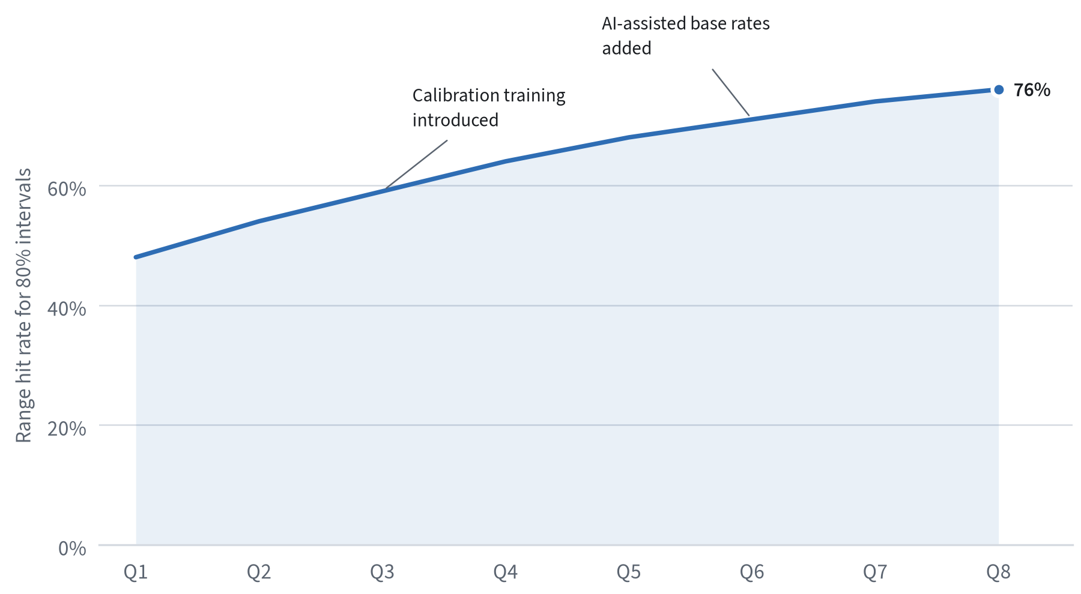
Illustrative trajectory for this pipeline sample; real programs vary widely in starting point and pace.
Figure 12 shows a pattern that programs commonly report. Initially, stated 80 percent ranges capture the outcome only about half the time, a clear sign of overprecision. Simple feedback, followed by calibration training and better access to base rates, steadily widens ranges where needed and narrows them where justified. The goal is not to reach exactly 80 percent but to approach it while keeping ranges informative.

7.4 Reviewing decisions
Decision reviews are the mechanism that converts measurement into learning. Effective reviews share several features. They are scheduled in advance, at the date recorded in the decision record, rather than triggered by a bad outcome. They examine the process separately from the outcome, asking whether the decision was reasonable given what was known at the time. And they focus on lessons that can be applied to future decisions, such as updating a base rate, improving a template or recognizing a recurring blind spot.
FIGURE 13 Classification of reviewed decisions by process and outcome quality
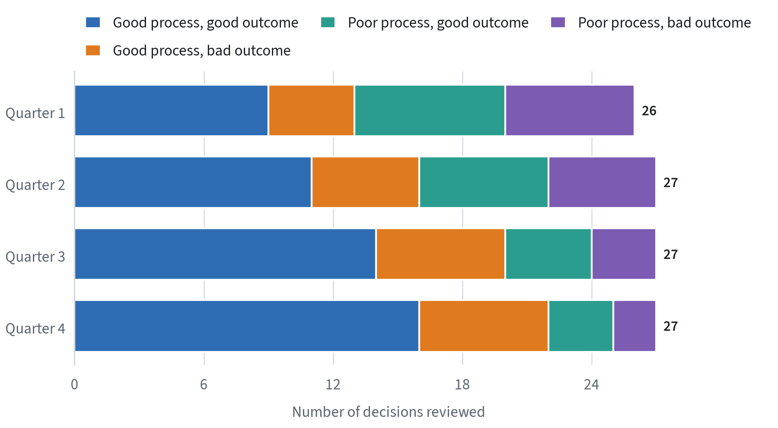
Illustrative distribution for this pipeline sample. The off-diagonal categories are where learning is concentrated.
A useful classification, shown in Figure 13, crosses process quality with outcome quality. Decisions with good process and bad outcomes, sometimes called “bad breaks”, should not be punished; they are the price of taking sensible risks. Decisions with poor process and good outcomes, “dumb luck”, are the most dangerous, because they reinforce habits that will eventually fail. A review culture that can distinguish these two categories has grasped the essential idea of decision quality.

7.5 Benchmarks and maturity
Organizations at different stages need different measures. Table 7 outlines a simple maturity model that can be used to set realistic goals and to communicate progress to boards and executive teams.
TABLE 7 Decision-quality maturity model
Level | Description | Typical evidence
1. Ad hoc | Decisions made informally; outcomes drive evaluation | No written records; post-mortems only after failures
2. Documented | Major decisions recorded; rationale captured | Decision records for most tier-one decisions
3. Quantified | Key forecasts stated as probabilities and scored | Brier scores and calibration curves by team
4. Learning | Reviews scheduled; lessons feed into templates and base rates | Updated reference classes; trend in accuracy
5. Adaptive | Human and AI judgment combined and benchmarked continuously | Comparative accuracy of human, AI and blended forecasts
Source: H Heuristics framework.
Most organizations we encounter operate at level one or two. Reaching level three is the most important step, because it creates the objective record of accuracy on which everything else depends. It is also the step at which the comparison between human and AI judgment becomes possible on fair terms, using the same questions, the same scoring rules and the same resolution criteria for both.
SECTION 08

Outlook and Recommendations

8.1 The next five years
Three trends are likely to shape organizational decision-making over the next five years. Each raises the importance of the practices described in this report.
AI agents will move from advising to acting. Today, most AI systems in organizations draft, summarize and recommend; a human makes the final call. Increasingly, agents will execute decisions within defined limits: reordering inventory, adjusting prices, triaging cases or approving routine requests. This shifts the critical design question from “is the recommendation good?” to “are the limits and monitoring right?” Tiering decisions by consequence and reversibility, as described in Section 6, provides a natural framework for setting those limits.
Forecasting will become ambient. As models become cheaper and better calibrated on structured questions, organizations will be able to attach a machine-generated probability to almost every plan and commitment. The scarce resource will no longer be forecasts but the discipline to state clear questions, compare forecasts honestly and act on the results. Organizations that already keep score will be best placed to know when to trust machine forecasts and when to override them.
Regulation will formalize oversight. Obligations under the EU AI Act for high-risk systems, together with sector-specific guidance in finance, health and employment, will require organizations to demonstrate meaningful human oversight of AI-assisted decisions. Meaningful oversight is, in practice, a decision-quality question: it requires knowing who decided what, on what basis, with what uncertainty, and how the decision was reviewed.
FIGURE 14 An indicative 24-month roadmap for a decision-quality program
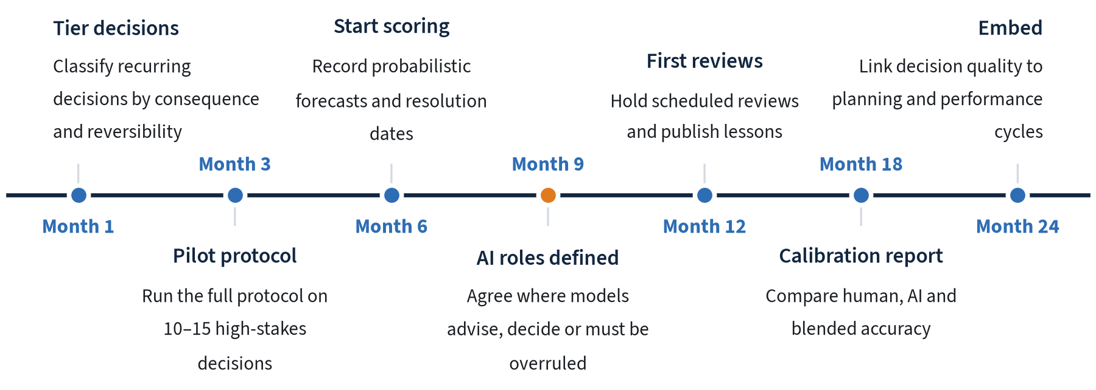
H Heuristics framework. Timing is indicative and should be adapted to organizational context.

8.2 Recommendations for leaders
Drawing together the evidence in this report, we offer eight recommendations. They are ordered roughly by the speed with which they can be implemented, and most can begin within a single quarter.
- Start a decision log this month. Ask every member of the executive team to record their next three significant decisions using a one-page template: the choice, the alternatives considered, the key forecast with a probability and a review date.
- Separate process reviews from outcome reviews. Schedule reviews of a sample of decisions irrespective of results, and evaluate the process on its own terms before discussing the outcome.
- Require the outside view. Make a reference class and its base rate a mandatory input to every business case above a set threshold, before any inside-view projections are presented.
- Collect independent estimates before meetings. For consequential decisions, gather private written estimates from participants, and from any AI model in use, before discussion begins.
- Institutionalize the pre-mortem. Add a structured pre-mortem to the approval process for large, hard-to-reverse commitments, and record the risks identified.
- Define AI decision rights explicitly. For each class of decision, specify whether AI advises, decides within limits or is excluded, and who is accountable for monitoring its performance.
- Keep score, for humans and machines alike. Track forecast accuracy with proper scoring rules, publish calibration results internally, and use them to weight future judgments.
- Reward good process. Incorporate decision quality, assessed on the record, into performance conversations and promotion decisions for leaders.
What success looks like after two years
- Every high-stakes decision has a short written record with explicit probabilities and a scheduled review.
- Forecast accuracy and calibration are reported by team, and improve over time.
- AI tools are used in defined roles, with their accuracy benchmarked against human and blended judgment.
- Leaders can point to specific decisions that were improved, or avoided, because of the process.

8.3 Questions for boards
Boards have a particular role in decision quality because they oversee the most consequential and least reversible choices an organization makes. The following questions can help a board assess whether management’s decision processes are fit for purpose, without intruding into operational detail.
- Which decisions in the past year would we classify as high-stakes and hard to reverse, and what process did each follow?
- For our largest commitments, what reference class did management use, and how does the plan compare with the base rate?
- Where do AI systems currently inform or make decisions on our behalf, and who is accountable for monitoring their performance?
- How accurate have management’s key forecasts been over the past three years, and how do we know?
- When did we last reverse a major decision on the basis of new evidence, and what did we learn?

8.4 Limitations and open questions
Several questions remain open, and leaders should treat the recommendations in this report as a starting point to be adapted rather than a finished blueprint.
First, most of the forecasting evidence comes from geopolitical and economic questions with clear resolution criteria and horizons of months rather than years. Corporate decisions often involve longer horizons, outcomes that are partly shaped by the decision itself, and questions that are hard to resolve unambiguously. The core lessons, including outside-view anchoring, independence and keeping score, appear to transfer, but the size of the benefits in corporate settings is less well established.
Second, research on human–AI collaboration is moving quickly and is sensitive to the particular model, task and interface studied. Findings from one generation of models may not hold for the next. Organizations should therefore treat their own measured results, gathered through the scorecard in Section 7, as the most relevant evidence, and should revisit AI decision rights at least annually.
Third, decision processes carry costs as well as benefits. Excessive process can slow organizations down, discourage initiative and push decisions into informal channels where they are not recorded at all. The tiering approach described in Section 6 is intended to limit this risk, but the right balance will differ between a regulated bank, a fast-growing software company and a public agency.
Finally, there is a risk that measurement itself becomes the goal. Brier scores and calibration curves are tools for learning, not targets for performance management. Organizations that tie compensation directly to forecast scores may find that people avoid hard questions or game resolution criteria. Used well, the measures in this report support honest conversation about judgment; used badly, they can undermine it.

8.5 Conclusion
The research on judgment and decision-making offers an unusually clear message for leaders. People are not hopelessly irrational, and simple heuristics often serve them well. But in the situations that matter most, those that are novel, high-stakes and slow to provide feedback, intuitive confidence is an unreliable guide, and predictable errors are common. The remedy is not more data or smarter individuals but better process: framing problems carefully, taking the outside view, preserving independent judgment, making uncertainty explicit and keeping score.
AI makes this message more urgent, not less. Machine assistance can reduce noise, widen the search for options and supply base rates at unprecedented speed. It can also amplify overconfidence, correlate errors across teams and erode the human skills needed to catch its mistakes. The organizations that benefit most from AI will be those that treat it as a participant in a well-designed decision process, subject to the same discipline of measurement and review as any human contributor.
Decision quality is, in the end, a capability that compounds. Each recorded forecast, each scheduled review and each lesson applied makes the next decision slightly better. Over years, small improvements in the quality of many decisions add up to a substantial and durable advantage, one that is difficult for competitors to observe and even harder for them to copy.
DECISION QUALITY IN THE AGE OF AI

References
- Simon, H. A. (1955). A behavioral model of rational choice. Quarterly Journal of Economics, 69(1), 99–118. doi.org/10.2307/1884852
- Tversky, A., & Kahneman, D. (1974). Judgment under uncertainty: Heuristics and biases. Science, 185(4157), 1124–1131. doi.org/10.1126/science.185.4157.1124
- Kahneman, D., & Tversky, A. (1979). Prospect theory: An analysis of decision under risk. Econometrica, 47(2), 263–291. doi.org/10.2307/1914185
- Kahneman, D., & Klein, G. (2009). Conditions for intuitive expertise: A failure to disagree. American Psychologist, 64(6), 515–526. doi.org/10.1037/a0016755
- Flyvbjerg, B. (2014). What you should know about megaprojects and why: An overview. Project Management Journal, 45(2), 6–19. doi.org/10.1002/pmj.21409
- Mellers, B., et al. (2014). Psychological strategies for winning a geopolitical forecasting tournament. Psychological Science, 25(5), 1106–1115. doi.org/10.1177/0956797614524255
- Grove, W. M., Zald, D. H., Lebow, B. S., Snitz, B. E., & Nelson, C. (2000). Clinical versus mechanical prediction: A meta-analysis. Psychological Assessment, 12(1), 19–30. doi.org/10.1037/1040-3590.12.1.19
- Dietvorst, B. J., Simmons, J. P., & Massey, C. (2015). Algorithm aversion: People erroneously avoid algorithms after seeing them err. Journal of Experimental Psychology: General, 144(1), 114–126. doi.org/10.1037/xge0000033
- Parasuraman, R., & Manzey, D. H. (2010). Complacency and bias in human use of automation: An attentional integration. Human Factors, 52(3), 381–410. doi.org/10.1177/0018720810376055
- Klein, G. (2007). Performing a project premortem. Harvard Business Review, 85(9). hbr.org
- Kahneman, D., Sibony, O., & Sunstein, C. R. (2021). Noise: A Flaw in Human Judgment. Little, Brown Spark. Overview
- National Institute of Standards and Technology (2023). Artificial Intelligence Risk Management Framework (AI RMF 1.0). nist.gov
- European Union (2024). Artificial Intelligence Act. artificialintelligenceact.eu
- OECD (2019, updated 2024). OECD AI Principles. oecd.ai
- Intelligence Advanced Research Projects Activity. Aggregative Contingent Estimation (ACE) program. iarpa.gov


■ H HEURISTICS
ABOUT
H Heuristics is an independent research firm. We study how organizations, markets and people make decisions under uncertainty, and turn that evidence into practical guidance for leaders. Our reports combine primary analysis, a review of the best available public evidence and transparent methods.
HOW TO CITE
H Heuristics Research Team (2026). Decision Quality in the Age of AI. H Heuristics Research Report HH-2026-001.
DISCLAIMER
This report is provided for general information only and does not constitute investment, legal, tax or other professional advice. Although H Heuristics has taken care to ensure the accuracy of the information contained herein, it makes no warranty, express or implied, as to its accuracy or completeness. Figures labelled as estimates reflect H Heuristics analysis and are subject to revision. Third-party sources are linked in the text and listed in the References. Reproduction is permitted with attribution.
© 2026 H Heuristics. November 2026 · HH-2026-001

