# Howell_Searcy.—Trends in Everglades herpetofaunal research.

# 

**The Role of Invasive Species and Charismatic Megafauna**

**In Everglades Herpetofaunal Research**

***Hunter J. Howell1 and Christopher A. Searcy***

*Department of Biology, University of Miami, 1301 Memorial Drive, Coral Gables, Florida 33146, USA*

*1Corresponding author, e-mail:* [*hunterhowell04@gmail.com*](mailto:hunterhowell04@gmail.com)

***Abstract.—*The Everglades of south Florida, USA, is a unique natural wildlife area, which is home to a diverse array of native herpetofaunal species. The Everglades have undergone transformations fueled by ongoing habitat loss and fragmentation, hydrological modification, a deluge of introduced exotic and invasive species, and the implementation of various ecosystem-wide restoration projects. Here, we analyzed trends in the herpetofaunal research over a 20-y period between 2001 and 2021 by conducting a review of the published scientific literature. We conducted a separate review of unpublished abstracts from the Greater Everglades Ecosystem Restoration Conference (GEER) to compare localized research trends and to include research that may not have been published in a peer-reviewed journal. We included 235 papers in our literature review of published articles and 150 poster and paper presentations from the GEER meetings from 2001–2021.** **We found a significant positive trend in the number of studies on Everglades herpetofauna over this period, driven primarily by an increase in research focused on invasive species. In addition, there are taxonomic biases in the literature, with Crocodilians being significantly over-represented relative to their taxon diversity and Caudates completely absent. Studies on a single invasive species, the Burmese Python (*Python bivittatus*), account for 22% of all published literature during this period and 30% of all GEER presentations. This review highlights both broad trends and large gaps in the Everglades herpetofaunal research and offers direction for future studies seeking to provide a more complete assessment of Everglades reptiles and amphibians.**

*Key Words*.—amphibians; literature review; reptiles; South Florida; trends

**Introduction**

The Everglades, a wetland ecosystem of southern Florida, USA, is a critically important ecoregion, a natural World Heritage site, and the largest wilderness area in the USA east of the Mississippi River (Brown et al. 2006). It serves as an important breeding ground for tens of thousands of migratory wading birds, a critical corridor for neotropical migrants, an annual spawning ground for many biologically and economically important fishes and is home to 68 threatened or endangered species (Brown et al. 2006; Trexler and Goss 2009; Cook and Baranski 2019). The importance of the Everglades has been recognized with a substantial body of research dedicated to the understanding and conservation of the flora and fauna that call it home.

The Everglades ecosystem has also been negatively impacted by a wide variety of anthropogenic factors including large-scale modifications to its hydrological regime, habitat destruction and fragmentation, nutrient pollution, invasive species, and climate change (Sklar and van der Valk 2002; Meshaka 2011). Some of these problems with the Everglades ecosystem have been faced head on and partially mitigated by large investments like the Comprehensive Everglades Restoration Plan, the implementation of which is projected to cost $23.2 billion over 50 y (https://crsreports.congress.gov/product/pdf/IF/IF11336) and through various other initiatives and water management strategies. Other issues like climate change and the increased abundance and diversity of invasive species, however, have continued to plague the ecosystem.

While the Everglades has received an immense amount of attention and research, including a biennial scientific conference dedicated to its restoration, the native herpetofauna of this ecosystem have remained relatively understudied compared to other taxa like wading birds and fish. This dearth of research is somewhat surprising given the abundance and importance of herpetofauna to the Greater Everglades Ecosystem (Kushlan and Kushlan 1980; Diffendorfer et al. 2001; Mazzotti et al. 2009). For example, American Alligators (*Alligator mississippiensis*) function as a top predator, ecosystem engineer, and keystone species in the Everglades (Kushlan and Kushlan 1980; Rice et al. 2005; Fujisaki et al. 2009; Mazzotti et al. 2009). Anurans, and amphibians in general, which are underrepresented in the literature, can be used as indicator species to give somewhat advanced warning of negative changes in the ecosystem (Welsh and Ollivier 1998). Also, the Everglades is home to a diverse community of squamates and chelonians that likely play a key role in nutrient cycling, secondary biomass production, and predator-prey interactions across trophic levels (Meshaka et al. 2000; Diffendorfer et al. 2001; Lovich et al. 2018; Howell et al. 2021).

Given the diversity and importance of the herpetofaunal community and the myriad anthropogenic factors currently impacting the Everglades ecosystem, we set out to analyze the body of research examining the herpetofaunal community in the Everglades. The objective of our review was to collate all published studies on Everglades reptiles and amphibians that have come out since the last comprehensive review of this literature by Meshaka et al. (2000). By doing this, we can evaluate taxonomic trends and shifts in research focus across time, with the goal of highlighting persistent knowledge gaps and prescribing a future research agenda.

**Materials and Methods**

For our literature review, we considered the Everglades to include all areas in Florida, USA, south of Lake Okeechobee (Meshaka and Layne 2015). While this may have included some studies that occurred in non-natural areas, most of this area was historically considered part of the Greater Everglades Ecosystem and so was included. We searched the Web of Science and Google Scholar using a series of keywords (Table 1). To search both databases, we used each combination of these search terms. We searched the literature between 10 October and 17 November 2021 for literature released 2001–2021. For all combinations of terms, we examined the first 100 query results in both databases. If it was obvious from the title that the study did not include information pertinent to the search terms, we excluded it. After the first round of exclusion based on article titles, we examined the abstracts of the remaining articles to identify those pertinent to the search terms. In addition, we scanned the titles of other published papers cited by papers included within this review to garner further studies that might have been missed during the original literature search. We excluded simple natural history notes or range extensions, non-peer-reviewed publications, and those that were strictly literature reviews of existing studies. While we did include theses and dissertations in the literature review, we recognize that not all theses and dissertations completed during this time period appear in our review due to lack of inclusion in searchable databases. While we excluded conference and workshop papers, posters, and talks from our dataset, we did conduct a separate review of the abstracts for both talks and posters that were presented at the biannual Greater Everglades Ecosystem Research Conference (GEER; see below) to serve as a representative sample of what research might have been presented and discussed at conferences but not published in a peer-reviewed journal.

Once we selected a paper for inclusion in our literature review, we extracted the paper title, year of publication, species or community of interest, the origin of the species (i.e., native vs. invasive), the order of the species, if the species was a charismatic megafauna (e.g., species that met specific size criteria (Ripple et al., 2019) and also capture public attention and funding), and funding information for the study. We classified funding sources as either state agency government funding, federal agency government funding, or local/private/academic funding. We classified all crocodilians, Burmese Pythons (*Python bivittatus*), North African Rock Pythons (*Python sebae*), Nile Monitors (*Varanus niloticus*), and sea turtles as charismatic megafauna based on the size classifications for reptilian megafauna developed by Ripple et al. (2019). We used native species counts from Meshaka et al. (2000) and included all invasive species that Krysko et al. (2011) considered to be established to calculate the number of native and invasive species referred to throughout this paper as being present in the Everglades. To analyze trends in the type of research being conducted, we grouped each study into one of 11 different research classifications (Table 2). We attempted to group studies based on broad research categories, without focusing on the origin (i.e., native or non-native) of the species in question. Naturally, many studies addressed topics across groups (e.g., studies that analyze both diet and reproduction within a population); in these cases, we attempted to group the study based on the primary research topic.

***Statistical analyses***.—We used Linear Regression to analyze the change through time in the number of published studies and the proportion of studies on invasive species and charismatic megafauna. These tests analyzed whether the observed trends in research vary significantly from a line with a slope of 0. We used a G-test of goodness-of-fit, which compares observed values within categories to an expected number predicted by theory, to compare the number of observed published papers on each taxonomic group to the expected number given the diversity of species within each group within the Everglades, and then *post-hoc* Binomial Tests to determine which taxa were over- versus under-represented in the literature relative to their respective species diversities. We used the same approach to analyze the distribution of GEER presentations across taxonomic groups. We then used additional G-tests to determine if funding sources differed in their likelihood to support studies on invasive species, charismatic megafauna, or particular research categories. We used R v. 4.2.0 (R Core Team 2019) with an alpha of 0.05 for all tests.

**Results**

We included 235 papers in our literature review of published articles and 150 poster and paper presentations from the GEER meetings from 2001–2021 (Supplemental Information Table 1). There was a significant increase in both the number of annually published studies across this time period (*r*2 = 0.58, *F*1,19 = 23.72, *P* < 0.001; Fig. 1) and the number of presentations at GEER (*r*2 = 0.69, *F*1,7 = 15.81, *P* = 0.005), mirroring broad trends in the number of published studies as a whole (National Science Board 2019). There was a significant difference between the observed number of published studies and the number expected based on the diversity within each taxonomic order (*G*2 = 46.1, n = 214, *P* < 0.001; Fig 2), with crocodilians (42 observed studies/six expected; *P* < 0.001) being significantly over-represented relative to their taxon diversity and Anurans (14 observed studies/25 expected; *P* = 0.013), caudates (zero observed studies/eight expected; *P* = 0.004), and chelonians (17 observed studies/35 expected; *P* < 0.001) being significantly under-represented relative to their taxon diversity (Fig 2). There was no significant over or under-representation relative to taxon diversity for the squamates (141 observed studies/141 expected; *P* = 0.494). There was also a significant difference between the observed number of GEER presentations and the number expected based on taxon diversity (*G*2 = 62.04, n = 150, *P* < 0.001; Fig 2), with crocodilians being significantly over-represented (47 observed studies/four expected; *P* < 0.0001) relative to their taxon diversity and caudates (zero observed studies/five expected; *P* < 0.001), chelonians (six observed studies/24 expected; < 0.001), and squamates (74 observed studies/99 expected; *P* < 0.001) being significantly under-represented relative to their taxon diversity (Fig 2). There was no significant over or under-representation relative to taxon diversity for the anurans (11 observed studies/18 expected; *P* = 0.062).

There was a significant increase in the proportion of both published studies (*r*2 = 0.27, *F*1,19 = 7.28, *P* = 0.014) and presentations at GEER (*r*2 = 0.89, *F*1,8 = 59.45, *P* < 0.001) on invasive species during 2001–2021 (Fig. 3), mirroring the increase in both the number and damage caused by invasive species in south Florida (Krysko et al. 2011; Meshaka 2011). In 2001, at the start of the study period, there were zero published studies or presentations on invasive species. By 2021, 71% of all published studies and presentations were on invasive species.

Charismatic megafauna were over-represented in both the published literature (*G*2 = 88.6, n = 235, *P* < 0.001) and GEER presentations (*G*2 = 112.4, n = 235, *P* < 0.001) relative to the expectation based on the proportion of species classified as charismatic megafauna. Research on charismatic megafauna accounted for 45% of all published studies and 63% of all GEER presentations despite representing only 8% of the herpetofaunal diversity (Fig. 4). There were 51 studies published on *P. bivvitatus* alone during this period, accounting for 22% of all published studies in our review and 30% of all presentations at GEER from 2006–2021. Just three species of charismatic megafauna, *P. bivittatus*, *A.* *mississippiensis,* and American Crocodiles (*Crocodylus acutus*), had nearly twice as many GEER presentations as all other species combined. There was a significant increase in the proportion of published studies (*r*2 = 0.20, *F*1,19 = 7.28, *P* = 0.041) on charismatic megafauna during the time period we studied.

We collected funding information from 171 of the published studies (72.8%). Thirty studies received state agency funding (18%), 136 received federal agency funding (80%), and 94 received local/private/academic funding (55%). The most common source of state agency funding was the South Florida Water Management District, which funded 17 studies. The U.S. Geological Survey was the most common source of federal agency funding with 71 funded studies, and the most common source of local/private/academic funds was the University of Florida (Gainesville, USA) with 22 funded studies. There was no relationship between funding sources and research on invasive species (*G*2 = 0.01, n = 172, *P* = 0.991) or charismatic megafauna (*G*2 = 0.24, n = 172, *P* = 0.864).

We recorded significantly increasing trends in five of our 11 primary research categories (i.e., Behavioral, Dietary, Evolution/Taxonomy, Reproductive Ecology, and Restoration/Conservation studies). There were no primary research categories that had significant negative trends in the number of published studies. Habitat Use/Distribution/Niche Modeling papers were the most common research topic (n = 52). Then the next two most common research topics were Restoration/Conservation (n = 35) and Evolution /Taxonomy (n = 34). State grants most often funded Restoration/Conservation (n = 6), Population Ecology (n = 5), and Dietary studies (n = 4). Federal grants most often funded Restoration/Conservation (n = 23), Evolution/Taxonomy (n = 22), and Habitat Use/Species Distribution studies (n = 22). Local and Private grants most often funded Habitat Use/Species Distribution (n = 18), Evolution/Taxonomy (n = 17), and Restoration/Conservation studies (n = 12). There was no relationship between the topic of research studied and which of the funding sources supported the work (G2 =14.3, n=172, *P* = 0.814).

**Discussion**

This literature review provides the first retrospective look specifically on Everglades herpetofaunal research since a review by Meshaka et al. (2000) at the turn of the century. Since that time, South Florida and the Everglades ecosystem have changed dramatically due to factors ranging from the negative impacts of an increase in the abundance and diversity of invasive herpetofauna to the positive ecosystem-wide benefits that a suite of restoration and management initiatives have brought over the last two decades (National Academies of Science Engineering and Medicine [NASEM] 2016, 2018; Capinha et al. 2017). Despite some improvement, however, there remains a great deal of work to be done through the implementation of the Comprehensive Everglades Restoration Plan and various other initiatives to achieve restoration targets across the Greater Everglades Ecosystem. While there has been a trend of increasing research into the herpetofaunal community of the Everglades, most of these investigations have been devoted to invasive species and charismatic megafauna, leaving entire clades completely unstudied.

***Crocodilians***.—The Everglades ecosystem is home to two species of native and one invasive crocodilian. Crocodilians account for < 2% of the herpetofaunal diversity in the Everglades, but account for 17% of all published studies and 31% of all GEER presentations. *Alligator mississippiensis* and *C*. *acutus* are the principal native charismatic reptilian megafauna of the Everglades ecosystem and serve as both keystone and flagship species in this system (Mazzotti et al. 2009) as well as restoration bioindicators (Briggs-Gonzalez et al. 2021). *Alligator mississippiensis* function as top predators, ecosystem engineers, and indicators of Everglades health and restoration (Kushlan and Kushlan 1980; Mazzotti et al. 2009). *Crocodylus* *acutus* similarly function as apex predators and indicators of Everglades health and given their previous status as a federally listed Endangered Species (U.S. Fish and Wildlife Service 1967), they have been the focus of a great deal of research and conservation effort, resulting in a historic increase in abundance and reclassification to a Threatened Species (Richards et al. 2003; Rodriguez et al. 2011; Mazzotti et al. 2007). Given their key roles in the ecosystem and as flagship species, there has been a large amount of research conducted on both these species and many aspects of their ecology (Kushlan and Kushlan 1980; Rice et al. 2005; Fujisaki et al. 2009; Mazzotti et al. 2009). This includes many studies into their importance as flagship species in the Everglades (Platt et al. 2013; Burtner and Frederick 2017; Briggs-Gonzalez et al. 2021) and their conservation status and population trajectory (Richards 2003; Richards et al. 2004; Mazzotti et al. 2007, 2019).

***Chelonians***.—The Everglades ecosystem is home to 11 species of native non-marine turtles, four invasive turtles, and three species of sea turtles. Despite this relatively diverse community, the published literature only covers five species, with 40% of chelonian studies on just the Mangrove Terrapin (*Malaclemys terrapin*) and another 24% on sea turtles. There have been no published community-wide studies on native chelonians in the Everglades and no studies examining the populations of some of the largest freshwater turtles like the Florida Softshell (*Apalone ferox*), the second largest turtle in North America, which acts as a predator of fish and as a food source for large predators like alligators (Ernst and Lovich 2009). Chelonian communities often have very substantial biomasses, similar to those of large schools of marine fish, and in some ecosystems have higher reported biomass than any other terrestrial vertebrate assemblage (Lovich et al. 2018). Due to their high overall secondary productivity and biomass, role in nutrient cycling, and importance in aquatic food chains, chelonian communities have an outsized impact in many freshwater ecosystems, making this gap of knowledge about the Everglades chelonian communities even more stark.

***Squamates***.—The Everglades is home to nine native and 43 invasive lizard species as well as 25 native and five invasive snake species. Squamates have both the highest diversity of species and the largest number of published studies (60%) and GEER presentations (49%); however, this is mainly due to the role of research on invasive squamates (91% of published squamate studies, even outpacing the 62% of squamates that are non-native), with very little work being conducted on native squamates. The main foci of invasive squamate research are *P. bivittatus* (33%), invasive anoles (*Anolis* spp.; 26%), the Argentine Black and White Tegu (*Salvator merianae*; 11%), and Nile Monitors (*Varanus niloticus*; 5%). This focus on invasive species coincides with a near extirpation of several native squamates from the Everglades ecosystem: the Southern Hognose Snake (*Heterodon simus*; Meshaka et al. 2000) and the Rim Rock Crowned Snake (*Tantilla oolitica*; Hines 2011). Future work on squamates in the Everglades should focus on attempting to map community composition using methodologies besides road-cruising, attempting to get baseline demographic data on abundant native species (e.g., water snakes; *Nerodia* spp.), and trying to directly monitor the impact that invasive species, especially invasive parasites, are having on native squamates.

***Anurans***.—There are 10 native anurans and three invasive anurans in the Everglades ecosystem. Studies on native anurans made up 4% of all studies and 6% of GEER presentations, despite accounting for 12% of the herpetofaunal diversity. While some studies have recognized the importance of amphibians as indicator species for both management and restoration (Walls et al. 2014; Clark 2020), there is still no overarching framework that can be used to measure restoration success of this key taxon in the Everglades. Ugarte et al. (2005, 2007) documented significant negative impacts from pollutants and human harvesting on Pig Frog (*Rana grylio*) populations in the central Everglades. There have been no follow-up studies to document how this has impacted abundances elsewhere, or if the same is true for other anurans. This lack of data is especially concerning given the global collapse of amphibian populations in recent decades (Hussain and Pandit 2012; Grant et al. 2020). Unfortunately, analysis of long-term datasets from the Everglades ecosystem show that true frog (Ranidae) abundances declined between 70–77%, treefrog (*Hyla*) abundances declined 81%, and cricket frog (*Acris*) abundances declined 28% from 1996–2019 (unpubl. data). Future work that both analyzes the efficacy of restoration practices in increasing anuran abundance and diversity and produces a generalized set of restoration targets for anurans is sorely needed.

***Caudates****.—*During the last 20 y, there have been no published studies or GEER presentations on Everglades salamanders. While there are only four species (Greater Siren, *Siren lacertina*, Everglades Dwarf Siren, *Pseudobranchus axanthus belli*, Two-toed Amphiuma, *Amphiuma means*, and Peninsula Newt, *Notophthalmus viridescens piaropicola*), they may play an outsized role in both food webs and energy flow through the Everglades (e.g., *A. means* sometimes make up the second largest component of *A.* *mississippiensis* diets by mass in some areas of the Everglades; Barr 1997). The two largest salamanders in the Everglades, *S. lacertina* and *A. means*, compose most of the salamander biomass in the Everglades (Howell et al. 2021); these species are two of the largest salamanders in the world, reaching nearly 1 m and 1.15-m maximum body size, respectively (Petranka 1998). Recent work at the Loxahatchee Impoundment Landscape Assessment in Palm Beach County, Florida (26.489°N, 80.219°W) has provided evidence that these two species exist at densities ~six-fold higher than previously estimated within Everglades National Park (ENP; Diffendorfer et al. 2001; Howell et al. 2021) and may be a significant competitor with wading birds for invertebrate prey resources during seasonal dry downs (unpubl. data). This extraordinarily high biomass, coupled with their role as predator for many aquatic invertebrates and as prey for wading birds and alligators means that the Everglades salamander community likely plays a critical role across multiple trophic levels. Analysis of long-term datasets from across the Everglades ecosystem show that salamander abundances declined between 34–66% from 1996–2019 (unpubl. data). Future work should focus on understanding the role of caudates in the Everglades food web and determining the status of *P. axanthus belli* that appears to be mostly extirpated from the region.

***Invasive species***.—South Florida is home to the largest number of non-native reptile and amphibian species in the world (n = 63; Krysko et al. 2016). The Everglades has not been immune to this flood of invasive species and has suffered dramatically because of *P. bivvitatus*, *S. merianae*, and Cuban Treefrog (*Osteopilus septentrionalis*) introductions (Meshaka et al. 2000; Rice et al. 2011; Dorcas et al. 2012). Studies have documented a 98% loss of small mammals within Everglades National Park because of predation by *P. bivittatus* (Dorcas et al. 2012; McCleery et al. 2015), and a significant decline in native treefrog abundance from competition and predation by *O. septentrionalis* (Meshaka 2001; Rice et al. 2011). While Rice et al. (2011) examined the effect of *O. septentrionalis* on native anurans, this type of work on other invasive species is rare given the high proportion of invasive species and the myriad impacts they could have on the native herpetofaunal community. For example, nest predation by mesopredators (e.g., Racoons, *Procyon lotor*, Striped Skunks, *Mephitis mephitis*), whose populations have increased because of a loss of top predators, is one of the most important components of chelonian population demographics, leading to extraordinarily low rates of nest and hatchling survivorship in both native and anthropogenically disturbed populations (Kolbe and Janzen 2002; Garmestani and Percival 2005; Doody et al. 2006). While tests with artificial nests have documented a significant decline in the rate of chelonian nest predation in areas where high *P. bivittatus* densities (Willson 2017) have basically removed all small mammals (including Racoons), no study has tracked how this dramatic form of predator release has affected actual nest success, demographic rates, or population abundance of Everglade chelonians.

The hyper-focus on invasive species has reached a point where studies on a single invasive species, *P. bivvitatus*, account for 22% of all studies during this time period and 30% of all GEER presentations. Excluding crocodilians, studies and presentations on *P. bivvitatus* outnumber those on all other native herpetofauna combined. While it is obviously critical for the Everglades ecosystem that we understand the impact of *P. bivvitatus*, it is quite clear that their eradication is currently impossible. In contrast, understanding the response of native herpetofaunal communities to prescribe potential mitigation and management strategies is an achievable and desirable goal.

Interestingly, 44% of the invasive species work included in this review occurred in some type of disturbed or urbanized habitat. This is almost certainly due to the development of urban ecology as its own field during the past two decades (Wu 2014), and the excellent study system provided by the diverse lizard community (particularly *Anolis* spp.) that have been introduced to South Florida (Capinha et al. 2017). While this type of habitat (and study) is likely not what is typically pictured when thinking of the Everglades ecosystem, we chose to include these studies as part of the review because nearly all the land in South Florida was historically considered part of the Greater Everglades Ecosystem, including the Pine Rocklands bordering the ridge and slough ecosystem of the Everglades, as well as the peat and marl transverse glades that existed in what is now the urbanized areas of Broward and Palm Beach counties. Therefore, we feel that it is proper both to refer to these areas as part of the Greater Everglades Ecosystem and to include these studies within the review.

***Charismatic megafauna and flagship species***.—The role of charismatic megafauna in conservation has been a hotly debated topic over the years, with many studies and reviews supporting both sides of the argument (Goodwin and Leader-Williams 2000). On one hand, charismatic megafauna increase public support for conservation, leading to funding, attention, and various forms of protection that would otherwise not occur (Goodwin and Leader-Williams 2000). Conversely, this focus limits funding, research, and attention on less charismatic species or areas that may be biodiverse but lack some charismatic megafauna as a flagship species (Goodwin and Leader-Williams 2000), leading to debates around the efficacy of flagship species for conservation (Simberloff 1998; Caro et al. 2004; Smith and Sutton 2008). While *A.* *mississippiensis* serve as a compelling flagship species for the Everglades ecosystem due to their charismatic appearance, large home ranges, and role as ecosystem engineers, it remains unclear if this role has been beneficial to the restoration of the entire herpetofaunal community. Even if *A.* *mississippiensis* sometimes produce favorable microhabitat conditions for the herpetofaunal community, such as chelonians and *A. means* nesting in alligator nests (Kushlan and Kushlan 1980; Thompson et al. 2020), anurans surviving in alligator wallows during the dry season (Kushlan and Kushlan 1980), and broad-scale habitat changes that may favor alligators (e.g., increased fish abundances), these conditions may not be beneficial for the broad herpetofaunal community (Harvey et al. 2010; Kline et al. 2014; Benson et al. 2018). To illustrate, the published literature has documented *A.* *mississippiensis* abundance increases since the turn of the century (Fujisaki et al., 2011, Waddle et al., 2015; however, see Farris et al. 2022 for recent work showing declines in Everglades *A. mississippiensis* populations) but these trends have coincided with a dramatic decline (74%–84%) in the abundances of amphibians between 1996–2019 (unpubl. data), and the enigmatic collapse of the herpetofaunal community on the western border of the Everglades over a 15-y period (Cassani et al. 2015). If *A.* *mississippiensis* are functioning as an effective flagship species and restoration bioindicator for the Everglades ecosystem, their conservation success should not be concurrent with a broadscale decline in the rest of the herpetofaunal community.

***Trends in research topics and funding***.—There has been a significant increase in the number of published studies funded by each of our three funding sources between 2001 and 2021. We were unable to detect any relationship between funding sources and research on invasive species or charismatic megafauna. The same increasing trends in the number of published studies on charismatic megafauna and invasive species can also be seen in finer detail within those research topics that have significant positive trends. One hundred percent of all Behavioral, 78% of all Dietary, 88% of all Evolution/Taxonomic, 100% of Reproductive Ecology, and 78% of all Restoration/Conservation studies were conducted on charismatic megafauna or invasive species. In short, increasing trends across research topics is driven nearly exclusively by an increase in studies on invasive species and charismatic megafauna.

While it is encouraging to see that Restoration/Conservation studies are those most often funded by both State and Federal agencies, once again, the majority of these studies (78%) go towards either the conservation of native charismatic megafauna or towards mitigation of the impact of invasive species. While this research is critical and should continue to be funded at equal or greater levels, this focus has left out entire clades (e.g., Caudates) from any conservation or restoration studies during this time period.

***Conclusion***.—Across the last 20 y, there has been a significant and sustained increase in the number of herpetofaunal studies being conducted in the Everglades and south Florida. These studies have dramatically expanded our understanding of the ecology of some species and the role they play in the Everglades (Mazzotti et al. 2009). Other studies have explored basic questions about community interactions and evolution, taking advantage of unique natural experiments resulting from novel community compositions (Krysko et al. 2003; Smith 2006; Stroud et al. 2020). A dramatic increase in the number of studies on invasive species has occurred during this period, primarily in response to the dramatic increase in the number of invasive species threatening the Everglades. While we are not arguing that work done to understand the ecology and threat of these invasive species in unwarranted, it has occurred concurrently with a lack of attention to important native members of the Everglades herpetofaunal community. It is striking that not a single study or GEER presentation has been given on Everglades salamanders over the last 20 y, despite their potentially large role in the food web. Similarly, while research on crocodilians is critical given their importance to the maintenance of the Everglades ecosystem, they represent just two members of a diverse native community and given that their population trends over the last 20 y may have not mirrored those of other native clades, we cannot be satisfied with focusing primarily on this one clade if it comes at the expense of understanding all of the others.

Future herpetological research in the Everglades should address the knowledge gaps discussed above, including the population and community ecology of previously neglected taxa. Other important topics include the expected effects of future climate change on native communities and producing models to measure how restoration practices are impacting the entire herpetofaunal community. While it is imperative that studies continue to assess the impact of invasive species and the conservation of charismatic megafauna, it is also crucial that these not be the only foci of Everglades herpetofaunal research. The Everglades provides a unique crucible to study the largest proposed restoration project in human history, the highest abundance of invasive herpetofauna in the world, and a globally important ecoregion and wilderness area. As the Everglades ecosystem faces the ever-mounting challenges of climate change and invasive species, research taking an ecosystem-wide approach may provide the answers needed to confront, mitigate, and restore this unique ecosystem for future generations.

*Acknowledgments*.—We thank Eric A. Cline and Mark I. Cook for their input and feedback during the study planning phase, andWalter E. Meshaka Jr. for his preliminary review and comments on this manuscript. Funding for this work was provided by the National Science Foundation Graduate Research Fellowship. We would also like to thank two anonymous reviewers whose comments and suggestions significantly improved the quality of this manuscript.

**Literature Cited**

Barr, B. 1977. Food habits of the American Alligator, *Alligator mississippiensis*, in the southern Everglades. M.Sc. Thesis. University of Miami, Coral Gables, Miami, Florida, USA. 24 p.

Benson, A.J., P.J. Schofield, and K.B. Gestring. 2018. Introduction and dispersal of non-native

bullseye snakehead *Channa marulius* (Hamilton, 1822) in the canal system of southeastern Florida, USA. Biological Invasions Records 7:451–457.

Briggs-Gonzalez, V.S., M. Basille, M.S. Cherkiss, F.J. Mazzotti. 2021. American Crocodiles

(*Crocodylus acutus*) as restoration bioindicators in the Florida Everglades. PLos ONE 16:e0250510. https://doi.org/10.1371/journal.pone.0250510

Brown M.T., M.J. Cohen, E. Bardi, and W.W. Ingwersen. 2006. Species diversity in the Florida

Everglades, USA: a systems approach to calculating biodiversity. Aquatic Science 68:254–277.

Burtner, B.F., P.C. Frederick. 2017. Attraction of nesting wading birds to Alligators (*Alligator*

*mississippiensis*). Testing the ‘nest protector’ hypothesis. Wetlands 37:697–704.

Capinha C., H. Seebens, P. Cassey, P. Garcia-Diaz, B. Lenzner, T. Mand, D. Moser, Y. Pysek,

D. Rodder. R. Scalera, et al. 2017. Diversity, biogeography and the global flows of alien amphibians and reptiles. Biodiversity Research 23:1313–1322.

Caro, T., A. Engilis, Jr., E. Fitzherbert, and T. Gardner. 2004. Preliminary assessment of the

flagship species concept at a small scale. Animal Conservation 7:63–70.

Cassani, J.R., D.A. Croshaw, J. Bozzo, B. Brooks, E.M. Everham, III, D.W. Ceilley, and D.

Hanson. 2015. Herpetofaunal community change in multiple habitats after fifteen years in a Southwest Florida Preserve, USA. PLoS ONE: e0125845. https://doi.org/10.1371/journal.pone.0125845

Clark, P.E. 2020. Monitoring the success of the Picayune Strand restoration project in Collier

County, FL. M.Sc. Thesis, Florida Gulf Coast University, Ft. Myers, Florida, USA. 205 p.

Cook, M.I., and M. Baranski. 2019. South Florida Wading Bird Report. Volume 24. South Florida Water Management District, West Palm Beach, FL, USA.

Diffendorfer, J.E., P.M. Richards, G.H. Dalrymple, and D.L. DeAngelis. 2001. Applying

linear programming to estimate fluxes in ecosystems or food webs: an example from the herpetological assemblage of the freshwater Everglades. Ecological Modeling 144:99–120.

Doody, J.S., B. Green, R. Sims, D. Rhind, P. West, and D. Steer. 2006. Indirect impacts of

invasive Cane Toads (*Bufo marinus*) on nest predation in Pig-nosed Turtles (*Carettochelys insculpta*). Wildlife Research 33:349–354.

Dorcas, M.E., J.D. Willson, R.N. Need, R.W. Snow, M.R. Rochford, M.A. Miller, W.E.

Meshaka, Jr., P.T. Andreadis, F.J. Mazzotti, C.M. Romagosa, and K.M. Hart. 2012. Severe mammal declines coincide with proliferation of invasive Burmese Pythons in Everglades National Park. Proceedings of the National Academy of Sciences 109:2418–2422.

Ernst, C.H., and J.E. Lovich. 2009. Turtles of the United States and Canada. Johns Hopkins

University Press, Baltimore, Maryland, USA.

Farris, S.C., C.E. Hackett-Farris, J.H. Waddle, L.A. Brandt, and F.J. Mazzotti. 2022. Improving

the use of ecological indicators using hierarchical modeling. Science Support Partnership/Quick Response Program Project 17-R4-06 Report for the U.S. Fish and Wildlife Service, Fort Lauderdale Research and Education Center, University of Florida, Fort Lauderdale, Florida, USA. 190 p.

Fujisaki, I., K.G. Rice, L.G. Pearlstine, and F.J. Mazzotti. 2009. Relationship between body

condition of American Alligators and water depth in the Everglades, Florida. Hydrobiolgia 635:329–338.

Fujisaki, I., F.J. Mazzotti, R.M. Dorazio, K.G. Rice, M. Cherkiss, and B. Jeffery. 2011.

Estimating trends in alligator populations from nightlight survey data. Wetlands 31:147–

155.

Garmestani, A.S., and H.F. Percival. 2005. Raccoon removal reduces sea turtle nest depredation

in the Ten Thousand Islands of Florida. Southeastern Naturalist 4:469–472.

Goodwin, H.J., and N. Leader-Williams. 2000. Protected area tourism - distorting conservation

priorities towards charismatic megafauna? Pp. 257–275 *In* Priorities for the Conservation of Mammalian Diversity: Has the Panda Had Its Day? Entwistle, A., and N. Dunstone (Eds.). Cambridge University Press, Cambridge, UK.

Grant, C., E.H. Miller, A.W. David, and E. Muths. 2020. A synthesis of evidence of drivers of

amphibian declines. Herpetologica 76:101–107.

Harvey, R.G., W.F. Loftus, J.S. Rehage, and F.J. Mazzotti. 2010. Effects of canals and levees

in Everglades ecosystems. Publication WEC304, Institute of Food and Agricultural Sciences (IFAS), Gainesville, FL, USA.

Hines, K.N. 2011. Status and distribution of the Rim Rock Crowned Snake, *Tantilla oolitica*.

Herpetological Review 42:352.

Howell, H.J., E. Cline, and C.A. Searcy. 2021. Community composition, seasonality, and

impacts of hydrological regimes on the herpetofaunal community. Pp. 364–375 *In* South Florida Environmental Report, Chapter 6. Sklar, F. (Ed.). South Florida Water Management District, West Palm Beach, FL, USA.

Hussain, Q.A., and A.K. Pandit. 2012. Global amphibian declines: a review. International

Journal of Biodiversity and Conservation 4:348–357.

Kline J.L., W.F. Loftus, K. Kotun, J.C. Trexler, J.S. Rehage, J.L. Lorenz, and M. Robinson.

2014. Recent fish introduction into Everglades National Park: an unforeseen consequence of water management. Wetlands 34:S175–S187.

Kolbe, J.J., and F.J. Janzen. 2002. Spatial and temporal dynamics of turtle nest predation: edge

effects. Oikos 99:538–544.

Krysko, K.L., C.M. Sheehy, III, and A.N. Hooper. 2003. Interspecific communal oviposition

and reproduction of four species of lizards (Sauria: Gekkonidae) in the lower Florida Keys. Amphibia-Reptilia 24:390–396.

Krysko, K.L., J.P. Burgess, M.R. Rochford, C.R. Gillette, D.Cueva, K.M. Enge, L.A.

Somma, J.L. Stabile, D.C. Smith, J.A. Wasilewski, et al. 2011. Verified non-indigenous amphibians and reptiles in Florida from 1863–2010: outlining the invasion process and identifying invasion pathways and stages. Zootaxa 3028:1–64.

Krysko, K.L., L.A. Somma, D.C. Smith, C.R. Gillette, D. Cueva, J.A. Wasilewski, K.M. Enge,

S.A. Jophnson, T.S. Campbell, J.R. Edwards, et al. 2016. New verified nonindigenous

amphibians and reptiles in Florida, 1976 through 2015, with a summary of over 152 years

of introductions. Reptiles and Amphibians 23:110–143.

Kushlan, J.A., and M.S. Kushlan. 1980. Everglades alligator nests: nesting sites for marsh

reptiles. Copeia 1980:930–932.

Lovich, J.E., J.R. Ennen, M. Agha, and J.W. Gibbons. 2018. Where have all the turtles gone, and

why does it matter. BioScience. 68:771–781.

Mazzotti F.J., L.A. Brandt, P. Moler, and M.S. Cherkiss. 2007. American Crocodile (*Crocodylus*

*acutus*) in Florida: recommendations for endangered species recovery and ecosystem restoration. Journal of Herpetology 41:122–132.

Mazzotti, F.J., G.R. Best, L.A. Brandt, M.S. Cherkiss, B.M. Jeffery, and K.G. Rice. 2009.

Alligators and crocodiles as indicators for restoration of Everglades ecosystems. Ecological Indicators 9:S137–S139.

Mazzotti, F.J., B.J. Smith, M.A. Squires, M.S. Cherkiss, S.C. Farris, C. Hackett, K.M. Hart,

V. Briggs-Gonzalez, and L.A. Brandt. 2019. Influence of salinity on relative density of American Crocodiles (*Crocodylus acutus*) in Everglades National Park: implications for restoration of Everglades ecosystems. Ecological Indicators 102:608–616.

McCleery R.A., A. Sovie, R.N. Reed, M.W. Cunningham, M.E. Hunter, and K.M. Hart. 2015.

Marsh Rabbit mortalities tie pythons to the precipitous decline of mammals in the Everglades. Proceedings of the Royal Society B 282:20150120. https://doi.org/10.1098/rspb.2015.0120

Meshaka, W.E., Jr., W.F. Loftus, and T. Steiner. 2000. The herpetofauna of Everglades national

park. Florida Scientist 63:84–103.

Meshaka, W.E., Jr. 2001. The Cuban Treefrog in Florida: Life History of a Successful

Colonizing Species. University of Florida Press, Gainesville, Florida, USA.

Meshaka, W.E., Jr. 2011. A runaway train in the making: the exotic amphibians, reptiles, turtles,

and crocodilians of Florida. Monograph 1. Herpetological Conservation and Biology 6:1–101.

Meshaka, W.E., Jr., and J.N. Layne. 2015. The herpetology of Southern Florida. Herpetological

Monograph 5. Conservation and Biology 10:1–353.

National Science Board, National Science Foundation. 2019. Publication Output: U.S. Trends

and International Comparisons. Science and Engineering Indicators NSB-2020-6. National Science Board, National Science Foundation, Alexandria, Virginia, USA. 35 p.

National Academies of Science Engineering and Medicine (NASEM). 2016. Progress toward

restoring the Everglades: the sixth biennial review - 2016. National Academies Press, Washington, D.C., USA.

National Academies of Science Engineering and Medicine (NASEM). 2018. Progress toward

Restoring the Everglades: The seventh biennial review - 2018. National Academies Press, Washington, D.C., USA.

Petranka, J.W. 1998. Salamanders of the United States and Canada. Smithsonian Institution

Press, Washington, D.C., USA.

Platt, S.G., R.M. Elsey, H. Liu, T.R. Rainwater, J.C. Nifong, A.E. Rosenblatt, M.R. Heithaus, and F.J. Mazzotti. 2013. Frugivory and seed dispersal by crocodilians: an overlooked form of saurochory? Journal of Zoology 291:87–99.

Rice, K.G., F.J. Mazzotti, and L.A. Brandt. 2005. Status of the American Alligator (*Alligator*

*mississippiensis*) in southern Florida and its role in measuring restoration success in the Everglades. Pp. 145–153 *In* Status and Conservation of Florida Amphibians and Reptiles. Meshaka, W.E., Jr. and K.J. Babbitt (Eds.). Krieger Publishers, Melbourne, Florida, USA.

Rice, K.G., J.H. Waddle, M.W. Miller, M.E. Crockett, F.J. Mazzotti, and H.F. Percival. 2011.

Recovery of native treefrogs after removal of nonindigenous Cuban Treefrogs, *Osteopilus septentrionalis*. Herpetologica 67:105–117.

Richards P.M. 2003. Evaluating the relative effects of life history stages in the conservation of the American Crocodile (*Crocodylus acutus*) in Florida. Florida Scientist 66:273–286.

Richards P.M., W.M. Mooij, D.L. DeAngelis. 2004. Evaluating the effect of salinity on a

simulated American Crocodile (*Crocodylus acutus*) population with applications to conservation and Everglades restoration. Ecological Modeling 180:371–394.

Ripple, W.J., C. Wolf, T.M. Newsome, M.G. Betts, G. Ceballos, F. Courchamp, M.W.

Hayward, B. Van Valkenburgh, A.D. Wallach, and B. Worm. 2019. Are we eating the world’s megafauna to extinction. Conservation Letters 12:e12627. https://doi.org/10.1111/conl.12627

Rodriguez, D., M.R.J. Forstner, P.E. Moler, J.A. Wasilewski, M.S. Cherkiss, and L.D.

Densmore, III. 2011. Effect of human-mediated migration and hybridization on the recovery of the American Crocodile in Florida (USA). Conservation Genetics 12:449–459.

Simberloff, D. 1998. Flagships, umbrellas, and keystones: is single-species management passe in

the landscape era? Biological Conservation 83:247–257.

Sklar ,F.H., and A.G. van der Valk. 2002. Tree Islands of the Everglades. Kluwer Academic

Publishers, Dordrecht, Netherlands.

Smith, K.G. 2006. Patterns of nonindigenous herpetofaunal richness and biotic homogenization

among Florida counties. Biological Conservation 127:327–335.

Smith, A.M., and S.G. Sutton. 2008. The role of flagship species in the formation of

conservation intentions. Human Dimensions of Wildlife 13:127–140.

Stroud, J.T., C.C. Mothes, W. Beckles, R.J.P. Heathcote, C.M. Donihue, and J.B. Losos.

2020. An extreme cold event leads to community-wide convergence in lower temperature tolerance in a lizard community. Biology Letters 16:20200625. https://doi.org/10.1098/rsbl.2020.0625

Thompson, L.M., A.C. Wood, and H.J. Howell. 2020. *Amphiuma means* (Two-toed

Amphiuma) Reproduction. Herpetological Review 51:289–290.

Trexler, J.C., and C.W. Goss. 2009. Aquatic fauna as indicators for Everglades restoration:

applying dynamic targets in assessments. Ecological Indicators 9:S108–S119.

Ugarte, C.A., K.G. Rice, and M.A. Donnelly. 2005. Variation of total mercury concentrations

in Pig Frogs (*Rana grylio*) across the Florida Everglades, USA. Science of the Total

Environment 345:51–59.

Ugarte, C.A., K.G. Rice, and M.A. Donnelly. 2007. Comparison of diet, reproductive biology,

and growth of the Pig Frog (*Rana grylio*) from harvested and protected areas of the Florida Everglades. Copeia 2007:436–448.

U.S. Fish and Wildlife Service. 1967. Native Fish and Wildlife Endangered Species. Federal Register 32:4001

Waddle, J.H., L.A. Brandt, B.M. Jeffrey, and F.J. Mazzotti. 2015. Dry years decrease

abundance of American Alligators in the Florida Everglades. Wetlands 35:865–875.

Walls, S.C., J.H. Waddle, and S.P. Faulkner. 2014. Wetland reserve program enhances site

occupancy and species richness in assemblages of anuran amphibians in the Mississippi alluvial valley, USA. Wetlands 34:197–207.

Welsh, H.H., Jr., L.M. Ollivier. 1998. Stream amphibians as indicators of ecosystems tress: a

case study from California’s redwoods. Ecological Applications 8:1118–1132.

Willson, J.D. 2017. Indirect effects of invasive Burmese Pythons on ecosystems in southern

Florida. Journal of Applied Ecology 54:1251–1258.

Wu, J. 2014. Urban ecology and sustainability: the state-of-the-science- and future directions.

Landscape and Urban Planning 125:209–221.

**Table 1**. Search terms used in both the Google Scholar and Web of Science searches for inclusion in the literature review. Searches included all pairwise combinations of terms from both sets.

|  |  |  |
| --- | --- | --- |
| Herpetofaunal Related Words | | Everglades Related Words |
| *amphib*/amphibian | Lizard | Everglades |
| *anura*/anuran | Python | Loxahatchee |
| Alligator | Salamander | Cypress |
| Anole | Snake | Picayune |
| Caudata | Tegu | South Florida |
| Crocodile | Terrapin |  |
| Frog | Tortoise |  |
| Herpetofauana | Turtle |  |

**Table 2.** Studies within each of the 11 primary research categories. To determine the trend in each of the research categories, we report whether the slope of a fit Linear Regression is positive (+) or negative (˗ ; corresponding to an increasing or decreasing trend in that research type). *P*-values in parentheses are from comparing the linear regression to a line with a slope of zero. Asterisks (*) denote statistically significant *P*-values.

|  |  |  |  |
| --- | --- | --- | --- |
| Primary Research Category | Number of Studies | Trend in Number of Studies Published | Trends in the Proportion of Studies Published |
| Animal Health and Disease | 18 | ˗ (0.90) | ˗ (0.20) |
| Behavioral | 8 | + (0.01)* | + (0.04)* |
| Community Science and Outreach | 3 | + (0.56) | ˗ (0.99) |
| Dietary | 22 | + (0.01)* | + (0.25) |
| Evolution/Taxonomy | 34 | + (0.02)* | + (0.09) |
| Habitat Use/Species Distribution | 52 | + (0.15) | ˗ (0.53) |
| Movement Ecology | 13 | + (0.06) | ˗ (0.82) |
| Population Ecology | 15 | + (0.93) | ˗ (0.07) |
| Reproductive Ecology | 15 | + (< 0.01)* | + (0.03)* |
| Restoration/Conservation | 35 | + (< 0.01)* | + (0.10) |
| Species Interaction/Community Ecology | 20 | + (0.80) | ˗ (0.04)* |

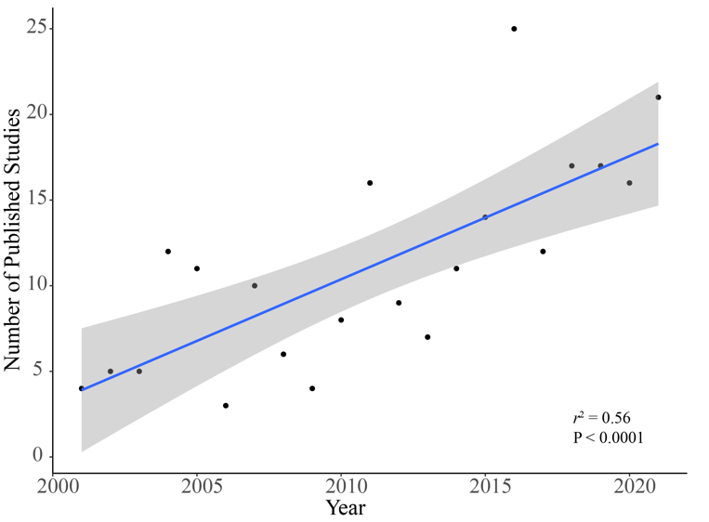

**Figure 1**. Increase in the total number of annually published herpetofaunal studies in South Florida, USA, between 2001 and 2021. Shading represents a 95% confidence interval produced with geom_smooth() within ggplot2 (www.https://ggplot2.tidyverse.org).

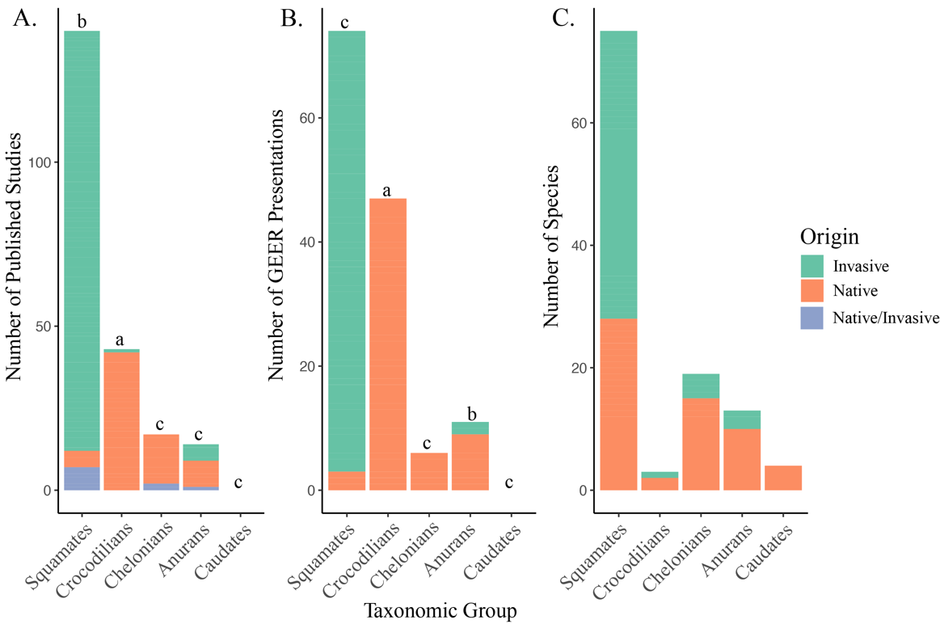

**Figure 2**. The number of published studies (Panel A) and Greater Everglades Ecosystem Restoration (GEER) Conference presentations (Panel B) between 2000–2021 for each taxon relative to the number of species present in South Florida, USA (Panel C). Letters above bars are classifications from Binomial tests, where a = significantly over-represented relative to other taxa given the actual diversity of each group, b = no significant over or under-representation, and c = significant under-representation. Native/Invasive studies were community-wide studies that encompassed both native and invasive species.

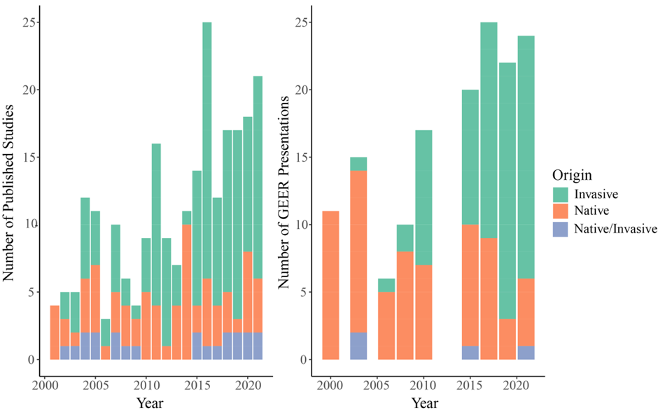

**Figure 3**. The number of published studies (left) and Greater Everglades Ecosystem Restoration (GEER) Conference presentations each year (right) between 2000–2021 on herpetofauna from the Florida Everglades. Native/Invasive studies were community-wide studies that encompassed both native and invasive species.

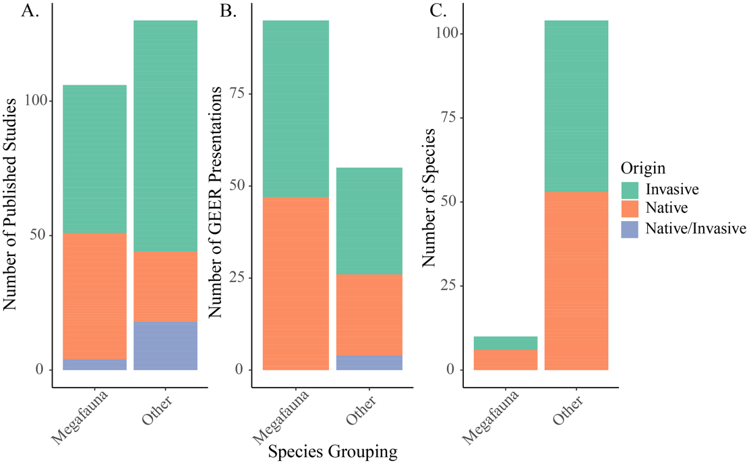

**Figure 4**. The overrepresentation of both published studies (Panel A) and Greater Everglades Ecosystem Restoration (GEER) Conference presentations (Panel B) between 2001–2021 on charismatic reptile and amphibian megafauna from the Florida Everglades compared to the number of species categorized as charismatic megafauna (Panel C). Native/Invasive studies were community-wide studies that encompassed both native and invasive species.

**Hunter J. Howell** is currently a Ph.D. Candidate at the University of Miami, Florida, USA, where his dissertation work focuses on the ecology, conservation, and management of the herpetofauna of the Everglades. His research focuses on applied conservation biology and management of threatened and endangered taxa through the use of population and community ecology. (Photographed by Scott McDaniel).

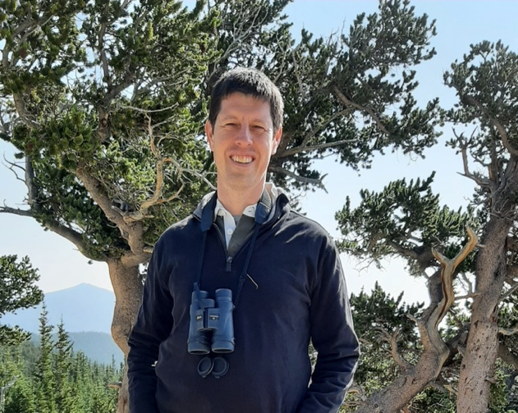

**Christopher J. Searcy** is an Associate Professor in the Biology Department of the University of Miami, Florida, USA. His lab group focuses on conservation ecology, especially of reptiles and amphibians. They are currently gathering data on population, community, and landscape ecology for numerous imperiled species and habitats to inform management decisions. (Photographed by Elizabeth Afkhami Searcy).