Florida Nonnative Reptiles
Distribution, Establishment, Husbandry, and Management
GIS, Power BI, and Field Case Study

Abstract
Florida supports an unusually large number of established nonnative reptiles. A 2026 review identified 61 nonnative reptile species as established in the state (Bonilla-Liberato et al., 2026). Their distributions reflect decades of escaped and released pets, repeated introductions, and successful reproduction due to the suitable semitropical environment. This project examines reported occurrences of five species in Florida from 2010 through 2025: Burmese python (Python bivittatus), green iguana (Iguana iguana), Argentine black and white tegu (Salvator merianae), Peter's rock agama (Agama picticauda), and Nile monitor (Varanus niloticus).
A total of 55,033 EDDMapS records were assembled and cleaned for analysis. Of these, 51,760 contained usable coordinates for mapping in QGIS. Power BI was used to compare species totals, county totals, and temporal patterns. The resulting maps show a strong concentration of records in South Florida, along with additional clusters on the Atlantic coast, in southwest Florida, and around Tampa Bay and Central Florida.
The idea for this project grew from my experience raising an Argentine black and white tegu named Ghost, an animal I acquired shortly before Florida prohibited new personal ownership of tegus. Caring for a large reptile over several years made the connection between exotic animal ownership and invasive species management difficult to ignore. A second case study developed when I began observing a population of Peter's rock agamas at a local Taco Bell establishment in Tampa. Field work at that site ultimately produced two live captures of different life stages: a small juvenile and an adult female.
The statewide data and the two case studies examine the same issue at different scales. The maps document where nonnative reptiles have been reported and where concentrations have developed, while the case studies examine how those populations can begin, what management looks like in the field, and what responsibility follows when an individual animal is adopted into human care.

Introduction
My interest in Florida's invasive reptiles began with a pet. I acquired Ghost, an Argentine black and white tegu, as a juvenile shortly before Florida restricted personal ownership of the species. My last lizard, an Ackie monitor, had recently passed away, and I was aware of the upcoming ban, so I felt very lucky to come across one for sale. He is now approximately four years old and remains legally maintained under FWC's grandfathered permitting system.
As he grew, I became increasingly interested in why tegus had become such a serious management concern in Florida. Ghost was an individual animal I knew well, but wild animals of the same species were being trapped and removed because established populations threatened native wildlife. The practical side of keeping him also made the problem easier to understand. An adult tegu bears little resemblance to the relatively manageable juvenile somebody might originally purchase. Ghost eventually required a custom eight-foot wooden enclosure, substantial heating and UVB equipment, an extremely varied omnivorous diet including whole prey and produce, and veterinary treatment that has included multiple surgeries. It was easy to imagine how an owner who was poorly prepared for that commitment could eventually want to get rid of the animal.
Florida wildlife managers believe the state's established tegu populations originated from escaped or intentionally released captive animals. Reproducing populations are now established in Hillsborough, Miami-Dade, and Charlotte counties, with an emerging population documented in St. Lucie County. FWC considers the Argentine black and white tegu invasive because of its effects on native wildlife, such as the consumption of alligator eggs (Florida Fish and Wildlife Conservation Commission [FWC], 2026a).
For this project, I decided to tackle some broader questions about the subject. Where are Florida's nonnative reptile populations concentrated? How do the distributions of different species compare? Which counties receive the most reports? Are reported ranges changing over time? Can occurrence databases help distinguish an isolated animal from an area where a population has become established? I chose five species for the project: Burmese python, green iguana, Argentine black and white tegu, Peter's rock agama, and Nile monitor.
The project later gained a field component when I happened upon an area that had numerous reported sightings. I found a population of Peter's rock agamas at a commercial property in Tampa. Instead of just seeing the species as coordinates in an occurrence database, I could watch several animals occupying the same small area, using drainage infrastructure, pavement, trees, and other pieces of an ordinary urban landscape. I eventually attempted live capture at the site and successfully removed two animals during separate trapping efforts: a very small juvenile and, later, an adult female. That experience changed how I thought about the data. A point on a map is useful because it records a species at a location. At the site itself, that point may belong to a population containing multiple animals, different age classes, preferred refuges, basking and feeding areas, and patterns of activity that the coordinate alone cannot describe.

Data and Methods
Occurrence records were obtained from EDDMapS, the Early Detection and Distribution Mapping System, which collects and maps reports of invasive and nonnative species from agencies, researchers, organizations, and members of the public. EDDMapS records available for mapping and download are reviewed by verifiers or entered as expert data (EDDMapS, 2026). The query covered Florida from January 1, 2010 through December 31, 2025. Original records with Positive or Treated infestation status were retained.
The combined dataset contained 55,033 records:
Species | Records | Share of dataset
Burmese python | 19,240 | 35.0%
Green iguana | 12,870 | 23.4%
Argentine black and white tegu | 11,955 | 21.7%
Peter's rock agama | 9,678 | 17.6%
Nile monitor | 1,290 | 2.3%
Total | 55,033 | 100%
The master dataset preserved records even when coordinates were unavailable so that they could still contribute to non-spatial summaries, as they often contained useful information, such as the county in which the occurrence was reported. A separate QGIS-ready dataset contained the 51,760 records with usable latitude and longitude, or about 94.1 percent of the original records. Coordinate coverage varied by species. Burmese python, green iguana, tegu, and Nile monitor records all had coordinate coverage above 95 percent. Peter's rock agama was an exception. Only 7,587 of its 9,678 records contained usable coordinates, a coverage rate of approximately 78.4 percent. Agama records therefore make up a smaller share of the mapped dataset than of the full database.
The cleaned point data were loaded into QGIS and compared with Florida county boundaries. County totals were calculated spatially so that mapped coordinates, rather than only the county names supplied in source records, determined county membership.
Data quality checks also produced several useful examples of the problems that can appear in large occurrence datasets. One tegu record contained a positive longitude that placed the animal far outside Florida. Changing the sign from +80.50196 to -80.50196 placed the point in Miami-Dade County and matched the accompanying location information. The correction was documented and integrated into my dataset. Eleven otherwise usable points fell outside Florida county polygons and remained visible as offshore anomalies. Seven belonged to green iguanas, two to Burmese pythons, one to Peter's rock agama, and one to a Nile monitor. Some were only slightly offshore, while two python records appeared much farther from land. These records were retained as examples of spatial uncertainty.
QGIS was used to create a statewide species map and a county-level choropleth based on the number of mapped records falling inside each county. The same cleaned data were imported into Power BI to provide interactive species, county, and year filters and to compare report totals across the dataset.

Results

Species composition
Burmese pythons were the most frequently represented species in the complete dataset, with 19,240 records, or 35 percent of all observations. Green iguanas were second with 12,870 records, followed by Argentine black and white tegus with 11,955. Peter's rock agamas accounted for 9,678 records, while Nile monitors were much less common in the dataset at 1,290.
The total for Peter's rock agama deserves some context. Recent Florida research describes the agama as the most frequently reported nonnative reptile to FWC since 2021. My dataset covers a longer period beginning in 2010 and includes records originating from multiple reporting channels and bulk datasets. The difference is a reminder that rankings depend on the database, time period, and reporting system being analyzed (Claunch et al., 2026).
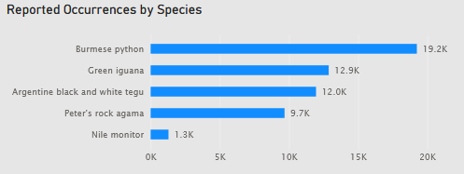
Figure 1. Power BI species-count visualization showing total records for the five selected reptile species.

Geographic concentration
The county analysis showed a pronounced geographic concentration. Of the 51,760 records with usable coordinates, 51,749 fell inside Florida county boundaries. Miami-Dade contained 22,247 of those points, approximately 43 percent of all county-assigned mapped observations. The highest county totals were:
County | Mapped records
Miami-Dade | 22,247
Collier | 6,698
Broward | 4,898
Palm Beach | 4,520
Monroe | 2,574
St. Lucie | 2,455
Lee | 1,728
Martin | 1,201
Charlotte | 1,127
Brevard | 650
Hillsborough | 528
These eleven counties accounted for an astonishing 94 percent of all county-assigned mapped records. The overall map is therefore heavily weighted toward southern Florida. Miami-Dade is dominant, but the distribution is not limited to a single region. The species map also shows concentrations along the Atlantic coast, in southwest Florida, and around parts of Central Florida and Tampa Bay.
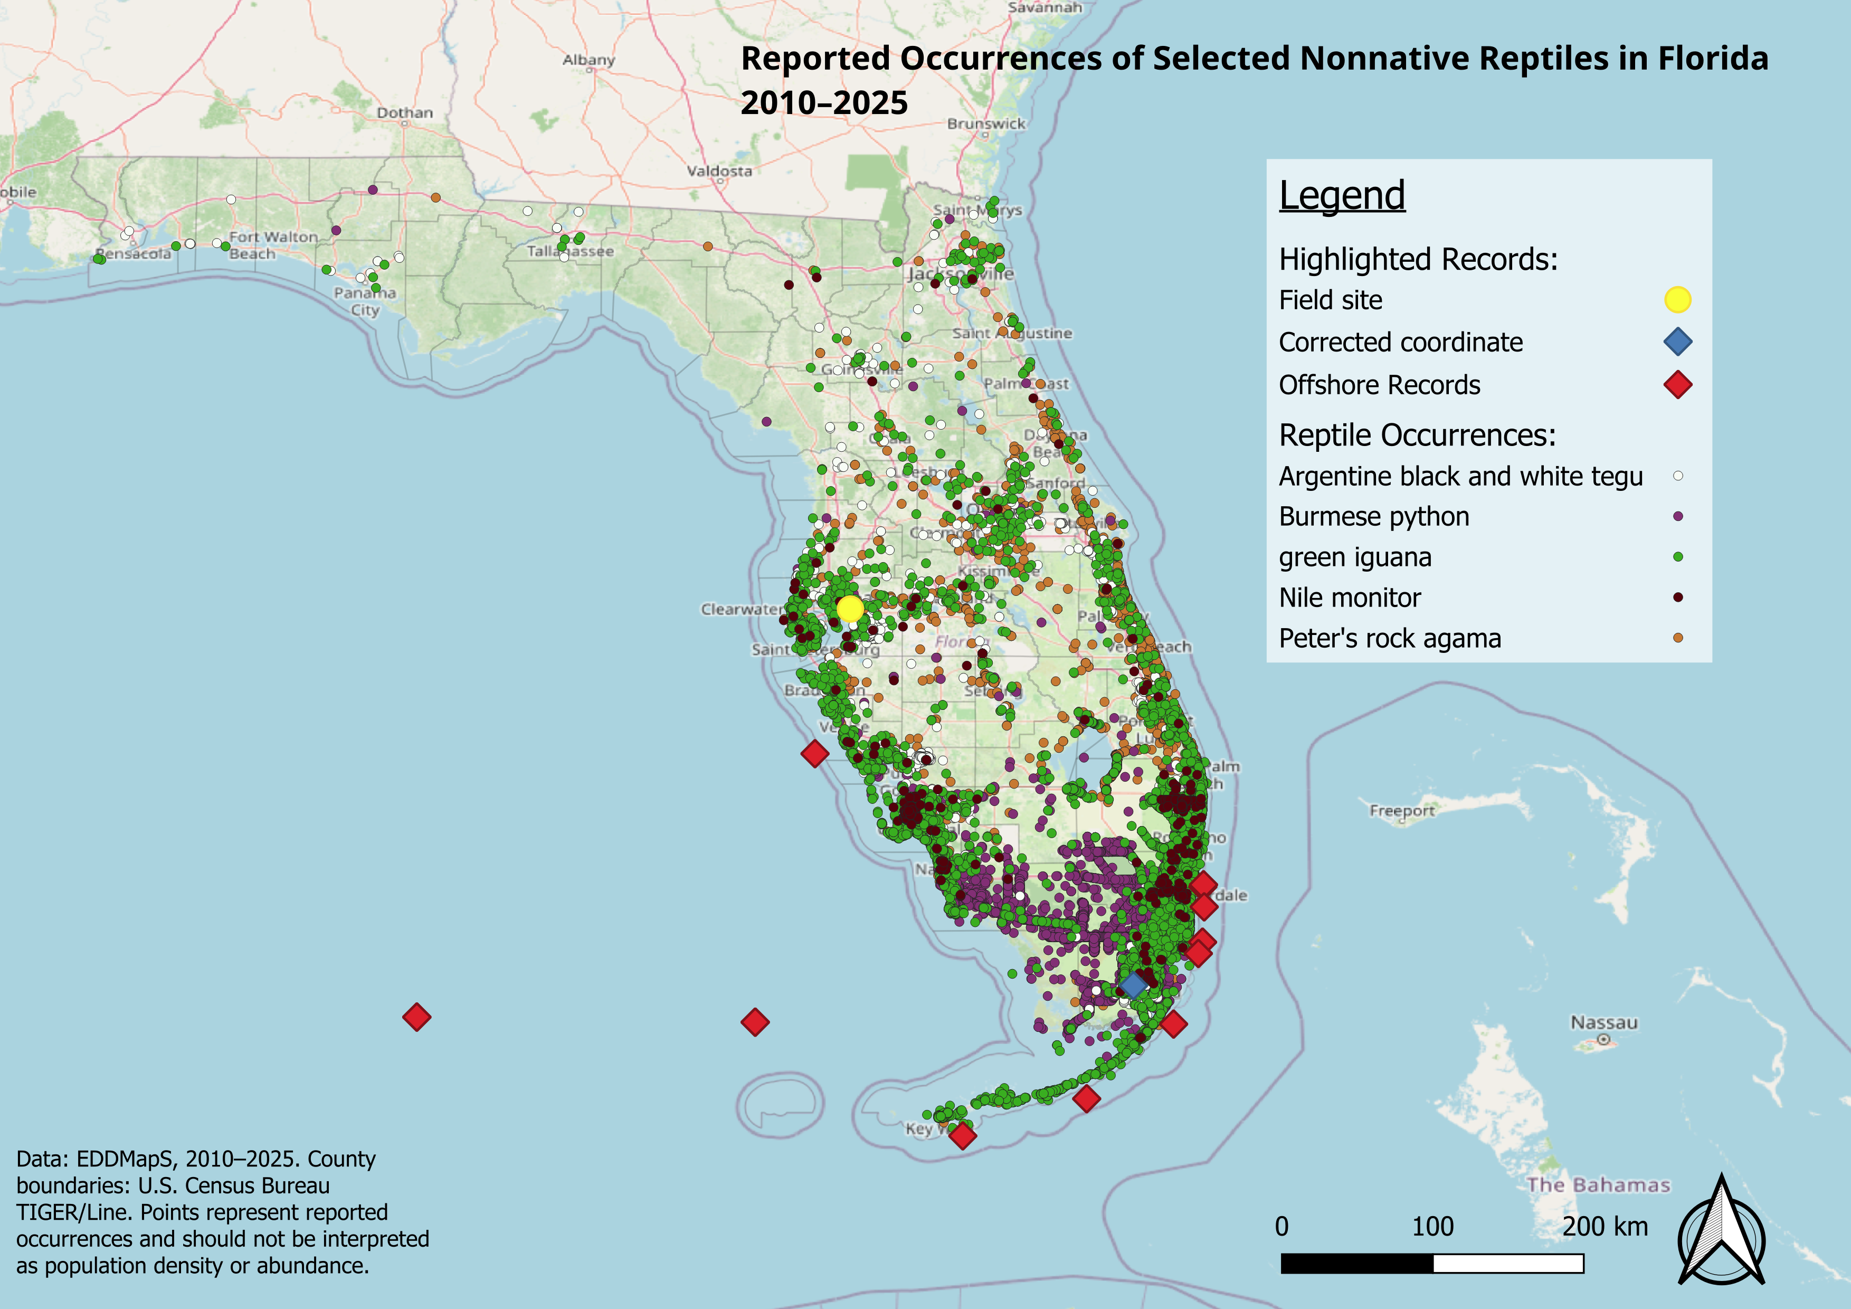
Figure 2. QGIS statewide occurrence map showing individual records symbolized by species.
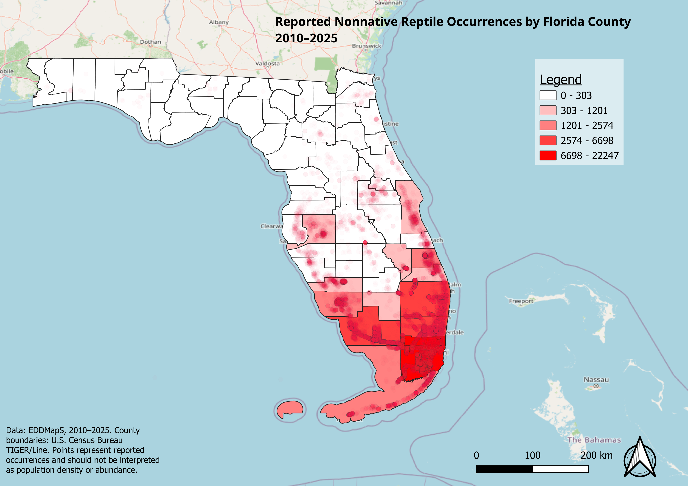
Figure 3. QGIS county choropleth showing total mapped records by Florida county.
The regional pattern changes when individual species are filtered. Burmese python records are heavily associated with South Florida and the Everglades region. Green iguana records are also strongly concentrated in southern Florida, particularly developed and coastal areas. Nile monitor records form a much smaller dataset and are associated with several known southwest and South Florida populations.
Tegus are useful for showing how several separate population centers can appear within the same state. FWC recognizes established reproducing populations in Hillsborough, Miami-Dade, and Charlotte counties and an emerging population in St. Lucie County (FWC, 2026a). I found these separated clusters particularly interesting when considering observed species trends. Peter's rock agama has a broader patchwork distribution. FWC states that it has become established in multiple counties across much of southern and central Florida, while UF/IFAS describes numerous populations occupying developed environments (FWC, 2026b; Gioeli & Johnson, 2025). These species-specific differences matter more than the statewide county ranking by itself. Miami-Dade's enormous total tells us that South Florida dominates the combined dataset, but filtering by species reveals different invasion histories within that broader pattern.

Reports through time
The dataset includes observation dates from 2010 through 2025, allowing the Power BI report to be filtered by year and species. Annual record counts are useful for examining changes in reporting, but they should not be treated as direct population estimates. EDDMapS combines observations from several source types, including public reports and bulk records from government agencies. Reporting intensity can change even when biological abundance does not.
A rise in records may result from population expansion, increased public awareness, additional agency monitoring, changes in reporting technology, or several of these at once. Peter's rock agama especially emphasizes this problem. The species has been FWC's most frequently reported nonnative reptile since 2021, while FWC now states that additional reports from counties where agamas are already established are not needed. Research conducted in fall 2024 and spring 2025 also tested targeted removal methods in established populations (Claunch et al., 2026; FWC, 2026b). The reporting and management environment therefore changed during the period covered by the dataset.
Spatial change is therefore especially important when interpreting the year filter. When later observations begin appearing repeatedly outside an older geographic concentration, they provide stronger evidence of possible range expansion than a simple increase in the number of reports from an existing population center. The interactive dashboard allows those patterns to be explored rather than reducing the entire sixteen-year dataset to a single statewide growth rate.
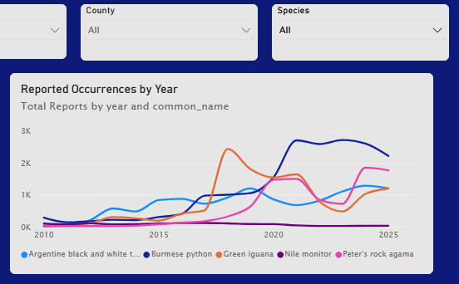
Figure 4. Power BI annual-report trend with filters for specific data types.

Data quality and reporting bias
The mapping process also exposed weaknesses in occurrence data that are easy to overlook when working only from a spreadsheet. Approximately 5.9 percent of the master records could not be mapped because coordinates were missing. The problem was particularly important for Peter's rock agama, which accounted for 2,091 of the 3,273 records without usable coordinates.
Spatial errors were present even among records that did contain coordinates. The corrected tegu longitude and eleven offshore points were obvious examples because the coordinates could be checked against county boundaries and Florida's coastline, but less obvious errors may remain.
Reporting effort is another source of bias. Counties with large human populations also contain more potential observers. Smartphones and reporting applications have made georeferenced observations increasingly easy to submit. EDDMapS itself allows users to report directly from mobile devices using GPS (EDDMapS, 2026). The resulting maps are maps of reported occurrence. They provide useful evidence] about distribution without functioning as a census.

Case Study 1: Ghost and the Origin of the Project
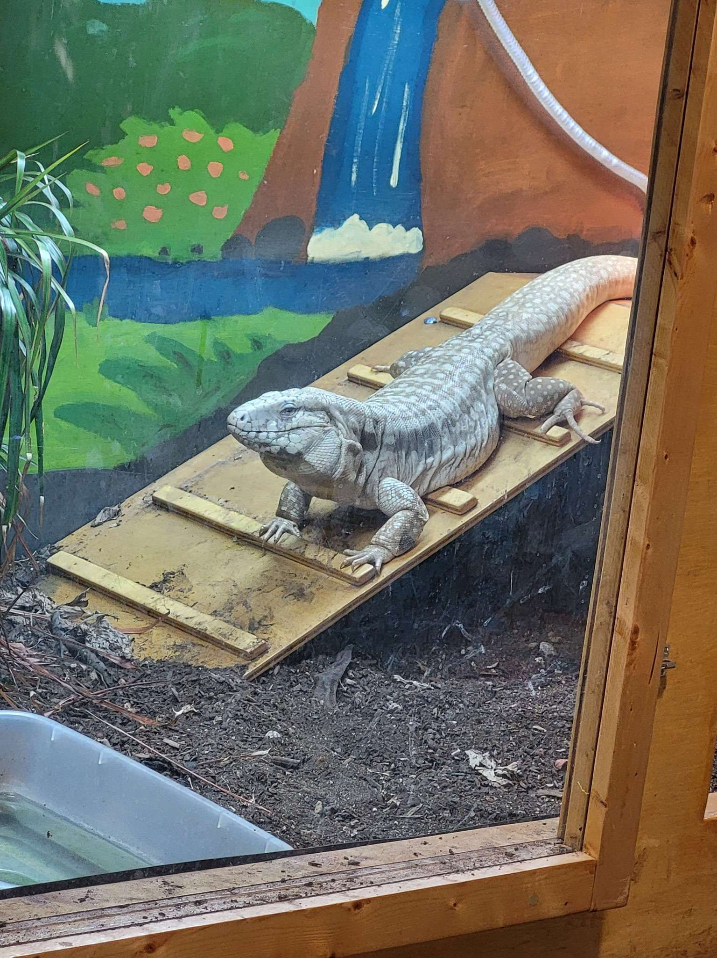  Figure 5. Ghost, an Argentine black and white tegu maintained under Florida's grandfathered permitting system. | Ghost was my introduction to the subject before I ever began downloading occurrence data. I acquired him as a juvenile shortly before tegus were added to Florida's Prohibited Species list in April 2021. He was already around 6 months old, having lost his green coloration found in juveniles. FWC allowed qualifying animals already legally possessed at the time of the rule change to remain with their owners under grandfathered personal-use permits (FWC, 2026a). I have now raised Ghost for approximately four years and he is well into his adult life.  He is an albino Argentine black and white tegu and lives in a custom-built wooden enclosure approximately eight feet long and four feet wide. His care includes controlled heat and UVB, humidity, secure housing, and an omnivorous diet that has included frozen-thawed rodents, insects, organ meats, cooked eggs, and vegetables.
His care was already demanding at first and changed enormously as he grew. That experience helped me perceive one of the pathways behind Florida's nonnative reptile populations. A juvenile exotic reptile can be relatively inexpensive and physically manageable. The same animal several years later may require a room-sized enclosure, large quantities of food, specialized equipment, and access to a veterinarian comfortable treating large reptiles, which can be very hard to come by.
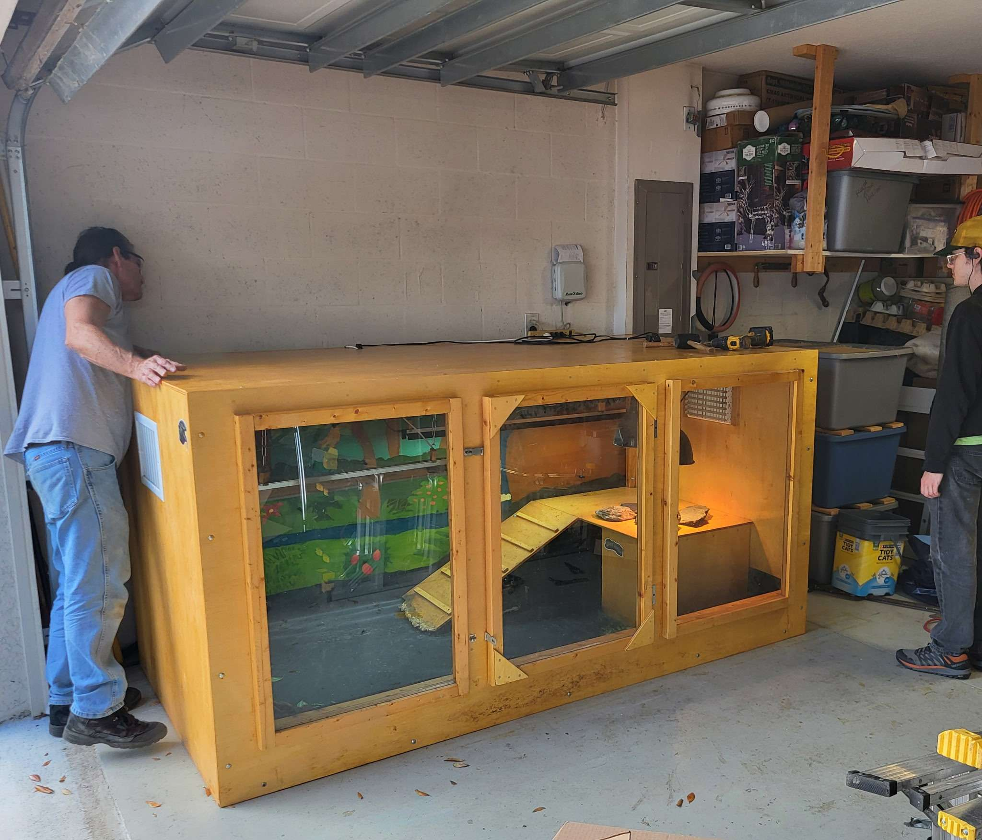
Figure 6. Ghost's custom eight-foot enclosure, showing the scale of long-term adult tegu husbandry.
Argentine black and white tegus can approach five feet in length and may live for as long as twenty years. Females can lay an average of about 35 eggs annually. Florida's reproducing populations are believed to have originated through escapes or deliberate releases of captive animals (FWC, 2026a).
Ghost has also required significant veterinary care. He developed pigment-cell tumors and has undergone multiple surgeries to remove them. Reptile chromatophoromas are documented in veterinary literature, but their causes are often uncertain. His albinism and history of artificial UVB exposure were my first guesses as to why he has had such significant issues with tumors, but with so many varying factors, I do not attribute the tumors to either factor (Monahan et al., 2022). | 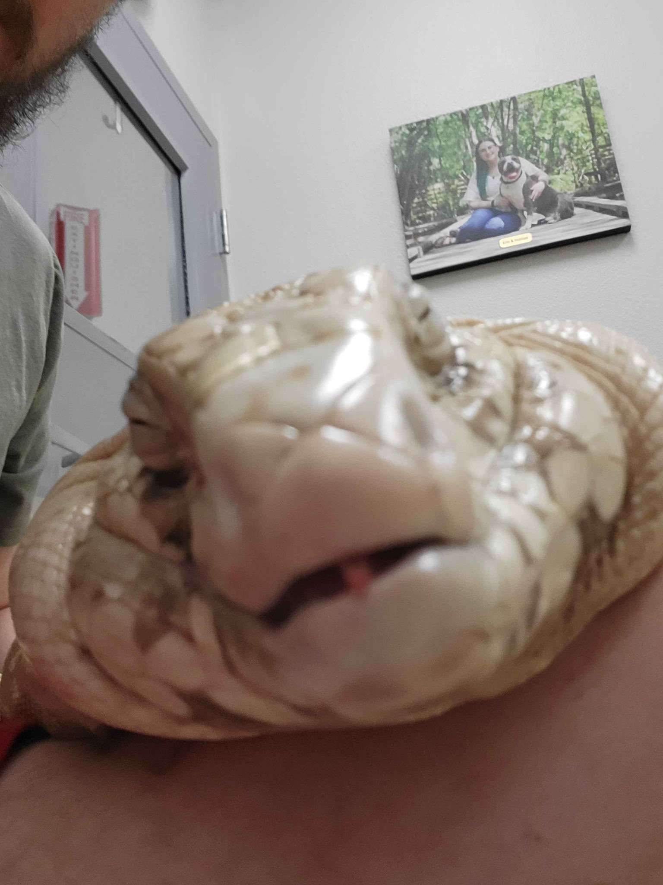  Figure 7. Ghost shortly after sedation during a veterinary visit, illustrating the medical care involved in his long-term husbandry.
The burden of keeping Ghost has never made me consider releasing him, as releasing that animal transfers the owner's problem to the surrounding ecosystem. Florida's Exotic Pet Amnesty Program now exists as an alternative. The program accepts nonnative pets year-round, including Conditional and Prohibited species, and connects owners with qualified adopters (FWC, 2026c).
Ghost also changed the way I react to wild tegu control. An acquaintance at my local parish community once mentioned that a tegu had appeared on his property and that it was shot and killed. Florida allows landowners to humanely kill wild tegus on private property, and FWC actively encourages their removal because of the risk established populations pose to native wildlife. Thousands have been removed by FWC and partner programs using methods such as these, as well as more humane ones (FWC, 2026a). I understood why he had done it and still found the story discouraging.
After living with a tegu for years, it is difficult for me to see one as interchangeable with a dot in an invasive species dataset. Tegus are behaviorally complex reptiles that can even show a surprising amount of affection in my experience. One example of advanced tegu behavior comes from studies showing that Argentine black and white tegus can follow conspecific chemical trails and use those cues when making navigation decisions (Parker et al., 2023; Richard et al., 2020). The wild animal on that property did not understand that it belonged to a prohibited species. It was behaving normally in an environment where humans had introduced its species. That does not produce an easy alternative.
Capturing every wild tegu and maintaining it permanently would be impractical. My experience with one adult makes the scale of such a proposal obvious. Thousands of large reptiles would require secure enclosures, food, staff, veterinary care, land, and long-term funding. Moving them to another uncontrolled location would simply move the ecological risk. Population control therefore has to remain practical even when the individual animals are worth caring about. That tension became one of the central ideas of this project. Prevention is preferable partly because establishment eventually creates situations where otherwise healthy animals must be removed or euthanized to protect an ecosystem. That's easy to say in retrospect, but it emphasizes why it's important for the state to be proactive about preventing future invasive populations from becoming established.

Case Study 2: Peter's Rock Agama Field Study
The Peter's rock agama case began much closer to the type of data represented in the GIS project. I had repeatedly seen agamas around a Taco Bell I frequent in Tampa. After several visits, it became clear that the site supported more than an occasional individual. I sometimes observed at least five animals active at once, including different size classes and sexes. Sex is often easy to identify in this species because males can develop bright red coloration. The property was heavily developed. Agamas used pavement, trees, curbs, and especially a drainage area between two restaurants containing numerous hiding places and tunnels. This habitat matched published descriptions of Florida Peter's rock agama populations. UF/IFAS notes that the species frequently occupies urban and suburban environments and uses buildings, sidewalks, curbs, fences, trees, and similar structures (Gioeli & Johnson, 2025).
Seeing the animals in person made detection feel much less absolute than it appears in a GIS layer. Some visits produced several visible animals. Rain could cause them to disappear. Their speed made close approaches difficult. Activity changed with weather and time of day. A population can therefore be present even when an observer fails to detect it during a particular visit.

Capture attempts
I received permission from the employees to place traps on the property. My primary method used collapsible fabric funnel traps baited with live insects. Earlier attempts used crickets, with one trap positioned near an area where agamas had been observed around a tree and another near the drainage structure where activity was particularly common. A later supervised attempt used superworms as bait. The approach closely resembled one evaluated in a 2026 Florida study by Claunch and colleagues. Their experiment compared fabric minnow traps, lizard-fishing, and air-rifle removal. The traps were baited with crickets and deployed for one-hour periods. Six agamas were captured by traps during the study, although trapping was less efficient than air-rifle removal. The researchers also observed agamas approaching or sitting on traps without successfully finding the funnel openings (Claunch et al., 2026).
My own attempts quickly produced several practical lessons. Rain interrupted one session and caused visible agama activity to decline. The published removal study likewise avoided rain because the animals retreated and became unavailable for removal during rain events (Claunch et al., 2026). I also left traps at the site overnight once. One was stolen. The other remained in the drainage area but was empty the next morning and contained numerous partially eaten cricket remains. The result was impossible to interpret confidently. An agama may have entered, fed, and eventually found its way out. Another animal may have eaten the crickets. The long unattended period removed the ability to distinguish among those possibilities.
The later trapping effort supported that change in approach. On September 10, 2026, I deployed a baited funnel trap during the early evening, roughly between 6 and 7 PM. The site is usually fairly active in the evenings when there has not been a recent rainstorm. Using superworms as bait, the trap captured an adult female after approximately 30 minutes. Together, the trapping efforts produced two successful live captures from the same urban population: a small juvenile approximately the size of a small anole and an adult female. The difference in body size and life stage also created two very different captive-husbandry problems.
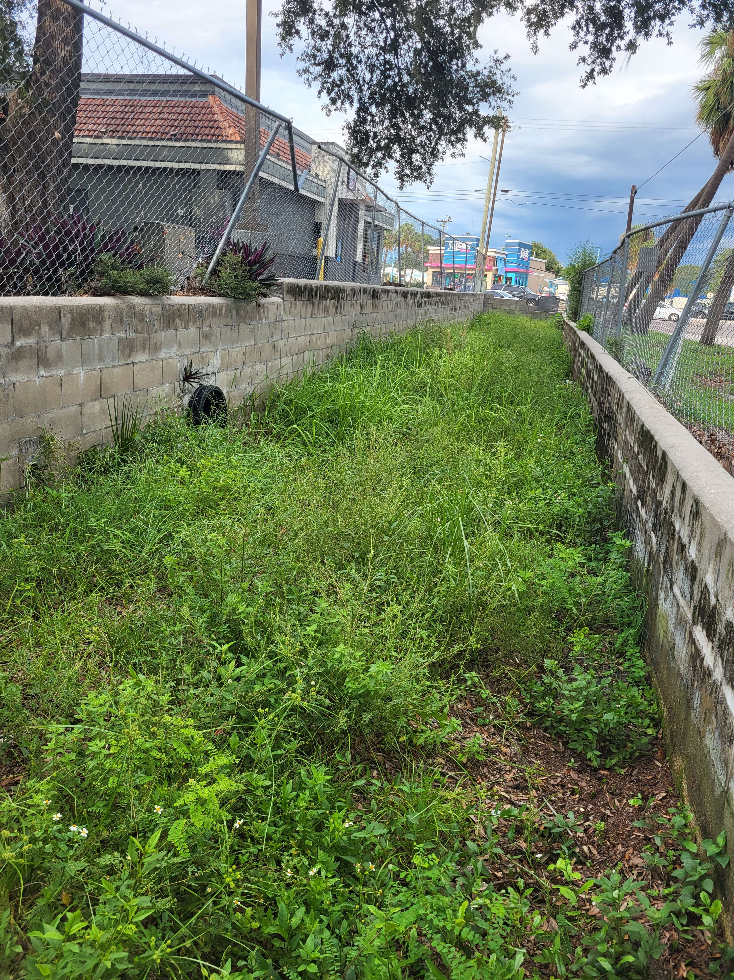
Figure 8. Urban Peter's rock agama observation site in Tampa, including the drainage and basking habitat.
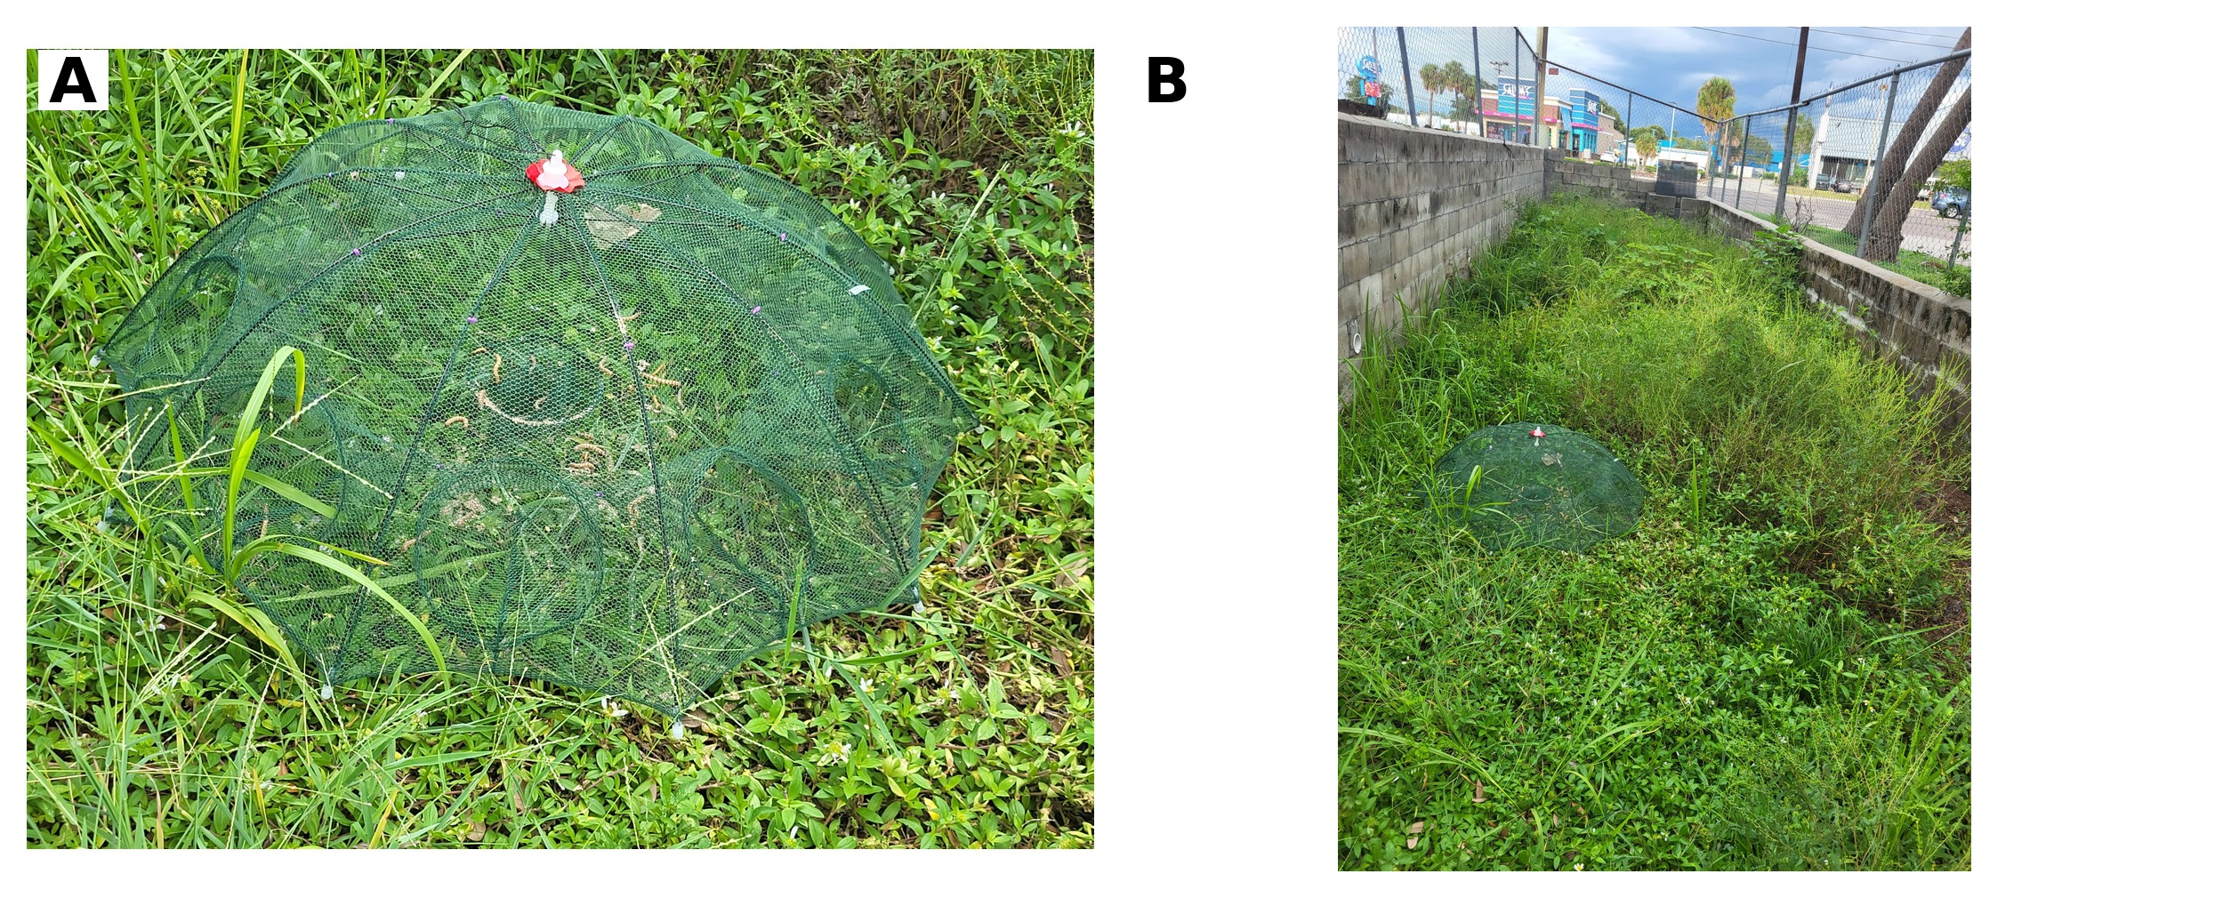
Figure 9. Capture setup at the Tampa field site: (A) collapsible funnel trap used for live capture; (B) the trap deployed within the drainage habitat used by Peter's rock agamas. Earlier attempts used crickets, while the later adult-female capture used superworms.
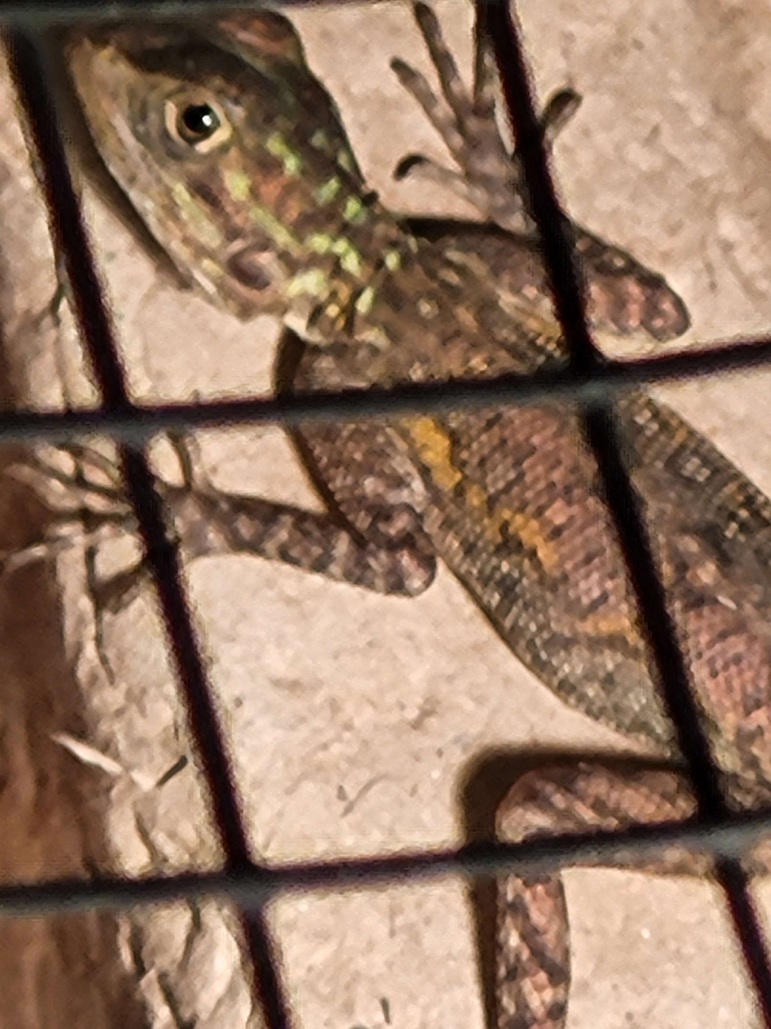
Figure 10. Captured juvenile Peter's rock agama shortly after removal from the field site.
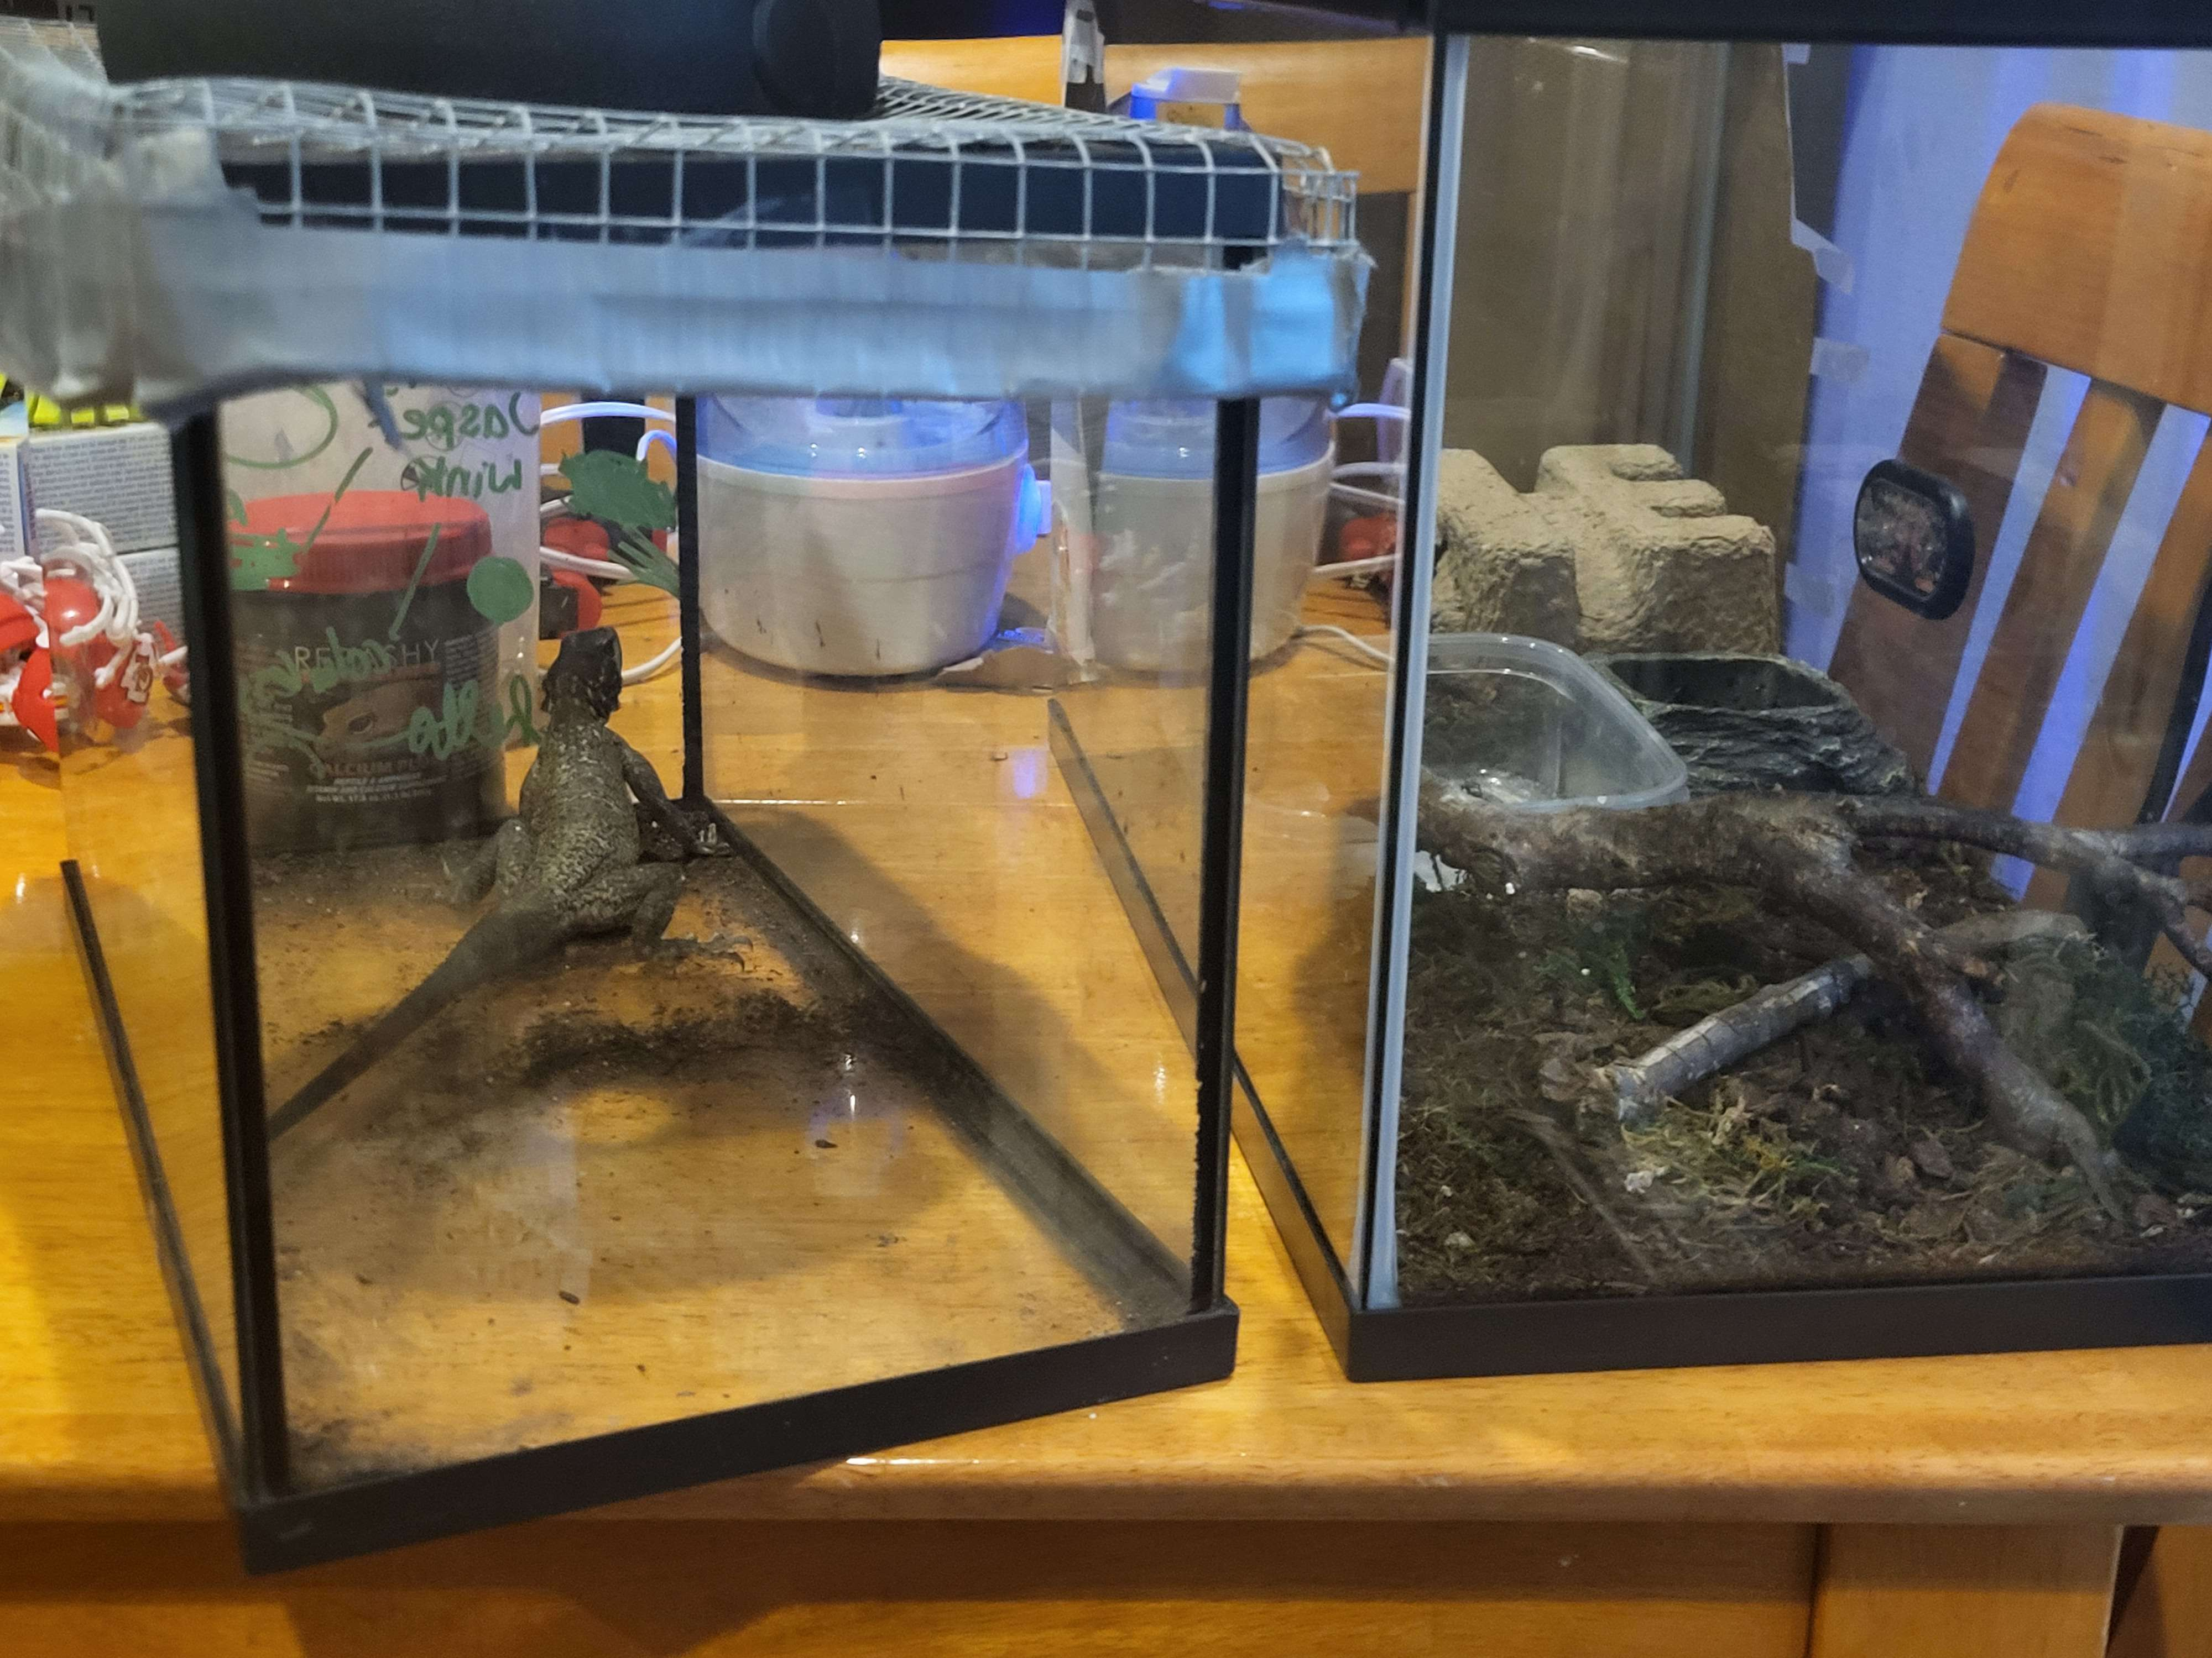
Figure 11. Adult female Peter's rock agama immediately after capture, temporarily held beside the juvenile enclosure before transfer to a larger 4 x 2 ft setup.

Early captive acclimation
The juvenile entered a temporary 10-gallon quarantine enclosure because an adult-sized enclosure would have made close observation of such a small animal unnecessarily difficult. Early husbandry involved establishing a suitable thermal gradient, secure housing, reliable feeding, and sourcing appropriate UVB lighting. An existing 100-watt intense basking bulb proved too powerful for prolonged use over the small aquarium. The basking surface could reach approximately 100 degrees Fahrenheit in around ten minutes. That required careful monitoring until lower-output equipment could be used. The enclosure initially received daylight through a nearby window, but visible sunlight through glass could not substitute for a proper UVB source. A dedicated UVB fixture was not immediately available during the first weeks of acclimation, so calcium with vitamin D3 was used as a temporary bridge while appropriate UVB lighting was being sourced.
Feeding required its own adjustment. I already maintained colonies of discoid roaches and expected small nymphs to make an easy feeder. The juvenile repeatedly ignored them, even when they were placed in a smooth-sided feeding dish where they could not immediately bury themselves. Waxworms were accepted first. Mealworms followed later, allowing calcium supplementation to be introduced on prey the animal already recognized. After several weeks, the juvenile also began accepting baby discoid roaches, although mealworms remained strongly preferred.
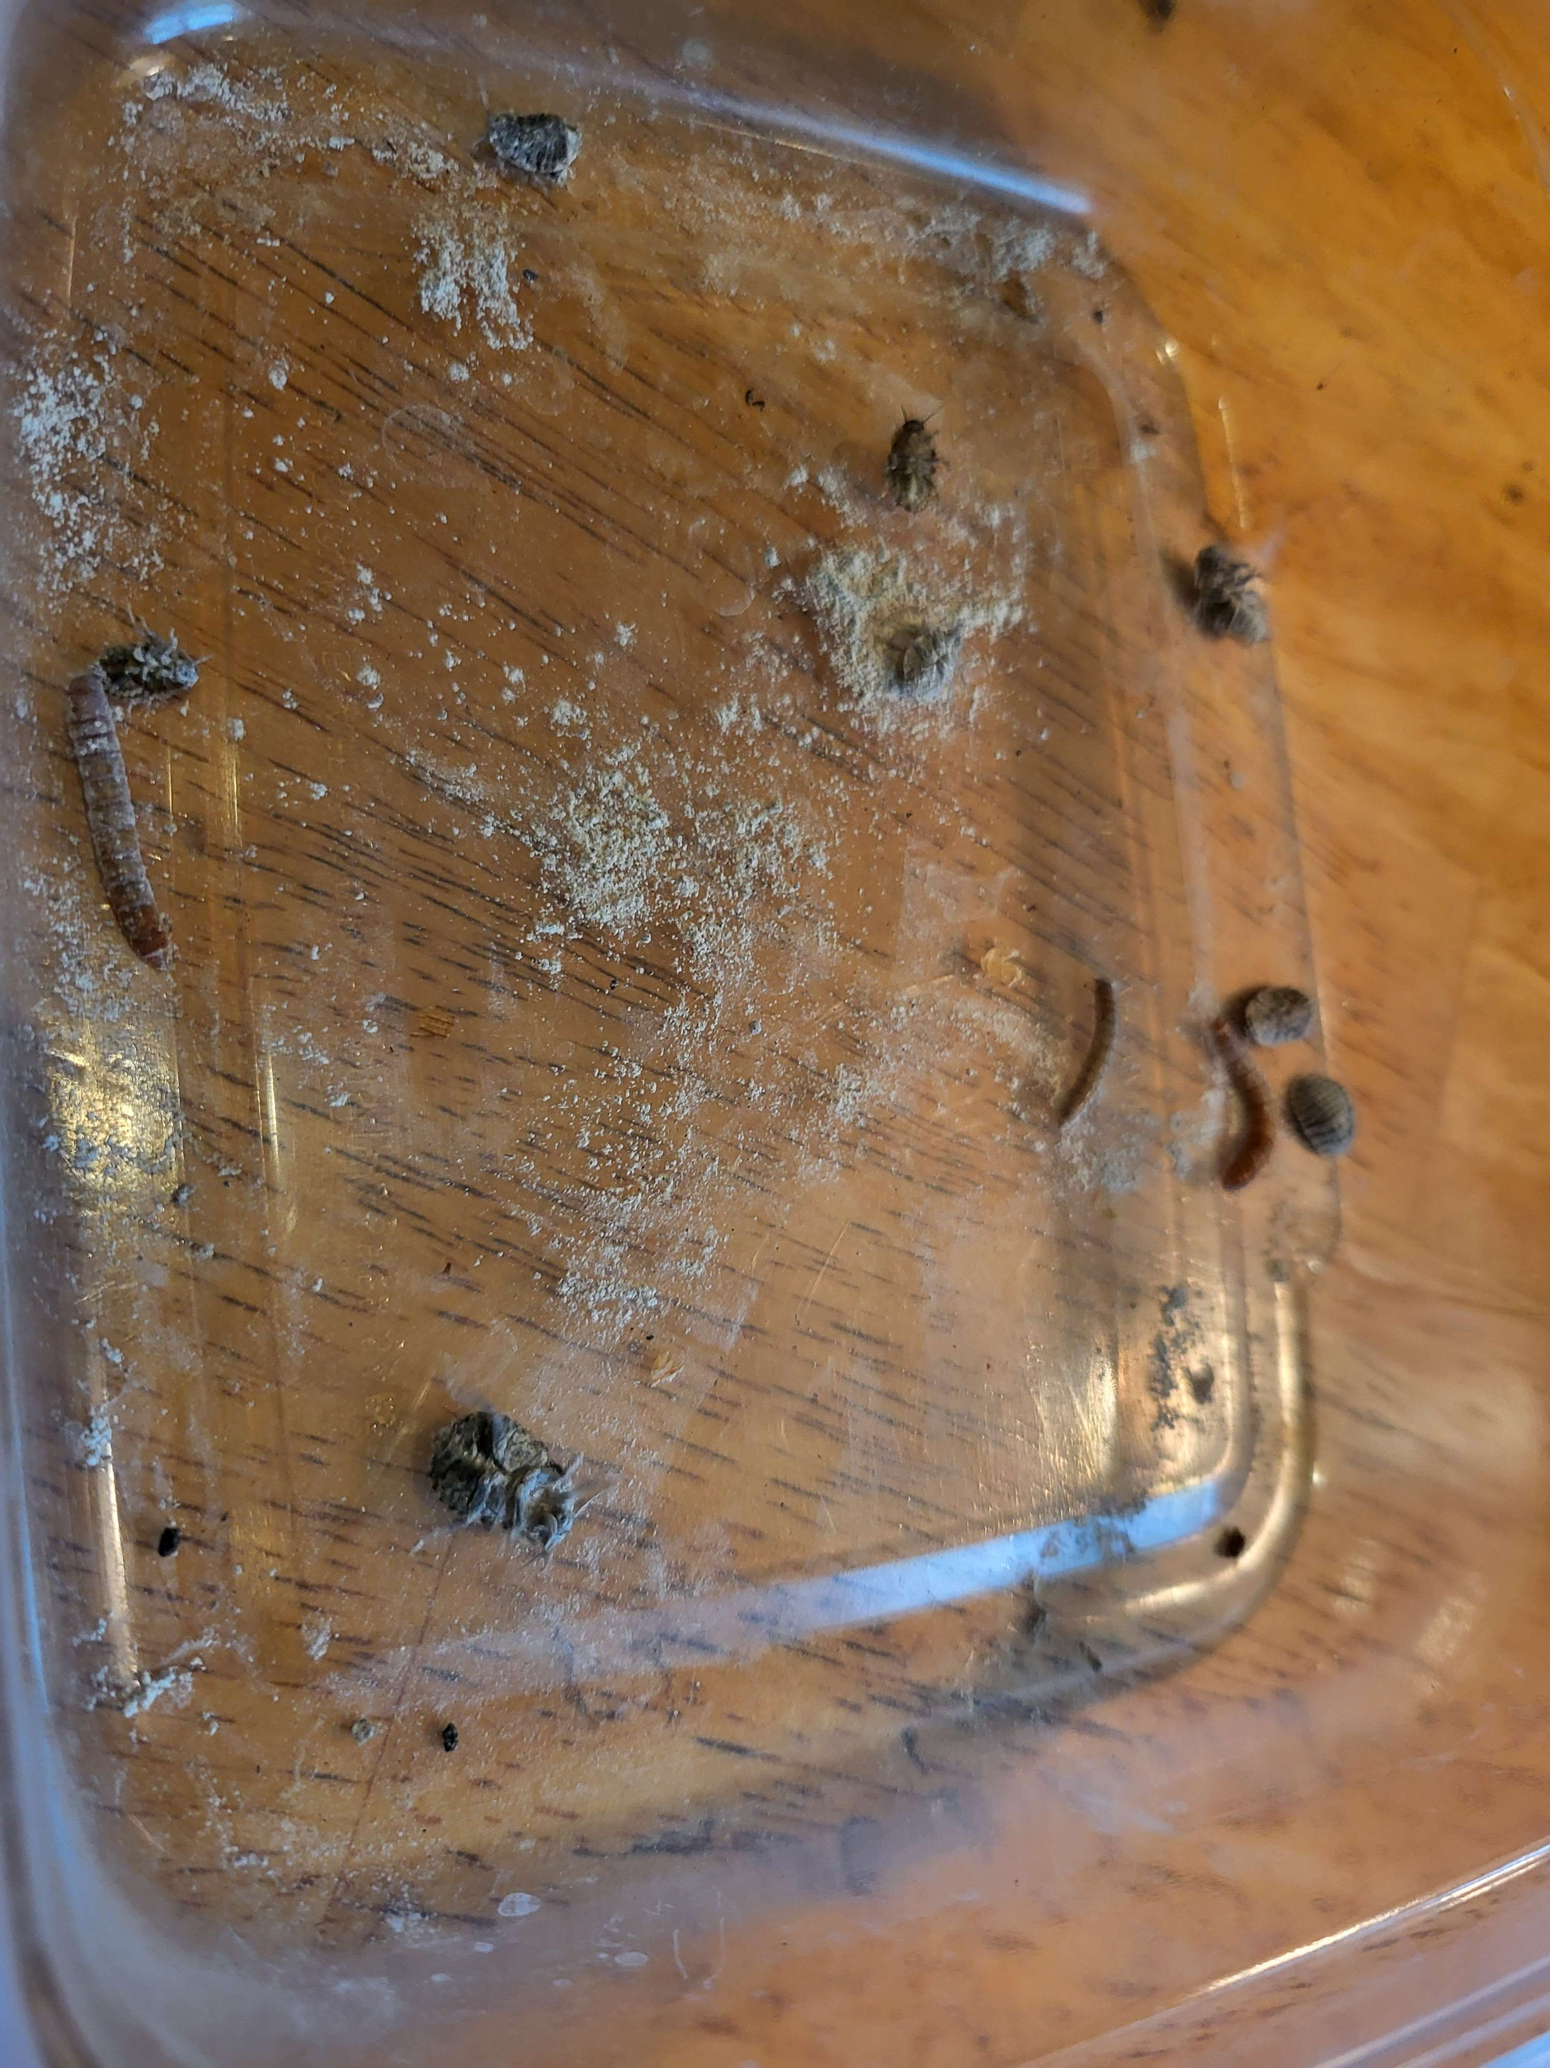
Figure 12. Juvenile feeding tray during the later acclimation period, containing calcium-dusted mealworms and baby discoid roaches.
The details are ordinary husbandry problems, but experiencing them after a field capture gave me another perspective on live removal. Before capture, the juvenile was one small member of a nonnative population. After capture, keeping it alive meant meeting the requirements of that individual animal. Food that was theoretically appropriate did little good if it refused to eat it. A heat lamp marketed for reptiles still had to be adjusted to the size of the enclosure. Human contact had to be introduced gradually because the animal remained highly wary. The transition from wild animal to captive animal was therefore an acclimation process rather than simply a change of location.
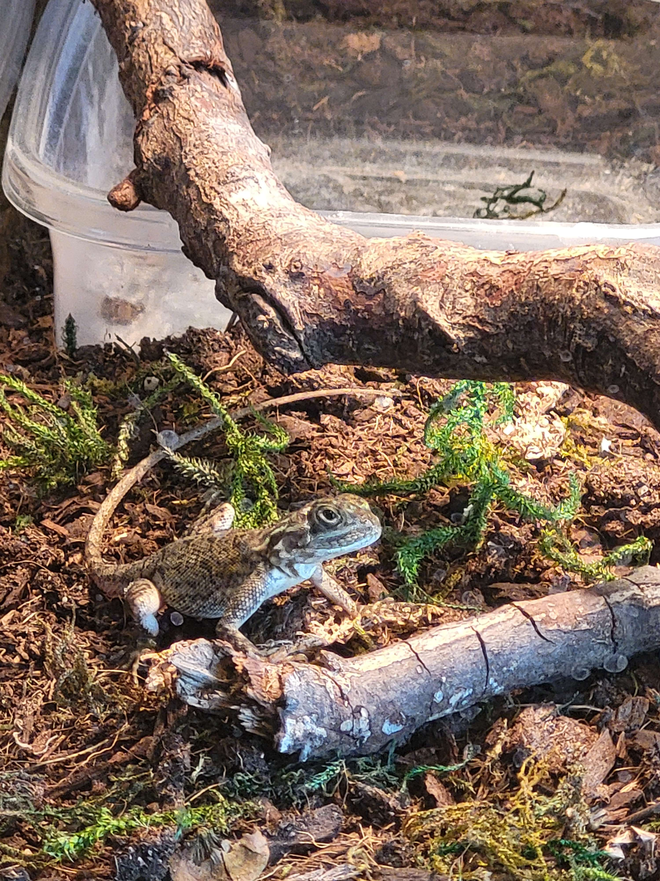
Figure 13. Juvenile Peter's rock agama several weeks after capture, photographed in its temporary enclosure after beginning to acclimate to captivity.

Adult female husbandry
The adult female requires a different setup from the juvenile. Although both animals need the same basic thermal, UVB, nutritional, and security requirements, the adult needs substantially more usable space and can no longer be monitored effectively in a small aquarium. A 4-by-2-foot enclosure is appropriate for the adult female and exceeds commonly published minimum dimensions for a single Peter's rock agama. The larger footprint also makes it easier to create a broad basking area near 95 degrees Fahrenheit while maintaining a cooler retreat on the opposite side. A linear high-output UVB source should overlap the basking zone rather than relying on sunlight through glass.
The adult will remain completely separate from the juvenile. Captive cohabitation is generally discouraged, and FWC notes that large agamas may consume smaller animals, including their own offspring. This cohabitation difficulty again emphasizes the difficulty of multiple live captures. The female can take larger insects than the juvenile, including appropriately sized discoids, crickets, superworms, and other feeder species. Adults generally consume less relative to body size than growing juveniles, so feeding response and body condition are more useful than simply matching the juvenile's intake.
Reproductive condition is another consideration that did not apply to the juvenile. Florida Peter's rock agamas usually lay eggs during spring and summer, and pregnant females can develop orange patches on the body. Because reproductive activity can extend beyond the main season, the adult enclosure should include a deep, slightly moist area of diggable substrate or a suitable laying area rather than only shallow decorative substrate. Persistent digging, restlessness, abdominal enlargement, or a sudden change in appetite would make reproductive condition worth watching closely.
As with the juvenile, the first priority after capture is acclimation rather than handling. A wild adult has had much longer to reinforce avoidance of people and may take longer to tolerate routine maintenance or tong feeding. Keeping the enclosure visually secure, providing multiple hides, and limiting unnecessary handling should make the transition less stressful. Another consideration is parasitic infection, as with any wild-caught animal brought into captivity. Once the two individuals are more established, I plan to have fecal testing done.

From Introduction to Establishment
Ghost and the agama represent opposite directions through the same human-created system. Ghost entered Florida through the exotic pet trade and has remained in captivity, while Florida's wild tegus descended from animals that did not. The juvenile and adult female agamas were most likely born into a Florida population descended from animals introduced through the pet trade decades earlier and were then removed from that population into captivity. FWC traces the state's Peter's rock agama populations to escaped or released pets beginning in the 1970s (FWC, 2026b). The GIS data capture the geographic consequences after those introductions occur.
An escaped reptile may die without reproducing. Another may survive but remain isolated. If multiple animals encounter one another in suitable habitat and reproduce successfully, their descendants can create a local cluster of observations. Continued reproduction and dispersal can gradually turn that local cluster into a regional distribution.
The maps suggest different stages and histories among the five species. Some have dense South Florida concentrations. Tegus have several geographically separated population centers. Peter's rock agamas appear across a broad part of the peninsula. Nile monitors remain much less frequently reported in this dataset. Climate matters, but human geography matters too. Urban and suburban areas provide heat, structures, food, disturbed habitat, and constant opportunities for people to move animals. They also provide observers, which complicates interpretation because the same development that may favor an introduced reptile can also increase the chance that somebody reports it.

Environmental Impact and Management
Nonnative status alone does not tell us how damaging a species is. Despite past removal efforts, Peter's rock agama is clearly established in Florida, although UF/IFAS notes that evidence of substantial ecological or economic harm remains limited. FWC nevertheless identifies potential concerns involving predation and competition, especially where populations become dense (Gioeli & Johnson, 2025; FWC, 2026b). Argentine black and white tegus have a stronger record of documented impact. FWC reports that tegus consume eggs and small animals and have been documented eating American alligator eggs and threatened juvenile gopher tortoises. Their broad diet, high reproductive output, and ability to survive in disturbed habitats make established populations difficult to ignore (FWC, 2026a).
Management therefore has to consider the species, location, size of the population, and strength of the evidence for harm. For a new introduction, rapid detection and removal may prevent establishment. For a localized breeding population, sustained trapping or targeted removal may still reduce numbers or contain expansion. Once a species becomes widespread, statewide eradication may no longer be realistic. Management may instead focus on local suppression, protecting sensitive habitats, preventing additional introductions, and monitoring newly occupied areas.
The previously mentioned 2026 agama removal study provides a useful example. Thirty-seven agamas were removed during 36 hours of experimental effort using three methods. Air rifles accounted for 27, traps for six, and lizard-fishing for four. The authors found all methods potentially useful but concluded that considerably more work would be needed to evaluate population reduction at larger scales (Claunch et al., 2026). The practical difficulty becomes obvious once a species is numerous. That is why early detection matters. FWC specifically asks observers to provide a photograph, location, and date when reporting nonnative wildlife because credible reports can help managers respond to new occurrences (FWC, 2026d).
Prevention remains even earlier in the process. Secure captive housing reduces escapes. Better education about adult size, lifespan, and husbandry requirements may reduce deliberate releases. Rehoming programs give owners an alternative when they can no longer maintain an exotic animal (FWC, 2026c). These measures are mundane compared with removing thousands of reptiles from the landscape, which is exactly why they are preferable.

Individual Welfare and Population Control
Working with occurrence data makes it easy to think at the population level. That is necessary when the question involves tens of thousands of records. My experiences with the animals made the same subject more concrete. Ghost is a member of a species that Florida is actively trying to remove from the wild, but my personal experience of him is an individual one. I know how he behaves, what he eats, how much space he requires, how he reacts to things, and what it is like when he needs surgery, including the difficulties that can bring. That background made hearing about a wild tegu being shot uncomfortable even though I understood the management reasoning.
The agama produced a similar shift from the other direction. At the field site, it was one animal among several. After I removed the juvenile alive, its ecological classification did not tell me how to feed it or how much heat it needed. There is no practical management program in which every invasive reptile can be relocated into permanent captive care, but some of this suffering can be avoided through different methods. Humane euthanasia, careful trapping practices, secure ownership, surrender programs, and prevention of future releases allow population management to remain practical without pretending the animals involved have no individual value. The reptiles did not decide to become invasive. They are behaving according to their biology in environments where people placed them. Although that doesn’t remove the environmental consequences, it does put the responsibility for dealing with those consequences largely on us.

Conclusion
When I began working with invasive reptile data, most of my questions were geographic. I wanted to know where the animals were being reported, which species were most common in the dataset, and whether recognizable populations appeared in different parts of Florida. The completed dataset produced some clear patterns: Burmese pythons had the largest number of records among the five selected species. Miami-Dade contained by far the greatest concentration of mapped observations, and the eleven highest-count counties accounted for roughly 94 percent of all points assigned to Florida counties. South Florida dominates the combined map, while species filtering reveals additional Atlantic coast, southwest Florida, Tampa Bay, and Central Florida populations.
Raising Ghost was what first made me curious about the statistics behind Florida's invasive reptiles. His species went from exotic pet to prohibited invasive wildlife within the context of my own ownership, and caring for him showed how demanding large reptile husbandry can become. The agama field study brought the project outside. I could visit an actual population represented by the type of records I had been mapping, observe the habitat the animals were using, test live-capture methods, and ultimately remove both a juvenile and an adult female during separate efforts.
The larger management problem is difficult partly because the two scales cannot be separated completely. Florida has populations that may damage native ecosystems and require control. Those populations are made of individual animals that did not choose to be introduced. Once establishment has occurred, practical wildlife management may require trapping and killing animals because permanent captive placement is not realistic at population scale. The better outcome is to prevent that point from being reached whenever possible. Occurrence reporting, GIS analysis, early removal, secure exotic-animal ownership, realistic husbandry education, and surrender programs all address different parts of that process. The maps tell us where introductions have left a geographic footprint, but tracking that print back to the individual animals makes the gravity of the problem strikingly apparent.

References
Bonilla-Liberato, E. D., Suarez, E., Romer, A. S., Balaguera-Reina, S. A., Mazzotti, F. J., & Miller, M. A. (2026). Importation dynamics as proxies for propagule pressure are necessary but not sufficient to explain establishment success in non-native herpetofauna. Frontiers in Amphibian and Reptile Science, 4, 1777939. https://doi.org/10.3389/famrs.2026.1777939
Claunch, N. M., Legare, M., Nicely, A., Hall, P. T., Edwards, J., Rivera-Milán, F., Kluever, B. M., & Romagosa, C. M. (2026). Assessment of three removal methods for an invasive lizard, Peters' rock agama (Agama picticauda). Frontiers in Amphibian and Reptile Science, 4, 1699230. https://doi.org/10.3389/famrs.2026.1699230
Early Detection and Distribution Mapping System. (2026). EDDMapS Florida. Center for Invasive Species and Ecosystem Health, University of Georgia. https://www.eddmaps.org/project/florida/
Florida Fish and Wildlife Conservation Commission. (2026a). Argentine black and white tegu. https://myfwc.com/wildlifehabitats/profiles/reptiles/lizards/argentine-black-and-white-tegu/
Florida Fish and Wildlife Conservation Commission. (2026b). Peter's rock agama. https://myfwc.com/wildlifehabitats/profiles/reptiles/lizards/peters-rock-agama/
Florida Fish and Wildlife Conservation Commission. (2026c). Exotic Pet Amnesty Program. https://myfwc.com/wildlifehabitats/nonnatives/amnesty-program/
Florida Fish and Wildlife Conservation Commission. (2026d). Report sightings of nonnative species. https://myfwc.com/wildlifehabitats/nonnatives/report/
Gioeli, K. T., & Johnson, S. A. (2025). Peters's rock agama in Florida. UF/IFAS Extension, WEC431/UW476. https://ask.ifas.ufl.edu/publication/UW476
Monahan, C. F., Garner, M. M., & Kiupel, M. (2022). Chromatophoromas in reptiles. Veterinary Sciences, 9(3), 115. https://doi.org/10.3390/vetsci9030115
Parker, M. R., Tillman, E. A., Nazarian, L. A., Barlowe, M. L., Lincoln, J. M., & Kluever, B. M. (2023). Skin lipids alone enable conspecific tracking in an invasive reptile, the Argentine black and white tegu lizard (Salvator merianae). PLOS ONE, 18(10), e0293591.
Richard, S. A., Bukovich, I. M. G., Tillman, E. A., Jayamohan, S., Humphrey, J. S., Carrington, P. E., et al. (2020). Conspecific chemical cues facilitate mate trailing by invasive Argentine black and white tegus. PLOS ONE, 15(8), e0236660.

