# 

**PROJECT REPORT ON**

# TWITTER LITE

SUBMITTED TO THE SAVITRIBAI PHULE PUNE UNIVERSITY, PUNE

SUBMITTED BY

|  |  |
| --- | --- |
| ANKIT KUMAR | 31 |
| ANKIT KUMAR THAKUR | 13 |
| ADESH VIKRAM SINGH | 02 |

## DEPARTMENT OF COMPUTER ENGINEERING

**D.Y.PATIL INSTITUTE OF ENGINEERING**

**AMBI, TALEGAON, PUNE 410506**

**SAVITRIBAI PHULE PUNE UNIVERSITY**

### 2017-2018



## CERTIFICATE

This is to certify that the project report entitles

**TWITTER LITE**

Submitted by

**NAME: ANKIT KUMAR EXAMSEAT NO: T150914229**

**NAME: ANKIT KUMAR THAKUR EXAMSEAT NO: T150914256**

**NAME: ADESH VIKRAM SINGH EXAMSEAT NO: T150914201**

Is a bonafide work carried out by them under the supervision of Prof. Amruta Gadekar and it is approved for the partial fulfilment of the requirement of University of Pune as a part of

Database Management Lab Work syllabus (Third year Computer Engineering)

|  |  |
| --- | --- |
| Prof. Amruta Gadekar | Prof.Mangesh Manke |
| Department of Computer Engineering | Head, Department of Computer Engineering |

### ACKNOWLEDGEMENT

We would like to express profound gratitude to our guide Prof. Amruta Gadekar Mam for his invaluable support, encouragement, supervision and useful suggestions throughout this project work. His moral support and continuous guidance enabled us to complete our work successfully.

We are grateful for the cooperation and constant encouragement from our honourable Head of Department. Her regular suggestions made our work easy and proficient.

And last but not the least, we are thankful and indebted to all those who helped us directly or indirectly in completion of this project.

**CONTENTS**

**LIST OF ABBREVATIONS I**

### LIST OF FIGURES II

|  |  |  |
| --- | --- | --- |
| **CHAPTER** | **TITLE** | **PAGE NO.** |
| **01** | **Problem Definition** | **7** |
| **02** | **Software Requirements Specification** | **7** |
| **2.1** | **Introduction** | **8** |
| **2.2** | **Scope** | **9** |
| **03** | **Relational database design** | **9** |
| **04** | **Test cases with results** | **11-13** |
| **05** | **Conclusions** | **14** |
| **06** | **References** | **14** |

## LIST OF ABBREVIATIONS

|  |  |
| --- | --- |
| **Abbreviations** | **Illustrations** |
| DBMS | Database Management System |
| SQL | Structuredquery language |
| GUI | Graphics user interface |
| ODBC | Open database connectivity |
| CRUD | Create retrieve update and delete |
| API | Application programming interface |
| IDLE | Integrated development environment |

## LIST OF FIGURES

|  |  |  |
| --- | --- | --- |
| **Figures** | **Illustrations** | **Page no.** |
| **1.** | MENU PAGE. | 11 |
| **2.** | USER SIGN IN | 12 |
| **3.** | IF USER PERFORM ANY OPERATION | 12 |
| **4.** | FOR NEW USER | 13 |
| **5.** | DATABASE SECTION | 13 |

## PROBLEM DEFINATION

This system developed for Sharing thoughts, Leadership and participating in industry conversation. Building Relationships with community. Collaborate with creative and curious people across the globe.Give everyone the power to create and share ideas and information instantly, without barriers.eDifferent perspectives make people stronger. By ensuring that Twitter reflects the diversity of users, we can make product decisions that include everyone. veryone the power to create and share ideas and information instantly, without barriers.

## SYSTEM SPECIFICATION

1. **HARDWARE REQUIREMENTS (Minimum Requirement)**

Minimum RAM: - 1GB

Hard Disk: - 128 GB

1. **SOFTWARE REQUIREMENTS (minimum Requirement)**

Operating system: Linux or windows

Front-End Language: Python3.4.0

Back-End: MySQL Server5.7

Back-End Connectivity: MySQL Connector python v2.1.7

### INTRODUCTION

The growing phenomena of social media, such as: Facebook, Twitter, LinkedIn, and Instagram, with each one has its own characteristics and its usages, are constantly affecting out societies. Facebook, for example, is considered as a social network where everyone in the network has a reciprocated relationship with another one in the same network. The relationship in this case is undirected. Conversely, in Twitter everyone in the network does not necessarily have a reciprocated relationship with others. In this case, the relationship is either directed or undirected. In this paper, we focus on twitter for data analysis, where twitter is an offline networking service that enable users to send and read short 140- character messages called “tweets”. They may also access their profile using various operations. In addition to its publicity, twitter is accessible for unregistered users to read and monitor most tweets, unlike Facebook where users can control the privacy of their profiles. Twitter is also a large social networking microblogging site. The massive information provided by twitter such as tweet messages, user profile information, and the number of followers/ followings in the network play a significant role in data analysis, which in return make most studies investigate and examine various analysis techniques to grasp the recent used technologies**.**

### Scope

This project has a very vast scope in future. The project can be implemented on intranet in future. Using this, the workload of maintaining files or registers can reduce. Management can be done in a much better, accurate and error free manner. Students information and attendance can be retrieved, updated and found at one place.

#### REALTIONAL DATABASE DESIGN

*Relational database* was proposed by Edgar Codd (of IBM Research) around 1969. It has since become the dominant database model for commercial applications (in comparison with other database models such as hierarchical, network and object models). Today, there are many commercial *Relational Database Management System* (RDBMS), such as Oracle, IBM DB2 and Microsoft SQL Server. There are also many free and open-source RDBMS, such as MySQL, MySQL (mini-SQL) and the embedded Java DB (Apache Derby).

A relational database organizes data in *tables* (or *relations*). A table is made up of rows and columns. A row is also called a *record* (or *tuple*). A column is also called a *field* (or *attribute*). A database table is similar to a spreadsheet. However, the relationships that can be created among the tables enable a relational database to efficiently store huge amount of data, and effectively retrieve selected data.

#### TEST CASES WITH RESULTS

1. **MENU PAGE.**

Sign in, Signup & Exit

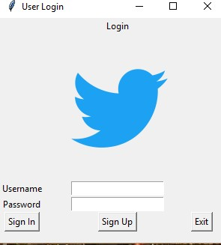

1. **IF USER Sign in:**

To leave, Update, Delete &show Tweet.

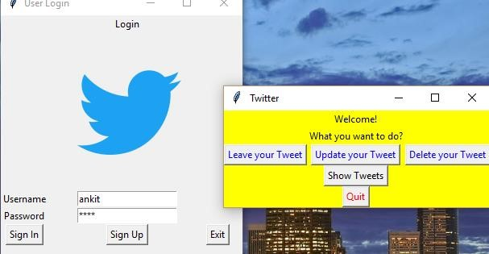

1. **IF USER perform any operation:**

A message box for every event performed.

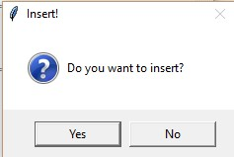

1. **For New user:**

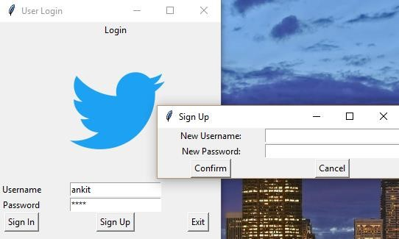

1. **Database section:**

Tweets

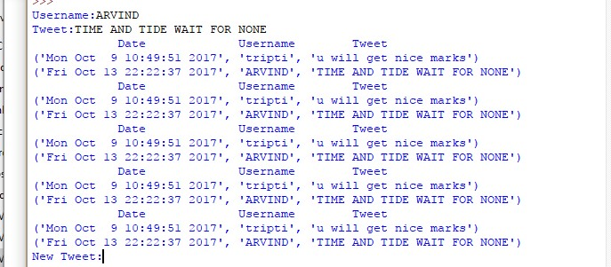

#### CONCLUSIONS

The sheer amount and the different types of data on twitter and the public nature of tweets have allowed exploiting twitter information in data analysis. First by measuring the life cycle of a specific topic by measuring the number of tweets over a period of time, and second by measuring the sentiment of users. Our aim is to enhance the analysis of twitter data for specific events to measure the effect and the behaviour of users towards different events categories like insert, update and deleting their details of their accounts. A successive work will focus on studying the data and its attributes, and investigating modelling techniques to identify the frequency distribution for each event.

**REFERENCES**

1. From https://en.wikipedia.org/wiki/Twitter
2. http://www.tutorialspoint.com/
3. www.youtube.com/bucky