PROGRAM 8A : Word Count program using MapReduce WITH hadoop

Step1:goto Search button run cmd prompt as administrator Step2: Initiate all required component of hadoop by command start-all.cmd
Step3: Create a text file where we have folder running hadoop java program in my case I have created in Desktop
U can create anywhere as u wish
Step4: Create a Directory in HDFS console using command
hadoop fs -mkdir /textformat
Where textform is ur input directory
Step5: We have to add text into a directory<textformat> in my case b.txt is in desktop folder copy the path and type command hadoop fs -put C:\Users\User\Desktop\b.txt /textformat
After completion of above command u be able to see b.txt in /textformat directory of hdfs console
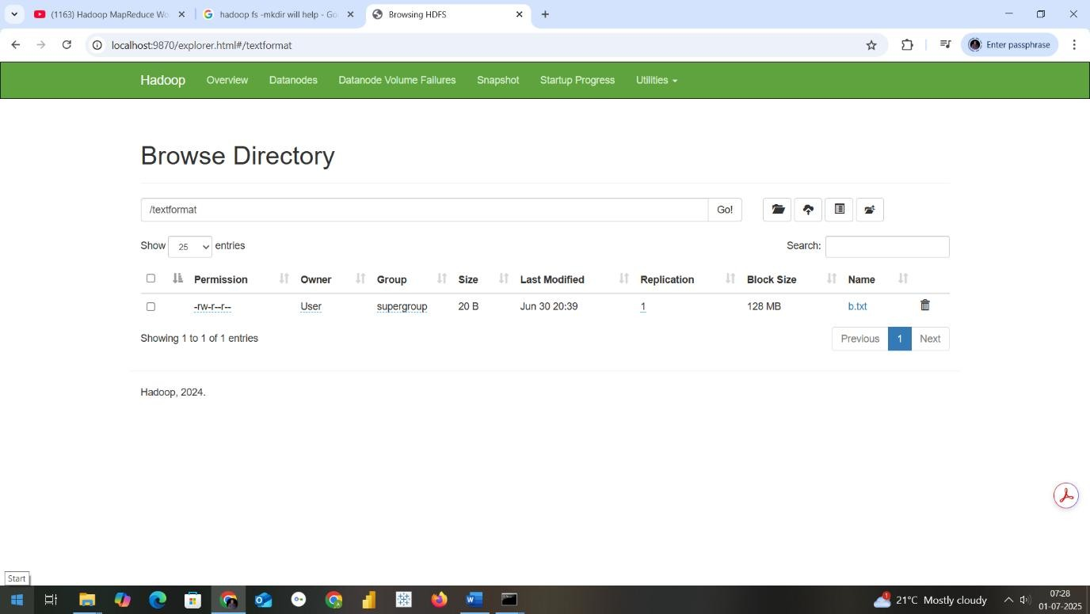
In cmd prmpt if u want to check type the command as hadoop fs -ls /textformat

Step6: Now we need a jar file to execute mapreduce program fr wordcount
So open Eclipse
Create a java project with name MapReduceWordCount
Select execution environment as JavaSE-1.8
And click on next&finish

Step7: Right Click on Projectname---→ Click on New---→create a package
with name com.mapreduce.wc and click on Finish
Step8: Add required libraries to support hadoop by navigating as in below
Right Click on Project-------→Right Click on BuildPath-------→ Configure
Buildpath Then goto Libraries as in second screen below
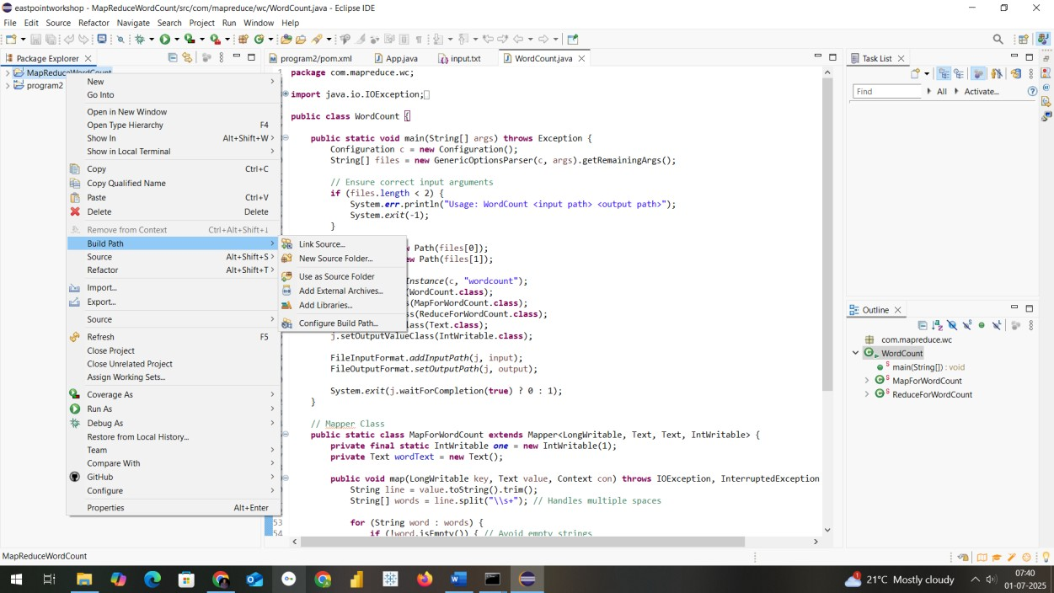

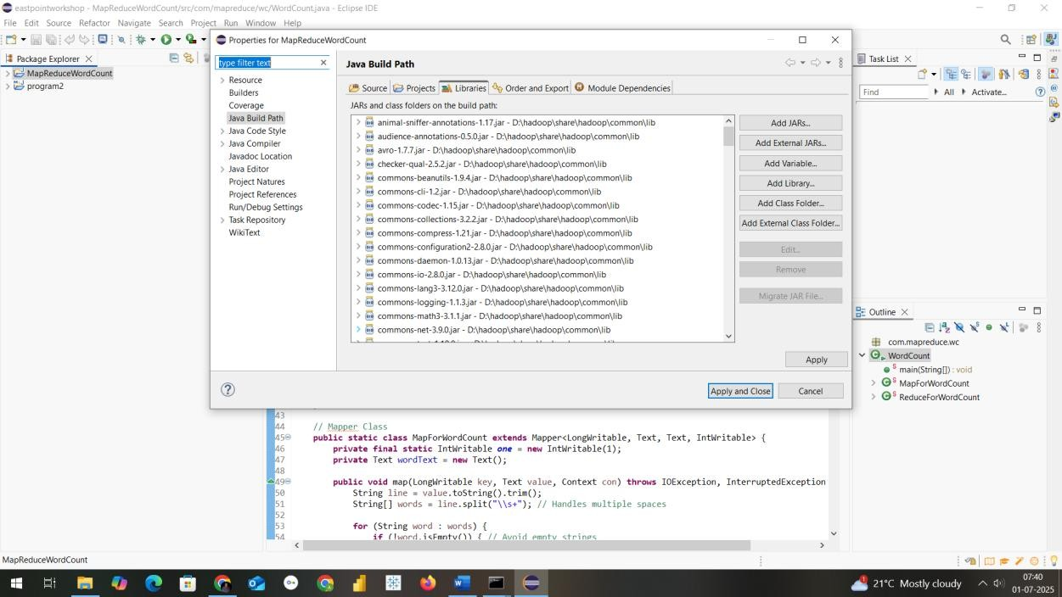
Step9: Add necessary External jar file from D:\hadoop\share\hadoop
Like clients,common,hdfs,mapreduce & yarn to support packages for hadoop
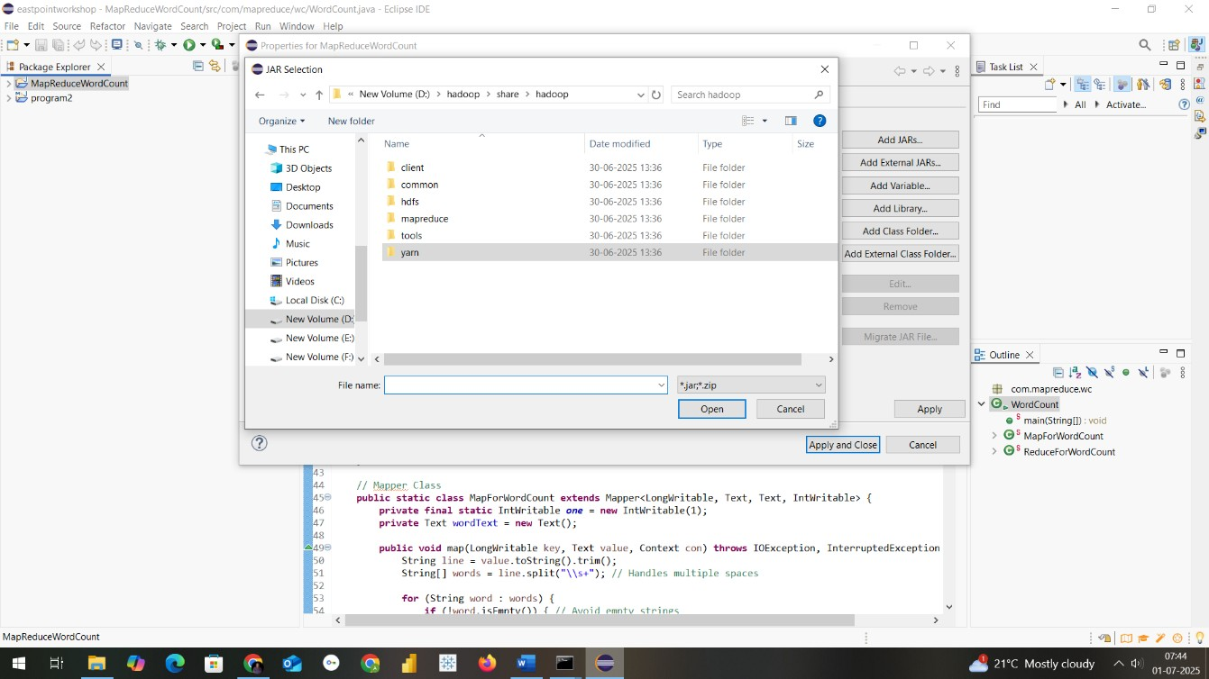

Step10: Create aclass within package com.mapreduce.wc with name
WordCount and paste this code
package com.mapreduce.wc;

import java.io.IOException; import org.apache.hadoop.conf.Configuration; import org.apache.hadoop.fs.Path; import org.apache.hadoop.io.IntWritable; import org.apache.hadoop.io.LongWritable; import org.apache.hadoop.io.Text; import org.apache.hadoop.mapreduce.Job; import org.apache.hadoop.mapreduce.Mapper; import org.apache.hadoop.mapreduce.Reducer; import org.apache.hadoop.mapreduce.lib.input.FileInputFormat; import org.apache.hadoop.mapreduce.lib.output.FileOutputFormat; import org.apache.hadoop.util.GenericOptionsParser;

public class WordCount {

public static void main(String[] args) throws Exception {
Configuration c = new Configuration();
String[] files = new GenericOptionsParser(c, args).getRemainingArgs();

// Ensure correct input arguments
if (files.length < 2) {
System.err.println("Usage: WordCount <input path> <output path>"); System.exit(-1);
}

Path input = new Path(files[0]);
Path output = new Path(files[1]);

Job j = Job.getInstance(c, "wordcount"); j.setJarByClass(WordCount.class);
j.setMapperClass(MapForWordCount.class);
j.setReducerClass(ReduceForWordCount.class);
j.setOutputKeyClass(Text.class);
j.setOutputValueClass(IntWritable.class);

FileInputFormat.addInputPath(j, input);
FileOutputFormat.setOutputPath(j, output);

System.exit(j.waitForCompletion(true) ? 0 : 1);
}

// Mapper Class
public static class MapForWordCount extends Mapper<LongWritable, Text, Text, IntWritable> {
private final static IntWritable one = new IntWritable(1); private Text wordText = new Text();

public void map(LongWritable key, Text value, Context con) throws
IOException, InterruptedException {
String line = value.toString().trim();
String[] words = line.split("\\s+"); // Handles multiple spaces

for (String word : words) {
if (!word.isEmpty()) { // Avoid empty strings wordText.set(word.trim().toUpperCase()); con.write(wordText, one);
}
}
}
}

// Reducer Class
public static class ReduceForWordCount extends Reducer<Text, IntWritable, Text, IntWritable> {
public void reduce(Text word, Iterable<IntWritable> values, Context con) throws IOException, InterruptedException {
int sum = 0; for (IntWritable value : values) { sum += value.get();
}
con.write(word, new IntWritable(sum));
}
}
}

PROGRAM 8B:Word Program Count Procedure using Apache Spark
Step 1: Prerequisites
Ensure you have the following installed:
- Java JDK (8 or 11)
- Eclipse IDE (preferably Eclipse IDE for Java Developers)
- Apache Maven

Step 2: Create Maven Project in Eclipse
- Open Eclipse → File → New → Maven Project → Next.
- Select maven-archetype-quickstart, click Next.
- Provide the following:
o Group Id: com.example.spark o Artifact Id: spark-wordcount o Click Finish.

Step 3: Add Spark Dependencies in pom.xml Add this to your pom.xml:
<dependencies>
<dependency>
<groupId>org.apache.spark</groupId>
<artifactId>spark-core_2.12</artifactId>
<version>3.3.2</version>
</dependency>

<!-- Apache Spark SQL (Optional) -->
<dependency>
<groupId>org.apache.spark</groupId>
<artifactId>spark-sql_2.12</artifactId>
<version>3.3.2</version>
</dependency>

<!-- Logging (to avoid SLF4J warnings) -->
<dependency>
<groupId>org.slf4j</groupId>
<artifactId>slf4j-simple</artifactId>
<version>1.7.30</version>
</dependency>
</dependencies>

<build>
<plugins>
<!-- Plugin to build a fat JAR -->
<plugin>
<groupId>org.apache.maven.plugins</groupId>
<artifactId>maven-shade-plugin</artifactId>
<version>3.2.4</version>
<executions>
<execution>
<phase>package</phase>
<goals><goal>shade</goal></goals>
</execution>
</executions>
</plugin>
</plugins>
</build>

Step 4: Create WordCount Program Create a class WordCount.java under:
src/main/java/com/example/spark/WordCount.java package com.example.spark.spark_wordcount;
import org.apache.spark.api.java.*; import org.apache.spark.SparkConf; import scala.Tuple2;
import java.util.Arrays;

public class App { public static void main(String[] args) {
// Set Spark Configuration
SparkConf conf = new
SparkConf().setAppName("WordCount").setMaster("local[*]"); JavaSparkContext sc = new JavaSparkContext(conf);

// Load input file
JavaRDD<String> input = sc.textFile("D:/hadoopprograms/input.txt"); //
Replace with your file path

// FlatMap each line to words
JavaRDD<String> words = input.flatMap(line -> Arrays.asList(line.split(" ")).iterator());

// Map each word to a pair (word, 1)
JavaPairRDD<String, Integer> wordPairs = words.mapToPair(word -> new Tuple2<>(word, 1));

// Reduce by key (word)
JavaPairRDD<String, Integer> wordCounts = wordPairs.reduceByKey(Integer::sum);

// Print output
wordCounts.foreach(result -> System.out.println(result._1() + ": " + result._2()));

sc.close();
}
}

Step 5: Input File
Create a input.txt file in folder where u r saving Hadoop programs in mine its in
D:\hadoopprograms

Example content:
hello world hello spark
spark is fast
Step 6: Run the Program
- Right-click WordCount.java → Run As → Java Application.
- Console should print:
hello: 2 world: 1 spark: 2 is: 1 fast: 1

RESULT
