# **Project: Analyzing a Market Test**

By: Huong Ivy Nguyen

## ***Step 1: Plan Your Analysis***

1. What is the performance metric you’ll use to evaluate the results of your test?

The sum of gross margin per store per month by region will be used as the performance metric. This metric helps to evaluate whether the introduction of the new gourmet sandwiches and limited wine offerings would increase the sale growth of Round Roasters.

1. What is the test period?

The test period is from 29-April-2016 to 21-July-2016, which is a 12-week period.

1. At what level (day, week, month, etc.) should the data be aggregated?

The data should be aggregated at the weekly level.

## ***Step 2: Clean Up Your Data***

## 

Figure 1. The Alteryx workflow that was used to clean up the data and to make three new datasets: weekly_store_traffic, store_lists, and store_sales_analysis_data.

The data was cleaned up by using the following steps:

* Identify number of weeks needed for the AB analysis: a total of 52 weeks + 12 weeks minimum for weekly level is required by Alteryx AB analysis tool. There is a 12-week test period for this experiment. Therefore, a sum of 52+12+12=76 weeks of data is needed for this report.
* Filter out unnecessary data from the Round_RoastersTransactions.csv file by removing data before 06-Feb-2015 and after 21-July-2016.
* Create 4 new columns: week_end, week_start, week, and new_product_flag to the RoundRoastersTransactions.csv using Floor, DateTimeDiff, and DateTimeAdd functions.
* Join RoundRoasterTransactions.csv and round_roasters_stores.csv by the store_id
* Summarize the joined data by store_id, region

## ***Step 3: Match Treatment and Control Units***

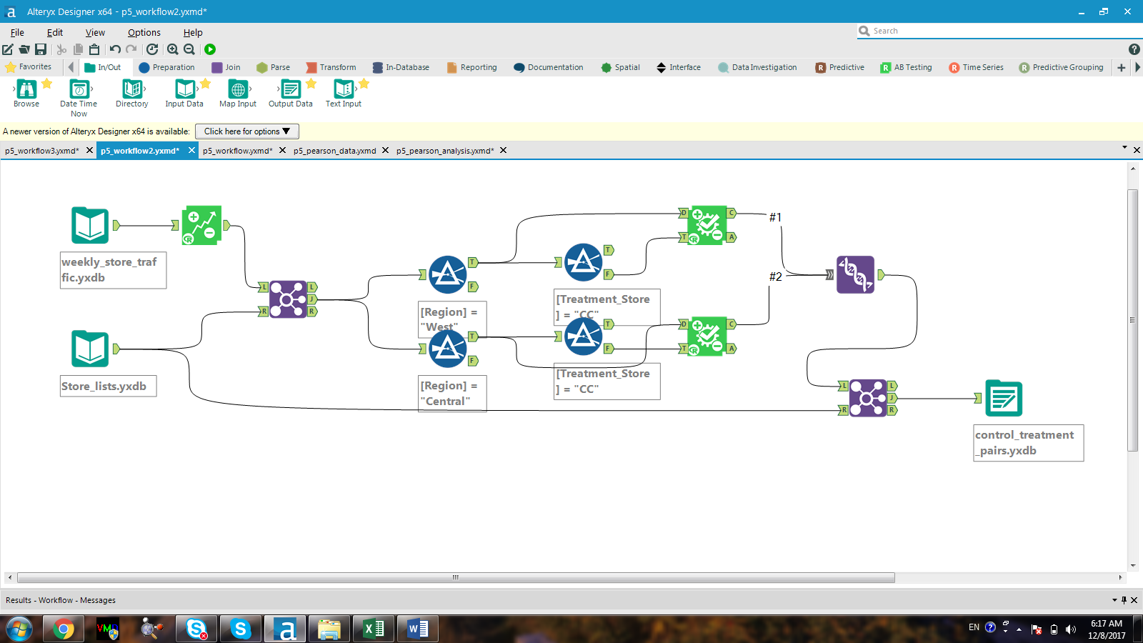

Figure 2. The Alteryx workflow that was used to generate the control_treatment_pairs dataset by using the AB trend and AB controls tools.

1. What control variables should be considered?

Both AvgMonthSales and Sq_Ft are potential candidates for being control variables. However, to fully determine if they are truly a good choice, a full Pearson correlation matrix would need to be established.

1. What is the correlation between your each potential control variable and your performance metric?

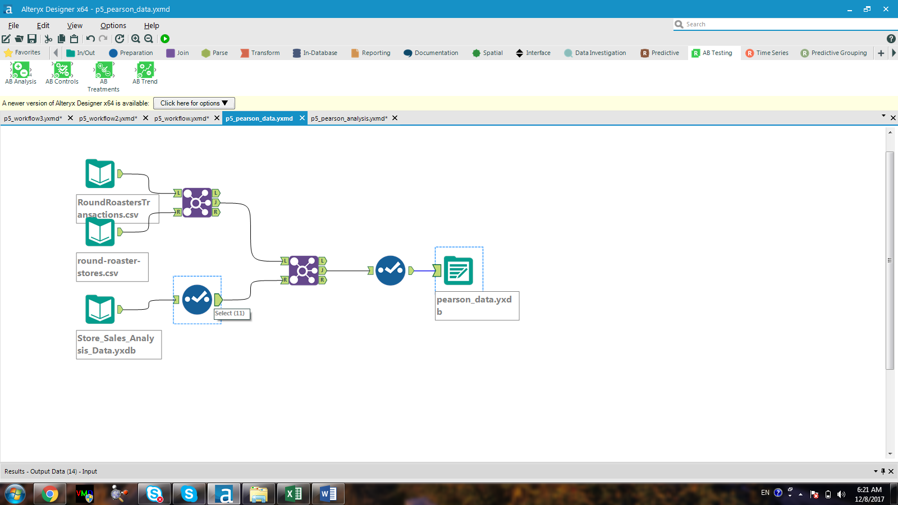

Figure 3. The Alteryx workflow used in generating the dataset for Pearson correlation analysis

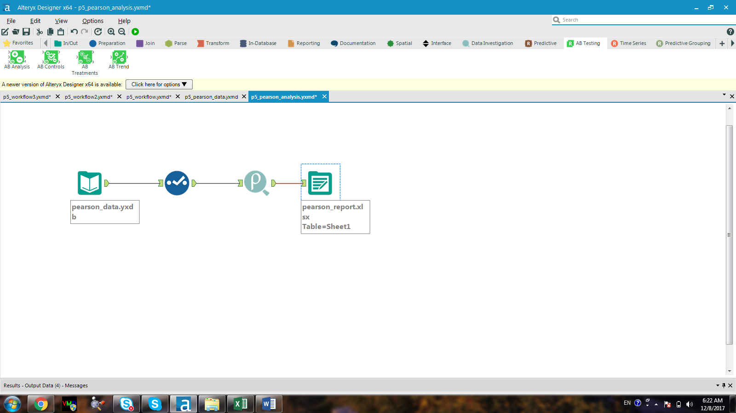

Figure 4. The Alteryx workflow for generating the full Pearson correlation matrix

Table 1. Full Pearson Correlation Matrix between performance metric and potential control variables. (Note: sum_sum_sales is included for additional information)

|  |  |  |  |  |
| --- | --- | --- | --- | --- |
| FieldName | Sq_Ft | AvgMonthSales | Sum_Sum_Sales | Sum_Sum_Gross Margin |
| Sq_Ft | 1 | -0.098990132 | -0.06407915 | -0.061912607 |
| AvgMonthSales | -0.098990132 | 1 | 0.786283812 | 0.787443833 |
| Sum_Sum_Sales | -0.06407915 | 0.786283812 | 1 | 0.9986944 |
| Sum_Sum_Gross Margin | -0.061912607 | 0.787443833 | 0.9986944 | 1 |

According to Table 1, the sum of gross margin and the average month sales have a strong correlation of 0.78 whereas the square footage and the sum of gross margin barely has any relationship. Matter of fact, the correlation between the sum of gross margin and the square footage is -0.06. Therefore, it makes sense to eliminate sq_ft from the control variable list.

1. What control variables will you use to match treatment and control stores?

The AvgMonthSales, Trend and Seasonality would be used to match treatment and control stores.

1. Please fill out the table below with your treatment and control stores pairs:

|  |  |  |
| --- | --- | --- |
| Treatment Store | Control Store 1 | Control Store 2 |
| 1664 | 1964 | 7162 |
| 1675 | 1807 | 1508 |
| 1696 | 1863 | 7534 |
| 1700 | 7037 | 2014 |
| 1712 | 8162 | 2114 |
| 2288 | 9081 | 2568 |
| 2293 | 12219 | 9639 |
| 2301 | 9238 | 2301 |
| 2322 | 2409 | 3235 |
| 2341 | 2572 | 3102 |

## ***Step 4: Analysis and Write-up***

Answer these questions. Be sure to include visualizations from your analysis:

1. What is your recommendation - Should the company roll out the updated menu to all stores?

The company definitely should roll out the updated menu to all stores. This recommendation is based on the obtained AB test analysis for both the West and the Central regions shown below.

**AB Test Analysis for the West Region**

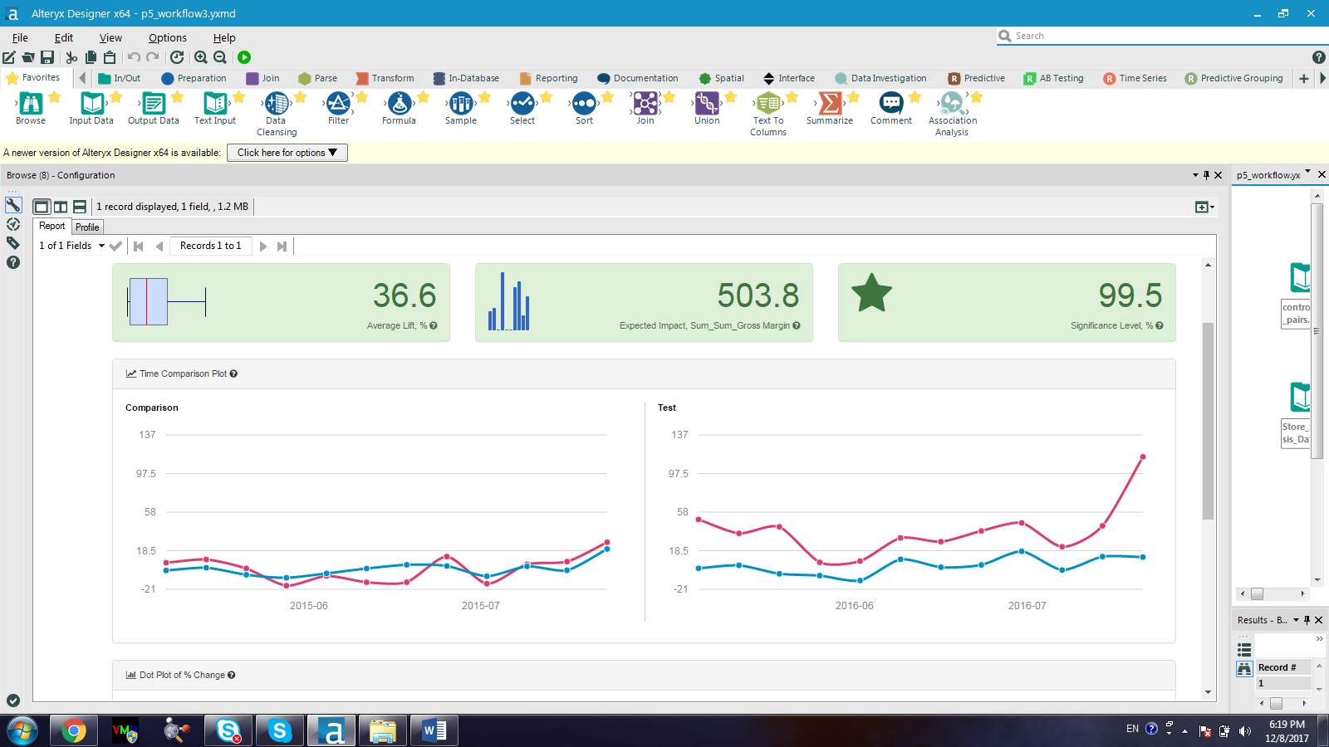

**AB Test Analysis for the Central Region**

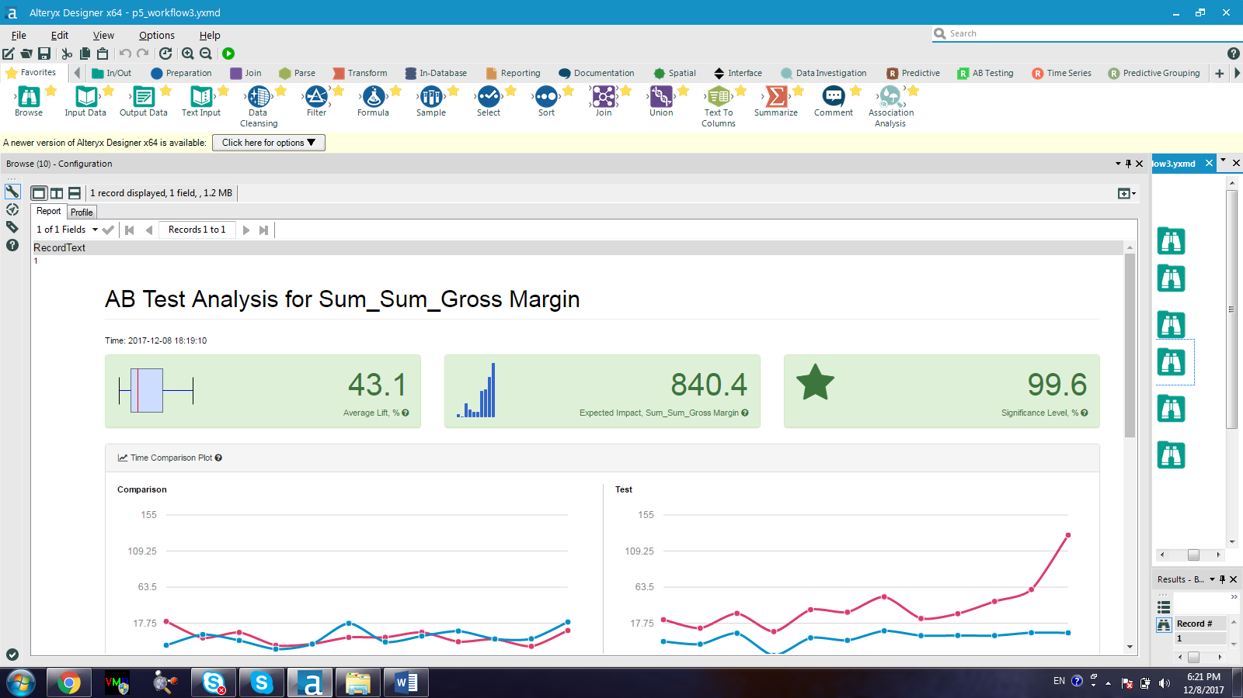

**Overall AB Test**

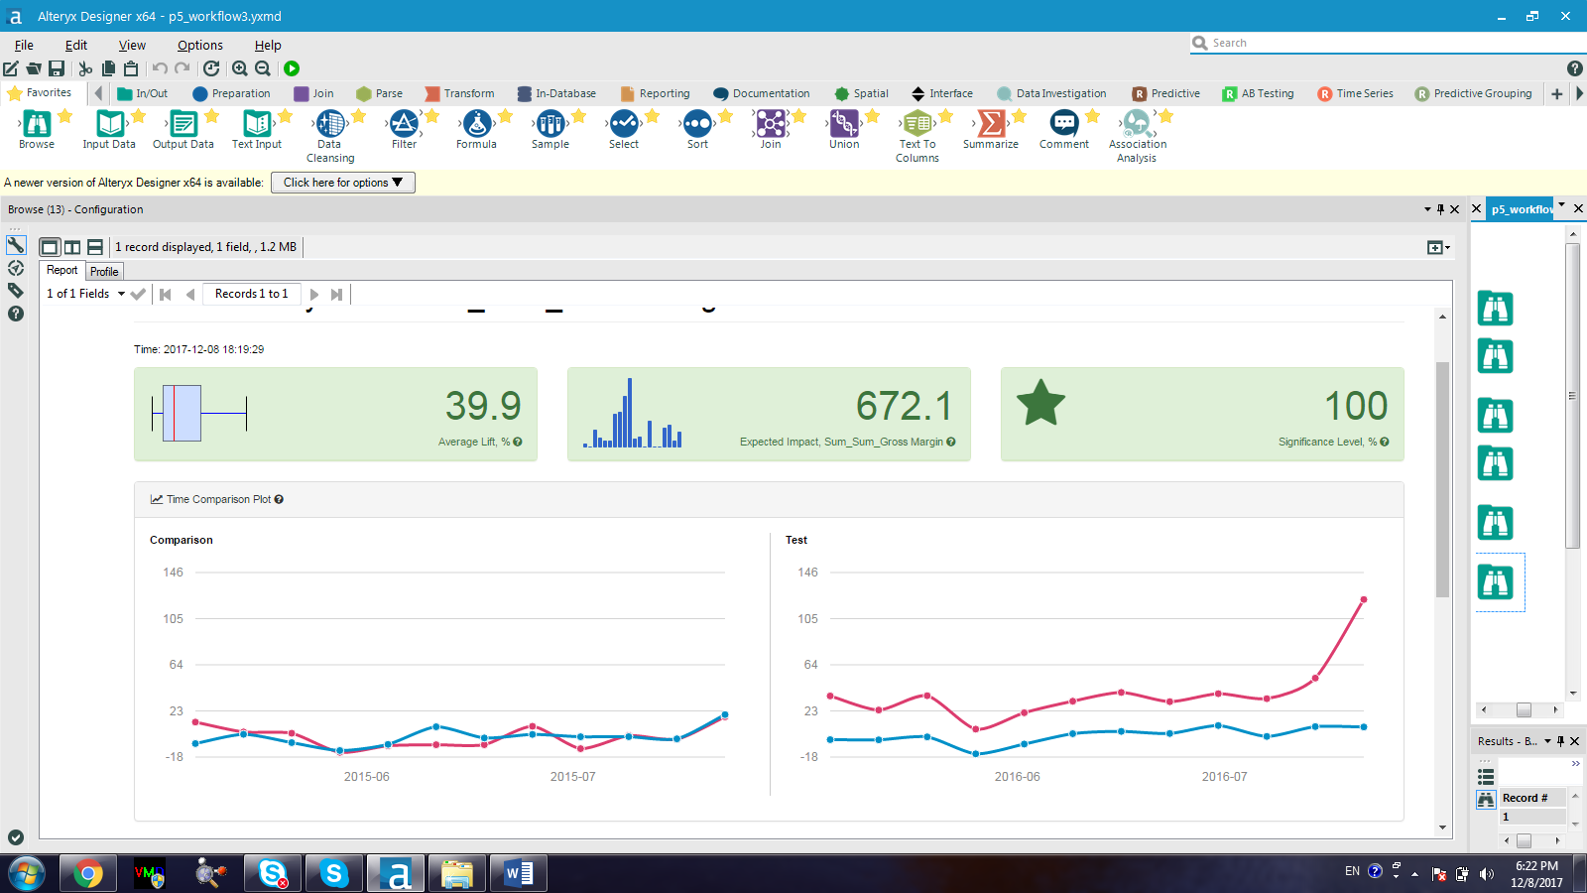

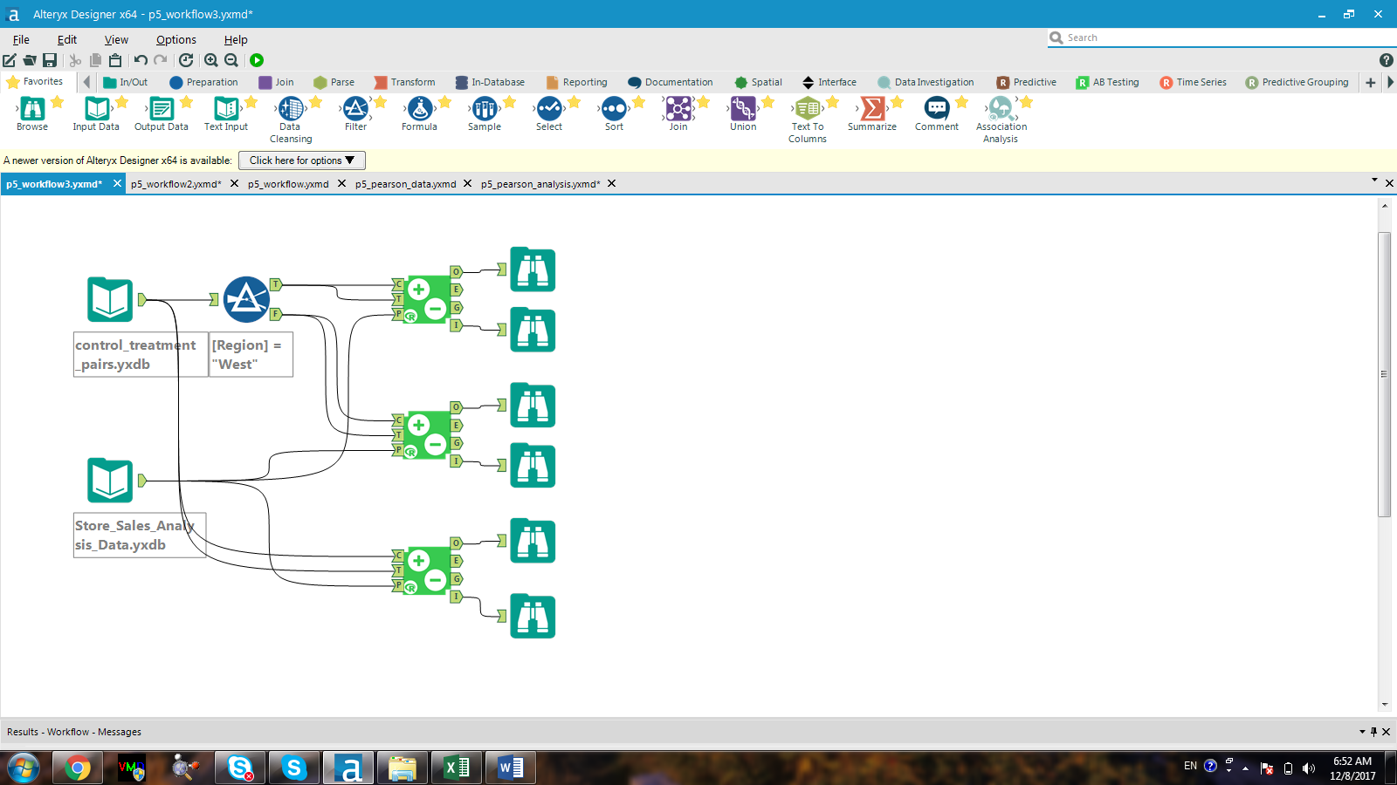

Figure 5. AB Analysis workflow

1. What is the lift from the new menu for West and Central regions (include statistical significance)?

The lift for the new many for the West region is 36.6% and that for the Central region is 43.1%. The statistical significance for the west and the central regions are 99.5 and 99.6, respectively.

1. What is the lift from the new menu overall?

The lift from the new menu overall is 39.9%