**Project: Forecasting Sales**

By Huong Ivy Nguyen

## ***Step 1: Plan Your Analysis***

1. Does the dataset meet the criteria of a time series dataset? Make sure to explore all four key characteristics of a time series data.

The given dataset meets the criteria of a time series dataset since it was collected in a continuous time interval. In addition, each measurement of the dataset is sequential with an even interval. Each time unit of the dataset has at most one data point. The ordering of the measurements matters and is dependent on the time that was taken.

1. Which records should be used as the holdout sample?

Since the prediction is for the sales of next 4 months, the hold-out sample would need to be at least 4 month worth of data. Therefore, the last 4 data points should be separated from the overall dataset as a hold-out sample.

## ***Step 2: Determine Trend, Seasonal, and Error components***

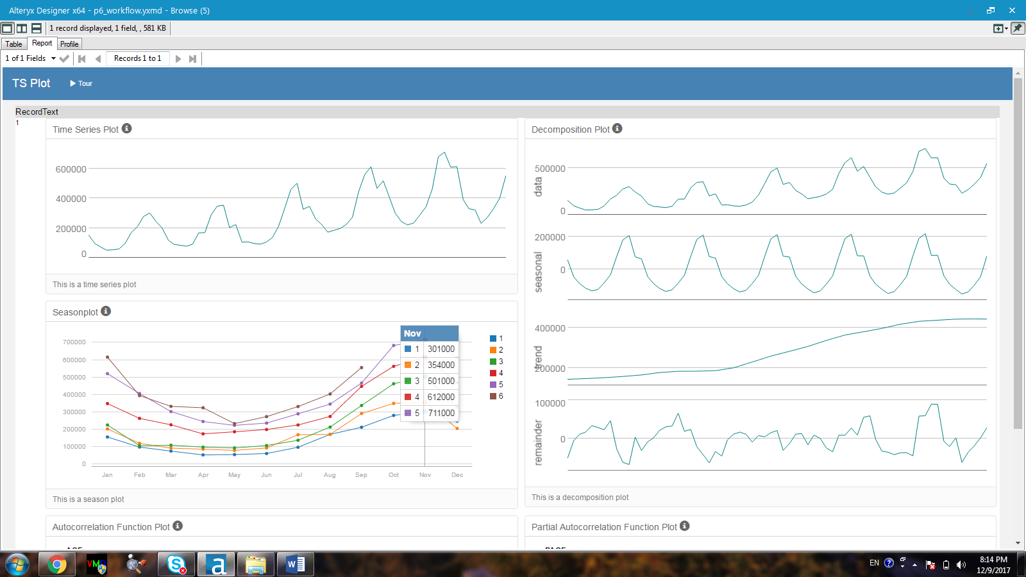

Figure 1. Time series plot on the top-left corner, season plot on the bottom-left corner, decomposition plot on the right-hand side.

1. What are the trend, seasonality, and error of the time series? Show how you were able to determine the components using time series plots. Include the graphs.

Based on the decomposition plot of Figure 1, the following conclusion is drawn:

* The seasonal plot has a slight increase in magnitude every month which signals the use of multiplicative for this component.
* The trend plot appears to be linear and therefore additive should be used for this component.
* The remainder plot or the error plot shows variation over time which signals the error should be used multiplicatively.

***Step 3: Build your Models***

1. What are the model terms for ETS? Explain why you chose those terms.
   1. Describe the in-sample errors. Use at least RMSE and MASE when examining results

The terms for the ETS models (both non-dampened and dampened) are multiplicative, addictively, and multiplicative for error, trend, and season respectively. The effect from dampening is tested out and each model is then evaluated for its accuracy by fitting the hold-out sample from the last 4 months. The notation is thus ETS (M,A,M). The results are then compared as follows.

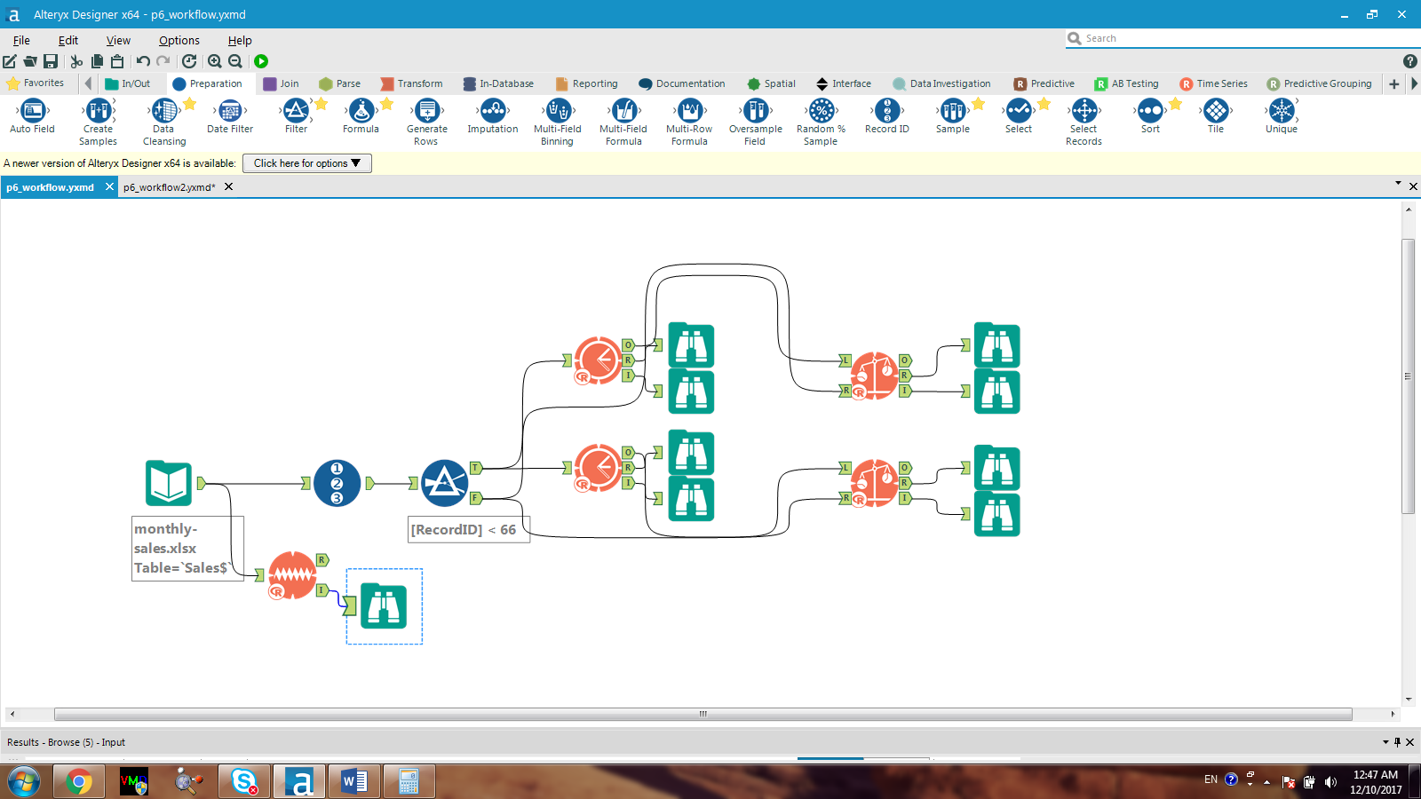

Figure 2. The Alteryx workflow for both non-dampened and dampened ETS models

**Non-dampened ETS Model:**

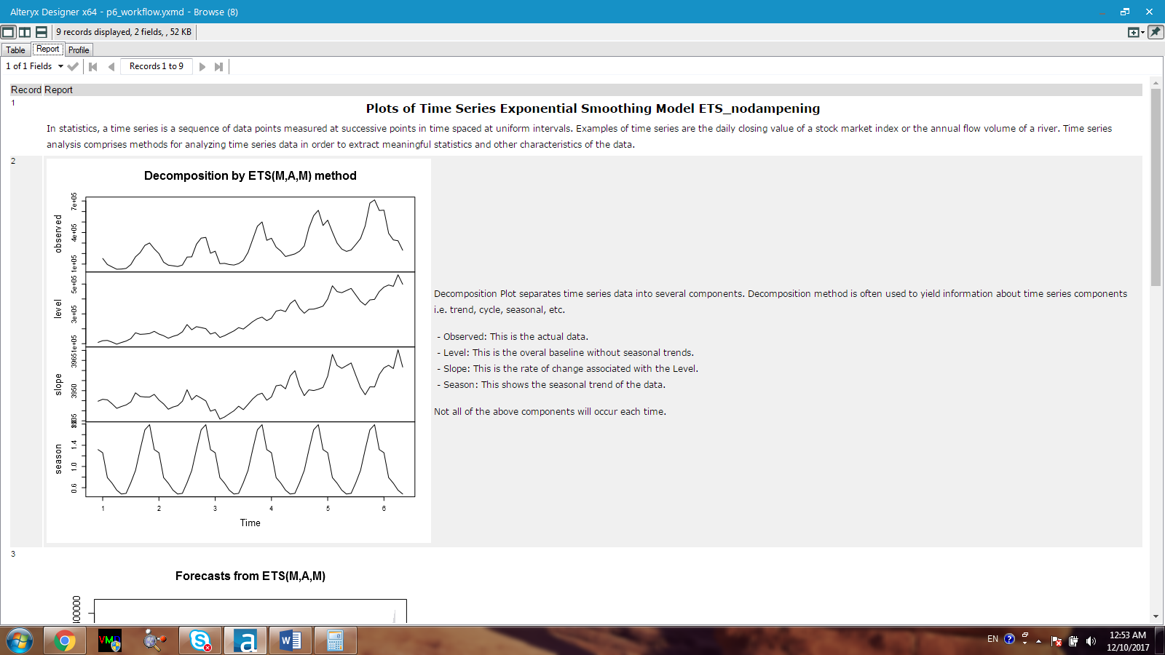

Figure 3. Decomposition plot by ETS non-dampened model

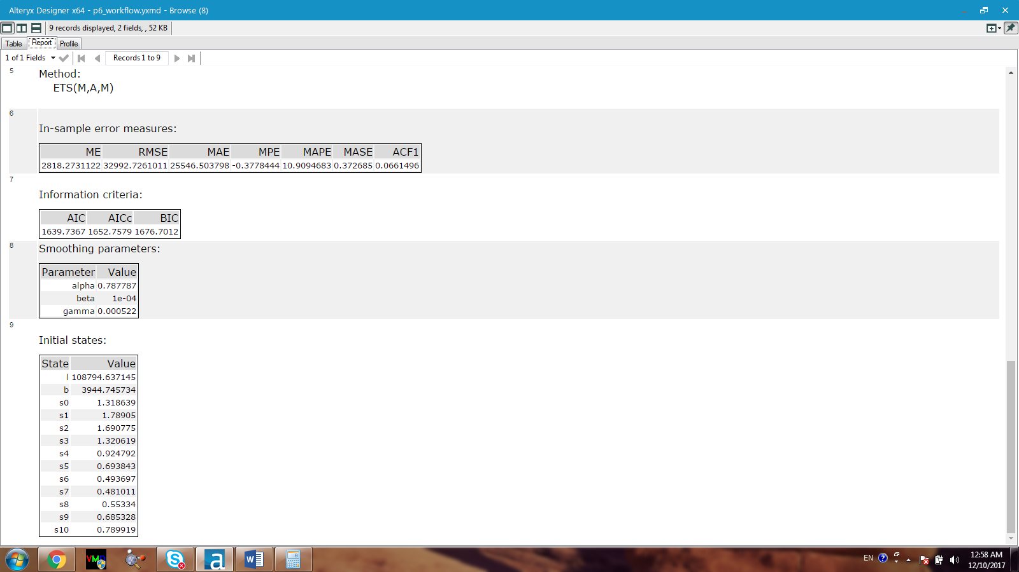

Figure 4. In-sample error measures and information criteria reports for non-dampened ETS

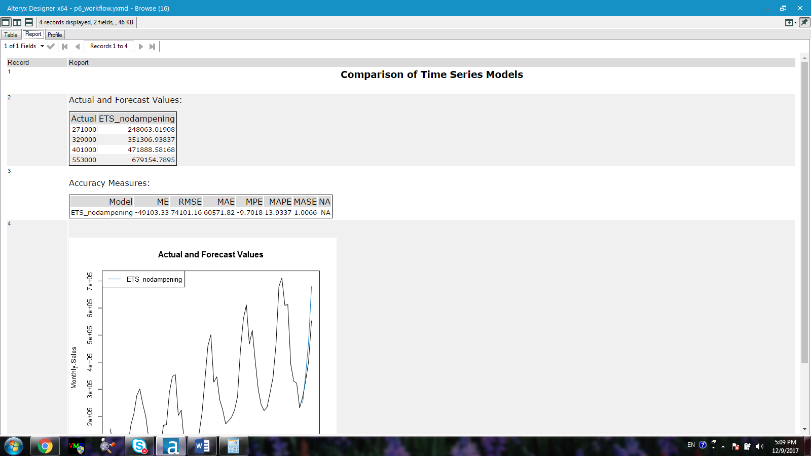

Figure 5. Top: Actual versus forecast values using the hold-out sample for evaluating the accuracy of the non-dampened ETS model. Bottom: accuracy measures for the non-dampened ETS model in terms of mean error (ME), root mean squared error (RMSE), absolute mean error (MAE), average percentage error (MPE), average absolute percentage error (MAPE) and mean absolute scaled error (MASE)

**Dampened ETS Model:**

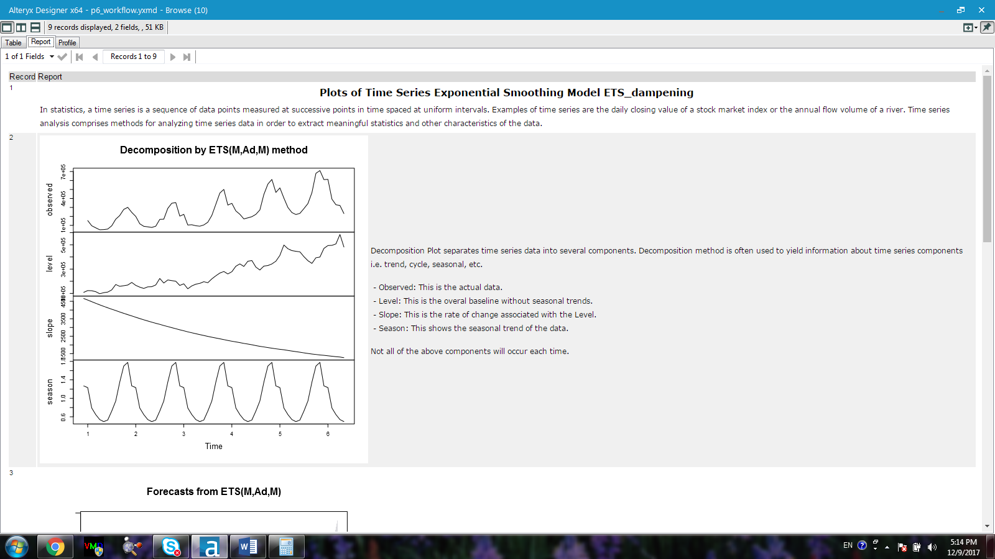

Figure 6. Decomposition plot by ETS dampened model

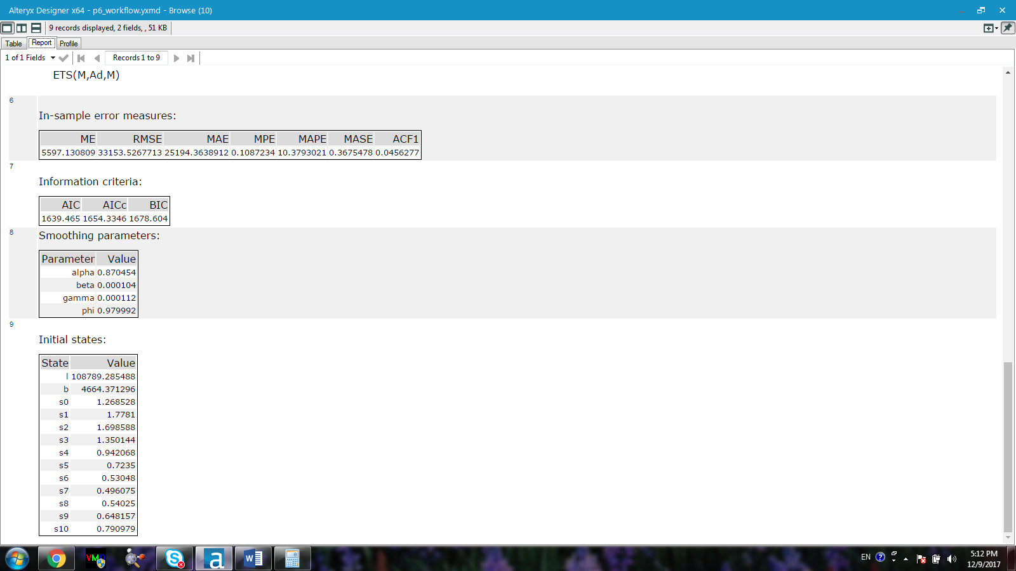

Figure 7. In-sample error measures and information criteria reports for dampened ETS

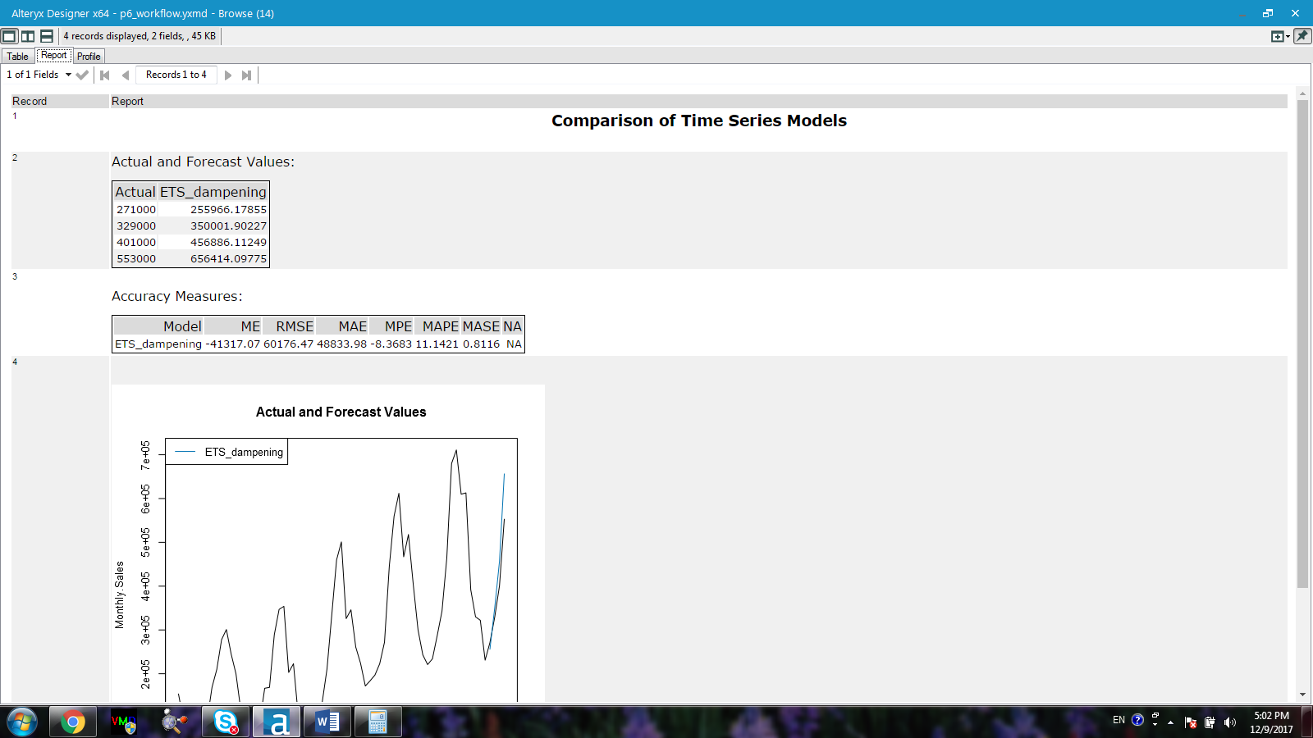

Figure 8. Top: Actual versus forecast values using the hold-out sample for evaluating the accuracy of the dampened ETS model. Bottom: accuracy measures for the dampened ETS model in terms of mean error (ME), root mean squared error (RMSE), absolute mean error (MAE), average percentage error (MPE), average absolute percentage error (MAPE) and mean absolute scaled error (MASE)

**Comparison between non-dampened ETS and dampened ETS:**





When we put the forecast values and the accuracy measures obtained from non-dampened ETS model and dampened ETS model side-by-side, it appears that **dampened ETS model** gives better forecast results using the hold-out sample. Specifically, all accuracy measures except ME and MPE of the non-dampened ETS model are higher than those of the dampened ETS model.

For example, the RMSE of dampened ETS is 60176.47 while that of the dampened model is 74101.16. In addition, while the RMSE measure obtained from the in-sample error measures (33153.5) of the dampened ETD model is higher than that of the non-dampened ETS model (32992.7), the MASE from the in-sample error measures (0.368) of the dampened ETS model is lower than that of the non-dampened ETS model (0.373). RMSE is the root mean squared error representing the standard deviation of the differences between the predicted values and the observed values. MASE is the mean absolute scaled error which is used to measure the relative reduction in error across the model. MASE is considered as one of the best metrics in evaluating the performance of a time series model. Since the MASE value of the dampened ETS model is lower than that of the non-dampened model, the **dampened ETS model should be chosen.**

1. What are the model terms for ARIMA? Explain why you chose those terms. Graph the Auto-Correlation Function (ACF) and Partial Autocorrelation Function Plots (PACF) for the time series and seasonal component and use these graphs to justify choosing your model terms.

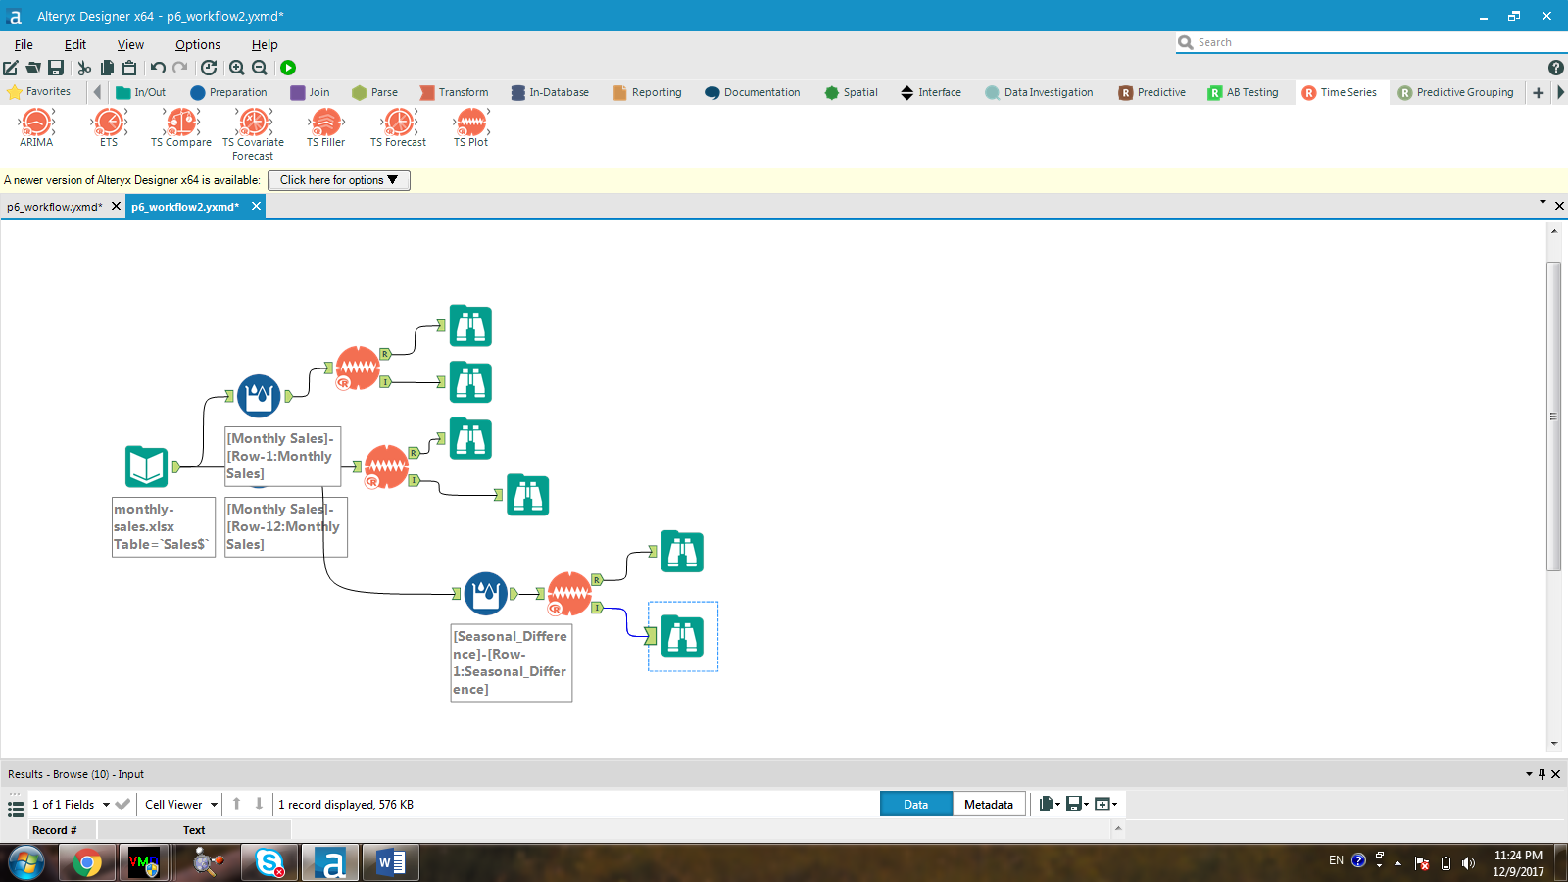

Figure 9. The Alteryx workflow for differencing

***Non-seasonal Component:***

Based on the time series plot obtained in Figure 1, the series is not stationary. First non-seasonal differencing is thus needed. After the first non-seasonal differencing, the time series plot is stationary (Figure 10). Therefore, the integrated part (I) should be 1 for the non-seasonal component of the ARIMA model.

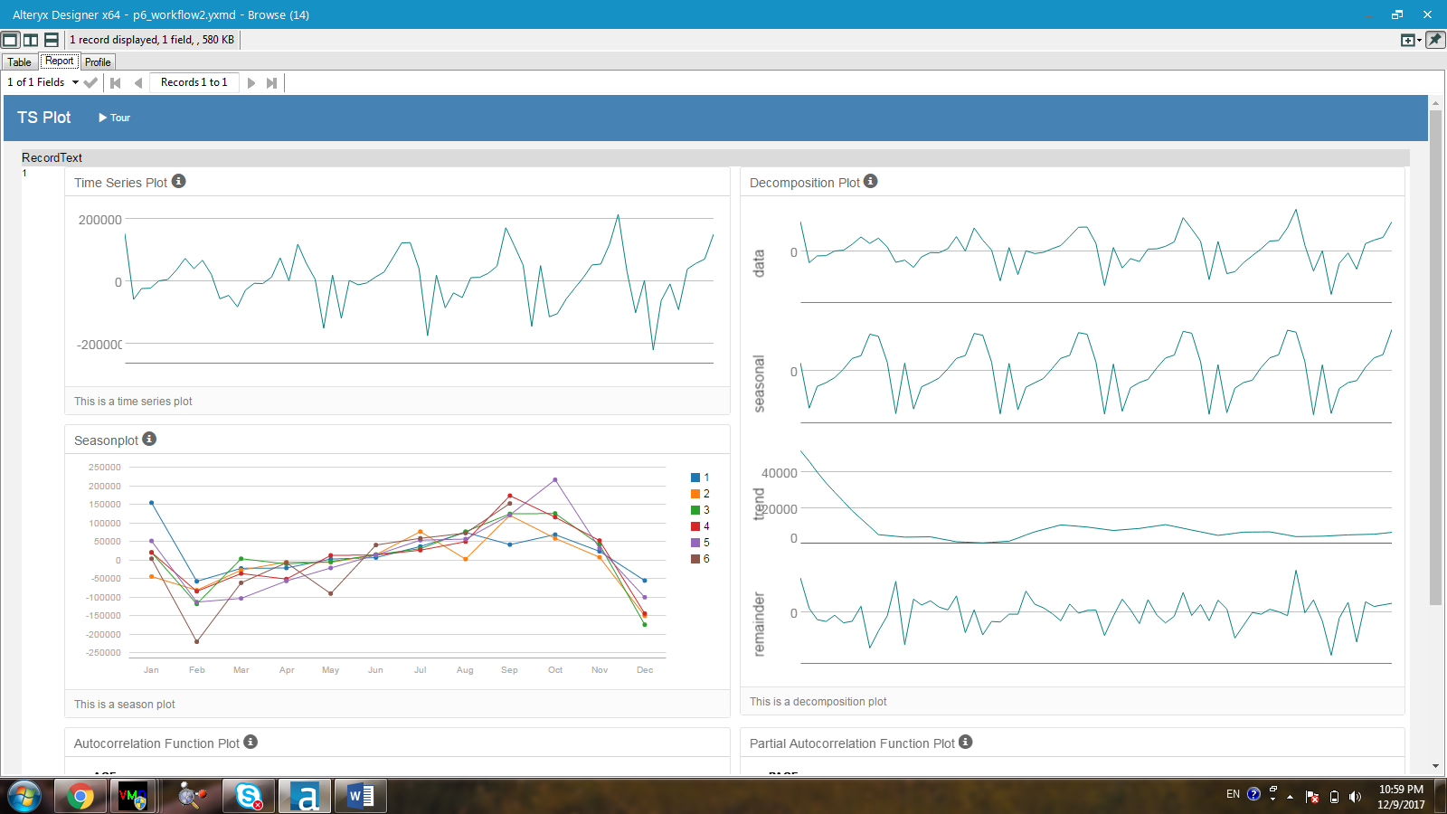

Figure 10. Time series plot and decomposition plot after the first non-seasonal differencing

According to Figure 11, the ACF plot generated after the first non-seasonal differencing shows sharp cut-off after a few lags whereas the PACF plot has a gradual decay towards 0. This fact signals the use of MA. Hence, the non-seasonal component of the ARIMA model should be (0,1,1).

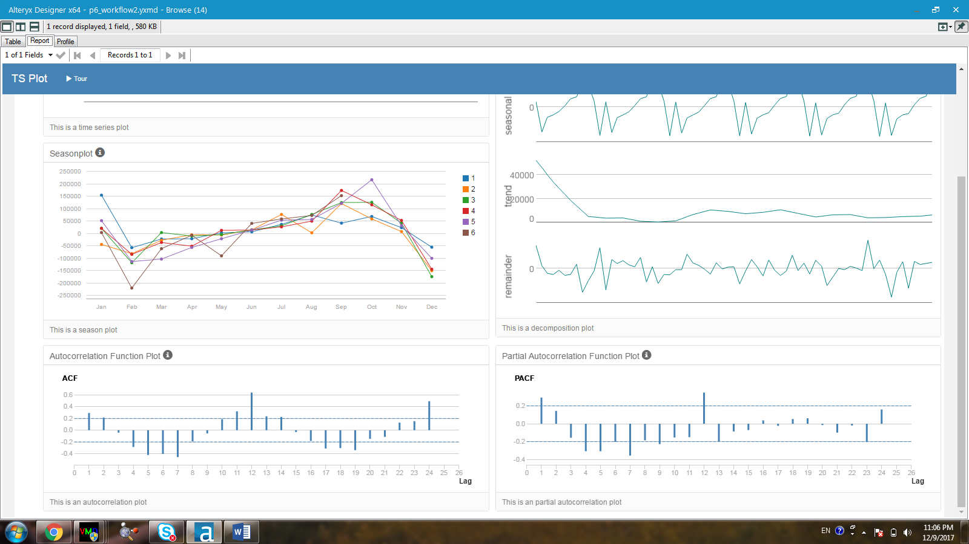

Figure 11. Left: autocorrelation function plot (ACF) without differencing; Right: partial autocorrelation function plot (PACF) after the first non-seasonal differencing.

***Seasonal Component:***

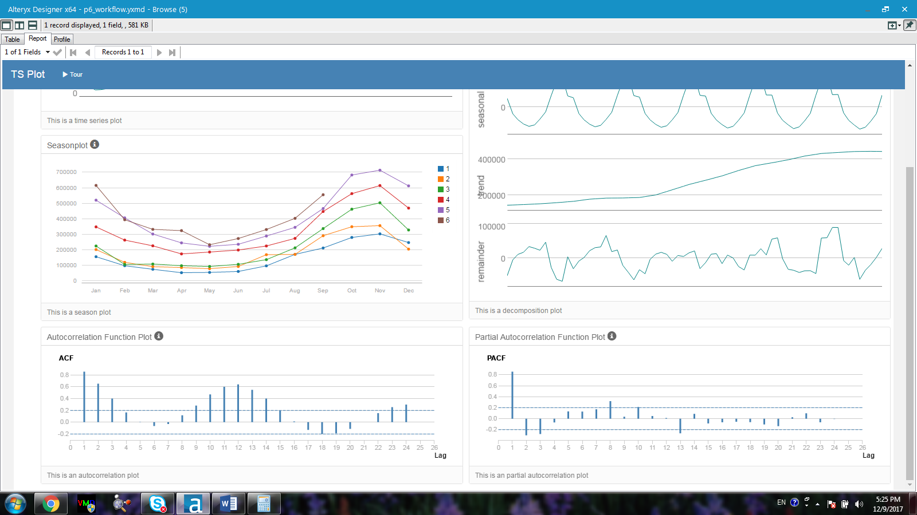

Figure 12. Left: autocorrelation function plot (ACF) without differencing; Right: partial autocorrelation function plot (PACF) without any seasonal differencing.

Based on Figure 12, The ACF and the PACF without any seasonal differencing plots show a high correlation of the series at lag 1. The correlation coefficient is on the vertical axis and the lag value is on the horizontal axis.

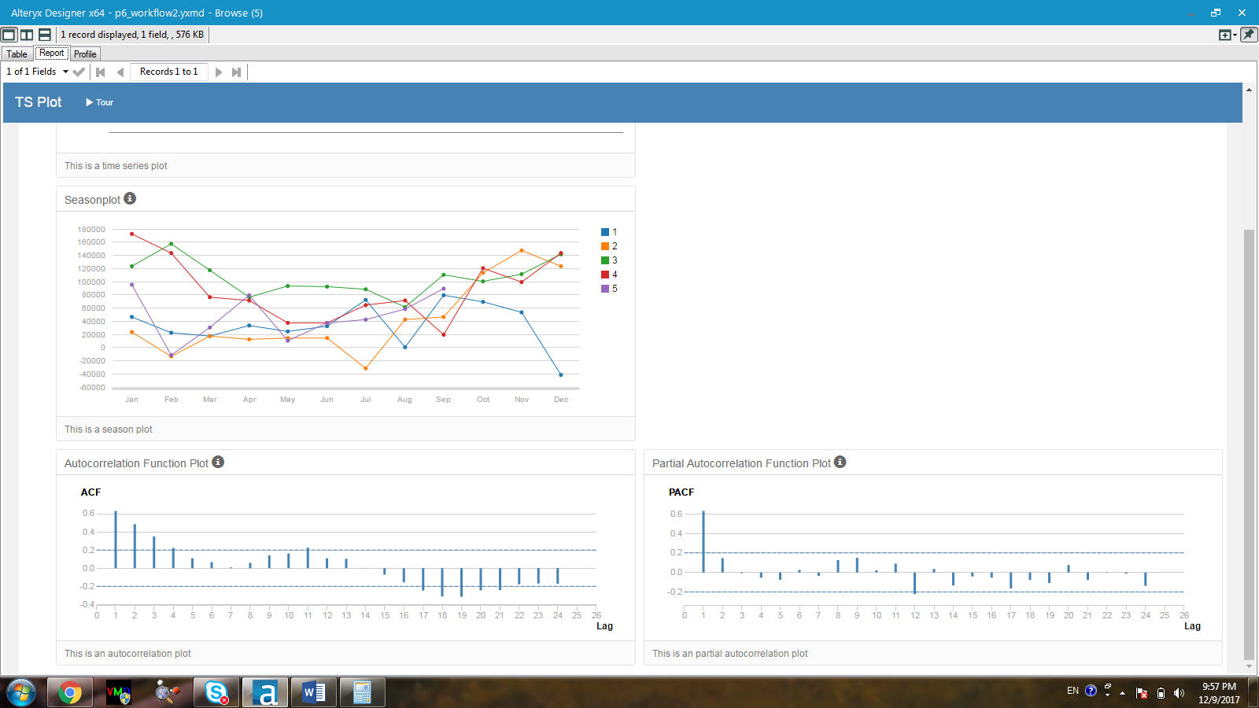

Figure 12. Left: autocorrelation function plot (ACF) without differencing; Right: partial autocorrelation function plot (PACF) after taking seasonal differencing.

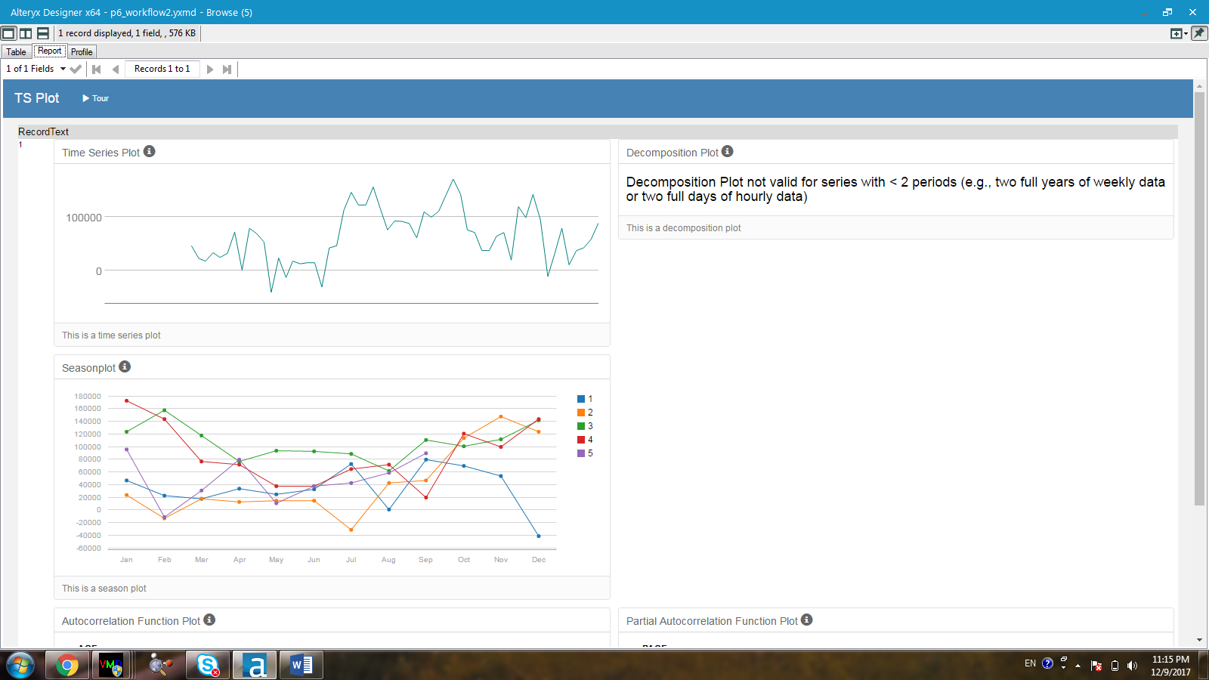

Figure 13. Time series plot after taking the seasonal differencing

According to Figure 12, there is still high correlation of the series after seasonal differencing has been performed. This fact is confirmed by looking at the high correlation at lag 1 in both the ACF and PACF plots of Figure 12. In addition, the time series plot after taking the seasonal difference is not stationary (Figure 13). Hence, the first seasonal differencing is needed.

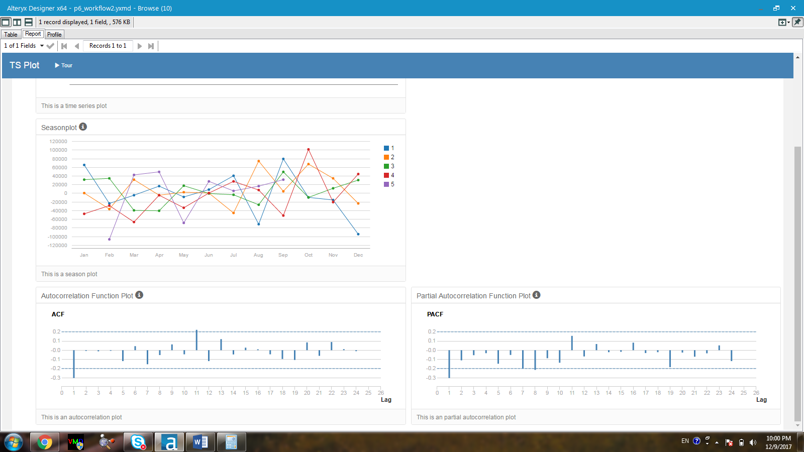

Figure 14. Left: autocorrelation function plot (ACF) without differencing; Right: partial autocorrelation function plot (PACF) after taking the first seasonal differencing.

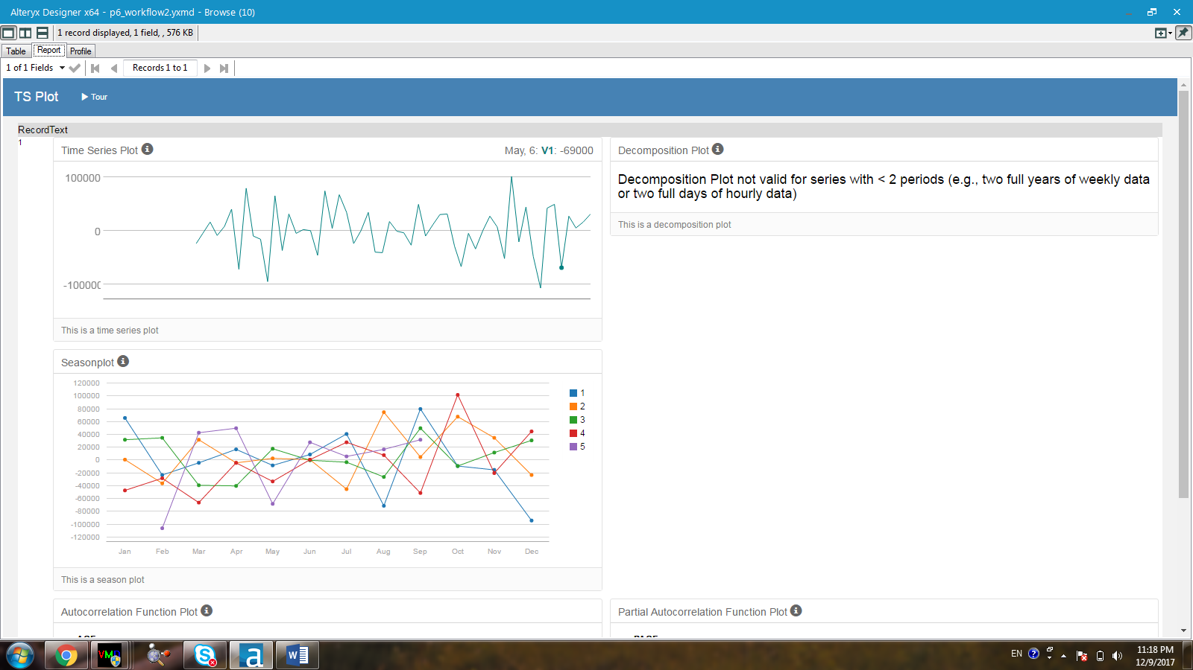

Figure 15. Time series plot after taking the first seasonal differencing

After taking the first seasonal differencing (Figure 15), there is no longer any high correlation shown in both the ACF and the PACF plots. The time series plot obtained after taking the first seasonal difference is stationary, meaning the series is now stationary. Since neither the ACF and PACF plot for this stationary dataset shows any signature of AR or MA term, neither AR or MA term would not be preferred. Overall, the ARIMA model would follow (0,1,1) for the non-seasonal part and (0,1,0) for the seasonal part with a period of 12. Thus, the notation should be ARIMA (0,1,1)(0,1,0)12. This analysis is consistent with what is chosen automatically by the Alteryx software.

**ARIMA (0,1,1)(0,1,0)12**

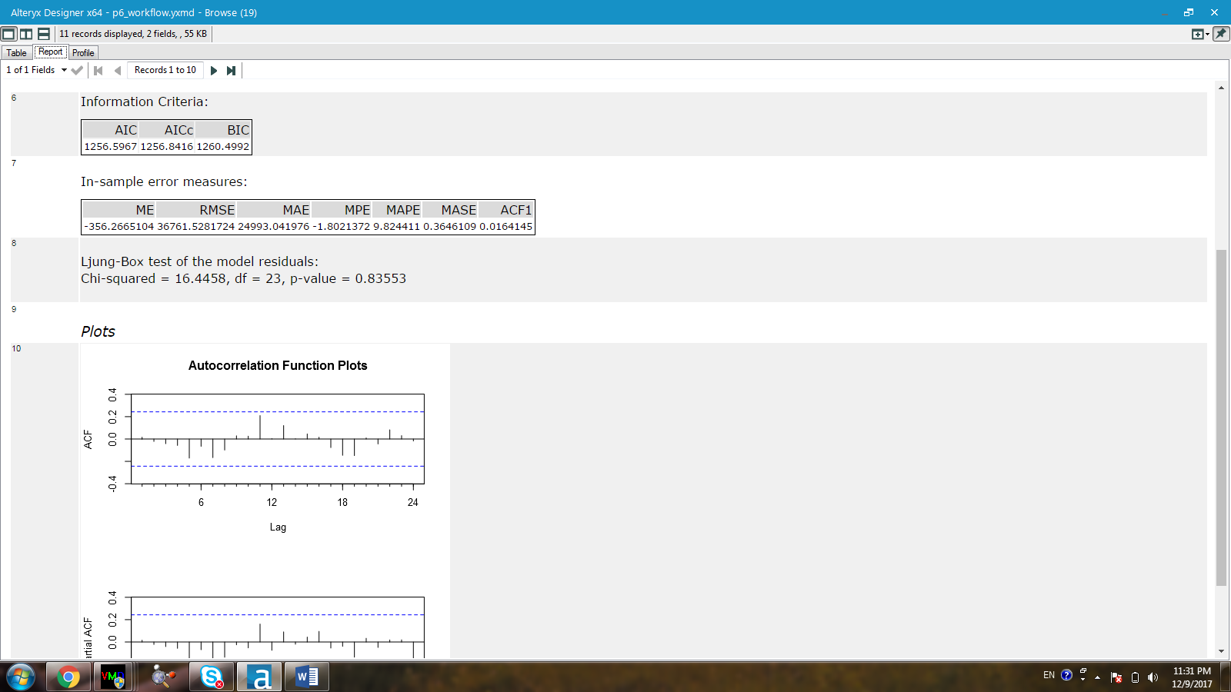

Figure 16. Information criteria and in-sample error measures for ARIMA (0,1,1)(0,1,0)12

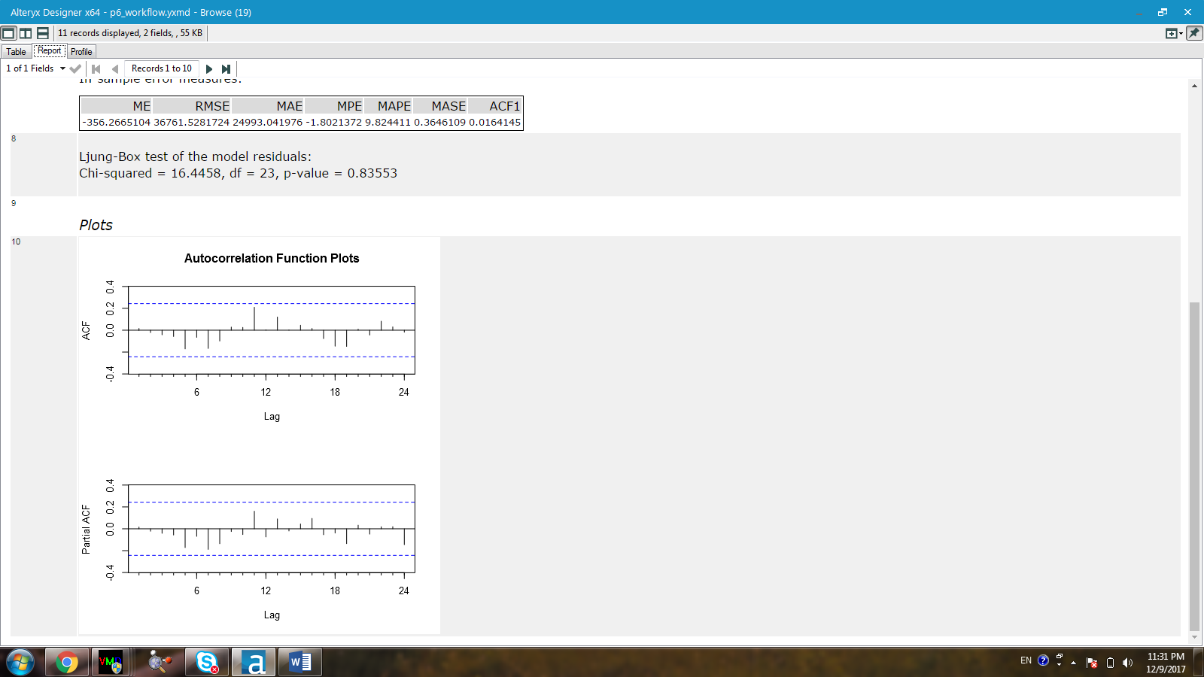

Figure 17. ACF and PACF plots for the ARIMA (0,1,1)(0,1,0)12

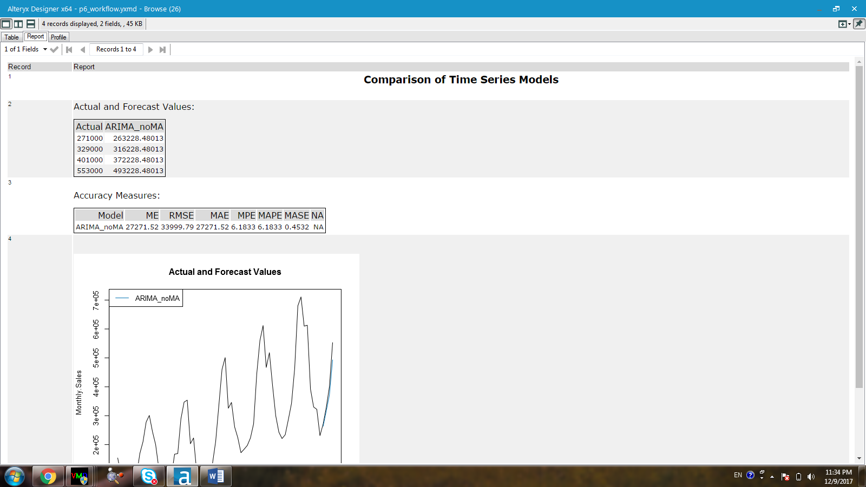

Figure 18. Forecast values and accuracy measures for the ARIMA (0,1,1)(0,1,0)12

The RMSE and MASE values obtained from the in-sample error measures for the ARIMA (0,1,1)(0,1,0)12 are 36761.5 and 0.365 respectively.

## ***Step 4: Forecast***

1. Which model did you choose? Justify your answer by showing: in-sample error measurements and forecast error measurements against the holdout sample.

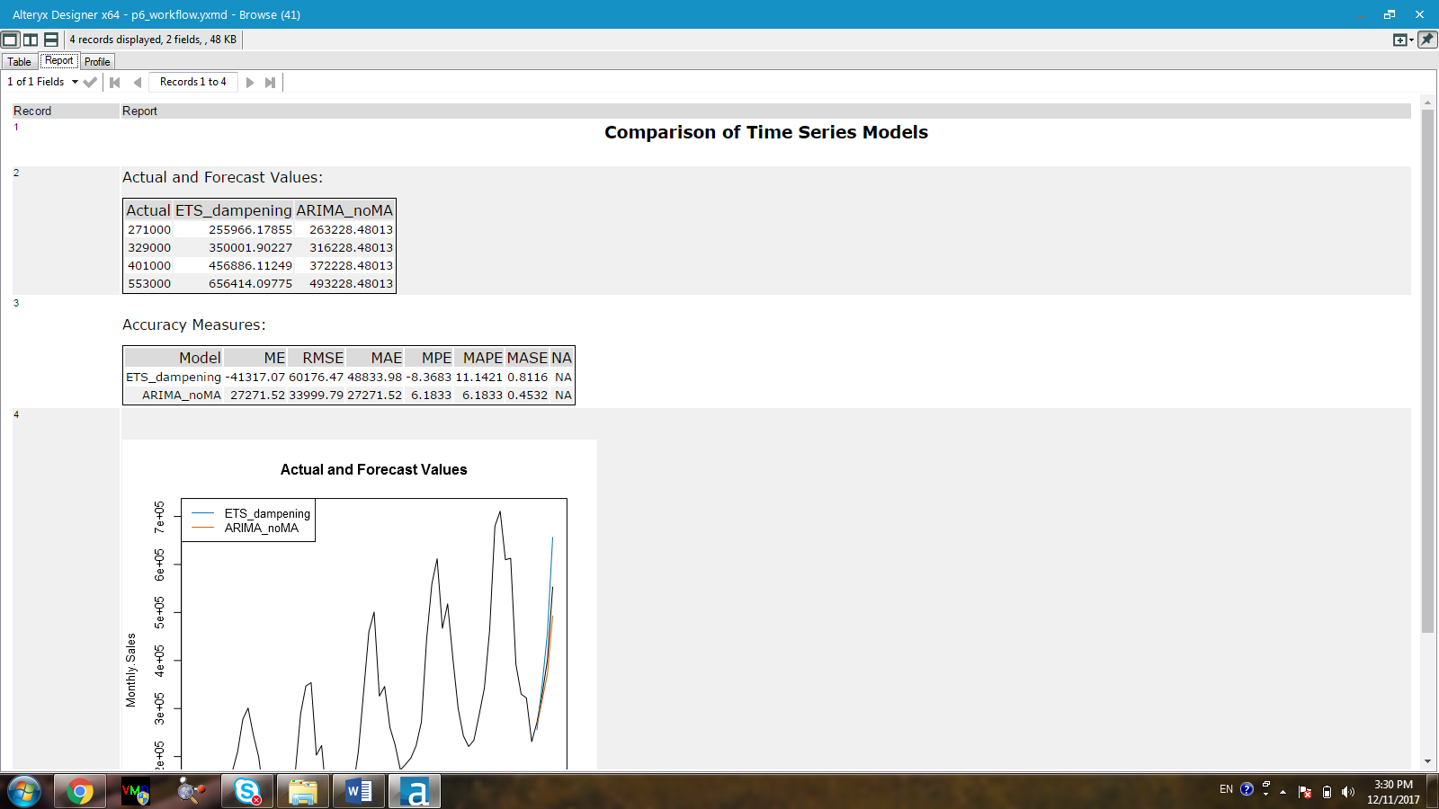

Figure 19. In-sample error measures and accuracy measures of the dampened ETS vesus the ARIMA model using the holdout sample.

The ARIMA (0,1,1)(0,1,0) model is chosen over the dampened ETS due to its higher accuracy in predicting the monthly sales for the hand-out samples. The RMSE value of the dampened ETS model is 60176.47, which is much higher than that of the ARIMA model, 33999.79. In addition, the MASE value of the ARIMA model (0.4532) is much lower than that of the ETS model (0.8116).

1. What is the forecast for the next four periods? Graph the results using 95% and 80% confidence intervals.

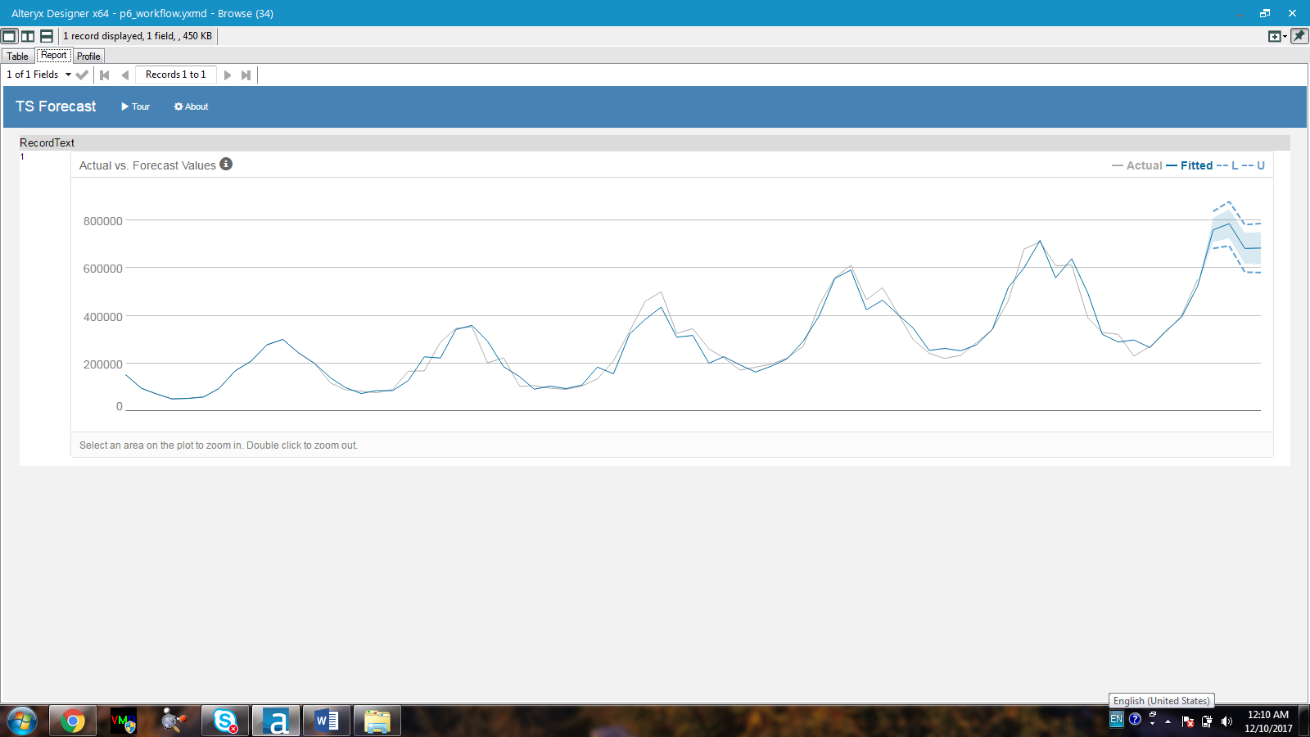

Figure 20. Forecast values for the next 4 months using 95% and 80% CI.

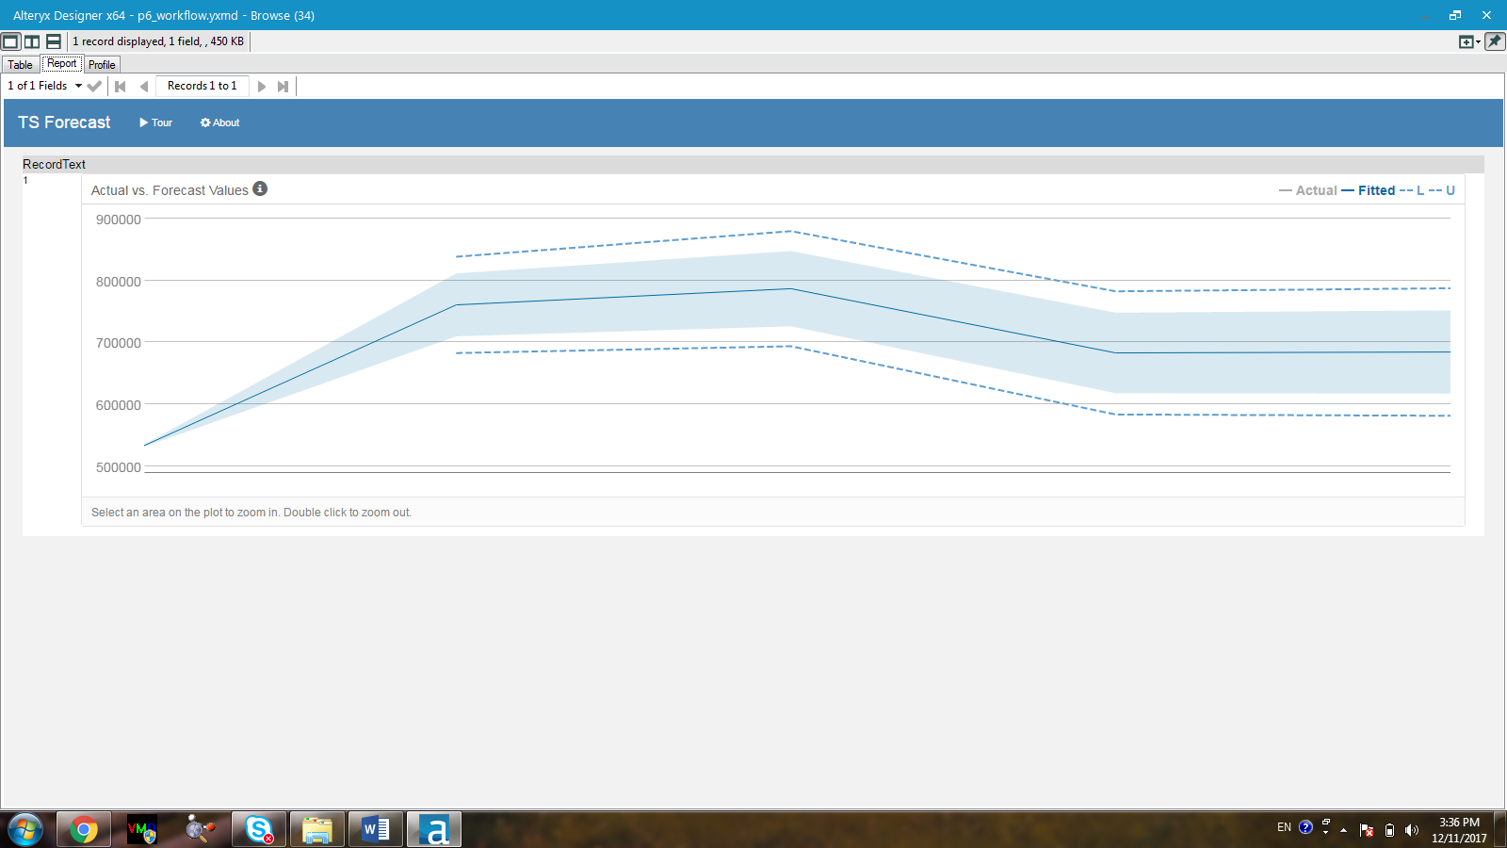

Figure 21. Zoom-out version of the forecast values for the next 4 months using 95% and 80% CI.

The forecast values for the next 4 months are:

|  |  |
| --- | --- |
| Oct-13 | 760617.2 |
| Nov-13 | 786812.7 |
| Dec-13 | 683059.1 |
| Jan-14 | 684481 |

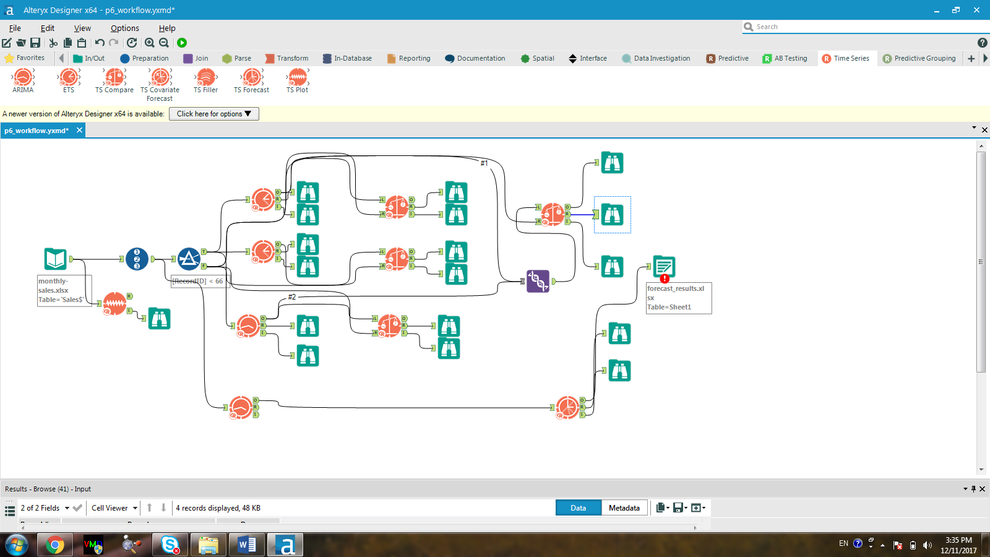

Full Alteryx workflow