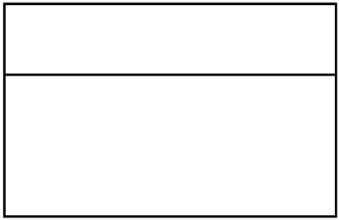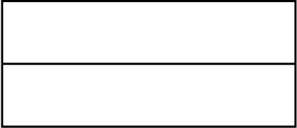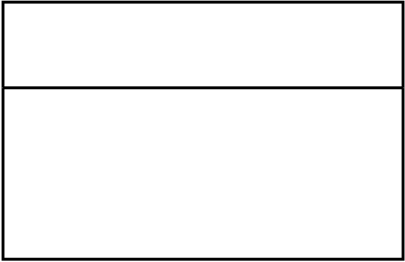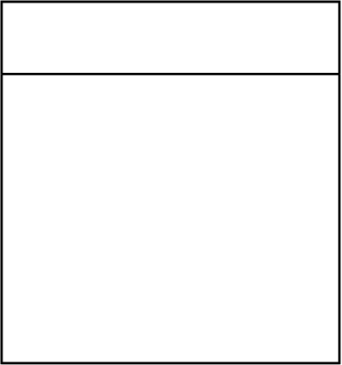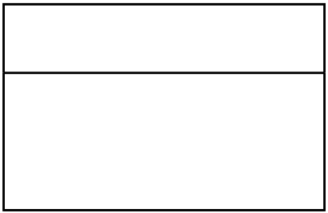

|  |  |  |  |  |  |
| --- | --- | --- | --- | --- | --- |
| name: | Customer | Order | | price: | Item |
| String | oderId: | int |
| phone: | String | orderType: OderType | | float |

pickupTime: Date

address: String

deliveryTime: Date

Pizza

|  |  |  |  |  |  |
| --- | --- | --- | --- | --- | --- |
| size: | String | type: | Topping | brand: | Drink |
| crustType: | String | String |
| String |
| numToppings: int | | flavor: | String |
| price: | float |
| name: | String |

