**ECCS 1621 – Programming 2**

**Lab 3 Part A – Easter Sunday Calculation**

**Lab 3 Part B – Properties of Triangles**

**Due 9 February 2021**

**P3-A** Easter Sunday is the first Sunday after the first full moon of spring. To compute the date, you can use this algorithm, invented by the mathematician Carl Friedrich Gauss in 1800:

1.  Let y be the year (such as 1800 or 2001).

2.  Divide y by 19 and call the remainder a. Ignore the quotient.

3.  Divide y by 100 to get a quotient b and a remainder c.

4.  Divide b by 4 to get a quotient d and a remainder e.

5.  Divide 8 * b + 13 by 25 to get a quotient g. Ignore the remainder.

6.  Divide 19 * a + b - d - g + 15 by 30 to get a remainder h. Ignore the quotient.

7.  Divide c by 4 to get a quotient j and a remainder k.

8.  Divide a + 11 * h by 319 to get a quotient m. Ignore the remainder.

9.  Divide 2 * e + 2 * j - k - h + m + 32 by 7 to get a remainder r. Ignore the quotient.

10. Divide h - m + r + 90 by 25 to get a quotient n. Ignore the remainder.

11. Divide h - m + r + n + 19 by 32 to get a remainder p. Ignore the quotient.

Then Easter falls on day p of month n. For example, if y is 2001:

a = 6 h = 18 n = 4

b = 20, c = 1 j = 0, k = 1 p = 15

d = 5, e = 0 m = 0

g = 6 r = 6

Therefore, in 2001, Easter Sunday fell on April 15. Write a program that uses a textfield to prompt the user for a year and subsequently displays the month and day of Easter Sunday for that year on a label. Please include a check to ensure that a numeric value is entered in the textfield, with a dialog popping up to properly shame the user if this is not the case.

**P3-B** For this program, you will perform calculations with triangles. A triangle is defined by the x- and y-coordinates of its three corner points. Your job is to compute the following properties of a given triangle:

* the lengths of all sides
* the angles at all corners
* the perimeter
* the area

Create your interface to look like the following (**but does not need to be exactly the same**); be sure to use meaningful widget names where appropriate.

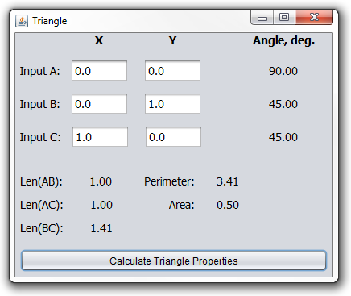

The only event handler needed is with the “Calculate Triangle Properties” button.

Implement the class Triangle with appropriate methods. Specify the pertinent interface information (e.g. pre- and post-conditions) for all public methods in the Triangle class. Supply a program that prompts a user for the triangle’s corner point coordinates and produces a nicely formatted table of the triangle properties.

HINTS:

1. Use double as your data type.
2. Use DecimalFormat such that all numeric output is given to two digits past the decimal point.
3. To calculate angles and area of triangles described by the lengths of all three sides:
   1. Law of Cosines: <https://www.mathsisfun.com/algebra/trig-solving-sss-triangles.html>
   2. Heron’s Formula: <https://www.mathsisfun.com/geometry/herons-formula.html>
4. Use the distance formula between two points for calculating all of your side lengths.
5. Within the Triangle class, write a helper function for calculating the length between two points.
6. Within the Triangle class, write a helper function for calculating the angle at a point, which is also the angle OPPOSITE the line connecting the OTHER two points (i.e., Law of Cosines).