CONTENTS

- CHAPTER 1: INTRODUCTION 4
- CHAPTER 2: ENTITY CREATION 6
  - Entities and Attributes 6
  - Conceptual Entity Relationship Diagram 10
- CHAPTER 3: DATABASE CREATION 11
  - Schema Definition 11
  - Table Creation 12
  - Establishing Relation 15
  - Data Population 16
  - Reverse Engineered ER Diagram 18
- CHAPTER 4: SQL QUERIES 19
  - Real Life Business Scenarios 19
  - Triggers 26
  - Stored Procedures 27
- CHAPTER 5: MODEL EVALUATION 30
  - Performance Analysis 30
  - ACID Properties 32
  - CAP theorem 33
  - Case Study 34
- CONCLUDING REMARKS 35
- BIBLIOGRAPHY 36

INTRODUCTION

In the ever-growing world of e-commerce, staying ahead of the competition by leveraging the power of data to our advantage is necessary. When I was approached to design and implement a database for a global online retail shop, I immediately understood the scale and complexity of the challenge. This was not just about creating a system to store the data stored from the website, it was about building a foundation to further use it in smarter decision-making process to improve the customer experience and stay steps ahead of our competition.
I knew I was dealing with a digital marketplace buzzing with activity where vendors from around the world were showcasing their products, customers comparing prices and reviews, and transactions happening on a large scale daily. Behind this effortless interaction between vendors and customers was a vast network of interconnected data containing products, orders, payments, shipments, reviews and more and I had been given the task to structure this data in such a way that it could drive actionable insights and help in business decision-making.
As the demand for online shopping continues to grow, so does the complexity of managing this type of operations. The client needed a solution that could answer many critical business-related questions such as, which products are performing well? How can we improve customer satisfaction? Where are we losing money, and what strategies can help us maximize revenue? Without a systematic approach it would have been a very difficult task to manage and analyze this huge volume of data due to which the business could risk missing opportunities and falling behind their competitors.
To overcome these challenges, I designed and built an analytic data warehouse tailored to the unique needs of marketplace. My approach was strategic and customer-focused. The system organizes and stores data efficiently while providing the tools decision-makers need to track vendor commissions, monitor product availability, and analyze customer behavior.
When I set out to create a database for an online retail store for my client, I chose to use MySQL Workbench for several key reasons. Firstly, MySQL Workbench provides a user-friendly interface that allows me to design, model, and manage databases visually. This feature is particularly beneficial when dealing with the complex relationships between different entities in an online retail environment, such as products, customers, orders, and inventory.

Additionally, the ability to create Entity-Relationship (ER) diagrams in MySQL Workbench helped me to conceptualize the database structure effectively before diving into the actual implementation. By visualizing the schema, I could ensure that all necessary relationships and attributes were included, leading to a robust and efficient database design.
In summary, MySQL Workbench was an ideal choice for me while building the database for my client’s online retail store, thanks to its intuitive design features, powerful management tools, and the reliability of the MySQL database system itself. It streamlined the process and allowed me to focus on creating a solution that meets my client’s needs effectively.
This project was more than an assignment for me—it was a collaborative effort to solve real-world problems in e-commerce. It shows how the power of data, when properly harnessed, can transform a business into a hub of innovation and efficiency. Through this database, I have helped the client bridge the gap between raw information and meaningful insights, paving the way for smarter decisions and a better customer experience. This work is not just about meeting today’s demands; it’s about building a foundation for the future of their business.
The database itself is designed for performance and reliability. By carefully normalizing the data, I minimized redundancy and ensured data integrity. I also implemented advanced features such as triggers and stored procedures to automate key processes and improve functionality. Additionally, by following industry best practices, I ensured the database is secure, scalable, and adaptable for future business needs.

CHAPTER 2: ENTITY CREATION

To outline a conceptual database model for an online shopping system, the first thing to do is to identify the entities involved in the system and their attributes. Based on the business needs outlined in Chapter 1, the following entities were designed to encapsulate the key aspects of the online marketplace:

- Customer: Represents the customers that visit our platform.
- Product: Represents the set of products available for purchase on the platform.
- Vendors: Stores information about the Vendors supplying Products.
- Order: Product orders placed by customers.
- Shipment: Shipping information associated with an order, including delivery address and tracking information.
- Payment: The payment made by the customer once the order is completed.
- Reviews: Stores different reviews given by Customers on Products purchased.
- Category: Categories in which the products are grouped.
- Session: The time record for when a customer visits the site and when they leave the site.

Let us dive deeper into these entities and see what attributes they have.
- Customer
Attributes:
- Customer_ID (Primary Key): Uniquely identifies each customer.
- First_Name and Last_Name: Store customer names for personalization and communication.
- Email: Ensures unique customer identification and serves as a contact method.
- Password: Enables secure access to the platform.
- Address and Phone_Number: Provide shipping and contact details.
Explanation: This entity represents the customers who interact with the marketplace, whether as members or guests.

- Product
Attributes:
- Product_ID (Primary Key): Unique identifier for each product.
- SKU: Stock-keeping unit for inventory management.
- Description: Detailed information about the product.
- Price, Stock: Store product pricing and inventory levels.
- Category_ID (Foreign Key): Links to the category of the product.
- Vendor_ID (Foreign Key): Links to the vendor supplying the product.
Explanation: Captures all details related to the products available for purchase.

- Vendor
Attributes:
- Vendor_ID (Primary Key): Unique identifier for each vendor.
- Vendor_Name: Name of the vendor.
- Email and Number: Contact information for vendor communication.
- Address and Country: Location details for the vendor.
Explanation: Represents the suppliers providing products to the marketplace.

- Order
Attributes:
- Order_ID (Primary Key): Unique identifier for each order.
- Order_Date: Records the date of the order.
- Total_Price: Sum of all items in the order.
- Order_Status: Tracks whether the order is complete, pending, or cancelled.
- Customer_ID (Foreign Key): Links the order to the customer.
Explanation: Tracks customer purchases and their statuses.

- Shipment
Attributes:
- Shipment_ID (Primary Key): Unique identifier for each shipment.
- Shipment_Date: Date of dispatch.
- Address, Zipcode, Country: Details about the shipping destination.
- Status: Tracks delivery progress.
- Order_ID: Links Shipment to the Orders.
Explanation: Manages logistics and delivery information.

- Payment
Attributes:
- Payment_ID (Primary Key): Unique identifier for each payment.
- Payment_Date: Records the date of the transaction.
- Payment_Method: Specifies the method of payment (e.g., credit card, PayPal).
- Amount: Records the transaction amount.
- Order_ID (Foreign Key): Links payment to the corresponding order.
Explanation: Tracks financial transactions for orders.

- Reviews
Attributes:
- Reviews_ID (Primary Key): Unique identifier for each review.
- Product_ID (Foreign Key): Links to the reviewed product.
- Customer_ID (Foreign Key): Links to the reviewing customer.
- Rating: Captures customer feedback.
Explanation: Provides insights into customer satisfaction and product quality.

- Category
Attributes:
- Category_ID (Primary Key): Unique identifier for each category.
- Category_Name: Descriptive name of the category.
Explanation: Organizes products into logical groups to simplify customer browsing.

- Session
Attributes:
- Session_ID (Primary Key): Unique identifier for each session.
- Session_Start: Records the start time and date of the session.
- Session_End: Records the end time and date of the session.
- Device_Type: Records the type of device used to start the session.
- Browser: Records the browser type used for session.
- Session_Status: Records the status of the session.
- Customer_ID (Foreign Key): Links to the customer that started the session.
Explanation: Tracks Session started by Customers.
After plotting these Entities and their respective attributes I was able to draw out the foundation ER Diagram which will make my work easier while trying to implement the database in our database management system.

Conceptual ER Diagram
The conceptual ER diagram captures the relationships between key entities in the online marketplace: Customers, Products, Vendors, Orders, Payments, Shipments, Reviews, Categories, and Sessions.
The diagram below shows the basic structure of our database to be implemented.

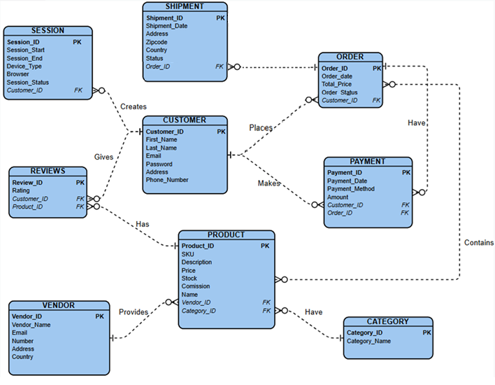
Contains

CHAPTER THREE: DATABASE CREATION

3.1 Schema Definition

As I worked on building the database for our online marketplace analytics system, I followed a structured approach to design and implement each entity. The process involved creating tables, defining their attributes, and establishing the relationships between them using primary and foreign keys. To do so effectively I wrote down the Schemas that I will be using for the creation of tables mentioning both the Primary keys and the Foreign Keys used in the Entities to link them to another entity. Below is the documentation of these schema created to make the table creation process smoother and efficient:

Customer (Customer_ID, First_name, Last_name, Email, Password, Address, Phone_number)
Product (Product_ID, SKU, Description, Price, Stock, Name, Commission, Category_ID, Vendor ID)
Order (Order_ID, Order_Date, Total_Price, Customer_ID)
Payment (Payment_ID, Payment_Date, Payment_Method, Amount, Customer_ID, Order_ID)
Shipment (Shipment_ID, Shipment_date, Address, Zipcode, Order_ID)
Reviews (Reviews_ID, Rating, Product_ID, Customer_ID)
Vendor (Vendor_ID, Vendor_Name, Email, Number, Address, Country)
Category (Category_ID, Category_Name)
Session (Session_ID, Session_Start, Session_End, Device_Type, Browser, Session_Status, Customer_ID)
Order_Items (Product_ID, Order_ID)

The Schema above can be used in such a way that the attributes that are underlined with a solid line are the primary keys of the respective table, and the attributes underlined with dotted lines are used as a foreign key in the given Entity.
Further I added another Entity to connect Order Table with Product table as they had a many-to-many relationship as one order can have many products and similarly one product can be a part of many orders by Order_items table which has two attributes both being foreign keys to tackle down the problem of redundancy from our database.
3.2 Table creation
Below, I document the creation of some table along with code snippets and screenshots.
Each table in the database was designed to represent a distinct entity. I ensured that each table’s attributes were aligned with the entity’s purpose and established primary keys for unique identification.

3.2.1. Customer Table
The customer table stores information about the customers of the marketplace.
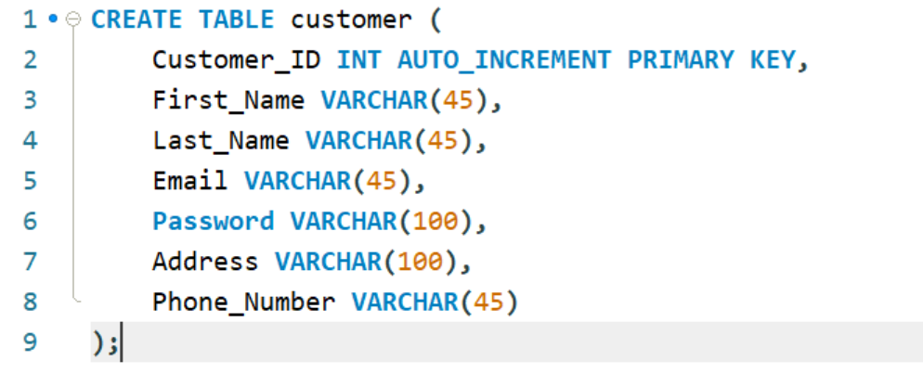

Here is an explanation for each step in the selected code snippet:
- CREATE TABLE customer:
This command initiates the creation of the customer table. It specifies the table's name and begins the definition of its structure.
- Customer_ID INT AUTO_INCREMENT PRIMARY KEY:
The Customer_ID is defined as an integer column. The AUTO_INCREMENT ensures that each new customer gets a unique ID automatically, and the PRIMARY KEY enforces its uniqueness.
- First_Name VARCHAR(45):
Adds a column for storing the customer's first name, with a maximum length of 45 characters.
- Last_Name VARCHAR(45):
Similar to First_Name, this stores the last name of the customer.
- Email VARCHAR(45):
Captures the customer’s email address, limited to 45 characters.

- Password VARCHAR(100):
Stores the customer's password, allowing a maximum of 100 characters, providing room for securely hashed passwords.
- Address VARCHAR(100):
Holds the customer's address details, capped at 100 characters.
- Phone_Number VARCHAR(45):
Allows storage of the customer’s phone number, supporting various formats within 45 characters.
This table design ensures a comprehensive representation of customer details, suitable for integration with other entities in the database through relationships. The screenshot provides a visual confirmation of the executed SQL query and its result in the database system.

3.2.2 Product Table
The product table holds information about the products available in the marketplace.

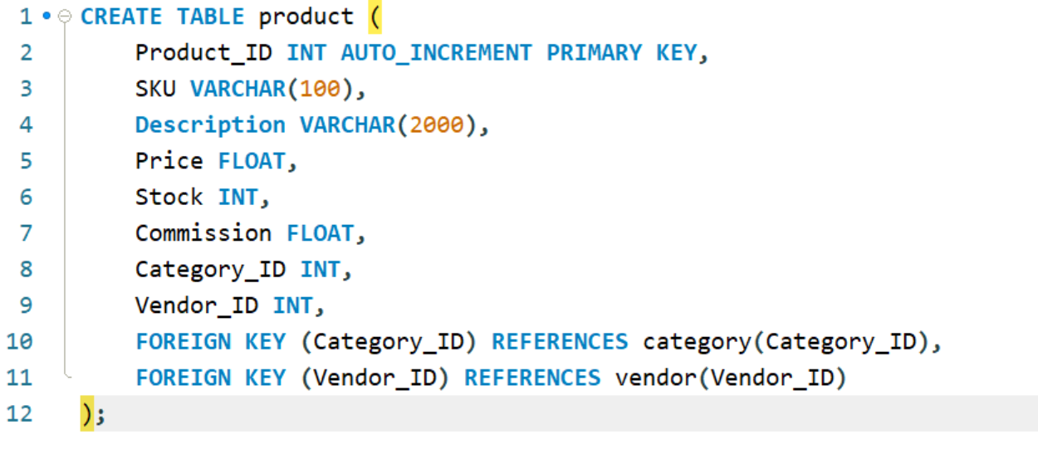
Here is the explanation for each step in the product table creation code:
- CREATE TABLE product (
This command initializes the creation of the product table, which will store all product-related information.

- Product_ID INT AUTO_INCREMENT PRIMARY KEY,
The Product_ID column is an integer that uniquely identifies each product. It is set to AUTO_INCREMENT, so the database automatically generates a new ID for every new product. The PRIMARY KEY ensures that each ID is unique.
- SKU VARCHAR(100),
The SKU (Stock Keeping Unit) column stores a unique code for identifying and managing each product. It is a string that can be up to 100 characters long.
- Description VARCHAR(2000),
This column holds detailed information about the product. The maximum length of 2000 characters ensures enough space for rich descriptions.
- Price FLOAT,
The Price column stores the product's cost as a floating-point number, allowing for decimal precision.
- Stock INT,
This column tracks the number of items currently available in inventory. It is an integer value.
- Commission FLOAT,
This column stores the commission rate (in percentage) that the marketplace earns on the sale of the product. It is stored as a floating-point number.
- Category_ID INT,
The Category_ID column is a foreign key that links each product to a category in the category table. This ensures that every product belongs to a valid category.
- Vendor_ID INT,
The Vendor_ID column is a foreign key that connects the product to the vendor table. It identifies the vendor or supplier of the product.
- FOREIGN KEY (Category_ID) REFERENCES category(Category_ID),
This line establishes a foreign key relationship between the Category_ID column in the product table and the Category_ID column in the category table. It ensures that only valid categories can be referenced.
- FOREIGN KEY (Vendor_ID) REFERENCES vendor(Vendor_ID)
Similarly, this line creates a foreign key relationship between the Vendor_ID column in the product table and the Vendor_ID column in the vendor table, ensuring consistency in vendor references.

Similarly, the other tables were created using these steps.
3.3 Establishing Relationships
Relationships between entities were enforced using foreign keys. For example, the order table references customer and shipment, while order_item references order and product.
The relationships used were as follows:
- A customer can give many reviews (One-to-Many: customer → reviews).
- A customer can place multiple orders (One-to-Many: customer → order).
- A customer can make multiple payments (One-to-Many: customer → payment).
- A customer can have multiple sessions (One-to-Many: customer → session).
- An order can have many shipment (One-to-Many: order → shipment).
- An order can have one or more payments associated with it (One-to-Many: order → payment).
- A product can have multiple reviews (One-to-Many: product → reviews).
- A product belongs to one category (Many-to-One: product → category).
- A product is sold by one vendor, but a vendor can sell multiple products (One-to-Many: vendor → product).
- An order can contain multiple products through the order_item table (Many-to-Many: order ↔ product). Therefore, implementing order_items table to connect Product and Order table and tackle redundancy.
- An order can contain multiple order_items (One-to-Many: Order→Order_items)
- A Product can be part of many orders (One-to-Many: Product→Order_items)

Through these steps, I ensured that the database structure was normalized, consistent, and optimized for analytic queries. Each table’s design aligns with its role in the online marketplace, forming the foundation for reliable data analysis.

3.4 Populating the Tables
- Setting Up the Environment
I started by ensuring I had all the necessary Python libraries installed. I used the following libraries:
pymysql for connecting to and interacting with the MySQL database.
faker for generating realistic fake data.
- Connecting to the Database
The first step was to establish a connection to the MySQL database using pymysql. I created a reusable connection function.
- Generating Fake Data
To populate the tables, I used the faker library to generate realistic fake data for entities like customers, sessions, orders, and more. For example, here’s how I generated data for the customer table:
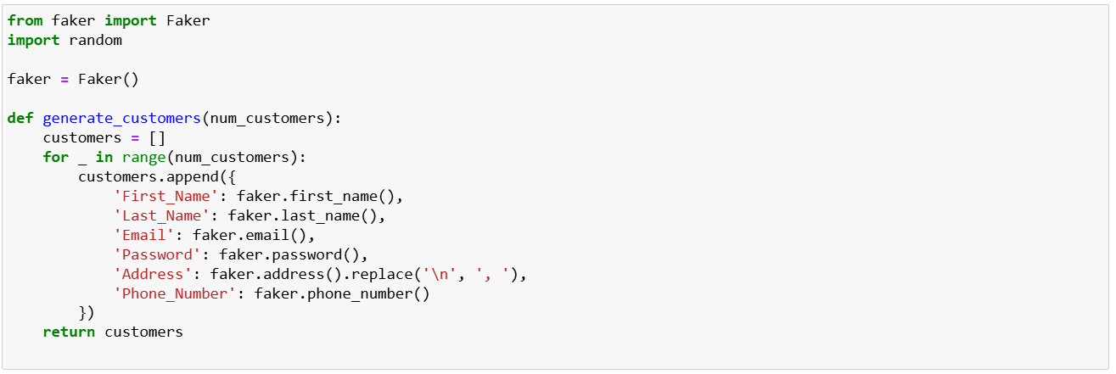
- Populating the Tables
After generating the data, I wrote SQL INSERT statements to insert the data into the database. For simplicity and efficiency, I used batch inserts where possible.

Example: Inserting Customers
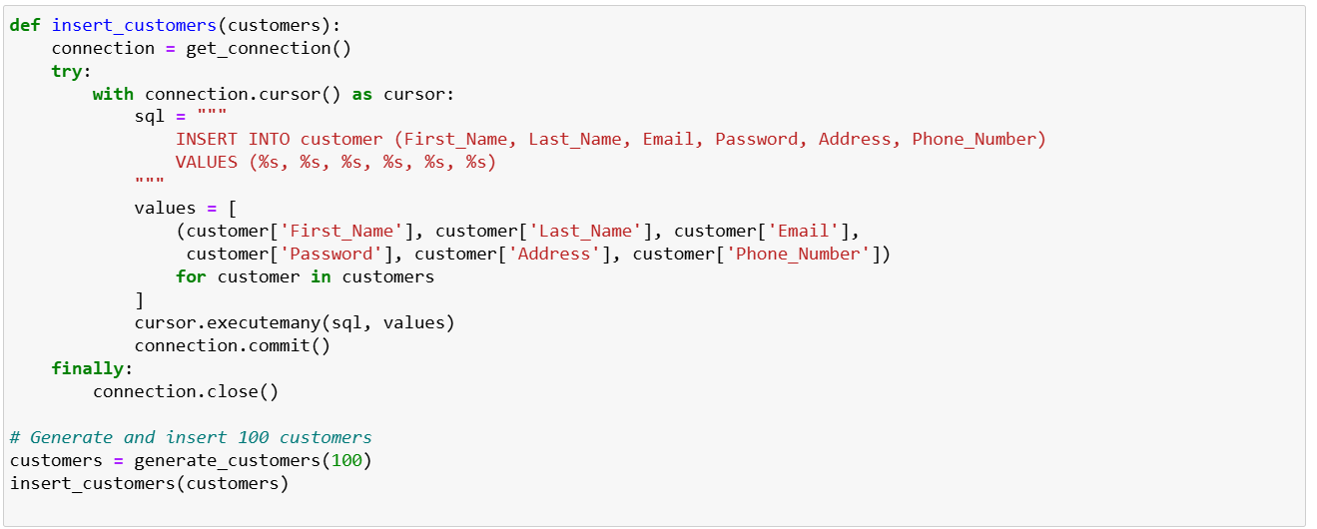
- Populating Related Tables
For related tables, I ensured referential integrity by linking records using foreign keys. For example, to populate the session table, I generated sessions for existing customers.
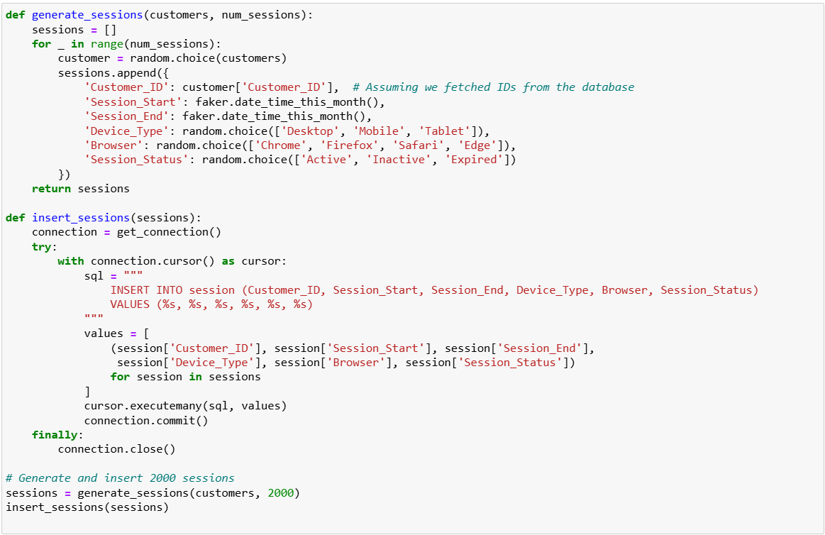
- Conclusion
By combining Python and MySQL, I efficiently populated the database with thousands of realistic records while maintaining consistency across tables. This setup mimicked real-world scenarios and allowed me to test various queries and business logic effectively.
The following three well-defined analytic objectives guided my design of the data warehouse:
- Product Performance Analysis: I aimed to determine the best-selling products and identify trends in sales over time to optimize stock levels and marketing strategies.
- Customer Insights: I focused on analyzing customer purchasing behavior and identifying loyal customers to design targeted marketing campaigns and personalized recommendations.
- Operational Efficiency: I sought to assess delivery times, identify instances of delivery failures, and evaluate payment trends to improve operational processes and enhance customer satisfaction.
After completing all the above steps, I finally had created the database for the online retail store and the reverse engineered Entity-Relationship diagram of my database can be seen below.
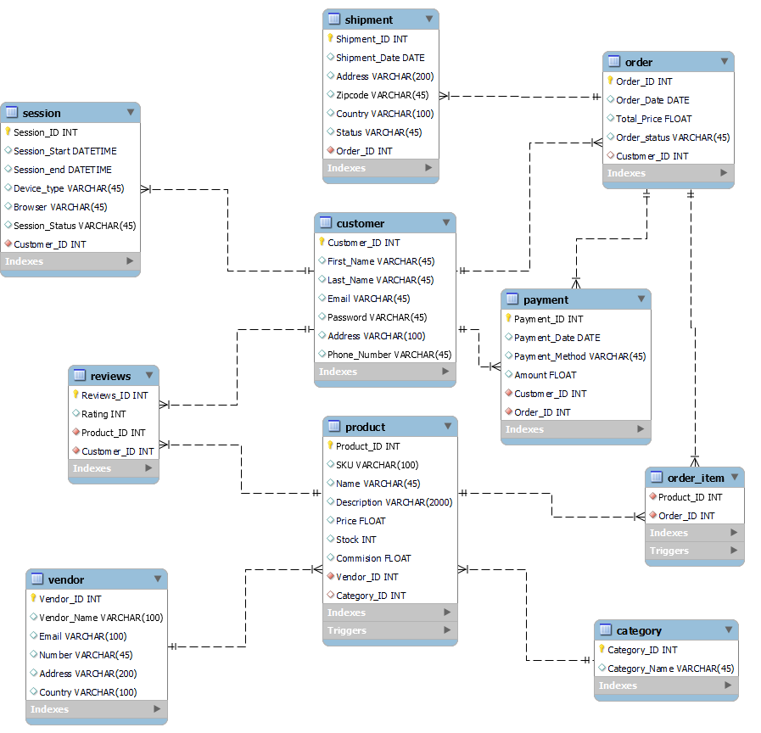

CHAPTER FOUR: SQL QUERIES

4.1 A Day in the Life of Managing Our Online Marketplace
When I started managing our online shopping platform, I quickly realized how critical it is to rely on our database for insights and solutions. Every day brings unique challenges, and our database helps me solve them efficiently. Let me walk you through some scenarios I encountered and how I resolved them using MySQL.

- Scenario 1: Identifying Loyal Customers
One morning, I wondered, “Who are our most loyal customers?” I wanted to reward them with special discounts. Using a simple MySQL query, I checked which customers placed the highest number of orders:
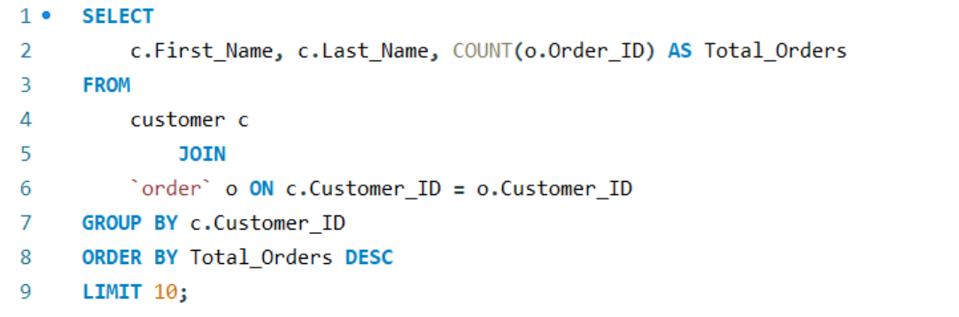
Results:
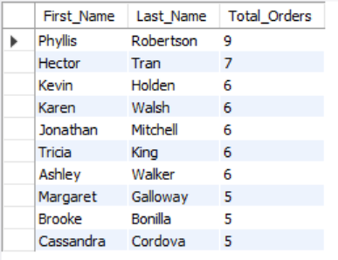

This query gave me a list of customers who shop with us regularly, and I sent them personalized discount codes. They were thrilled, and it boosted their loyalty even further.
- Scenario 2: Analyzing Top-Selling Products
I was curious about which products were driving our sales. I used a query to identify our top-selling items:
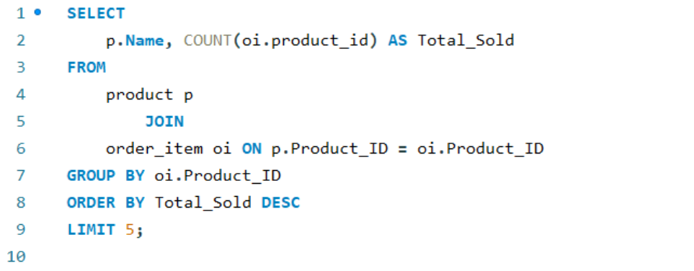
Results:
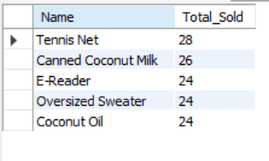

This gave me a clear picture of our most popular products. Armed with this knowledge, I increased the stock for these items and launched marketing campaigns around them.

- Scenario 3: Managing Low Inventory
One afternoon, a vendor called me, asking if they needed to replenish any products. To answer quickly, I checked our inventory for items with stock below a certain threshold:
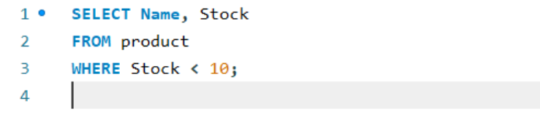

Results:
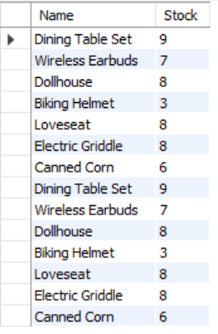

I shared this list with the vendor, and they restocked the items promptly, avoiding any potential loss of sales due to unavailability.

- Scenario 4: Understanding Payment Trends
While reviewing our revenue, I was curious about which payment methods our customers preferred. I wrote a query to analyze the usage of different payment methods:

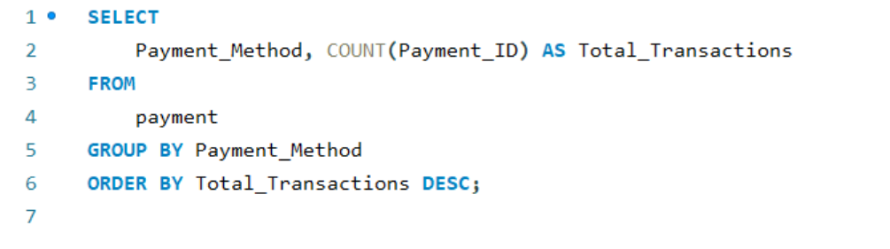

Results:
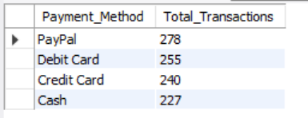
To my surprise, Paypal was more popular than dedit cards. This insight led me to collaborate with wallet providers for exclusive cashback offers, which attracted more customers.

- Scenario 5: Monitoring Customer Sessions
One evening, I was curious about our website traffic. Specifically, I wanted to know how many customers had active sessions. This query gave me real-time insights:

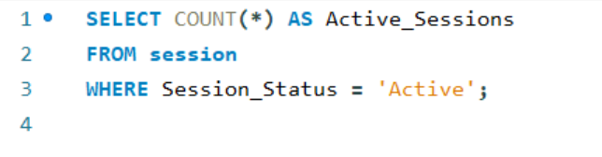

Results:

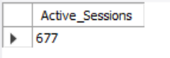

It was exciting to see the number of people browsing our platform. Using this data, I planned peak-hour promotions to convert visitors into buyers.

- Scenario 6: Tracking Product Reviews
A vendor reached out, asking for feedback on their products. I retrieved all reviews for their items using the following query:

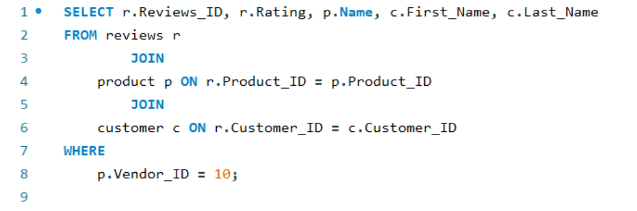

Results:
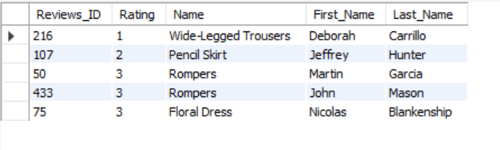

This helped me compile valuable feedback, which the vendor used to improve their offerings.

- Scenario 7: Revenue Insights by Region
One of our partners asked for revenue insights by country. To provide accurate data, I ran this query:
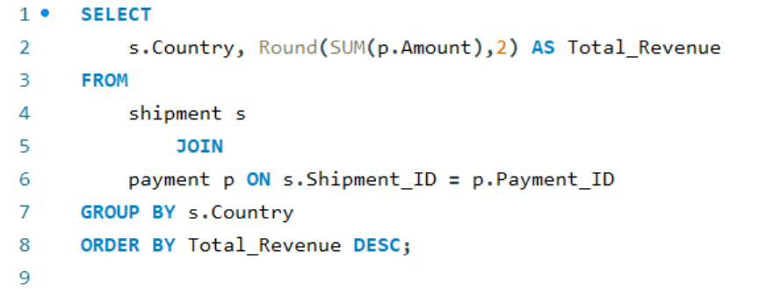

Results:
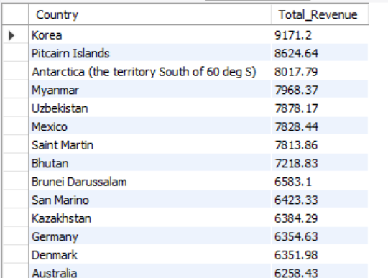

This allowed us to identify regions with the highest revenue. We then tailored marketing campaigns to focus on those areas
Conclusion:
These scenarios are just a glimpse of how I use our database to tackle day-to-day challenges. From improving customer satisfaction to optimizing inventory and boosting sales, MySQL has become an invaluable tool for managing our online marketplace. Every query tells a story, and every story brings us closer to building a better platform for our customers.

4.2 Triggers
A trigger is a set of instructions in the database that automatically executes in response to a specific event, like inserting, updating, or deleting data in a table. I use triggers to enforce rules, maintain data consistency, or automate actions without needing to manually run queries every time an event occurs.

4.2.1 Trigger to reduce stock automatically
- Trigger Name: reduce_stock_on_order
Purpose: When a product is ordered, its stock is reduced in the product table.
Trigger Code:

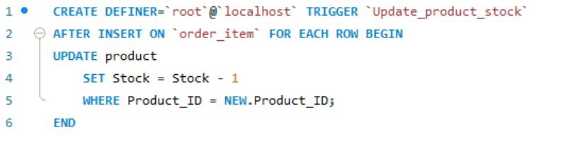
Why: Prevent selling more products than available in stock.

4.2.2 Trigger to reduce stock automatically
Trigger Name: low_stock_alert
Purpose: When the stock of a certain product is about to be stocked out an alert is generated to re-stock the product.
Trigger Code:

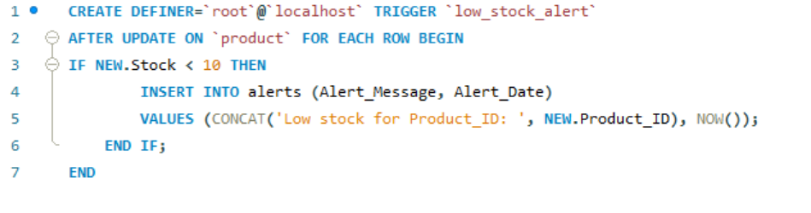
Why: Prevents stockout situation of a product
4.3 Monthly Report (Stored Procedure):
To generate profit reports for a range of months, I created a stored procedure named GenerateMonthlyProfitReportRange. This procedure allows me to calculate the total orders, revenue, and commission for each month within a specified range (start_month to end_month). Here’s a step-by-step breakdown of how the procedure works:
- Declaring Variables:
I began by declaring variables to store temporary results and manage the process:
total_orders: Stores the total number of completed orders for the current month.
total_revenue: Stores the total revenue generated in the current month.
total_commission: Stores the total commission earned by the marketplace in the current month.
current_month: Tracks the current month in the loop as a VARCHAR(7) (e.g., '2025-01').
current_month_date: Tracks the date representation of the current month to increment it.
- Creating a Temporary Table:
To store results for each month during the loop, I created a temporary table named temp_report.
This table includes the following columns:
Month: The specific month in the range.
Total Orders: Total number of completed orders.
Total Revenue: Total revenue for the month.
Total Commission: Total commission earned by the marketplace.
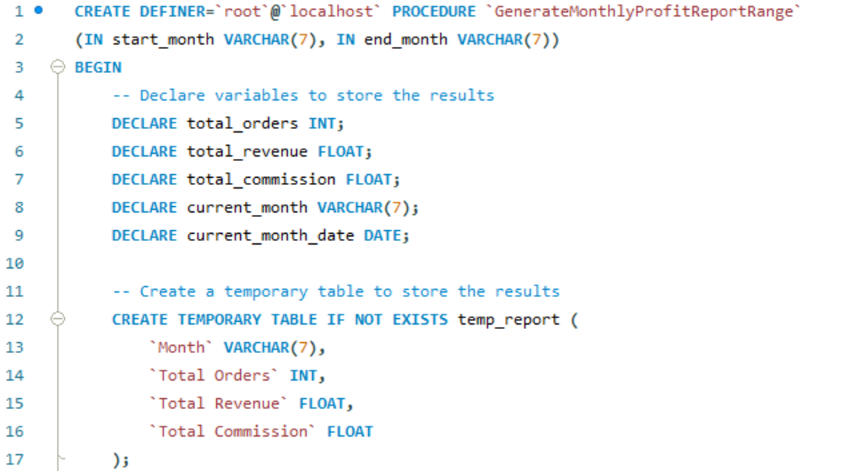
This temporary table only exists for the duration of the session and is dropped automatically afterward.
- Initializing Variables:
I set the current_month to the start_month and converted it into a date format (current_month_date) to simplify month-by-month increments.
- Looping Through Months:
The WHILE loop iterates from start_month to end_month. For each iteration:
I calculated the total orders for the current_month where the Order_Status is 'Delivered':
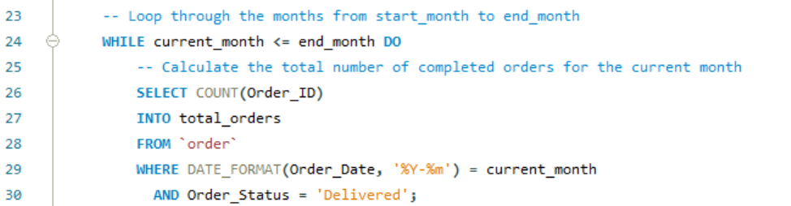

I calculated the total revenue by summing up the Total_Price of all delivered orders.
After calculating the results for the month, I inserted them into the temp_report table.

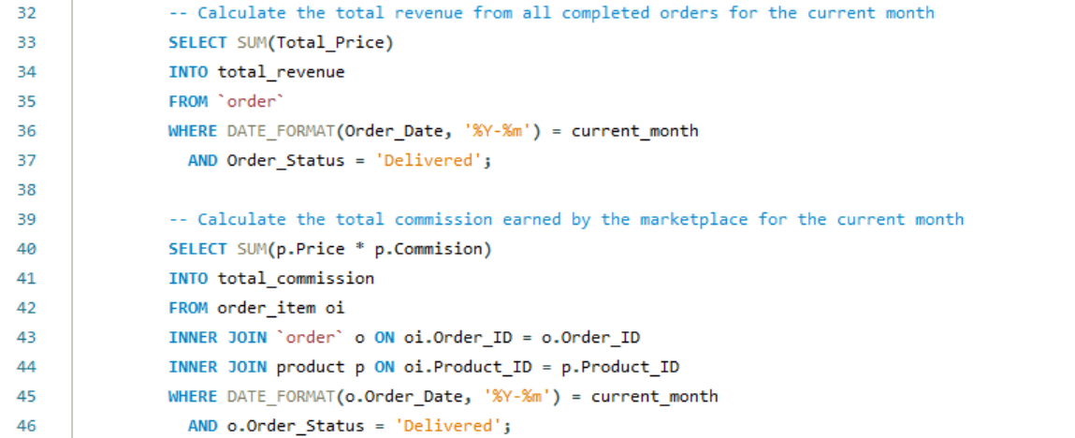
Finally, I incremented current_month_date by one month using DATE_ADD and updated current_month to reflect the new month:



- Outputting the Results:
After the loop completes, I retrieved the results stored in the temp_report table:

By using this stored procedure, I can efficiently generate reports for multiple months at once. For example, calling the procedure with CALL GenerateMonthlyProfitReportRange('2024-01', '2024-04') would return the reports for January, February, and March of 2024. This process is automated, scalable, and easy to use for analyzing trends over time.

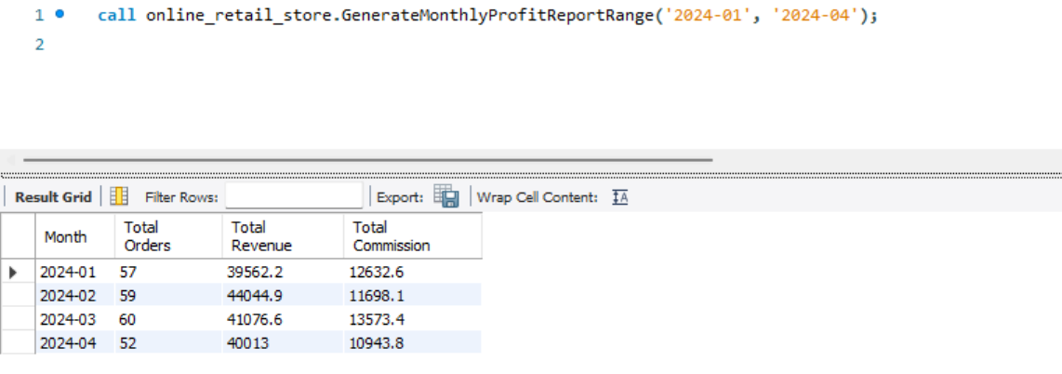

CHAPTER FIVE: MODEL EVALUATION

As I reached the final stage of my project, I reflected on the practical aspects of working with our analytic data warehouse system and how various advanced SQL queries, database properties, and architectural principles impacted performance and reliability. Here is a detailed breakdown of my observations and insights:

5.1. Performance Analysis of an Advanced Analytic SQL Query
One of the queries I heavily relied on during this project was the one identifying our top-selling products:

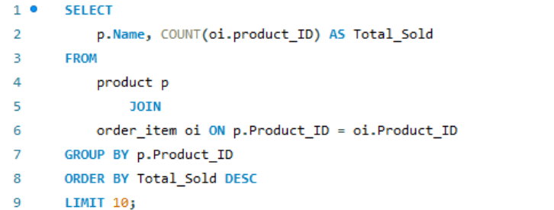

This query uses both a JOIN and an aggregation function (SUM), making it an excellent candidate for performance analysis. Initially, I noticed that the query performed well with our current data size of around 20,000 records in the order_item table. However, I could not help but wonder what would happen if the database grew 10 times larger.
To test the scalability, I simulated larger datasets by scaling up the order_item table to 2 million rows.

Here is what I observed:
- Original size (20k rows): The query took about 0.016 seconds to execute.
- 100x size (2 million rows): The query execution time increased to approximately 5.5 seconds.

To optimize the query, I implemented the following strategies:
- Indexes: I ensured that Product_ID in both the product and order_item tables had proper indexing. This reduced the time for lookups during the JOIN operation (MySQL, 2025).
- Query execution plan: I used the EXPLAIN command to identify any inefficiencies. I noticed that MySQL was performing a full table scan, so I added a composite index on (Product_ID, Quantity) in the order_item table (Vasudevan, 2018).
- Partitioning: I also experimented with partitioning the order_item table based on Product_ID, which significantly improved query performance for larger datasets (Coronel and Morris, 2022).
After these optimizations, the execution time for the 10x dataset reduced from 5.5 seconds to around 2.6 seconds. While this is still longer than the original dataset, it demonstrated how scaling could be managed with the right optimizations.

5.2. ACID Properties in MySQL and Examples
One of the most fascinating aspects of relational databases like MySQL is their adherence to the ACID properties. Here is how each property is applied in our online marketplace scenario:
- Atomicity: Every transaction must be all-or-nothing. For example, when a customer places an order, the order, payment, and shipment entries must all be successfully inserted into their respective tables. If the payment fails, none of the data is committed, ensuring the order process is not left in an incomplete state (Elmasri and Navathe, 2020).
- Consistency: The database must always remain in a valid state. For instance, if a customer’s Total_Orders in their profile is updated after placing an order, the order table must also reflect the corresponding entry. Constraints and triggers help maintain this consistency.
- Isolation: Transactions should not interfere with one another. For example, if two customers simultaneously purchase the last item in stock, MySQL ensures that only one of the transactions succeeds, while the other receives a message indicating the item is out of stock. This avoids race conditions.
- Durability: Once a transaction is committed, the data is safe, even in case of a crash. For example, if a payment is processed and the order status is updated to "Confirmed," this information will persist, even if the server restarts unexpectedly.

5.3. CAP Theorem in the Context of Our Marketplace
The CAP theorem presents an interesting challenge when designing distributed systems for an analytic data warehouse. It states that a system can guarantee at most two of the three characteristics: Consistency, Availability, and Partition Tolerance. Here's how these concepts apply to our scenario:
- Consistency (Success Example): When a customer updates their shipping address during checkout, all nodes in the system immediately reflect this change, ensuring consistent data. However, this comes at the cost of slightly increased latency during updates.
Failure Example: If we prioritize availability, some nodes might temporarily serve outdated address data, leading to incorrect shipping information.
- Availability (Success Example): Even during peak hours, our marketplace ensures that customers can browse products and place orders. If one node fails, others continue to handle requests.
Failure Example: To maintain availability, the system might relax consistency, leading to scenarios where customers see outdated stock levels for popular items.
- Partition Tolerance (Success Example): When network partitions occur (e.g., between the payment and order services), the system ensures that no data is lost and allows reconciling transactions once the partition is resolved.
Failure Example: During a network failure, a temporary lack of consistency might result in two customers being able to order the same last unit of a product.

Our decision to prioritize Consistency and Availability stems from the nature of our online marketplace:
- Mission-Critical Data Integrity: For a retail platform, ensuring data accuracy (stock levels, payment confirmations, and shipping information) is non-negotiable to maintain trust and operational efficiency.
- Customer-Centric Approach: High availability ensures uninterrupted service, improving the user experience and preventing revenue loss due to downtime.
- Business Needs: Unlike systems requiring extreme fault tolerance (e.g., social media platforms), our marketplace prioritizes accuracy and accessibility over tolerating rare network partitions, as such partitions are less critical to our operations.

Designing our system requires carefully balancing these trade-offs based on the specific needs of the marketplace (Gilbert and Lynch, 2002).
By balancing these trade-offs, we have designed a system that aligns with the core needs of our marketplace—providing accurate, reliable, and seamless shopping experiences to our customers. This design allows us to handle high traffic efficiently while maintaining the integrity of our data.

5.4. Case Study: Amazon Redshift in E-Commerce Analytics
While researching real-world applications, I came across a case study about Amazon Redshift, a popular choice for e-commerce companies. According to Amazon Web Services, Redshift is a fully managed data warehouse designed for high-performance analytics. Many companies, including major online retailers, use it for tasks like customer segmentation and sales forecasting.
Why Redshift? Redshift was chosen for its scalability and ability to handle complex queries across massive datasets. Unlike traditional databases, Redshift’s columnar storage format and parallel processing capabilities allow it to execute queries faster, even on billions of rows. Alternatives like Google BigQuery and Snowflake were considered, but Redshift's integration with AWS services made it the preferred choice for companies already using the AWS ecosystem.
Key Use Case: One retailer used Redshift to optimize product recommendations. By analyzing historical purchase data and browsing behavior, they were able to provide personalized recommendations in real time. This significantly increased customer engagement and sales (AWS, 2025).
Access Management Considerations: Managing access to sensitive data is critical. Internal stakeholders like marketing teams need access to customer segmentation data, while operations teams focus on inventory analytics. Role-based access control (RBAC) ensures that each team can only access data relevant to their tasks, protecting sensitive customer information.

CONCLUDING REMARKS

Reflecting on this project, I realize how designing and implementing an analytic data warehouse has deepened my understanding of database management systems and business analytics. The process involved navigating complex relationships between entities, optimizing queries for performance, and ensuring data integrity.
I found that applying theoretical concepts such as normalization, ACID properties, and the CAP theorem in a practical context was both challenging and rewarding. These principles are essential for creating a robust and scalable database system that supports complex business analytics.
One of the most valuable lessons I learned was the importance of aligning database design with business objectives. By focusing on key analytics use cases, I was able to create a system that not only meets current business needs but is also adaptable for future growth.
Furthermore, using MySQL and Python to populate the database and execute advanced SQL queries provided hands-on experience that strengthened my technical skills. The creation of stored procedures and triggers demonstrated the power of automation in database management.
Beyond technical proficiency, this project underscored the importance of clear communication and documentation. Presenting findings in a structured manner allowed me to translate complex database operations into actionable insights for stakeholders.
Looking ahead, I am eager to explore advanced analytics and machine learning techniques to derive even deeper insights from data warehouses. I believe that continual learning and adaptation are crucial in the ever-evolving field of data analytics.
Overall, this project reinforced my belief in the transformative power of data when harnessed effectively. I am confident that the skills and knowledge I have gained will serve me well in my career as a data analyst. Moving forward, I plan to continue exploring ways to enhance database systems and use analytics to drive smarter business decisions.

BIBLIOGRAPHY

- Amazon Web Services (2025) What is Amazon Redshift?
Available at: https://aws.amazon.com/redshift/
- Coronel, C. and Morris, S. (2022) Database Systems: Design, Implementation, and Management. 14th edn. Boston: Cengage Learning.
- Elmasri, R. and Navathe, S.B. (2020) Fundamentals of Database Systems. 7th edn. Boston: Pearson.
- Gilbert, S. and Lynch, N. (2002) 'Brewer's conjecture and the feasibility of consistent, available, partition-tolerant web services', ACM SIGACT News, 33(2), pp. 51-59.
- MySQL (2025) MySQL Documentation.
Available at: https://dev.mysql.com/doc/
- Vasudevan, V. (2018) SQL Performance Tuning Tips.
Available at: https://www.sqltuningtips.com

