**Explore all Charts types**

Submitted by: **Hurair**

Submitted to: **Usman Afridi**

1. For Comparing Values, we use the following Types of Charts.
   1. **Horizontal Bar Chart**

It is used for different items comparison. While column charts show information vertically, and bar graphs show data horizontally. we can use both to display changes in data

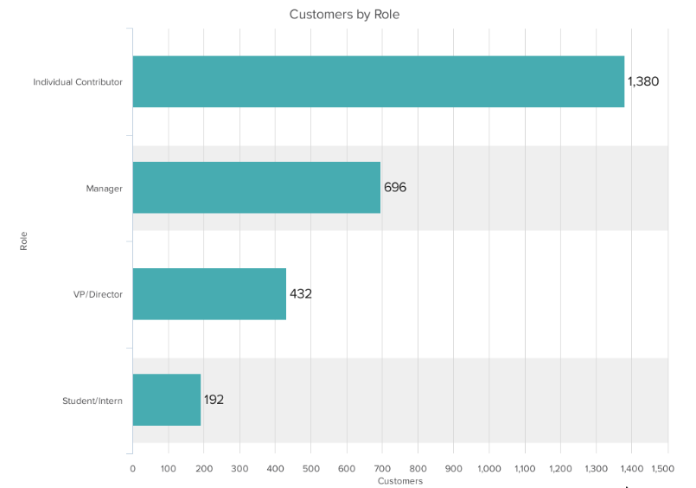

* 1. **Vertical Bar chart / Column Chart**

Use to compare different groups or track changes over time Bar graph are useful when there are big changes over time. This chart is best for negative data

e.g., at the start of the pandemic, online businesses saw a big jump in traffic. So, if you want to look at monthly traffic for an online business, a bar graph would make it easy to see that jump.

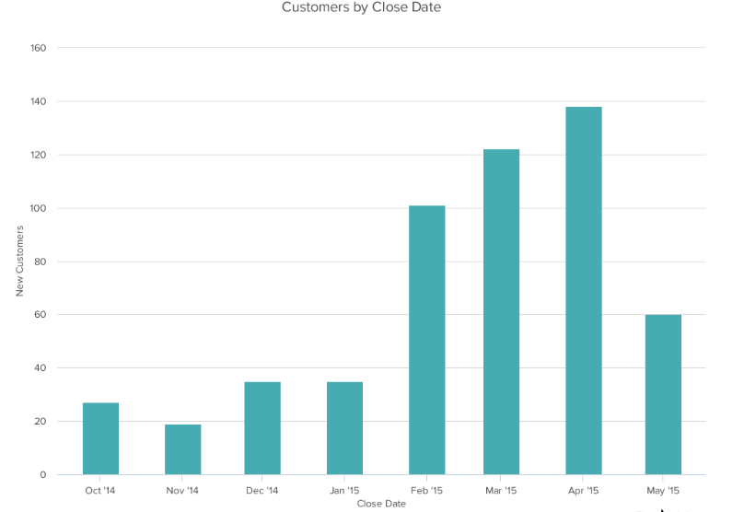

* 1. **Mekko**

Also known as a Marimekko chart, this type of graph can compare values, measure each one's composition, and show data distribution across each region. We can use a Mekko chart to show growth, market share, or competitor analysis. Mekko charts can seem more complex than other types of charts and graphs. So, it's best to use these in situations where you want to emphasize scale or differences between groups of data.

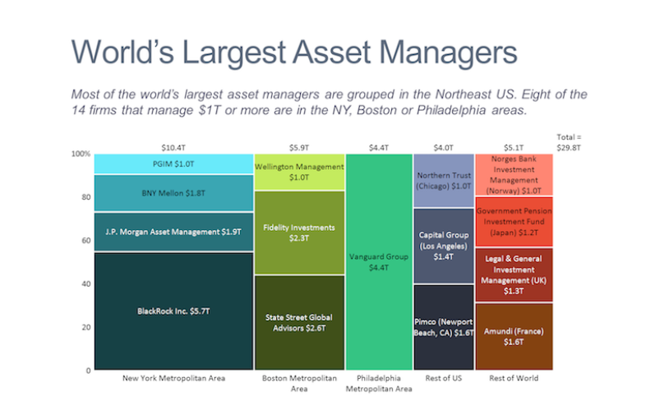

* 1. **Pie**

A pie chart shows a static number and how categories represent part of a whole — the composition of something. Pie charts make it easy to see a section in relation to the whole chart.

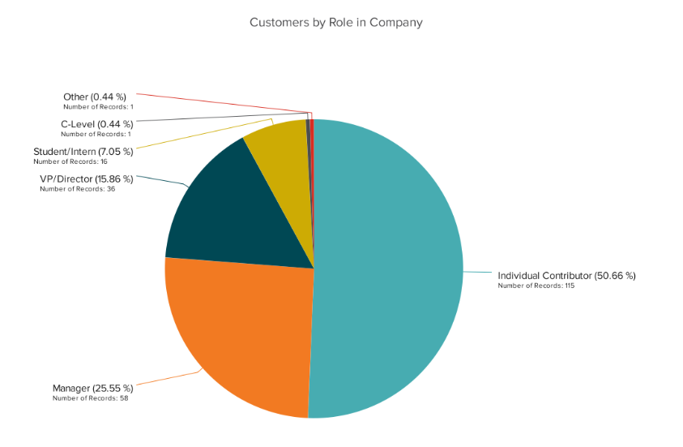

* 1. **Line**

Line graph show trend or progress overtime and can be used to show different categories of data. It should be used for continuous data. It helps in comparing changes for more than one group over the same period of time.

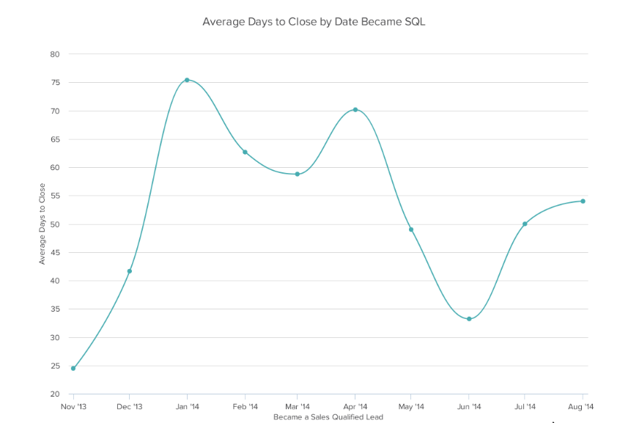

* 1. **Scatter Plot**

This chart will show the relationship between two different variables or reveals distribution trends. This is useful for understanding the distribution of your data.

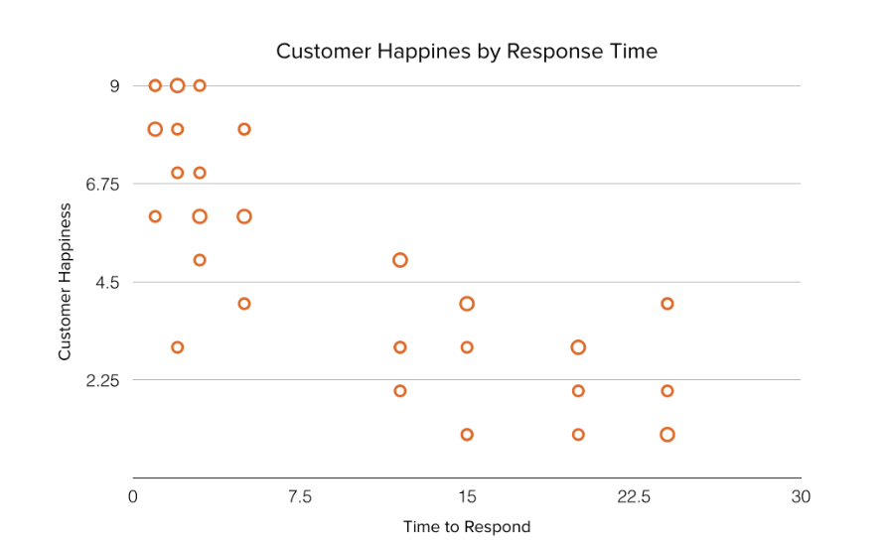

* 1. **Bullet**

A bullet graph reveals progress toward a goal, compare this to another measure and provide context in the form of rating or performance. This graph can also help teams to assess possible roadblocks because you can analyze data in a tight visual display.

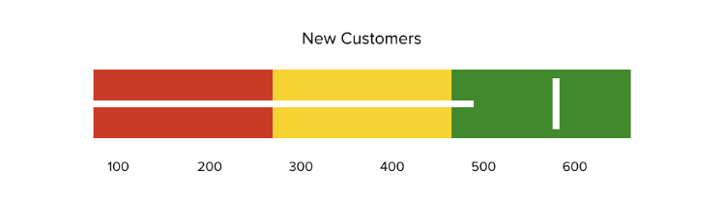

1. For Showing the composition
   1. **Funnel**

A rate for each step. Use this type of chart to track the sales process or the conversion rate. Most common used for marketing or sales funnel.

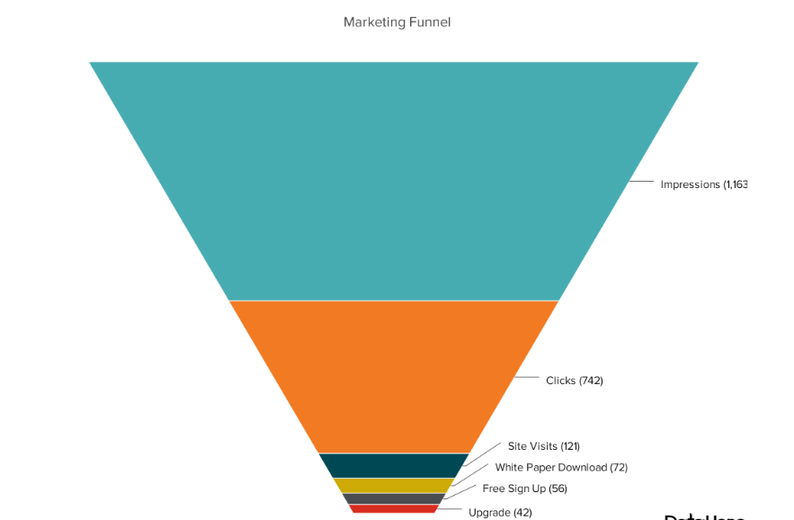

* 1. **Stacked Bar / Bar charts with Long Format Data**

Use this chart to compare many different items and show the composition of each item you’re comparing. Stacked bar charts are excellent for marketing. They make it simple to add a lot of data on a single chart or to make a point with limited space.

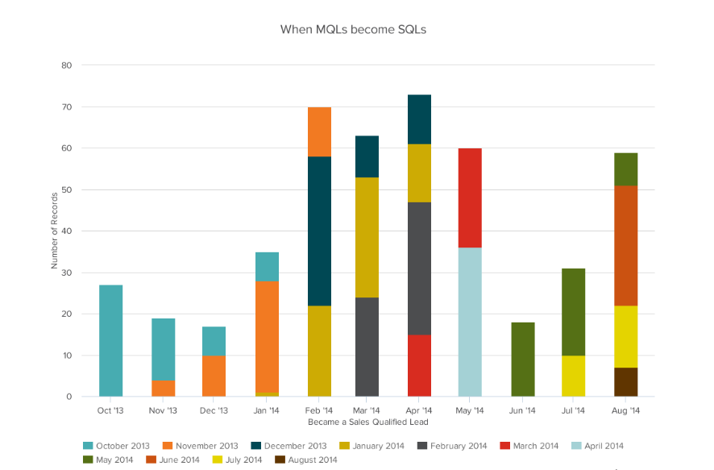

* 1. **Area**

It is basically a line chart but the space b/w the x-axis and the line are filled with a color It is useful for showing part-to-whole relations, like showing individual sales reps' contributions to total sales for a year. It helps in analyzing both overall and individual trend information. work best for big differences between data sets and also help visualize big trends.

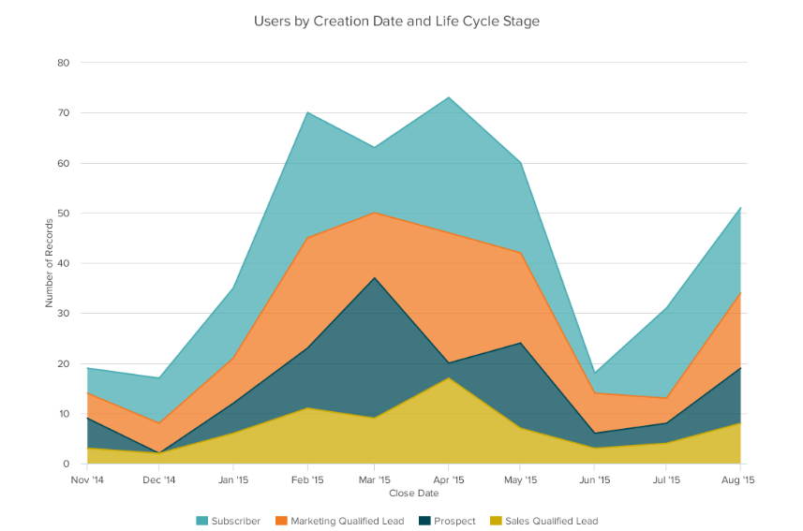

* 1. **Waterfall**

Use a waterfall chart to show how an initial value changes with intermediate values — either positive or negative — and results in a final value. It is used to show the composition of the number. This type of chart makes it easier to understand how internal and external factor impact a product or campaign as a whole.

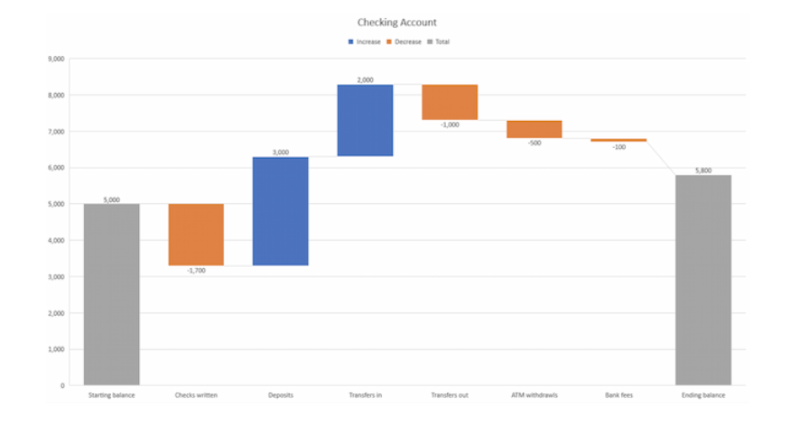

* 1. **Heat Map**

A heat map shows the relationship between two items and provides rating information, such as high to low or poor to excellent. Heat maps can also help with spotting patterns, so they're good for analyzing trends that change quickly, like ad conversions.

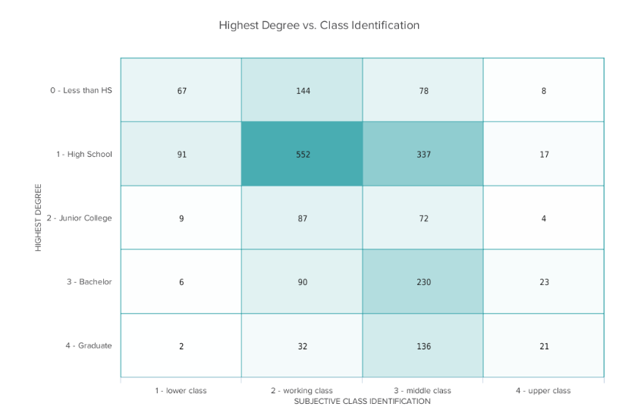

1. Understanding the Distribution of Data, we use the following Plots
   1. **Dual-axis Line**

Dual axis chart allows to plot data using 2 y-axis and a shared x-axis. It has three data sets. One is continuous set of data and the other is better suited to grouping by categories. Use this chart to visualize a correlation or the lack thereof between these three data sets.

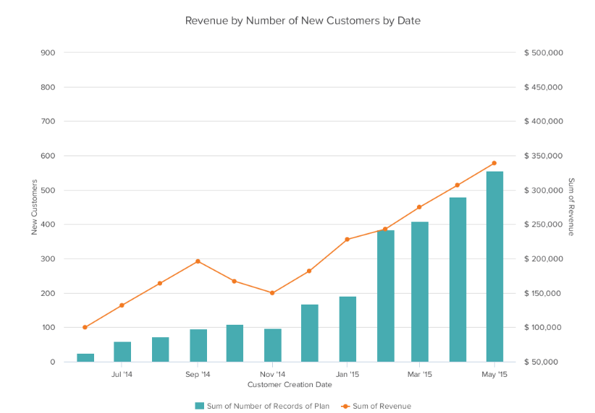

* 1. **Bubble**

A bubble chart is similar to a scatter plot in that it can show distribution or relationship. bubble charts useful for seeing the rise or fall of trends over time.

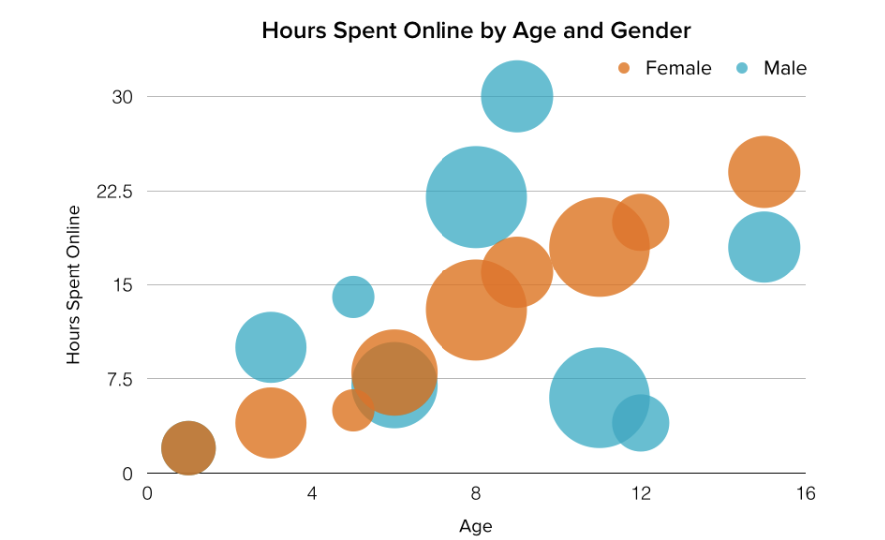

* 1. **Gantt Chart**

It uses for project schedules. The Horizontal axis represent time on the vertical axis a bar display project tasks.

