Research Paper Template
Your Name
Table of contents

1 Abstract
Background:
Brief statement of the problem.
Methods:
What you did, very succinctly.
Findings:
Major results (1–3 key outcomes).
Interpretation:
Why it matters.
Funding: (optional)

2 Introduction

2.1 Background
Introduce the scientific/clinical context and importance. For example, previous research has established foundational concepts in this field (Smith and Doe 2022).

2.2 Knowledge Gap
What is unknown or unresolved in prior work. As noted by Smith and Doe (2022), several questions remain unanswered.

2.3 Objectives
- Objective 1
- Objective 2
- Objective 3

2.4 Overview of the Paper
Briefly describe how the rest of the paper is organized.

3 Methods

3.1 Study Cohorts / Data Sources
Describe the datasets, inclusion/exclusion criteria, and preprocessing.

3.2 Experimental / Computational Workflow
Outline the pipeline and main steps.

3.3 Models / Algorithms
Describe models, training procedures, hyperparameter tuning, and evaluation. We followed established protocols (Smith and Doe 2022).

3.4 Statistical Analysis
Detail metrics, tests, corrections, and significance thresholds.

3.5 Ethics (if applicable)
IRB approval, consent, and data governance.

4 Results

4.1 1. Cohort / Dataset Overview
High-level description of samples and data characteristics. Reference Table ?@tbl-cohort.
| Group | N | Key features |
|--------------|-----|--------------|
| Group A | 100 | ... |
| Group B | 120 | ... |

4.2 2. Primary Findings
Present your main results, linking to figures and tables.
For example, as shown in Figure 1, we observe clear separation between groups.
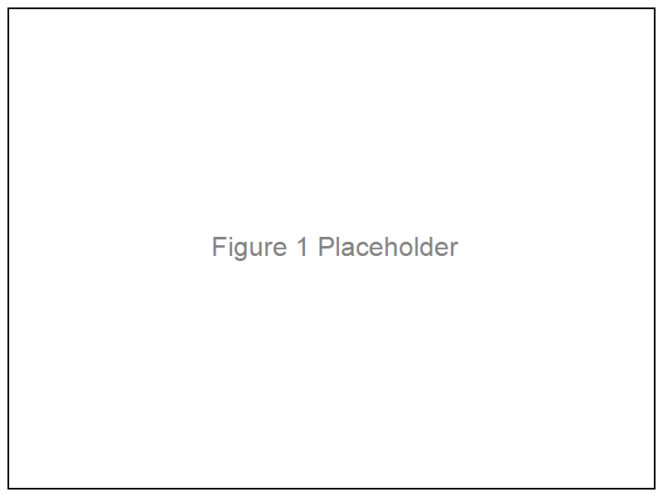
Figure 1: Example placeholder figure caption

4.3 3. Secondary Analyses
Robustness checks, ablation studies, subgroup analyses.

4.4 4. Sensitivity Analyses (optional)
Alternative models, parameter sweeps, or additional tests.

5 Discussion

5.1 Summary of Main Findings
Recap the key results in plain language.

5.2 Comparison With Prior Work
How do your findings agree or conflict with existing literature? Our results are consistent with those reported by Smith and Doe (2022), who also observed similar patterns.

5.3 Biological / Clinical / Practical Implications
What do the results mean in practice?

5.4 Strengths
- Strength 1
- Strength 2
- Strength 3

5.5 Limitations
Be transparent about limitations and potential biases.

5.6 Future Directions
Follow-up studies, applications, or method improvements.

6 Conclusion
Concise paragraph highlighting the key takeaway and impact of the work.

7 Acknowledgements
Recognize collaborators, laboratories, and funding sources.

8 References
References will be generated automatically from bibliography.bib.
Smith, John, and Jane Doe. 2022. “An Example Study for a Research Paper Template.” Journal of Illustrative Examples 10 (1): 1–10.

