Request from:

Ramy Arnaout, MD, DPhil, FCAP, FASCP  
[http://arnaoutlab.org](http://arnaoutlab.org" \t "_blank)  
Assistant Professor, Department of Pathology  
Associate Director, Clinical Microbiology  
Director, Reference Laboratory Testing  
Faculty, Division of Clinical Informatics, Department of Medicine  
Beth Israel Deaconess Medical Center  
Faculty, Department of Systems Biology  
Harvard Medical School

617-538-5681

[rarnaout@gmail.com](mailto:rarnaout@gmail.com)

There is a nationwide shortage of the nasopharyngeal (NP) swabs used to collect samples for Covid19 testing. These swabs are also used for testing for flu and other upper respiratory infections. The situation is serious enough that hospitals are beginning to triage flu testing as well as Covid19 testing.

They are currently doing 300 tests a day that require NP swabs but expect this volume to rise at least 10 fold in the near future (Covid19 cases are currently doubling every 2.5 days in the United States).

NP swabs are flexible sticks with a bristled the end (see pictures below) that go up your nose to the back of the nasal cavity and sweep around for gunk that sticks to or wicks up the bristles. Swab comes out of the nose and into a vial that contains fluid (there is currently no emergency for availability of vials). 7-8cm from the bristled end is a weak point in the stick where you can break it off so the bristled part stays in the vial which gets capped and sent for processing and then handle gets thrown away.

https://www.youtube.com/watch?v=hXohAo1d6tk&feature=youtu.be&t=40

The goal: reliable local source of swabs that can supply up to 3000/day until standard manufacturers can make & deliver more. This design will be shared with other areas and countries if swabs run low.

Requirements:

* Wand is stiff enough to push to the back of the nasal cavity but flexible enough to get up the nose and will bend when it hits resistance instead of stabbing people
* Current product has lots of tiny bristles perpendicular to the wand, replicate that if possible but if it works reasonably consistently and can collect enough sample it’s a win
* Bristles or collecting substrate (including any adhesive) must be firmly attached and not get left behind in the nasal cavity!
* Materials cannot inhibit PCR – no wood or cotton (see partial list of PCR inhibitors attached). Nylon and polypropylene seem to be good choices, but start with medical equipment/grade materials if possible since they should be high quality/pure (some additives can be inihibitors).
* Wand must break off inside the tube – better to be too short than too long. Wand could be manually scored to create a weak point

NOT requirements:

* Sterility not a major concern! The air and the nose are already full of gross things and the PCR assay is specific enough to ignore most contaminants (as long as other coronavirus contaminated things/people don’t come in contact with it and it doesn’t pick up PCR inhibitors)
* Labor intensive is ok, to fill short term needs there are students and researchers out of school&lab who are willing to volunteer to hand assemble these from inoculation loops + wicking substrate.

Closeup of the tip of the swab. The black marks are 1mm apart. These are nylon bristles

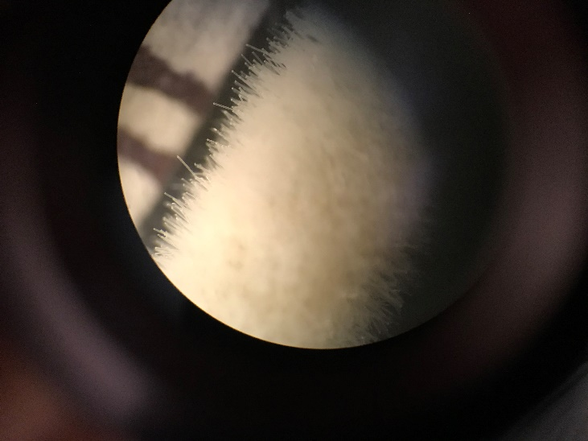

The whole swab. Total length 15cm, bristles 1.5cm, break-off point 7cm from the swab tip (red mark; note the website of the manufacturer of this particular swab, Copan—see wrapper below—says the break-off point is 8cm).

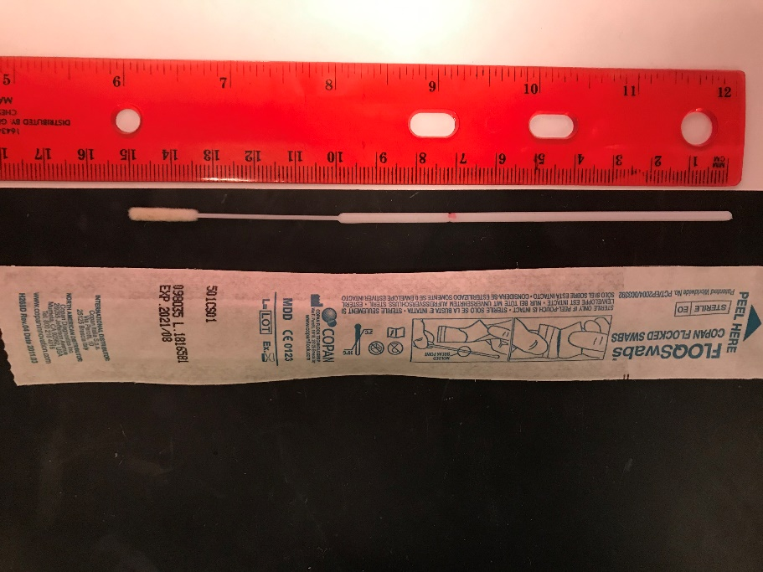

"Loops" that we have in abundance (used elsewhere in microbiology) might be repurposed; a large loop (blue) and small loop (green) are shown below.

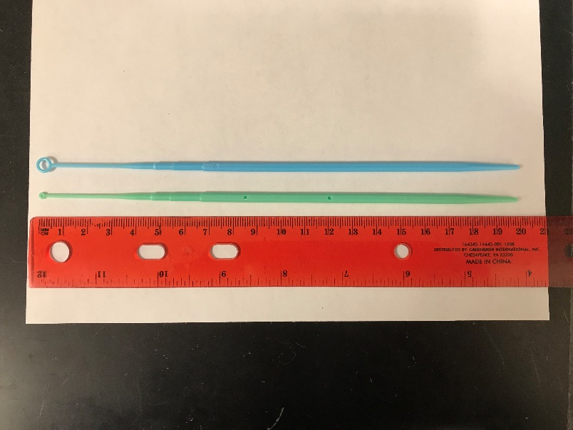

The following is a partial list of common materials known to be safe and unsafe (inhibitors) for PCR (from R. Kodzius et al. / Sensors and Actuators B 161 (2012) 349–358 Figure 3; for acronym meanings see the paper at <https://sci-hub.tw/10.1016/j.snb.2011.10.044> Or <http://www.phys.ust.hk/phwen/articles/2012/Inhibitory-effect-of-common-microfluidic-materials-on-PCR-outcome_2012_Sensors-and-Actuators,-B-Chemical.pdf>

Safe: PC, PVC, PP, PTFE, wax with melting point ≥80°C, SiO2 quartz, Pyrex glass, soda-lime glass, NOA68, mineral oil

Unsafe: PMMA, wax with melting point <80°C, silicon, SO2 5600Å, ITP glass, SU-8, NOA61, epoly glue, acrylic glue

Directions: Create an NP swab.

* Is there anything currently out there we can get in sufficient quantity quickly?
* What commonly available (or easy to get) materials might be usable as swab material?
* How to firmly attach to the wand?
* Any way to automate mass production of the whole thing or even partial steps?

Written by Jenny Wu, edited by Ramy Arnaout