Name: Hurmat Ilyas Roll No.: BSCS2019-02

Problem Statement:

After substitution using rot13, perform frequency analysis on the encrypted text obtained by rot13.

Given Statement:
The given statement and its encryption using rot 13 is as follows:
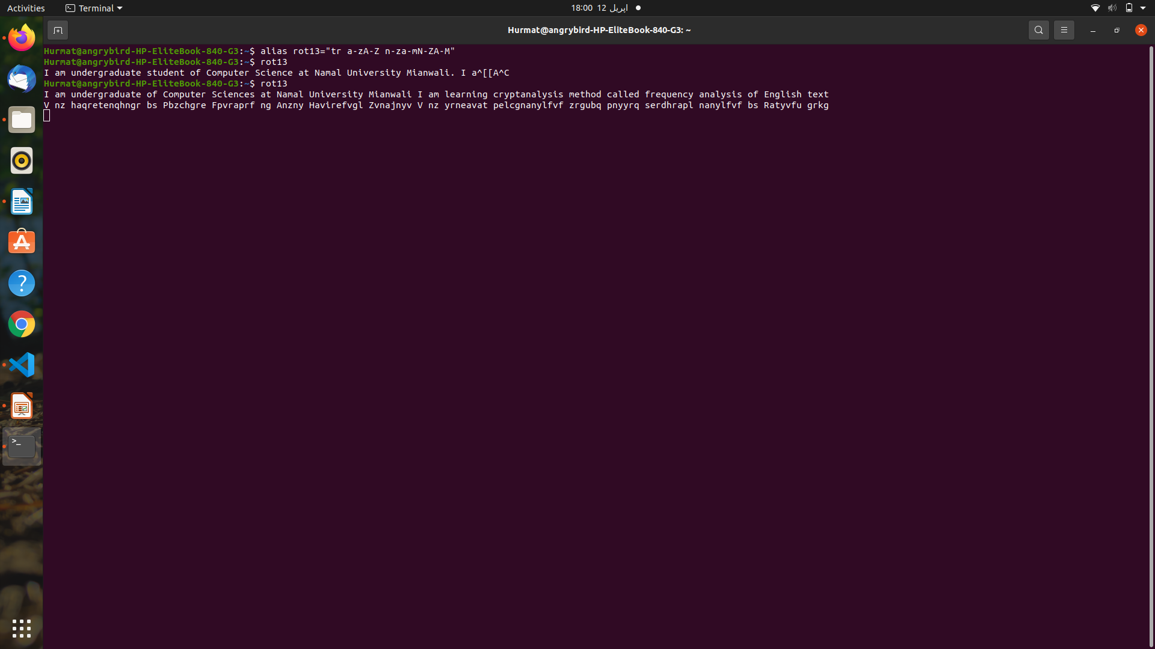

Methodology:

Given a cryptogram, the frequency analysis is considered of the following steps:
1. Single letter occurrence in a cryptogram
2. Digraphs occurrence in a cryptogram
3. Polygraphs occurrence in a cryptogram
4. Vowels occurrence in a cryptogram

The cryptogram is stored in a .txt file which is read using python’s open file command. After the file is being read, the occurrence of each single letter in a cryptogram is calculated means the number of times each letter is repeated using loops in python. Then, the occurrence of double letters is calculated. Then, the vowels are counted.

Single letter occurrence in a cryptogram:
The input file is the test file given on LMS.
The code for this is as follows:
import operator #to sort the dict in descending order easily
#Single Character's Occurrence

#Takes input from user or either store the input in a variable or in a file.txt
file= open("Cryptogram.txt")
for x in file:
Cryptogram= x
Cryptogram= Cryptogram.replace("\n", "")
Cryptogram= Cryptogram.replace(" ", "")
Cryptogram= Cryptogram.replace("\ufeff", "")

#Cryptogram= input("Enter the cryptogram: \n")
#Made a Dictionary with the name of frequency
frequency = {}
#Loop for counting characters in the given input and displaying the key-value pair in dictionary
for i in Cryptogram:
if i in frequency:
frequency[i] += 1
else:
frequency[i] = 1
sorted_d = dict( sorted(frequency.items(), key=operator.itemgetter(1),reverse=True))

#Displaying the result(occurence of each single character)
print ("Count of each single character is :\n" , sorted_d)

Digraphs occurrence in a cryptogram:
#Digraphs occurence in the cryptogram
n = 2
split_strings = [Cryptogram[index : index + n] for index in range(0, len(Cryptogram)-n+1)]
d = {x:split_strings.count(x) for x in split_strings}
sorted_d = dict( sorted(d.items(), key=operator.itemgetter(1),reverse=True))
print ("The Digrpahs and their occurence is:\n",sorted_d)

Polygraphs occurrence in a cryptogram:

#Polygraphs occurence
n=3
split_strings = [Cryptogram[index : index + n] for index in range(0, len(Cryptogram)-n+1)]
d1 = {x:split_strings.count(x) for x in split_strings}
d1 = dict( sorted(d1.items(), key=operator.itemgetter(1),reverse=True))
print ("The three letters pairs and their occurence is:\n",d1)

n=4
split_strings = [Cryptogram[index : index + n] for index in range(0, len(Cryptogram)-n+1)]
d2 = {x:split_strings.count(x) for x in split_strings}
d2 = dict( sorted(d2.items(), key=operator.itemgetter(1),reverse=True))
print ("The four letters pairs and their occurence is:\n",d2)

n = 5
split_strings = [Cryptogram[index : index + n] for index in range(0, len(Cryptogram)-n+1)]
d3 = {x:split_strings.count(x) for x in split_strings}
d3 = dict( sorted(d3.items(), key=operator.itemgetter(1),reverse=True))
print ("The five letters pairs and their occurence is:\n",d3)

Vowels occurrence in a cryptogram:
#Vowels Occurence
file= open("Cryptogram.txt")
for x in file:
Cryptogram= x
#Cryptogram = "SCERSAMONPL"
Cryptogram= Cryptogram.replace("\n", "")
Cryptogram= Cryptogram.replace(" ", "")
Cryptogram= Cryptogram.replace("\ufeff", "")

def Count_Vowels(Cryptogram, vowels):
Cryptogram = Cryptogram.casefold() #casefold to ignore the case
count = {}.fromkeys(vowels, 0)
for character in Cryptogram:
if character in count:
count[character] += 1
return count
vowels = "aeiou"
Cryptogram= Cryptogram.replace("\ufeff", "")

print ("The Count of each vowel in the file is:\n", Count_Vowels(Cryptogram, vowels))

Output:

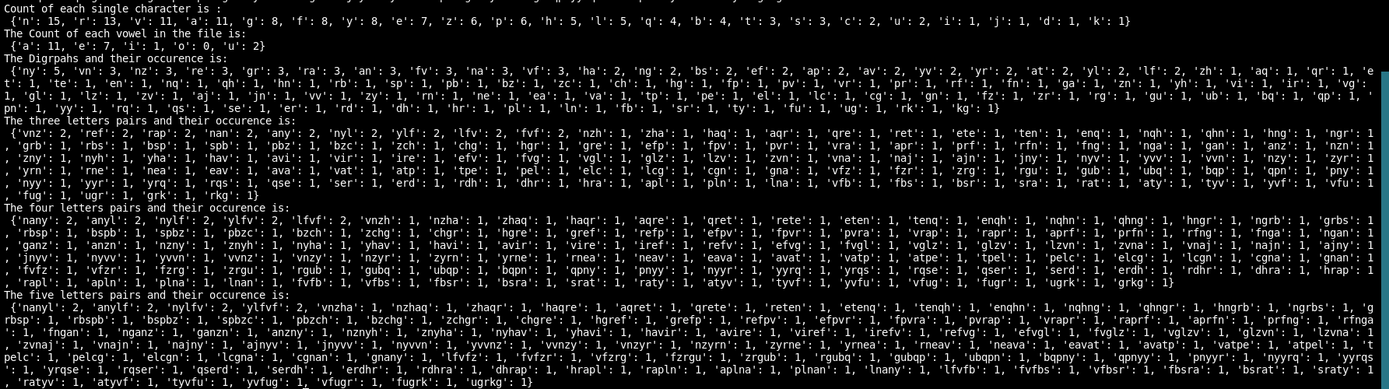

Tools used:
Python language is used for the frequency analysis. Moreover, the operator library of python is used to perform the cryptanalysis.

Technique used:
Sliding Window

