**Comprehension:**

Overview:

Automatization and digitalization are ruling the different fields along with agricultural sector too. One of the major problem that farmers usually face is keeping track of insect on plants in order to maintain the plant growth. To manually detect and count the insects on plants is challenging task as it requires a lot of time therefore, people came up with the idea of doing this task using different machine learning based approaches.

Purpose Statement

To count and detect whiteflies on eggplant leaves, the author proposed a density map-based approach in comparison with candidate selection and classification technique.

Methodology:

The algorithm proposed works in two steps where the first step is leaf segmentation and second one is insect counting. In insect counting, two different approaches used to solve the insect detection and count problem are describe in the given article. First approach is candidate selection and classification which is as follow:

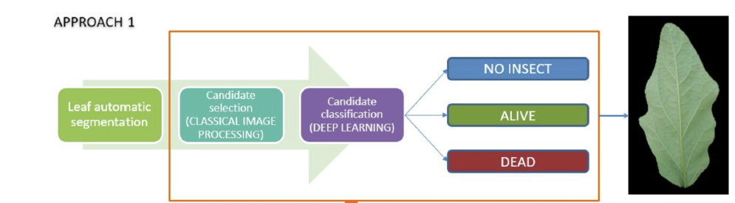

Using processing approach of classical image, the candidate picking is performed by alteration of input image on various color space. As the whiteflies are of white color so it becomes difficult to differentiate between them and white or damaged spots on the leaves. The dead whiteflies can also be there on leaves and it appears the same as alive whiteflies therefore, the differentiation between alive and dead whiteflies is also a challenging goal to be achieved by removing the pixels of reduced area of 30×30 pixels in a high resolution image. This method takes into account the shortcomings of traditional image processing approaches and seeks to select candidates on the basis of classifier (deep learning based).

This model is cannot appropriately filter all candidates. The model is not capable of filtering properly all the candidates. The only advantage of this approach is that it can be implemented fast and easily.

Second and best approach was density based map estimation in which each object/bug after dot annotation was defined by normalized Gaussian whose pixels sum is equal to 1. The sum will be 2 in the case of two Gaussians. Object detection approach become difficult when there are overlaps between two objects and only one is identified. The big advantage of this density based approach is that it handles overlapping objects naturally and can count 2 instead of 1.

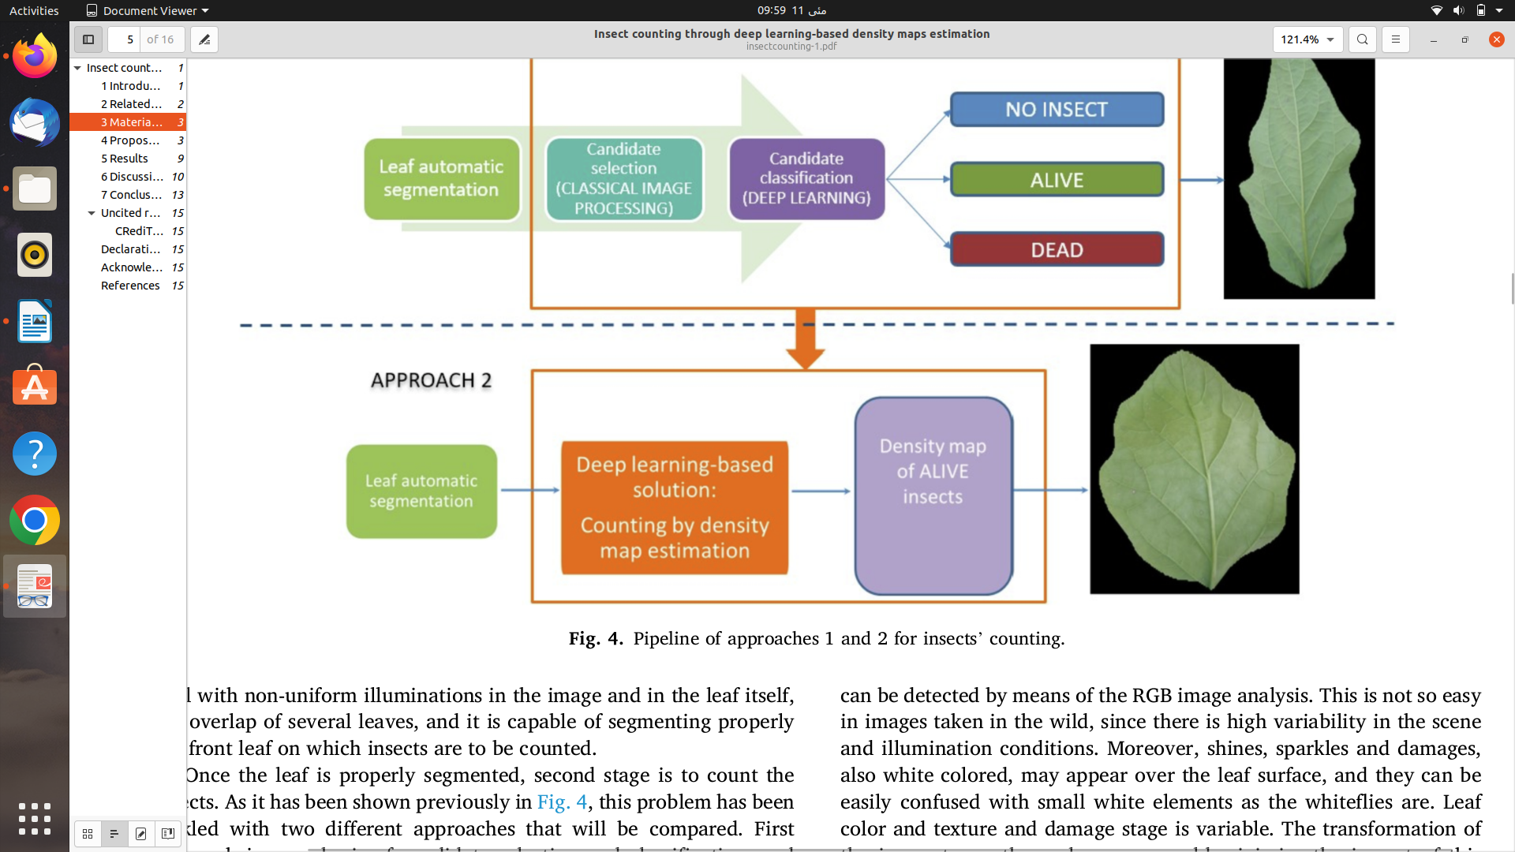

The following is the recommended answer to our unique situation. Because the bugs are so little (approximately 20–30 pixels in a 4000x6000 picture), resizing the image is impossible without losing the bugs. A convolutional neural network cannot process a full image because it is too large for GPU memory to support. As the image is processed one tile at a time. The tile's dimensions are set to 256x256 pixels. In all directions, each patch overlaps with its neighbors. The overlap margin is 40 pixels wide.

There have been changes made to the previous density map model. By using upsampling and deconvolution processes, Two further layers were added to the decoding part as a result of the addition of layers to the encoding component. Slight variations in sigma are required to accurately depict the size of the piece to be counted. Global sum pooling (GSP) is suggested than the global average pooling (GAP) in convolutional network. Fully connected layer is also not suggested here. The response is substantially better than when using GAP because global sum pooling allows the neural networks to learn a problem of simple linear mapping that is extended across the shape of input and present objects.

The Most Effective Network Model :

The following parameters were used to train the best network model.

The input picture is 256x256 pixels in size, with lr = 0.01, = 9, and l2 = 105% dropout. The training began with Considering 2000 epochs and weighted models that resulted in a lower validation loss were chosen. The optimizer was chosen to be Stochastic Gradient Descent. The network was trained on a GeForce GTX TITAN X having 12 GB of RAM[1]. The batch size was chosen at 12 photos due to the size and network of the input images.

Size of insect has a direct relationship with the sigma values used to generate the density map. For whitefly, the final sigma value is 9.

The available dataset consists of 731 photos, which have been divided in this manner.

For Training: 554 images

For validation: 54

For testing: 23

One of the most challenging aspects of the development was getting the network to learn throughout the training phase with such low activation levels. A Gaussian distribution with sigma = 9 has a maximum peak value of 0.0067. This number is so little that the model has no idea what has to be learned in float pictures with maximum values of 65536 between 0.0 and 0.0067. First attempts were unsuccessful.

To correct this issue, the entire image was given a scale factor of 50,000.

This allows the Gaussians to participate in the game. And also allow them in the picture to be seen throughout the training phase, and the model learns this way. After obtaining the forecast, the entire picture is split by the same scale factor to extract the true image value. The entire sum of the image's pixel values equals the number of defects.

As a result, the Gaussian's sum of pixels may differ significantly from the expected result

Gaussians with a total of pixels greater than 0.5 are said to be counted as one extra bug, whilst gaussians with activation values greater than 0.5 are said to be counted as two insects. And less than this activation value of 0.5, the pixels are discarded.

The same method is used to represent two insects using gaussians where values are less than 1.5 are considered as a single element and values greater than 1.5 considered two overlapping elements.[2]

This post-production phase, which may be thought of as "filtering," helped to enhance the findings and eliminate several dead whiteflies.

Findings and Claims:

The author discussed different approaches for insects counting where he started with discussing the work of Barbedo who tried counting the whiteflies in soybeans in which the classical image processing technique is used. Then, Liu and his partners proposed SVM and image processing based solution for detection of system for aphids. Based on color transformation and feature extraction, Gabriel proposed solution for counting pyralide insects in maize plant. The author argued that all these approaches described above imply careful feature selection which can be then used as input of a classifier. Moreover, the additional classes cannot be added in these easily.

A YOLO(You Only Look Once) approach was used by Zhong to count and detect the insects in greenhouse. But it also doesn’t provide a correct solution as in the crowded images the overlaps can exists. So, this object detection technique was also not accurate solution to this problem.

Object detection-based techniques does not perform well when there are overlapping objects while density map-based estimation performs best in detecting objects which are very small and overlapping.

So, that’s why the author used the density map-based estimation technique to count the white flies in the eggplant. In this approach, the author proposed a two step solution where leaf segmentation and insect counting are a part.

For insect counting, the two approaches are used which are candidate selection and classification is the first one where the white flies need to be detected. The author found out that the white flies as white in color can easily be confused with shines, sparkles and damages. So, the author used approach of transforming image to other color space which solved this problem almost but not completely. Then, the dead and alive flies needs to be differentiated as we are not interested in counting the dead flies. The irregularities of illumination are less in v plane. Moreover, the pixels of size <10 and >200 areas can be removed because the insects cannot be of this size therefore, the objects that remained can be insects.

Density map-based estimation is used then which is the best approach according to the author as it does not perform well in object detection method where the whiteflies are overlapping. The author claims that this would be able to differentiate between the alive and dead flies based on the gaussian values.

In the YOLO approach, the drawbacks found by the author are as follows:

YOLO presents three main drawbacks:

* It was not able to count two or more flies that are close.
* It also detected damage area of leaf as white flies and added false positives to the counting.

But in density map-based estimation, both these limitations are resolved by the author to almost detect all the white flies on a leaf correctly.

**Weaknesses:**

The author has just tried two approaches for insect counting. He has supported his solution in every aspect but still this model is not efficient as improvements can be done.

The execution time of proposed solution is one to two seconds which could be in milliseconds. The efficiency of this algorithm can be improved.

**References:**

*[1]. Arantza Bereciartua-Pérez, Laura Gómez, Artzai Picón, Ramón Navarra-Mestre, ChristianKlukas, Till Eggers. "Insect counting through deep learning-based density maps estimation",Computers and Electronics in Agriculture, 2022*

*[2]. Arantza Bereciartua-Pérez, Laura Gómez, Artzai Picón, Ramón Navarra-Mestre, ChristianKlukas, Till Eggers. "Insect counting through deep learning-based density maps estimation",Computers and Electronics in Agriculture, 2022*