Results
This section presents all experimental results organized into five parts: (1) Exploratory Data Analysis, (2) Core Model Comparison, (3) Regional Analysis, (4) Geopolitical Event & Outlier Analysis, and (5) Concept Drift Analysis.

1. Exploratory Data Analysis
We first explore the dataset to understand price trends, volatility patterns, and feature relationships before modeling.

1.1 Price Trends
U.S. gasoline prices show strong long-term trends with several major disruptions, including the 2008 spike and the COVID-19 crash.
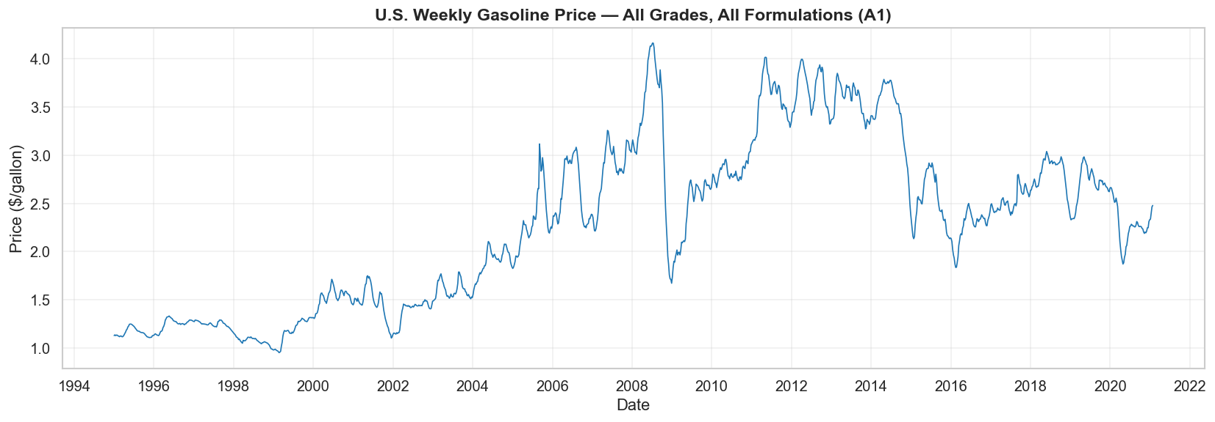
Figure 1: U.S. Weekly Gasoline Price (All Grades, 1995-2021)
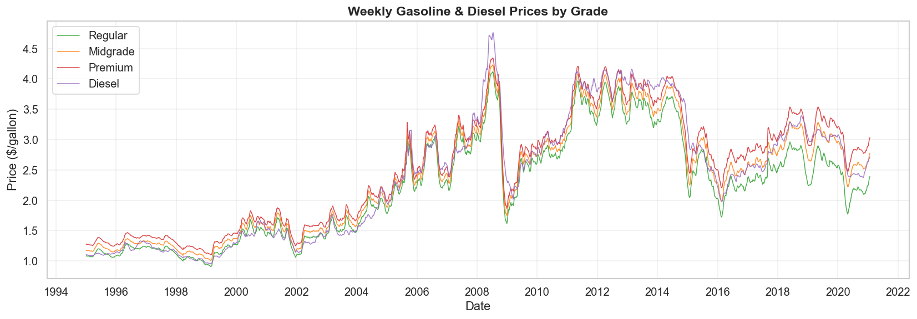
Figure 2: Weekly Gasoline & Diesel Prices by Grade

1.2 Price Distribution
Prices range from about $1 to $4 per gallon with a right-skewed distribution, reflecting occasional high-price spikes.
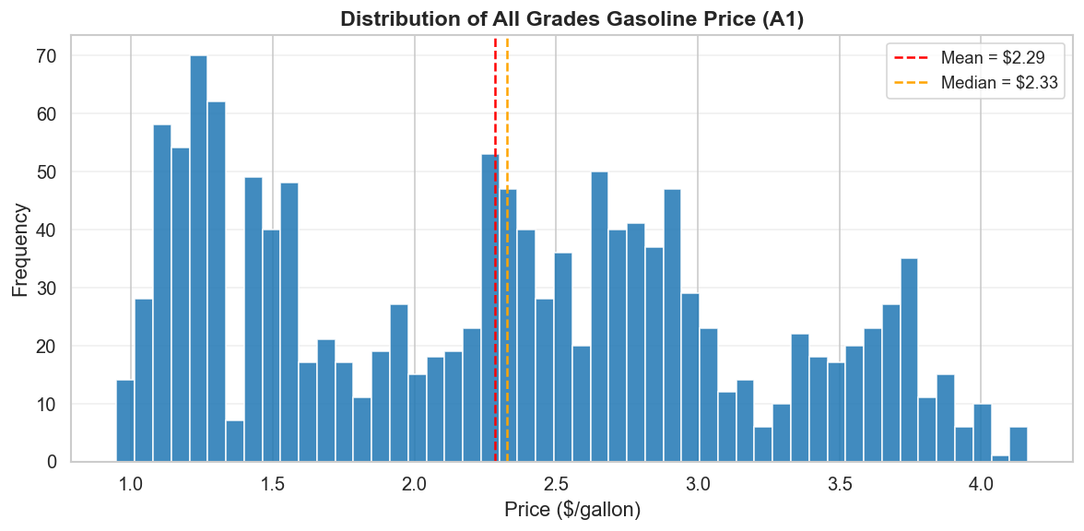
Figure 3: Distribution of All Grades Gasoline Price
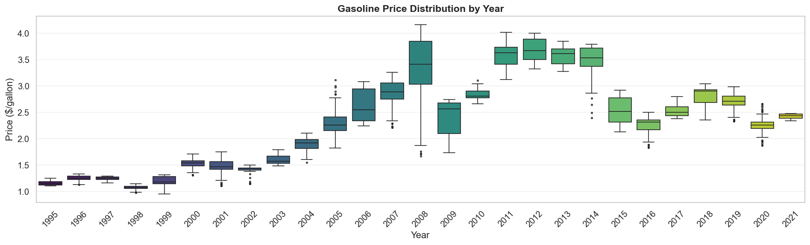
Figure 4: Gasoline Price Distribution by Year

1.3 Volatility Analysis
Weekly price changes are mostly small, but extreme swings cluster around major geopolitical events like the 2008 crisis and Hurricane Katrina.
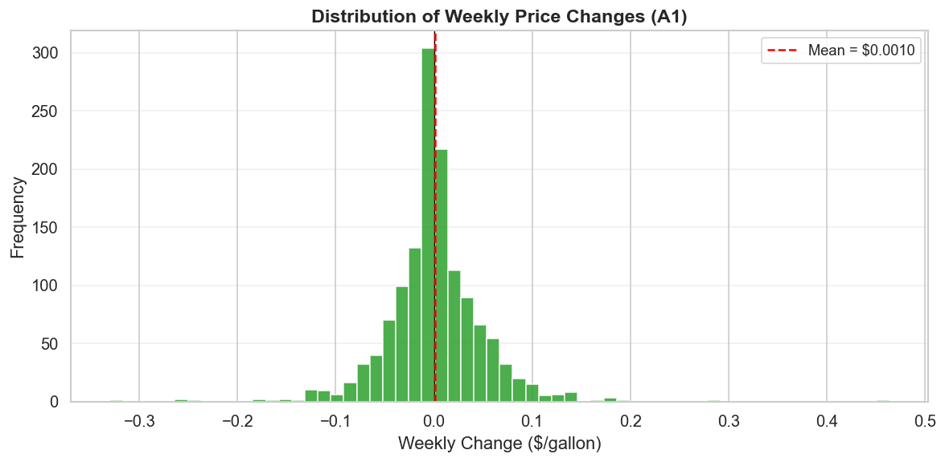
Figure 5: Distribution of Weekly Price Changes
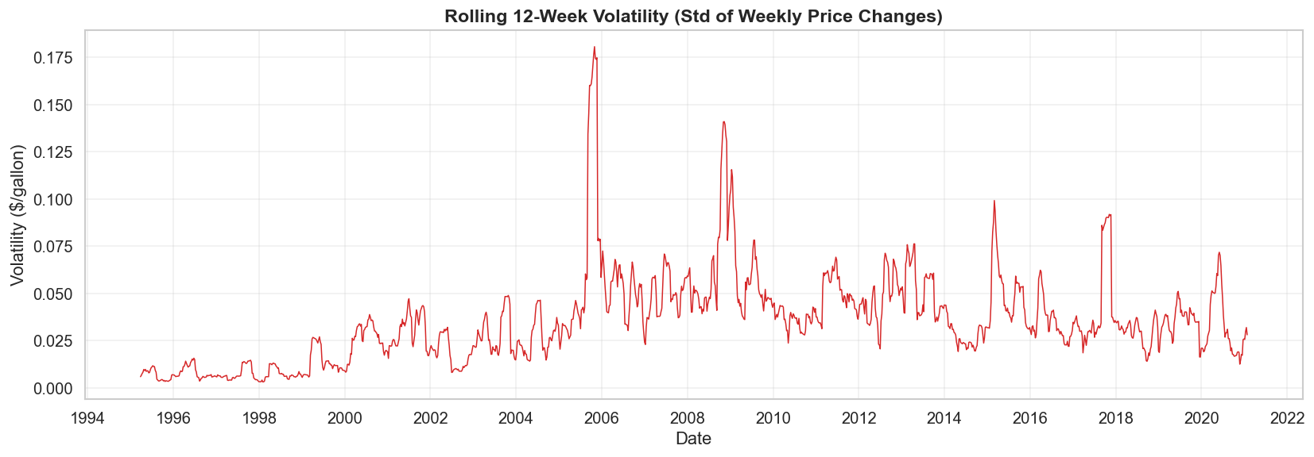
Figure 6: Rolling 12-Week Volatility
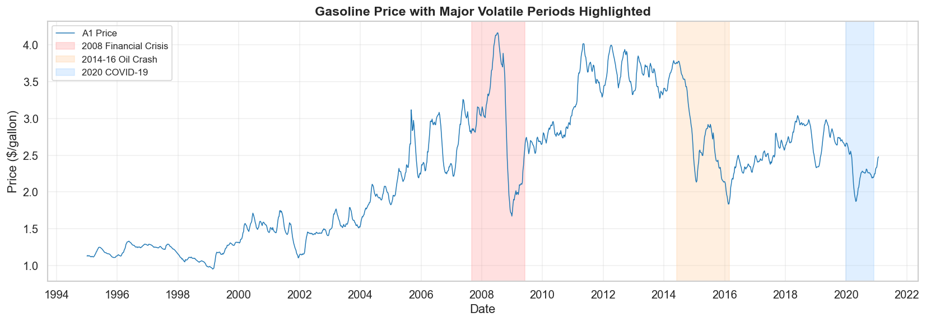
Figure 7: Gasoline Price with Major Volatile Periods Highlighted

1.4 Feature Engineering & Correlation
We engineer 30+ features including lag prices, rolling statistics, momentum indicators, and date features. Lag-1 price has the strongest correlation with the target.
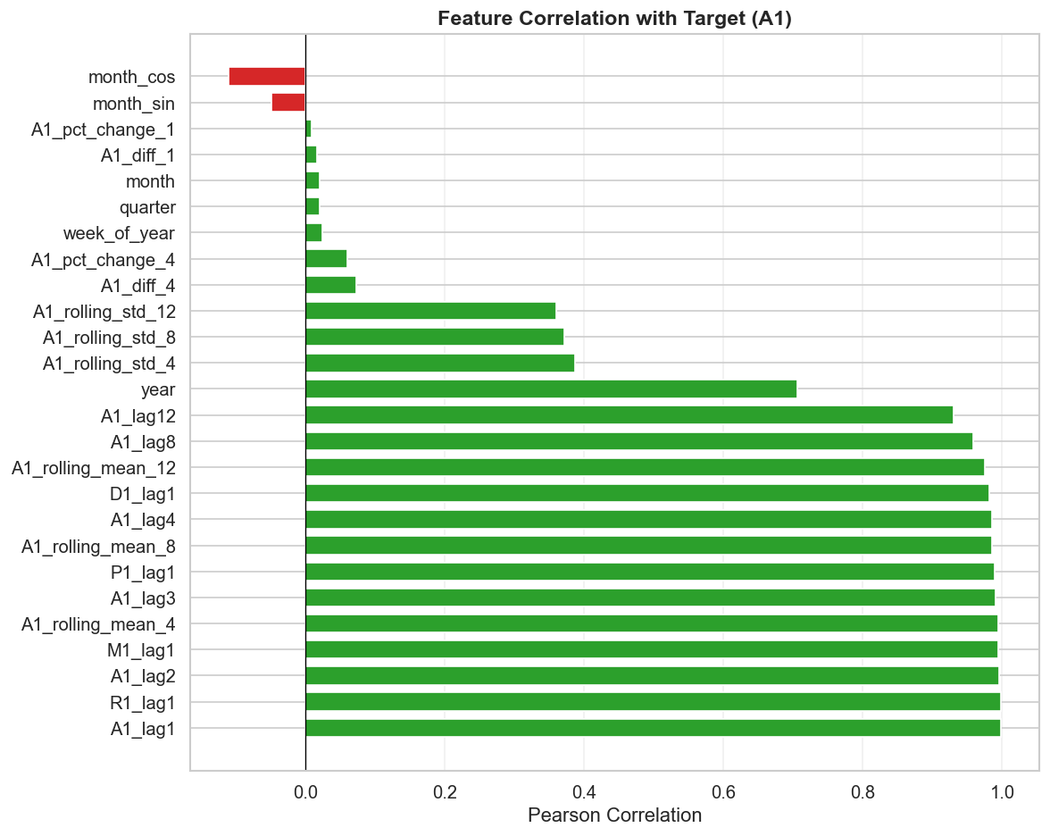
Figure 8: Feature Correlation with Target
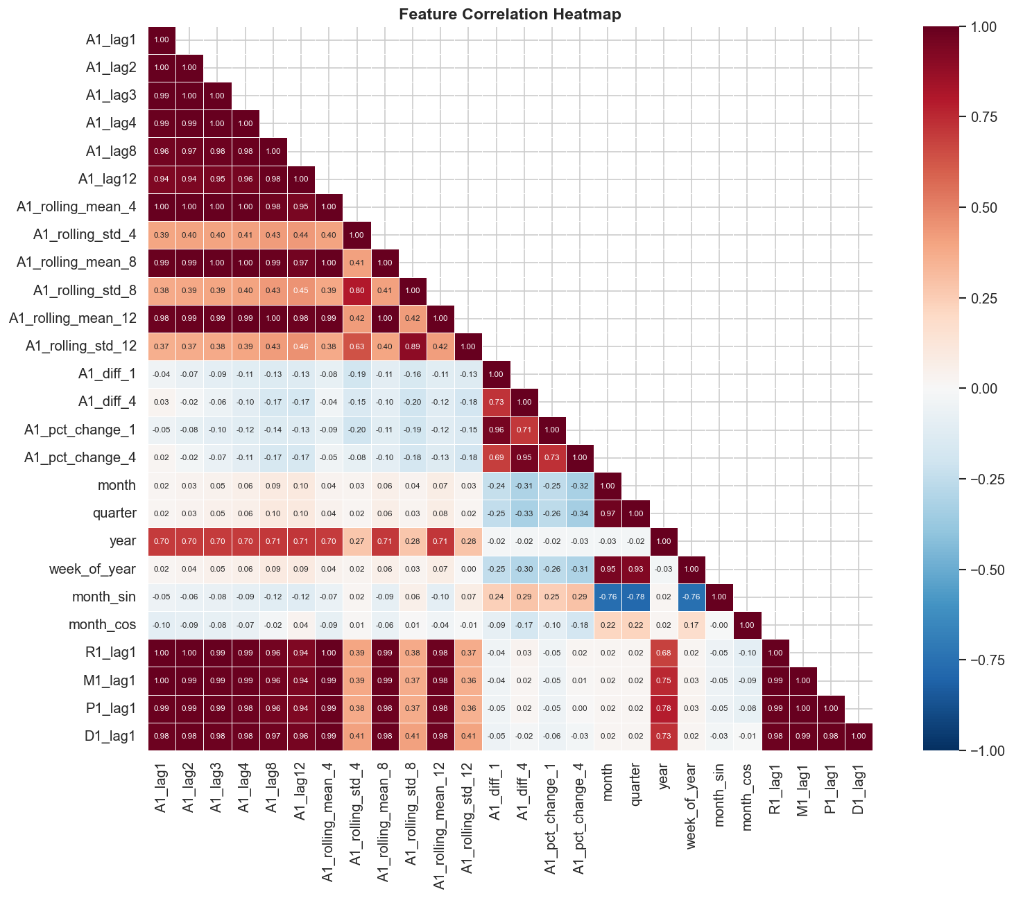
Figure 9: Feature Correlation Heatmap

1.5 Data Split
We use a chronological 70/15/15 split to respect the time series nature of the data: Train (1995-2013), Validation (2013-2017), Test (2017-2021).
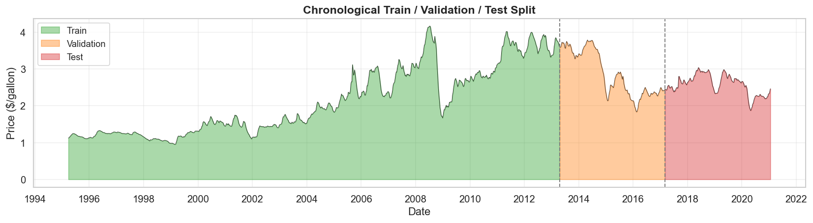
Figure 10: Chronological Train / Validation / Test Split

2. Core Model Comparison (1-Week Horizon)
We compare 15 model configurations across 5 categories. Surprisingly, Linear Regression with engineered features achieves the best overall performance.

2.1 All Models - 1-Week Horizon
Table 1 ranks all models by test RMSE. Linear Regression (full features) is the clear winner with RMSE=0.0412 and MAPE=1.18%.
Model | Features | Val RMSE | Val MAE | Val MAPE | Test RMSE | Test MAE | Test MAPE
Linear Regression | full | 0.0446 | 0.0357 | 1.33% | 0.0412 | 0.0303 | 1.18%
Lasso Regression | full | 0.0447 | 0.0359 | 1.34% | 0.0543 | 0.0452 | 1.78%
Linear Regression | basic | 0.0741 | 0.0576 | 2.10% | 0.0666 | 0.0481 | 1.86%
Naive Baseline | full | 0.0869 | 0.0681 | 2.54% | 0.0766 | 0.0576 | 2.28%
XGBoost (tuned) | full | 0.0570 | 0.0449 | 1.64% | 0.0772 | 0.0610 | 2.36%
LSTM-B (h=64,L=1,s=12) | full | 0.0709 | 0.0535 | 1.99% | 0.0921 | 0.0733 | 2.91%
GRU (h=64,L=2,s=12) | full | 0.0752 | 0.0568 | 2.09% | 0.0933 | 0.0742 | 2.91%
LSTM-A (h=32,L=1,s=8) | full | 0.0809 | 0.0623 | 2.31% | 0.0999 | 0.0818 | 3.25%
LSTM-C (h=64,L=2,s=12) | full | 0.0809 | 0.0635 | 2.41% | 0.1003 | 0.0794 | 3.25%
Random Forest (tuned) | full | 0.0797 | 0.0567 | 2.09% | 0.1065 | 0.0901 | 3.51%
LSTM-D (h=128,L=2,s=12) | full | 0.0784 | 0.0600 | 2.27% | 0.1087 | 0.0893 | 3.60%
Ridge Regression | full | 0.0567 | 0.0480 | 1.83% | 0.1119 | 0.1042 | 4.13%
MLP-Medium [128,64,32] | full | 0.1291 | 0.1073 | 3.66% | 0.1355 | 0.1065 | 4.30%
MLP-Large [256,128,64,32] | full | 0.1186 | 0.0996 | 3.68% | 0.1491 | 0.1156 | 4.87%
MLP-Small [64,32] | full | 0.1343 | 0.1117 | 4.00% | 0.1593 | 0.1317 | 5.23%
Table 1: All models - 1-week horizon, sorted by Test RMSE.

2.2 Model Category Comparison
When grouping by model type, linear models dominate. Neural networks underperform due to the small dataset size (~1,300 training samples).
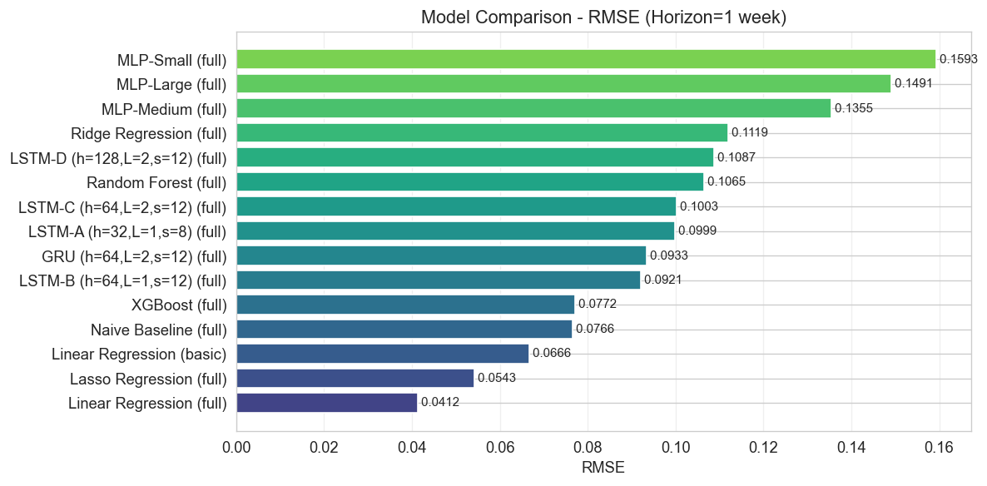
Figure 11: Model Category Comparison - 1-Week Horizon
Category | Best Model | RMSE | MAE | MAPE
Baseline | Naive Baseline | 0.0766 | 0.0576 | 2.28%
Linear | Linear Regression | 0.0412 | 0.0303 | 1.18%
Tree-Based | XGBoost | 0.0772 | 0.0610 | 2.36%
Recurrent (LSTM) | LSTM-B | 0.0921 | 0.0733 | 2.91%
Recurrent (GRU) | GRU | 0.0933 | 0.0742 | 2.91%
Feedforward (MLP) | MLP-Medium | 0.1355 | 0.1065 | 4.30%
Table 2: Best model per category.

2.3 Prediction Visualizations
The following plots show predicted vs actual prices on the test set. Linear models track the actual prices most closely.
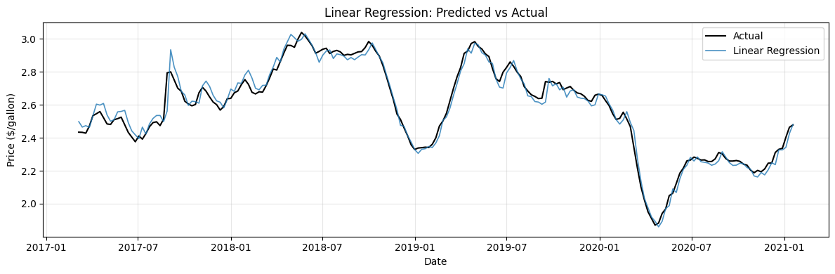
Figure 12: Linear Regression - Predictions vs Actual
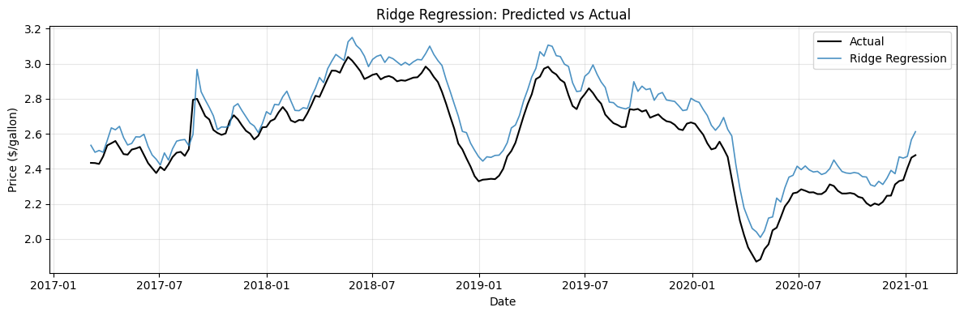
Figure 13: Ridge Regression - Predictions vs Actual
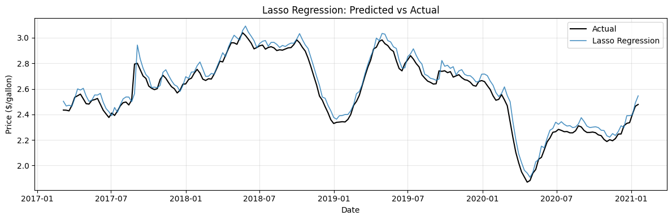
Figure 14: Lasso Regression - Predictions vs Actual
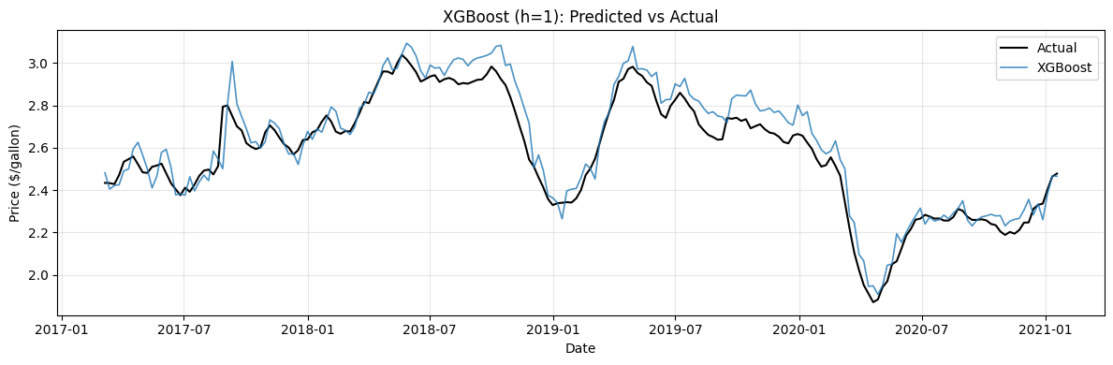
Figure 15: Tree-Based Models - Predictions vs Actual
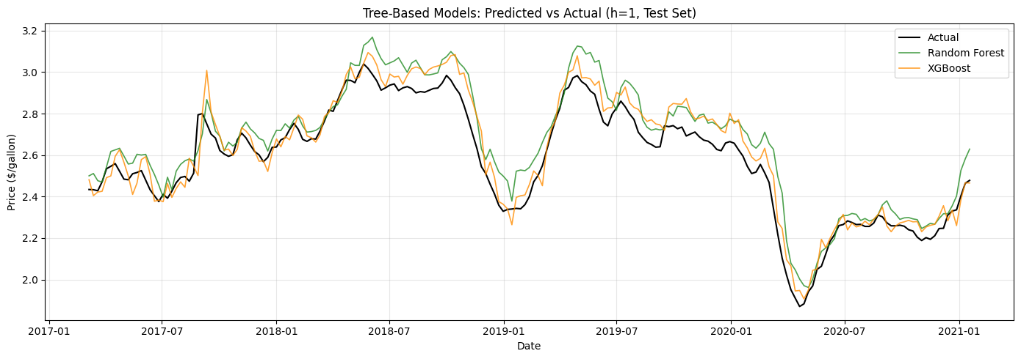
Figure 16: Tree-Based Models Overlay
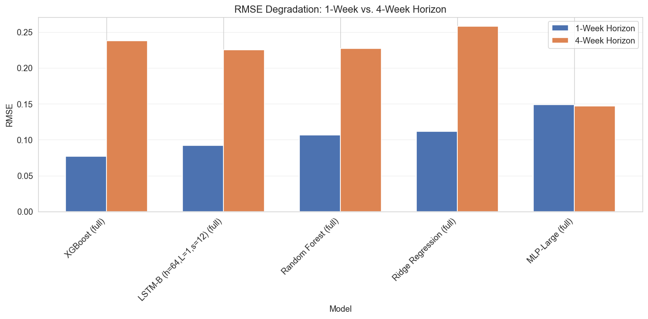
Figure 17: Top Model Predictions vs Actual

2.4 Feature Importance
Across all models, lag-1 price is by far the most important feature, confirming the strong autocorrelation in gasoline prices.
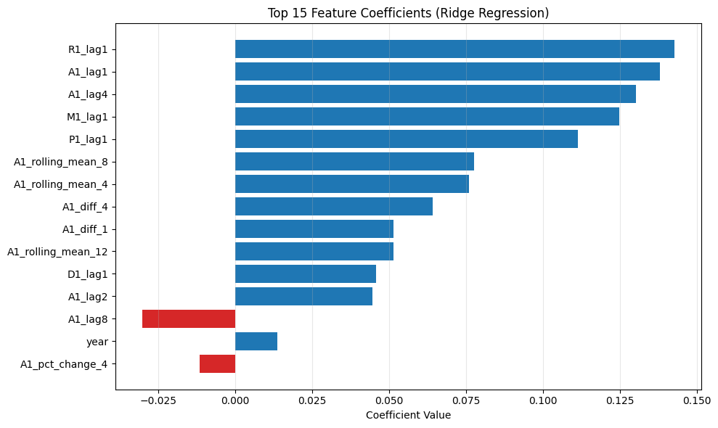
Figure 18: Top 15 Feature Coefficients (Ridge)
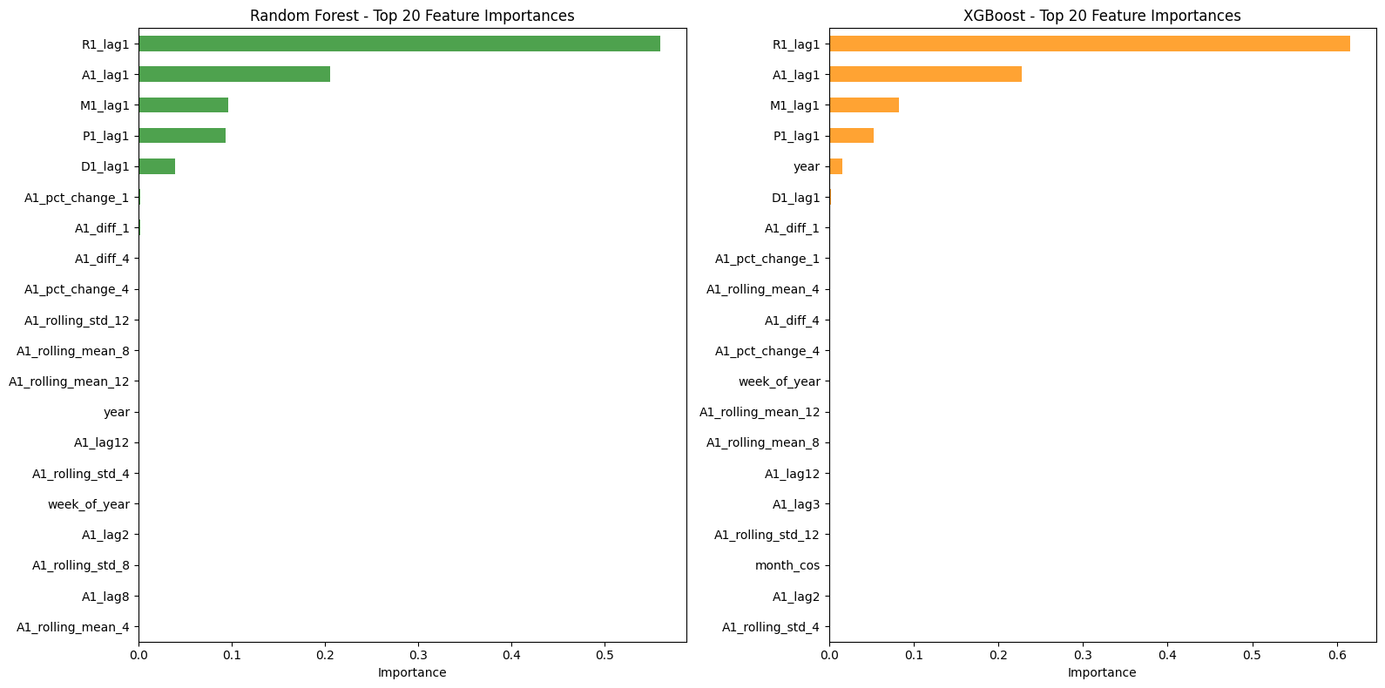
Figure 19: Random Forest - Top 20 Feature Importances
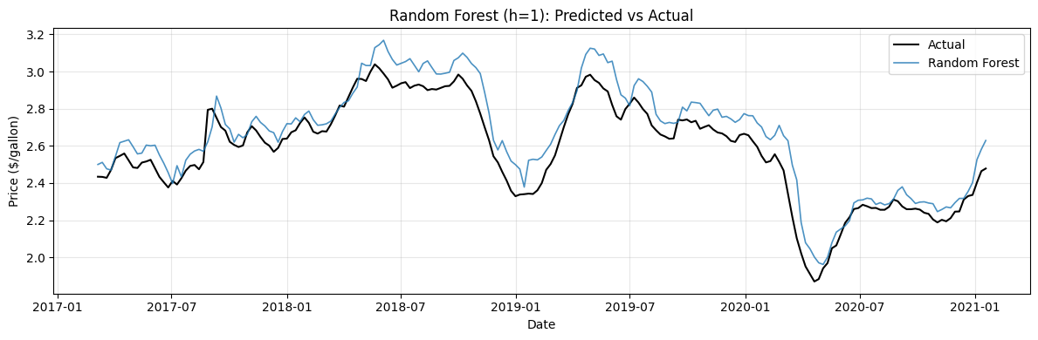
Figure 20: XGBoost - Top 20 Feature Importances

2.5 Feature Engineering Impact
Adding rolling statistics, momentum, and date features reduces Linear Regression RMSE by 38% compared to using only lag features.
Model | Basic (RMSE / MAPE) | Full (RMSE / MAPE) | Improvement
Linear Regression | 0.0666 / 1.86% | 0.0412 / 1.18% | 38.1%
Table 3: Feature engineering impact.
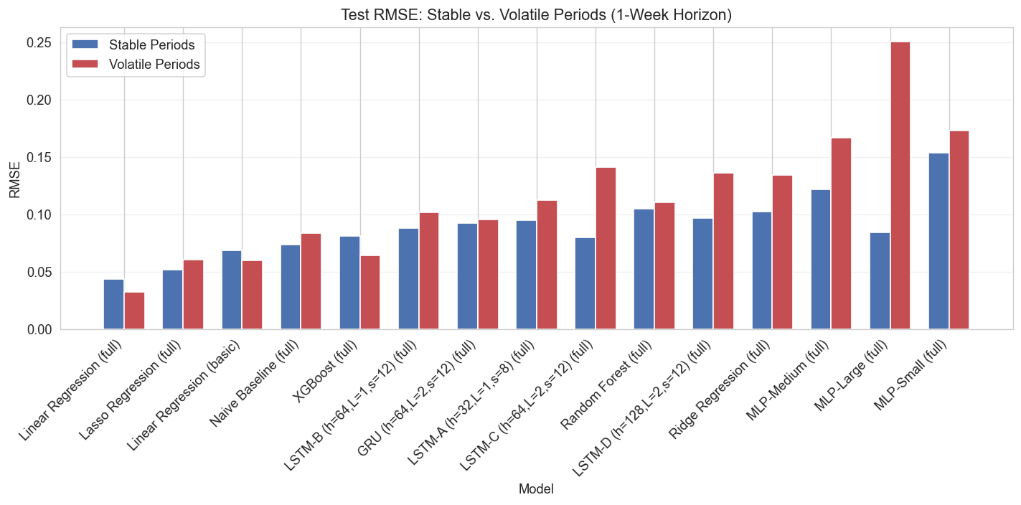
Figure 21: Impact of Feature Engineering

2.6 Stable vs Volatile Periods
All models perform worse during volatile periods (e.g., 2020 COVID crash), but linear models degrade the least.
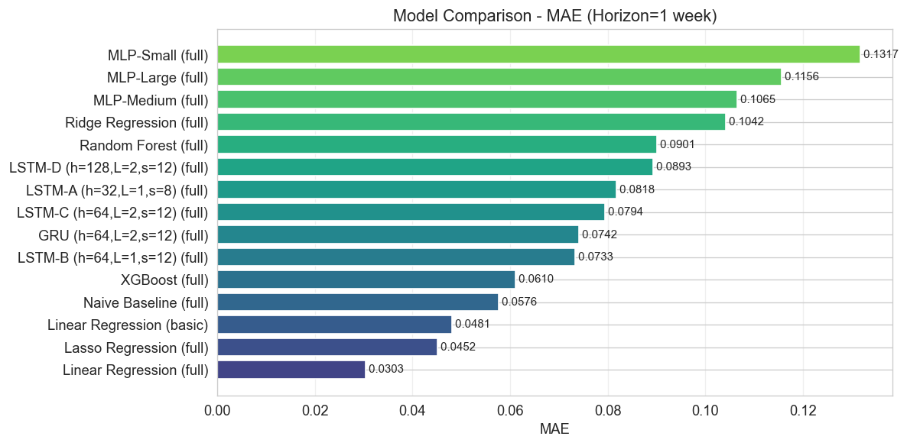
Figure 22: Test RMSE - Stable vs Volatile Periods

2.7 Horizon Comparison (1-Week vs 4-Week)
Predicting 4 weeks ahead is much harder. Most models see RMSE degrade by 100-200%, which is expected for time series with inherent uncertainty.
Model | 1-Week RMSE | 4-Week RMSE | Degradation
Ridge Regression | 0.1119 | 0.2580 | +130.6%
Random Forest | 0.1065 | 0.2269 | +113.0%
XGBoost | 0.0772 | 0.2379 | +208.2%
LSTM-B | 0.0921 | 0.2252 | +144.5%
MLP-Large | 0.1491 | 0.1471 | -1.3%
Table 4: Horizon comparison.
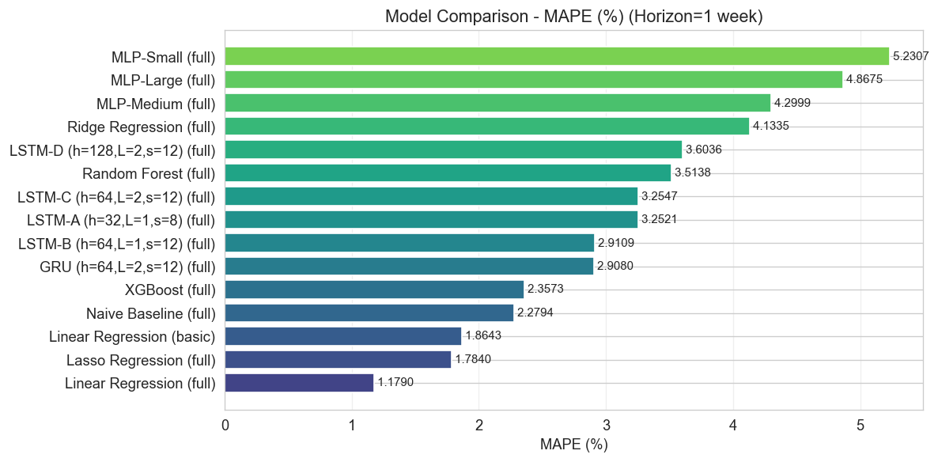
Figure 23: RMSE Degradation - 1-Week vs 4-Week
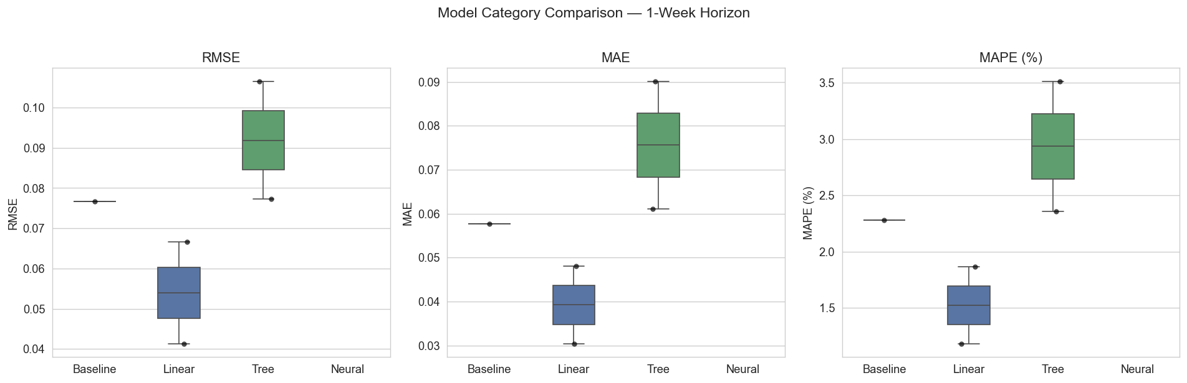
Figure 24: Accuracy Degradation Percentage
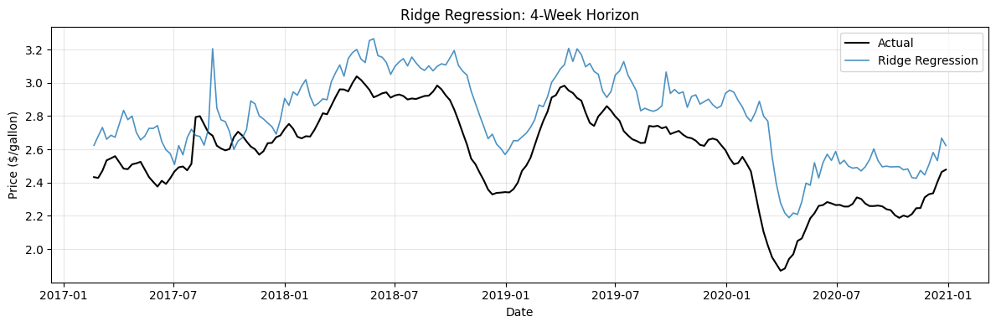
Figure 25: Ridge Regression - 4-Week Horizon

2.8 Error Analysis
Errors are generally small and centered around zero, but spike during volatile market periods like COVID-19 and the 2014 oil crash.
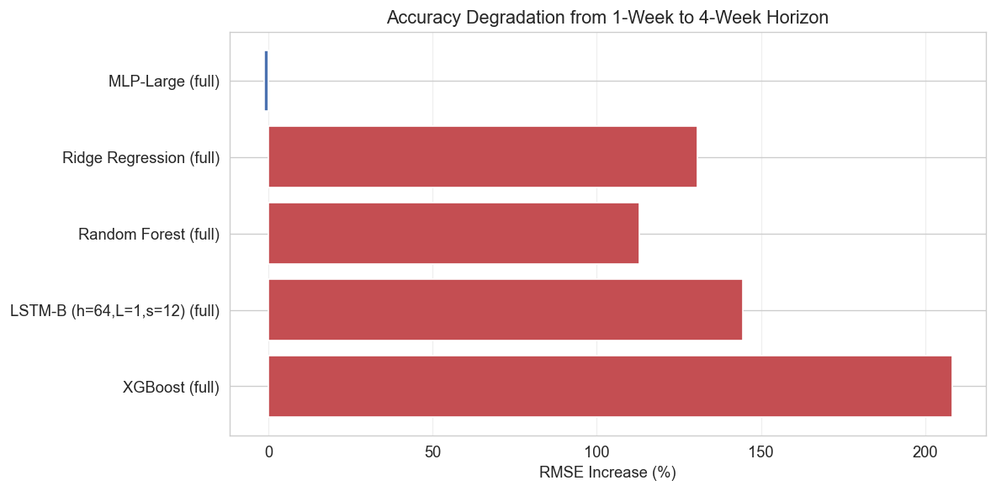
Figure 26: Residuals Over Time
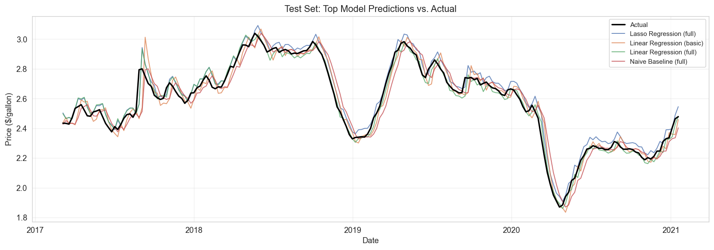
Figure 27: Error Distributions
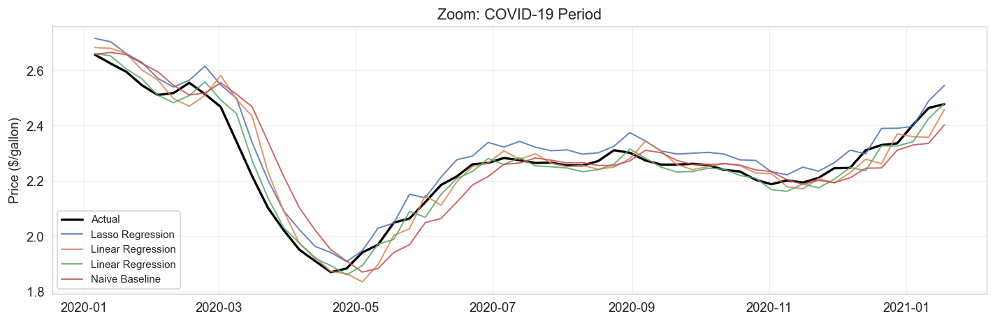
Figure 28: Actual Prices and Model Errors Over Time
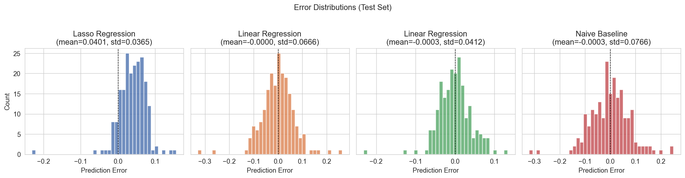
Figure 29: Actual vs Predicted Scatter (Best Model)

2.9 Zoom into Volatile Periods
Zooming into crisis periods reveals that all models lag behind sudden price movements, but recover quickly once prices stabilize.
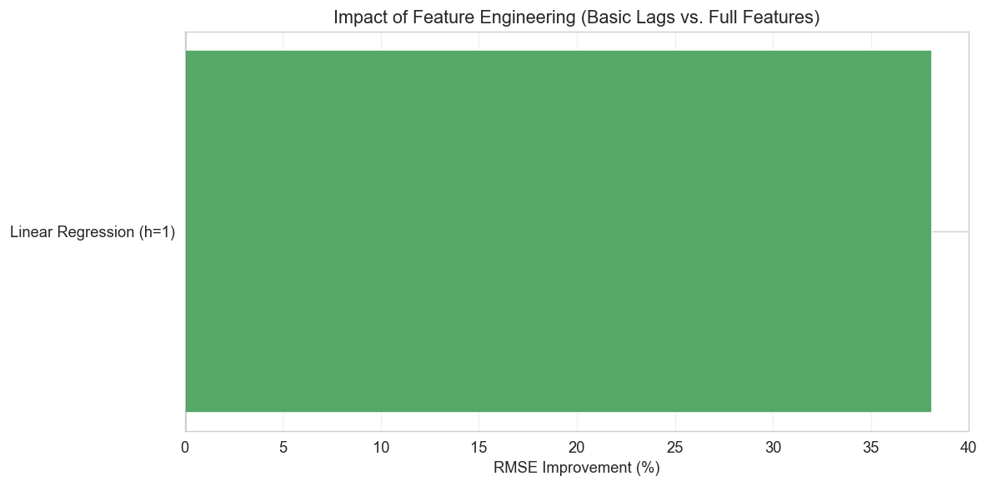
Figure 30: Zoom - COVID-19 Period
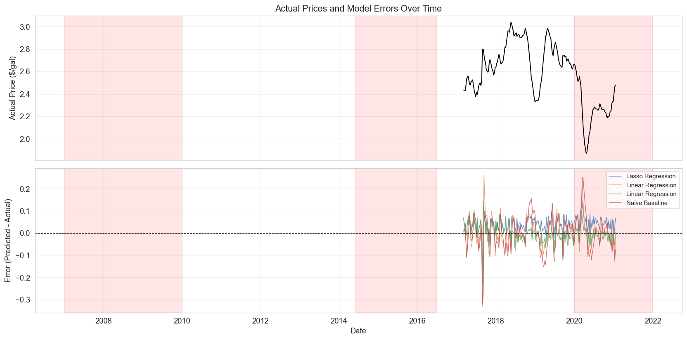
Figure 31: Zoom - 2008 Financial Crisis
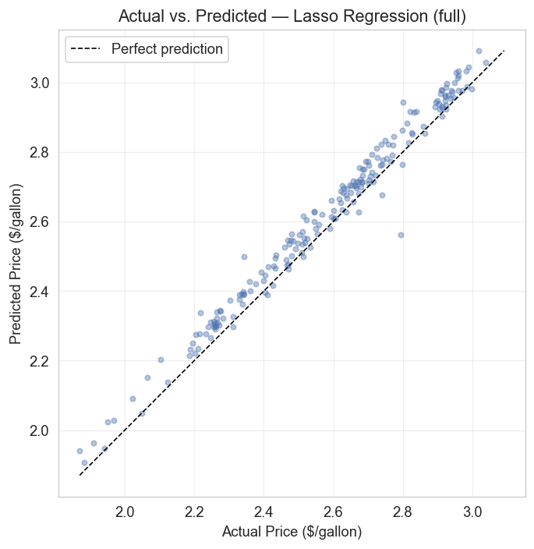
Figure 32: Zoom - 2014 Oil Price Crash

3. Regional Analysis
We test whether models trained on national data generalize across 5 PADD regions with different market dynamics and price levels.

3.1 Regional Price Overview
All regions follow similar long-term trends, but the West Coast consistently has higher and more volatile prices due to stricter fuel regulations.
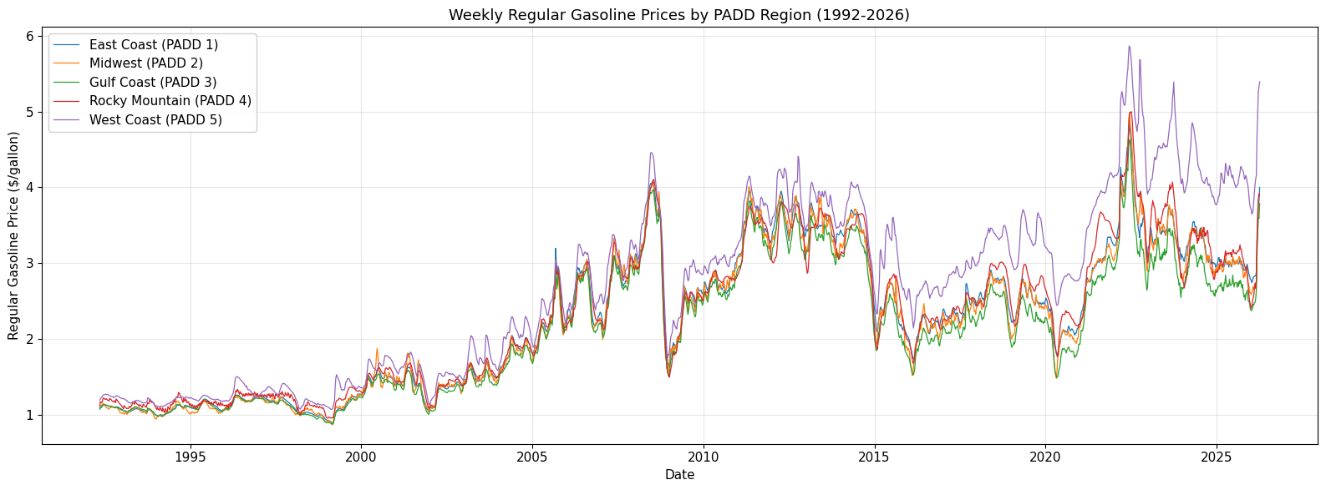
Figure 33: Weekly Gasoline Prices by PADD Region
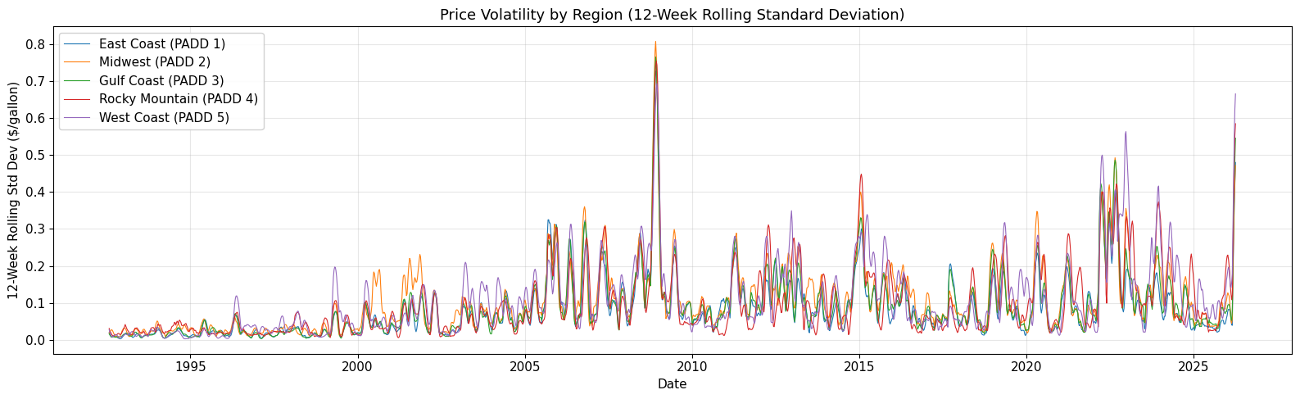
Figure 34: Price Volatility by Region
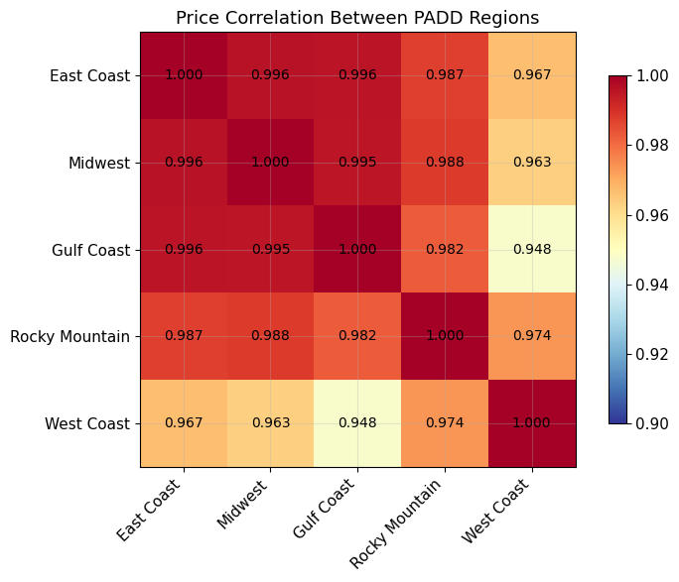
Figure 35: Price Correlation Between Regions

3.2 Regional Performance (Baseline / LR / XGBoost)
Linear Regression remains the best model in most regions. Performance varies, with West Coast being hardest to predict.
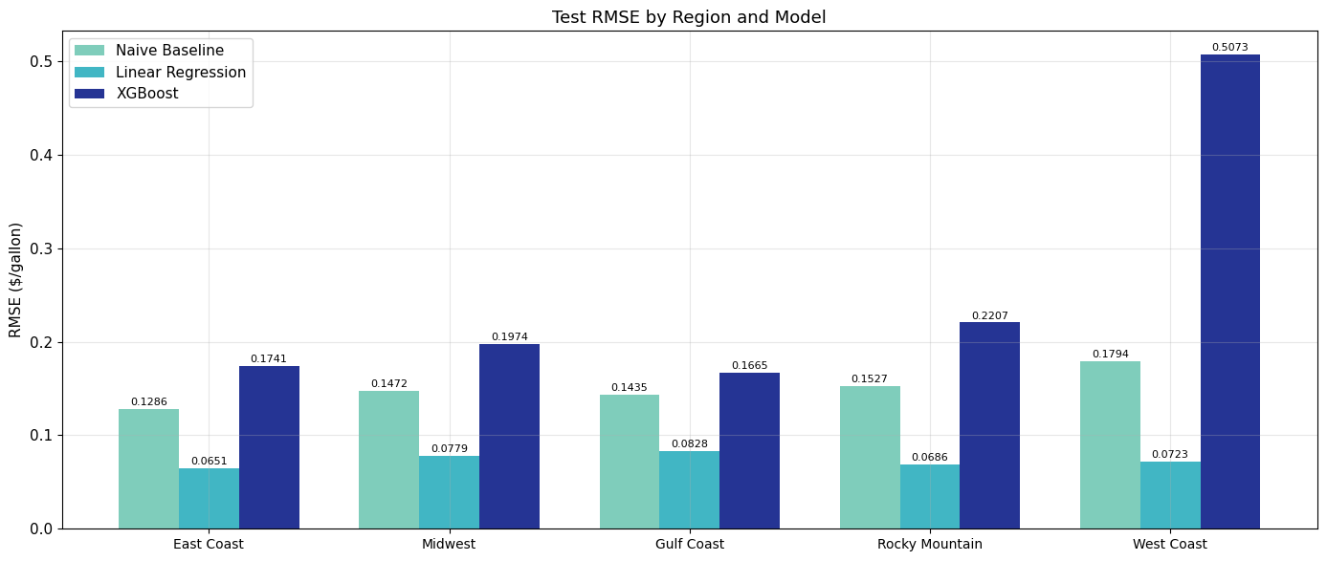
Figure 36: Test RMSE by Region and Model

3.3 Regional LSTM Performance
LSTM shows the same regional pattern: East Coast is easiest (MAPE=1.67%) and West Coast is hardest (MAPE=3.68%).
Region | RMSE | MAE | MAPE
PADD1 East Coast | 0.1024 | 0.0596 | 1.67%
PADD2 Midwest | 0.1178 | 0.0754 | 2.17%
PADD3 Gulf Coast | 0.12 | 0.0815 | 2.57%
PADD4 Rocky Mountain | 0.138 | 0.0862 | 2.34%
PADD5 West Coast | 0.2741 | 0.1783 | 3.68%
Table 5: LSTM regional comparison.
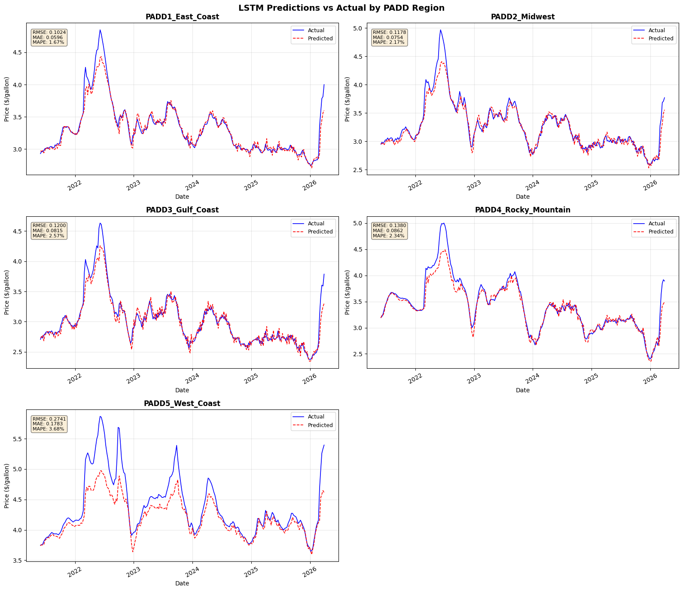
Figure 37: LSTM Predictions vs Actual by PADD Region

4. Geopolitical Event & Outlier Analysis
We examine how well models handle unprecedented price shocks by training on pre-event data and testing during the event period.

4.1 Outlier Detection
Using IQR and Z-score methods, we find that outlier weeks cluster heavily around geopolitical events (17-57% outlier rate) compared to normal periods (~5%).
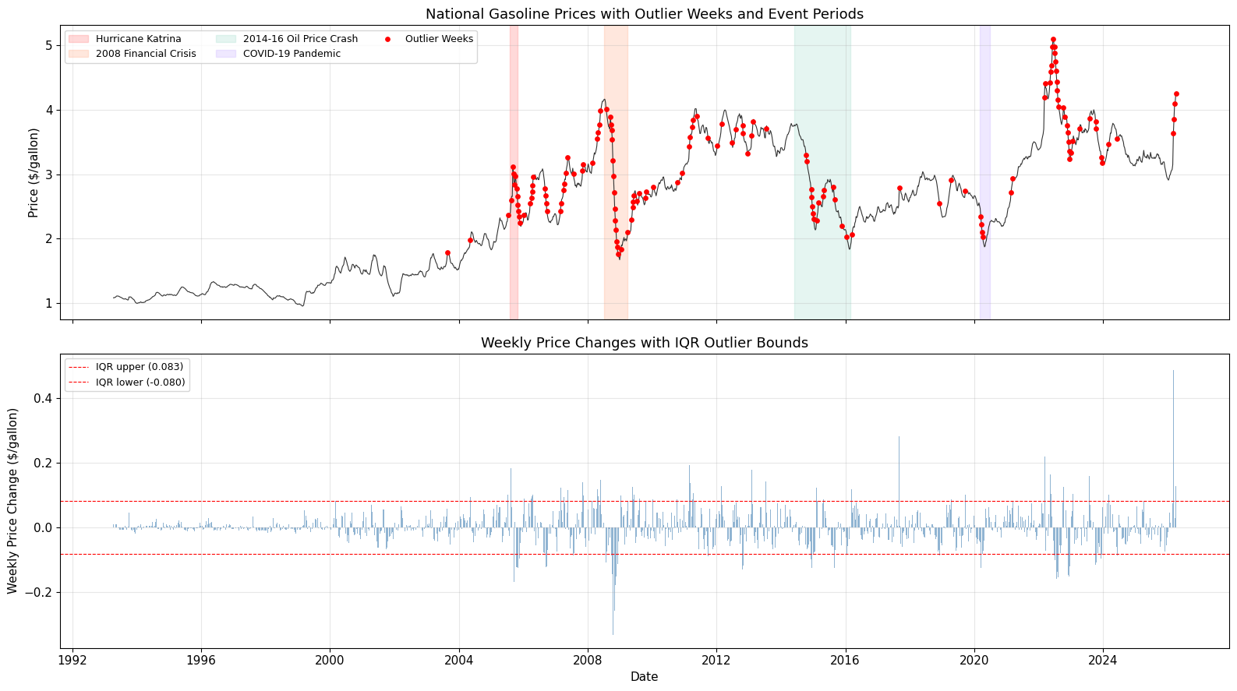
Figure 38: Gasoline Prices with Outlier Weeks and Events
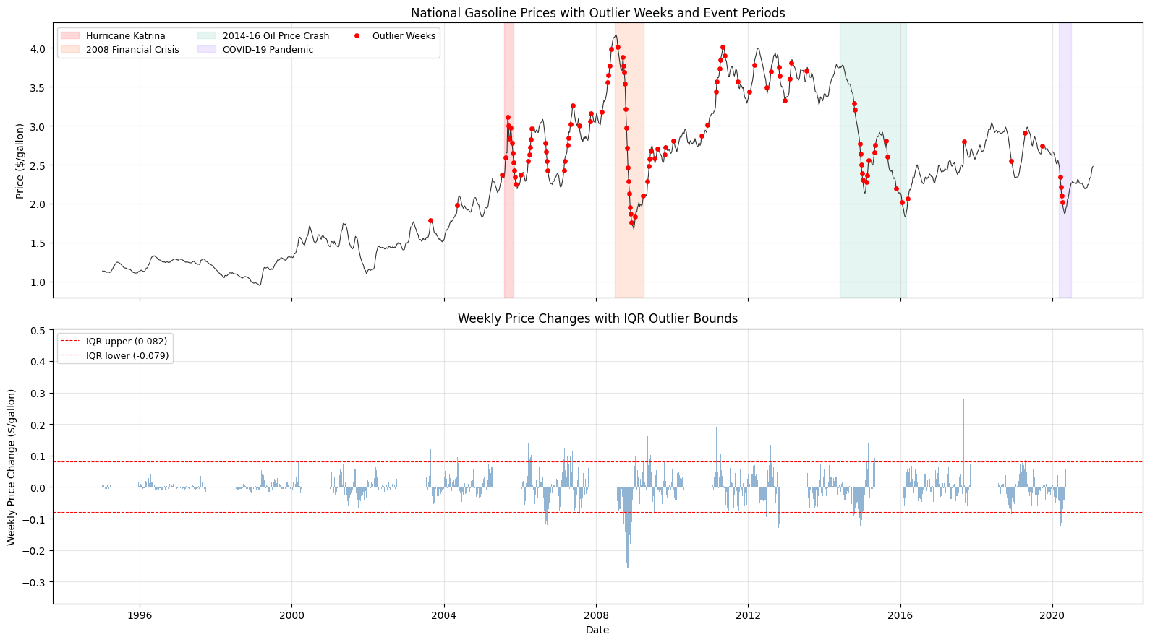
Figure 39: Weekly Price Changes with IQR Bounds

4.2 Event Impact - Baseline / LR / XGBoost
All models show amplified errors during price spikes. Linear models tend to be slightly more robust than tree-based models during sudden movements.
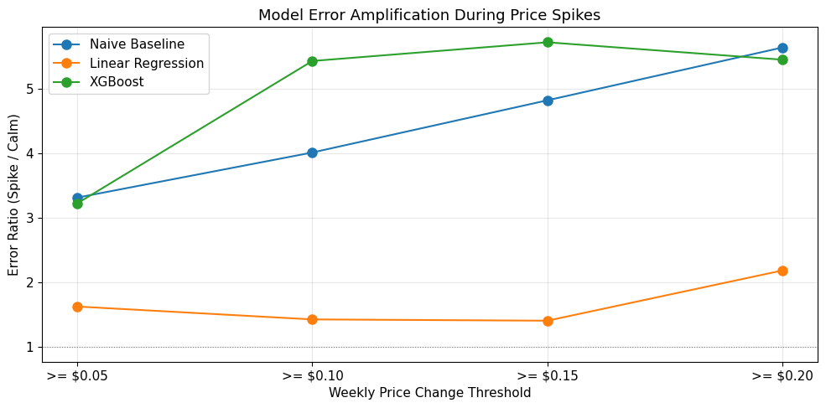
Figure 40: Model Error Amplification During Price Spikes

4.3 Event Impact - LSTM
LSTM struggles most with Hurricane Katrina (sudden spike, few test points) and the 2008 crisis (prolonged crash). Gradual events like the 2014-16 oil crash are easier to handle.
Event | Train Weeks | Test Weeks | RMSE | MAE | MAPE
Hurricane Katrina | 539 | 2 | 0.6458 | 0.6434 | 24.81%
2008 Financial Crisis | 692 | 27 | 0.2018 | 0.1421 | 7.18%
2014-16 Oil Price Crash | 1000 | 80 | 0.0531 | 0.0418 | 1.69%
COVID-19 Pandemic | 1300 | 6 | 0.0342 | 0.0283 | 1.32%
Table 6: LSTM event impact results.
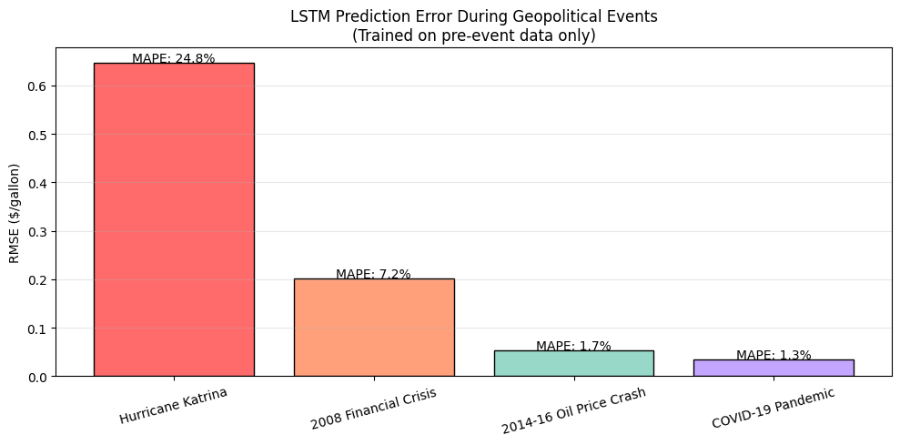
Figure 41: LSTM Prediction Error During Events

5. Concept Drift Analysis (2022-2026)
We test whether models trained on 1995-2021 data still work on recent 2022-2026 data, which includes the Russia-Ukraine war price spike.

5.1 Updated Price Data
Post-2021 prices show a dramatic spike in 2022 due to the Russia-Ukraine conflict, followed by a gradual decline back to pre-spike levels.
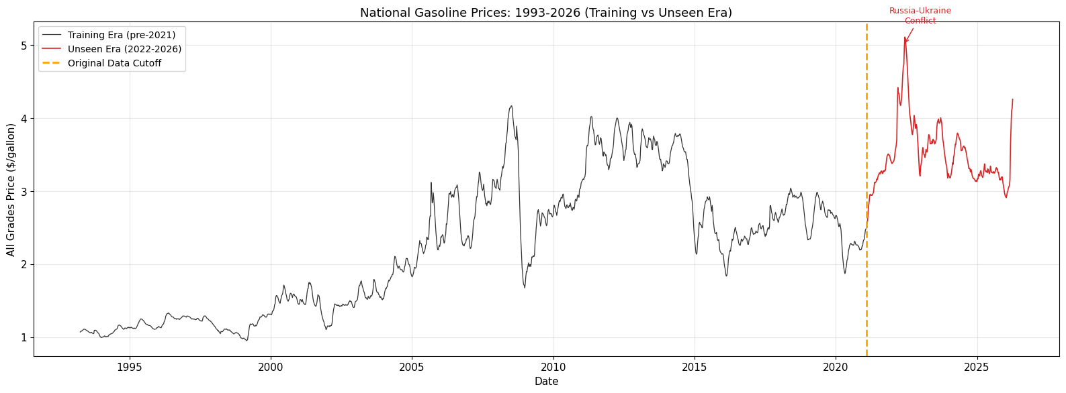
Figure 42: National Prices 1993-2026
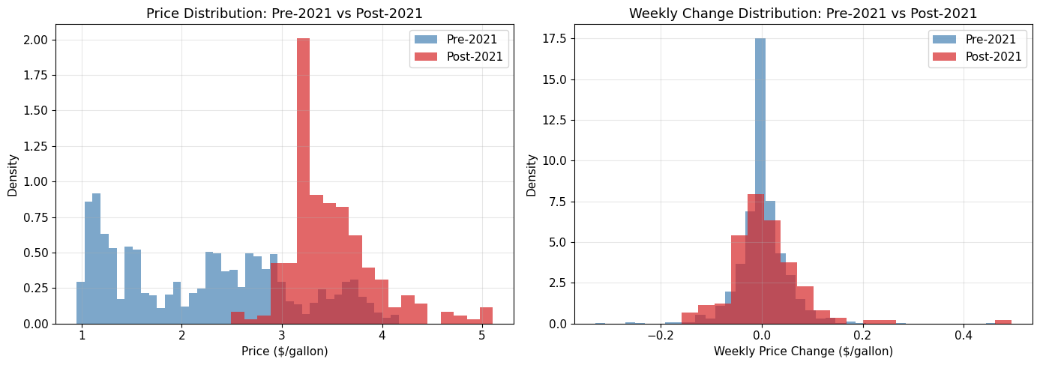
Figure 43: Price Distribution - Pre-2021 vs Post-2021

5.2 Concept Drift - Baseline / LR / XGBoost
Models trained on historical data still produce reasonable predictions on 2022-2026 data, though accuracy drops during the 2022 price spike.
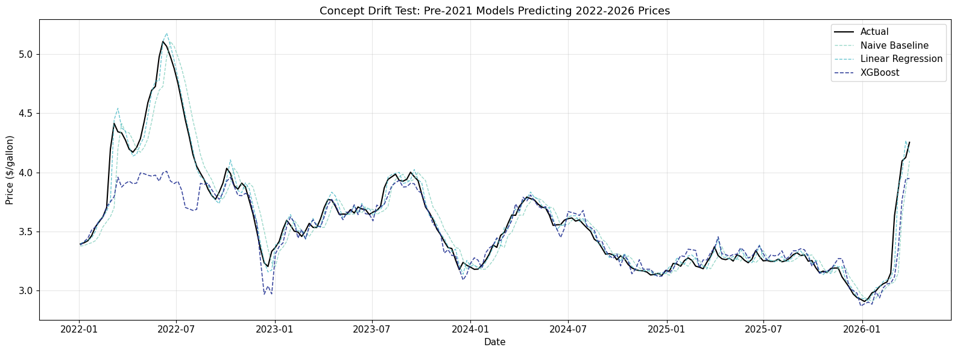
Figure 44: Pre-2021 Models Predicting 2022-2026

5.3 Concept Drift - LSTM
Retraining with data through 2024 improves LSTM RMSE by 16% (0.1124 to 0.0945), confirming concept drift exists but is manageable.
Scenario | RMSE | MAE | MAPE
No retrain (test 2022-2026) | 0.1124 | 0.0692 | 1.79%
Retrained (test 2025-2026) | 0.0945 | 0.0562 | 1.61%
Table 7: LSTM concept drift comparison.
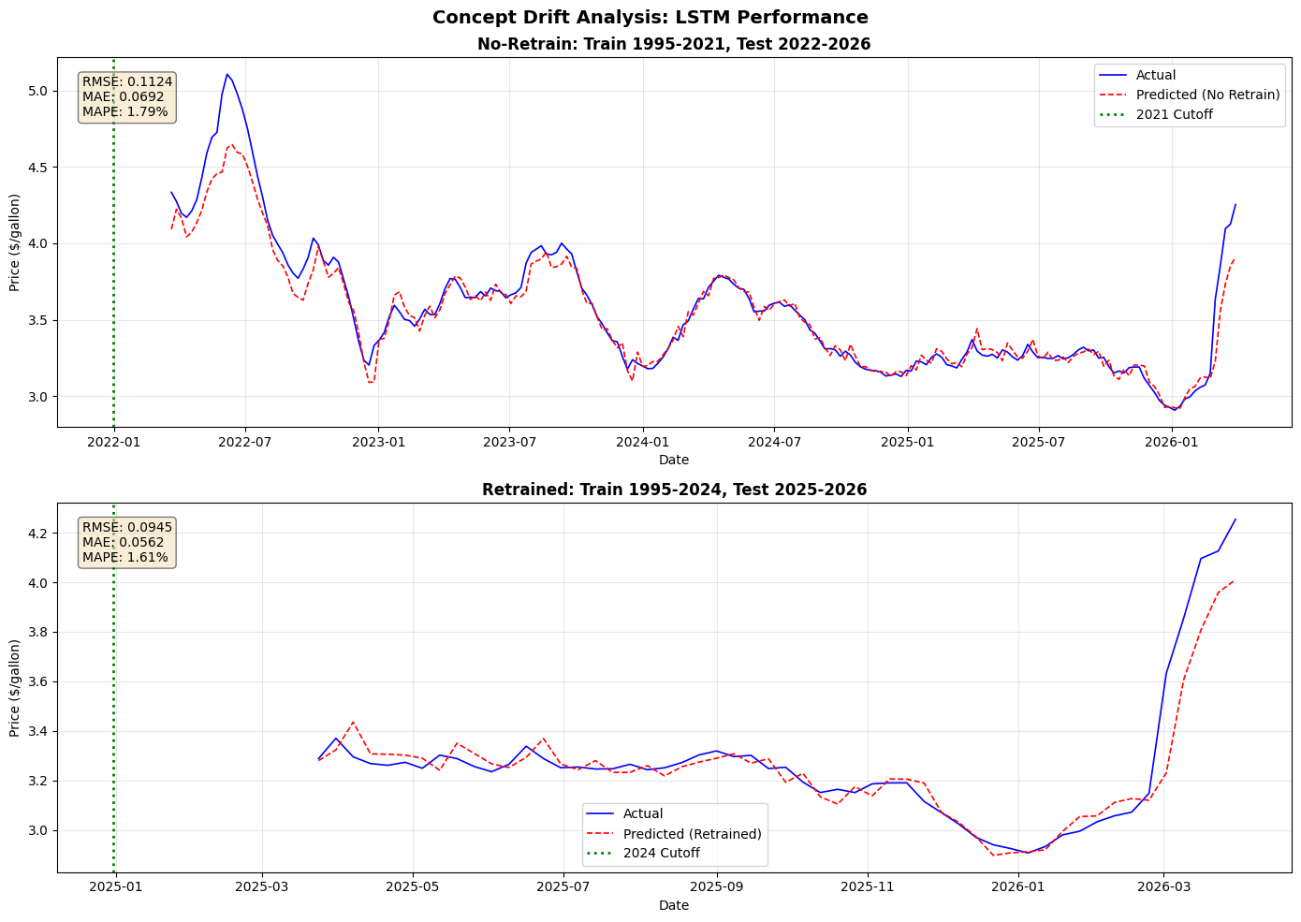
Figure 45: Concept Drift - LSTM Performance

6. Summary of Key Findings
1. Simple models win: Linear Regression with engineered features achieves the best performance (RMSE=0.0412, MAPE=1.18%), beating all complex models.
2. Feature engineering matters: Rolling statistics, momentum, and date features reduce LR error by 38% compared to lag-only features.
3. All models beat baseline: Every trained model outperforms the naive baseline, confirming ML adds value to this task.
4. Neural networks underperform: With only ~1,300 training samples, LSTM/GRU/MLP cannot match simpler models.
5. LSTM > MLP: Sequence models outperform feedforward networks, confirming temporal structure matters.
6. Longer horizons are harder: 4-week RMSE is typically 2-3x worse than 1-week prediction.
7. Regional variation exists: West Coast is hardest to predict; East Coast is easiest across all models.
8. Events degrade accuracy: All models struggle during unprecedented price shocks like the 2008 crisis.
9. Concept drift is manageable: Pre-2021 models still achieve MAPE < 2% on 2022-2026 data.
10. Complexity does not equal accuracy: For this dataset, the simplest model performs best.

