# **WOW CarShare Booking a Trip**

**Previous step: WOW** [**CarShare Registration**](https://site.mondofi.com/mobile-app-content/car-share-user-guide/registration/)

## Overview

Once your application as a WOW CarShare driver has been approved, you obtain access to the WOW CarShare fleet of vehicles.

To access **Car Sharing** in the **Mondofi Mobile App,** tap on **MOCAR** in the **Bottom Tab Navigation**.

## Current & Upcoming Trips

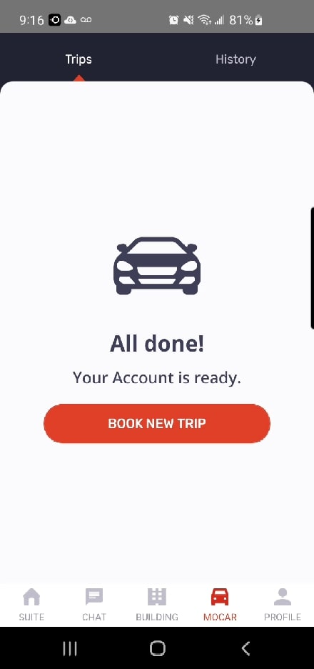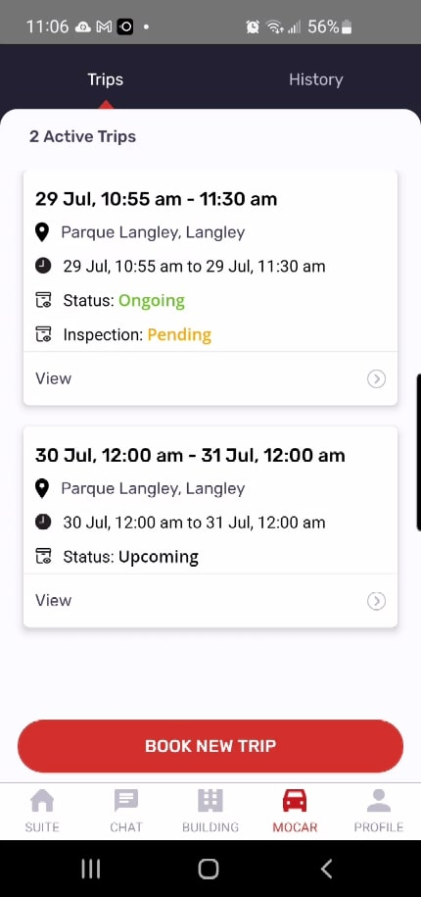Once your application is approved, tapping **MOCAR** in the Bottom Tab Navigation will display your trips in a tabbed panel.

By default, the **Trips** tab is selected, listing any ongoing or upcoming trips you have scheduled, if any.

Trips will be listed and accessible from this screen.

To create a new booking, tap the large red  **Book New Trip** button at the bottom of the screen.

Tapping the **History** tab, at the top of the screen, will display all prior bookings in reverse chronological order. For more information, please see the [Trip History](https://site.mondofi.com/mobile-app-content-car-share-user-guide-trip-history/) section of this user guide.

## Booking a New Trip

### *Location Permission*

Tapping the  **Book New Trip** button for the first time may prompt the App to request permission to access your device’s location.

Please allow access to your device’s location in order to proceed.

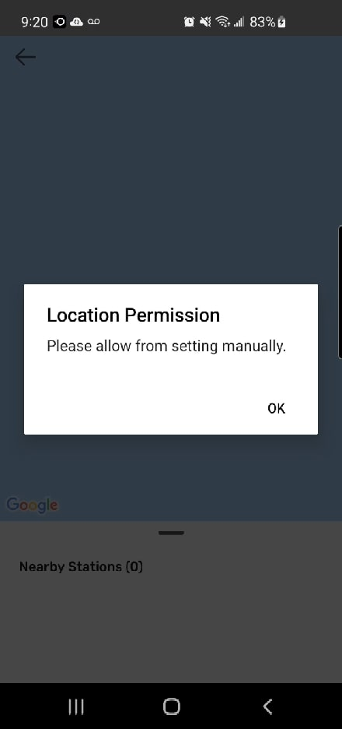

If you do not allow the App to access your device’s location, then attempting to proceed will display an alert, asking you to do so manually via your device’s settings.

### *Selecting a Station*

Tapping the  **Book New Trip** button, and if you have allowed the App to access your device’s location, will display a map of your geographical location.

At the bottom of the screen is a list of **stations** to which you have access to.These **stations** are locations where WOW CarShare vehicles are designated to park.

To proceed, tap on a **station** from the list, to proceed with a booking.

On the next screen, you will be prompted to select a trip type, and then details on start and end times.

### *Selecting a Return Type*

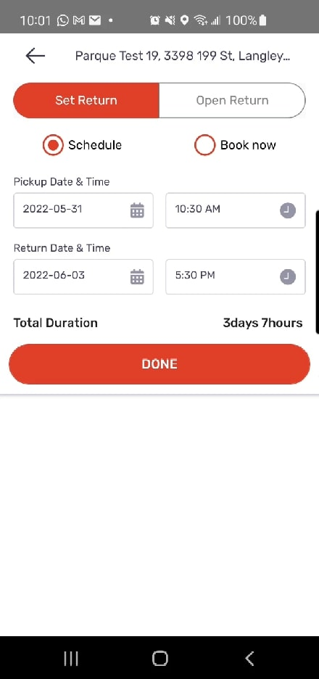

Selecting a **station** will display a short form to specify your trip details.

First, you must specify the **return type**, which are as follows:

* **Set Return**

You must specify the **Return Date & Time**.

You may select any date and time that is within **1 month of today’s date**.

* **Open Return**

Maximum of 24 hour booking duration.

Return Time is not specified, however a **Latest Return time** is set to 24 hours from the Pickup time.

**Important:** An additional Open Return Fee may be applied for Open Return trips.

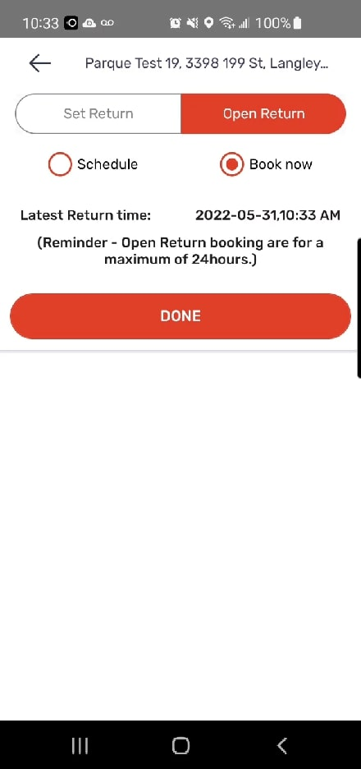

### *Selecting a Pickup Type*

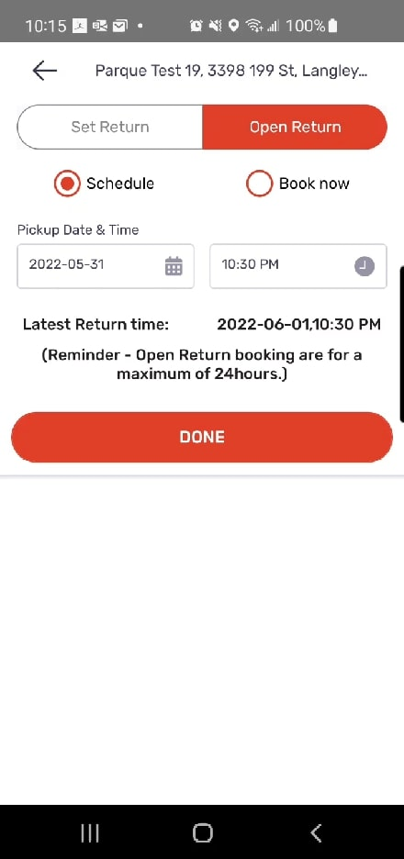

Second, you must specify the **booking type**, which are as follows:

* **Schedule**

You must specify the **Pickup Date & Time**

You may select any date and time that is at least **2 minutes** in the future and within **1 month of today’s date**.

* **Book Now**

Pick-up time is immediate once the booking process is complete.

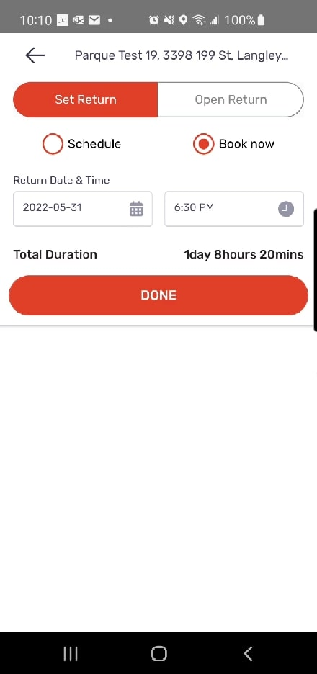

### *Selecting a Vehicle*

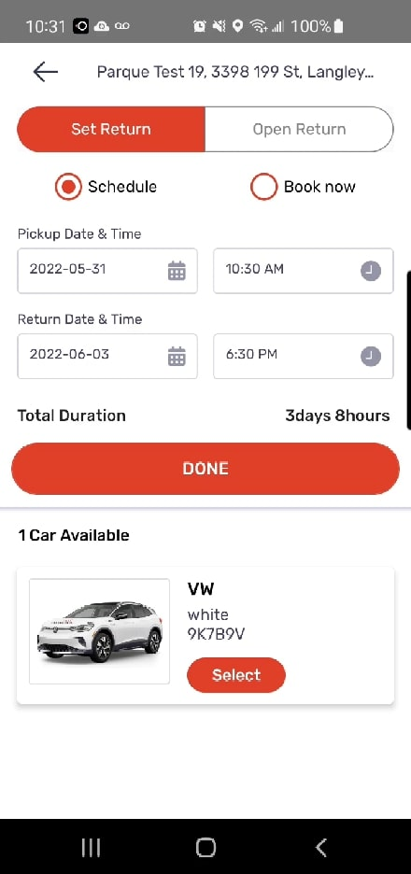

Once the **Return Type** and the **Pickup Type** are selected, tap on the **Done** button, to view a list of available vehicles at the bottom of the screen.

If multiple vehicles are available, you may scroll through the list to view them all.

Tap the **Select**  button to select a vehicle and proceed to the next step.

## Confirm Reservation Details

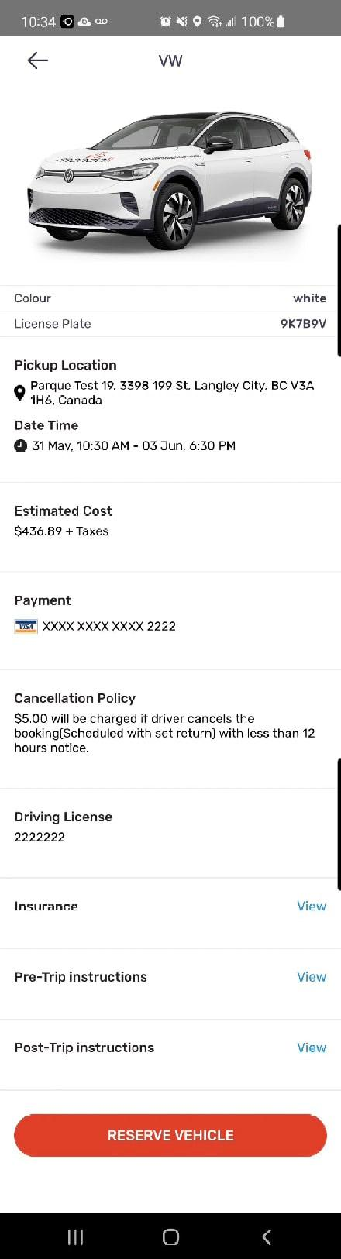

Once you’ve selected your booking specifications, a confirmation screen will be displayed, containing all the details of your reservation, including:

Vehicle details

Pickup location

Pickup date & time

Estimated Cost

Payment method selected

Copies of the following documents are available and required to be reviewed before reserving your vehicle:

* [Insurance](https://site.mondofi.com/mobile-app-content/mobile-app-content-car-share-insurance-info/)
* [Pre-Trip Instructions](https://site.mondofi.com/mobile-app-content/mobile-app-content-car-share-pre-trip-info/)
* [Post-Trip Instructions](https://site.mondofi.com/mobile-app-content/mobile-app-content-car-share-post-trip-info/)

To proceed with the booking, tap the **Reserve Vehicle**  button at the bottom of the screen.

Then, you will be asked to confirm you wish to proceed with the reservation.

To proceed, tap the  **Yes**  button.

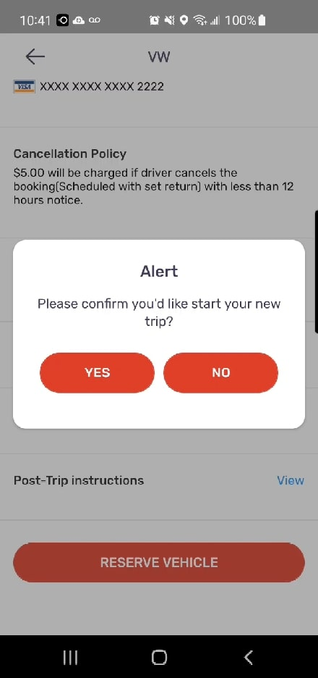

## Reservation Confirmed

Once you have reserved your reservation, a message will appear on your screen as confirmation.

The following information is displayed:

* Pickup Date & Time
* Expected Return Date & Time
* Pickup Location

Tapping the  **Ok**  button will direct you to the main MOCAR screen, **Trips** tab, where you may access your reservation.

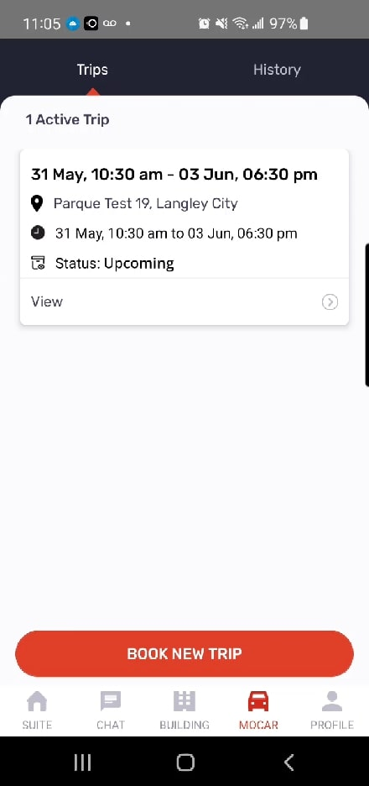

Your recently reserved booking is displayed as a card on the main MOCOAR Screen, **Trips** tab.

All current and upcoming trips are listed in chronological order, with summarized information displayed, including:

* Pickup Date & Time
* Expected Return Date & Time
* Pickup Location
* Status
  + Upcoming
  + Ongoing
* Inspection Status (if Status: Ongoing)
  + Pending
  + Completed

You may access a trip by tapping the **View** link located at the bottom of any reservation card.

For information on reservation details and actions, please see WOW [CarShare Pre-Trip Info](https://site.mondofi.com/mobile-app-content/mobile-app-content-car-share-pre-trip-info/).

**Next steps:**

* [**Mondofi Car Share Pre-Trip Info**](https://site.mondofi.com/mobile-app-content/mobile-app-content-car-share-pre-trip-info/)
* [**Mondofi Car Share Post-Trip Info**](https://site.mondofi.com/mobile-app-content/mobile-app-content-car-share-post-trip-info/)
* [**Mondofi Car Share Trip History**](https://site.mondofi.com/mobile-app-content/car-share-user-guide/trip-history/)

## Related Documents

* [Glossary of Terms](https://site.mondofi.com/mobile-app-content/mobile-app-content-car-share-glossary/)
* [Terms & Conditions](https://site.mondofi.com/mobile-app-content/mobile-app-content-car-share-terms-conditions/)
* [Privacy Policy](https://site.mondofi.com/mobile-app-content/mobile-app-content-privacy/)
* [FAQ](https://site.mondofi.com/mobile-app-content/mobile-app-content-car-share-faq/)
* [Rate Schedule](https://site.mondofi.com/mobile-app-content/mobile-app-content-car-share-rate-schedule-parque-langley/)
* [Pre-Trip Info](https://site.mondofi.com/mobile-app-content/mobile-app-content-car-share-pre-trip-info/)
* [Post-Trip Info](https://site.mondofi.com/mobile-app-content/mobile-app-content-car-share-post-trip-info/)
* [Insurance Info](https://site.mondofi.com/mobile-app-content/mobile-app-content-car-share-insurance-info/)
* [User Guide](https://site.mondofi.com/mobile-app-content/car-share-user-guide/)