# **WOW CarShare Registration**

**Previous step:** [**Getting Started, Mondofi Mobile Application**](https://site.mondofi.com/help-centre/residents/getting-started-mondofi-mobile-application/)

## Overview of Car Share Registration

WOW CarShare program requires all WOW CarShare Members to also be members of WOW Tri-Cities. Then all WOW Tri-Cities members are able to submit an application as a Driver, directly from the App.

All Car Share users must complete the application process and be approved before being able to use the Vehicles. Please refer to the [Terms & Conditions](https://site.mondofi.com/mobile-app-content/mobile-app-content-car-share-terms-conditions/) for eligibility criteria.

The Car Share application process includes:

* Reading and agreeing the [Terms & Conditions](https://site.mondofi.com/mobile-app-content/mobile-app-content-car-share-terms-conditions/) and the [Privacy Policy](https://site.mondofi.com/mobile-app-content/mobile-app-content-privacy/)
* Submitting photos of your Driver’s License in the App
* Submitting a Selfie in the App
* Submitting Driver’s License information in the App
* Arrange for your official Driving Record to be sent to [carshare_records@mondofi.com](mailto:carshare_records@mondofi.com) directly from your Driver’s Licensing Office. It must be in English, or supplemented with a certified English translation.
* Adding a Payment Method in the App

The below documentation outlines the application process in detail.

## Agree to Terms & Conditions and Privacy Policy

On the Mondofi Mobile App, tapping **MOCAR Tab** at the bottom of the screen before you have submitted a Car Share application will initiate the Car Share application process.

The first steps in the Application process includes **reading and accepting**:

* [Terms & Conditions](https://site.mondofi.com/mobile-app-content/mobile-app-content-car-share-terms-conditions/)
* [Privacy Policy](https://site.mondofi.com/mobile-app-content/mobile-app-content-privacy/)

Tap each **checkbox** once complete, then tap op  **I Agree & Continue** .

## Verify Driver’s License, Overview

Next, your Driver's License information must be submitted.

Please complete the form, with the following information:

* Upload a Photo of your Driver’s License, Front Side
* Upload a Photo of your Driver’s License, Back Side
* Take a Selfie, to validate that the driver’s license belongs to you
* Specify the Country or State of Issue
* Provide Driver’s License Number
* Provide Your Full Name as it appears on your Driver’s License
* Provide License Expiration Date
* Provide Your Birthdate

### 

### 

### 

### 

### 

### 

### 

### 

### 

### 

### 

### 

## Photo of Front & Back Side of Driver’s License

Please **upload** or **take two photos** of your **U.S Driver's License**:

* Front Side
* Back Side

Tapping on either boxes labeled **Front Side** or **Back Side** will display a **menu** of options available to upload a photo:

* Take Photo
* Choose Photo Library

### 

### 

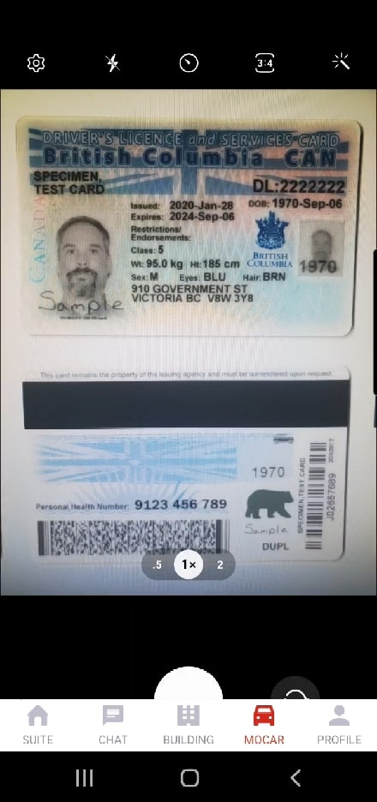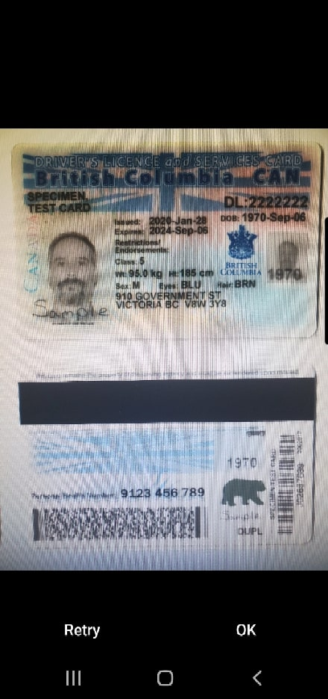

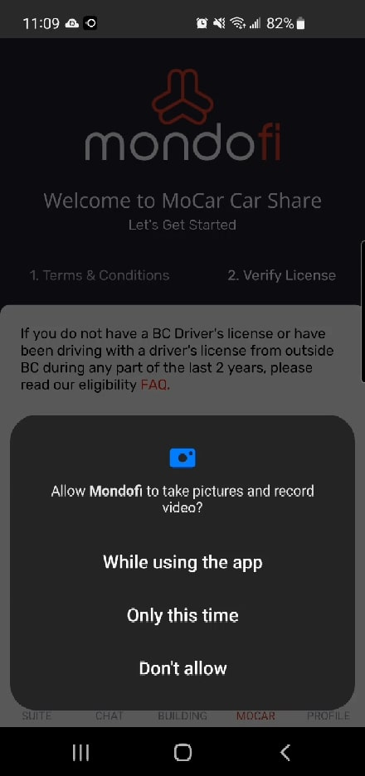

### Take Photo, Grant Permission

The first time you tap on **Take Photo**,you may be asked to **Allow WOW to take pictures and record video.**

To proceed, please **grant permission**.

### Option 1: Taking a Photo

Tapping **Take Photo**, will trigger your device's camera to turn on, allowing you to immediately take a photo.

Take a photo of the **front** or **back** of the ID card, depending which field you’re submitting the photo under (**Front** or **Back**).

Once the photo is taken, you will be asked to confirm whether the image is **Ok**, or if you wish to **Retry**.

If you wish to **retake the photo**, then tap **Retry**.

If you wish to **use this photo**, then tap **Ok**.

### Editing the Photo

You may **Crop** the image by moving and resizing the **white rectangle** on the photo.

**Dragging the center** of the white rectangle will move it across your screen.

**Dragging the edges** of the white rectangle will resize it.

Tapping the **rotate** **icon** in the top-right corner will rotate the image 90 degrees clockwise.

Please ensure that the entire **front** or **back** of the ID card is clearly visible.

Once ready, please click  **Submit** to proceed.

Once submitted, the Mocar screen will be updated and display the uploaded image in the box under which it was submitted.

Please ensure to upload:

* A photo of the front of your ID under the **Front** field**.**
* A photo of the back of your ID under the **Back** field**.**

### Option 2: Choose Photo from your Device, Grant Permission

The first time you tap on **Choose Photo Library**,you may be asked to **Allow WOW CarShare to access photos and media on your device**.

To proceed, please **grant permission**.

### Choose Photo from your Device

Tapping **Choose Photo Library** will open your device's file browsing, prompting you to select a photo from your device.

Browse your device and select a photo of your front or back of your ID card.

### Editing the Photo

You may **Crop** the image by moving and resizing the **white rectangle** on the photo.

**Dragging the center** of the white rectangle will move it across your screen.

**Dragging the edges** of the white rectangle will resize it.

Tapping the **rotate** **icon** in the top-right corner will rotate the image 90 degrees clockwise.

Please ensure that the entire **front** or **back** of the ID card is clearly visible.

Once ready, please click  **Submit** to proceed.

Once submitted, the Mocar screen will be updated and display the uploaded image in the box under which it was submitted.

Please ensure to upload:

* A photo of the front of your ID under the **Front** field**.**
* A photo of the back of your ID under the **Back** field**.**

## Take a Selfie to Validate Driver’s License

In order to validate that the Driver’s License belongs to the WOW account holder, an additional photo taken through the Mondofi App must be uploaded.

In this step, you must **take a selfie (photo of yourself)** with your device's camera, in order to verify that the driver's license belongs to you, the WOW account holder.

Tap on the large box with a **plus (+)** symbol, under **Take a Selfie**.

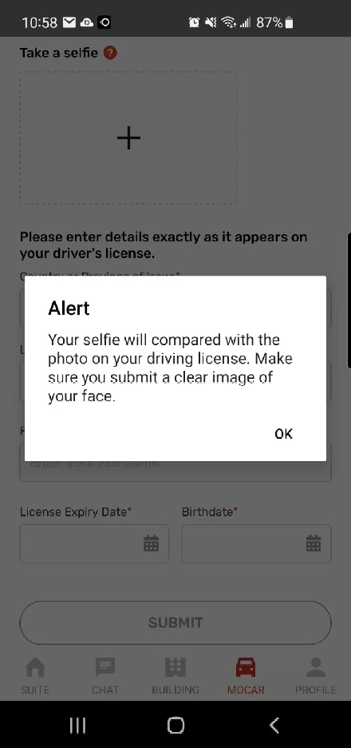If prompted, please allow permission for WOW to take pictures and record video, in order to proceed.

Tapping the **question mark (?)** next to **Take a selfie** will display more information and instructions about this step.

### Taking the Selfie

Tapping **Take a Selfie box** will trigger your device's camera to turn on (if permission is granted), allowing you to immediately take a photo.

Initially, your device’s **back camera** may be activated. 

To **swap** between **back camera** and **front camera**, click on the **rotate icon** in the bottom-right corner of the screen.

Take a **clear, well lit photo of your face**.

Once the photo is taken, you will be asked to confirm whether the image is **Ok**, or if you wish to **Retry**.

If you wish to **retake the photo**, then tap **Retry**.

If you wish to **use this photo**, then tap **Ok**.

Tapping **Ok** will upload the photo, and it will appear inside the Take a Selfie box, on the Mocar screen.

## Inputting Dates

When inputting dates, such as License Expiration Date and Birthdate, tapping the date field will open the date picker.

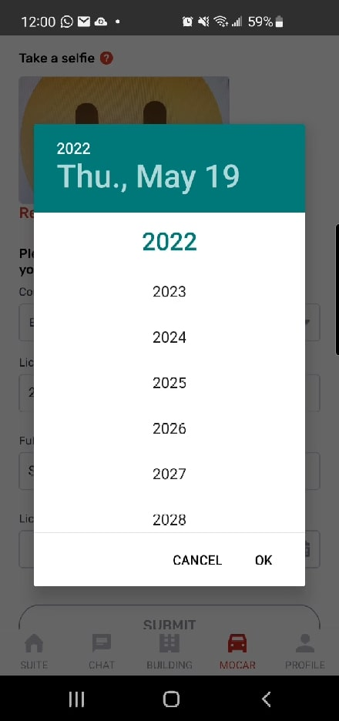

First, tap the **Year** in the top-right corner of the date picker.

Then, select the desired **Year**.

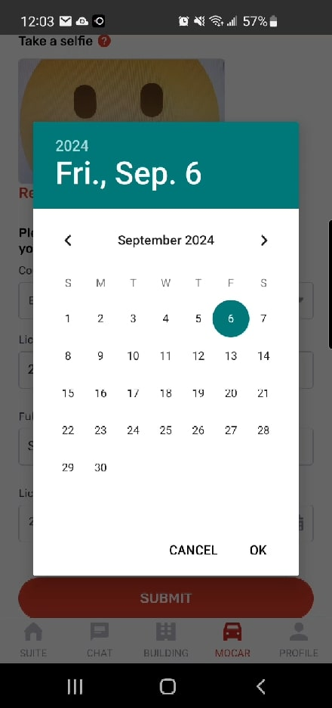Then, cycle through the **months** by tapping the arrows or above.

Once the desired **month** is selected, tap the desired **day**.

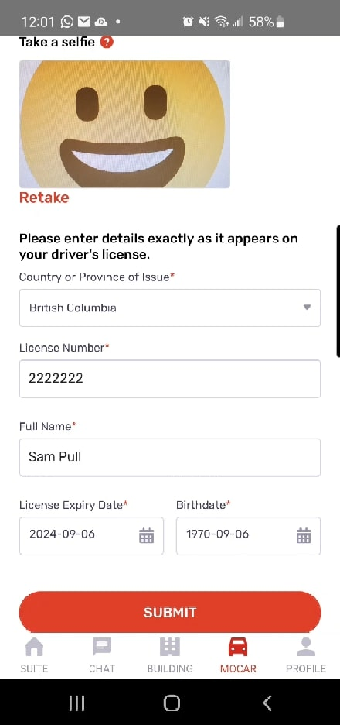

Once the correct date is selected, as appearing at the top, tap **Ok.**

The date entered will appear in the date field.

## Submitting Driver’s License Information

Input Driver’s License information accurately, providing the following information:

* Country or State of Issue
* License Number
* Full Name
* License Expiration Date
* Birthdate

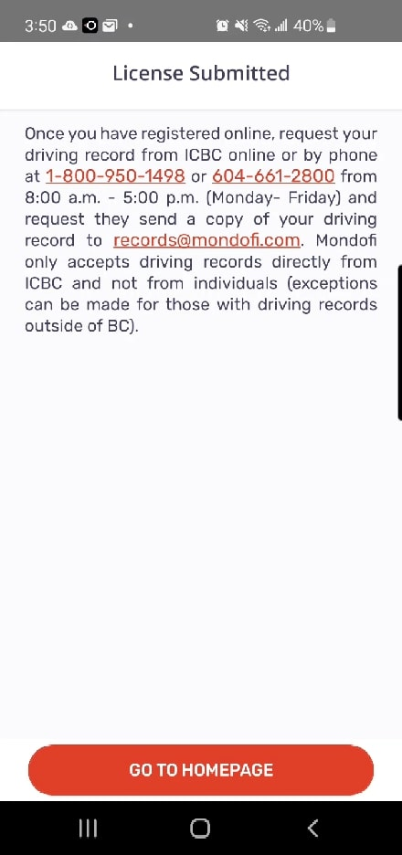**Note:** if your Driver’s License photo is clear enough, the License Number will be populated automatically. Please ensure to review the License Number.

Once all information is entered, including the required photos of your Driver’s License and Selfie, please click  **Submit** to proceed.

## Choose Payment Method

After submitting your Driver’s License information, you will be asked to **select a credit card** as the default method of payment for **WOW Car Share**.

The **Choose Payment Method** screen displays the **credit cards** you’ve added to your WOW account.

To add a new credit card, tap the  **Add New Card**  button at the bottom of the screen.

The guide for adding a new credit card to your WOW Account is found here: [**Profile, Payment Method**](https://site.mondofi.com/help-centre/residents/mobile-app-profile-payment-method/)

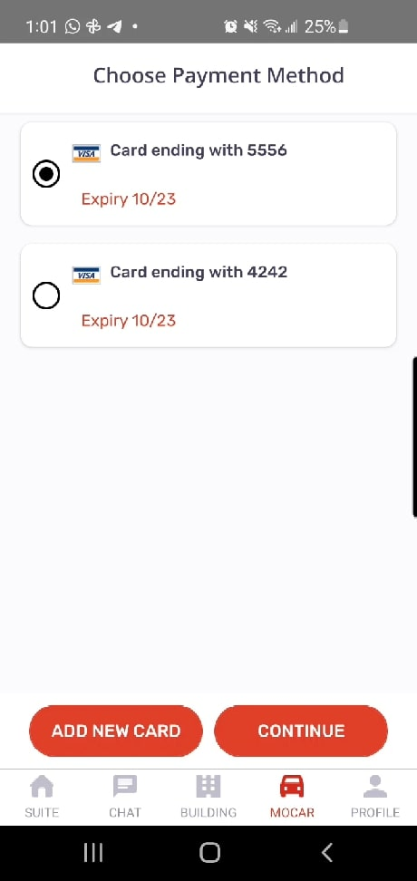Once **one or more credit cards** are added to your account, you may **select** a credit card by tapping on the credit card.

The **radio button** indicates which credit card is selected.

To **assign the credit card**, click  **Continue** .

Any subsequent changes to your **WOW Car Share Payment Method** can be made from the **Payment Method** screen, under Profile.

The guide to using the Payment Method screen is found here:

[**Profile, Payment Method**](https://site.mondofi.com/help-centre/residents/mobile-app-profile-payment-method/)

## Arrange your Driving Record to be Submitted

Once you have submitted your Driver’s License information via the App, please request your “insurance’ driving record to be sent from your driver’s licensing office **directly** to [carshare_records@mondofi.com](mailto:carshare_records@mondofi.com) .

If you have a WA Driver’s License, you may request your driving record from WA Department of Licensing online at <https://www.dol.wa.gov/media/1882/download?online>. Ensure ‘Driving record release of interest (dol.wa.gov/driverslicense) to WOWTriCities@gmail.com. or by phone at **1-360-902-3900** from 8:00 a.m. - 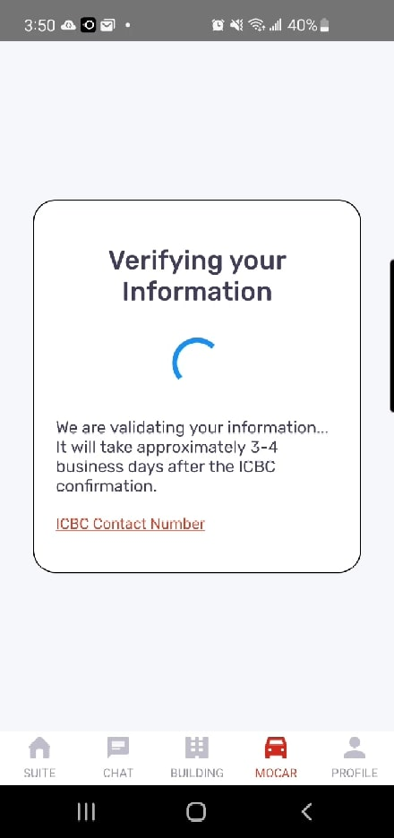5:00 p.m. (Monday - Friday).

WOW CarShare only accepts driving records directly from License issuing agencies and not from individuals.

If you have a Driver’s License from another country,, then you must provide an up-to-date official driving record from the issuer of your Driver’s License. Your driving record abstract must be in English, or supplemented by a certified English translation.

Tapping  **Go To Homepage** will direct you to the Suite screen in the Mondofi Mobile App.

If you access the **MOCAR** screen in the Mondofi Mobile App while your Driver’s License and Records are **pending review**, then you will be presented with a message stating “Verifying Your Information”.

**Next steps:**

* [**Mondofi Car Share Booking a Trip**](https://site.mondofi.com/mobile-app-content/car-share-user-guide/booking-a-trip/)
* [**Mondofi Car Share Pre-Trip Info**](https://site.mondofi.com/mobile-app-content/mobile-app-content-car-share-pre-trip-info/)
* [**Mondofi Car Share Post-Trip Info**](https://site.mondofi.com/mobile-app-content/mobile-app-content-car-share-post-trip-info/)
* [**Mondofi Car Share Trip History**](https://site.mondofi.com/mobile-app-content/car-share-user-guide/trip-history/)
* [**Profile & Settings**](https://site.mondofi.com/help-centre/residents/mobile-app-profile-settings/)

## Related Documents

* [Glossary of Terms](https://site.mondofi.com/mobile-app-content/mobile-app-content-car-share-glossary/)
* [Terms & Conditions](https://site.mondofi.com/mobile-app-content/mobile-app-content-car-share-terms-conditions/)
* [Privacy Policy](https://site.mondofi.com/mobile-app-content/mobile-app-content-privacy/)
* [FAQ](https://site.mondofi.com/mobile-app-content/mobile-app-content-car-share-faq/)
* [Rate Schedule](https://site.mondofi.com/mobile-app-content/mobile-app-content-car-share-rate-schedule-parque-langley/)
* [Pre-Trip Info](https://site.mondofi.com/mobile-app-content/mobile-app-content-car-share-pre-trip-info/)
* [Post-Trip Info](https://site.mondofi.com/mobile-app-content/mobile-app-content-car-share-post-trip-info/)
* [Insurance Info](https://site.mondofi.com/mobile-app-content/mobile-app-content-car-share-insurance-info/)
* [User Guide](https://site.mondofi.com/mobile-app-content/car-share-user-guide/)