# **WOW CarShare Trip History**

**Previous step:** [**WOW CarShare Bookings**](https://site.mondofi.com/mobile-app-content/car-share-user-guide/booking-a-trip/)

## Overview

You may view your prior bookings, and the corresponding invoices, at any time.

## History of Prior Trips

To view a list of your prior trips, open the **Mondofi Mobile App** and tap on **MOCAR** in the Bottom Tab Navigation. Then, tap on the **History** tab at the top of the screen.

A list of all prior trips will be displayed in reverse chronological order, if any exist.

Each prior trip is displayed as a card, including the following summarized information:

* Title of the trip is a composition of:
  + Booking Start Date and Time
  + Booking End Date and Time
* Building Name / Pick up location
* Trip Start Date and Time
* Trip End Date and Time
* Ending Status, can be either:
  + **Ended**
  + **Canceled**

To view **further details** about an individual trip, tap the bottom of its card, where the **status** is listed.

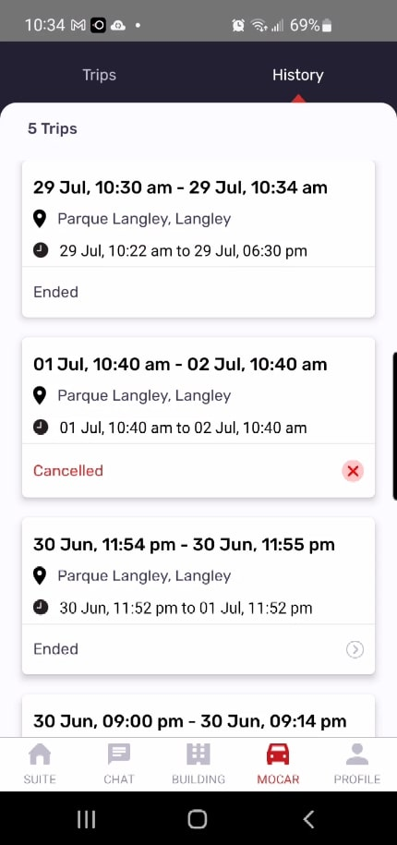

## Prior Trip Details

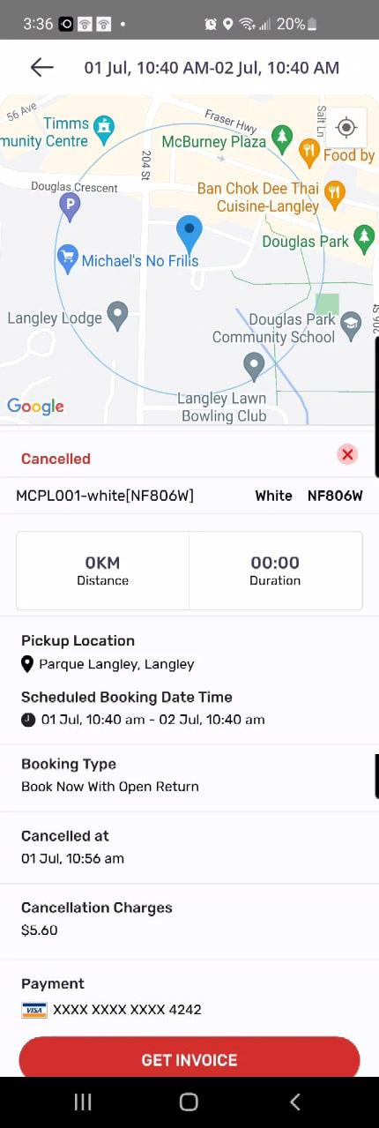On the History tab, tapping the status on a trip’s card will direct you to the booking details.

Full details about the booking are displayed, along with access to the corresponding invoice.

The following information is displayed:

* Ending Status, can be either:
  + **Ended**
  + **Canceled**
* Vehicle details, including:
  + License plate
  + Color
  + Vehicle Name in the system
* Total distance
* Total duration
* Pick-up location
* Scheduled booking date time
* Booking type, can be either:
  + Scheduled, Set Return
  + Scheduled, Open Return
  + Book Now, Set Return
  + Book Now, Open Return
* Associated charges
* Payment method used, partial credit card number

The booking details screen also allows access to view the invoice via the  **Get Invoice** button at the bottom of the screen.

## Prior Trip Invoice

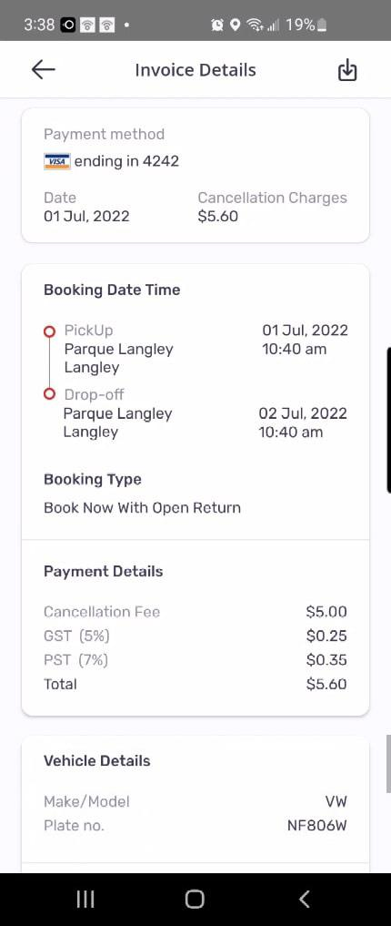

Tapping the  **Get Invoice** button from the Trip Details screen will display the invoice details for the trip.

You may download a PDF copy to your device by tapping the **download icon** in the top-right corner of the screen.

The following information is included on the invoice:

* Payment method details
  + Last 4 digits of the credit card used
  + Date of the payment
  + Amount
* Booking details
  + Pick-up & drop-off location
  + Pick-up & drop-off dates & times
  + Booking type
* Payment details
  + Fees applied
  + Taxes applied
  + Total amount
* Vehicle details

**Next steps:**

* [**Profile & Settings**](https://site.mondofi.com/help-centre/residents/mobile-app-profile-settings/)
* [**Suite Screen**](https://site.mondofi.com/help-centre/residents/mobile-app-suite-screen/)
* [**Chat Screen**](https://site.mondofi.com/help-centre/residents/mobile-app-chat/)
* [**Building Screen**](https://site.mondofi.com/help-centre/residents/mobile-app-building-screen/)

## Related Documents

* [Glossary of Terms](https://site.mondofi.com/mobile-app-content/mobile-app-content-car-share-glossary/)
* [Terms & Conditions](https://site.mondofi.com/mobile-app-content/mobile-app-content-car-share-terms-conditions/)
* [Privacy Policy](https://site.mondofi.com/mobile-app-content/mobile-app-content-privacy/)
* [FAQ](https://site.mondofi.com/mobile-app-content/mobile-app-content-car-share-faq/)
* [Rate Schedule](https://site.mondofi.com/mobile-app-content/mobile-app-content-car-share-rate-schedule-parque-langley/)
* [Pre-Trip Info](https://site.mondofi.com/mobile-app-content/mobile-app-content-car-share-pre-trip-info/)
* [Post-Trip Info](https://site.mondofi.com/mobile-app-content/mobile-app-content-car-share-post-trip-info/)
* [Insurance Info](https://site.mondofi.com/mobile-app-content/mobile-app-content-car-share-insurance-info/)
* [User Guide](https://site.mondofi.com/mobile-app-content/car-share-user-guide/)