**Roll number: @00652748**

**User ID: agg845**

**1. Site content and design:**

**Url:** <https://husain-mahdi.github.io/H-Mahdi.github.io/>

**Subject:**

I created this website in order to contain my artwork and act as a portfolio for both my traditional and digital art.

**Website design:** Fluid design.

**Website resource:**

These resources are wireframes for my website.

Navigation

Logo

Title Text

Picture

Sub-Title Text

Picture

Title Text

Sub-Title Text

Paragraph

Paragraph

Title Text

Sub-Title Text

Sub-Title Text

Picture

Sub-Title Text

Picture

Footer

**2. Use of HTML5:**

I used the ‘header’ element to separate the introduction part of my web pages from the other aspects of my web page. I used the ‘div’ element in to divide certain elements of my web page and style them to my liking. I used the ‘nav’, ’ul’, and ‘li’ elements in conjunction with each other to create a list of navigation on my webpages. I used the ‘a’ element along with ‘href’ in order to add hypertext link. Similarly, to the ‘header’ and ‘div’ elements I used the ‘section’ element to section off my webpage, but it had been used more thoroughly because my main webpage can be divided into three clearly labeled sections so I couldn’t use the ‘header’ element and I used the div element within each section so I had decided to use the ‘section’ element. I had used the ‘footer’ element as well to similarly divide my web pages for more styling, and I used the ‘img’ element to add images in my webpages. I had used the ‘h1’, ‘h2’, and ‘p’ elements all to add text to my webpage but due to different styles which texts have I used all three.

**3. CSS Explanation:**

For my design of my website the layout I had decided to give my website a layout that has both a good flow and not overwhelming. So, that is why I decided on a longer webpage which has three clearly defined sections with navigation to each one and has a clear flow from the introduction which leads to ‘About Me’ section in which I talk about my art and then the ‘My Art’ section comes last. My color scheme had picked the first color which was light blue due to fact that it Is one of my favorite colors and the other two colors of dark green and light pink I had chosen to compliment it, the color scheme had come- out as calm but not bland which is what I envisioned for my website. I believe the most complex and interesting techniques I had used where in the ‘My Art’ sections in the three webpages specifically in the images where they are on a grid which has a template of columns which will be automatically corrected to any screen size and if the user where to hover over the image it will expand and lower it opacity.

**4. CSS Techniques:**

* CSS Variables: <https://www.w3schools.com/css/css3_variables.asp>
* CSS Web Fonts: <https://www.w3schools.com/css/css3_fonts.asp>
* CSS Media Queries: <https://www.w3schools.com/css/css3_mediaqueries.asp>
* CSS Colors: <https://www.w3schools.com/css/css3_colors.asp>
* CSS Color Keywords: <https://www.w3schools.com/css/css_colors_keywords.asp>
* CSS Grid Layout: <https://www.w3schools.com/css/css_grid.asp>
* CSS Grid Container: <https://www.w3schools.com/css/css_grid_container.asp>
* CSS Grid Item: <https://www.w3schools.com/css/css_grid_item.asp>
* CSS Box Shadow: <https://www.w3schools.com/css/css3_shadows_box.asp>
* CSS 2D Transforms: <https://www.w3schools.com/css/css3_2dtransforms.asp>

**5. Graphics and other media:**

All my original content.

**6. Testing (browser, font and screen size, platform including mobile):**

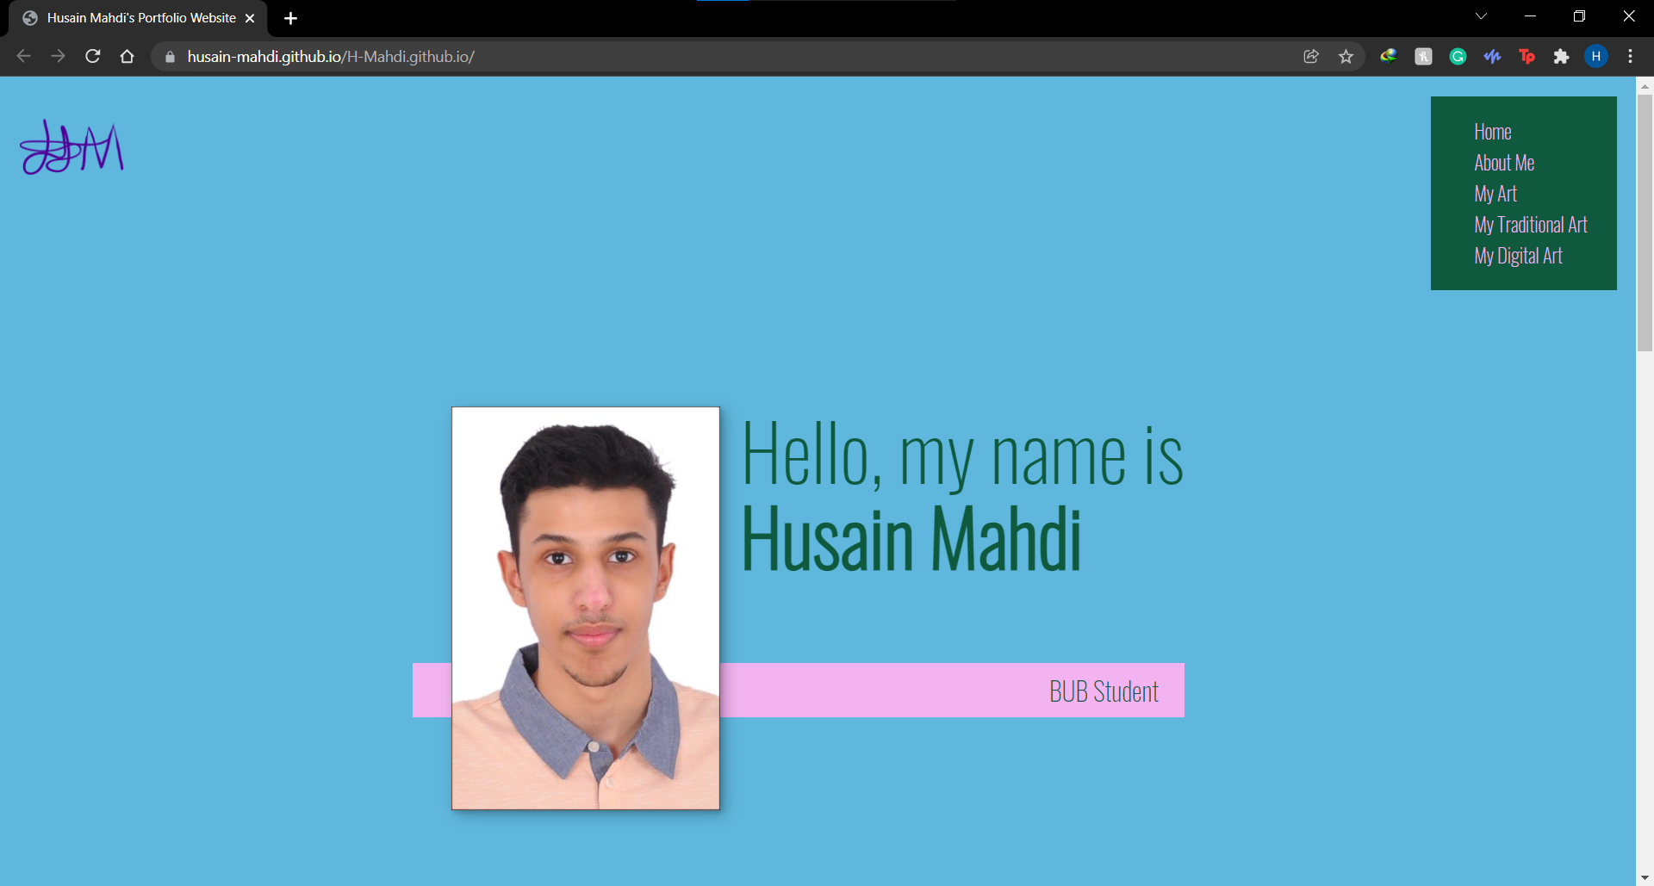

This screenshot is from Google Chrome a Windows operating system

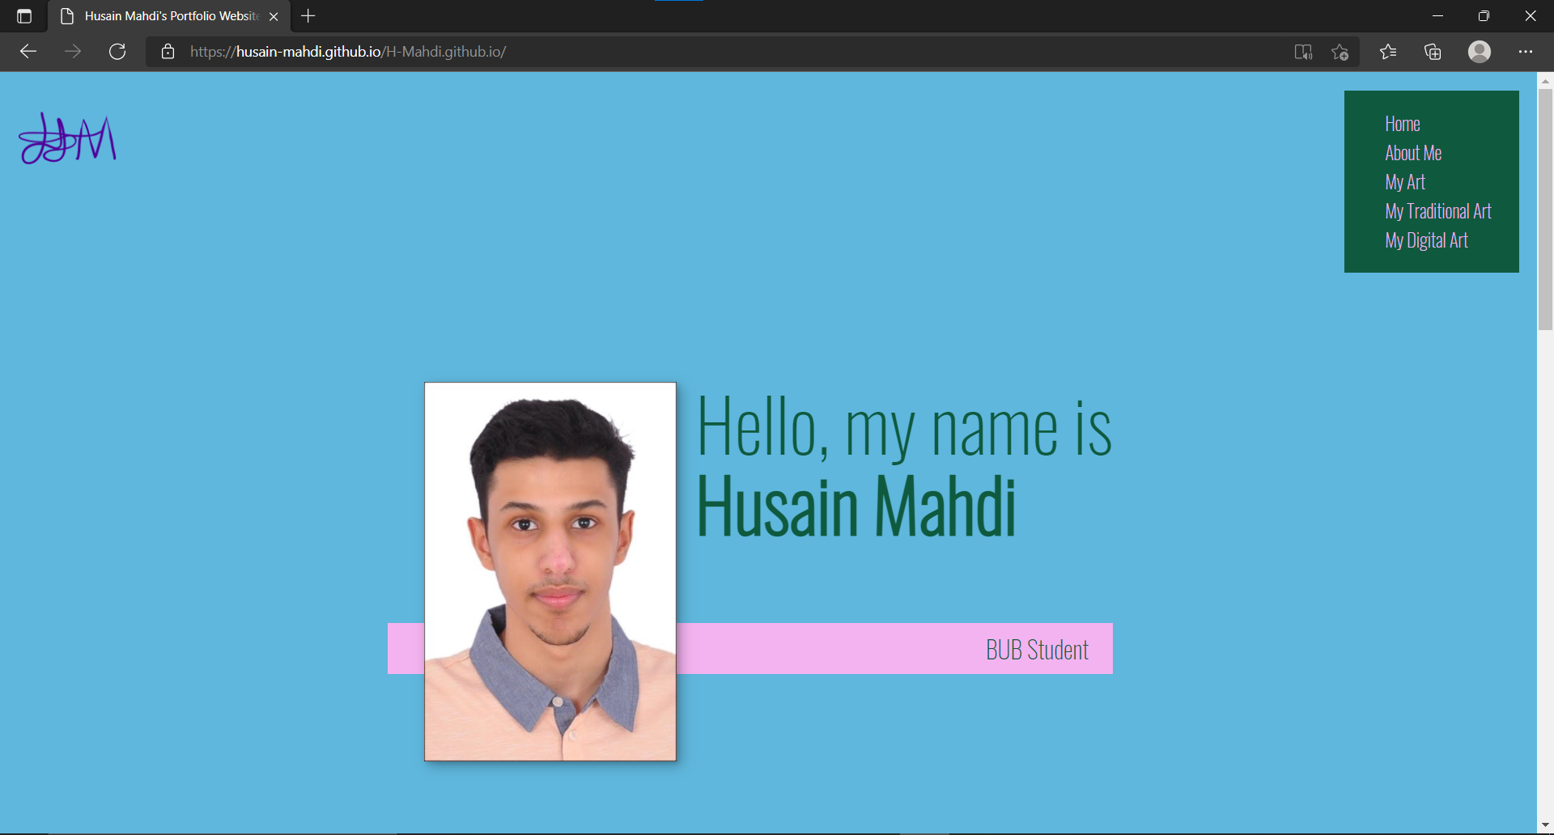

This screenshot is from Microsoft Edge on a Windows operating system

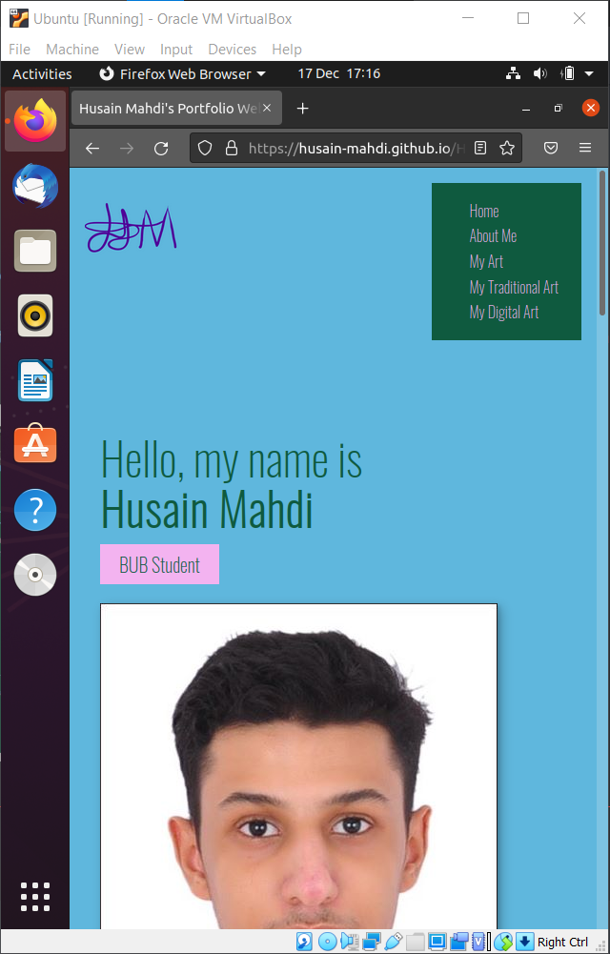

This screenshot is from Firefox on an Ubuntu Linux operating system

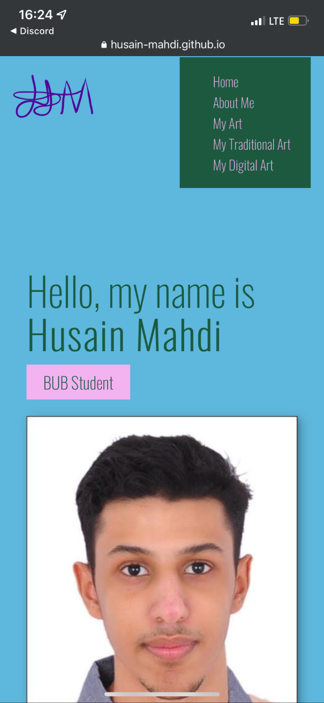

This screenshot is from an iPhone 12 with an iPhone operating system.

**7. Validation:**

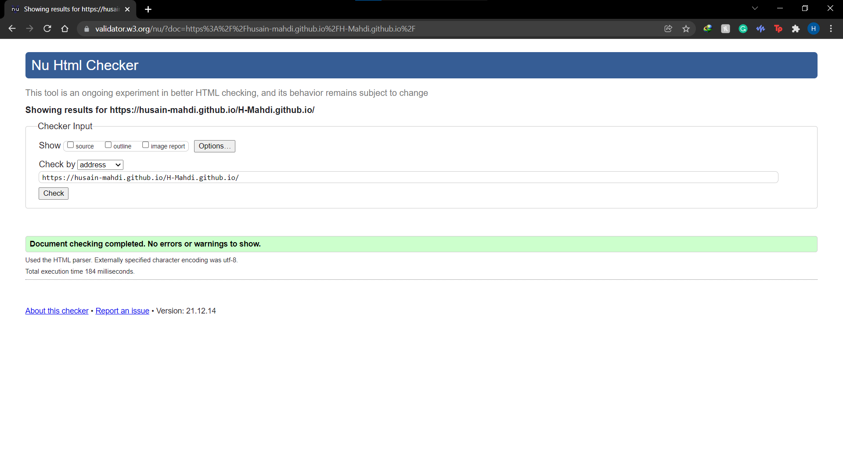

This screenshot is to validate the main page of my website.

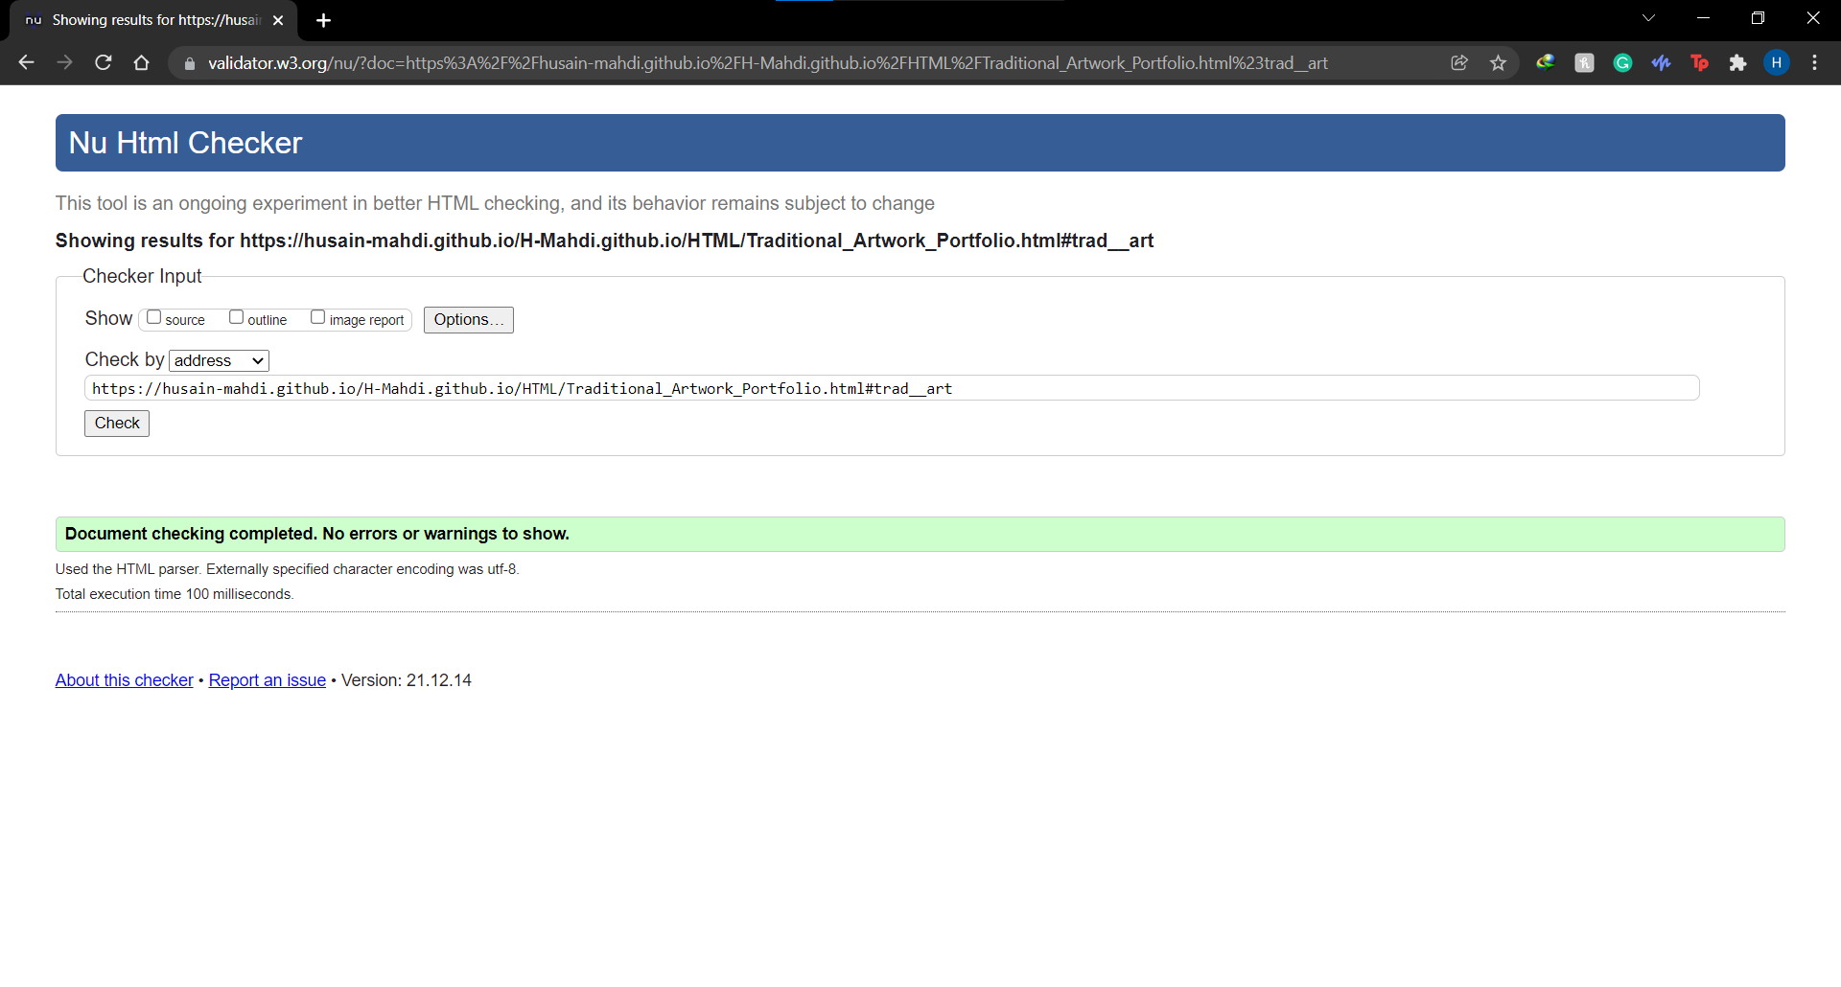

This screenshot is to validate the web page which is called “Traditional_Artwork_Portfolio”

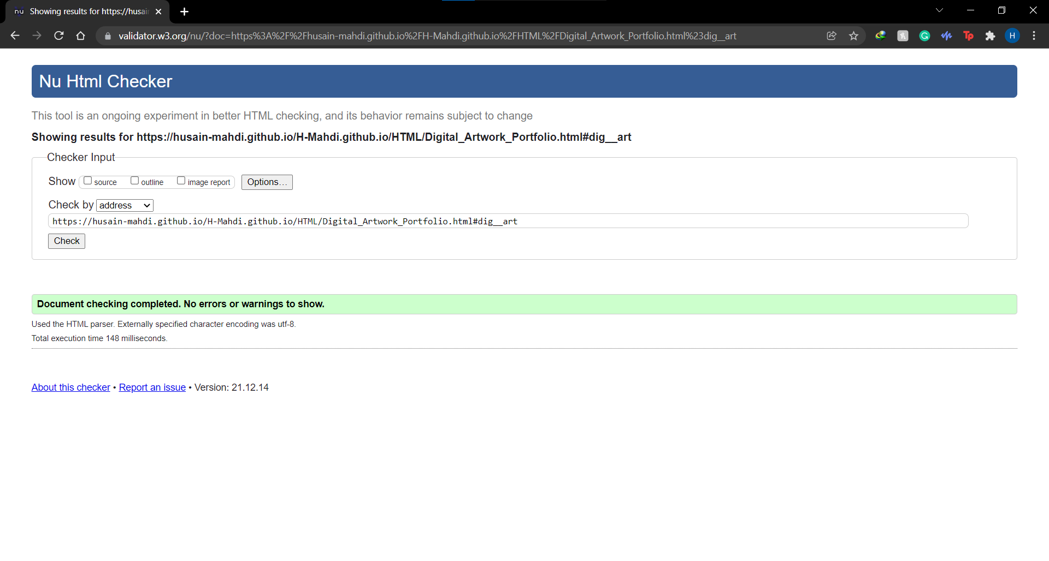

This screenshot is to validate the web page which is called “Digital_Artwork_Portfolio”

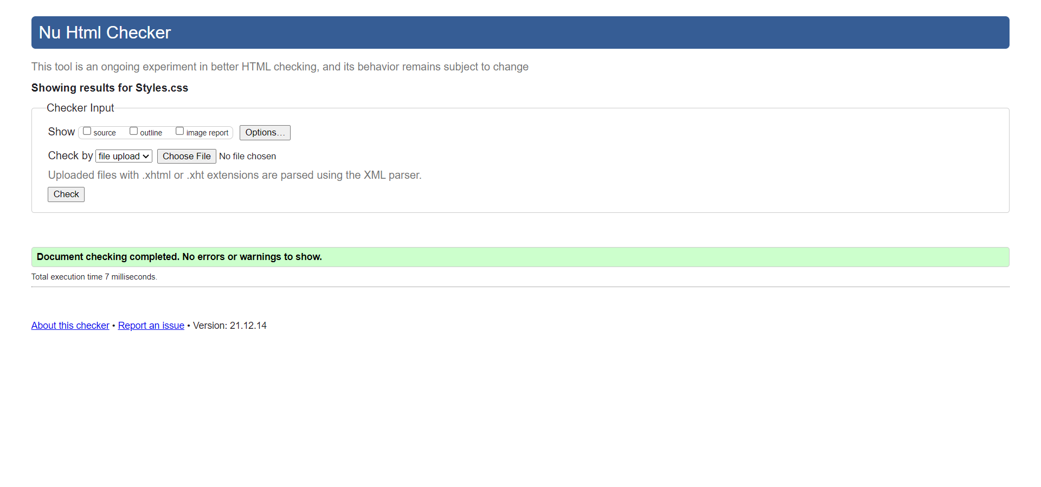

This screenshot is to validate the Css of the website.

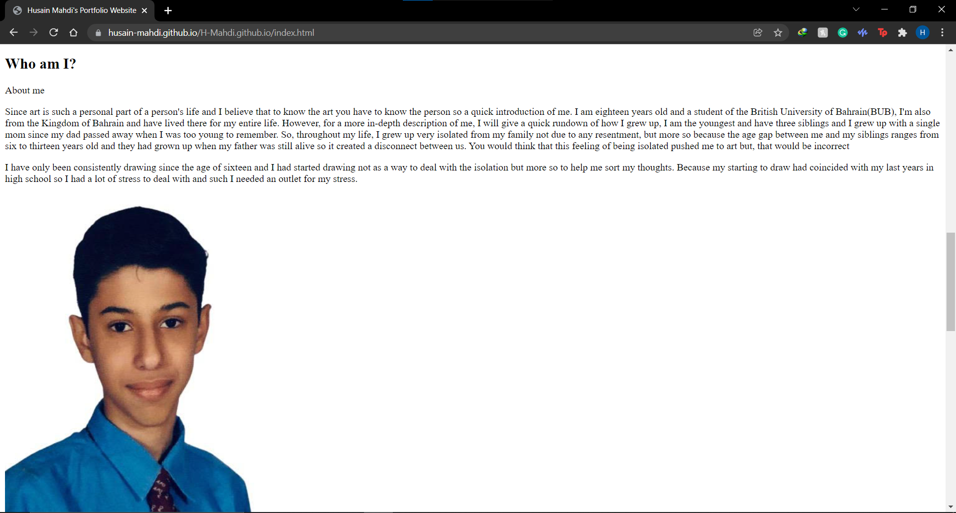

This screenshot is to validate that the website is still functional without the Css file.

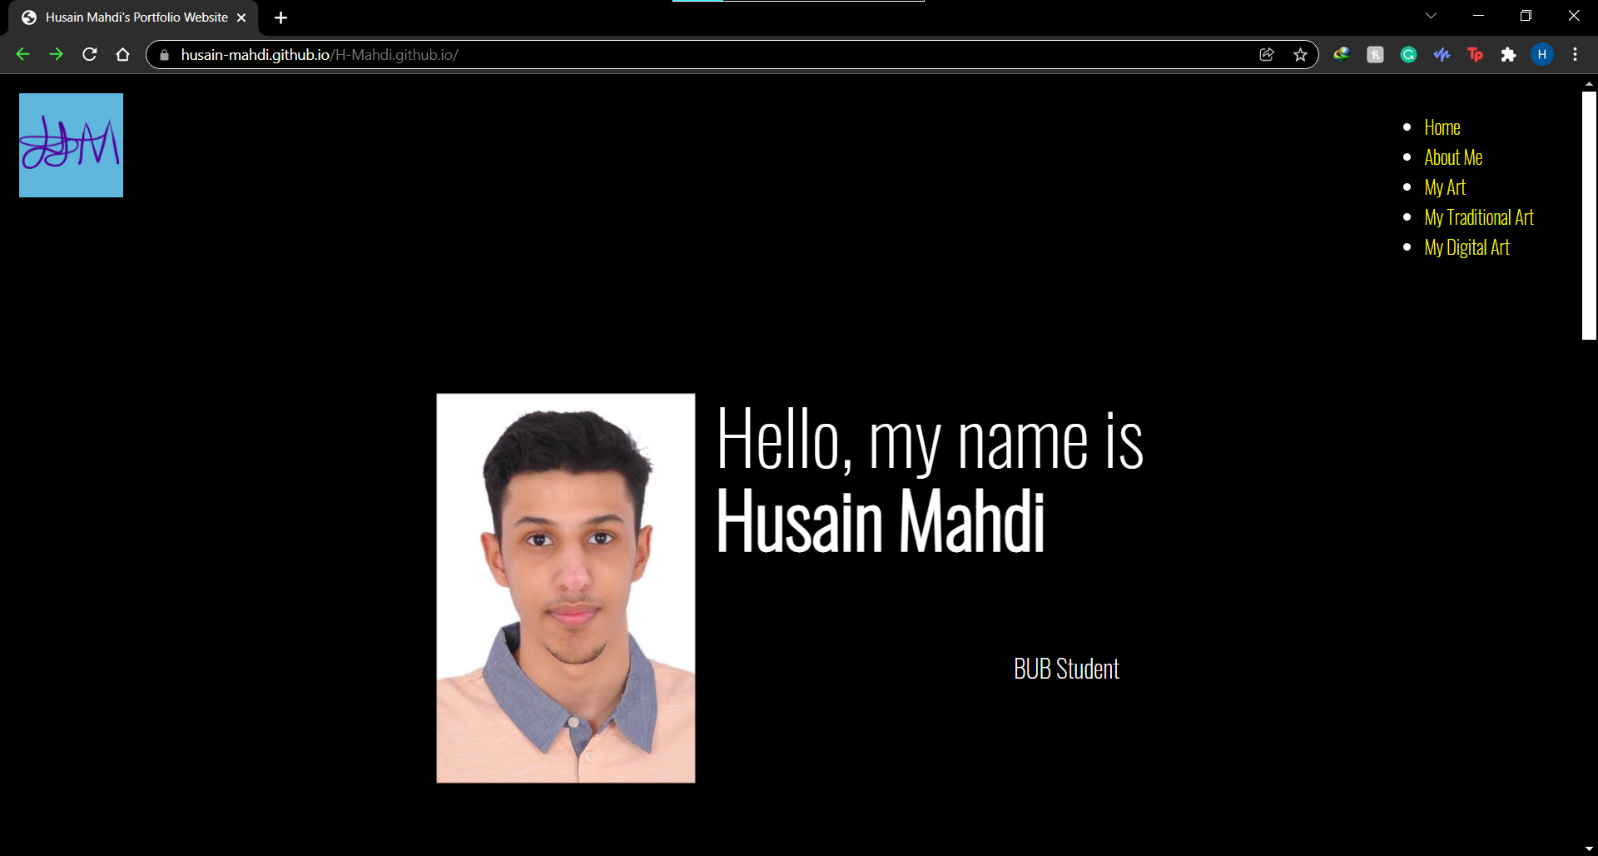

This screenshot is to show that the website is accessible with an example of if high contrast mode is activate it is still readable.