Ideation Phase
Empathize & Discover

Date | 1 November 2026
Team ID | Individual project (Team ID not provided)
Project Name | EV Market Performance & Insights
Maximum Marks | 4 Marks

Empathy Map Canvas:
An empathy map is a simple, easy-to-digest visual that captures knowledge about a user’s behaviours and attitudes.

It is a useful tool to helps teams better understand their users.
Creating an effective solution requires understanding the true problem and the person who is experiencing it. The exercise of creating the map helps participants consider things from the user’s perspective along with his or her goals and challenges.
Example:
Reference: https://www.mural.co/templates/empathy-map-canvas

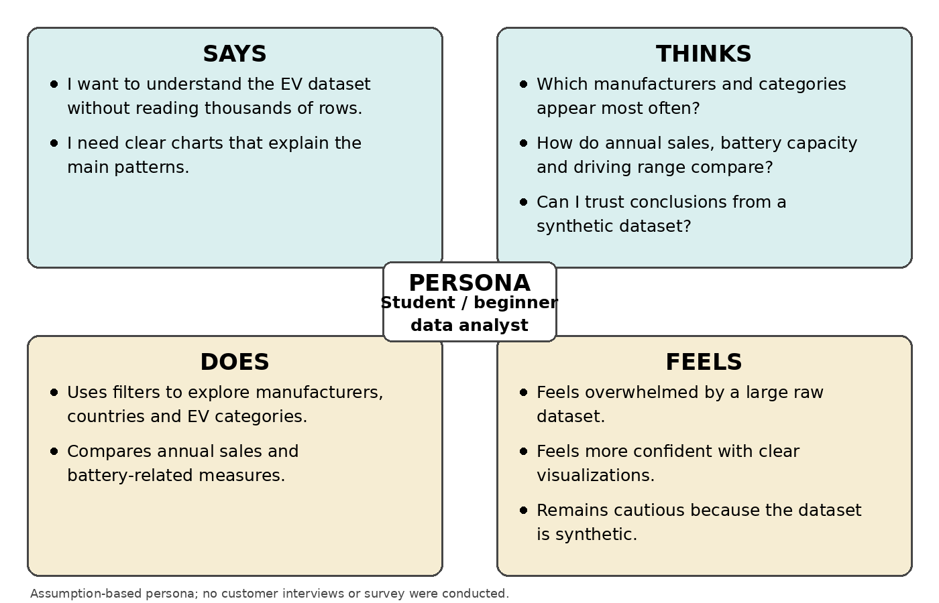

Completed Empathy Map
Persona: Student / beginner data analyst exploring an EV market dataset
Evidence note: This is an assumption-based project persona created for the design exercise. No customer interviews or user survey were conducted.
Perspective | What the persona may say, think, do or feel
SAYS | “I want to understand the EV dataset without reading thousands of rows.”  “I need clear charts that explain the main patterns.”
THINKS | Which manufacturers and categories appear most often?  How do annual sales, battery capacity and driving range compare?  Can I trust the conclusions drawn from this dataset?
DOES | Uses filters and charts to explore manufacturers, countries and EV categories.  Compares yearly sales and battery-related measures.  Looks for simple summaries that can be presented to others.
FEELS | Overwhelmed by a large raw dataset.  More confident when information is shown in clear visualizations.  Cautious about conclusions because the dataset is synthetic.
Design implication: Provide an interactive Tableau dashboard with summary KPIs, filters and focused visualizations. Clearly describe the dataset as synthetic and avoid presenting its values as verified real-world EV market statistics.

