Data Flow Diagram & User Stories
Electric Vehicle Market Performance & Insights
Date: 1 November 2026 | Project type: Individual | Tool: Tableau Public

1. Data Flow Diagram
The diagram shows the actual high-level flow used in this Tableau project: the synthetic training CSV is connected to Tableau, analysed through fields, filters and aggregations, and presented as worksheets, a dashboard and a six-point Story.
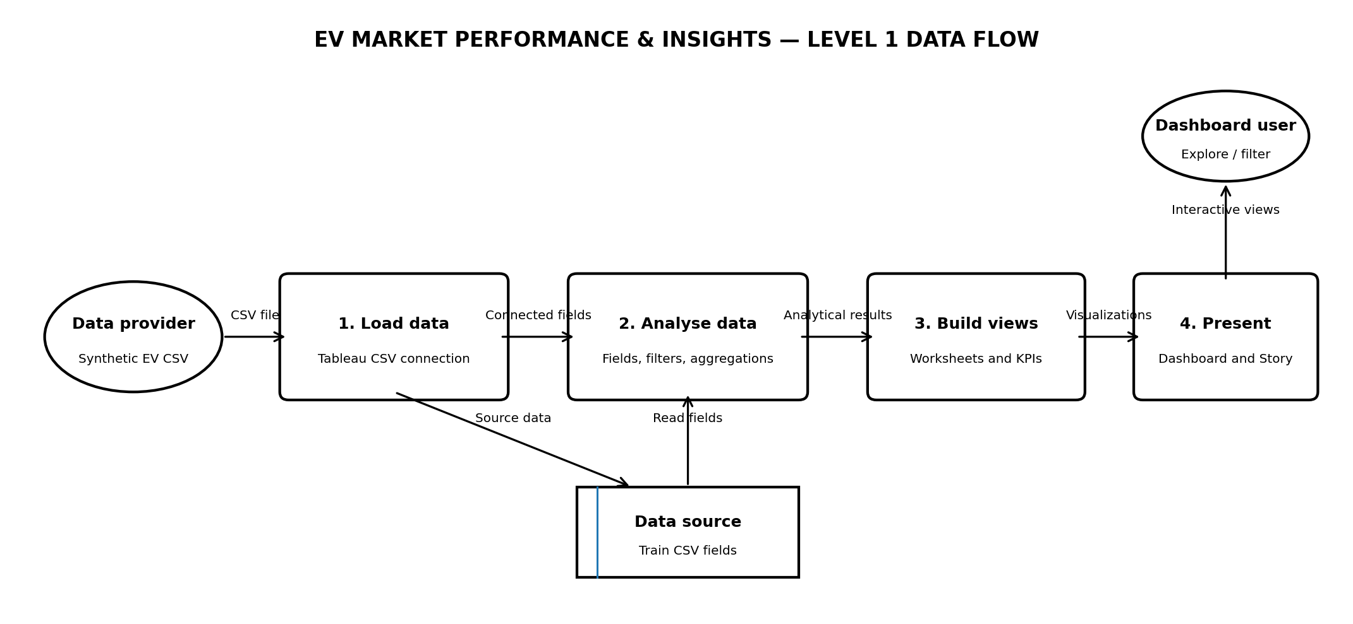
Data stores and processing are logical representations of the Tableau workflow. No separate application database, API, ETL server or custom backend was implemented.

2. User Stories
The primary user is an analyst, student or decision-maker exploring the supplied EV dataset. These stories describe dashboard capabilities, not user accounts or features that were not built.
User type | Epic | Story ID | User story | Acceptance criteria | Priority | Release
Dashboard user | Market overview | US-01 | As a dashboard user, I want to see key EV market KPIs so I can understand the dataset at a glance. | All six KPI cards are visible with clear labels and units. | High | Dashboard
Dashboard user | Category analysis | US-02 | As a dashboard user, I want to compare EV records by category so I can see how the dataset is distributed. | Category distribution chart displays categories and their record counts. | High | Dashboard
Dashboard user | Manufacturer comparison | US-03 | As a dashboard user, I want to view the top 10 manufacturers by EV records so I can identify the manufacturers with the most records. | Chart displays up to ten manufacturers and a clearly identified record-count measure. | High | Dashboard
Dashboard user | Sales trend | US-04 | As a dashboard user, I want to view annual EV sales totals so I can inspect changes across model years. | Trend chart shows annual totals for the available years. | High | Dashboard
Dashboard user | Rating analysis | US-05 | As a dashboard user, I want to compare customer ratings by category so I can inspect rating differences. | Chart shows the aggregated rating for each category with a readable axis. | Medium | Dashboard
Dashboard user | Battery analysis | US-06 | As a dashboard user, I want to compare battery technologies so I can understand their distribution in the dataset. | Chart displays the available battery technologies and their record counts. | High | Dashboard
Dashboard user | Geographic analysis | US-07 | As a dashboard user, I want to explore EV records by manufacturing country so I can see the geographic distribution represented in the data. | Map uses manufacturing country as its geographic dimension and displays the associated measure. | Medium | Dashboard
Dashboard user | Technical comparison | US-08 | As a dashboard user, I want to compare battery capacity with driving range so I can inspect their relationship in the dataset. | Scatter plot displays battery capacity and driving range using labelled axes. | Medium | Dashboard
Dashboard user | Interactive exploration | US-09 | As a dashboard user, I want to filter by available manufacturer and country fields so I can focus on selected records. | Filters update the intended views and the selected filter values are visible. | High | Dashboard
Dashboard user | Guided presentation | US-10 | As a dashboard user, I want a Story that presents the main analyses in sequence so I can follow the project findings. | Story contains six named points and each point opens its intended view. | Medium | Story

3. Scope clarification
This is a read-only analytical dashboard. User registration, login, customer-care workflows, payments, automated email alerts and live data ingestion are not part of the implemented solution.

