Project Design Phase-I
Problem – Solution Fit Template

Date | 1 November 2026
Team ID | Individual Project
Project Name | Electric Vehicle Market Performance & Insights
Maximum Marks | 2 Marks

Problem – Solution Fit Template:
The Problem-Solution Fit simply means that you have found a problem with your customer and that the solution you have realized for it actually solves the customer’s problem. It helps entrepreneurs, marketers and corporate innovators identify behavioral patterns and recognize what would work and why
Purpose:
- Solve complex problems in a way that fits the state of your customers.
- Succeed faster and increase your solution adoption by tapping into existing mediums and channels of behavior.
- Sharpen your communication and marketing strategy with the right triggers and messaging.
- Increase touch-points with your company by finding the right problem-behavior fit and building trust by solving frequent annoyances, or urgent or costly problems.
- Understand the existing situation in order to improve it for your target group.

Template:
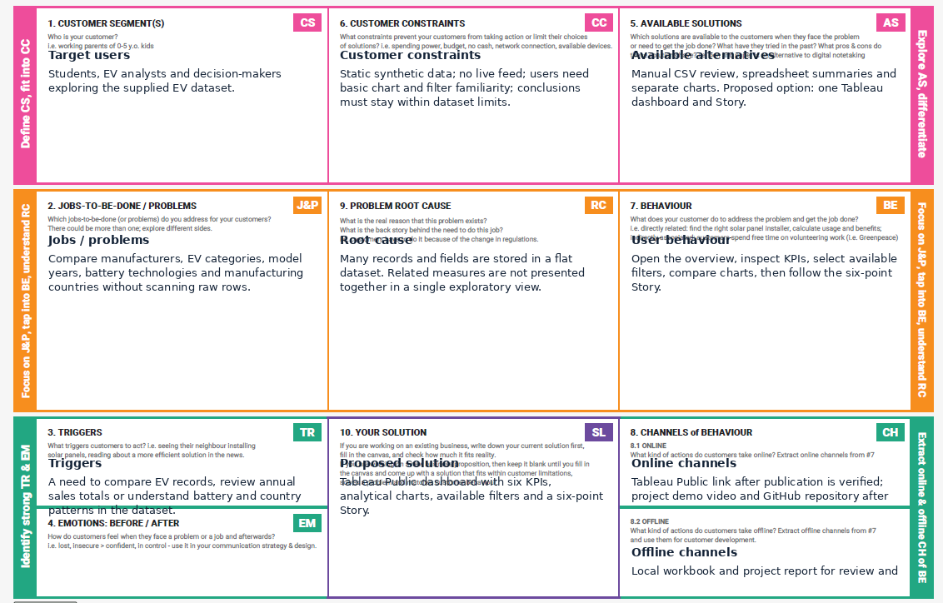
References:
- https://www.ideahackers.network/problem-solution-fit-canvas/
- https://medium.com/@epicantus/problem-solution-fit-canvas-aa3dd59cb4fe

Completed Problem–Solution Fit Canvas
Target user: a student, analyst or decision-maker exploring the supplied EV dataset. This persona is a design assumption, not a result of recorded customer interviews.
Canvas element | Project-specific response
Target customer | Students, analysts and decision-makers who need to explore EV data.
Customer problem | The dataset contains many records and fields. Manual inspection makes it difficult to compare manufacturers, categories, model years, battery technologies and countries.
Existing alternatives | Manually scanning CSV rows, preparing separate spreadsheet summaries or viewing disconnected charts.
Customer pains | Large tables are difficult to scan; comparisons take time; patterns across fields are not immediately visible; chart definitions can be unclear.
Desired gains | A quick overview, consistent comparisons, interactive filtering, geographic exploration and a guided presentation of patterns.
Proposed solution | A Tableau Public dashboard and six-point Story built from the supplied synthetic EV training CSV.
Problem–solution fit | The dashboard turns the structured data into KPI cards, category and manufacturer charts, annual sales trend, battery analysis, country map, scatter plot and heatmap.
Channels and adoption | Share the Tableau Public workbook after successful publication; explain the dashboard through the project report and demo video.
Success indicators | Views render; KPI values match source and aggregation logic; filters affect intended views; Story points open; titles, units and limitations are understandable.
Key limitation | The dataset is synthetic and the dashboard is descriptive. It does not establish real-world market share, prove causation or provide predictive forecasts.

Fit assessment
The solution is a reasonable fit for the defined analytical problem because it makes the supplied dataset easier to explore and compare. This is a design assessment, not validated market demand or evidence from interviews.

