Project Design Phase-I
Solution Architecture
Date | Team ID | Project Name | Maximum Marks
1 November 2026 | Individual Project | Electric Vehicle Market Performance & Insights | 4 Marks

Solution Architecture
The solution architecture describes how the supplied EV training dataset is connected, analysed and presented through Tableau Public Desktop. The architecture is a descriptive business-intelligence workflow rather than a multi-tier software application.
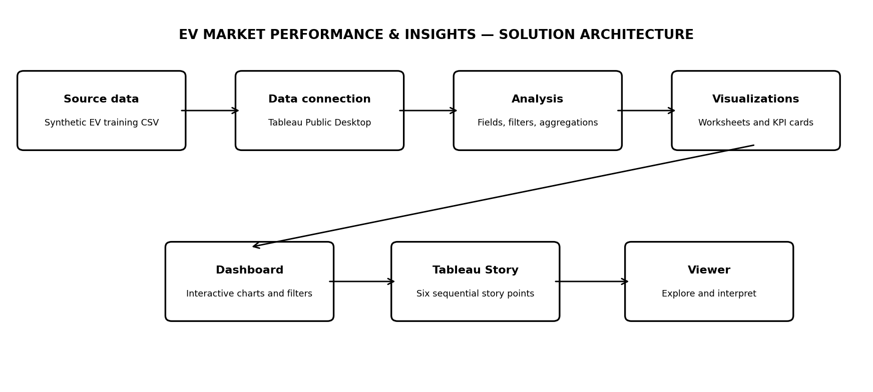

Component Description Table
Component Name | Description / Role in Architecture | Technology Used
Source Data | Provides the EV records used for analysis. | Synthetic EV training CSV; 200,000 rows and 37 columns.
Data Connection | Connects the CSV fields to the workbook. | Tableau Public Desktop text-file connection.
Data Analysis | Uses dimensions, measures, filters and aggregations. | Built-in Tableau features; no separate ETL pipeline claimed.
Visualization Layer | Displays KPIs and analytical charts. | Tableau worksheets.
Dashboard Layer | Combines selected views and available filters. | Tableau dashboard.
Story Layer | Presents six analysis points in sequence. | Tableau Story.
Sharing / Delivery | Makes outputs available to reviewers after verification. | Tableau Public / GitHub; publication and upload must be verified.

Data Flow
Training CSV → Tableau data connection → dimensions, measures, filters and aggregations → worksheets → dashboard → six-point Story → sharing and demonstration.

Architecture Decisions and Limitations
This is a descriptive BI dashboard. No separate database, backend, API, cloud ETL service, authentication module or predictive model was built. The source is synthetic, static and local; refreshes require an updated file. Tableau Public workbooks are public, so confidential data must not be included.

