Project Planning Phase
Project Planning Template (Product Backlog, Sprint Planning, Stories, Story points)

Date | 1 November 2026
Team ID | Individual Project
Project Name | Electric Vehicle Market Performance & Insights
Maximum Marks | 8 Marks

Product Backlog, Sprint Schedule, and Estimation (4 Marks)
Use the below template to create product backlog and sprint schedule
Sprint | Functional Requirement (Epic) | User Story Number | User Story / Task | Story Points | Priority | Team Members
Sprint 1 | Data understanding | US-01 | Inspect the synthetic EV training CSV, understand fields, dimensions, measures and data-quality limitations. | 3 | High | Husain (individual)
Sprint 1 | Requirements | US-02 | Define the dashboard audience, problem statements, business questions and functional requirements. | 3 | High | Husain (individual)
Sprint 1 | Project design | US-03 | Prepare the problem–solution fit, proposal and Tableau solution architecture. | 3 | High | Husain (individual)
Sprint 2 | Data connection | US-04 | Connect the training CSV to Tableau Public Desktop and inspect field types and available measures. | 3 | High | Husain (individual)
Sprint 2 | KPI development | US-05 | Create KPI views for manufacturers, EV model records, annual sales, driving range, customer rating and battery capacity. | 4 | High | Husain (individual)
Sprint 2 | Visual analysis | US-06 | Build category, manufacturer, annual sales, customer rating and battery technology views. | 4 | High | Husain (individual)
Sprint 3 | Advanced views | US-07 | Build manufacturing-country map, battery capacity versus range scatter plot and category versus battery type heatmap. | 4 | Medium | Husain (individual)
Sprint 3 | Dashboard | US-08 | Arrange the worksheets into the EV Market Performance & Insights dashboard and configure available filters. | 4 | High | Husain (individual)
Sprint 3 | Story | US-09 | Create and title the six-point Tableau Story using the completed dashboard views. | 3 | Medium | Husain (individual)
Sprint 4 | Verification | US-10 | Check KPI totals, chart labels, filter scope, dashboard layout and Story navigation; record only tests actually performed. | 4 | High | Husain (individual)
Sprint 4 | Documentation | US-11 | Complete project templates, final report, README and source/dataset references. | 3 | High | Husain (individual)
Sprint 4 | Demonstration & delivery | US-12 | Prepare the demo video and verify Tableau Public and GitHub links. | 2 | High | Husain (individual)

Project Tracker, Velocity & Burndown Chart: (4 Marks)
Sprint | Total Story Points | Duration | Sprint Start Date | Sprint End Date (Planned) | Story Points Completed (as on Planned End Date) | Sprint Release Date (Actual)
Sprint 1 | 9 points | 5 working days | Proposed / reconstructed | Proposed / reconstructed | Not recorded | Not recorded
Sprint 2 | 11 points | 5 working days | Proposed / reconstructed | Proposed / reconstructed | Not recorded | Not recorded
Sprint 3 | 11 points | 5 working days | Proposed / reconstructed | Proposed / reconstructed | Not recorded | Not recorded
Sprint 4 | 9 points | 5 working days | Proposed / reconstructed | Proposed / reconstructed | Not recorded | Not recorded

Velocity (planned estimate):
For this individual project, the backlog has an estimated 40 story points across four proposed sprints. The planned average is 10 story points per 5-day sprint, or 2 story points per working day. Calculation: 10 story points ÷ 5 working days = 2 story points per day. This is a planning estimate, not measured historical velocity.

Burndown Chart:
A burn down chart is a graphical representation of work left to do versus time. It is often used in agile software development methodologies such as Scrum. However, burn down charts can be applied to any project containing measurable progress over time.

https://www.visual-paradigm.com/scrum/scrum-burndown-chart/
https://www.atlassian.com/agile/tutorials/burndown-charts

Reference:
https://www.atlassian.com/agile/project-management
https://www.atlassian.com/agile/tutorials/how-to-do-scrum-with-jira-software
https://www.atlassian.com/agile/tutorials/epics
https://www.atlassian.com/agile/tutorials/sprints
https://www.atlassian.com/agile/project-management/estimation
https://www.atlassian.com/agile/tutorials/burndown-charts

Project Burndown (Illustrative)
The chart below shows an ideal straight-line burn from 9 story points to zero over 5 working days, matching the estimated Sprint 1 backlog. It is illustrative only; actual daily remaining work was not recorded.
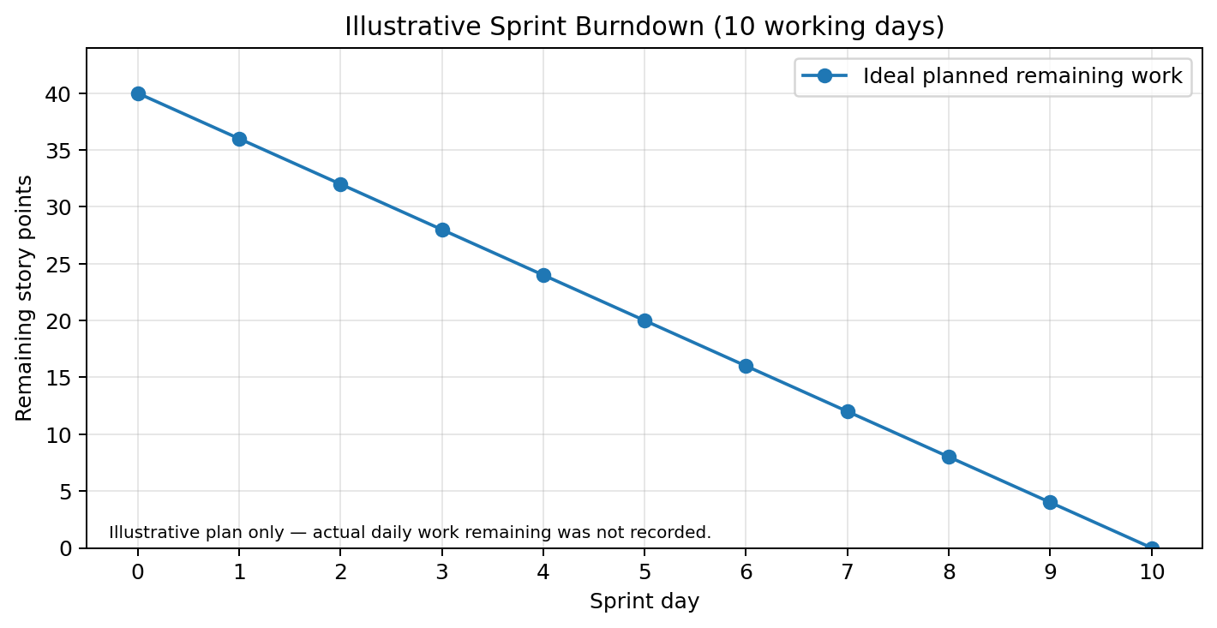

Planning assumptions and status
This schedule is a reconstructed planning baseline based on the project's known deliverables. Exact historical start dates, sprint completion dates, actual story-point completion and release dates were not documented, so those values are deliberately marked as not recorded rather than invented.
The work was carried out by one student. The 'Team Members' column therefore identifies the individual project owner rather than a team.
Project status at the time of preparing this template: dashboard and six-point Story have been developed; project documentation templates are being completed. Tableau Public publication, GitHub upload and demo-video completion remain subject to direct verification.

Backlog summary
Total estimated backlog: 40 story points across 12 user stories/tasks. Priority is assigned according to the dependency of each task on the final dashboard and submission.

